Novel Imidazolium Based Catalyst for the Chemical Fixation of Carbon Dioxide
Lucia Anna Bivona,^{1,2} Ornella Fichera,¹ Mireia Buaki-Sogo,*^{,1} Luca Fusaro,¹ Michelangelo Gruttadauria,*^{,2} Carmela Aprile*^{,1}

¹ Unit of Nanomaterial Chemistry (CNano), University of Namur (UNAMUR), Department of Chemistry, Rue de Bruxelles 61, 5000 Namur, Belgium. Phone number: +32 81 724514
² Dipartimento di Scienze e Tecnologie Biologiche Chimiche e Farmaceutiche (STEBICEF), Sezione di Chimica, Università di Palermo, Viale delle Scienze, Ed. 17, 90128, Palermo, Italy.
(*) Corresponding authors: carmela.aprile@unamur.be ; mireia.buakisogo@unamur.be; michelangelo.gruttadauria@unipa.it

Keywords: chemical fixation of carbon dioxide, polyhedral oligomeric silsesquioxane (POSS), ionic liquids, catalysis

Introduction
Development of green processes based on chemical fixation of carbon dioxide has attracted the attention in industrial chemistry from the standpoint of the possibility to transform a waste, such as CO₂, into useful products.¹ CO₂ gas is produced in large amounts from fuel combustion and represents an easy available, inexpensive and abundant carbon source. However, due to its thermodynamic and kinetic stability, its conversion is difficult to achieve and an efficient catalyst is required.² Cyclic carbonates, synthetized through the reaction between CO₂ and epoxides, are interesting compounds that can be used for several applications, such as electrolytic for lithium batteries, polar aprotic solvents, intermediates for organic synthesis and precursor for pharmaceuticals. Various homogeneous and heterogeneous processes have been proposed for this reaction. Recently, ionic liquids have emerged as a novel class of organocatalysts. In particular, imidazolium-based ionic liquids have become very attractive because they are one of the most efficient catalysts for CO₂ fixation to produce cyclic carbonate from epoxydes.³
In this work, the synthesis and applications of a novel imidazolium based catalyst is presented. Polyhedral oligomeric silsesquioxane (POSS) presenting a nanometer-size silica based structure, have been functionalized with imidazolium units to obtain an imidazolium-based POSS (POSS-mim-Cl, fig. 1 left). This new material was employed for the reaction of CO₂ and epoxides in homogeneous conditions with excellent results. In addition, it was easily recovered from the reaction mixture. To the best of our knowledge, the application of these materials for the fixation of CO₂ is a domain still unexplored.

Experimental/methodology
The synthesis of POSS-mim-Cl was carried out by means of a synthetic strategy divided in two steps: the first step employed a commercially available octa-vinyl POSS which was reacted with chloropropanethiol, through a thiol-ene reaction. Once the product (POSS-Cl) was obtained, the following step was its functionalization with an excess of 1-methylimidazole to obtain POSS-mim-Cl. The material was extensively characterized by ¹H, ¹³C and ²⁹Si-NMR, and elemental analysis. In order to explore its catalytic activity, styrene oxide was selected as model compound for the chemical fixation of CO₂. In addition, different parameters (solvent, temperature, pressure of CO₂, and mass of the catalyst) were modified to find the best condition for CO₂ fixation.

Results and discussion
The material POSS-mim-Cl was obtained with high yield. ¹H and ¹³C NMR spectra confirm the structure of the catalyst and elemental analysis shows a high degree of functionalization of the material. ²⁹Si NMR spectrum displays different signals suggesting the presence of the hepta imidazolium- based POSS. The fixation of CO₂ was performed using 24 mL of styrene oxide, varying different parameters such of pressure of CO₂, temperature, amount of catalyst and co-solvent. The catalytic tests were carried out in a batch reactor for 3 h, in homogeneous conditions. In general, the catalyst POSS-mim-Cl displayed good catalytic performances. When using water as co-solvent, the material showed good conversion (70 %) and TON (410) with a CO₂ of 40 bar, at 150°C and using 110 mg of catalyst. However, the presence of water decreased the selectivity due to the formation of the styrene glycol as by-product. In order to increase the selectivity, other co-solvents were also tested. The best results were obtained when using isopropanol. Under these conditions almost quantitative conversion and selectivity > 90% were obtained (TON of 553, fig. 1 right).
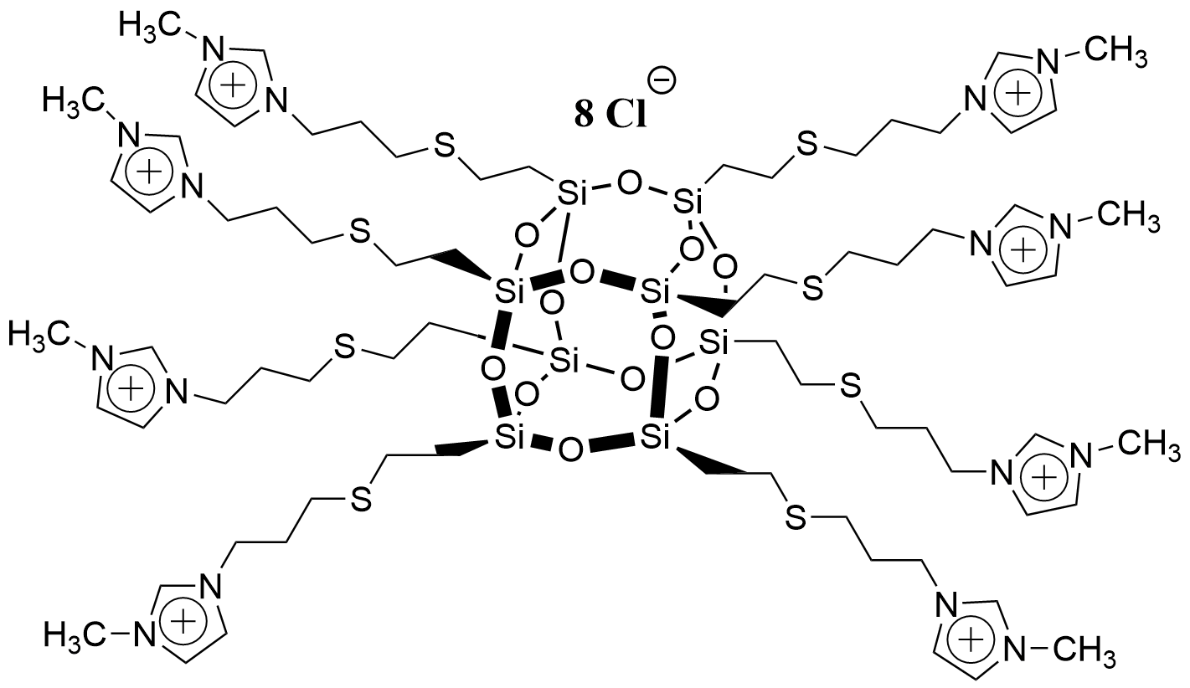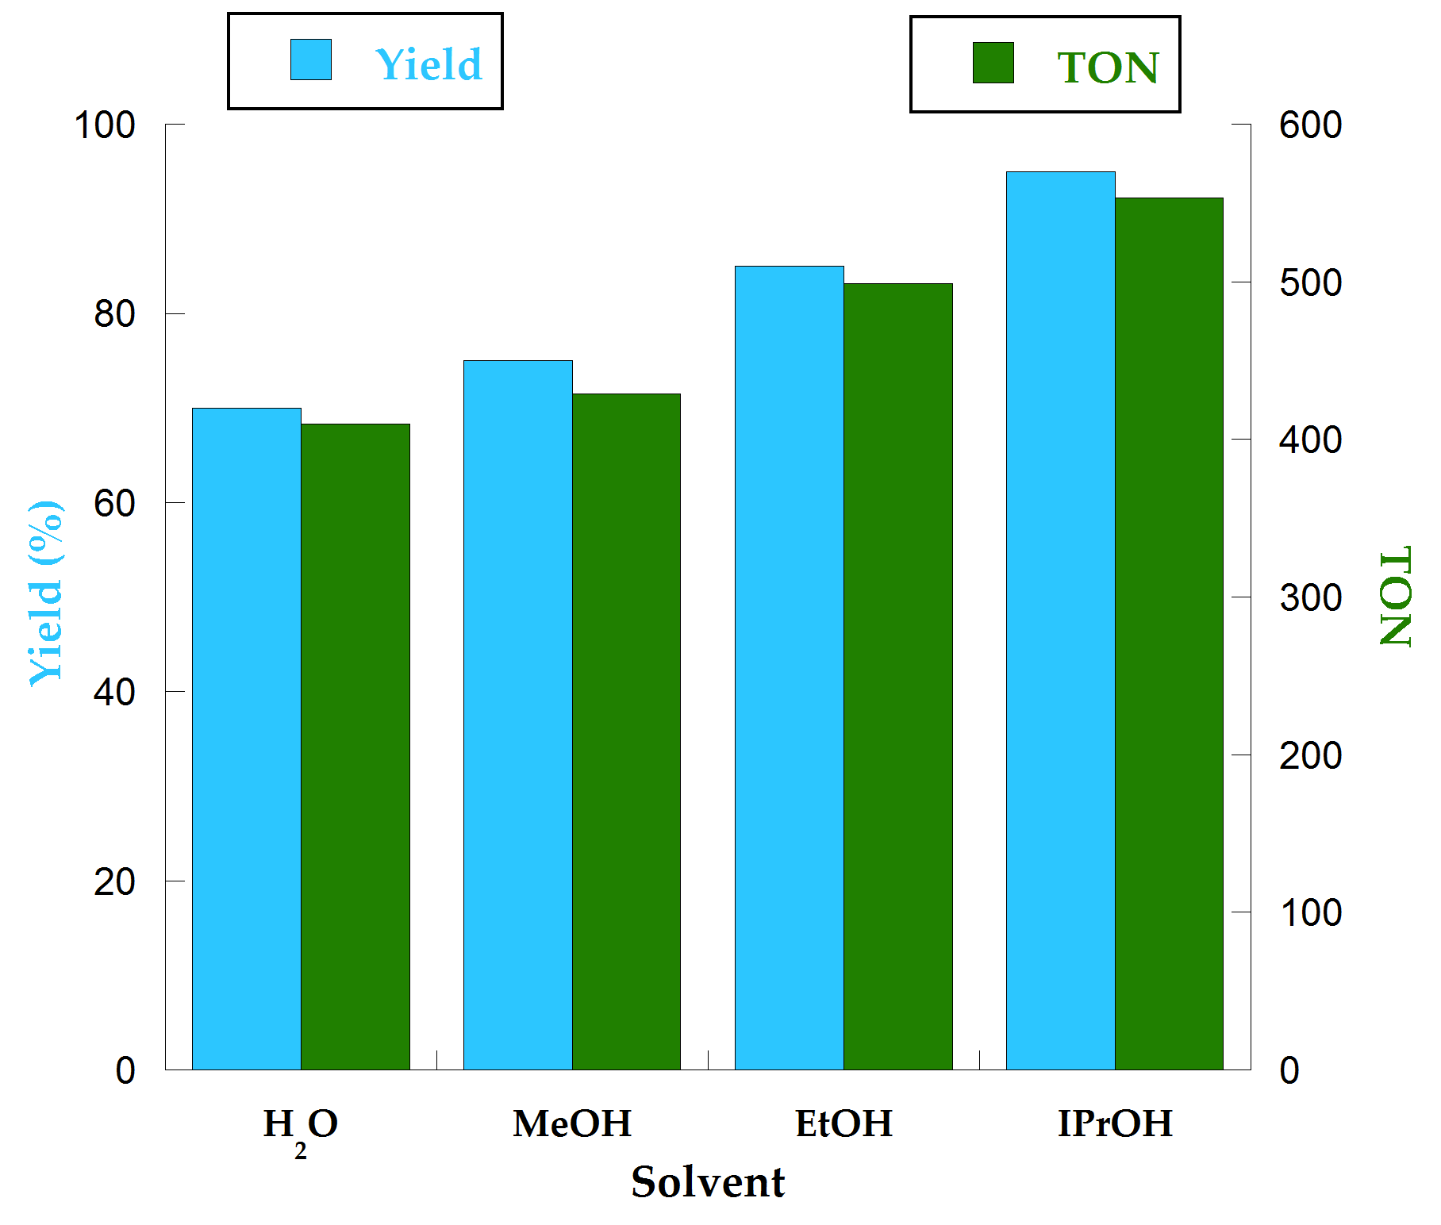
Fig. 1.Structure of the catalyst POSS-mim-Cl (left); Yield and TON of the fixation of CO₂, varying co-solvent at 40 bar, 150°C, using 110 mg of catalyst for 3 h (right).
Additional tests were performed in anhydrous solvents and excellent results in term of selectivity (> 99 %) were obtained for anhydrous ethanol. In order to study the influence of the nano-cage, 1-butyl-3-methyl imidazolium chloride (bmimCl) was also tested as catalyst in the same conditions than POSS-mim-Cl. It is worth to mention that POSS-mim-Cl displayed better performance (TON = 429) than the bmim-Cl (TON = 328). POSS-mim-Cl was also recovered by extraction from the reaction mixture, and its structure was confirmed by ¹H NMR spectrum.

Conclusions
A novel class of material based on POSS-mim-Cl was prepared and tested for the reaction of CO₂ with epoxides. The POSS-mim-Cl displayed a very high catalytic performance, in presence of isopropanol as co-solvent. The results were compared with those obtained with bmimCl moiety, proving that the nano-cage (POSS) plays an active role in the reaction probably due to the proximity effect.⁴ As far as we know this is the first use of imidazolium-based POSS as catalysts for the chemical fixation of CO₂.

Acknowledgements
L. A. Bivona thanks the University of Namur and the Università di Palermo for a co-founded PhD fellowship.
References
[1] a) W.-L. Dai, S.-L. Luo, S.-F. Yin, C.-T. Au, Applied Cat. A: General 366 (2009) 2-12; b) J. H. Clements, Ind. Eng. Chem. Res. 42 (2003) 663-674.
[2] T. Sakakura, J.-C. Choi, H. Yasuda, Chemical Reviews 107 (2007) 2365-2387.
[3] C. Aprile, F. Giacalone, P. Agrigento, L.F. Liotta, J. A. Martens, P. P. Pescarmona, M. Gruttadauria, ChemSusChem 4 (2011) 1830-1837.
[4] a) M. Buaki-Sogo, H. Garcia, C. Aprile, Catal. Sci. Technol. (2015) DOI: 10.1039/C4CY01258E. b) M. Taherimehr, A. Decortes, S. M. Al-Amsyhar, W. Lueangchaichaweng, C. Whiteoak, E. C. Escudero-Adán, A. W. Kleij, P. P. Pescarmona, Catal. Sci. Technol. 2 (2012), 2231-2237.

