

UNIVERSITA DEGLI STUDI DI PALERMO

Dottorato di Ricerca in MEDICINA MOLECOLARE E CLINICA
Dipartimenti Promozione della Salute, Materno-Infantile, di Medicina Interna e Specialistica di Eccellenza “G. D’Alessandro

ARTIFICIAL INTELLIGENCE-BASED ANALYSIS OF THE ANTI-ARTHRITIC ACTIVITY OF POLYPHENOLS IN RHEUMATOID ARTHRITIS CELLULAR MODEL

IL DOTTORE IL COORDINATORE
Dott. Muhammad Ali Prof. AntoninoTuttolomondo

IL TUTOR CO TUTOR
Prof. Domenico Di Raimondo Dott. Albert Comelli

CYCLE XXXVII

ABSTRACT

Rheumatoid arthritis (RA) is a chronic autoimmune disorder characterized by persistent synovial inflammation, leading to joint damage and functional impairment. The disease involves a complex interplay of genetic, environmental, and immunological factors, with pro-inflammatory cytokines such as TNF-α, IL-1, and IL-6 playing a pivotal role in disease progression. Current therapeutic strategies aim to mitigate inflammation and prevent joint destruction, but challenges remain due to adverse effects and incomplete responses to treatment.
Polyphenols, naturally occurring compounds with anti-inflammatory and antioxidant properties, have emerged as potential therapeutic agents for RA. Studies suggest that polyphenols such as curcumin, resveratrol, EGCG, and quercetin modulate key inflammatory pathways, including NF-κB and MAPK, thereby reducing oxidative stress and immune dysregulation. However, their bioavailability and targeted delivery remain significant challenges. Nanoparticle-based drug delivery systems offer a promising solution by enhancing polyphenol stability, improving bioavailability, and ensuring targeted delivery to inflamed synovial tissues. Various nanoparticles, including polymeric, liposomal, and metallic carriers, have been explored for optimizing RA treatment.
Artificial intelligence (AI) and machine learning (ML) have revolutionized microscopic image analysis in biomedical research, enabling precise detection and classification of synovial tissue alterations in RA. Deep learning models, particularly convolutional neural networks (CNNs), have demonstrated high accuracy in identifying pathological changes, facilitating early diagnosis and disease monitoring. Additionally, radiomic analysis, an advanced technique that extracts high-dimensional quantitative features from medical imaging data, has been explored for evaluating joint abnormalities and detecting synovial malignancies. By integrating AI-driven radiomic analysis with conventional imaging, clinicians can enhance diagnostic precision, assess disease severity, and improve personalized treatment strategies.
This research explores the anti-arthritic potential of polyphenols, employing nanoparticles for targeted drug delivery, AI-based microscopic image analysis, and radiomic analysis for comprehensive disease assessment. The study aims to enhance therapeutic efficacy while minimizing adverse effects, providing novel insights into the application of advanced technologies in RA management.

CONTENT
1. INTRODUCTION…………………………………………………………… 6
1.1 Rheumatoid Arthritis: An Overview…………………………………………. 6
1.2 Role of Polyphenols in Rheumatoid Arthritis…………………………………6
1.3 Nanoparticles for Targeted Drug Delivery…………………………………… 6
1.4 Artificial Intelligence and Machine Learning in Microscopic Analysis……… 7
1.5 Radiomics for Tumor Detection……………………………………………….7
1.6. Thesis outline………………………………………………………………….7
2. PATHOGENEGIS OF RHEUMATOID ARTHRITIS AND ANTIARTHRITIC EFFECT OF POLYPHENOLS……………………………………………………..10
2.1. Pathogenesis of Rheumatoid arthritis…………………………………………10
2.2. Envionmenta, genetic and pathogic factors of causing RA…………………...11
2.3. Polyphenols in disease management………………………………………….11
2.4. Polyphenols modulate signaling pathways……………………………………15
2.5. Olive oil: a rich source of bioactive polyphenols……………………………..16
2.6. Spices and grape as sources of bioactive polyphenols………………………..16
2.7. Antiarthritic activity of vitamin E…………………………………………..…20
3. THE USE OF NANOPARTICLES FOR THE DELIVERY OF RESVERATROL
3.1 Liposomes……………………………………………………………………..22
3.2. Solid Lipid Nanoparticles ……………………………………………………..23
3.3. Polymeric Nanoparticles……………………………………………………….23
3.4. Zinc Oxide Nanoparticles………………………………………………………24
3.5. Gold Nanoparticles…………………………………………………………..…25
3.6. Carbon Nanotubes………………………………………………………………25
3.7. Zeolitic Imidazolate Framework-8 Nanoparticles (ZIF-8 NPs) ……………..…27
3.8. Mesoporous Silica Nanoparticles………………………………………….……28
3.9. Bioactive glasses…………………………………………………………...……29
4. THE USE OF ARTIFICIAL INTELLIGENCE APPLIED IN MICROSCOPIC IMAGES OF CELLS AND TISSUES……………………………………
4.1. Cell culture: A foundational technique in molecular and cellular biology research..30
4.2. Machine learning and artificial intelligence revolution in microscopic image of cells and tissues……………………………………………………………………….………….30
4.3. Reinforcement learning…………………………………………………….……31
4.4. Evaluation matrics………………………………………………………………32
4.5. Introduction of Artificial Neural networks………………………………...……33
4.6. Deep convolutional neural networks……………………………………………34
4.7. Introduction of generative adversarial networks……………………………..…35
4.8. Introduction of vision transformers…………………………………………..…37
5. RADIOMICS ANALYSIS IN MAGNETIC RESONANCE IMAGING TO DETECT TUMORS……………………………………………………………………………41
5.1. Prostate cancer detection methodology………………………………………….41
5.1.1 Material and methods…………………………………………………….…….41
5.1.1.1. Population……………………………………………………………………41
5.1.1.2. Using the MRI technique……………………………………………………42
5.1.1.3. Manual segmentation…………………………………………………..……42
5.1.1.4. Radiomics features extraction………………………………………….……43
5.1.1.5. Computational and statistical analysis………………………………………43
5.5. Methodology for bladder cancer………………………………………...………43
5.2.1.1. Population……………………………………………………………………44
5.2.1.2. MRI technique………………………………………………………….……44
5.2.1.3. Qualitative image analysis……………………………………………...……44
5.2.1.4. Segmentation and radiomics features extration………………………...……45
5.2.1.5. Computational and statistical analysis………………………………….……45
6. THE INVITRO EVALUATION OF SOME POLYPHENOLS
6.1. In vitro evaluation of tyrosol………………………………………..……………47
6.2. In vitro evaluation of Oleocanthal……………………………….…………….…50
6.3. In vitro evaluation of Curcumin……………………………………………..……50
6.4. In vitro evaluation of Stillbenes……………………………………..……………53
6.5. In vitro evaluation of Kaemperitrin…………………………….…………………54
6.6. In vitro evaluation of Gallic acid……………………………….…………………59
6.7. In vitro evaluation of Quercetin……………………………...……………………59
7. THE USE OF NANOPARTICLES FOR DELIVERY OF RESVERATROL....67
8. THE EVALUATION OF USE OF AI IN MICROSCOPIC IMAGES OF CELLS…79
9. THE EVALUATION OF USE OF RADIOMICS ANALYSIS FOR TUMOR DETECTION…………………………………………………………………………..………86
9.1.1. Population…………………………………………………………….…………86
9.1.2. Radiomics performance…………………………………………………………87
9.2. Bladder cancer……………………………………………………………...……. 89
9.2.1. Population………………………………………………………………….……89
9.2.2. Texture features……………………………………………………………....…89
10. CONCLUSION AND DISCUSSION……………………………………………90
REFERENCES

Chapter 1

Introduction

1.1 Rheumatoid Arthritis
Rheumatoid arthritis (RA) is an autoimmune disease where the immune system mistakenly attacks the synovium, the lining of the joints, causing inflammation, pain, and potential joint damage. The primary symptoms of RA include joint pain, particularly in the small joints such as the hands, wrists, and feet, with the pain often being symmetrical, affecting both sides of the body. Swelling, redness, and warmth around the affected joints are common signs of inflammation. People with RA also experience joint stiffness, especially in the morning or after periods of inactivity, which can last for over an hour and hinder movement [1]. Fatigue is another prevalent symptom, often leading to a general feeling of tiredness that disrupts daily activities. Chronic inflammation can result in decreased range of motion in the affected joints, and low-grade fever may also accompany flare-ups. In more severe cases, RA can affect organs beyond the joints, including the heart, lungs, and eyes, contributing to symptoms such as shortness of breath or dry eyes. The disease can fluctuate in severity, with periods of flare-ups followed by times of remission, making early diagnosis and treatment crucial for managing symptoms and preventing long-term joint damage [2]. RA affects approximately 1% of the global population, with women being three times more likely to develop the condition than men [1] in Italy, the annual economic cost of RA exceeded EUR 2.0 billion in 2015, with 45% attributed to direct medical costs, 45% to indirect costs, and 10% to direct non-medical expenses [3].
The pathogenesis of RA involves a complex interplay of genetic, environmental, and immunological factors. Pro-inflammatory cytokines such as tumor necrosis factor-alpha (TNF-α), interleukin-1 (IL-1), and interleukin-6 (IL-6) play a crucial role in disease progression. The activation of immune cells, including T cells, B cells, and macrophages, contributes to synovial inflammation and the production of autoantibodies such as rheumatoid factor (RF) and anti-citrullinated protein antibodies (ACPAs). The dysregulated immune response leads to synovial hyperplasia, angiogenesis, and the formation of pannus, which invades and destroys the joint structures[4].

1.2 Role of Polyphenols in Rheumatoid Arthritis
Polyphenols are naturally occurring compounds found in various plants, fruits, and vegetables. They exhibit potent anti-inflammatory, antioxidant, and immunomodulatory properties. Studies have demonstrated that polyphenols such as curcumin, resveratrol, epigallocatechin gallate (EGCG), and quercetin can inhibit inflammatory pathways, suppress oxidative stress, and modulate immune cell activity in RA. By targeting key signaling pathways, including NF-κB and MAPK, polyphenols hold promise as potential therapeutic agents for RA management [5].

1.3 Nanoparticles for Targeted Drug Delivery
The incorporation of nanoparticles (NPs) into biomedical applications has garnered substantial interest, primarily due to their potential to revolutionize drug delivery systems. These nanoscale carriers facilitate targeted therapy, improving drug bioavailability while minimizing systemic toxicity. By enabling controlled and sustained release, NPs enhance therapeutic efficacy, reduce adverse effects, and optimize treatment outcomes. Their versatility extends across various medical fields, including oncology, regenerative medicine, and infectious disease management, making them a promising tool for advancing modern healthcare solutions.In RA treatment, nanoparticle-based drug delivery systems can provide targeted therapy to inflamed synovial tissues. Polymeric nanoparticles, liposomes, and metallic nanoparticles have been explored for the encapsulation and delivery of anti-inflammatory agents, including polyphenols and biologics, to improve therapeutic efficacy and minimize adverse effects [6].

1.4 Artificial Intelligence and Machine Learning in Microscopic Analysis
Artificial intelligence (AI) and machine learning (ML) have revolutionized biomedical research, particularly in the analysis of microscopic images of cells and tissues. AI-driven image processing techniques enable the automated detection, segmentation, and classification of synovial tissue alterations in RA. Deep learning algorithms, including convolutional neural networks (CNNs), have demonstrated high accuracy in identifying pathological changes in synovial biopsies and cellular morphology. The integration of AI and ML in microscopic analysis enhances diagnostic precision and accelerates the assessment of disease progression [7].

1.5 Radiomics for Tumor Detection
Radiomics is an emerging field that involves the extraction of high-dimensional quantitative features from medical imaging data, such as MRI, CT, and PET scans. These features provide valuable insights into tissue heterogeneity, aiding in the early detection and characterization of tumors. In RA, radiomics has been explored for evaluating joint abnormalities and detecting synovial malignancies. By integrating AI-based radiomic analysis with traditional imaging techniques, clinicians can achieve more accurate and personalized disease assessment, leading to improved treatment strategies [8,9].

1.6 Thesis outline
This thesis is structured as follows:
- Chapter 2: Pathogenesis of rheumatoid arthritis and antiarthritic effect of polyphenols
- Chapter 3: The use of nanoparticles for the delivery of polyphenols
- Chapter 4: The use of artificial intelligence applied in microscopy imaging of cells
- Chapter 5: Radiomics analysis in magnetic resonance imaging to detect tumors
- Chapter 6: The invitro evaluation of some polyphenols
- Chapter 7: The use of various nanoparticles for delivery of polyphenol
- Chapter 8: The evaluation of the use of AI in microscopic imaging of cells
- Chapter 9: The evaluation of using radiomic analysis for tumor detection

  - Research Contributions
- Ali, M.; Benfante, V.; Stefano, A.; Yezzi, A.; Di Raimondo, D.; Tuttolomondo, A.; Comelli, A. Anti-Arthritic and Anti-Cancer Activities of Polyphenols: A Review of the Most Recent In Vitro Assays. Life 2023, 13, 361. https://doi.org/10.3390/life13020361
- Ali, M.; Benfante, V.; Di Raimondo, D.; Salvaggio, G.; Tuttolomondo, A.; Comelli, A. Recent Developments in Nanoparticle Formulations for Resveratrol Encapsulation as an Anticancer Agent. Pharmaceuticals 2024, 17, 126. https://doi.org/10.3390/ph17010126
- Ali, M.; Benfante, V.; Di Raimondo, D.; Laudicella, R.; Tuttolomondo, A.; Comelli, A. A Review of Advances in Molecular Imaging of Rheumatoid Arthritis: From In Vitro to Clinic Applications Using Radiolabeled Targeting Vectors with Technetium-99m. Life 2024, 14, 751. https://doi.org/10.3390/life14060751
- Ali, M.; Benfante, V.; Basirinia, G.; Alongi, P.; Sperandeo, A.; Quattrocchi, A.; Giannone, A.G.; Cabibi, D.; Yezzi, A.; Di Raimondo, D.; et al. Applications of Artificial Intelligence, Deep Learning, and Machine Learning to Support the Analysis of Microscopic Images of Cells and Tissues. J. Imaging 2025, 11, 59. https://doi.org/10.3390/jimaging11020059
- Ali, M Viviana Benfante, Giuseppe Cutaia, Leonardo Salvaggio, Sara Rubino, Marzia Portoghese, Marcella Ferraro, Rosario Corso, Giovanni Piraino, Tommaso Ingrassia, Gabriele Tulone, Nicola Pavan, Domenico Di Raimondo, Antonino Tuttolomondo, Alchiede Simonato, Giuseppe Salvaggio (2024). Prostate Cancer Detection: Performance of Radiomics Analysis in Multiparametric MRI. In: Foresti, G.L., Fusiello, A., Hancock, E. (eds) Image Analysis and Processing - ICIAP 2023 Workshops. ICIAP 2023. Lecture Notes in Computer Science, vol 14366. Springer, Cham. https://doi.org/10.1007/978-3-031-51026-7_8
- Viviana Benfante, Giuseppe Salvaggio, Ali, M Giuseppe Cutaia, Leonardo Salvaggio, Sergio Salerno, Gabriele Busè, Gabriele Tulone, Nicola Pavan, Domenico Di Raimondo, Antonino Tuttolomondo, Alchiede Simonato, Albert Comelli (2024). Grading and Staging of Bladder Tumors Using Radiomics Analysis in Magnetic Resonance Imaging. In: Foresti, G.L., Fusiello, A., Hancock, E. (eds) Image Analysis and Processing - ICIAP 2023 Workshops. ICIAP 2023. Lecture Notes in Computer Science, vol 14366. Springer, Cham. https://doi.org/10.1007/978-3-031-51026-7_9
- Benfante, V.; Stefano, A.; Ali, M.; Laudicella, R.; Arancio, W.; Cucchiara, A.; Caruso, F.; Cammarata, F.P.; Coronnello, C.; Russo, G.; et al. An Overview of In Vitro Assays of ⁶⁴Cu-, ⁶⁸Ga-, ¹²⁵I-, and ^{99m}Tc-Labelled Radiopharmaceuticals Using Radiometric Counters in the Era of Radiotheranostics. Diagnostics 2023, 13, 1210. https://doi.org/10.3390/diagnostics13071210
- Lo Casto, A.; Spartivento, G.; Benfante, V.; Di Raimondo, R.; Ali, M.; Di Raimondo, D.; Tuttolomondo, A.; Stefano, A.; Yezzi, A.; Comelli, A. Artificial Intelligence for Classifying the Relationship between Impacted Third Molar and Mandibular Canal on Panoramic Radiographs. Life 2023, 13, 1441. https://doi.org/10.3390/life13071441
- Basirinia, G.; Ali, M.; Comelli, A.; Sperandeo, A.; Piana, S.; Alongi, P.; Longo, C.; Di Raimondo, D.; Tuttolomondo, A.; Benfante, V. Theranostic Approaches for Gastric Cancer: An Overview of In Vitro and In Vivo Investigations. Cancers 2024, 16, 3323. https://doi.org/10.3390/cancers16193323
- Piras, A.; Corso, R.; Benfante, V.; Ali, M.; Laudicella, R.; Alongi, P.; D'Aviero, A.; Cusumano, D.; Boldrini, L.; Salvaggio, G.; et al. Artificial Intelligence and Statistical Models for the Prediction of Radiotherapy Toxicity in Prostate Cancer: A Systematic Review. Appl. Sci. 2024, 14, 10947. https://doi.org/10.3390/app142310947

Chapter 2
Pathogenesis of rheumatoid arthritis and antiarthritic effect of polyphenols

2.1. Pathogenesis of Rheumatoid arthritis
Rheumatoid arthritis (RA) is driven by chronic synovial inflammation, immune dysregulation, and joint destruction. In healthy joints, the synovium is a thin layer of synoviocytes that lubricates cartilage[10]. In healthy joints, the synovium is a thin layer of synoviocytes that lubricates cartilage. In RA, immune cell infiltration (T/B lymphocytes, macrophages, dendritic cells) triggers synovial hyperplasia, hypoxia, and villous projections [11]. Activated fibroblast-like synoviocytes (FLSs) secrete proinflammatory mediators (IL-6, prostaglandins, leukotrienes), while macrophage-like synoviocytes release IL-1, TNF-α, and reactive oxygen species (ROS), perpetuating inflammation and cartilage degradation [12]In RA, however, immune cell infiltration (T and B lymphocytes, macrophages, dendritic cells) triggers synovial thickening, hypoxic conditions, and the formation of villous projections. Activated fibroblast-like synoviocytes (FLSs) secrete proinflammatory mediators, including IL-6, prostaglandins, and leukotrienes, while macrophage-like synoviocytes release IL-1, TNF-α, and reactive oxygen species (ROS), perpetuating inflammation and cartilage degradation (figure 1).
Hypoxia within the inflamed synovium drives angiogenesis via vascular endothelial growth factor (VEGF), sustaining the formation of pannus—a destructive fibrovascular tissue.. Pannus erodes cartilage and bone through matrix metalloproteinases (MMPs) and osteoclast activation. Osteoclastogenesis is further fueled by RANKL (secreted by T cells and FLSs) and cytokines (IL-1, IL-6, TNF-α), which stimulate osteoclasts to release bone-degrading enzymes such as cathepsin K [13].Post-translational modification of proteins via peptidyl-arginine deiminase (PAD)-mediated citrullination generates autoantigens that interact with anti-citrullinated protein antibodies (ACPAs), a serological hallmark of RA. This interaction amplifies autoimmune responses, contributing to disease progression [13–15].
The maturation and activation of osteoclasts are primarily driven by the receptor activator of nuclear factor-kappa B (RANK) ligand, which is produced by T cells. This signaling pathway is further amplified by pro-inflammatory cytokines such as interleukin-1 (IL-1), interleukin-6 (IL-6), and tumor necrosis factor (TNF), which are secreted by fibroblast-like synoviocytes (FLSs) and macrophages within the inflamed joints. These cytokines contribute to the activation of osteoclasts, the cells responsible for the resorption of bone tissue. Once activated, osteoclasts release a variety of proteases, including cathepsin K, which plays a pivotal role in the degradation of both bone and cartilage, leading to joint destruction [14].
In addition to these direct mechanisms, osteoclasts also play a role in promoting their own activation through the release of citrullinated peptides, which are proteins that have undergone a chemical modification called citrullination. These citrullinated peptides are recognized by anti-citrullinated protein antibodies (ACPAs), a hallmark of rheumatoid arthritis (RA), creating a self-perpetuating cycle. The interaction between citrullinated peptides and ACPAs not only enhances osteoclast activation but also amplifies the inflammatory response in the joint. This feedback loop of osteoclast activation and inflammatory cytokine release drives the chronic bone erosion and cartilage damage seen in RA, contributing to the progressive nature of the disease. The continuous activation of osteoclasts and the degradation of the joint tissues result in the progressive loss of joint function and significant morbidity for those suffering from RA [15].
2.2. Enviornmental, genetic and pathogic factors of causing RA
The exact triggers of RA remain unclear, but some genetic factors play important contribution, such as class II major histocompatibility complex (MHC) antigens (HLA-DR) and non-HLA genes [16]. Certain HLA and non-HLA genes are associated with the presence of citrullinated proteins, which are targeted by ACPAs. Citrullination, mediated by the enzyme peptidyl-arginine deiminase (PAD), converts arginine to citrulline during inflammation, leading to immune recognition of altered proteins as foreign antigens [17]. Environmental factors, such as exposure to air pollutants (smoke, dust, silica ), can activate TLRs, stimulating PADs and APCs to produce citrullinated proteins. It is highly evident that smoking has been linked to citrullinated protein generation in individuals with the HLA-DR SE gene [16].
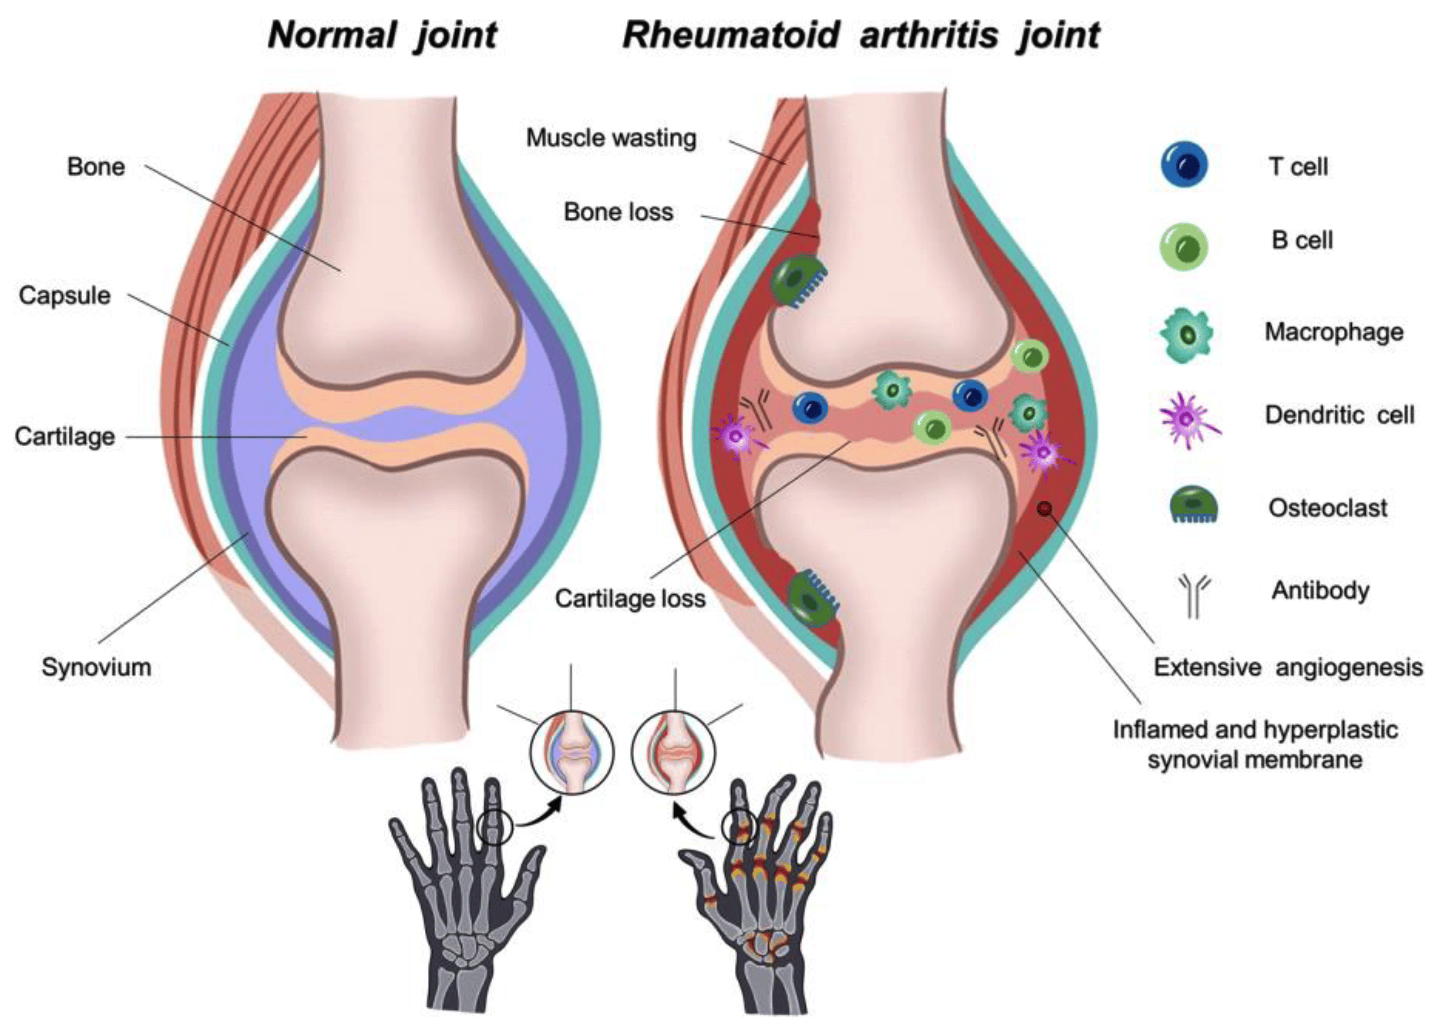
Figure 1. Healthy vs. Rheumatoid Arthritis-Affected Joints. Reprinted from [18] Under CC BY license
Pathogens like Aggregatibacter actinomycetemcomitans (Aa) and Porphyromonas gingivalis (P. gingivalis) also contribute to RA development. P. gingivalis induces ACPAs through neutrophil extracellular trap (NET) formation and the action of arginine gingipain proteins and PAD, which generate citrullinated proteins. Aa releases leukotoxin A, causing excessive citrullination in the neutrophils and cause the secretion of of citrullinated autoantigens [19,20]. The pathogenesis of RA is driven by the interplay between innate and adaptive immune responses. There are various cytokines that increase the adhesion molecule expression on the synovial membrane, facilitating the migration of inflammatory cells (e.g., lymphocytes, macrophages, plasma cells) into the synovium. These cells activate FLSs, which promote RANKL expression, leading to increased pro-inflammatory cytokine production and osteoclast activity. Osteoclasts degrade bone, while FLSs release matrix metalloproteinases (MMPs) that break down cartilage. Chronic inflammation causes synovial hyperplasia and pannus formation, an abnormal fibrovascular tissue that invades joints and cartilage. VEGF overexpression drives angiogenesis, sustaining pannus formation and exacerbating joint destruction [14,21,22]. Reactive oxygen species (ROS) produced by activated macrophages also contribute to cartilage and joint degradation. The innate immune system, involving dendritic cells, neutrophils, macrophages, T lymphocytes, and natural killer cells, plays a critical role in RA progression. Macrophages release inflammatory cytokines (e.g., IL-1β, IL-6, TNF-α), matrix-degrading enzymes, and ROS, while also stimulating FLS proliferation [23–25]. TNF-α, produced by various cells such as natural killer cells, macrophages, activated lymphocytes, endothelial cells, and neutrophils, regulates immune cell activation, migration, and adhesion. It also promotes angiogenesis and osteoclastogenesis, contributing to joint and bone destruction. IL-6, produced by FLSs and macrophages, stimulates chemokine release, activates B cells, T cells, and osteoclasts, and promotes VEGF production, further driving pannus formation. IL-1β, produced by macrophages and monocytes, shares many functions with TNF-α [12,26–28]. These cytokines activate signaling pathways such as MAPKs, JNK, ERK, p38, PI3K/AKT, and NF-κB, leading to inflammation. Key inflammatory markers, including IL-6, IL-10, TNF-α, NLR, PLR, and CRP [29–32]. T-cell involvement is marked by increased T-cell concentration and reduced naive CD4 T-cells at inflammation sites. APC interact with naive CD4 cells, leading to T-cell differentiation into T helper cells and regulatory T cells, which release cytokines like IL-17, IL-1β, IL-10, and IL-6. IL-17 activates macrophages, FLSs, and cytokines, promoting Th17 T helper cell differentiation, regulated by the AhR. Regulatory T cells produce anti-inflammatory cytokines like TGF-β and IL-10 [27,33–35] (figure 2).
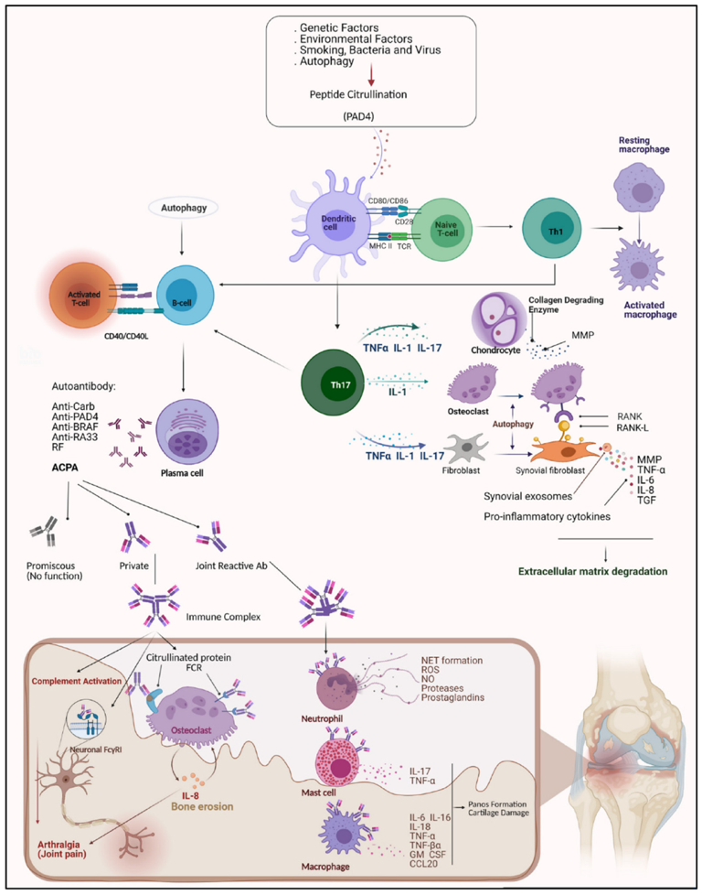
Figure 2. Etiology of Rheumatoid Arthritis. Reprinted from [36]
The innate immune system acts as the body's first line of defense against invading pathogens by utilizing a variety of protective mechanisms, including antibacterial peptides, mannose-binding lectins, the alternative complement activation pathway [37,38]. This system comprises a diverse range of immune cells, such as dendritic cells, neutrophils, macrophages, T lymphocytes, and NK cells, which work in coordination to detect and eliminate potential threats. Among these immune cells, macrophages play a particularly significant role in the pathogenesis and progression of rheumatoid arthritis (RA). These cells contribute to the inflammatory environment by secreting a variety of pro-inflammatory cytokines, including interleukin-1 beta (IL-1β), interleukin-6 (IL-6), and tumor necrosis factor-alpha (TNF-α). These cytokines not only promote systemic inflammation but also contribute to joint destruction by activating other immune cells and enhancing the production of matrix-degrading enzymes and ROS [26,27]. Macrophages interact closely with fibroblast-like synoviocytes (FLS), a key component of the synovial lining. Through cytokine signaling and direct cell-to-cell interactions, macrophages stimulate the hyperproliferation of FLS, leading to an aggressive, tumor-like phenotype that invades and degrades cartilage and bone. This persistent activation of FLS further amplifies the inflammatory cascade, creating a vicious cycle that sustains chronic synovial inflammation and joint damage characteristic of RA In addition to their direct contributions to inflammation, macrophages also influence the adaptive immune response by presenting antigens to T cells and shaping the overall immune landscape within the synovium. The sustained activation of both innate and adaptive immune pathways in RA underscores the complexity of the disease and highlights the critical role of macrophages in driving its progression [24].

TNF-α, a potent inflammatory cytokine secreted by various immune cells including macrophages, natural killer (NK) cells, endothelial cells, activated lymphocytes, and neutrophils, plays a central role in regulating immune cell activation, migration, and adhesion. Beyond its immune regulatory functions, TNF-α is instrumental in driving pathological processes that exacerbate rheumatoid arthritis (RA). It promotes angiogenesis, the formation of new blood vessels, which enhances the supply of nutrients and inflammatory cells to the affected joints, perpetuating the inflammatory cycle. Additionally, TNF-α stimulates osteoclastogenesis, the differentiation of osteoclasts responsible for bone resorption, thereby contributing to the bone destruction seen in RA. Through these combined effects, TNF-α serves as a key mediator in the progression of joint inflammation and damage in RA, making it a critical target for therapeutic intervention. [27,39,40].
Interleukin-6 is secreted by fibroblast-like synoviocytes (FLS) and macrophages, playing a crucial role in rheumatoid arthritis (RA) by stimulating endothelial cells to release chemokines and activating B cells, T cells, and osteoclasts. It also promotes vascular endothelial growth factor (VEGF) production, which contributes to pannus formation. Similarly, interleukin-1 beta (IL-1β), produced by macrophages and monocytes in inflamed synovium, shares many functions with tumor necrosis factor-alpha (TNF-α) [4,41].

These inflammatory cytokines play a crucial role in driving inflammation by activating a range of signaling pathways, such as mitogen-activated protein kinases (MAPKs), including c-Jun N-terminal kinase (JNK), extracellular signal-regulated kinase (ERK), and p38, as well as the phosphatidylinositol 3-kinase (PI3K)/protein kinase B (AKT) pathway and nuclear factor kappa B (NF-κB). These signaling responses are innate, non-antigen-specific, and lack the immunologic memory characteristic of adaptive immunity. As a result, they contribute to the persistent, nonspecific inflammation observed in rheumatoid arthritis (RA). Key inflammatory markers, including interleukin-6 (IL-6), interleukin-10 (IL-10), tumor necrosis factor-alpha (TNF-α), and biomarkers such as the neutrophil-to-lymphocyte ratio (NLR), platelet-to-lymphocyte ratio (PLR), and C-reactive protein (CRP), are often significantly elevated in the serum and synovial fluid of RA patients [36–38]. These markers reflect the ongoing inflammatory state and are often used as indicators of disease activity and severity.
In RA, T-cells are activated by self-antigens presented by antigen-presenting cells, triggering an autoimmune response. These activated T-cells, particularly CD4+ T-helper cells, release pro-inflammatory cytokines such as interleukin-17 (IL-17), tumor necrosis factor-alpha (TNF-α), and interferon-gamma (IFN-γ). These cytokines amplify the inflammatory cascade, recruiting other immune cells to the site of inflammation and promoting the production of matrix metalloproteinases, which break down cartilage and bone. Additionally, regulatory T-cells (Tregs), which are normally involved in controlling immune responses, are often dysfunctional in RA, further exacerbating the disease [42–44].. The persistent activation of T-cells in RA leads to chronic inflammation and tissue damage, making them a key target for therapeutic interventions aimed at modulating the immune response in RA patients [45–47].
2.4. Polyphenols in Disease Management
For over 5,000 years, plants have played a central role in traditional medicine, providing remedies for a wide range of human ailments. Their healing properties are largely attributed to phytochemicals—naturally occurring secondary metabolites produced by plants. These compounds are known for their diverse pharmacological activities, which include antiviral, anti-inflammatory, antineoplastic (anti-cancer), and antioxidant effects [48–50] . The therapeutic potential of phytochemicals has made them a focus of scientific research, with numerous studies highlighting their ability to support health and combat various diseases.
Among the many classes of phytochemicals, polyphenols stand out as particularly significant bioactive compounds. These polyphenolic compounds are widely distributed in nature and are found in a variety of foods commonly consumed in everyday diets, such as grapes, berries, nuts, olives, and flaxseed. In addition to these well-known sources, polyphenols are also abundant in beverages like coffee and tea, as well as in a range of spices and herbs, including Rosmarinus officinalis (rosemary), Origanum vulgare (oregano), Salvia officinalis (sage), and Majorana syriaca (marjoram) [47–51].
The widespread presence of polyphenols in these foods and herbs not only contributes to their distinct flavors and colors but also enhances their potential health benefits. Numerous studies have shown that polyphenols exhibit a broad spectrum of biological activities that make them highly effective in protecting the body from oxidative stress, inflammation, and chronic diseases such as cancer, cardiovascular conditions, and neurodegenerative disorders. The ability of polyphenols to interact with cellular signaling pathways and modulate the immune system further underscores their importance in maintaining overall health.
As researchers continue to investigate the mechanisms behind the therapeutic effects of polyphenols, the growing body of evidence suggests that these plant-derived compounds may hold the key to developing novel, natural-based therapies for a variety of ailments. By tapping into the power of plants and their bioactive constituents, we are able to harness centuries of traditional knowledge and combine it with modern scientific advancements to improve human health and prevent disease [51–55].
Polyphenols are a diverse group of naturally occurring compounds, structurally distinguished by the presence of aromatic rings that are attached to one or more hydroxyl groups. These compounds exhibit a broad range of chemical structures and biological activities, and they are found in various plant-based sources. The family of polyphenols includes several important classes, such as flavonoids, which are known for their potent antioxidant and anti-inflammatory properties; xanthones, which possess antimicrobial and anticancer effects; catechins, commonly found in tea and known for their cardiovascular benefits; hesperetin and quercetin, which have been linked to enhanced immune function and reduced oxidative stress; ellagic acid, a compound with promising anticancer properties; lignans, which are recognized for their potential to support hormonal health; stilbenes, including resveratrol, which is famous for its potential role in promoting longevity; chalcones, polyphenolic amides, and resveratrol. These compounds are not only abundant in nature but also hold significant potential for various therapeutic applications, making polyphenols an area of keen scientific interest in the study of human health and disease prevention [54,56–60].
2.4.1. Polyphenols modulates signaling pathways
Polyphenols have garnered significant attention for their potent anticancer and anti-inflammatory properties. These compounds exert their therapeutic effects by modulating crucial signaling pathways, inducing apoptosis in various cancer cell types, and reducing the activity of nucleoside diphosphate kinase B (NME2) in cells from lung, bladder, and colon cancers. NME2 is a critical regulator of several cellular processes, including energy metabolism, cell proliferation, and differentiation, and its inhibition has been shown to impact tumor progression and metastasis [30,30,61–63]. In recent decades, there has been a surge in research focusing on the potential of medicinal plants and their phytochemicals to regulate molecular signaling pathways involved in various diseases, including cancer RA, and other chronic conditions. Polyphenols, in particular, have been found to influence multiple cellular processes, such as inhibiting fatty acid synthesis, suppressing topoisomerase I/II, promoting the accumulation of tumor suppressor protein p53, inducing cell cycle arrest, and regulating mechanisms that control cell survival and proliferation. These diverse effects underscore the potential of polyphenols as therapeutic agents in the management of complex diseases. Unlike conventional treatments, which often require prolonged and invasive procedures and can lead to numerous side effects, plant-based therapies generally offer a safer alternative with fewer adverse effects. This advantage has spurred increasing interest in developing polyphenol-based treatments as an effective strategy to improve patient outcomes while minimizing the risks and complications typically associated with traditional therapies [64,65].
The Mediterranean diet, which has long been recognized for its anti-inflammatory effects, emphasizes the consumption of plant-based foods, including fruits, vegetables, nuts, and legumes, with extra virgin olive oil (EVOO) playing a central role in reducing chronic inflammation. EVOO is rich in phenolic compounds, such as tyrosol, hydroxytyrosol (HTyr), and oleuropein, all of which possess potent antioxidant and anti-inflammatory properties. These phenolic compounds have been shown to modulate inflammatory pathways, protect against oxidative stress, and reduce the risk of chronic diseases, making them essential components of a healthy diet [52,66,67]. Numerous in vitro and in vivo studies have explored the anti-arthritic effects of HTyr, particularly in the context of RA. These studies have proposed various mechanisms of action through which HTyr exerts its beneficial effects. For instance, in one study, it was investigated the efficacy of HTyr in SW982 cell line. The results demonstrated that HTyr treatment significantly reduced the expression of pro-inflammatory cytokines, including tumor necrosis factors (TNF), matrix metalloproteinases (MMPs), and IL-6. Additionally, HTyr inhibited the phosphorylation of NF-κB and mitogen-activated protein kinases (MAPKs), which are key mediators of inflammation and are activated by IL-1β signaling. These findings suggest that HTyr may play a crucial role in mitigating the inflammatory processes involved in RA, positioning it as a promising candidate for the prevention and management of this debilitating disease.
Overall, the growing body of evidence supports the therapeutic potential of polyphenols, particularly those found in Mediterranean foods like EVOO, in the treatment of chronic diseases such as RA. As research continues to unravel the precise mechanisms through which these compounds exert their effects, polyphenols may become a cornerstone in the development of natural, plant-based therapies aimed at reducing inflammation, preventing disease progression, and improving quality of life for patients with chronic inflammatory conditions [48].
Mitogen-activated protein kinases (MAPKs) are a family of serine/threonine protein kinases that play a pivotal role in cellular signal transduction. They are activated by various extracellular signals, such as growth factors, stress, cytokines, and environmental changes, and are crucial in regulating diverse cellular processes, including cell proliferation, differentiation, survival, apoptosis, and inflammation. MAPKs are typically activated through a three-tiered signaling cascade involving MAPK kinase kinases (MAPKKKs), MAPK kinases (MAPKKs), and the MAPKs themselves. There are several distinct MAPK pathways, including the Extracellular Signal-Regulated Kinase (ERK) pathway, which regulates cell growth and differentiation; the C-Jun N-terminal Kinase (JNK) pathway, which is involved in stress responses, inflammation, and apoptosis; and the P38 MAPK pathway, which plays a key role in responding to stress signals, such as oxidative stress and cytokine signaling, as well as regulating immune responses and inflammation. Dysregulation of MAPK pathways is associated with various diseases, including cancer, cardiovascular diseases, and inflammatory conditions, making them important therapeutic targets for drug development aimed at modulating these pathways to treat these conditions [30,68–71] (figure 3).
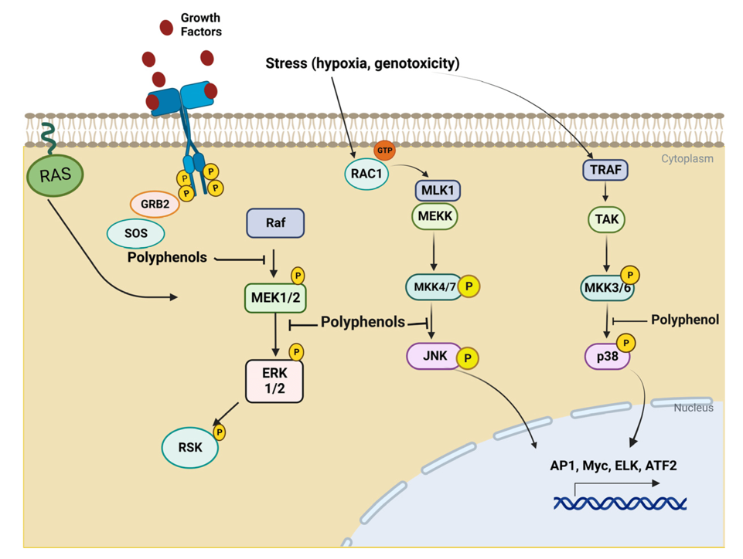
Figure 3. Possible Inhibitory Targets of Polyphenols in MAPK Signaling Pathways: ERK, and p38. [72]

Another key signaling pathway which involve the cell survival is the PI3K/Akt pathway, which interacts with the mTOR. These pathways regulate various cellular processes. Polyphenols have been found to modulate immune responses by inhibiting the varous pathways such as MAPK, ERK, JNK, PI3K/Akt, mTORC1, and JAK-STAT signaling cascades. polyphenols such as tyrosol, hydroxytyrosol, oleuropein, oleocanthal, resveratrol apigenin, luteolin, and quercetin have demonstrated the ability of inducing apoptosis in different cancer cell lines [5,56,73] (figure 4).
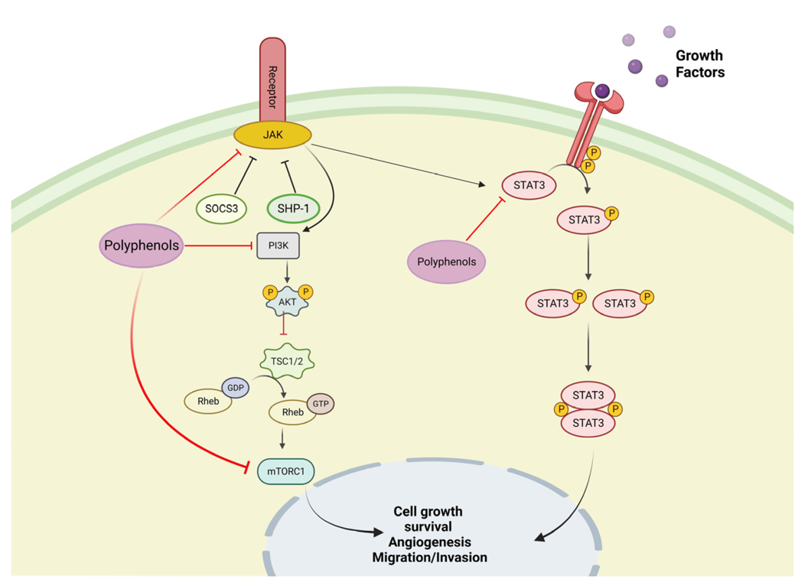
Figure 4. Possible Inhibitory Sites of Polyphenols in the PI3K/Akt and mTOR Pathways.
2.5. Olive oil: a rich source of bioactive polyphenols
Olive oil, derived from Olea europaea L., is an integral part of the Mediterranean diet (MD), which is globally recognized for its health benefits. This slow-growing evergreen tree, capable of living for up to a thousand years, plays a crucial economic role in the Mediterranean region, with commercial applications in food, cosmetics, and timber. One distinguishing feature of the MD is its high consumption of extra virgin olive oil (EVOO), estimated at 15.3 to 23 kg per person annually. Due to its rich composition of omega-3 fatty acids and bioactive compounds, EVOO has been shown to be effective in preventing and managing chronic conditions such as Type 2 diabetes, rheumatoid arthritis (RA), cardiovascular disease (CD), and neurodegenerative disorders [74].
Olive oil is a rich source of phenolic compounds, which are primarily responsible for its health benefits and distinctive flavor. These compounds have potent antioxidant, anti-inflammatory, and anticancer properties. The most notable phenolic compounds in olive oil include oleuropein, hydroxytyrosol, tyrosol, oleocanthal, and ligstroside. Oleuropein, found mainly in the olive fruit and leaves, is known for its strong antioxidant and anti-inflammatory effects, contributing to cardiovascular health and protection against chronic diseases. Hydroxytyrosol, one of the most powerful antioxidants in olive oil, has been widely studied for its ability to combat oxidative stress, reduce the risk of cardiovascular disease, and protect against neurodegenerative disorders. Tyrosol, a metabolite of hydroxytyrosol, also offers antioxidant benefits and plays a role in promoting heart health. Oleocanthal, with its anti-inflammatory and analgesic properties, is similar to ibuprofen in its effects and may help reduce the risk of conditions like Alzheimer's and cancer. Ligstroside, another phenolic compound, provides additional antioxidant and anti-inflammatory effects, further enhancing olive oil’s overall health benefits. Together, these phenolic compounds work synergistically to promote heart health, reduce inflammation, and protect against oxidative damage, making olive oil an essential part of the Mediterranean diet and a valuable source of bioactive compounds for overall well-being. The most prevalent secoiridoids in olive oil are the decarboxymethyl-EA dialdehyde forms, which are linked to hydroxytyrosol (HT) or tyrosol (Tyr). Two key secoiridoid compounds of this class are 3,4-DHPEA-EDA (decacarbomethyl-oleuropein aglycone) and p-HPEA-EDA (a hydroxytyrosol derivative), both of which have been identified as the most abundant and bioactive forms in olive oil. These compounds are believed to play a crucial role in the anti-inflammatory and antioxidant activities associated with olive oil consumption. In addition to 3,4-DHPEA-EDA and p-HPEA-EDA, other notable secoiridoids include the oleuropein aglycone isomer, 3,4-DHPEA-EA, and ligstroside aglycone, also known as p-HPEA-EA. These secoiridoid compounds exhibit various pharmacological activities, including antioxidant, anti-inflammatory, and antimicrobial effects, and have been linked to the protective properties of olive oil against a range of chronic diseases, such as cardiovascular disease, cancer, and neurodegenerative conditions [67,71,75].
Phenolic acids are an important group of bioactive compounds found in olive oil, contributing to its well-known health benefits. These compounds possess powerful antioxidant and anti-inflammatory properties, which help reduce the risk of chronic diseases. The main phenolic acids in olive oil include caffeic acid, ferulic acid, and p-coumaric acid. Caffeic acid is recognized for its strong antioxidant effects, protecting cells from oxidative damage and reducing inflammation, which supports cardiovascular health and disease prevention. Ferulic acid, also present in olive oil, has significant antioxidant and anti-inflammatory properties, promoting heart health and potentially offering anticancer benefits through its ability to neutralize free radicals. P-coumaric acid, while present in smaller quantities, also contributes to the antioxidant properties of olive oil, helping to alleviate oxidative stress and inflammation. Together with other phenolic compounds such as oleuropein, oleocanthal, tyrosol and hydroxytyrosol. These phenolic acids enhance the overall health benefits of olive oil, particularly in promoting cardiovascular health, reducing inflammation, and protecting against oxidative damage, making olive oil a valuable source of bioactive compounds for overall well-being [56].
Lignans are a type of polyphenolic compound found in olive oil, albeit in smaller amounts compared to other phenolic compounds like flavonoids and phenolic acids. These compounds are known for their antioxidant, anti-inflammatory, and potential anticancer properties. In olive oil, lignans are mainly present as secoiridoids, which are derived from the phenolic precursors in the olives The most common lignans found in olive oil are pinoresinol and ligstroside. Pinoresinol has demonstrated strong antioxidant properties, which help in neutralizing free radicals and reducing oxidative stress. Additionally, it has been shown to possess potential anticancer effects by inhibiting the growth of cancer cells. Ligstroside, another important lignan, is also known for its antioxidant effects and its ability to reduce inflammation, contributing to the overall health benefits of olive oil Although the concentration of lignans in olive oil is lower compared to other polyphenolic compounds, their presence still adds to olive oil’s broad spectrum of health benefits, particularly in promoting cardiovascular health, reducing oxidative stress, and potentially lowering the risk of cancer. This makes olive oil a valuable source of bioactive compounds that contribute to its role in the Mediterranean diet and its associated health benefits [76]. Overall, the diverse bioactive compounds in EVOO, particularly polyphenols, contribute to its powerful antioxidant, anti-inflammatory, and anticancer effects, reinforcing its role in the Mediterranean diet as a natural agent for disease prevention and management [75].

Flavonoids, although present in olive oil in smaller amounts compared to other polyphenols, still contribute significantly to its health benefits due to their antioxidant, anti-inflammatory, and cardiovascular-protective properties. Key flavonoids found in olive oil include quercetin, kaempferol, and luteolin. Quercetin is a well-known flavonoid with powerful antioxidant and anti-inflammatory effects, helping to protect cells from oxidative damage and supporting heart health. It has also been studied for its potential to reduce the risk of chronic diseases such as cancer and neurodegenerative disorders [57]. Kaempferol, found in smaller quantities, plays a role in reducing inflammation and oxidative stress, further contributing to the cardiovascular and anticancer benefits of olive oil. Luteolin, another flavonoid in olive oil, offers antioxidant and anti-inflammatory benefits, with research indicating its potential to reduce the risk of inflammatory diseases and improve heart health. While flavonoids are less abundant than other phenolic compounds in olive oil, their presence enhances its therapeutic effects, helping to protect against oxidative stress, reduce inflammation, and promote overall cardiovascular health, making olive oil an essential part of the Mediterranean diet [77].
2.7. Anti arthritic activity of Vitamin E
Vitamin E is a potent antioxidant naturally occurring in plants, characterized by a chromanol ring and an isoprenoid side chain. It encompasses a group of compounds, such az tocopherols and tocotrienols, which are sub divided into three isomers such as alpha-, beta-, gamma-, and delta-isomers. Among these, alpha-tocopherol is the most abundant form of vitamin E in nature and within the human body [78,79].Interestingly, it is also found in synovial fluid, despite its aqueous nature. The antioxidant properties of vitamin E stem from the OH group on the chromanol ring, that’s give H atoms to neutralize, of the free radicals. Research has shown that tocotrienols exhibit stronger antioxidant activity than tocopherols due to three key factors: (1) tocotrienols distribute more evenly within lipid membranes; (2) the double bonds in their isoprenoid side chains enhance interactions with free radicals; and (3) tocotrienols demonstrate greater redox cycling efficiency compared to tocopherols [80].
Beyond its role as a free radical scavenger, vitamin E can influence NRF2. Studies have indicated that vitamin E supplementation enhances antioxidant activity in the musculoskeletal system. Additionally, it can suppress the NFκB pathway and reduce inflammation, both of which play a critical role in the progression of joint degradation in osteoarthritis. vitamin E has the potential to mitigate oxidative stress and inflammation, that play vital role in the development of osteoarthritis [81,82].

Chapter 3

The use of nanoparticles for the delivery of Resveratrol
In nanotechnology, particles are classified based on their physical dimensions, with ultrafine particles typically measuring between 1 and 100 nm in at least one dimension [83]. Nanoparticles offer a versatile platform for drug delivery, allow therapeutic agents to conjugate to their surfaces by ionic or covalent bond [84]. The advanced formulations significantly enhance drug absorption, bioavailability, and chemical stability while leveraging the enhanced permeability and retention (EPR) effect to improve membrane penetration and ensure precise drug delivery to cancer cells [85].
The various studies have shown that Resveratrol (RSV)-loaded nanoparticles exhibit prolonged circulation times compared to free RSV, as nanoparticles shield RSV from rapid metabolism and clearance, thereby maintaining sustained blood levels. Pharmacokinetic studies further reveal that nanoencapsulation extends RSV's half-life and significantly enhances its bioavailability. By improving the absorption of RSV in GI tract and bypass phase I metabolism in the liver [86].
Additionally, biodistribution analyses confirm that nanoparticles promote greater accumulation of the RSV in tumor tissues due to the EPR effect, facilitating targeted delivery. Beyond enhancing bioavailability and retention, nanoformulations enable controlled and sustained RSV release, ensuring prolonged therapeutic action while reducing the frequency of dosing. This strategic approach not only maximizes treatment efficacy but also enhances patient compliance, making nanoparticles a promising avenue for optimizing RSV-based therapies [70].
In pH-sensitive nanoparticles, the release of RSV is triggered by the acidic conditions of tumor microenvironments, promoting targeted drug delivery while minimizing unintended release in healthy tissues. Thermosensitive nanoparticles, on the other hand, respond to local temperature changes, with hyperthermia treatments further enhancing the release of the drug. The enzyme-triggered RSV is achieved by incorporating cleavable ezymes within the structure of nanoparticles. Tumor-specific enzymes, such as MMPs, facilitate the breakdown of these compounds, leading to localized drug release [87].
Redox-responsive nanoparticles leverage the elevated reactive oxygen species (ROS) levels found in tumor sites to initiate RSV release. Similarly, photo-responsive nanoparticles integrate light-sensitive materials, allowing precise light-induced drug activation. Magnetic-responsive nanoparticles which are loaded with RSV can be used to direct to target the specific cites by using the external magnetic fields, which not only direct the nanoparticles but also trigger the release of the drug at the specific site [88].
RSV-loaded nanoparticles represent a promising approach for targeted drug delivery, leveraging external stimuli such as magnetic fields and ultrasound to achieve precise control over drug release. Magnetic field-guided targeting involves the use of magnetic nanoparticles loaded with resveratrol, which can be directed to a specific site in the body using an external magnetic field. Once the nanoparticles accumulate at the target site, the magnetic field can also be utilized to trigger the release of the drug, ensuring high local concentrations and minimizing systemic exposure. Similarly, ultrasound-responsive nanoparticles loaded with RSV can be activated by the ultrasound waves, helped to release the drug at the desired location. These stimulation-activated approaches enable control of drug release kinetics, increase the therapeutic index while reducing side effects associated with systemic administration [89].
Nanoparticles used in drug delivery can be broadly categorized into organic and inorganic types. Organic nanoparticles, such as liposomes, polymersomes, polymeric constructs, and micelles, have been extensively studied for their applications in imaging, drug delivery, and gene therapy. These systems offer biocompatibility and versatility in encapsulating therapeutic agents. On the other hand, inorganic nanoparticles, despite their highly material- and size-dependent physicochemical properties, have also gained significant attention due to their unique characteristics, such as optical, magnetic, and electronic properties [90].

3.1. Liposomes
Liposomes are spherical vesicles composed of a phospholipid bilayer surrounding an aqueous core, making them versatile carriers for both hydrophobic and hydrophilic drugs. The hydrophobic drugs incorporates into the site of phospholipid bilayer, while hydrophilic drugs can be encapsulated within the region of aqueous core [91]. The structure of liposomes tailored to achieve specific therapeutic outcomes, such as by attaching small molecules like antibodies or ligands to their surface, enabling targeted delivery to specific cells (figure 5). Liposomes also offer controlled drug release under specific conditions, such as changes in pH, enzymatic activity, or exposure to ultrasound. Additionally, they provide protection to drugs from degradation, such as photodegradation caused by UV light. For instance, trans-resveratrol (RSV) encapsulated in liposomes remains 70% intact for 16 minutes, compared to free RSV, which degrades more rapidly [92].

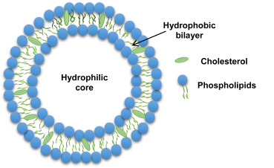

Figure 5. Schematic representation of liposomes. Reprinted from [93]. Under CC BY license.

The preparation of liposomes is highly dependent on their intended characteristics, including size, drug properties, solvent type half-life, and the compounds used. One common method for synthesizing liposomes is thin-film hydration, where lipids are dissolved in an organic solvent, followed by evaporation to form a thin film, which is then dispersed in an aqueous solution. Other techniques include such as dehydration–rehydration, solvent injection, reverse-phase evaporation, and microfluidic-based methods, which are particularly useful for achieving high drug encapsulation efficiency [94].

3.2. Solid Lipid Nanoparticles

The Solid lipid nanoparticle are ranging from 40 to 1000 nm in diameter[95]. SLNs play a important role in drug protection from being hydrolysis and oxidation while significantly enhancing their bioavailability [96] (figure 6) .I In a subsequent study, SLNs were successfully employed to deliver RSV to skin keratinocytes for skin cancer treatment. Fluorescence imaging provided compelling evidence that SLNs smaller than 180 nm exhibit rapid transmembrane migration. Once inside the cells, they disperse efficiently throughout the cytoplasm, progressively moving through various cellular layers and ultimately localizing in the perinuclear region—all without inducing cytotoxic effects. This efficient intracellular trafficking highlights their potential as a safe and effective drug delivery system. Furthermore, the sustained release of RSV from SLNs enhanced its bioavailability, prolonged its therapeutic effects, and improved its stability against enzymatic degradation. These findings underscore the promise of SLNs as a targeted delivery platform for RSV, paving the way for advanced nanocarrier-based strategies in skin cancer therapy [91].
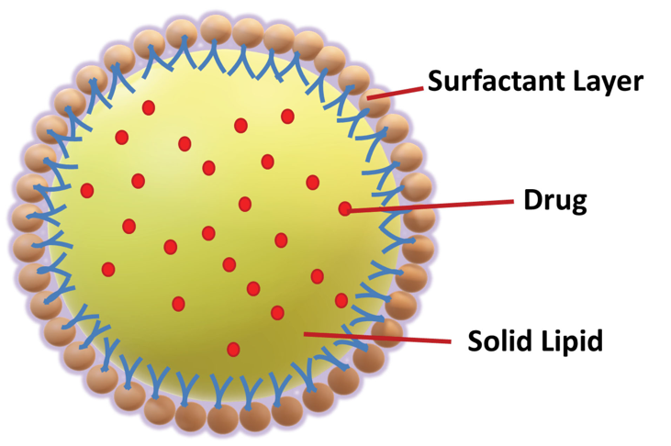
Figure 6. Solid Lipid Nanoparticles [97]

3.3. Polymeric Nanoparticles
Polymeric nanoparticles are made up of different polymer matrices that encapsulate various substances, including poly(methacrylic acid), poly(acrylic acid), , poly(lactic acid) (PLA), poly(ε-caprolactone) (PCL),polypropylene imine (PPI), albumin, zein, silk, and gelatin [98] (figure 7). Encapsulating drugs within a polymeric matrix protects them from degradation, enables sustained release, and enhances therapeutic efficacy. Furthermore, structural modifications of polymeric nanoparticles facilitate targeted delivery to tumor cells [98].
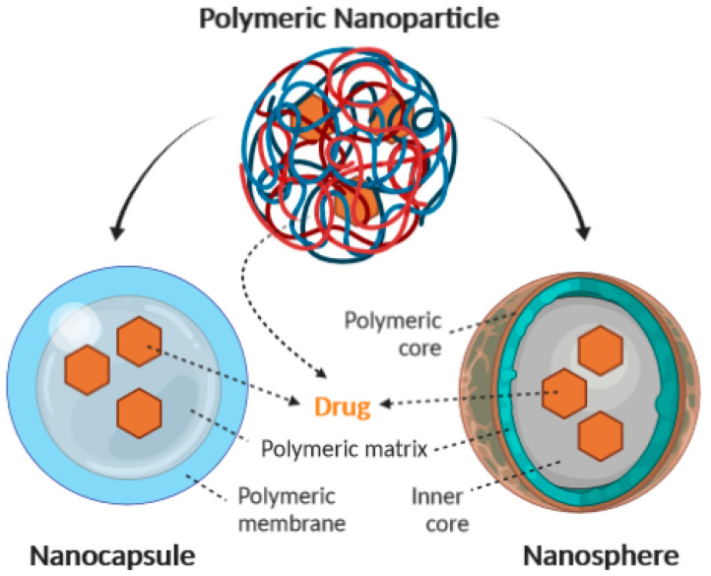
Figure 7. Polymeric Nanoparticles. Adapted from [99].

Incorporating RSV into polymeric nanoparticles offers significant advantages, including controlled drug release and protection against light-induced degradation. Extensive research on formulations, machanism of action, and pharmacokinetics bring valuable details into their safety and efficacy. The synthesis of mixed micelles, such as P127/TPGS a has demonstrated the controlled release of RSV. Various reseraches further highlight the impact of nanoparticle formulations on drug accumulation in organs, indirectly indicating potential off-target side effects. Notably, folic acid-conjugated P127/TPGS mixed micelles have been shown to reduce undesired organ accumulation, potentially lowering RSV-associated adverse effects. Additionally, glyceryl behenate-based solid lipid nanoparticles (SLN), TPGS-coated and PLGA:TPGS combined with FA have showed excellend enhacned targeting of cancerous cells , improving therapeutic precision and efficacy [100].

3.4. Zinc Oxide Nanoparticles
Zinc oxide nanoparticles (ZnONPs) are inorganic nanoparticles that have gained significant attention due to their diverse applications across multiple fields. They are extensively utilized in cancer diagnosis, drug delivery, and therapeutic interventions, as well as in industries such as textiles, cosmetics, and electronics. Their unique physicochemical properties, including high surface area, biocompatibility, and tunable structural characteristics, make them highly suitable for these applications [84].
A variety of synthesis techniques have been developed to produce ZnONPs, broadly categorized into physical, chemical, and biological methods. Chemical synthesis methods include microemulsion, precipitation, hydrothermal techniques, and sol–gel processes, each offering advantages in terms of particle size control, uniformity, and stability. Physical approaches, such as ultrasonic irradiation, plasma treatment, and vapor deposition, enable the production of ZnONPs with distinct morphological and structural attributes. Additionally, biological synthesis, which involves using plant extracts, microorganisms, or biomolecules, is gaining traction as an eco-friendly and sustainable alternative, minimizing the use of toxic reagents and harsh conditions.
One of the most notable applications of ZnONPs is their role in drug delivery systems, particularly in oncology. They serve as effective carriers for anticancer agents, facilitating controlled and targeted drug release, thereby enhancing therapeutic efficacy while minimizing systemic toxicity. Their ability to induce apoptosis in cancer cells through reactive oxygen species (ROS) generation and DNA damage further underscores their potential as a multifunctional tool in cancer treatment. Ongoing research continues to explore the optimization of ZnONPs for improved biocompatibility, enhanced drug-loading efficiency, and tailored surface modifications, broadening their applicability in nanomedicine and beyond [101].

3.5. Gold Nanoparticles
Gold nanoparticles (GNPs) demonstrate exceptional adaptability, as they can be engineered into a wide range of shapes and architectures [102]. These kind of nanoparticles differ from bulk gold in their density, color, and size, with diameters of ranging from 1 nanometer to 8 millimeters (figure 8). The unique physicochemical properties make them highly valuable in medical applications, particularly in the development of therapeutic solutions for diseases such as cancer, neurological disorders, and hepatitis [103].
In recent years, there has been a growing interest in the physiological synthesis of gold nanoparticles (AuNPs) using phytochemicals, which are natural compounds derived from plants. These phytochemical-based nanoformulations enhance cellular absorption, bioavailability, and therapeutic efficacy, particularly in anticancer applications. For example RSV-GNCs have demonstrated a significantly stronger anticancer effect compared to resveratrol (RSV) treatment alone. The combination of resveratrol's bioactive properties with the unique characteristics of gold nanoparticles results in a synergistic effect, improving drug delivery and therapeutic outcomes. This innovative approach highlights the potential of gold nanoparticles in advancing targeted and efficient treatments for complex diseases [104].
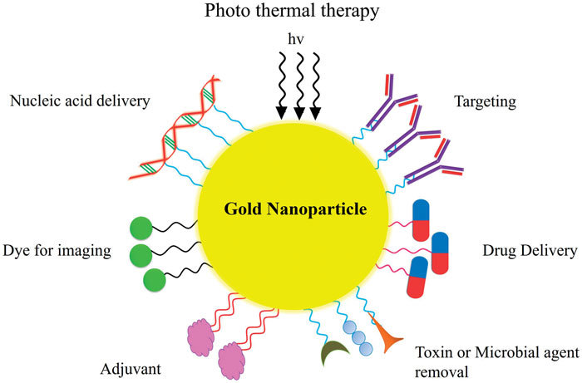
Figure 8. Gold Nanoparticles. Adapted from [105]

3.6. Carbon Nanotubes

CNTs typically have diameters ranging from 1 to 100 nm, with both ends capped by half of a fullerene molecule. Structurally, they consist of cylindrical layers of coaxial graphene sheets, where each carbon atom is bonded to three neighboring atoms, providing exceptional strength [106].CNTs are broadly classified into two types: single-walled carbon nanotubes (SWCNTs) and multi-walled carbon nanotubes (MWCNTs) . SWCNTs are composed of a single graphene sheet seamlessly rolled into a hollow cylindrical structure, with diameters ranging from approximately 0.5 to 2.0 nm. Their unique one-dimensional configuration imparts them with remarkable electrical, mechanical, and optical properties, making them highly valuable for applications in nanotechnology, electronics, and biomedical research [107]. In contrast, MWCNTs consist of multiple concentric graphene layers arranged in a nested, tube-like formation, resulting in structures with progressively larger diameters (figure 9).
This multilayered composition provides enhanced mechanical strength, superior electrical conductivity, and increased thermal stability compared to SWCNTs. The presence of multiple walls also grants MWCNTs greater resistance to structural defects and environmental degradation, making them suitable for heavy-duty applications such as composite reinforcement, energy storage, and drug delivery systems.
Due to their distinct characteristics, SWCNTs and MWCNTs exhibit different behaviors in terms of flexibility, conductivity, and surface functionalization. While SWCNTs offer higher electron mobility and sensitivity, making them ideal for nanoscale electronic devices and sensors, MWCNTs provide improved durability and load-bearing capacity, rendering them more suitable for structural and industrial applications. Ongoing research continues to explore ways to optimize and tailor CNT properties through surface modifications, doping, and hybridization with other nanomaterials, further expanding their potential across diverse scientific and technological domains [108].
CNTs have significant applications in diagnostics, including protein and DNA detection, serum protein identification, and drug delivery. They are particularly valuable in targeted cancer therapies, as their structure, high surface area, and high biocompatibility enable efficient drug transport. Their ability to traverse biological barriers, penetrate plasma membranes, and enter the cytoplasm makes them ideal drug carriers [109–111].

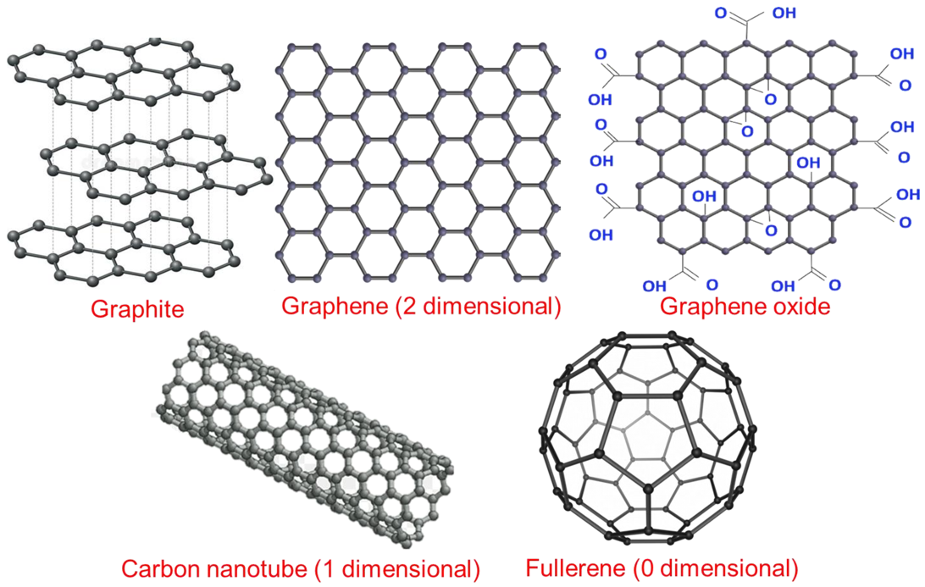
Figure 9. Carbon Nanotubes. Adpated from [112] under CC BY license

3.7. Zeolitic Imidazolate Framework Nanoparticles
Zeolitic imidazolate frameworks (ZIFs) represent a distinct subclass of metal–organic frameworks (MOFs). its framework consists of tetrahedral metal ions linked by four imidazolate ligands, forming a metal–imidazole–metal bond angle that closely resembles the Si–O–Si bond angle found in zeolites. This unique architecture imparts ZIFs with a combination of properties from both zeolites and MOFs, including high porosity, well-defined crystallinity, and exceptional chemical and thermal stability, making them highly versatile materials for a wide range of applications [113] (figure 10).
Since their discovery, ZIFs have attracted immense research interest due to their tunable structural properties and broad functional capabilities. These glassy ZIFs exhibit amorphous characteristics while retaining high thermal resistance and structural integrity, further expanding the potential of ZIFs in advanced material science. Their ability to form stable frameworks with variable pore sizes has made them particularly valuable in fields such as gas separation, catalysis, water purification, and biomedical applications, particularly in drug delivery and therapeutic interventions.
Among the various ZIF structures, ZIF-8, composed of zinc ions coordinated with 2-methylimidazolate linkers, has emerged as one of the most widely studied due to its remarkable drug encapsulation efficiency and stability. Its high biodegradability and biocompatibility further facilitate its use in biomedical applications. Notably, ZIF-8 exhibits pH-responsive degradation, allowing it to break down in the acidic tumor microenvironment and release therapeutic agents in a targeted manner. This targeted release mechanism minimizes systemic toxicity and enhances the bioavailability of encapsulated drugs, thereby improving therapeutic efficacy. In addition to its role in drug delivery, ZIF-8 and other ZIFs have been explored for use in biosensing, bioimaging, and tissue engineering. Their customizable surface chemistry enables functionalization with biomolecules, antibodies, and other ligands, paving the way for their integration into precision medicine. The ongoing development of novel ZIF formulations continues to enhance their potential, with researchers exploring ways to optimize their structural stability, surface modifications, and responsiveness to external stimuli, such as temperature and enzymatic activity. As a result, ZIFs are poised to play a crucial role in the advancement of nanomedicine and other high-impact scientific fields, making them a key focus of contemporary materials research [114,115].

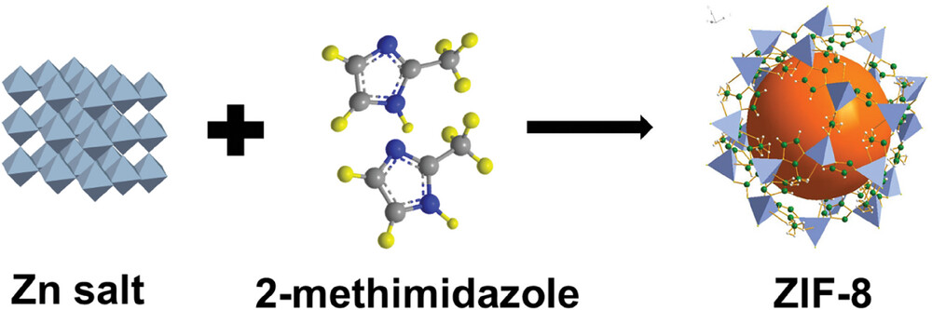

Figure 10. Zeolitic Imidazolate Framework Nanoparticles. Reprinted with permission from [116]

3.8. Mesoporous Silica Nanoparticles
Mesoporous silica nanoparticles (MSNs), a type of inorganic nanoparticle that play important role due to their desirable properties, including controlled size and shape, unique morphology, high porosity, large surface area, excellent physicochemical characteristics, superior dispersion, and stability [88,117]. MSNs are synthesized through the reaction of a micellar rod template with tetraethyl orthosilicate, resulting in nano-sized rods arranged in a regular porous structure (figure 11). The concept of mesoporous silica was first patented around 1970 but remained largely unnoticed until it was replicated in 1997. In the early 1990s, Japanese researchers independently developed MSNs, which were later synthesized in the laboratories [117–119].

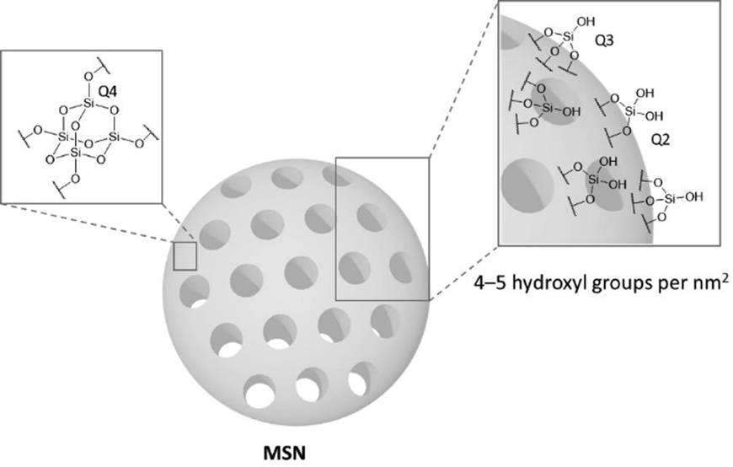
Figure 11. Mesoporous Silica Nanoparticles. Reprinted from [120] under CC BY license.

3.9 Bioactive Glass Nanoparticles
Bioactive glass (BG), a type of glass-ceramic material composed of SiO₂, Na₂O, CaO, and P₂O₅, was initially discovered by Larry Hench in 1969. This breakthrough led to the development of a material that can interact biologically with tissues, facilitating healing and regeneration [121]. The original formulation, known as 45S5 bioglass, contained 46.1% SiO₂, 24.4% Na₂O, 26.9% CaO, and 2.6% P₂O₅ (in mol%) [122]. This pioneering material gained significant recognition for its exceptional ability to bond with bone tissue, facilitating regeneration and repair [123]. Over the years, extensive research has led to modifications in its composition and structure, allowing for enhanced bioactivity and expanded biomedical applications [124]
Beyond its well-established role in bone regeneration, BG has emerged as a promising material in cancer treatment. Its potential applications include hyperthermia therapy, phototherapy, and targeted anticancer drug delivery. Mesoporous bioactive glass (MBG) nanoparticles, characterized by their high surface area and tunable pore sizes, have been widely explored for their exceptional drug-loading capabilities and ability to deliver therapeutic agents with precision These nanoparticles enable the controlled release of anticancer drugs, improving treatment efficacy while minimizing systemic side effects [125].
To further optimize drug-release kinetics and enhance therapeutic outcomes, researchers have investigated various surface modification techniques. Functionalization strategies, such as grafting bioactive molecules, have been employed to improve drug-binding affinity and cellular interactions. Additionally, composite formulations integrating BG with polymers and hydrogels have been developed to achieve sustained drug release, enhance biocompatibility, and improve mechanical properties. These advancements position bioactive glass as a multifunctional material with immense potential in regenerative medicine and oncology, paving the way for future innovations in targeted therapy and personalized medicine [126].

Chapter 4

The Use of Artificial Intelligence applied in Microscopy Imaging of cells

4.1. Cell culture:A foundational technique in molecular and cellular biology research

Cell culture serves as fundamental technique in molecular and cellular biology research, offering a powerful platform for investigating a wide array of cellular processes, including metabolism, physiology, and biochemistry, in both healthy and diseased cell models [127,128]. It is crucial for assessing the cytotoxic effects of various substances, such as cosmetics, novel chemicals, and pharmaceutical compounds, on specific cell types. Furthermore, in the field of virology, mammalian cell cultures are often utilized as hosts for viral replication, facilitating detailed studies on viral growth and development. Cell culture also plays a key role in gene expression analysis by allowing the introduction of specific genes into the nuclei of cultured mammalian cells, thus enabling the study of genetic behavior and interactions within a controlled environment. The use of clonal cell lines in research is particularly advantageous, as their homogeneity and reproducibility contribute to the reliability and consistency of experimental data, making cell culture a valuable tool for addressing a broad spectrum of both fundamental and applied scientific inquiries [127,129,130].
Within the practice of cell culturing, it is crucial to examine various characteristics of cells through diverse methods, such as traditional plate counting, semi-automated or fully automated cell counters, inverted microscopy for evaluating cell morphology and size, as well as live-cell tracking to observe dynamic cellular processes over extended periods [131–133].

4.2. Machine Learning and Artificial Intelligence revolution in Microscopic image of cells and tissues

Despite these advancements, cell identification and classification, particularly in the realms of histopathology and cell culture workflows, remain complex challenges. This is largely due to the continued reliance on manual microscopy techniques, which can be labor-intensive, time-consuming, and subject to inconsistencies, resulting in limited repeatability and potential inaccuracies [134,135].
In recent years, the incorporation of machine learning (ML), a subfield of artificial intelligence (AI), into microscopy imaging has revolutionized the way these challenges are approached [136]. Machine learning algorithms possess the ability to learn from large datasets, recognizing patterns and features without explicit programming, which significantly enhances the speed, precision, and reproducibility of image analysis processes. ML has proven especially beneficial for a wide range of tasks, such as automated cell counting, phenotype analysis, noise reduction in fluorescence microscopy, and addressing variations introduced by staining techniques, including immunohistochemistry (IHC), hematoxylin and eosin (H&E), and fluorescence staining. For instance, machine learning excels in identifying key cellular features, accurately delineating irregular cell boundaries, and classifying different cell types, such as stromal, epithelial, or immune cells, based on intricate details of nuclear morphology and cytoplasmic characteristics. This integration of ML in microscopy enhances the overall efficiency and effectiveness of cellular analysis, making it an essential advancement in the field [137–139] (figure 12).
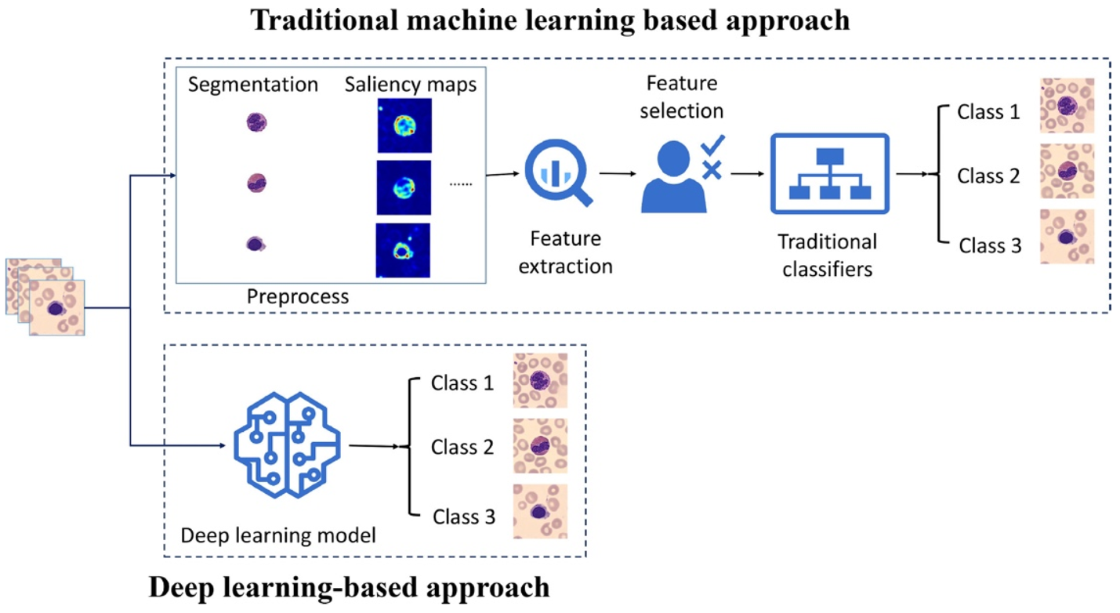
Figure 12. Conventional Machine Learning and Deep Learning Methods. Adapted with permission [140]

The application of AI and ML is important in the study of diseased tissues i.e., cancer cells, where cellular heterogeneity plays a critical role in understanding disease progression and therapeutic response [141,142]. ML models on large datasets, biologists can classify cells or tissues with high accuracy, enabling the differentiation between healthy and diseased tissues in histopathological samples [142]. These models can also identify subtle changes in cells subjected to drug treatments or uncover patterns that may be difficult for human to observe [130,131,143,144].
In high-content screening, ML is invaluable for analyzing the vast datasets produced by advanced imaging technologies. This capability allows researchers to detect subtle phenotypic changes in cells resulting from genetic modifications or environmental perturbations, which might otherwise go unnoticed [145,146]. The integration of AI and ML in this field offers numerous benefits, including enhanced accuracy, consistency, and reproducibility in data analysis [142,147,148]. Moreover, these technologies significantly improve time and cost efficiency by automating labor-intensive tasks and enabling real-time analysis. For instance, AI-driven tools can rapidly process and interpret complex imaging data, accelerating the discovery of novel biomarkers, therapeutic targets, and diagnostic patterns. By leveraging AI and ML, researchers can gain deeper insights into cellular behavior, disease mechanisms, and drug responses, ultimately advancing precision medicine and improving patient outcomes [135,149,150].

4.3. Reinforcement Learning

Reinforcement Learning (RL) is a branch of machine learning that focuses on training agents to make a sequence of decisions in an environment to maximize cumulative rewards over time. Unlike supervised learning, where the model learns from labeled data, RL employs a trial-and-error approach where an agent learns by interacting with the environment and receiving feedback in the form of rewards or penalties based on its actions. This feedback helps the agent update its knowledge, refine its decision-making policies, and optimize its behavior. The process is iterative, where the agent navigates through states and takes actions to transition to new states, with the aim of achieving a long-term goal [151]. Central to RL is the concept of the reward function, which quantifies the desirability of a particular state-action pair, and the policy, which dictates the agent's behavior in response to different states. The agent must balance exploration, where it tries new actions to discover potentially better outcomes, and exploitation, where it relies on known strategies that maximize reward. The core components of RL include the agent, environment, state, action, reward, and policy, which are combined into a framework known as the Markov Decision Process (MDP). In this framework, the agent's objective is to learn an optimal policy that will maximize the expected sum of future rewards, often modeled as the value function or Q-function. RL algorithms, such as Q-learning, Deep Q-Networks (DQN), and Proximal Policy Optimization (PPO), have been developed to efficiently solve various decision-making problems, leveraging both traditional tabular methods and advanced neural networks [152]. RL has shown great potential in diverse areas, from robotics, where it is used for teaching machines to perform tasks through trial and error, to healthcare, where it can optimize treatment strategies based on patient-specific data. Its ability to handle dynamic, uncertain environments and adapt to new challenges makes it an indispensable tool in modern artificial intelligence research, with applications ranging from autonomous driving and finance to personalized medicine and beyond [153].

4.4. Evaluation matrics

Artificial Intelligence (AI) has emerged as a transformative tool for automating image analysis, improving diagnostic accuracy, and accelerating research. AI techniques, particularly deep learning (DL) models, are applied to a variety of microscopy techniques, including brightfield, fluorescence, confocal, and electron microscopy, to analyze cellular structures, identify tissue abnormalities, and monitor changes in cellular morphology over time [147,154]. These models are trained to detect and classify patterns such as cell shapes, tissue architecture, and the presence of specific biomarkers or lesions. The evaluation of AI regarding analysis of microscopic images relies on various performance metrics to assess segmentation accuracy, classification performance, and the ability to generalize across diverse datasets. Key metrics commonly used in the evaluation of AI performance on microscopic images include accuracy, sensitivity, specificity, precision, recall, and F1-score, which quantify the model’s ability to correctly identify cell types or detect pathological features. However, in tasks such as image segmentation, where the model needs to delineate specific regions of interest, metrics like the Dice coefficient and Jaccard index are of particular importance. The Dice coefficient is widely used to assess the overlap between predicted and ground truth regions [155].
This metric evaluates the similarity between the predicted and true regions, with higher values indicating better segmentation. Both the Dice coefficient and Jaccard index provide quantitative measures for evaluating how accurately the AI model identifies structures such as cell nuclei, cytoplasm, and tissue boundaries, which are crucial for analyzing tissue morphology and diagnosing diseases [155].
In addition to these metrics, the mean squared error (MSE) and structural similarity index (SSIM) are used to evaluate the quality of reconstructed or denoised images in tasks such as image enhancement or noise reduction in microscopic images. For instance, AI models can be applied to improve image clarity, enhancing the ability to distinguish fine cellular details. The pixel accuracy and boundary detection accuracy are also essential for tasks that require precise delineation of cellular structures or tissue layers.
For more advanced evaluation, metrics like spatial localization accuracy can be employed in the context of cell tracking or tumor growth monitoring, where the model is required to track the movement of cells or accurately localize regions of interest over time. Additionally, cross-validation techniques, such as k-fold validation, ensure that AI models trained on microscopic images generalize well across different datasets and are not biased by overfitting to specific image characteristics.
Ultimately, the use of AI in microscopic image analysis of cells and tissues, combined with the evaluation metrics discussed, leads to more efficient and reliable interpretation of cellular structures, aiding in the diagnosis and monitoring of diseases such as cancer, neurodegenerative disorders, and infections. The ability of AI to deliver consistent, reproducible results while handling large-scale, high-dimensional image data makes it a powerful tool in both clinical and research settings, driving improvements in patient outcomes and advancing our understanding of cellular biology [156].

4.5. Introduction to Artificial Neural Networks

Artificial Neural Networks (ANNs) are computational models inspired by the structure and functionality of the human brain. They consist of interconnected layers of nodes, or neurons, where each connection is assigned a weight that determines its influence [141]. The fundamental part of an ANN include an input layer, hidden layers, and an output layer. So, input layer receives data, which is then processed through the hidden layers using activation functions that capture intricate patterns. The final output is generated in the output layer, which produces predictions or classifications based on learned representations [157].

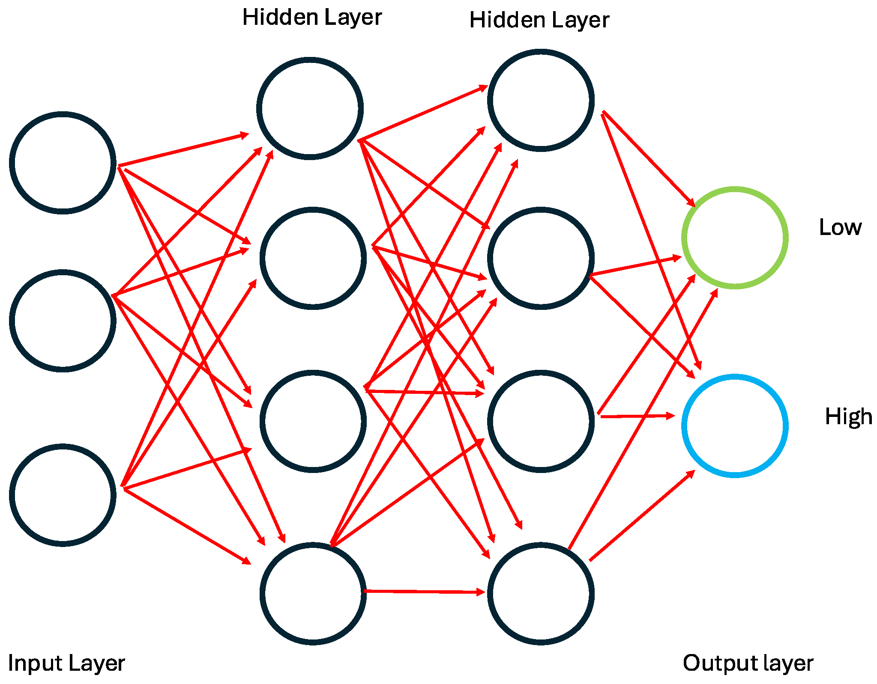
Figure 13. The structure of deep learning models.

Training ANNs involves optimizing several critical hyperparameters, including batch size, loss function, and optimizer, all of which significantly influence model performance and convergence. Batch size refers to the number of training samples processed before updating the model’s weights [158]. Smaller batch sizes introduce randomness in weight updates, helping the model escape local minima and improve generalization at the cost of stability. In contrast, larger batch sizes lead to more stable updates but may increase computational demand and risk overfitting. The ideal batch size, typically ranging from 16 to 256, depends on factors such as dataset size, model architecture, and available computational resources Loss functions quantify the error between predicted and actual target values during training. For example, in autoencoders, commonly used for dimensionality reduction and denoising, Mean Squared Error (MSE) is widely employed to minimize reconstruction loss [159]. For binary or sparse datasets, Binary Cross-Entropy is preferred to optimize classification accuracy [160]. Optimizers adjust the network’s weights to minimize the loss function by computing gradients during backpropagation [161]. Popular optimizers include Stochastic Gradient Descent (SGD), which updates weights in small steps and introduces stochasticity for better generalization, and Adam (Adaptive Moment Estimation), which adapts learning rates dynamically, leading to faster convergence, particularly in complex models [156][141]. ANNs rely on backpropagation to iteratively refine their weights based on prediction errors. This iterative learning process continues until the model achieves a desired accuracy level [162].

4.6. Convolutional Neural Networks (CNNs)

A specialized subset of ANNs, Convolutional Neural Networks (CNNs), are designed to efficiently process grid-structured data, such as images. CNNs excel in image recognition and classification by automatically learning spatial hierarchies of features through multiple layers.
A typical CNN consists of Conv layers that apply filters to the indput data, extracting meaningful patterns such as edges, textures, and shapes [163]. Pooling layers that downsample feature maps, reducing computational complexity while preserving essential information. Max pooling and average pooling are commonly used techniques to enhance feature selection and control overfitting. Fully connected layers that integrate the extracted features to produce the final classification or prediction. CNNs have revolutionized various fields, including medical imaging, autonomous driving, and facial recognition, by enabling precise and automated image analysis [141] (figure 14).
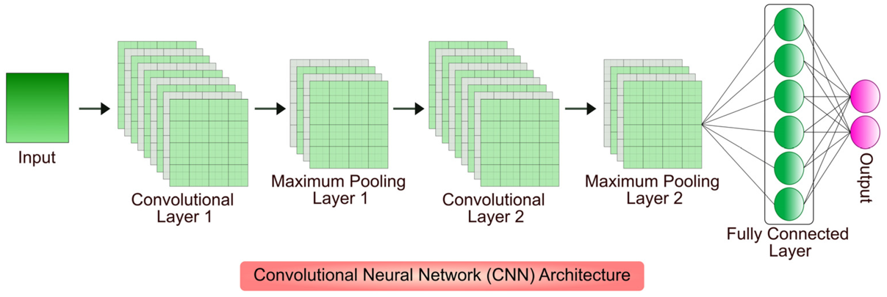
Figure 14. CNN consists of multiple convolutional and pooling layers to process spatial information. The convolutional layer applies filters to extract essential features, while the pooling layer reduces feature size to improve computational efficiency. Finally, the fully connected layer utilizes the processed data to generate the final output prediction. Reprinted from [164].

4.7 Deep Convolutional Neural Networks (DCNNs)

Deep Convolutional Neural Networks (DCNNs) extend CNN capabilities by incorporating multiple convolutional layers, leading to deeper architectures capable of extracting progressively complex patterns. DCNNs are particularly effective in image and video recognition, as their hierarchical structure allows them to capture fine-grained details across multiple layers. Their architecture typically includes: Convolutional layers for feature extraction, detecting spatial patterns in input images [142]. Pooling layers to reduce dimensionality, making the model more robust to slight variations and distortions. Max pooling and average pooling help maintain essential features while minimizing overfitting. Fully connected layers that consolidate learned features and enable final decision-making [163] (figure 15).

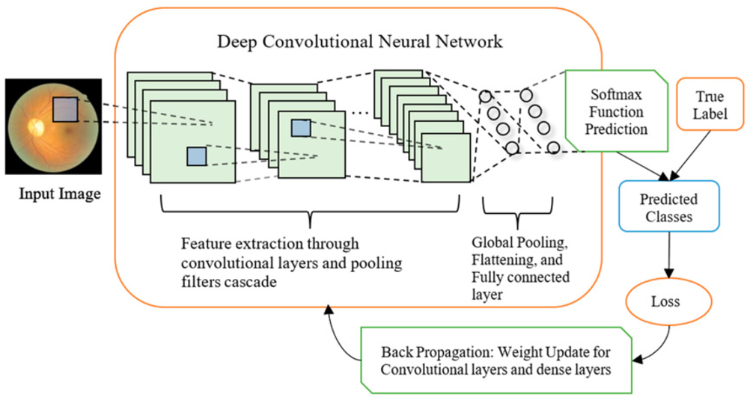
Figure 15. The classification process in deep CNNs (Convolutional Neural Networks) begins with an input image analyzed using convolutional filters that detect patterns within small receptive fields, generating feature maps. From [165]

By leveraging deep learning, DCNNs have significantly enhanced object detection, medical diagnostics, and real-time image processing, proving indispensable in modern AI-driven applications. Deep Convolutional Neural Networks (DCNNs) represent an advanced evolution of Convolutional Neural Networks (CNNs), incorporating multiple convolutional layers to form deep architectures. These networks excel in handling complex data patterns, making them highly effective for tasks such as image and video recognition. By leveraging hierarchical feature learning, DCNNs progressively extract intricate patterns from raw input data, allowing for more precise and detailed representations [166]. DCNNs consist of three primary types of layers: Convolutional Layers: These layers apply filters to input data, generating feature maps that capture essential patterns such as edges, textures, and shapes. As the depth of the network increases, these layers progressively detect higher-level features, enhancing the model's ability to recognize intricate spatial relationships [167].
Pooling Layers: Techniques like max pooling and average pooling are used to downsample feature maps, reducing computational complexity while preserving critical information. Pooling also enhances translation invariance, making the network more robust to variations in input images.
Fully Connected Layers: After feature extraction, these layers integrate the learned information to produce final classifications or predictions. By stacking multiple convolutional and pooling layers, DCNNs build deep feature hierarchies, enabling them to automatically extract, refine, and classify patterns with remarkable accuracy. Their ability to generalize across different image and video datasets has led to groundbreaking advancements in fields such as medical imaging, autonomous systems, and real-time object detection [168].

As the depth of neural networks increases, Deep Convolutional Neural Networks (DCNNs) become increasingly adept at capturing complex and abstract features, enabling them to excel in recognizing intricate patterns and objects within images. The fully connected layers at the end of the network synthesize these learned features to perform final classification or regression tasks. This layered architecture allows DCNNs to achieve remarkable accuracy in tasks such as image classification, object detection, and semantic segmentation, making them indispensable in modern computer vision.
DCNNs have transformed numerous fields, including medical imaging, autonomous driving, and facial recognition, often surpassing human-level accuracy in these domains [169]. They are widely employed to develop systems capable of identifying objects in images and videos with exceptional precision. However, despite their power, DCNNs face challenges such as the need for extensive datasets, high computational requirements, and the complexity of interpreting learned features. Despite these hurdles, ongoing advancements in network architectures, optimization techniques, and computational resources continue to propel the evolution and success of DCNNs across diverse applications [170].
A compelling example of DCNNs in action is their application in binary classification tasks within cell biology. For instance, a recent study developed a DCNN to classify human-induced pluripotent stem cell-derived endothelial cells (hiPSC-derived ECs) using photomicrographs [171]. The network incorporated a variety of convolutional modules, kernel sizes, pooling layers, and activation functions, achieving high performance with minimal trainable parameters [158].
The widespread adoption of deep learning in imaging sciences can be traced back to the success of AlexNet, a DCNN that achieved a 15% error rate in the ImageNet Large Scale Visual Recognition Challenge, outperforming its competitors by nearly 10%. This breakthrough highlighted the potential of deep learning in medical imaging, leading to a surge in research exploring DCNNs for biological image analysis. Following AlexNet’s success, numerous DCNN architectures have been developed for specialized applications, such as cell segmentation in microscopy and lesion detection in magnetic resonance imaging. Unlike traditional methods reliant on human-defined equations, DCNNs can identify patterns in raw visual data, even if these patterns are not immediately interpretable by humans. These patterns, however, are critical for achieving reliable and accurate results in image classification and segmentation tasks.
Another notable architecture is the Keypoint Graph Network (KG Network), which uses ResNet34-based feature extraction to identify key points that discretize the input image. These key points are processed to extract bounding boxes for cells or nuclei, which are then used to generate masks. Unlike U-Net, the KG Network provides object-by-object segmentation but requires more forwarding time and a longer training duration—approximately four hours on the same GPU used for U-Net. This study employed a PyTorch implementation of the KG Network[172].
Mask R-CNN, another powerful architecture, utilizes region-based CNNs to extract detailed masks for cells and nuclei. While it offers high precision, it demands more forwarding time and substantial VRAM for training compared to U-Net and the KG Network [173].
In summary, DCNNs have revolutionized image analysis across various domains, driven by their ability to learn complex features and deliver high accuracy. Despite challenges such as computational demands and interpretability, continuous advancements in architecture and technology are expanding their capabilities and applications. From binary classification in cell biology to semantic segmentation in medical imaging, DCNNs are paving the way for innovative solutions that enhance efficiency, accuracy, and scalability in research and industry.

4.8. Introduction of Generative Adversarial Networks

A Generative Adversarial Network (GAN) is a class of machine learning models that consists of two neural networks, a generator and a discriminator, which are trained simultaneously in a competitive setting. GANs are primarily used for generating synthetic data, such as images, that are indistinguishable from real data. The architecture is based on a game-theory framework, where the generator tries to produce realistic-looking data, while the discriminator attempts to distinguish between real and generated data. Over time, both networks improve their performance through this adversarial process, resulting in a generator capable of creating highly realistic synthetic data.
The generator in a GAN is responsible for generating synthetic data, such as images, that resemble the real data from a given distribution. It takes in random noise (a latent vector) and transforms it into data samples, like images of faces, landscapes, or medical images, depending on the task. The generator's goal is to produce data that is indistinguishable from real data, which it achieves by learning the underlying patterns in the training dataset
The discriminator, on the other hand, is a binary classifier that tries to distinguish between real data (from the true distribution) and fake data (generated by the generator). It outputs a probability score indicating how likely a given data sample is real. The discriminator’s objective is to correctly identify whether the input data is real or generated.
During training, the generator and discriminator are in a constant "game" with each other. The generator aims to fool the discriminator into classifying its fake data as real, while the discriminator strives to correctly identify the authenticity of the data. This dynamic continues through multiple iterations, with both networks improving their performance over time. The process is guided by a loss function for both networks, typically the binary cross-entropy loss, where the generator minimizes the likelihood of the discriminator correctly identifying its fakes, and the discriminator maximizes its ability to classify data correctly [154].
The training process of GANs involves a back-and-forth optimization between the two networks. Initially, the generator produces poor-quality data that the discriminator can easily identify as fake. However, as the generator improves, the discriminator becomes more adept at detecting subtle differences between real and fake data, leading to a situation where both networks achieve high performance. The ideal outcome is when the generator creates data so realistic that the discriminator cannot reliably tell the difference between real and generated samples. This process is often referred to as minimax game, where the generator is trying to minimize the discriminator's ability to classify data correctly, and the discriminator is maximizing its ability to correctly classify the data [174].
GANs have found numerous applications across various domains, including image synthesis, style transfer, super-resolution, and data augmentation. In the field of biomedical imaging, GANs have been applied to generate high-quality synthetic medical images, such as MRI scans, CT scans, or histopathological slides, for training AI models when annotated data is scarce. They can also be used for tasks like image denoising, image-to-image translation, and super-resolution, where low-quality or noisy medical images can be enhanced to improve the accuracy of diagnosis. Additionally, GANs have been used in the generation of synthetic patient data for research purposes, ensuring that sensitive patient data can remain private while still enabling robust machine learning model training [174–176].
Moreover, variants of GANs, such as Conditional GANs (cGANs) and CycleGANs, have been developed to handle specific tasks. Conditional GANs allow for the generation of data based on specific conditions or labels (e.g., generating a particular type of image given a label), while CycleGANs enable image-to-image translation without requiring paired datasets, making them ideal for tasks like converting MRI scans from one modality to another[177].
In conclusion, GANs are a powerful tool in machine learning for generating realistic synthetic data and improving tasks that involve image generation, enhancement, and transformation. Their ability to generate high-quality, realistic data has made them a valuable asset in fields like computer vision, medical imaging, and data augmentation, where they help overcome the challenges of limited or biased datasets and contribute to advancements in AI-based applications [178].

4.9 Introduction of Vision Transformers

Vision Transformers (ViTs) represent a transformative shift in computer vision, extending the success of transformer models from natural language processing (NLP) to image analysis tasks [179]. ViTs have demonstrated remarkable performance in tasks such as image segmentation, classification, and feature extraction, often surpassing the capabilities of conventional CNNs. Their ability to model global relationships within an image allows for more accurate and robust analysis of microscopic data, where fine details and spatial relationships are critical. For example, ViTs can be integrated with architectures like U-Net to enhance segmentation accuracy in microscopic images, enabling precise identification of cellular and tissue structures[128].
The architecture of ViTs involves dividing an image into fixed-size patches, which are then flattened and processed by a transformer encoder. This encoder uses self-attention mechanisms to weigh the importance of different patches, capturing both local and global features. The resulting representations are then used for downstream tasks such as classification or segmentation [180] (figure 16).
The application of ViTs in microscopic image analysis holds significant importance for advancing research in fields such as cellular biology, histopathology, and medical diagnostics. By providing a more comprehensive understanding of image data through global context modeling, ViTs work to enhance the accuracy and efficiency of image-based analyses. However, challenges such as computational complexity and the need for large-scale training datasets remain areas of active research [181] .
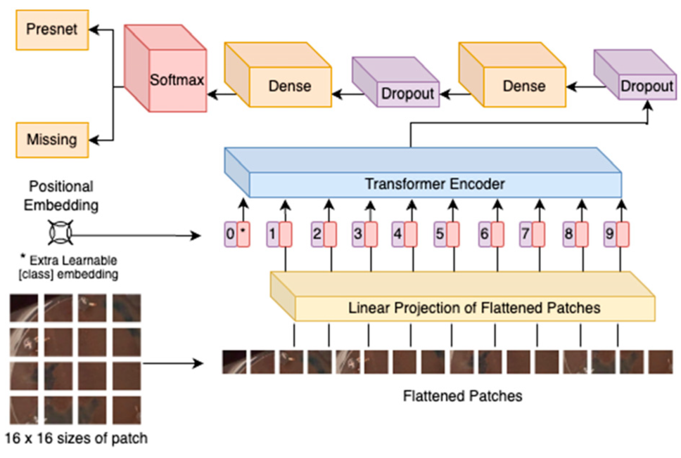
Figure 16. The diagram illustrates the Vision Transformer (ViT) architecture used for image analysis. Reprinted from [182].

The analysis of cell or tissue images presents a range of unique challenges, primarily due to the inherent complexity of biological samples. Factors such as high levels of heterogeneity, where individual cells or tissue regions display significant variation, contribute to the difficulty of accurate interpretation. Additionally, overlapping structures within the images can hnder important details, making it harder to distinguish between different biological components. Furthermore, biological features often exist at multiple scales, requiring advanced techniques to capture fine details at both cellular and tissue levels. These complexities have importance for the development of sophisticated image analysis methods capable of addressing these issues to ensure precise and reliable results in biological research and diagnostics.Traditional methods often face difficulties in addressing these complexities. However, image transformers provide a revolutionary approach by analyzing entire image patches at once, allows transformers to capture spatial relationships, detect subtle morphological patterns, and accurately delineate cellular boundaries with remarkable precision. For example, they are highly effective at segmenting complex cellular components, distinguishing overlapping structures, and identifying fine morphological changes in tissues—essential elements in supporting disease diagnosis and biological research.
One of the standout advantages of image transformers in microscopy is their ability to scale efficiently for large datasets, which is crucial for applications like high-content screening, single-cell analysis, and large-scale biomedical research. By leveraging self-attention mechanisms, transformers process high-resolution images while preserving fine details, making them invaluable for tasks such as cell type classification, subcellular structure identification, and phenotype prediction.
Additionally, hybrid models that integrate CNNs with transformers have demonstrated superior performance by combining the localized feature extraction of CNNs with the global context modeling of transformers. This synergy increases the accuracy and robustness of microscopic image analysis, making it a powerful tool for automated cell and tissue characterization.
Transformers are also reshaping the field of image reconstruction and enhancement, addressing common challenges in microscopy such as image noise, low resolution, and inconsistent contrast. Denoising transformers effectively remove noise from fluorescence microscopy images, while super-resolution transformers enhance image clarity, revealing intricate cellular structures that might otherwise remain obscured.
Beyond image processing, transformers play a pivotal role in multimodal analysis, integrating data from multiple imaging techniques—such as fluorescence and phase-contrast microscopy—to provide a more holistic view of biological processes. This capability is particularly beneficial for applications in disease modeling, drug discovery, and personalized medicine.
Despite their immense potential, the application of image transformers in microscopic imaging remains an emerging field, with ongoing research focused on overcoming challenges such as computational complexity and the need for large annotated datasets. However, their ability to extract intricate spatial relationships, analyze vast datasets, and enhance image quality positions them as a revolutionary tool in cellular and tissue-level research.
From precision diagnostics to advanced drug discovery, image transformers are set to redefine how researchers visualize, analyze, and interpret microscopic images. As technology continues to evolve, these AI-driven models will play a crucial role in accelerating biomedical discoveries and transforming healthcare applications

Chapter 5

Radiomics Analysis in Magnetic Resonance Imaging to detect tumors

Prostate cancer (PCa) and bladder cancer (BCa) rank among the most diagnosed cancers globally, representing a major public health concern. Both PCa and BCa contribute to high death rates and considerable healthcare expenses, they highlight the urgent need for more effective prevention, early detection, and treatment strategies to reduce their impact on public health. The rising prevalence of these cancers calls for increased research and innovative therapeutic approaches to improve outcomes and alleviate the burden on healthcare finance. These cancers require early and accurate detection to enhance patient outcomes, reduce disease burden, and optimize treatment strategies [183]. Over the past few decades, advancements in imaging technologies have significantly transformed the field of oncology, providing clinicians with improved methods for detecting, characterizing, and monitoring tumors. Multiparametric MRI (mpMRI) has emerged as a critical imaging modality in the diagnosis and characterization of PCa, as it integrates anatomical and functional imaging sequences to provide a more comprehensive evaluation of the prostate gland [184]. Similarly, MRI has demonstrated substantial advantages in the staging of BCa, particularly in local T staging, due to its superior soft tissue contrast resolution, which allows for more precise differentiation of tumor infiltration within the bladder wall and surrounding structures [185,186].
Multiparametric MRI (mpMRI) has proven to be an extremely effective tool for detecting prostate cancer (PCa). To standardize the interpretation of MRI results, the Prostate Imaging Reporting and Data System (PI-RADS) Version 2 was developed. T. By providing a consistent and reliable method for assessing PCa on MRI, PI-RADS enhances diagnostic accuracy, aiding in more informed clinical decision-making. With the continuous increase in imaging data volume per patient, the need for sophisticated computational methods to process and analyze these images has grown exponentially. One of the most promising approaches in this regard is radiomics, an innovative field that applies advanced data-characterization algorithms to extract and analyze vast amounts of quantitative features from radiographic medical images. Radiomics has demonstrated remarkable potential in improving diagnostic accuracy, prognostic assessment, and predictive modeling across multiple cancer types, including both PCa and BCa [8,185,187].
The core principle of radiomics relies in its ability to convert standard medical images into high-dimensional, mineable data that can reveal intricate tumor characteristics and patterns that may be unobservable to the human eye. In the context of PCa, radiomics-driven analysis of MRI has gained significance attention due to non-invasive technique for enhancing diagnostic precision and distinguishing between benign and malignant prostate tissues. Through the extraction of detailed imaging biomarkers, radiomics can provide additional insights into tumor heterogeneity, aggressiveness, and potential treatment response, thereby refining clinical decision-making processes. Similarly, in BCa, radiomics has been extensively investigated for its ability to support differential diagnosis, assess tumor aggressiveness, and predict patient responses to therapy. MRI-based radiomics has demonstrated particular value in differentiating between low-grade (LG) and high-grade (HG) bladder lesions, distinguishing non-muscle-invasive bladder cancer (NMIBC) and muscle-invasive bladder cancer (MIBC) [183,186,188,189].
Given the immense potential of radiomics in enhancing the precision of cancer diagnostics and treatment personalization, this study aims to explore the application of MRI radiomics analysis in the detection and characterization of PCa and BCa. By leveraging the advanced computational capabilities of radiomics, this research seeks to identify novel imaging biomarkers and unseen patterns in MR images to improved early detection, better patient stratification, and more tailored therapeutic interventions. Furthermore, the integration of radiomics into clinical practice holds the promise of revolutionizing oncology by facilitating non-invasive, image-based tumor characterization, thereby reducing the need for invasive biopsy procedures while ensuring a more comprehensive understanding of tumor behavior [190–193].
5.1. Prostate cancer detection methodology

5.1.1. Materials and Methods
Between 2019 and 2020, a total of 503 individuals underwent multiparametric MRI (mpMRI) at our radiology department. The primary indications for mpMRI included the lower urinary tract symptoms (LUTS). Additionally, patients with suspicious findings on digital rectal examination (DRE) and/or transrectal ultrasound (TRUS) suggestive of prostate abnormalities were referred for imaging. Elevated prostate-specific antigen (PSA) levels exceeding 4 ng/mL also warranted mpMRI evaluation. Furthermore, the imaging modality was utilized for post-radiotherapy monitoring and for patients with a history of PCa undergone through radical prostatectomy but exhibited rising serum PSA levels above 0.2 ng/mL, indicating potential biochemical recurrence.
To maintain the accuracy and relevance of the study, specific exclusion criteria were applied. Patients with incomplete MRI studies due to claustrophobia were excluded, as were those with a history of radical prostatectomy, transurethral resection of the prostate (TURP), or prior radiotherapy. Additionally, individuals with negative mpMRI findings or a Prostate Imaging-Reporting and Data System (PI-RADS) lesion score below 3 were not included in the analysis. Finally, cases lacking histopathological confirmation from fusion biopsy were also excluded, ensuring that only patients with definitive diagnostic outcomes were considered for evaluation.

5.1.1.2. Using the MRI technique
The MRI examinations were performed using a 16-channel phased-array coil (HD Torso XL, Philips Healthcare) on a 1.5 Tesla system (Achieva, Philips Healthcare, Best, The Netherlands). The imaging was conducted by an experienced radiologist with over 14 years of expertise in prostate MRI. To minimize potential diagnostic errors, scans were scheduled at least six weeks post-prostate biopsy, allowing sufficient time for the reabsorption of postoperative hemorrhage.
The imaging protocol encompassed multi-planar sequences, including axial, coronal, and sagittal T2-weighted (T2W) imaging of the prostate and seminal vesicles. Axial T1-weighted (T1W) imaging was employed to identify hyperintense residual bleeding following biopsy. In addition, diffusion-weighted imaging (DWI) and dynamic contrast-enhanced (DCE) MRI were incorporated into the protocol for improved lesion characterization. DWI sequences were acquired using b-values of 0, 800, and 1400 s/mm², with the corresponding apparent diffusion coefficient (ADC) maps generated for quantitative assessment.
For DCE imaging, patients received an intravenous injection of 1 mmol/kg body weight of Gadoteric acid (Gd-DOTA, Dotarem, Guerbet) at a controlled rate of 3 mL/sec, immediately followed by a saline flush of 20–30 mL at the same injection speed. Post-contrast imaging was performed using axial T1W three-dimensional spoiled gradient-recalled echo (3D-SPGR) volumetric interpolated sequences to facilitate MRI analysis.
5.1.1.3. Manual Segmentation
This process was meticulously performed by experienced radiologist to ensure precise identification of the regions of interest. To achieve accurate segmentation, we employed a methodology similar to that described by Cutaia et al., manually outlining the entire prostate gland and detected lesions.
The segmentation workflow began with importing each MRI examination into 3D Slicer (https://slicer.org/), a widely used open-source DICOM viewer and medical imaging analysis tool. This software provides an extensive suite of features for interactive visualization, image processing, and analysis across multiple imaging modalities, including MRI. Its advanced capabilities make it a preferred choice for segmentation tasks in the medical imaging field.
For this study, segmentation was performed primarily on axial T2-weighted (T2W) sequences, which offer high soft-tissue contrast, allowing for clear differentiation between the prostate zones and potential lesions. The radiologist manually traced the contours of the prostate gland and any detected tumor on each axial slice. A closed polygon contouring tool was employed to carefully delineate the anatomical structures (figure 17).
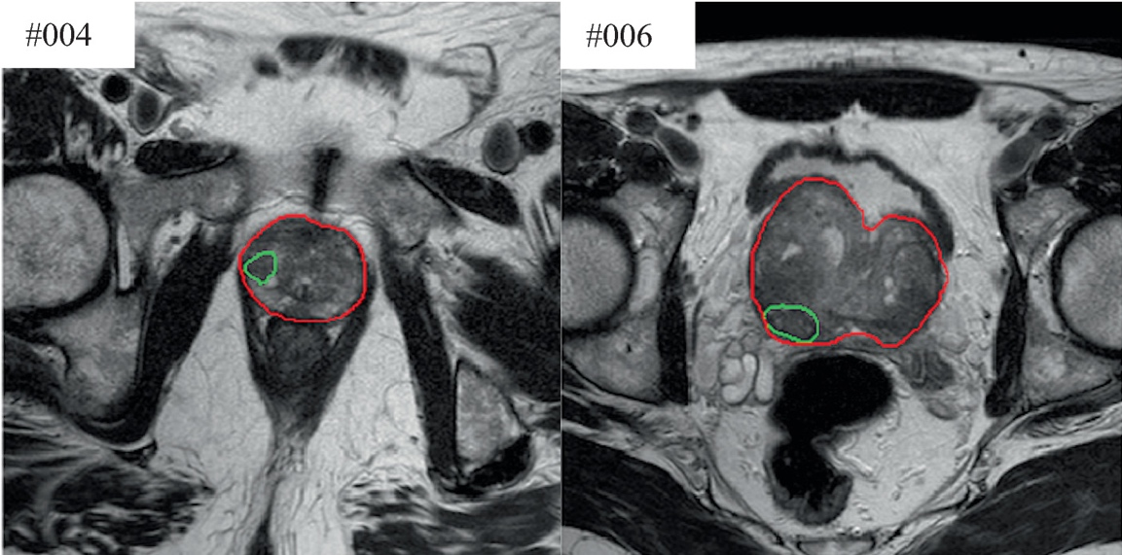
Figure 17. An example of the whole prostate gland (highlighted in red) and prostate cancer segmentation (shown in green) on T2-weighted (T2W) prostate sequences.
Once the manual segmentation was completed, the "Compute Volume" tool in 3D Slicer was used to determine the volumetric measurements of both the whole prostate gland and individual lesions. it calculates volume based on the segmented regions, providing quantitative data to be utilized in radiomic analysis. Lesion volume is a crucial parameter, offering valuable insights into tumor size, progression, and potential treatment response. These volumetric measurements serve as foundational data for further computational analysis, including machine learning-based radiomic feature extraction and predictive modeling.

5.1.1.4. Radiomics features extraction
PyRadiomics, an open-source software compliant with the Image Biomarker Standardization Initiative (IBSI), was employed for radiomic feature extraction in this study. A key element of radiomics research is ensuring the reproducibility of extracted textures, as consistent features are essential for reliable analysis. PyRadiomics offers a powerful platform for the extraction of a broad spectrum of radiomic features through a wide array of well-established algorithms. These algorithms are hard-coded into the software and implemented using Python, a popular and versatile open-source scientific computing language. PyRadiomics is compatible with a variety of operating systems, making it accessible for users across different platforms. The software’s back-end interface also allows for automation in the processing of large datasets, efficient feature definition, and streamlined batch management, enhancing reproducibility and efficiency in radiomics research.
The software provides multiple classes of features, including shape descriptors, first-order statistics, and texture matrices, each offering different insights into the characteristics of the region of interest.
For the extraction of these features using PyRadiomics, specific settings were applied to ensure consistency and standardization. The Normalize parameter was set to True to adjust for varying image intensities, and the BinWidth was configured to 0.27 to standardize the bin size for histogram calculations. All other parameters were left at their default settings, ensuring compatibility with the standard radiomic feature extraction process. This rigorous extraction method allows for detailed and reproducible analysis, facilitating the identification of imaging biomarkers for prostate cancer diagnosis, prognosis, and treatment response.

5.1.1.5. Computational and statistical analyses
A senior researcher in biomedical imaging analyzed radiomic parameters using computational methods. A two-way ANOVA was performed to compare radiomic features between whole-prostate and tumor-specific segmentations 183], identifying statistically significant features (p < 0.05) from a total of 112. A hybrid statistical approach, incorporating point-biserial correlation and logistic regression, was employed to refine feature selection. Discriminant analysis was then used to develop a predictive model distinguishing prostate tissue from tumors [194]. The model was validated using a 5-fold cross-validation method [195], and its diagnostic accuracy was assessed through ROC curves, AUROC values, sensitivity, specificity, and overall accuracy [189,195].
5.2. Methodology for baldder cancer:
5.2.1. Materials and Methods
This single-center retrospective investigation received approval from the institutional ethics board, with no requirement for informed consent.
5.2.1.1.Population
The research included 30 sequential patients with verified BCa who underwent MRI scans between March 2019 and May 2020. Patients were selected based on the following criteria: (1) BCa confirmed by postoperative pathology; and (2) 1.5 T MRI examinations conducted within one month prior to surgery. Exclusion criteria encompassed (1) prior treatments such as chemotherapy, radiotherapy, TURBT, or BCG before MRI examination. A radiologist evaluated the acquired studies. Demographic information and histopathological findings were documented.
5.2.1.2. MRI technique
All patients underwent MRI using an identical protocol on a 1.5T scanner (Achieva, Philips Healthcare, Best, The Netherlands) with a phased array coil (16 channel HD Torso XL). The sequence details are outlined in Table 1. The standard bladder MRI protocol comprised axial, coronal, and sagittal T2-weighted images, axial T1-weighted images, and diffusion weighted imaging (DWI) with b values of 0, 800, and 1400 s/mm2. ADC maps were generated from the DWI images. Following non-contrast imaging, patients received 1 mmol/kg body weight of contrast agent (Gd-DOTA, Dotarem®, Guerbet, USA) at 3 ml/s, followed by 20-30 ml of saline solution at the same rate. A volumetric 3D-T1-GRE sequence was then performed to obtain the prostate perfusion study (dynamic contrast-enhanced - DCE).
5.2.1.3. Qualitative imaging analysis
We developed a novel operational methodology for implementing a radiomics study with bladder lesions undergoing MRI. This approach was achieved by integrating and modifying various existing and new techniques, some of which were previously utilized in other studies [196]. Our method successfully addressed the constraints typically associated with radiomics research. The process began with the identification of target lesions, followed by a three-dimensional segmentation of both the lesions and the adjacent bladder wall [197].

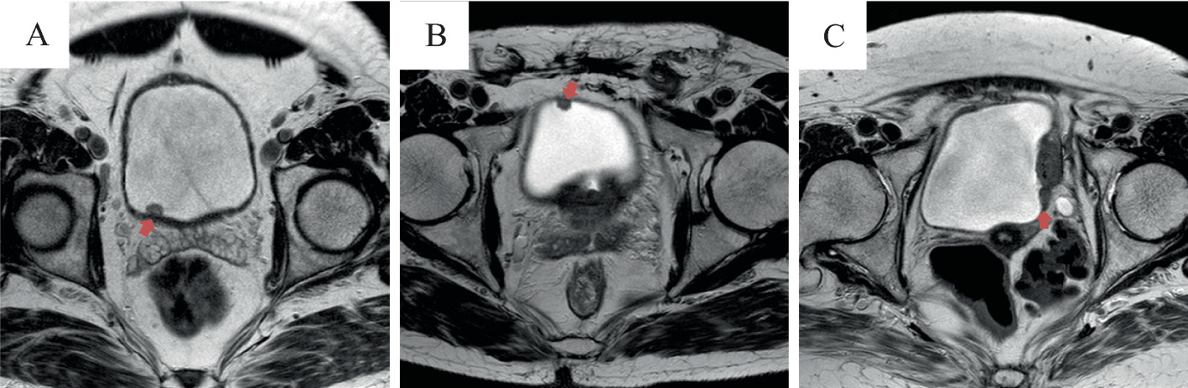

Figure 18. A: Low-grade bladder lesion in the right posterior wall (indicated by the red arrow). B: High-grade bladder lesion in the right anterior wall (indicated by the red arrow). C: Muscle-invasive bladder cancer (MIBC) in the left lateral wall (indicated by the red arrow).

5.2.1.4. Segmentation and radiomics features extraction

PyRadiomics (3.0, Computational Imaging & Bioinformatics lab - Harvard Medical School) was employed to extract radiomics parameters. Each ROI yielded over 120 automated radiomics parameters, encompassing first-order texture parameters (related to gray level distribution within the ROI, disregarding spatial relationships between voxels), second-order parameters (considering voxel spatial relationships), and third-order parameters (evaluating spatial relationships among three or more voxels). Texture parameters were derived from gray level histogram analysis. Additionally, a "run-length matrix" was calculated in four directions. Detailed descriptions of radiomics parameters can be found in the PyRadiomics online manual [198].
Computational and statistical analyses
5.2.1.5. Computational and statistical analyses
The computational analysis of radiomics features was performed by an experienced senior scientist specializing in biomedical imaging, with a decade of expertise in image and data processing and analysis. This expert had access to both the extracted radiomic features and the reference standards for comparison. The gathered data, which consisted of continuous variables, were presented as mean values along with standard deviation (SD), while categorical variables were represented as frequencies and percentages. According to the histopathological results, the lesions under analysis were categorized into two groups: "low grade" and "high grade," as well as "non-muscle invasive" and "muscle invasive." Our approach to MRI texture analysis incorporated an operator-independent statistical system designed for feature reduction and selection. This system was integrated with a predictive method based on discriminant analysis, following methodologies applied in previous studies for similar analyses. [198,199].
T The initial step involved employing a mixed descriptive-inferential sequential approach aimed at identifying the most discriminating features while simultaneously reducing redundant data. Specifically, for each characteristic, the punctual biserial correlation index between continuous variables and dichotomous variables was computed, with the dichotomous variable assuming values of 1 or 0 (based on the reference standard). Subsequently, the characteristics were ranked in descending order according to the absolute value of their biserial correlation index. Following this, a process of iterative addition was initiated, where one characteristic was added at a time, and logistic regression analysis was performed at each stage. After each iteration, the p-value obtained was compared to that from the previous iteration. The cycle was stopped when no improvement was observed in the p-value of the current iteration compared to the previous one. This procedure allowed for the identification of the most discriminative characteristics, which were crucial for differentiating between "low grade" and "high grade" lesions, as well as between "non-muscle invasive" and "muscle invasive" cases.
In the second phase, discriminant analysis was applied to construct a predictive model tailored to our patient dataset. This method aimed to refine and validate the diagnostic capacity of the identified features, ensuring that they could effectively predict outcomes in clinical practice. Through this dual approach, we sought to enhance the accuracy of our differential diagnoses, ultimately improving the clinical decision-making process [186]. The discriminant analysis model was trained using the most discriminative features identified during the earlier stages of analysis. This training process aimed to develop an effective predictive tool capable of distinguishing between "low grade" and "high grade" lesions, as well as differentiating between "non-muscle invasive" and "muscle invasive" conditions. After the completion of the training phase, the model was fully equipped to apply the learned patterns and classify the radiomics texture data encountered in subsequent steps. This classification process ensured that the model could accurately assign new, unseen data to the correct diagnostic categories, thereby enhancing its clinical applicability. By leveraging the most relevant features, the trained discriminant analysis model offers a robust and reliable method for supporting the predicting the diagnosis, supporting more informed clinical decisions and improving diagnostic precision [200]. To create the training input for the classifier, histopathological examination results were utilized as the reference standard. In our study, 80% of the available samples were designated for training the classifier, ensuring that the model had enough data to learn the distinguishing features effectively. The remaining 20% of the samples were reserved for testing, allowing us to assess the classifier's ability to make accurate and reliable predictions on previously unseen data. To further enhance the robustness of the results and mitigate potential issues such as overfitting, we incorporated a 5-fold cross-validation technique. This approach divides the dataset into five subsets, iteratively training the model on four of these subsets while testing on the fifth, ensuring that the model’s performance is evaluated comprehensively and reducing the likelihood of it becoming overly specialized to one particular subset of the data. Through these combined strategies, we sought to improve the generalizability and reliability of the classifier, making it more capable of handling real-world clinical data with high accuracy [186] For the sake of clarification, it is important to note that the k-fold cross-validation technique was applied solely for the purpose of validating the performance of two classification methods—Generalized Linear Models (GLM) and Discriminant Analysis (DA) [201,202] —and was not employed for feature selection in this study. To assess the diagnostic performance of the most discriminating parameters derived from T2-weighted imaging (T2WI), we calculated the Receiver Operating Characteristics (ROC) curves along with their corresponding 95% confidence intervals (C.I.), as well as the areas under the ROC curve (AUROC) and their respective 95% C.I. values. The computational statistical analysis that supported this study was carried out using the Matlab R2019a. The analysis was performed on a 2.5 GHz, 16 GB Intel Core i7-based iMac computer, equipped with 1600 MHz DDR3 memory and running the macOS Sierra operating system.

Chapter 6
The result of the effect of polyphenols against rheumatoid arthritis
6.1. In Vitro Evaluation of Tyrosol
To comprehensively investigate the potential anti-inflammatory effects of tyrosol on lipopolysaccharide (LPS)-induced acute lung injury (ALI) and to elucidate the underlying molecular mechanisms, a well-structured in vivo study was conducted using BALB/c mice as the experimental model. The mice were pre-treated with oral administration of tyrosol at graded doses of 0.1, 1, and 10 mg/kg, precisely one hour before they were subjected to an intratracheal injection of LPS at a concentration of 25 μg/50 μL. This approach aimed to mimic the pathological features of ALI and assess the efficacy of tyrosol in mitigating inflammatory responses. The results demonstrated that tyrosol treatment led to a marked improvement in multiple pathological indicators associated with ALI. Specifically, tyrosol significantly reduced lung vascular permeability, thereby preventing excessive fluid accumulation and edema in pulmonary tissues. Additionally, histopathological evaluations revealed that tyrosol alleviated structural damage to the lungs, preserving the integrity of alveolar walls and reducing cellular infiltration into the lung parenchyma. Furthermore, a substantial decline in the wet-to-dry lung weight ratio, a key parameter indicative of pulmonary edema, was observed following tyrosol administration. This suggests that tyrosol effectively attenuated fluid retention and maintained pulmonary homeostasis.
Moreover, tyrosol exhibited a pronounced inhibitory effect on the infiltration of inflammatory cells into the pulmonary vasculature, further emphasizing its protective role in lung inflammation. These findings collectively suggest that tyrosol exerts a significant protective effect against LPS-induced lung injury by modulating key inflammatory pathways, potentially offering a novel therapeutic approach for the management of acute lung injury and related inflammatory pulmonary disorders. Future investigations into the precise molecular targets of tyrosol may provide deeper insights into its pharmacological potential and broaden its applicability in clinical settings. Furthermore, tyrosol was found to modulate the LPS-induced imbalance in enzymatic activities, including superoxide dismutase and myeloperoxidase, both of which are key indicators of oxidative stress and inflammation. The treatment with tyrosol also resulted in a reduction in the levels of pro-inflammatory cytokines, such as tumor necrosis factor-α, interleukin (IL)-1β, and IL-6, in both bronchoalveolar lavage fluid (BALF) and lung tissue, further supporting its anti-inflammatory potential. Additionally, tyrosol inhibited the activation of key inflammatory mediators, including inducible nitric oxide synthase (iNOS), cyclooxygenase-2 (COX-2), and phosphorylated-IκBα, in lung tissue. Notably, tyrosol decreased nitric oxide production and suppressed the expression of pro-inflammatory cytokines, iNOS, and COX-2, as well as the nuclear translocation of nuclear factor-κB (NF-κB) in LPS-stimulated RAW 264.7 macrophages. These results collectively suggest that tyrosol exerts significant anti-inflammatory effects through the modulation of key inflammatory pathways, highlighting its potential as a therapeutic agent for treating inflammatory lung diseases [203](figure 19 and 20).
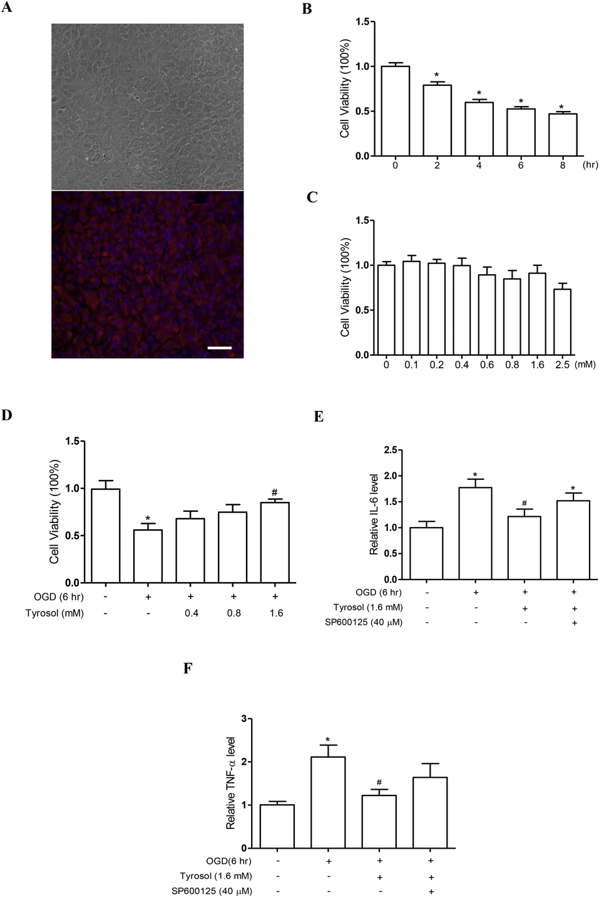
Figure 19 Tyrosol safeguarded astrocytes from OGD-induced reductions in cell viability and mitigated the inflammatory response in cultured astrocytes subjected to OGD (6 hours) through JNK signaling. Reprinted from [204] (A) Representative phase-contrast and GFAP-labeled images of astrocytes in a 4-week-old culture. (B) Time-dependent effects of OGD on astrocyte viability in culture. (C) Dose-dependent impact of tyrosol on astrocyte viability under normal conditions (without OGD). (D) Treatment with tyrosol (1.6 mM) significantly enhanced the viability of astrocytes exposed to OGD. Scale bar: 40 μM. (E) Tyrosol reduced IL-6 levels in the culture media of astrocytes subjected to OGD via JNK signaling. (F) Tyrosol also lowered TNF-α levels in the culture media of astrocytes exposed to OGD through JNK modulation.

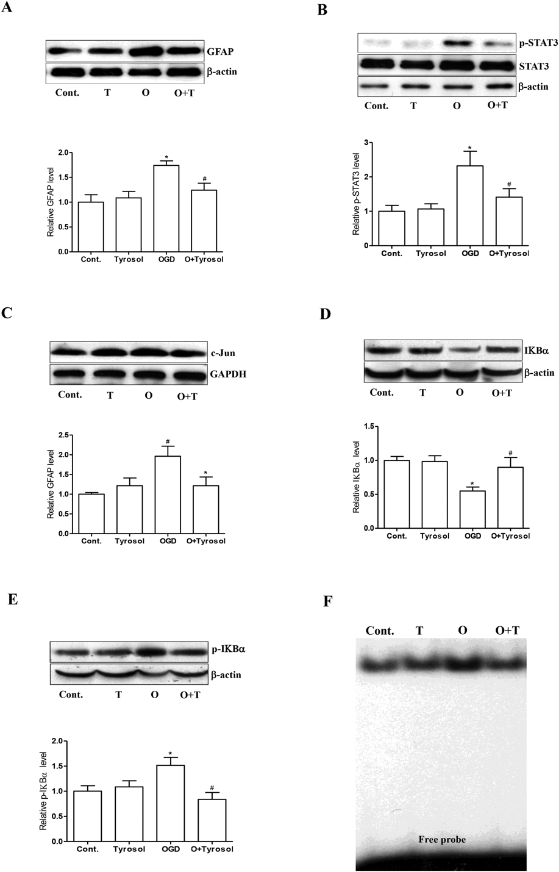
Figure 20. Tyrosol reduced STAT3 phosphorylation, suppressed astrocyte activation, and inhibited NF-κB activity in astrocytes subjected to OGD. Reprinted from [204] (A) Tyrosol lowered GFAP expression in cultured astrocytes exposed to OGD. (B) It also decreased phosphorylated STAT3 levels in these astrocytes. (C) A reduction in total c-Jun expression was observed following tyrosol treatment. (D) Representative images and statistical analysis demonstrated that tyrosol increased total IκBα levels in astrocytes. (E) Additionally, tyrosol reduced phosphorylated IκBα levels, as shown in representative images and statistical results. (F) EMSA analysis indicated that OGD elevated NF-κB activity, which was effectively suppressed by tyrosol treatment.

6.2. In Vitro Evaluation of Oleocanthal
Oleocanthal, a polyphenolic compound and a key component of extra virgin olive oil, exhibits notable anti-inflammatory properties. It has been shown to inhibit lipopolysaccharide-induced nitric oxide production and the expression of inducible nitric oxide synthase (iNOS), while also suppressing the expression of macrophage inflammatory protein-1α. Additionally, oleocanthal reduces the production of IL-6 in both J774 macrophages and ATDC5 chondrocytes, as well as the production of IL-1β, TNF-α, GM-CSF, and nitric oxide (NO) in J774 macrophages. These cytokines are critically involved in the inflammatory processes and cartilage degradation associated with RA. The findings suggest that oleocanthal possesses significant anti-inflammatory effects and holds significance importance as a potential therapeutic agent for the treatment of RA [205] (figure 21 and figure 22)
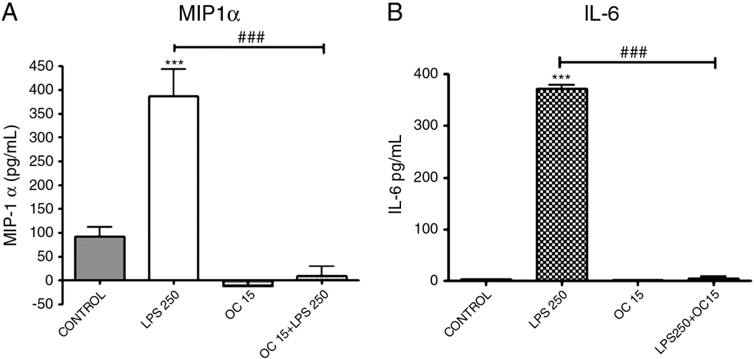
Figure 21. Modulatory Effects of Oleocanthal on MIP-1α and IL-6 Protein Secretion in ATDC5 Chondrocytes Under Lipopolysaccharide (LPS)-Induced Inflammatory Stimulation. ATDC5 cells (2.5 × 10⁶ cells/well) were pretreated with 15 μM oleocanthal for 12 hours prior to stimulation with 250 ng/ml LPS for 24 hours. Post-stimulation, cell culture supernatants were collected, and secreted MIP-1α levels were quantified via enzyme-linked immunosorbent assay (ELISA) to evaluate the anti-inflammatory activity of oleocanthal

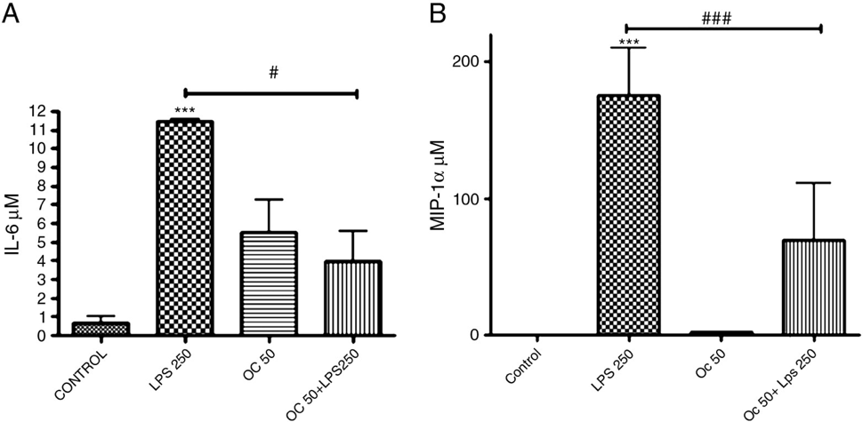
Figure 22. Modulatory Effects of Oleocanthal on IL-6 and MIP-1α Protein Secretion in J774 Macrophages Under Lipopolysaccharide (LPS)-Induced Inflammatory Conditions. J774 murine macrophage cells (1 × 10⁶ cells/well) were pretreated with 50 μM oleocanthal for 12 hours prior to inflammatory challenge with 250 ng/ml LPS for 24 hours. Post-stimulation, cell culture supernatants were collected, and secreted IL-6 levels were quantified via enzyme-linked immunosorbent assay (ELISA) to evaluate the anti-inflammatory efficacy of oleocanthal [205]
6.3. In Vitro Evaluation of Oleuropein
Oleuropein, the predominant phenolic compound in olive oil, is known for its antioxidant and anti-inflammatory properties. Its effects were studied on the IL-1β-induced human synovial sarcoma cell line (SW982), revealing a significant reduction in the expression of inflammatory cytokines and enzymes, including IL-6, TNF-α, MMP-1, MMP-3, mPGES-1, and COX-2. These findings demonstrate that oleuropein effectively mitigates inflammatory responses, highlighting its potential for use in the management and prevention of RA [206]. (figure 23, 24, 25, and 26)

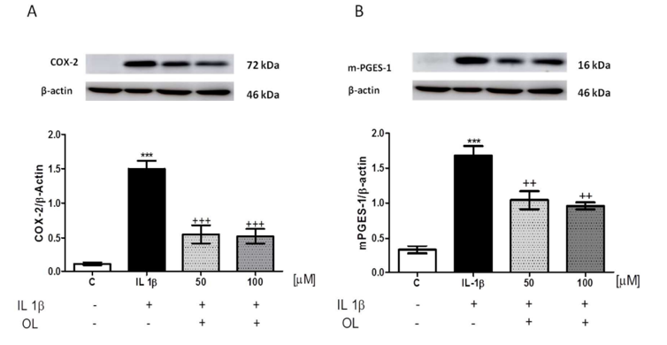

Figure 23. Cells were either left untreated or treated with OL (50 and 100 μM) for 24 hours in the presence of IL-1β (5 ng/mL). Control cells were cultured without IL-1β. The plots illustrate band intensity, with β-actin used as a loading control for normalization. [206]

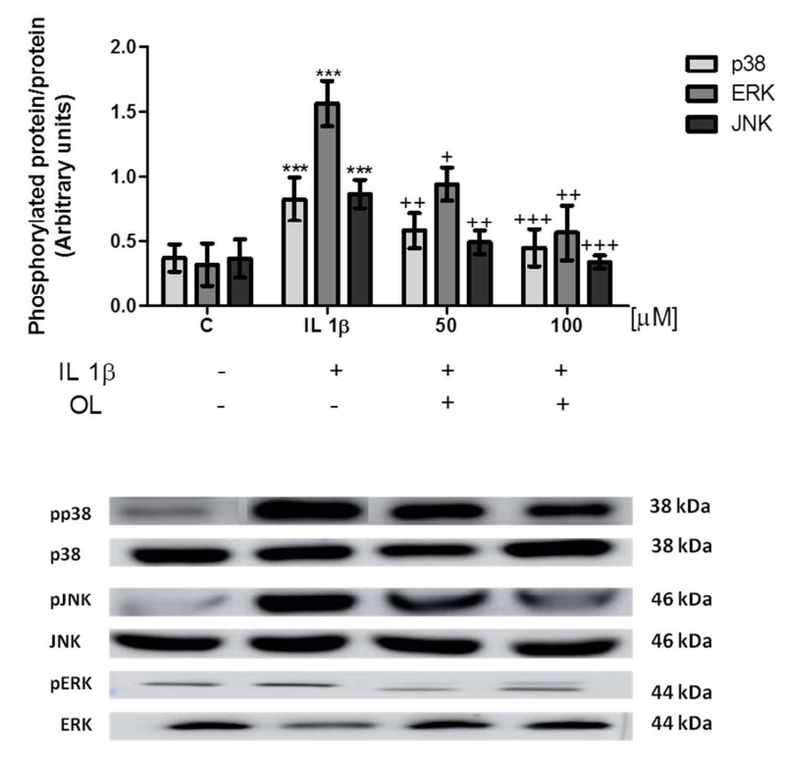

Figure 24. Cells were either untreated or treated with OL (50 and 100 μM) for 24 hours in the presence of IL-1β (5 ng/mL) for 30 minutes. Control cells were cultured without IL-1β. Densitometric analysis was performed, with normalization to the control housekeeping genes (JNK, p38, and ERK (1/2)) [206].
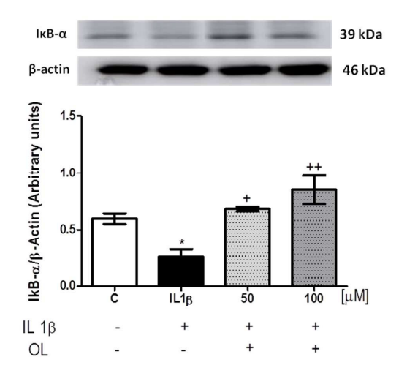

Figure 25. Cells were either left untreated or exposed to OL (50 and 100 μM) for 24 hours, followed by stimulation with IL-1β (5 ng/mL) for 30 minutes. Control cells were maintained without IL-1β. Densitometric analysis was conducted after normalization to the control[206].

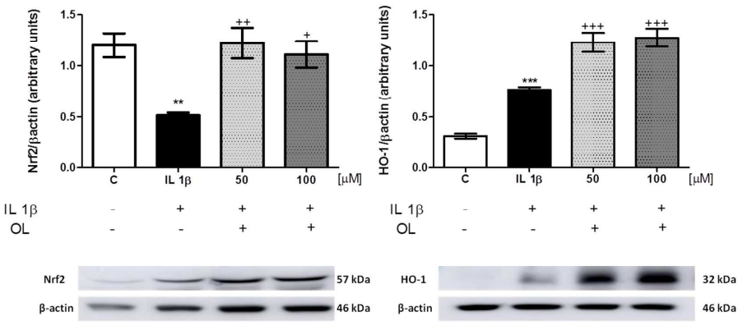

Figure 26. Cells were either untreated or treated with OL (50 and 100 μM) for 24 hours, then stimulated with IL-1β (5 ng/mL) for 30 minutes. Control cells were cultured without IL-1β. Densitometric analysis was performed after normalization to the control [206].

6.4. In Vitro Evaluation of Curcumin
The synthesis of RANKL and its associated receptor, RANK, plays a pivotal role in osteoclastogenesis. When RANK binds to RANKL, it triggers the differentiation of osteoclasts. Inflammatory cytokines can upregulate RANK expression, promoting the development of osteoclast precursors and increasing their sensitivity to RANKL, which may contribute to bone erosion in RA. Curcumin has been shown to inhibit the osteoclastogenic potential of peripheral blood mononuclear cells (PBMCs) from RA patients by suppressing the MAPK/RANK/c-Fos/NFATc1 signaling pathways.
Additionally, elevated IL-6 expression in RA synovial fibroblasts results from histone modification, specifically increased acetylation of histone H3 in the IL-6 promoter region. Curcumin inhibits histone acetyltransferase, which reduces histone H3 acetylation and consequently lowers IL-6 expression. Curcumin also diminishes cell proliferation and IFN-γ production in TEM cells. A 2014 study demonstrated that curcumin enhances the expression of miR-181b, while decreasing the levels of pro-inflammatory chemokines CXCL1 and CXCL2, further supporting its anti-inflammatory potential (figure 27).

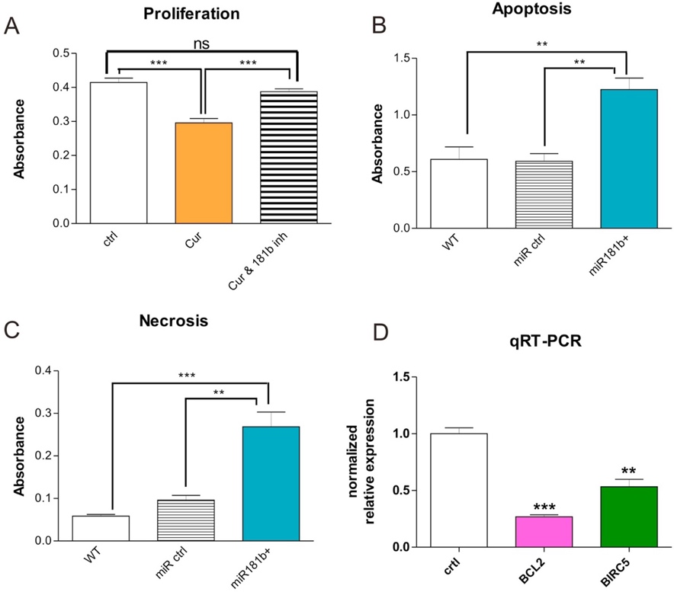
Figure 27. Role of miR-181b in Tumor Cell Proliferation, Apoptosis, and Invasion
(A) Curcumin suppresses proliferation via miR-181b. Treatment of MDA-MB-231 breast cancer cells with curcumin (Cur) for 24 hours reduces cell proliferation. However, co-treatment with a miR-181b hairpin inhibitor (Cur & 181b inh) negates curcumin’s anti-proliferative effect, restoring proliferation to control levels (P < 0.001; Student’s t-test). "ns" denotes non-significance. (B, C) miR-181b overexpression enhances apoptosis and necrosis. Functional assays show that miR-181b overexpression significantly increases apoptosis (left panel) and necrosis (middle panel). At 24 hours post-transfection with miR-181b oligos, apoptosis rates double compared to wild-type and control oligo-transfected MDA-MB-231 cells. Similarly, necrosis rates increase approximately fivefold compared to wild-type and over 2.5-fold relative to control oligo-expressing cells (P < 0.01;* P < 0.001; ANOVA with Bonferroni’s post-test). Data represent mean ± SD from three independent experiments. (D) Downregulation of apoptosis-related factors. Quantitative RT-PCR analysis at 72 hours post-transfection reveals a significant decrease in BCL2 and survivin/BIRC5 expression in miR-181b-overexpressing MDA-MB-231 cells compared to controls.
[207].

6.5. In Vitro Test with Stilbenes

RSV increases the expression of heme oxygenase-1 (HO-1) and nuclear factor erythroid 2-related factor 2 in H₂O₂ treated (RA-FLS) RA fibroblast-like synoviocyte cells. Furthermore, it also downregulates the expression of kelch-like ECH-related protein 1 (keap1), ROS, and MDA. It also blocks the expression of nuclear factor-κB (NF-κB) p65 and enhances the expression of Bcl-2/Bax, which leads to inhibition of cell proliferation and apoptosis [208] (figure 28, 29, 30, and 31).

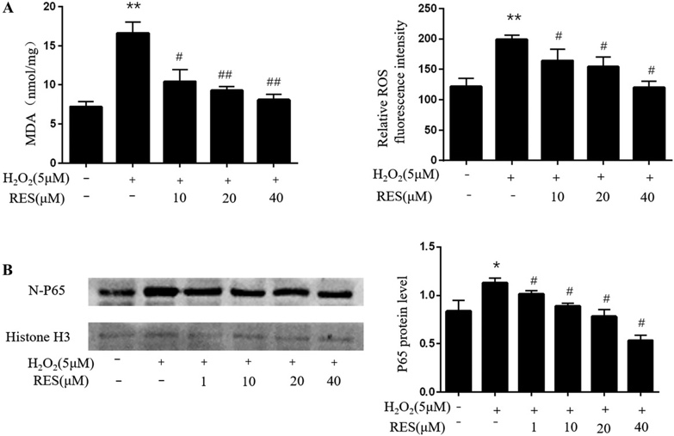

Figure 28. (A) The effects of different RSV concentrations on malondialdehyde (MDA) levels and intracellular reactive oxygen species (ROS) in RA-FLS supernatants following treatment with 5 µM H₂O₂. (B) RA-FLSs were treated with varying concentrations of Res (0, 1, 10, 20, and 40 µM) for 24 hours, and nuclear p65 levels were assessed via western blot analysis to evaluate NF-κB signaling activity [208].
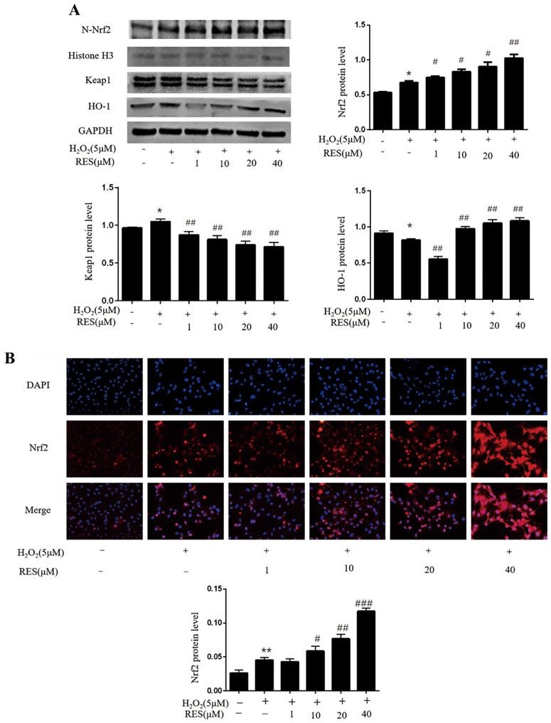

Figure 29. (A) Western blot analysis of Nrf2, histone H3, Keap1, HO-1, and GAPDH in RA-FLSs treated with 5 µM H₂O₂. Protein expression levels were quantified relative to histone H3 and GAPDH across three independent experiments. (B) Immunofluorescence analysis showing Nrf2 localization in RA-FLSs (40× magnification). Red fluorescence represents Nrf2, while blue fluorescence indicates DAPI-stained nuclei [208].

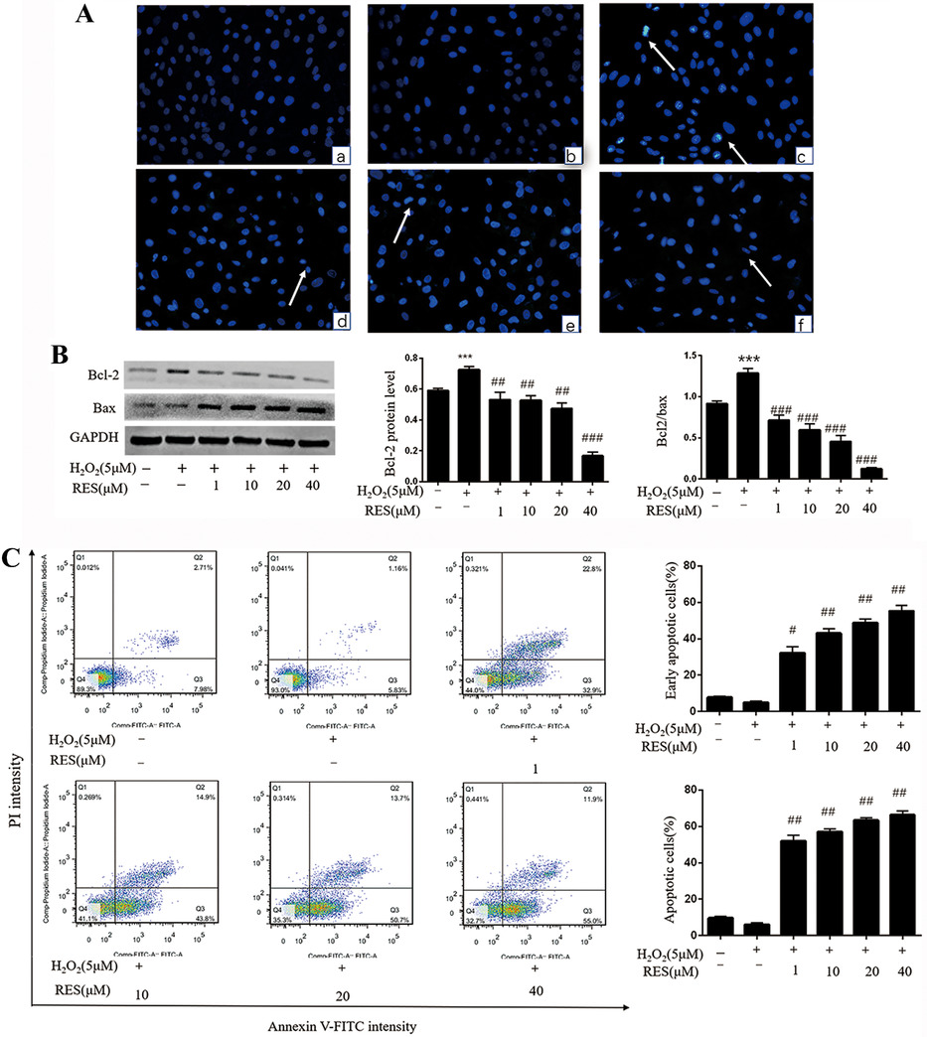

Figure 30. (A) Morphological changes indicative of apoptosis were assessed using Hoechst 33342 staining (40× magnification). (B) Western blot analysis of Bcl-2, Bax, and GAPDH in RA-FLSs. Protein expression levels were quantified relative to GAPDH across three independent experiments. (C) Apoptosis was analyzed using flow cytometry with Annexin V-FITC/PI double staining. The left upper quadrant indicates necrotic cells, the lower left quadrant represents normal cells, the upper right quadrant shows advanced apoptotic cells, and the lower right quadrant shows early apoptotic cells. Quantitative analysis of apoptotic cells is provided [208].
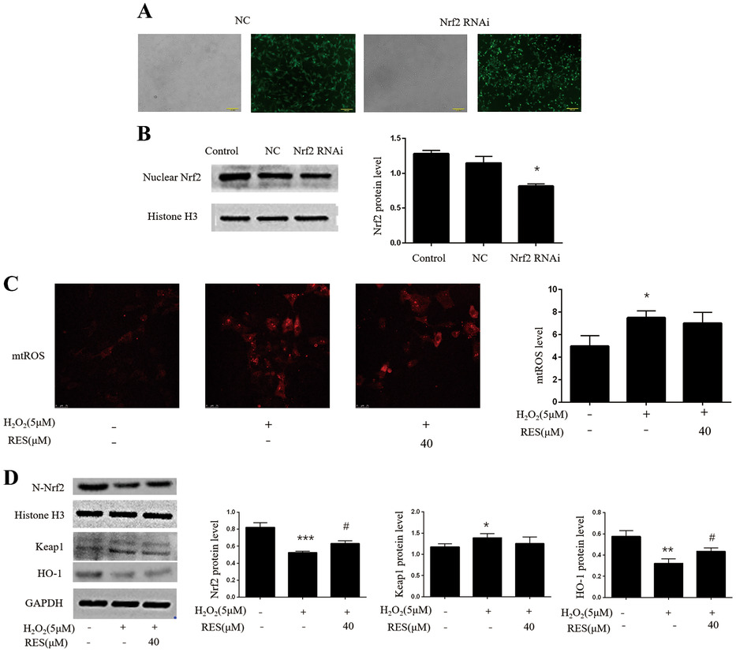

Figure 31. (A) RA-FLSs were infected with lentivirus at an MOI of 50, and GFP expression was observed using fluorescence microscopy (10× magnification) 72 hours post-infection.(B) Western blot analysis showing the inhibition of Nrf2 expression in the Nrf2 RNAi-treated group.
(C) Laser confocal microscopy was used to assess mitochondrial reactive oxygen species (mtROS) levels. The histogram quantifies mitochondrial superoxide levels, expressed as a percentage change relative to the negative control group. (D) Western blot analysis of Nrf2, histone H3, Keap1, HO-1, and GAPDH in each group, with corresponding quantitative analysis. Protein expression levels were measured relative to histone H3 and GAPDH across three independent experiments [208].

RSV also induces cell apoptosis in the MH7A cell line by activation of caspase-9 and caspase-3 and disruption of mitochondria. Disruption of mitochondria causes the downregulation of the expression of Bcl-XL and the release of cytochrome c into the cytosol from mitochondria [209] (figure).

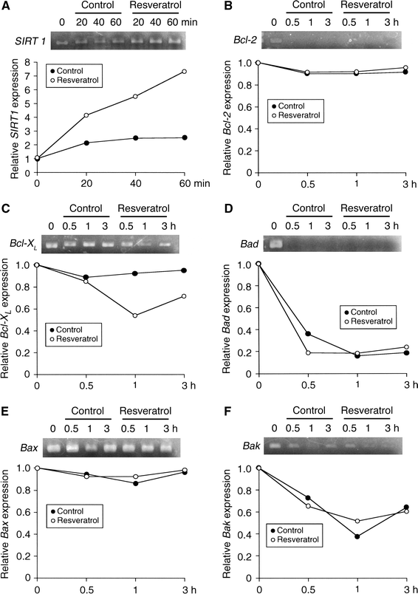

Figure 35. MH7A cells were either untreated (Control) or treated with resveratrol (100 μM) for 20–60 minutes or 0.5–3 hours in serum-free culture medium. RT-PCR was performed to analyze mRNA expression levels. In the graph, each point represents the ratio relative to the intensity at 0 min/h, which is set as 1.Similar results were obtained in three independent experiments [209].

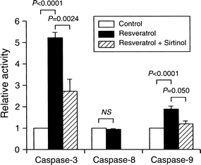

Figure 36. MH7A cells were treated with resveratrol (100 μM) for 3–6 hours in serum-free culture medium. After treatment, cells were fractionated into mitochondrial (M) and cytosolic (C) components, and Western blot analysis was performed. In the graph, each point represents the ratio relative to the immunoreactive intensity at 0 hours for the mitochondrial component, which is set as 1. Cyto c refers to cytochrome c.
Similar results were obtained in three independent experiments[209].

6.6. In Vitro Evaluation of Kaemperitrin
Kaempferitrin has been demonstrated to reduce the levels of IL-6, IL-1β, MMP-1, MMP-3, and TNF-α in MH7A cell lines. Furthermore, kaempferitrin inhibits the activation of Akt and NF-κB, pathways that are involved in inflammation and immune response [210].
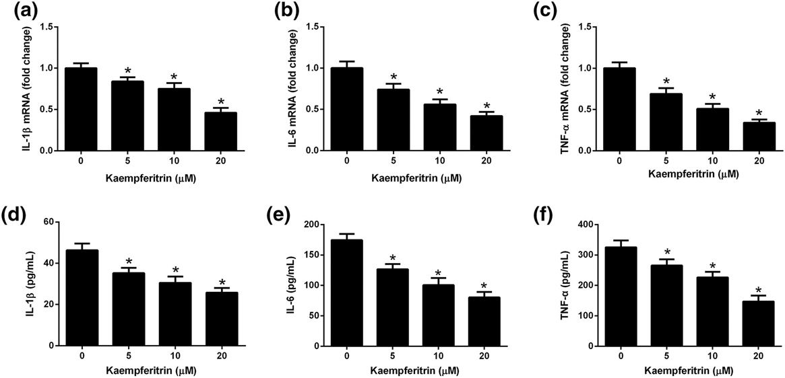
Figure 37. MH7A cells and their supernatants were collected after incubation with different concentrations of kaempferitrin (0, 5, 10, and 20 μM) for 48 hours to assess the expression and secretion of IL-1β, IL-6, and TNF-α. (a-c) qRT-PCR analysis was conducted to measure the mRNA levels of IL-1β, IL-6, and TNF-α. (d-f) Enzyme-linked immunosorbent assay (ELISA) was used to evaluate the secretion of IL-1β, IL-6, and TNF-α.

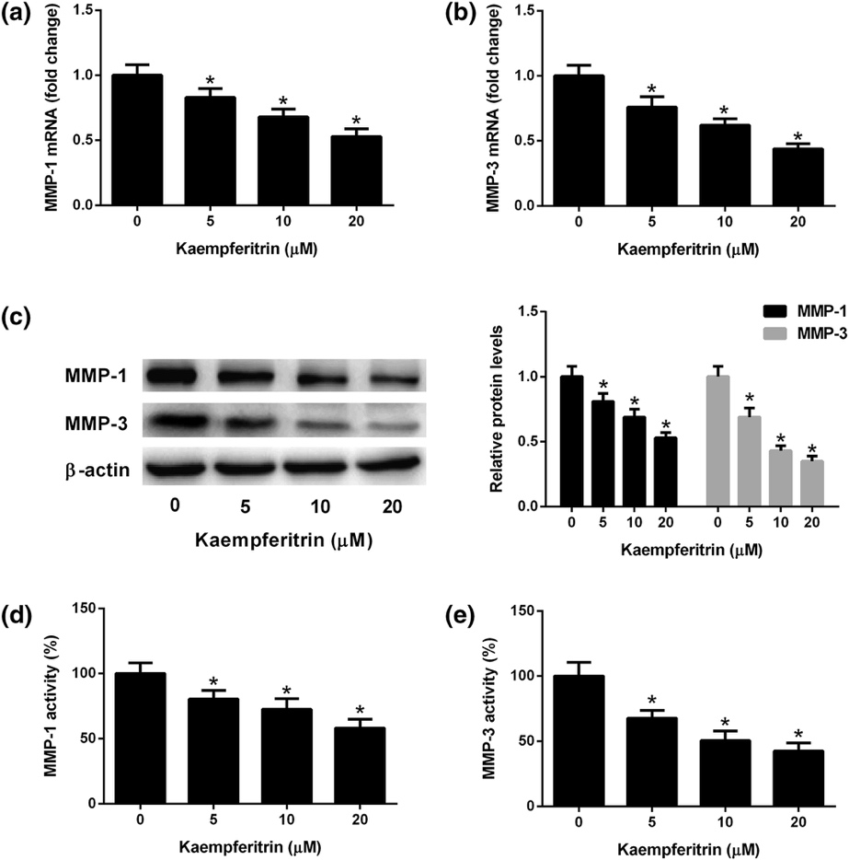
Figure 38. MH7A cells and their supernatants were collected after incubation with various concentrations of kaempferitrin (0, 5, 10, and 20 μM) for 48 hours to assess the expression of MMP-1 and MMP-3. (a, b) Quantitative real-time polymerase chain reaction (qRT-PCR) analysis was performed to measure the mRNA levels of MMP-1 and MMP-3. (c) Western blotting was used to evaluate the protein levels of MMP-1 and MMP-3. (d, e) Enzyme-linked immunosorbent assay (ELISA) was conducted to determine the activities of MMP-1 and MMP-3.

Kaemperitin also inhibits the activation of NF-jB and MAPK, and decrease the expression level of MMP-1, MMP-3, CoX-2, and PGE in IL-1β-stimulated RASFs [211].
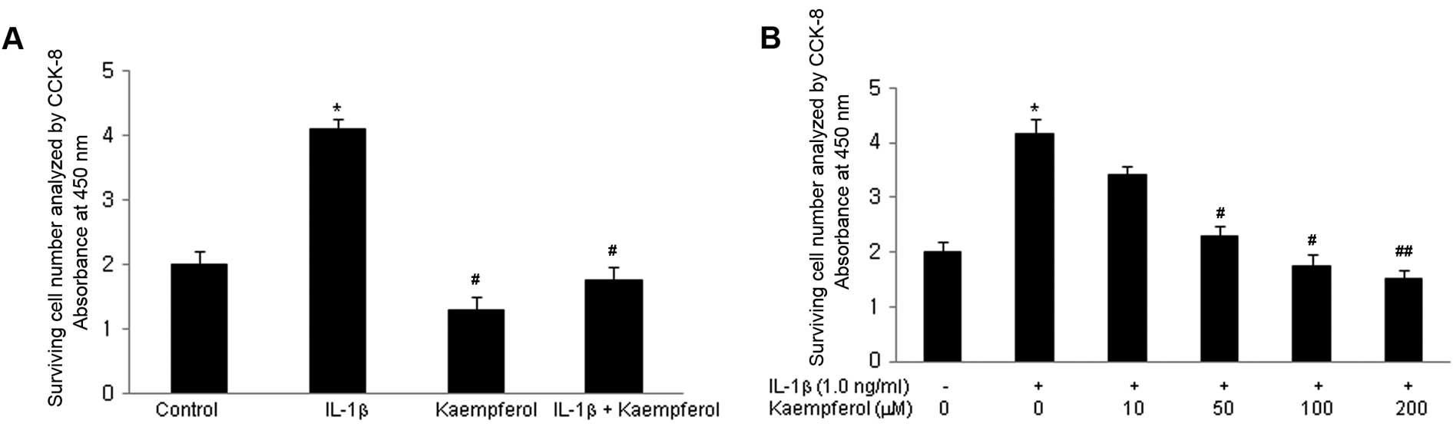
Figure 39. (A) To evaluate the effects of kaempferol on IL-1β-induced RASF proliferation, kaempferol (100 μM) was added to RASF cultures with or without IL-1β (1.0 ng/ml) for 3 days, and a CCK-8 assay was performed. Kaempferol significantly inhibited IL-1β-induced proliferation of RASFs after 2–3 days of culture (P<0.05). *P<0.05 vs. no IL-1β and kaempferol (control), #P<0.05 vs. IL-1β without kaempferol. (B) To determine the dose-dependent effects of kaempferol on IL-1β-induced RASF proliferation, varying doses of kaempferol (10, 50, 100, and 200 μM) were added to RASF cultures with IL-1β (1.0 ng/ml) for 2 days, and a CCK-8 assay was performed. Kaempferol inhibited IL-1β-induced proliferation of RASFs in a dose-dependent manner [211].
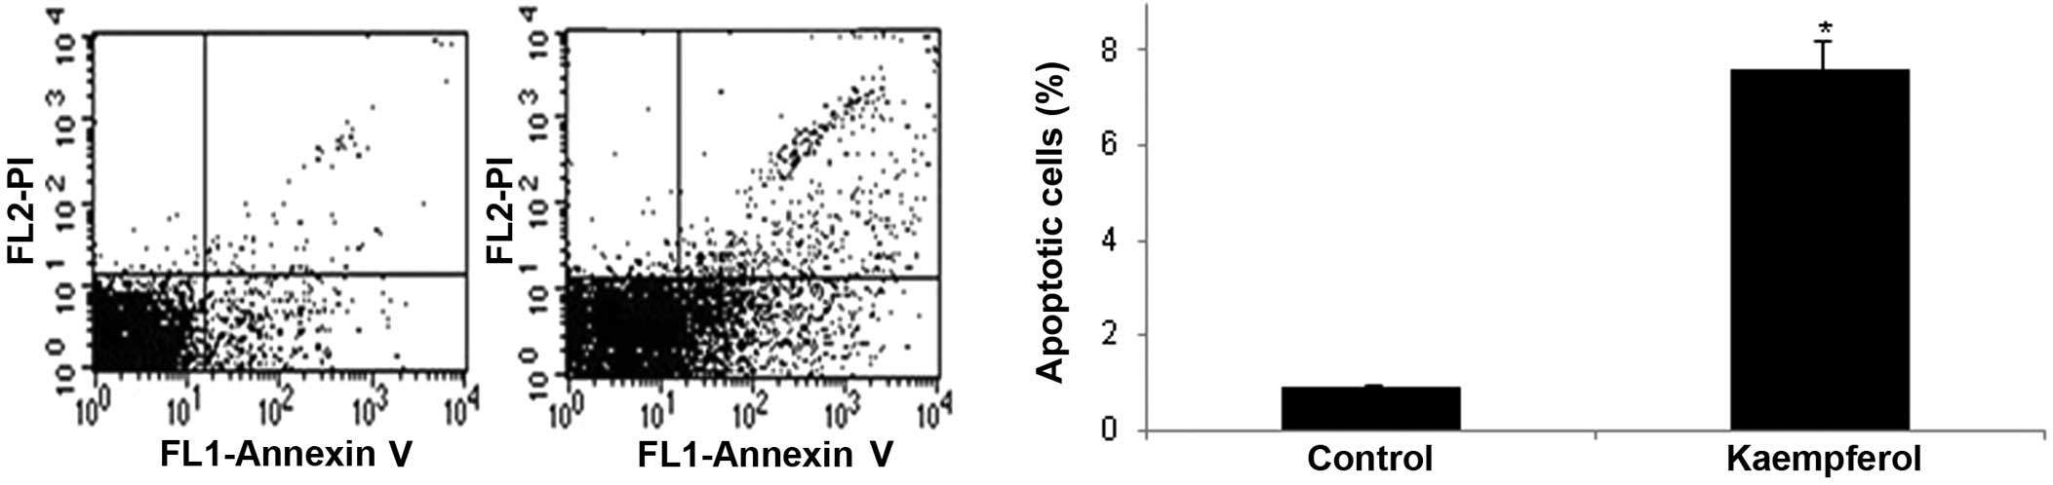

Figure 40. To investigate the cause of the decreased proliferation induced by kaempferol, its effects on RASF apoptosis were assessed by flow cytometry. RASFs (1×10⁵) were cultured in 33-mm dishes in DMEM with DMSO, with or without kaempferol (100 μM). After 24 hours of culture, the cells were stained with Annexin V and propidium iodide (PI) and analyzed by flow cytometry. Kaempferol significantly increased the apoptosis of RASFs compared to control cells cultured in DMSO without kaempferol [211].
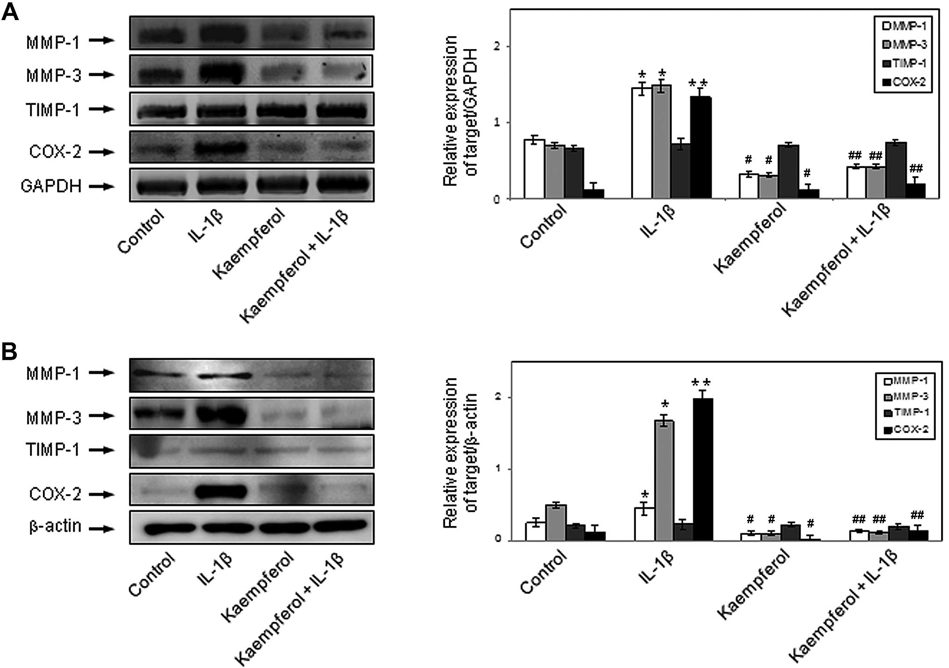

Figure 41. Kaempferol Inhibits Interleukin-1β (IL-1β)-Induced Production of Matrix Metalloproteinases (MMPs) and Cyclooxygenase (COX)-2 in Rheumatoid Arthritis Synovial Fibroblasts (RASFs). To assess the mRNA and protein expression of MMP-1, MMP-3, TIMP-1, COX-1, and COX-2, RASFs (1×10⁶ cells) were cultured for 2 days with or without IL-1β (1.0 ng/ml) and kaempferol (100 μM). RNA and protein were extracted from the RASFs and analyzed by: (A) RT-PCR and (B) Western blot analysis. IL-1β enhanced the protein expression of MMP-1, MMP-3, TIMP-1, and COX-2 compared to cells cultured without IL-1β. Kaempferol inhibited the IL-1β-induced protein expression of MMP-1, MMP-3, and COX-2 [211].
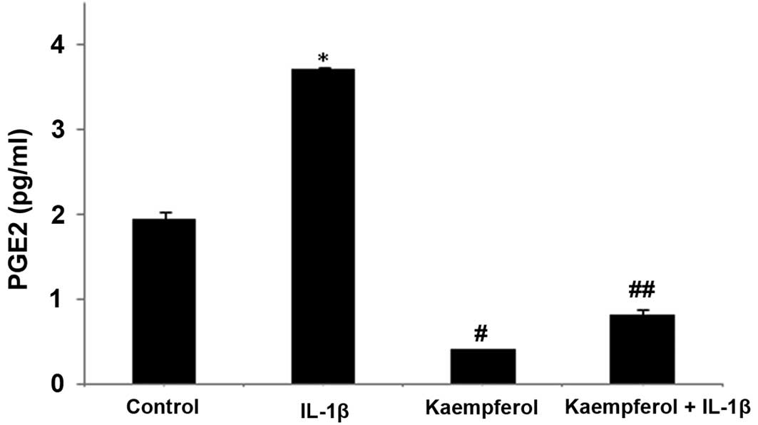
Figure 42. Kaempferol Inhibits Prostaglandin E2 (PGE2) Production in Rheumatoid Arthritis Synovial Fibroblasts (RASFs) RASFs (1×10⁴ cells) were cultured in 25 cm² tissue-culture flasks for 48 hours, with serum starvation overnight prior to stimulation. RASFs were treated for 2 days with or without interleukin (IL)-1β (1.0 ng/ml) and kaempferol (100 μM). The production of PGE2 by RASFs was evaluated using ELISA. IL-1β-induced PGE2 production was significantly inhibited by kaempferol [211].

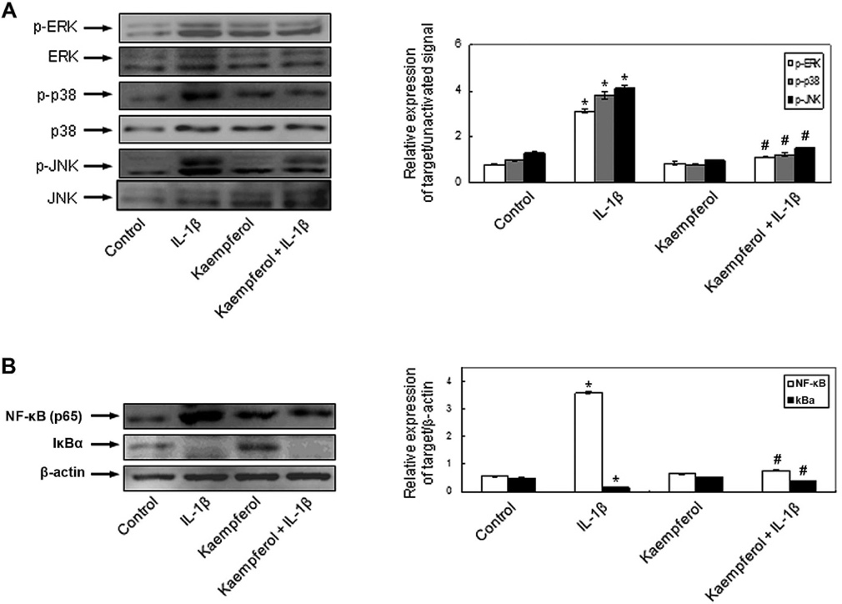
Figure 43. Effects of Kaempferol on IL-1β-Induced Activation of MAPK Signaling Pathways and NF-κB in Rheumatoid Arthritis Synovial Fibroblasts (RASFs). To investigate the mechanisms underlying the effects of kaempferol on IL-1β in RASFs, MAPK signaling pathways (ERK, p38, and JNK) as well as NF-κB and IκBα activation were evaluated by immunoblotting. RASFs were cultured for 10 minutes with or without IL-1β (1.0 ng/ml) and kaempferol (100 μM). (A) IL-1β induced the phosphorylation of ERK, p38, and JNK. Kaempferol inhibited the IL-1β-induced activation of p38 and JNK. (B) IL-1β activated nuclear NF-κB and decreased cytoplasmic IκBα. Kaempferol inhibited the IL-1β-induced activation of NF-κB [211].

6.7. In Vitro Evaluation of Gallic acid

Gallic acid suppresses the expression of various chemokines, proinflammatory cytokines, MMP-9, and COX-2, while promoting cell apoptosis through the regulation of Bcl-2, caspase-3, p53, and Bax [212].
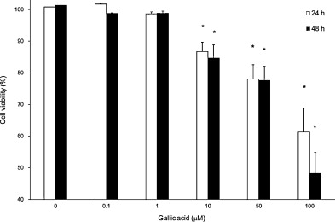
Figure 44. Effect of Gallic Acid on Cell Viability of Rheumatoid Arthritis (RA) Fibroblast-Like Synoviocytes (FLS) RA FLS were treated with varying concentrations of gallic acid (0.1-100 μM) or DMSO vehicle for 24 and 48 hours. Cell viability was assessed using the MTT assay. Results are presented as the mean ± SEM from 5 independent experiments [212].
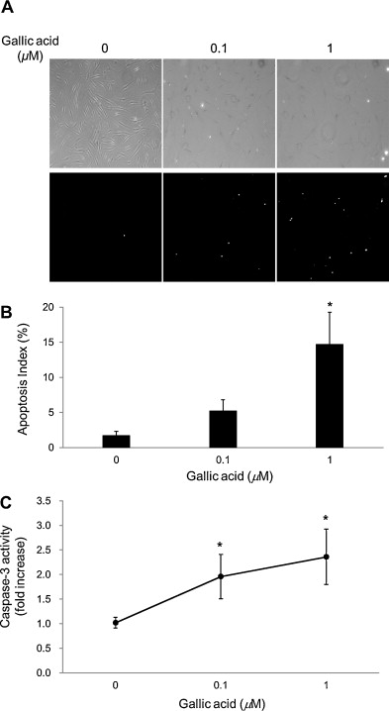
Figure 45. Effect of Gallic Acid on Cellular Apoptosis of Rheumatoid Arthritis (RA) Fibroblast-Like Synoviocytes (FLS). A. RA FLS were treated with gallic acid (0.1 and 1 μM) or DMSO vehicle for 48 hours. Apoptotic cell death was measured by the TUNEL assay (×100 magnification). Bright spots represent TUNEL-positive apoptotic cells. Corresponding phase contrast microscopy images are shown in the upper panels. B. The apoptosis index of RA FLS treated with 0.1 and 1 μM of gallic acid or DMSO vehicle. C. Caspase-3 activity in RA FLS treated with 0.1 and 1 μM of gallic acid or DMSO vehicle [212].
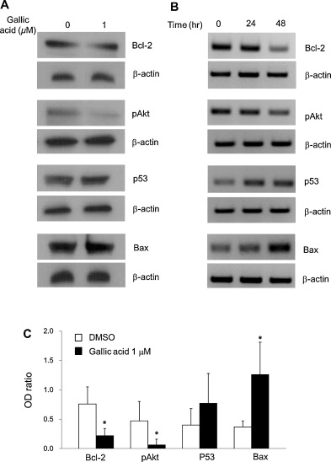

Figure 46. Effect of Gallic Acid on Pro-/Anti-Apoptotic Protein Production in RA Fibroblast-Like Synoviocytes (FLS) A. The production of Bcl-2, pAkt, p53, and Bax in RA FLS treated with gallic acid (0.1 and 1 μM) or DMSO vehicle for 48 hours was determined by Western blot analysis. B. Time-dependent changes in the production of Bcl-2, pAkt, p53, and Bax in RA FLS treated with 1 μM gallic acid for the indicated times. C. The optical density (OD) ratio of Bcl-2, Bax, or pAkt expression to β-actin [212].

6.8. In Vitro Evaluation of Quercetin

Quercetin inhibits the proliferation of both IL-1β-stimulated and unstimulated RASFs. It reduces the expression of PGE2, COX-2, and MMPs by blocking several signaling pathways, such as ERK1/2, p-38, JNK, NF-kB, and MAP kinases. These findings suggest that quercetin could be an effective option for the prevention and treatment of RA [213].
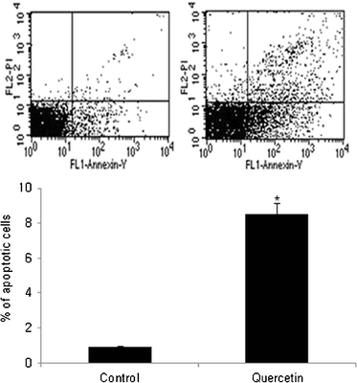

Figure 47. Quercetin Induces Apoptosis of Rheumatoid Arthritis Synovial Fibroblasts (RASFs)
To investigate the exact cause of the decreased proliferation induced by quercetin, the effect of quercetin on apoptosis in RASFs was assessed using flow cytometry. RASFs (1 × 10^5) were cultured in 33 mm dishes in DMEM media with DMSO, with or without quercetin (100 μM). After 24 hours of culture, the cells were stained with Annexin-V and PI and analyzed by flow cytometry. Quercetin treatment significantly increased apoptosis in RASFs compared to the DMSO control group, which had no quercetin [213].
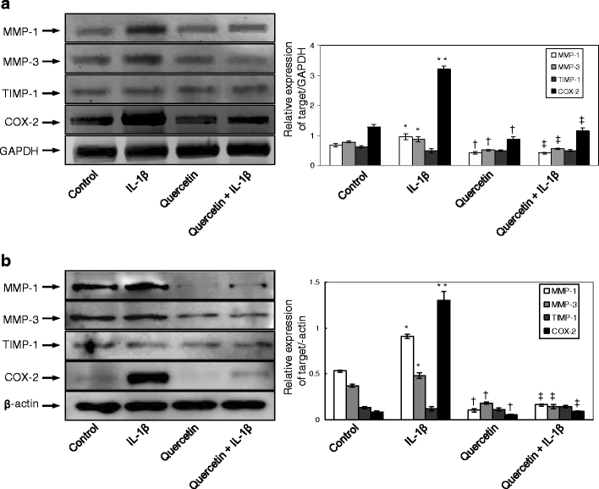
Figure 48. Quercetin Inhibits IL-1β-Induced Production of MMPs and COX-2 in Rheumatoid Arthritis Synovial Fibroblasts (RASFs). To assess the expression of MMP-1, MMP-3, TIMP-1, and COX-1 and COX-2 at both the mRNA and protein levels, RASFs (1 × 10^6 cells) were cultured for 2 days with or without IL-1β (1.0 ng/ml) and quercetin (100 μM). RNA and protein were extracted and analyzed using RT-PCR (a) and Western blotting (b). IL-1β treatment enhanced the expression of MMP-1, MMP-3, TIMP-1, and COX-2 proteins compared to the control group. However, quercetin inhibited the IL-1β-induced expression of MMP-1, MMP-3, and COX-2 proteins [213].
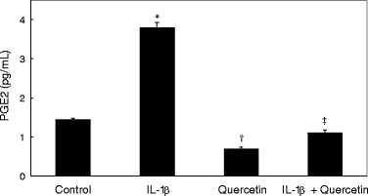
Figure 49. Quercetin Inhibits PGE2 Production in RASFs RASFs (1 × 10^4 cells) were cultured in 25 cm² tissue-culture flasks for 48 hours, with serum starvation overnight before stimulation. The cells were then cultured for 2 days with or without IL-1β (1.0 ng/ml) and quercetin (100 μM). The production of PGE2 was measured using an ELISA kit. IL-1β-induced PGE2 production was significantly inhibited by quercetin treatment [213].

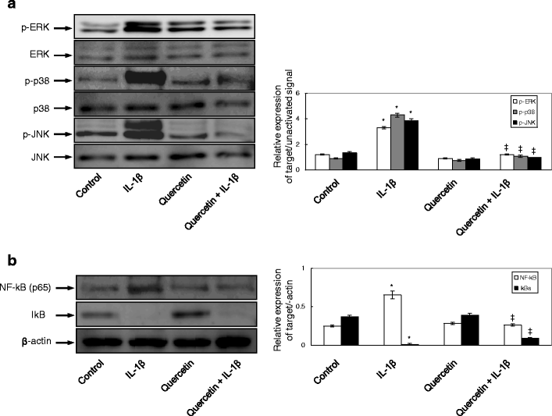
Figure 50. Effects of Quercetin on IL-1β-Induced MAPK Pathways and NF-κB Activation in RASFs
To investigate the mechanism behind quercetin's effects on IL-1β in RASFs, MAPK signaling pathways (ERK, p38, JNK) and NF-κB activation were assessed by immunoblotting. RASFs were treated with or without IL-1β (1.0 ng/ml) and quercetin (100 μM) for 10 minutes. IL-1β enhanced the phosphorylation of ERK, p38, and JNK, and quercetin inhibited the IL-1β-induced activation of p38 and JNK (panel a). Additionally, IL-1β activated nuclear NF-κB and decreased cytoplasmic IκBα, while quercetin inhibited the IL-1β-induced activation of NF-κB (panel b). Results are presented as mean ± SD (n = 3) [213].

Chapter 7
The result of nanoparticles for delivery of Resveratrol
RSV-loaded liposomes were prepared and their antiproliferative effects were thoroughly evaluated in vitro using U-87 MG cells. The results demonstrated that these nanoparticles exhibited remarkable anticancer activity, significantly surpassing the effects observed with free RSV. This suggests that the liposomal formulation enhanced the therapeutic potential of RSV, offering a more effective approach for targeting and inhibiting the growth of cancer cells compared to the unencapsulated compound [214].
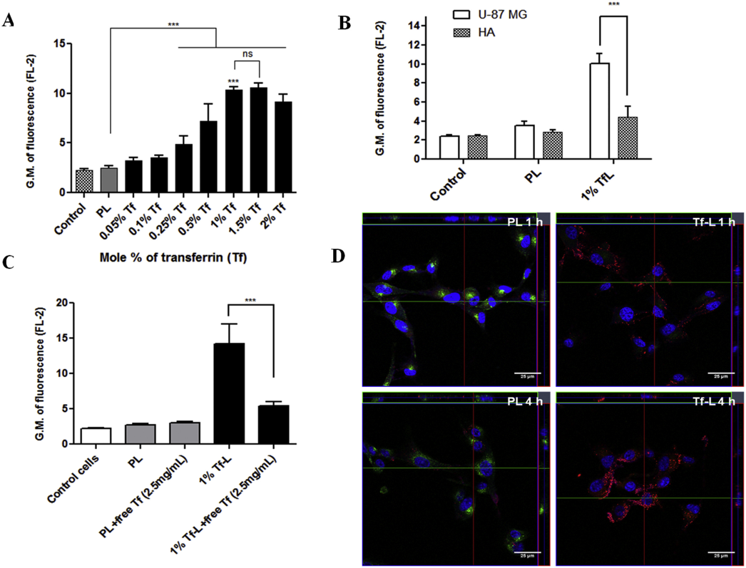
Figure 51. The study investigated the cellular association and uptake of transferrin-conjugated liposomes (Tf-L) in U-87 MG cells. Cells were treated with Rh-labeled Tf-L at varying Tf densities (0.05–2 mol%) for 4 hours, and competitive inhibition was tested by pre-treating cells with free transferrin. Both U-87 MG and HA cells were also treated with Rh-labeled plain liposomes (PL) and 1% Tf-L for 4 hours. Fluorescence intensity was measured, and confocal microscopy was used to visualize intracellular localization at 1 and 4 hours, with Hoechst 33,342 staining the nucleus and Tf-Alexa Fluor 680® marking endosomes. Orthogonal projections (XY, YZ, XZ planes) provided detailed spatial insights. The experiments aimed to understand Tf-L uptake mechanisms and competitive inhibition in these cells.
RSV-loaded liposomes demonstrated outstanding anticancer efficacy in xenografted A549/cDDP model. This research highlighted the enhanced therapeutic potential of the RSV-loaded liposomes in overcoming resistance to chemotherapy, suggesting their promising role in improving cancer treatment outcomes, particularly in resistant tumor models [215].
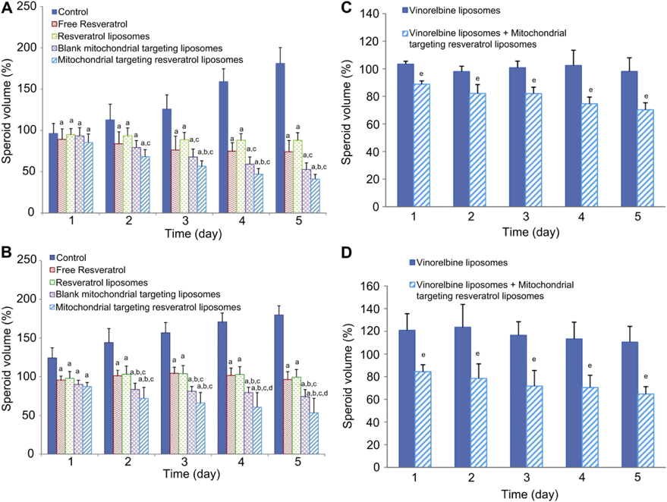
Figure 52. The inhibitory effects on (A, C) A549 and (B, D) A549/cDDP tumor spheroids after applying different formulations of resveratrol, vinorelbine liposomes or vinorelbine liposomes in combination with mitochondrial targeting resveratrol liposomes. Data are presented as mean ± standard deviation (n = 6). Notes: a, p < 0.05, vs blank control; b, p < 0.05, vs free resveratrol; c, p < 0.05, vs resveratrol liposomes; d, p < 0.05, vs blank mitochondrial targeting liposomes; e, p < 0.05, vs vinorelbine liposomes.
Liposomes that were co-loaded with paclitaxel and RSV. The study highlighted several important outcomes, including the enhanced tumor retention and improved bioavailability of the liposomes in mice bearing drug-resistant tumors. These advancements were especially notable in the context of overcoming the challenges posed by drug resistance. Additionally, the RSV-paclitaxel-loaded liposomes were shown to effectively induce cytotoxicity in MCF-7/ADR cells, a drug-resistant breast cancer cell line, underscoring their promising potential as a therapeutic strategy for combating drug-resistant cancers. This approach not only improved drug delivery but also contributed to enhanced anti-tumor activity in resistant cancer models [94].
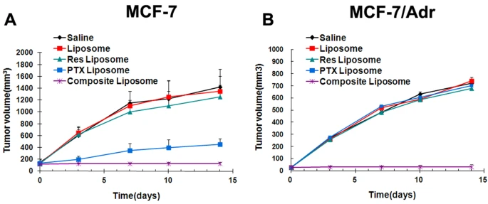
Figure 53. The in vivo antitumor effects were evaluated for the saline solution, blank liposome, Res liposome, PTX liposome, and the composite liposome containing both Res and PTX. Tumor growth was monitored for MCF-7 (A) and MCF-7/Adr (B) cell lines, with error bars representing the 95% confidence intervals. Tumor volumes were measured on days 0, 3, 8, 10, and 14 following the injection of tumor cells.
Cancer cells exhibit a higher expression of transferrin receptors (TfRs) compared to normal cells, leading to an elevated demand for iron. Transferrin (Tf), a serum glycoprotein, facilitates iron transport into cells by binding to TfRs. Due to the overexpression of TfRs in cancer cells, these receptors serve as an effective target for directed drug delivery. Studies have demonstrated that resveratrol-loaded liposomes targeted with transferrin (Tf-resveratrol-L) exhibit greater cytotoxicity, induce higher apoptosis rates in glioblastoma cells, and reduce the growth of in mice compared to non-targeted RSV-PEGylated liposomes.
A folate-conjugated RSV nanostructure was synthesized. This folate-targeted formulation demonstrated significantly enhanced cytotoxicity against MCF-7 breast cancer cells compared to its non-targeted counterpart. When administered intravenously in rats, the folate-targeted nanocarrier showed a ninefold increase in bioavailability relative to free RSV, highlighting its potential for improved therapeutic delivery [216].
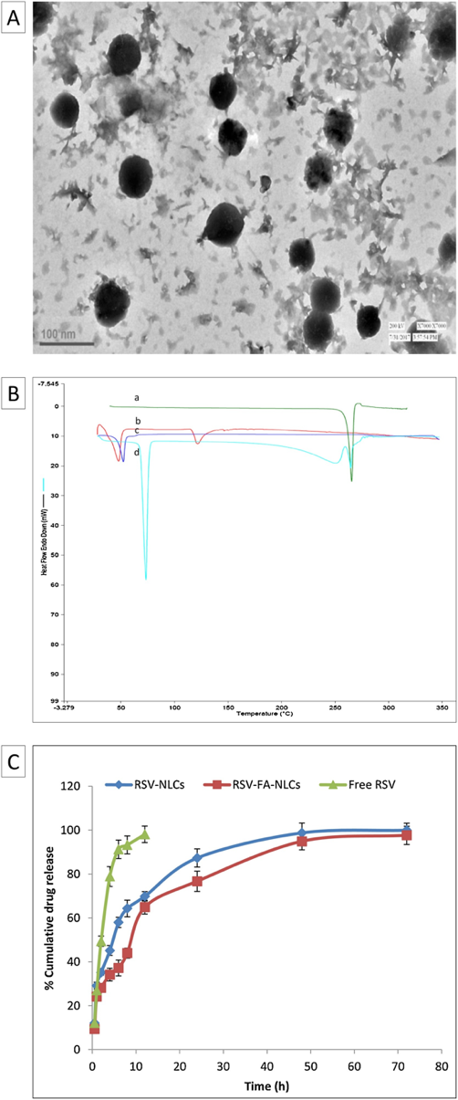

Figure 54. (A) A transmission electron microscopy (TEM) image of resveratrol-folic acid nanostructured lipid carriers (RSV-FA-NLCs); (B) Differential scanning calorimetry (DSC) thermograms comparing RSV (a), RSV-FA-NLCs (b), RSV-NLCs (c), and a mixture of RSV with stearic acid (d); (C) An in vitro drug release profile illustrating the release of RSV from various formulations.
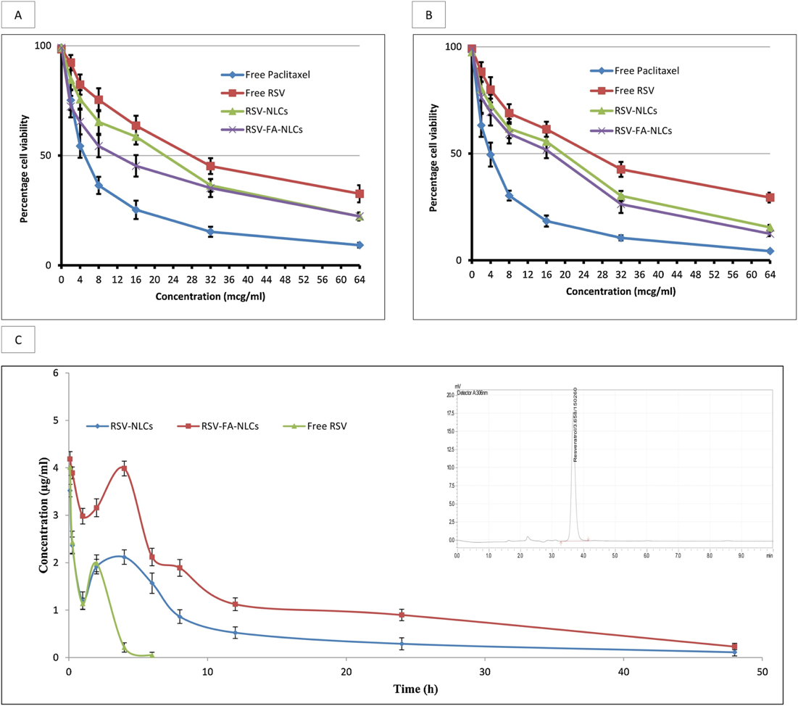

Figure 55. The in vitro cell viability of (A) MCF-7 and (B) A549 cells was assessed at varying drug concentrations following a 72-hour treatment period. (C) The plasma concentration-time profile of RSV in was evaluated after intravenous administration of free RSV, RSV-loaded nanostructured lipid carriers (RSV-NLCs), and folic acid-conjugated RSV-NLCs (RSV-FA-NLCs). The inset displays a representative high-performance liquid chromatography (HPLC) chromatogram of RSV detected in rat plasma.

The anticancer potential of resveratrol-loaded transferrin-modified polyethylene glycol-polylactic acid nanoparticles (Tf-PEG-PLA-RSV) in a rat model xenografted with C6 glioma tumors. The results demonstrated that the RSV-conjugated nanoparticles exhibited significantly enhanced anticancer effects compared to free RSV. These nanoparticles not only led to a noticeable reduction in tumor volume but also promoted a higher accumulation of the drug specifically within the tumor cells. This finding underscores the effectiveness of the nanoparticle formulation in improving the targeted delivery of resveratrol, thereby potentially overcoming limitations associated with conventional treatment methods and enhancing therapeutic outcomes in glioma. [217].
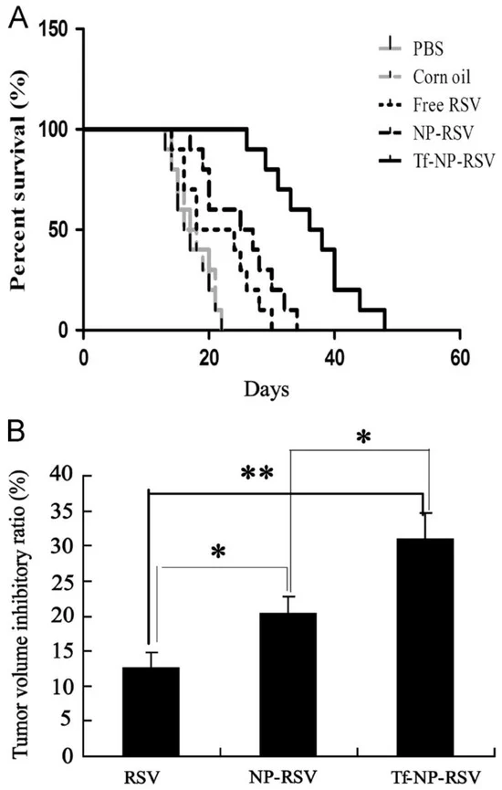
Figure 56. examines the effects of RSV conjugates on survival and tumor volume in C6 glioma-bearing rats. (A) The in vivo impact of RSV and RSV-polymer conjugates was observed after intraperitoneal injection at a dose of 15 mg RSV-equivalent/kg, focusing on their influence on the survival rates of rats with brain tumors. (B) The tumor volume inhibitory ratios in brain-glioma-bearing rats were assessed following treatment with either RSV solution or RSV-polymer conjugates, providing a comparison of their efficacy in reducing tumor growth.

PAMAM dendrimer nanoparticles were employed for the delivery of resveratrol (RSV) in both in vitro and in vivo environments. These dendrimers were functionalized with polyethylene glycol (PEG), RGDyC, and 4-Hydroxy-phenylboronic acid (PBA) to enhance their drug delivery capabilities. The in vitro cytotoxicity of two formulations—RGDyC-PEG-PAMAM-PBA-RSV (RPPPR) and PEG-PAMAM-PBA-RSV (PPPR)—was evaluated. The results showed a significant increase in cytotoxic effects when compared to free RSV, indicating improved therapeutic efficacy. Further in vivo studies confirmed that these functionalized dendrimer formulations effectively induced apoptosis in tumor cells and inhibited tumor growth. Importantly, these formulations did not show any signs of toxicity to major organs, suggesting a high level of biocompatibility and safety. This combination of enhanced cytotoxicity and minimal systemic toxicity underscores the potential of PAMAM dendrimer-based delivery systems for more effective and targeted cancer therapy [218].

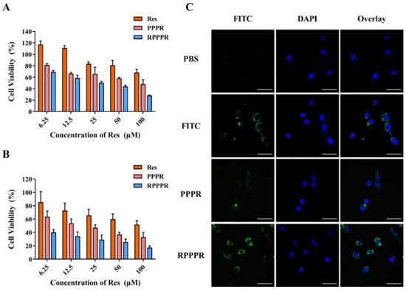
Figure 57. The effects of RSV, PPPR, and RPPPR were analyzed on L929 cells (A) and CT26 cells (B). (C) Confocal laser scanning microscopy (CLSM) was used to investigate the in vitro targeting and cellular uptake of the nano-prodrugs. CLSM images of CT26 cells were obtained after 24 hours of incubation with PBS, free FITC, FITC-labeled PPPR, and FITC-labeled RPPPR.
The anticancer effects of resveratrol-loaded gold nanoparticles (RSV-GNCs) were evaluated in breast cancer cells (MCF-7) that were stimulated by 12-O-tetradecanoylphorbol 13-acetate (TPA). TPA is known to enhance the invasion and migration abilities of breast cancer cells, making it an effective tool for studying cancer progression. The findings revealed that RSV-GNPs significantly reduced the TPA-induced migration and invasion of these cells, demonstrating their potential as effective anti-metastatic agents. Furthermore, RSV-GNPs were found to substantially inhibit the activation of key transcription factors such as NF-kB and AP-1 in the TPA-stimulated cells. These factors are critically involved in regulating genes associated with inflammation and cancer progression.
Tumor growth and metastasis are closely linked to the PI3K/Akt and MAPK signaling pathways, which regulate various molecules that promote invasion and metastasis, such as matrix metalloproteinases (MMPs) and cyclooxygenase-2 (COX-2). RSV-GNPs were shown to suppress both the PI3K/Akt and MAPK signaling pathways, which play pivotal roles in the development and progression of tumors. The inhibition of these pathways by RSV-GNPs highlights their potential to disrupt crucial molecular signaling involved in cancer metastasis. Given that the PI3K/Akt and ERK pathways are implicated in a variety of cancers, the study suggests that RSV-GNPs may provide a novel and promising therapeutic strategy for the treatment of metastatic breast cancer and potentially other malignancies [103].

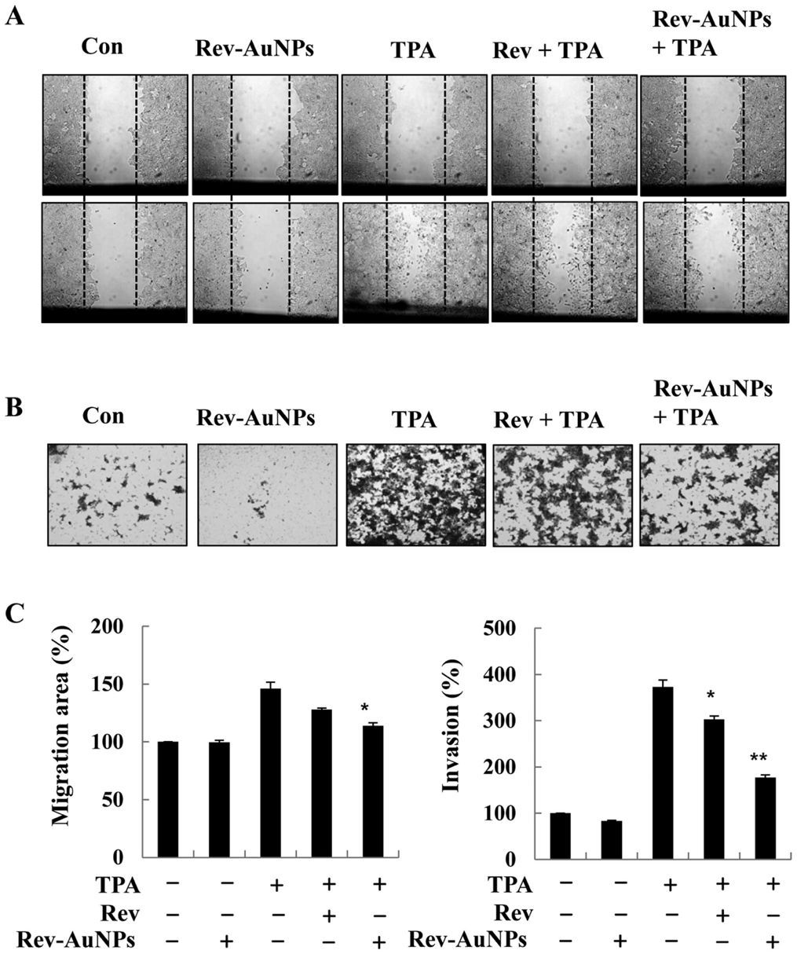
Figure 58. - Gold-conjugated resveratrol nanoparticles (Rev-AuNPs) were found to inhibit TPA-induced migration and invasion of human breast cancer cells. (A) MCF-7 cells were scratched with a pipette tip, pretreated with resveratrol (Rev) (10 µM) or Rev-AuNPs (10 µM), and then exposed to 12-O-tetradecanoylphorbol-13-acetate (TPA; 50 ng/ml) for 24 hours. Migrating cells were analyzed using phase contrast microscopy. (B) Cells were treated with Rev-AuNPs (10 µM), followed by TPA (50 ng/ml) treatment for 24 hours. Cells that invaded through the filter were stained with crystal violet and counted under a microscope. (C) The levels of cell migration and invasion were quantified and expressed relative to the basal invasion of untreated cells. Each bar represents the mean ± SE of 3 independent experiments for each group. *P<0.05, **P<0.01, indicating significant differences compared to cells treated with TPA alone.

RSV-conjugated gold nanoparticles by utilizing cross-linked polyvinylpyrrolidone (PVP), resulting in RSV-PVP-GNPs. They then assessed the anticancer activity of these nanoparticles in Raw264.7 murine macrophage cells. The study demonstrated that RSV-PVP-GNPs were more effective than free RSV in inducing S-phase cell cycle arrest and promoting apoptosis. Specifically, RSV-PVP-GNPs triggered a more pronounced apoptotic response through the intrinsic mitochondrial pathway, compared to free RSV. In preclinical trials, RSV-PVP-GNPs, when conjugated with the AS1411 aptamer, successfully reduced tumor volume without causing renal toxicity, highlighting the potential of these nanoparticles as an effective and safe therapeutic strategy for cancer treatment [219].
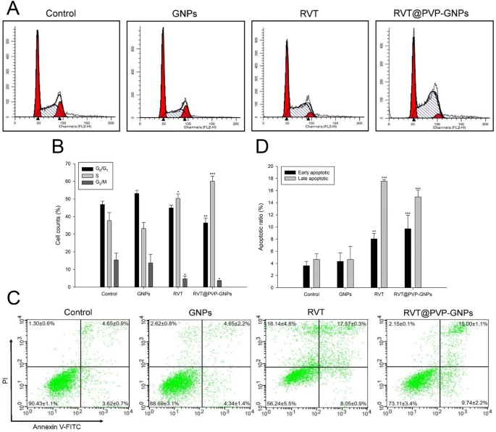
Figure 59. Induction of apoptosis in PANC-1 cells. (A, B) Alterations in PANC-1 cell cycle progression following drug treatment. After 72 hours of treatment, cells were fixed with ethanol and analyzed using flow cytometry. The distribution of cell populations across different phases is shown in (B). (C, D) Analysis of apoptotic cells post-drug treatment. Cells were stained with Annexin V/PI and assessed via flow cytometry. The proportion of cell populations is depicted in (D). Data are presented as mean ± SEM. *p < 0.05, **p < 0.01, and ***p < 0.001 indicate significant differences compared to the control group.
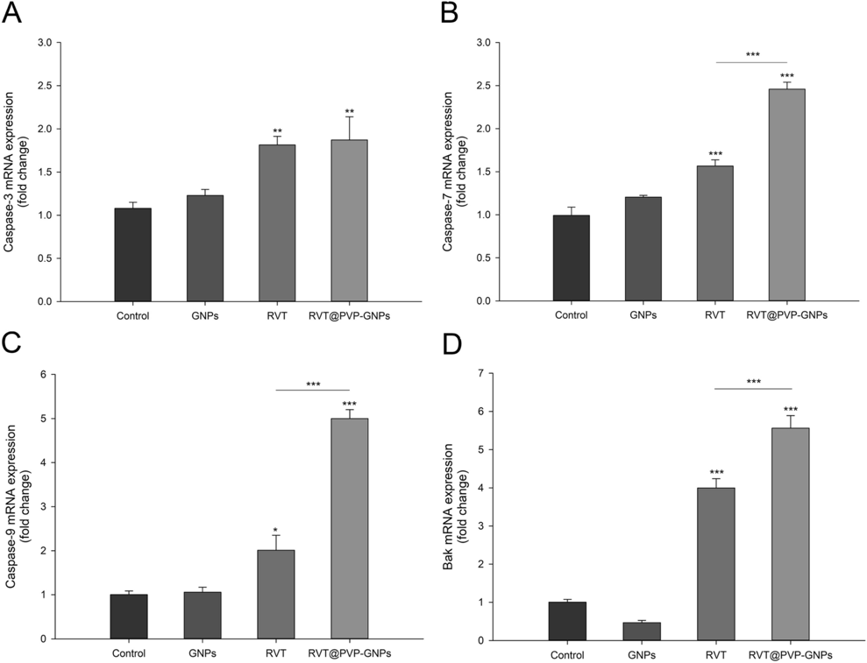
Figure 60. The mRNA expression levels following drug treatment were quantitatively analyzed. Panels A–D show the measurement of genes associated with the intrinsic apoptotic pathways using q PCR. The expression levels were normalized to the GAPDH housekeeping gene.
the anticancer potential of resveratrol-loaded zinc oxide nanoparticles (RSV-ZnONPs) in ovarian cancer PA1 cell lines and animal models. Their study found that RSV-ZnONPs were significantly more effective in inducing apoptosis in the PA1 cell line compared to free resveratrol. To better understand the underlying mechanism of this enhanced apoptotic effect, the researchers conducted Western blot analysis to assess the expression of key proteins involved in apoptosis, such as caspase-9, Bax, and Bcl-2, within the PA1 cells. Caspase-9 and Bax are integral to the activation of the intrinsic apoptotic pathway, which is triggered by cellular stress, while Bcl-2 is known for its anti-apoptotic function, helping to regulate the cell’s survival. The results indicated that RSV-ZnONPs induced apoptosis through the modulation of these critical proteins, leading to a higher apoptotic rate compared to free resveratrol. This suggests that RSV-ZnONPs act by disrupting the balance between pro-apoptotic and anti-apoptotic signals, thus promoting cell death in ovarian cancer cells.
These findings underscore the potential of RSV-ZnONPs as a powerful therapeutic tool in ovarian cancer treatment. By enhancing the anticancer effects of resveratrol, RSV-ZnONPs offer a promising strategy for overcoming the limitations of free resveratrol, such as its poor bioavailability. The study provides valuable insight into the mechanisms by which RSV-ZnONPs enhance cancer cell apoptosis, paving the way for further research into their clinical application. With their ability to specifically target cancer cells and modulate apoptotic pathways, RSV-ZnONPs hold significant promise as part of a broader strategy to improve cancer therapy and treatment outcomes [220].

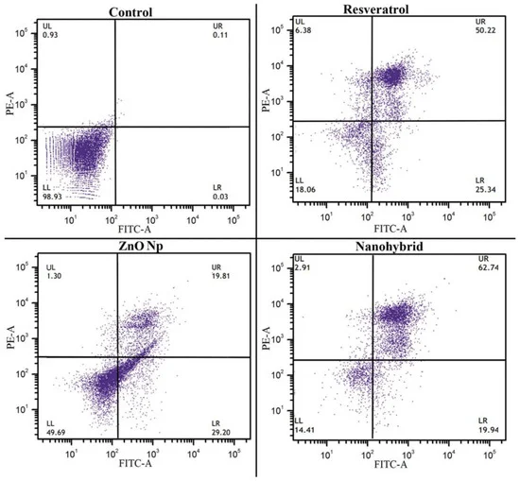
Figure 61. The apoptotic effects of RSV, ZnO, and RSV–ZnO on PA1 cells were evaluated. Representative dot plots from four independent experiments show the results of Annexin V-FITC/PI staining of the cells.
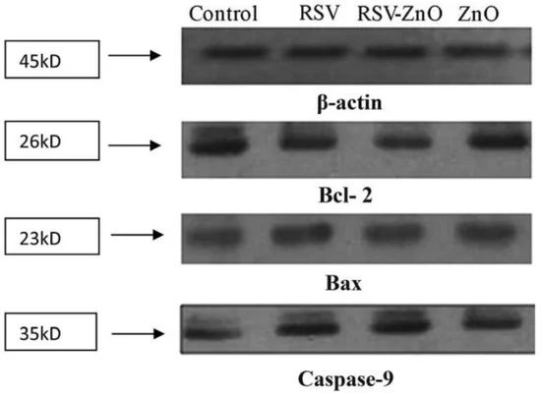
Figure 62. Western blot analysis was performed to evaluate the expression of Bax, Bcl-2, and caspase-9 proteins in PA1 cells treated with RSV, RSV–ZnO, and ZnO, along with their corresponding IC50 values.

anticancer efficacy of resveratrol-loaded mesoporous silica nanoparticles (MSN-RSV) using the cell line HGC-27 and mice models. Their research demonstrated that MSN-RSV significantly outperformed other treatment options in reducing gastric cancer growth. The results revealed that MSN-RSV was not only more effective in inhibiting the proliferation of gastric cancer cells, but it also substantially suppressed the ability of these cells to invade surrounding tissues and migrate to distant sites, which are key processes in cancer metastasis. The study highlights the potential of MSN-RSV as an innovative and highly efficient delivery system for resveratrol, offering improved therapeutic outcomes for gastric cancer. Furthermore, the enhanced anticancer activity observed in both the cell culture and animal models suggests that MSN-RSV could serve as a promising candidate for further clinical development in the treatment of gastric cancer. By leveraging the unique properties of mesoporous silica nanoparticles, such as their large surface area and ability to encapsulate therapeutic agents, MSN-RSV represents a novel approach to improving the bioavailability and targeted delivery of resveratrol, potentially leading to better control over tumor growth and metastasis [221].

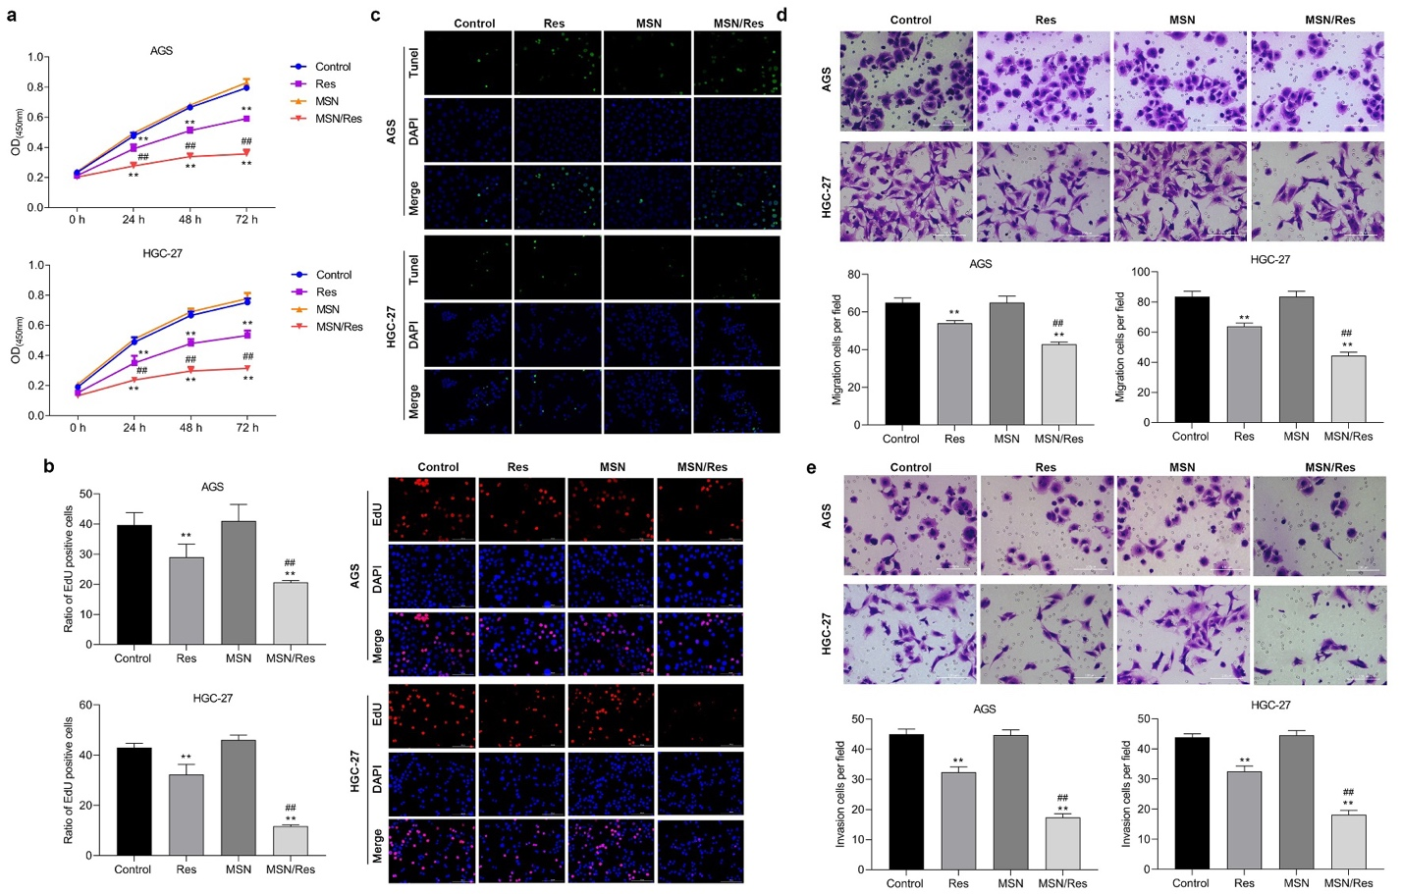

Figure 63. Both in vitro and in vivo assays were performed to evaluate cell proliferation and migration. (A) The EdU assay was used to assess the proliferation of HGC-27 and AGS cells following treatment withRes, MSN-SH, or Res-loaded MSN. (B) Apoptosis induced by these treatments was analyzed using thetunnel assay. (C) Cell migration and invasion were performed through trnaswell assay

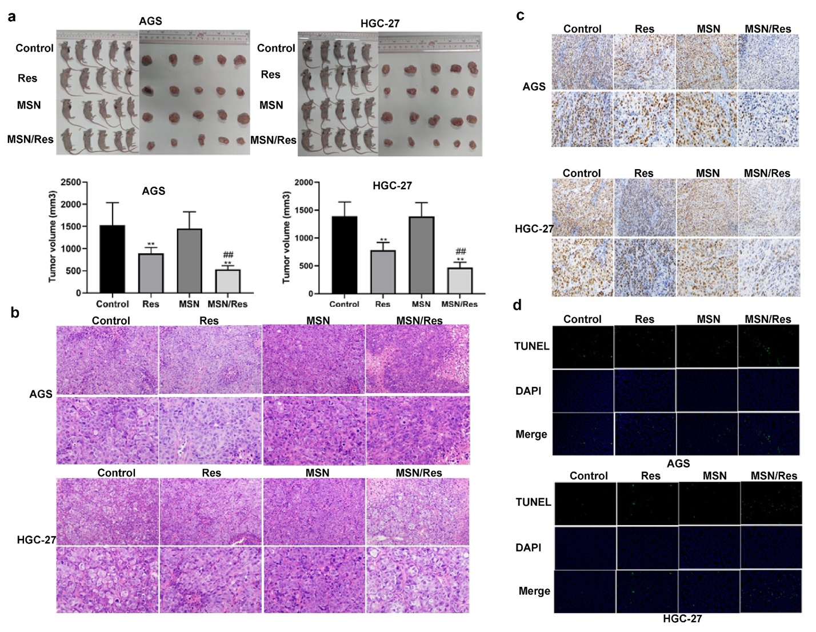
Figure 64. The figure presents the results of biopsy and histological analysis conducted on tumor-bearing mice treated with RSV, MSN-SH, or Res-loaded MSNs. Panel (a) illustrates tumor size measurements in HGC-27 and AGS tumor-bearing nude mice, which were treated with the respective compounds to evaluate their effects on tumor growth. Panel (b) shows H&E staining performed on tumor tissues to assess the extent of inflammatory cell infiltration, providing insight into the inflammatory response to the treatments. Panel (c) displays Ki67 immunohistochemical staining, used to evaluate cell proliferation in HGC-27 and AGS tumors, highlighting the impact of the treatments on tumor cell proliferation. Finally, panel (d) shows the results of a TUNEL assay, which was used to analyze apoptosis in HGC-27 and AGS cells following treatment with RSV, MSN-SH, or RSV-loaded MSNs, providing a measure of the pro-apoptotic effects of the treatments.

Chapter 8
The Evaluation of use of AI in microscopic images of cells
CellDeathPred was used to validate and determine the precise classification of different types of cell death, specifically apoptosis and ferroptosis. This model utilized imaging data from the HT-1080 fibrosarcoma cell line, subjected to various inducers and inhibitor. The study focused on the necessity of establishing accurate concentration series for the substances used to generate standardized data, which helps minimize technical variability. Through the cell painting assay, the researchers observed healthy, apoptotic, and ferroptotic cells based on overall cellular content rather than specific markers, enabling a clear classification of different cell death modes. CellDeathPred integrated contrastive learning with EfficientNet models, leveraging contrastive and cross-entropy losses to achieve high prediction accuracy. The model demonstrated near-perfect classification performance, outperforming traditional machine learning methods like Random Forest, Logistic Regression, and AdaBoost Future research could explore additional substances and cell death types, such as necroptosis and pyroptosis, to further validate and broaden the model's applicability[222].

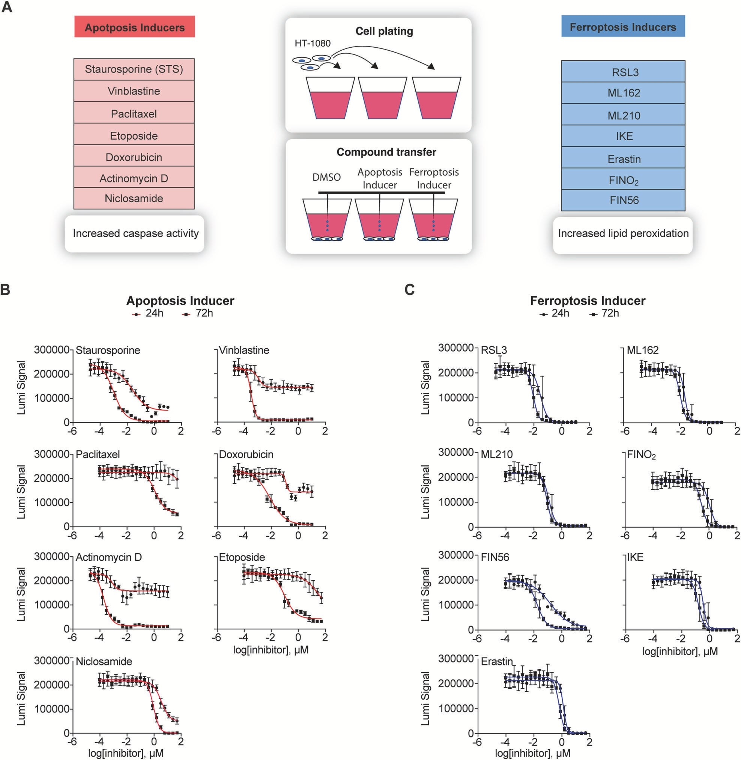
Figure 65 . Summary of cell death inducers. A) HT-1080 cells were exposed to apoptosis and ferroptosis inducers, with DMSO as a solvent control. Cells treated with apoptosis triggers apoptosis through caspase activation. In contrast, treatment with ferroptosis inducers leads to lipid peroxide accumulation, leading to ferroptosis. B) Viability assay results for HT-1080 cells treated with apoptosis stimulants after 24 h and 72 h incubation. Cellular ATP levels were assessed using luminescence signals. C) Similar results were obtained in B but for ferroptosis inducers. Reprinted from under CC BY license.

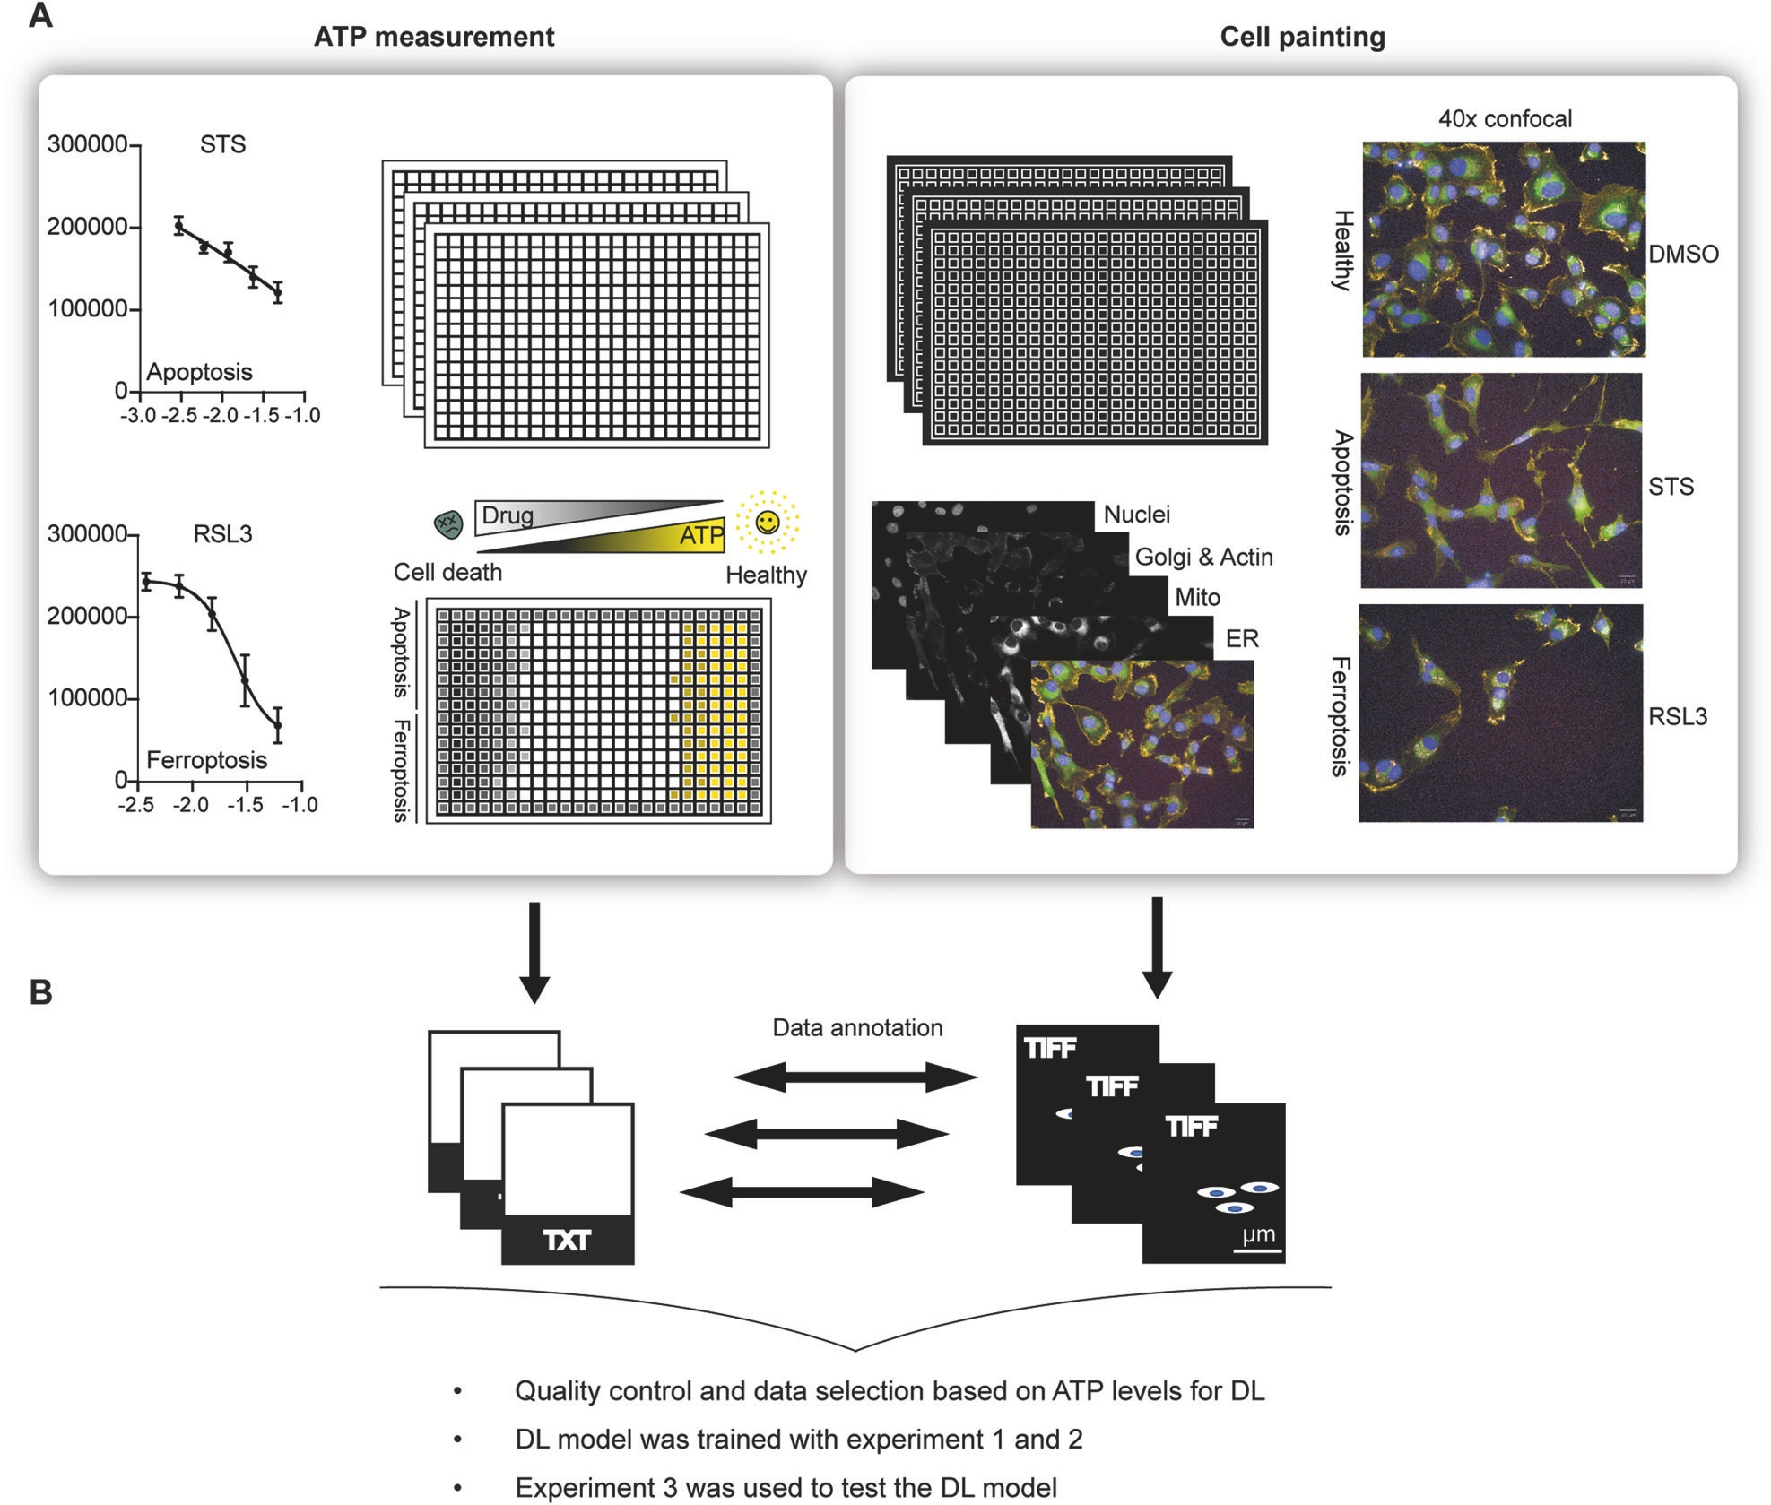

Figure 66. A) HT-1080 cells were treated with five varying concentrations of apoptosis and ferroptosis inducers. Simultaneously, ATP levels were assessed, and cell painting assays were conducted. Staurosporine (STS) and RSL3 served as representative compounds for apoptosis and ferroptosis induction

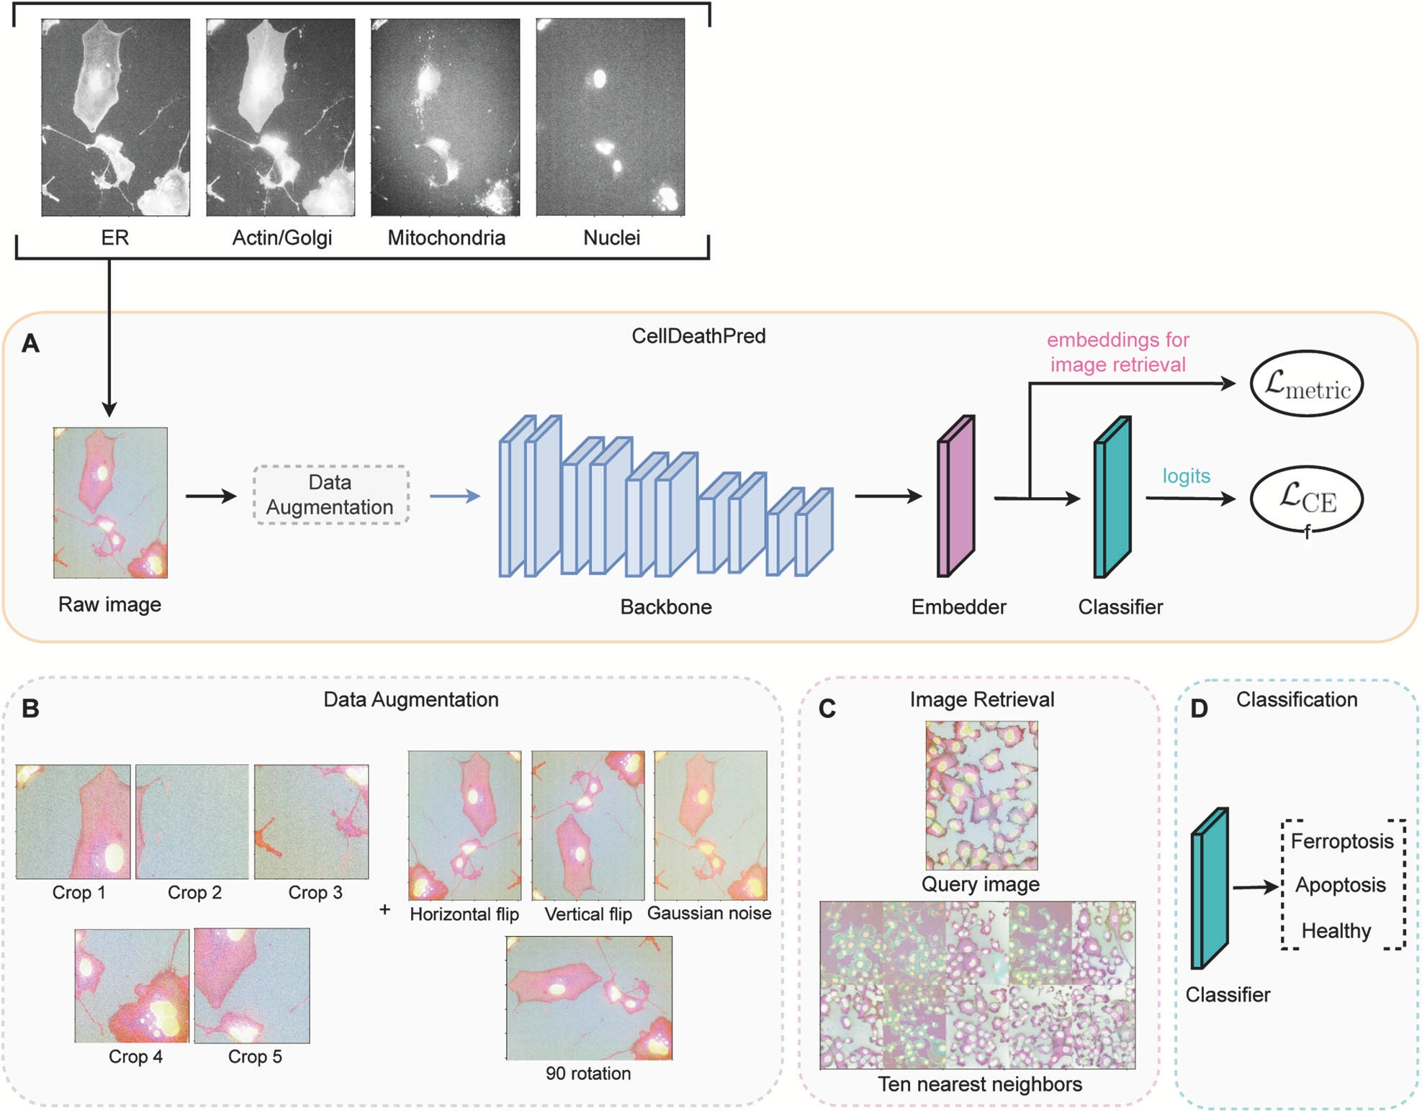

Figure 67. (A) The neural network processes input images—ER, Actin/Golgi, Mitochondria, and Nuclei—to determine whether the tested drug induces DMSO-induced apoptosis or ferroptosis. this consists of four stages: EfficientNet-B0 model (1) data augmentation to enhance model robustness, (2) an embedder comprising fully connected layers for low-dimensional feature extraction, and (3) a classifier, also made up of fully connected layers, that outputs the predicted modality. (B) Applied data augmentations with amplification for each. (C) A retrieval image example showing the ten closest neighbors in the embedding space for a given query image. (D) The final model layer, containing three nodes, classifies the input into three distinct categories.

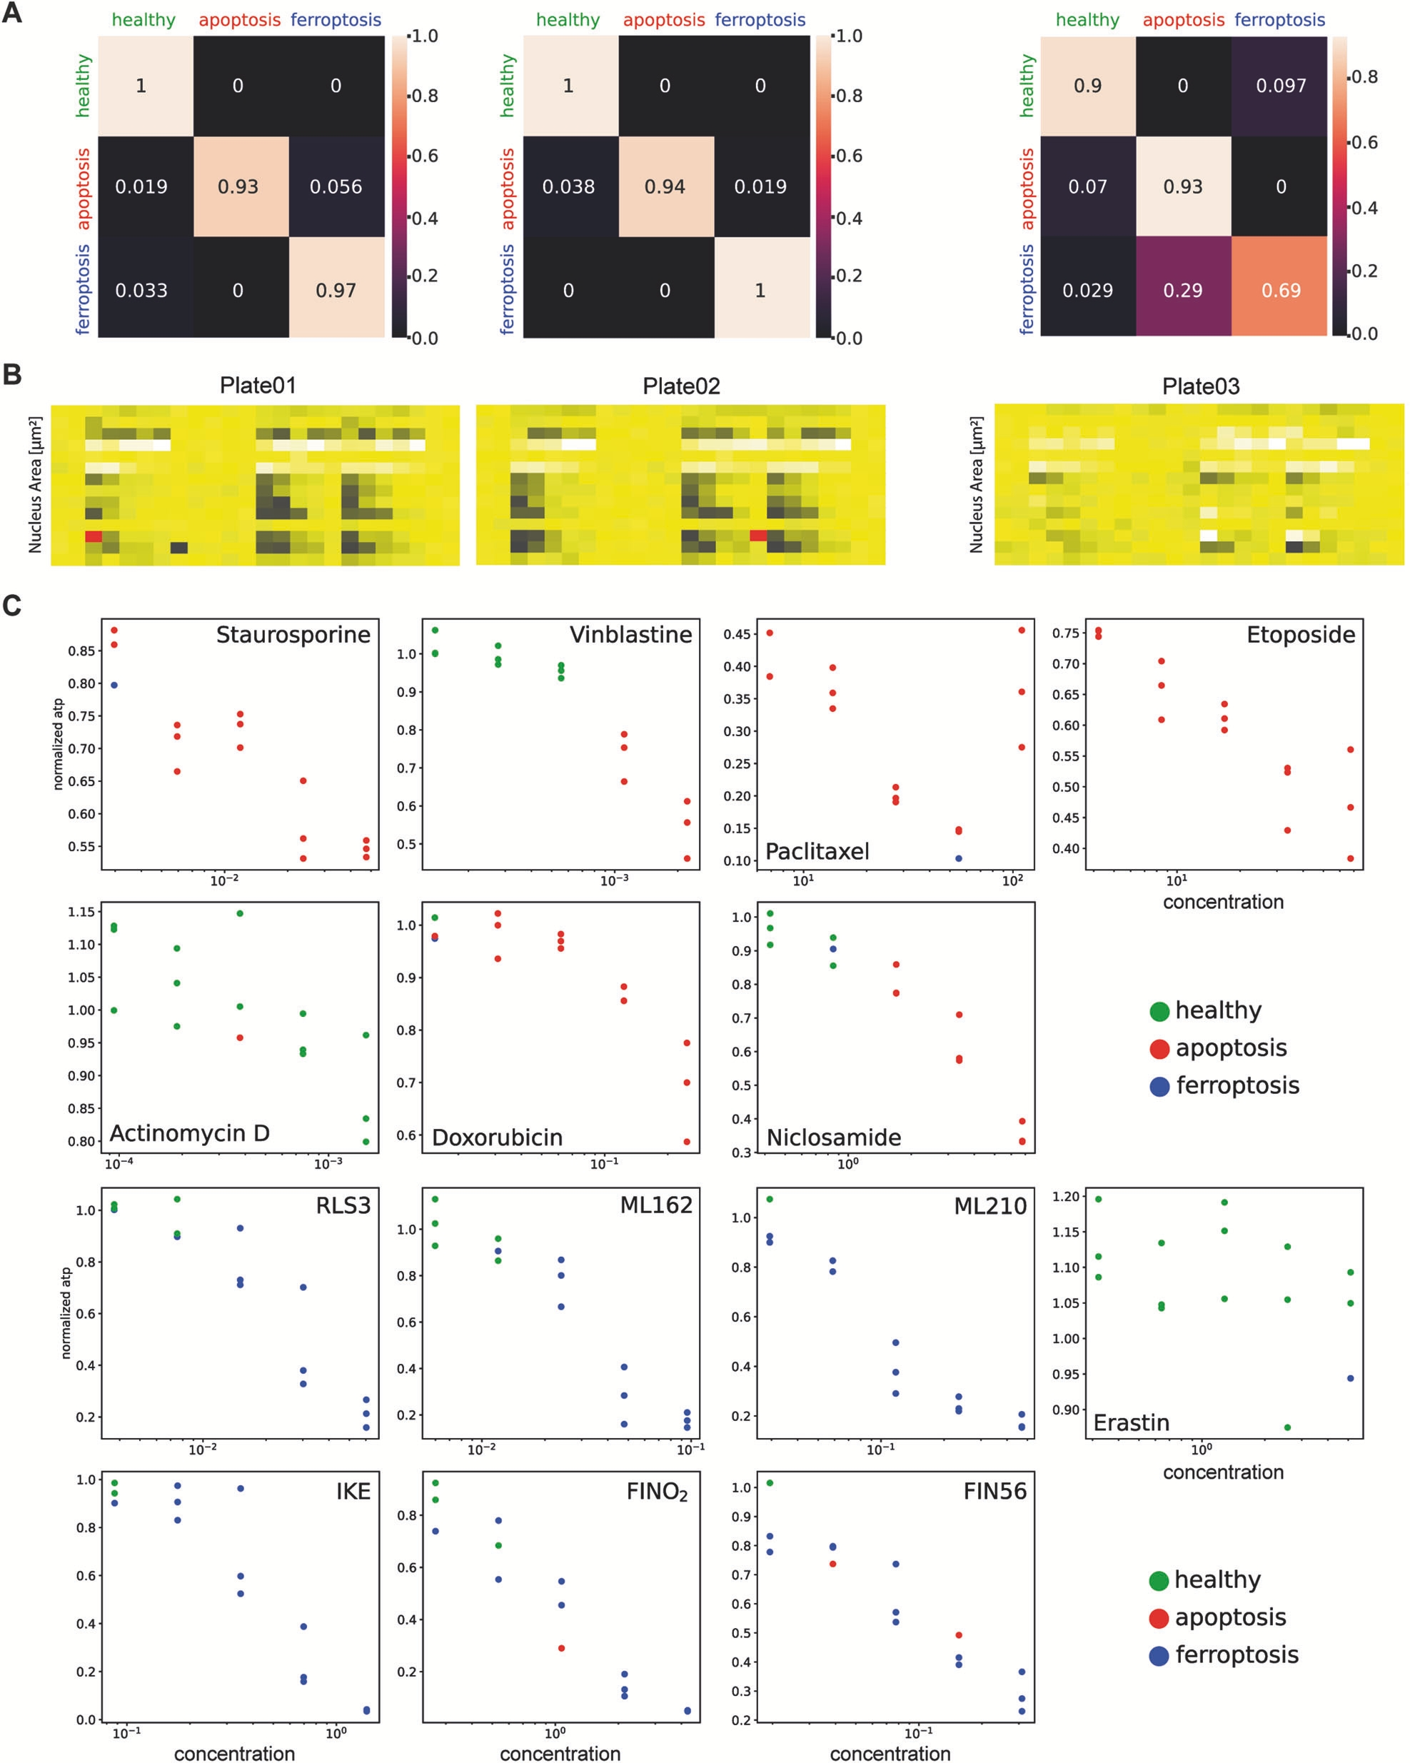
Figure 68. A: Confusion matrix based on the model CellDeathPred for the experiment (non-confocal). The images from the first and second experiments were used to train the model. Plates are arranged from left to right. B heatmap showing the number of nuclei found in the cell painting experiment photos. Low and high signals indicate the number of selected nuclei. Three plates were used as technical replicates for the experiment. Five different concentrations of each tiny chemical were applied to the cells. C Prediction of each material based on the ATP level (normalized) at each concentration throughout the plate was conducted with the CellDeathPred model on Plate 01 (non-confocal) for Experiment 3. Three duplicates represent each concentration. Reprinted from [172] under CC BY license.

Deep CNN was used to segment different cell types. i.e., the cytoplasm of both human and bacterial cells (figure 11 and figure 12). this methodology surpassed existing methods in accuracy, as indicated by the Jaccard Index (JI). The study concluded that deep CNNs are precise and generalizable across various cell types, from bacteria to mammalian cells. Their findings revealed impressive success rates, with a Jaccard Index of 0.95 for bacteria, 0.89 for human nuclei, and 0.77 and 0.84 for various human cytoplasms[223].

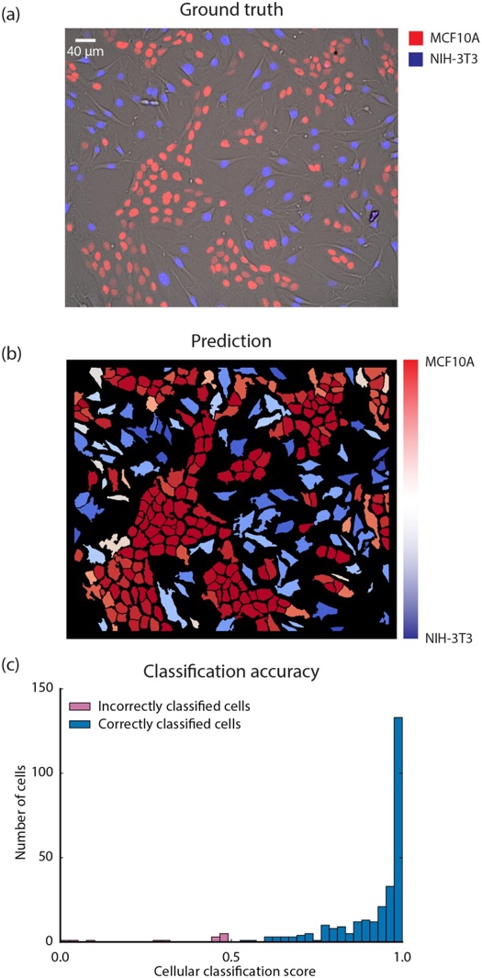

Figure 69. A convolutional neural network (Conv-Net) was employed to segment and recognize NIH-3T3 and MCF10A cells. The nuclear marker Hoechst 33342 was incorporated as a separate channel in each image to construct the training dataset. (A) The image presents a co-culture of MCF10A and NIH-3T3 cells, where MCF10A cells are marked by an iRFP nuclear marker (red), and NIH-3T3 cells express an mCerulean nuclear marker (blue). The Hoechst 33342 nuclear marker image is not shown. (B) The trained Conv-Net was applied to segment the image in (A) and classify the detected cell types simultaneously.(C) The classification accuracy for cell type prediction at the single-cell level is visualized. A histogram illustrates the categorization scores corresponding to each predicted cell type. The accuracy of classification correlates with the categorization score, with NIH-3T3 cells achieving 86% accuracy and MCF10A cells reaching 100%.

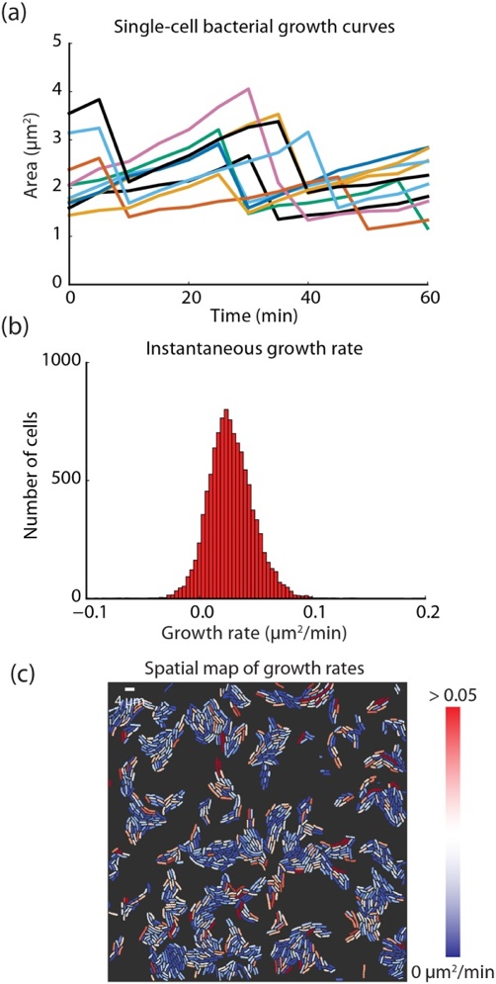

Figure 70. A) Single-cell growth curves for E. coli were generated using convolutional neural networks (Conv-Nets), which enable precise segmentation of bacterial cells from videos of expanding colonies. A linear assignment problem-based approach was employed for lineage construction.(B) A histogram of the instantaneous growth rate is created by calculating the change in area for each cell between consecutive frames.(C) By applying segmentation masks and calculating instantaneous growth rates, a spatial map of growth rates can be produced with high accuracy. This map allows for the identification of cells with slow division rates or those that are metabolically dormant.

The cell viability was also evaluated based on intracellular dynamic activity. The research tracked the fluorescence mean and intensity of six HeLa cell samples over a 24-hour period using a DFFOCM system. Supervised ML algorithms were trained on these intracellular measurements at both the 0-hour and 24-hour time points to differentiate between live and dead cells. Despite challenges in cell counts due to decomposition and detachment, the ML models (Logistic Regression, Random Forest, SVM, Gaussian Naïve Bayes) achieved a high balanced accuracy of 93.92 ± 0.86% (Figure 13). The study noted a gradual decrease in cell viability, from 95.59% at 15 minutes to 16.30% at 6 hours, reflecting natural cell death in a non-CO2 supplemented environment (Figure 14). ML-based assessments revealed notable differences compared to trypan blue staining in measuring cell death, underscoring ML's superior sensitivity and reliability. The research suggests that ML-based analysis of intracellular dynamics could transform clinical trials by enabling real-time predictions of cell status and supporting cancer treatment monitoring, particularly for dynamic and malignant cancer cells. The study proposes expanding this method to other cell types, including breast cancer (MCF-7), lung cancer (A549), and immunotherapy (Jurkat cells), to broaden its applicability. These findings are expected to significantly advance medical research by improving cellular analysis in various fields. [224]
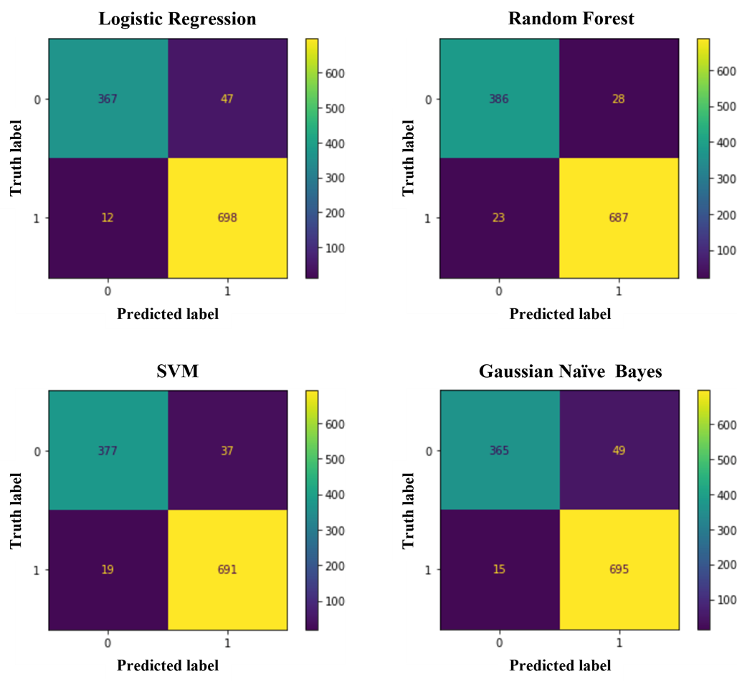

Figure 71 . Confusion matrices for the four machine learning models of the cell viability test set. The color bar indicates the number of cells. Reprinted from under CC BY license.

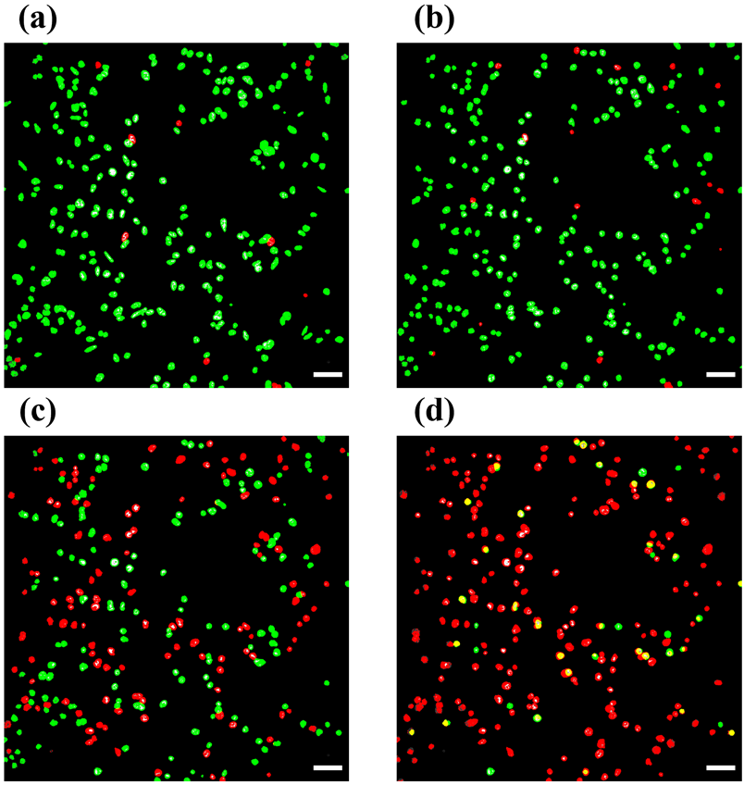

Figure 72. Assessment of cell viability states over time by training a logistic regression model. After (a) 15-minute, (b) 2-hour, (c) 4-hour, and (d) 6-hour mark. Green and red labels indicate live and dead cells, respectively. The inset white scale bar represents 100 µm. Reprinted from under CC BY license.

The use of Convolutional Neural Networks (CNNs) in accurately predicting specific cancer cell lines for label-free identification. The main goal of this research was to determine whether CNN models could reliably classify cancer cell lines based solely on their metastatic potential, without relying on chemical labels or advanced instrumentation commonly used in traditional diagnostic methods. This approach aimed to simplify and expedite cancer diagnostics while reducing the need for costly and complex equipment.

To achieve this, the study gathered three distinct binary datasets of cancer cell lines, each representing different levels of metastatic potential. Two CNN architectures—EfficientNetV2 and ResNet-50—were employed for classification purposes. These models were carefully trained and tested, with detailed analyses performed at each stage of the machine learning pipeline. The models were evaluated on their ability to correctly classify the cell lines based on their metastatic characteristics, with particular attention to how well each architecture handled the data.
The results of the study were revealing. EfficientNetV2 demonstrated impressive performance, with a test set accuracy reaching as high as 99%. In contrast, ResNet-50 consistently underperformed compared to EfficientNetV2, with the latter showing an average accuracy improvement of 3.5% across all datasets. This finding indicates that EfficientNetV2 has a clear advantage when it comes to processing and classifying cancer cell lines, providing a promising tool for researchers seeking to improve cancer diagnosis and understanding of metastatic behavior.
These findings underscore the potential of deep learning models like CNNs to significantly enhance diagnostic precision in cancer research. The success of EfficientNetV2 highlights its suitability for retraining and adapting to other datasets, suggesting that such models could be scaled for broader clinical applications. In the future, this approach could revolutionize the way cancer diagnostics are conducted, making them more accessible, faster, and less reliant on expensive and invasive procedures. Additionally, as the models can be adapted to various cancer types, they could contribute to personalized treatment plans and real-time monitoring of disease progression, further improving patient outcomes.
[225]
cell counting tasks was performed by using CNN. The first method combined multiple feature extractors with traditional machine learning (ML) regression models. However, this approach proved to be labor-intensive and unpredictable due to the complexities of hand-crafted feature extraction. To overcome these limitations, the researchers employed CNNs and treated the cell counting task as a regression problem, using the actual cell count in the image as a supervised training annotation. They used a deep Residual Network architecture, xResNet, which not only improved model performance but also benefited from transfer learning by utilizing a pre-trained model.
The proposed method was tested on dense microscope images of two different cell lines: human osteosarcoma (U2OS) and human leukaemia (HL-60). The results showed that the CNN-based approach significantly outperformed conventional ML techniques in terms of accuracy and efficiency. The error margin of the model was found to be 12 ± 15, which was comparable to that of a human lab worker performing the same task. Moreover, the CNN-based regression model was able to provide rapid results, processing the images in mere milliseconds. This is in stark contrast to the much slower, manual counting process, which can take several minutes to complete.
These results highlight the practical potential of CNN-based regression models for cell counting tasks, demonstrating their efficiency and accuracy in real-world applications. The ability to perform fast and reliable cell counting has significant implications for research and clinical settings, where timely and precise cell quantification is crucial. This study suggests that CNNs can revolutionize routine tasks like cell counting, enabling faster, more consistent results while reducing the labor and time involved in traditional manual methods [226].

Chapter 9

The result of using radiomic analysis for tumor detection
9.1. Prostate cancer
9.1.1. Population
The research encompassed a total of 73 patients diagnosed with varying prostate conditions, all of whom fell within an age bracket of 51 to 88 years. The average age of the study participants was calculated to be 67 years, with a standard deviation of ±7.6 years, reflecting a diverse age distribution across the cohort. Throughout the study, a comprehensive assessment identified 80 distinct lesions. Among these cases, it was observed that 7 individuals presented with two separate lesions each, highlighting the complexity and variability of the disease presentation in the sample population.
The classification of these lesions was meticulously conducted based on the Prostate Imaging-Reporting and Data System (PI-RADS) scoring criteria. The categorization resulted in three primary groups:
- PI-RADS 3 Lesions: This subset included a total of 5 lesions. Upon further histopathological evaluation, it was determined that 4 of these cases were associated with chronic inflammation, while 1 lesion was diagnosed as an atypical small acinar proliferation (ASAP), a condition that could potentially indicate a premalignant state.
- PI-RADS 4 Lesions: A significantly larger group, consisting of 45 lesions, fell under this classification. The detailed breakdown of these cases revealed 21 lesions indicative of chronic inflammation, 1 lesion that exhibited both prostatic intraepithelial neoplasia (PIN) and ASAP, and a range of malignant cases characterized by varying Gleason scores (GS). Specifically, 11 lesions were identified as GS 6, 3 lesions were categorized as GS 7 (3+4), 5 lesions as GS 7 (4+3), 3 lesions exhibited GS 8 characteristics, and 1 lesion was diagnosed with GS 9.
- PI-RADS 5 Lesions: This high-risk category comprised 30 lesions in total. Among them, 5 cases were linked to chronic inflammation, 1 lesion was determined to be an acinar carcinoma, and the remaining cases were distributed across different Gleason score classifications. These included 7 lesions with GS 6, 4 lesions classified as GS 7 (3+4), 5 cases with GS 7 (4+3), 5 lesions exhibiting GS 8, 3 cases diagnosed as GS 9, and 1 lesion categorized as GS 10, representing the most aggressive tumor grading in this study.
To ensure accuracy in evaluating the malignant potential of these lesions, non-cancerous cases were systematically excluded from the final assessment. A total of 31 lesions, which were determined not to be associated with prostate cancer (PCa), were omitted from further analysis. Consequently, the final dataset used for statistical evaluation consisted of 49 lesions that were conclusively diagnosed as prostate cancer, allowing for a focused investigation into tumor characteristics and disease progression.
9.1.2.RadiomicsPerformance
An extensive analysis of radiomic parameters revealed that a total of 71 features exhibited statistically significant differences when comparing the entire prostate gland to tumor-specific regions. These findings highlight the potential of radiomic texture analysis in distinguishing between normal and malignant prostate tissues.
Among the significant features identified, one particularly notable parameter derived from the T2-weighted sequences was original_glrlm_ShortRunLowGrayLevelEmphasis. This feature demonstrated a highly significant statistical value (p = 0.00072), indicating its strong discriminatory ability in differentiating tumor lesions from the whole prostate gland
Further assessment of this feature’s diagnostic performance was conducted using the area under the receiver operating characteristic (AUROC) curve. The analysis yielded an AUROC score of 68.46, with a 95% confidence interval ranging from 0.544 to 0.824 (p = 0.022), suggesting moderate effectiveness in classification.
In terms of classification metrics, the feature exhibited a sensitivity of 67.25%, indicating its ability to correctly identify tumor lesions, while its specificity was measured at 73.15%, reflecting its accuracy in correctly classifying non-tumorous regions within the prostate. Additionally, the overall classification accuracy for this radiomic feature was calculated to be 71.02%, reinforcing its potential as a valuable biomarker for distinguishing between malignant and normal prostate tissue structures.
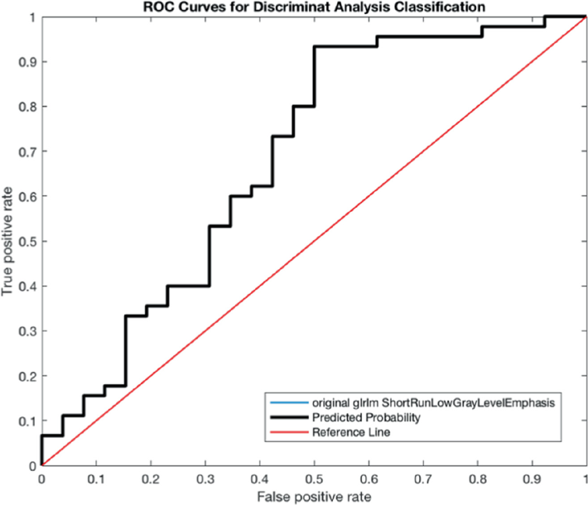
Figure 73: Receiver operating characteristics curve of Original_glrlm_ShortRunLowGrayLevel Emphasis on T2W sequences of the prostate.
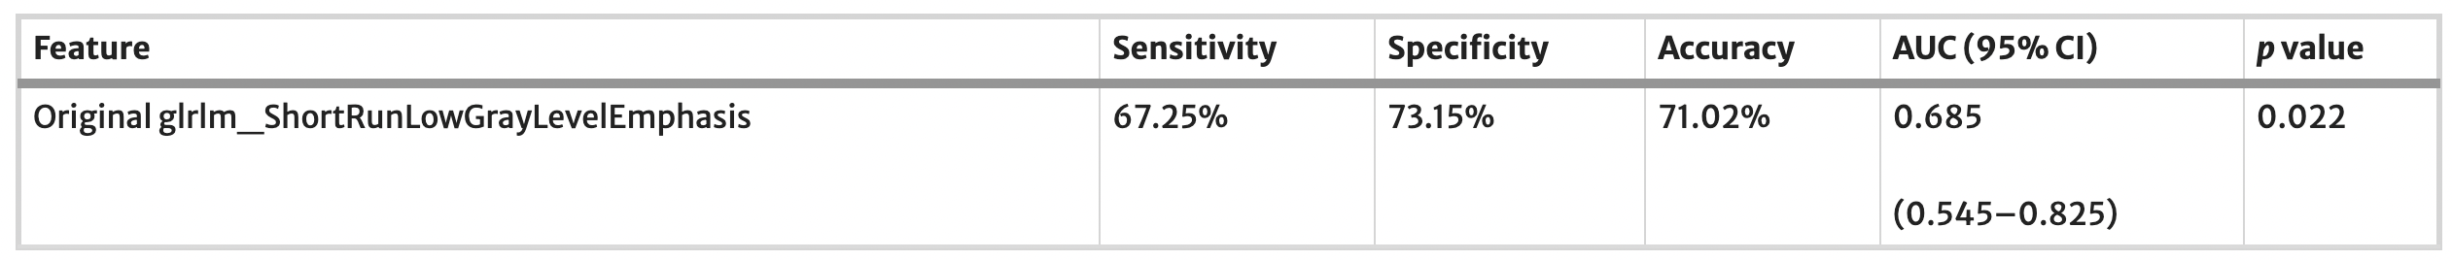
Table Key Radiomic Features and Their Diagnostic Performance in Differentiating the Whole Prostate from Tumor Lesions
The use of radiomics in prostate MRI spans various applications, including tumor detection, predicting outcomes, and tracking treatment progress. Combining radiomics with AI algorithms [10, 11] can help standardize interpretations, reducing discrepancies among radiologists. In mpMRI, radiomics enhances diagnostic reliability by incorporating both qualitative factors (such as PI-RADS scores, which rely on radiologist expertise) and quantitative data (like tumor dimensions, prostate volume, and radiomic features, which are objectively generated by algorithms). Our study focused on the role of radiomics in mpMRI for distinguishing between prostate tissue and tumor lesions in PCa detection. The findings showed strong performance, with an AUC of 0.685 (95% CI 0.544–0.824; p = 0.022), sensitivity of 76.25%, specificity of 73.15%, and accuracy of 71.02%.
The results of this study underscore the potential of radiomic analysis applied to multiparametric MRI (mpMRI) imaging as an effective approach for distinguishing tumor lesions from the entire prostate gland in prostate cancer (PCa) detection. The observed high sensitivity and notable area under the curve (AUC) values highlight the capability of radiomics to function as a complementary diagnostic tool, aiding clinicians in assessing disease presence and progression. Additionally, the moderate specificity and accuracy suggest that incorporating radiomic analysis into diagnostic workflows could contribute to reducing false-positive rates, thereby improving overall precision in prostate cancer evaluation.
These findings are in line with prior research efforts exploring the role of radiomics in PCa detection. For example, Woznicki et al. demonstrated that quantitative biomarkers extracted from mpMRI scans offer reliable indicators of prostate malignancy. Their radiomic model achieved a mean AUC of 0.783 in differentiating malignant from benign lesions. Furthermore, when their model was integrated with PI-RADS (Prostate Imaging-Reporting and Data System), prostate-specific antigen density (PSAD), and digital rectal examination (DRE), the diagnostic performance significantly improved, yielding an AUC of 0.889, emphasizing the added value of radiomic features when combined with traditional diagnostic parameters.
Similarly, another study reported promising outcomes in the detection of clinically significant prostate cancer in the peripheral zone. Utilizing an automated volume-of-interest (VOI) selection approach, this method achieved a peak AUC of 0.87. The enhanced performance was attributed to the integration of multiple imaging modalities, including T2-weighted imaging, diffusion-weighted imaging (DWI), and dynamic contrast-enhanced (DCE) MRI, which contributed to a more comprehensive assessment of tissue characteristics.
In another notable study, Khalvati et al. developed a radiomics-based framework for the automated localization and detection of prostate cancer using clinical mpMRI data from a cohort of 30 patients. Their model demonstrated strong diagnostic capabilities, achieving a sensitivity of 0.82, specificity of 0.89, and an overall accuracy of 0.86 in distinguishing cancerous tissue from healthy prostate regions. These findings collectively reinforce the growing evidence supporting the integration of radiomic analysis with conventional imaging techniques to enhance PCa diagnosis and improve patient outcomes.

9.2. Bladder cancerous
9.2.1. Population
The study included a total of 16 patients (14 men, 2 women), with a mean age of 72 years ± 8.5 (ranging from 57 to 87 years). A total of 35 bladder cancer (BCa) lesions were examined, with a mean diameter of 13.9 x 12.4 mm (ranging from 2 to 60 mm). The BCa lesions were categorized into low-grade (LG) (12 lesions) and high-grade (HG) (23 lesions), as well as muscle-invasive bladder cancer (MIBC) (32 lesions) and non-muscle invasive bladder cancer (NMIBC) (3 lesions), based on pathological results (table 1).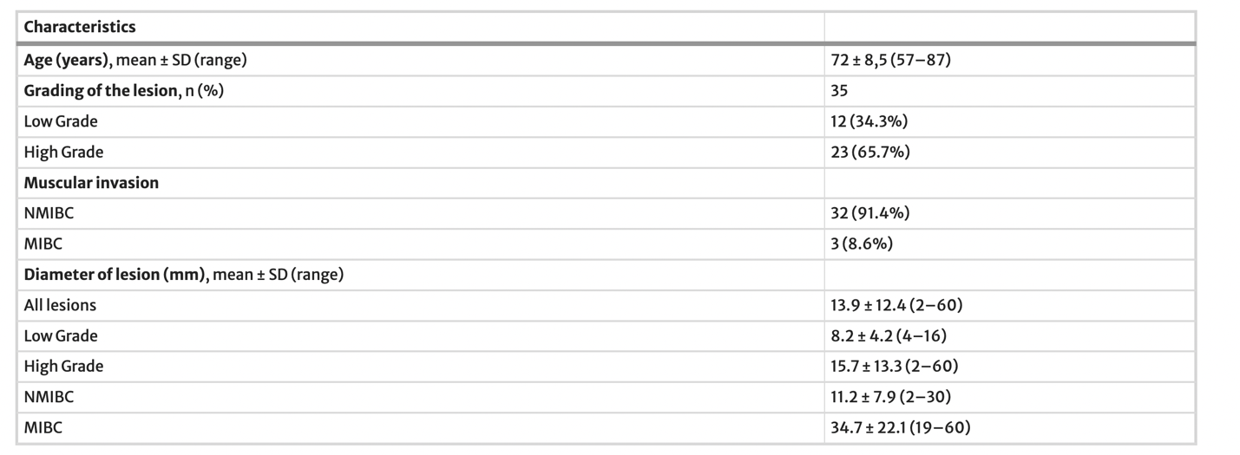
Table 1 . Characteristics of the study population.

Table 2. Discrimination of LG from HG lesions based on significant features.

Our findings demonstrated that a combination of two specific radiomics features significantly differentiated low-grade (LG) from high-grade (HG) bladder lesions. This suggests that these features, likely linked to structural or morphological characteristics of the lesions, can provide valuable insights into distinguishing bladder tumors based on their malignancy grade.
9.2.2. Texture Features
Feature | p-value
LargeAreaHighGrayLevelEmphasis (LAHGLE) | 0.00063
LargeAreaEmphasis (LAE) | 0.0018
In our investigation, we observed that not all radiomics parameters exhibit the same level of efficacy when it comes to distinguishing between low-grade (LG) and high-grade (HG) bladder lesions. Despite extracting over 120 different features, only two demonstrated a statistically significant correlation with the differentiation between the two lesion grades. We propose that the observed texture heterogeneity in bladder tumor MR images may serve as a reflection of the histopathological alterations that take place during the process of carcinogenesis. This finding underscores the critical importance of judiciously selecting and thoroughly evaluating specific radiomics parameters. Such careful consideration is essential to optimize the discriminative power of the model and enhance its ability to accurately differentiate between LG and HG lesions. This approach ensures that the radiomics analysis is both reliable and clinically relevant, potentially improving diagnostic accuracy and treatment planning.
Based on our results, texture features could serve as a useful tool for grading bladder lesions, potentially providing an early indicating malignancy grade. The validation of these radiomics parameters in the context of multiparametric MRI for bladder lesions holds considerable potential for clinical advancements. By enhancing the accuracy and reliability of lesion characterization, this approach could lead to improved diagnostic precision and more informed management strategies. Ultimately, incorporating validated radiomics parameters into clinical practice could refine the diagnostic process, allowing for more tailored treatment options and better outcomes for patients with bladder lesions. This progression in radiomic-based analysis would be a significant step toward more personalized and effective care.
The diagnostic efficacy of the model was evaluated by calculating the area under the curve (AUC), which returned a strong value of 0.84. This indicates that the model exhibits a high level of discriminative power when it comes to differentiating between low-grade (LG) and high-grade (HG) lesions. The 95% confidence interval, ranging from 0.71 to 0.98, reveals some degree of variability in the model’s accuracy, which is expected in real-world applications where factors such as patient heterogeneity and image quality may influence performance. Nevertheless, despite this observed variability, the model's overall performance remains solid and consistent. This suggests that, while there may be occasional fluctuations in accuracy, the model can still reliably distinguish between LG and HG lesions across a broad range of cases. Such robustness highlights its potential value as a diagnostic tool in clinical settings, where precise lesion differentiation is crucial for appropriate treatment decisions. Furthermore, this reliability underscores the importance of incorporating this model into routine practice, as it could provide clinicians with an additional layer of support for making informed and accurate diagnoses.

The model achieved a sensitivity of 65.6%, reflecting its ability to accurately detect positive cases (high-grade lesions), meaning it identified the majority of high-grade lesions in the study. Its specificity of 81.5% highlights its capability to correctly recognize negative cases (low-grade lesions). These findings indicate that the model effectively differentiates between low-grade (LG) and high-grade (HG) lesions, maintaining a balanced performance in terms of sensitivity and specificity.
In the task of differentiating between non-muscle invasive bladder cancer (NMIBC) and muscle-invasive bladder cancer (MIBC), radiomics analysis yielded promising results, particularly when two key radiomics features were combined. This combination demonstrated strong diagnostic performance, achieving an area under the curve (AUC) of 0.7, indicating moderate discriminatory power. The 95% confidence interval (CI) for the AUC, ranging from 0.11 to 1, suggests some level of variability in the performance estimate, likely due to factors such as patient diversity and image quality. Despite this variability, the model showed remarkable sensitivity, reaching 100%, meaning it correctly identified all MIBC cases. Additionally, the model demonstrated a specificity of 86.7%, meaning it was also effective in accurately recognizing NMIBC cases. These results are statistically significant, with a p-value of 0.0031, reinforcing the presence of a meaningful association between the extracted radiomics features and their ability to differentiate between NMIBC and MIBC. The findings suggest that this radiomics-based model holds considerable potential for improving the diagnostic accuracy in distinguishing these two forms of bladder cancer, which is crucial for determining the appropriate treatment approach. Moreover, the combination of these features in the model highlights the value of radiomics as a powerful tool in oncology, where precision is key to ensuring optimal patient outcomes.
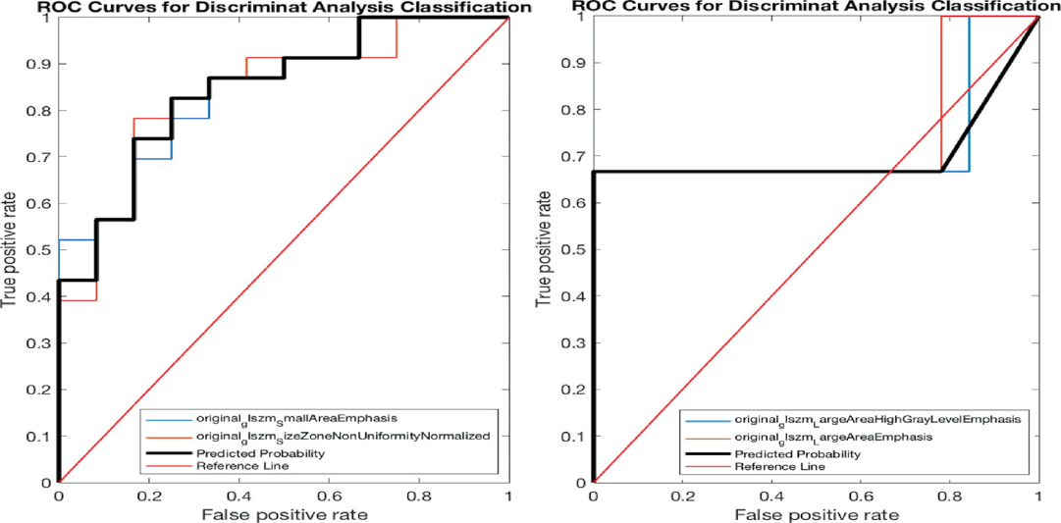
Figure 74: ROC curve relating to: a) the two features analysed (SAE and SZNN); b) the two features analysed (LAHGLE and LAE).
Wang et al. utilized radiomics features derived from T2-weighted imaging (T2WI), diffusion-weighted imaging (DWI), and apparent diffusion coefficient (ADC) sequences. They developed a radiomics signature, referred to as Radscore, based on 36 selected radiomics features. The Radscore exhibited strong predictive capability for identifying muscle-invasive bladder cancer (MIBC), achieving an AUC of 0.880 in the training cohort and 0.813 in the validation cohort. Additionally, the researchers combined the Radscore with another independent predictor, the MRI-determined tumor stalk, into a nomogram. This combination further enhanced predictive performance, with the AUC rising to 0.924 in the training cohort and 0.877 in the validation cohort. These results demonstrate that integrating the Radscore with MRI-determined tumor stalk improves the accuracy of distinguishing between non-muscle invasive bladder cancer (NMIBC) and MIBC.
The study underscores the potential of combining radiomics features from multiple MRI sequences with other independent predictors to significantly boost the effectiveness of radiomics analysis. By leveraging diverse imaging modalities, the analysis becomes more comprehensive, capturing a wider array of tumor characteristics and improving classification accuracy. This approach highlights the value of integrating multifaceted data sources to achieve more reliable and precise differentiation between NMIBC and MIBC [193].

Discussion and Conclusion
The complexity of rheumatoid arthritis (RA), as well as other inflammatory and oncological diseases, necessitates the development of multi-targeted therapeutic strategies that not only alleviate symptoms but also modify disease progression. Over the past few decades, considerable research has been dedicated to exploring the potential of polyphenols, nanomedicine, and artificial intelligence (AI)-driven diagnostic tools. This study integrates these diverse domains to provide a understanding of how these advanced approaches can revolutionize disease treatment and diagnosis. The findings contribute significantly to the fields of pharmacology, nanotechnology, and medical imaging by offering novel insights into disease modulation at both Polyphenols, naturally occurring bioactive compounds found in plants, have long been recognized for their anti-inflammatory, antioxidant, and anti-cancer properties. These compounds, including hydroxytyrosol, quercetin, chalcones, and resveratrol (RSV), exert significant biological effects by modulating key signaling pathways such as NF-κB, MAPK, AP-1, and PI3K/Akt. Through these mechanisms, polyphenols play a crucial role in suppressing inflammation, regulating apoptosis, and inhibiting oxidative stress, making them promising candidates for therapeutic interventions in inflammatory diseases like RA and various malignancies. Despite the extensive pharmacological potential of polyphenols, their clinical applicability is often hindered by their poor bioavailability, rapid metabolism, and systemic instability. Many polyphenols are subject to first-pass metabolism, which significantly reduces their plasma concentration, thereby limiting their therapeutic efficacy. In addition, polyphenols often exhibit dose-dependent cytotoxicity, raising concerns about their long-term safety and effectiveness in clinical settings. The challenge, therefore, lies in optimizing the delivery mechanisms of these bioactive compounds to maximize their biological activity while minimizing unwanted side effects.Nanomedicine has emerged as a promising solution to overcome the pharmacokinetic limitations of polyphenols. The encapsulation of polyphenols into nanoparticles (NPs) has been shown to significantly improve their bioavailability, stability, and targeted delivery. Among various nanoparticle formulations, lipid-based, polymeric, and metallic nanoparticles have gained considerable attention for their ability to enhance drug solubility, prolong systemic circulation, and facilitate controlled release. One of the most extensively studied polyphenols in the context of nanomedicine is RSV. RSV-loaded nanoparticles (RSV-NPs) have demonstrated enhanced solubility, increased cellular uptake, and sustained drug release, making them a viable approach for improving RSV’s therapeutic potential in both inflammatory and oncological settings. In our study, we observed that RSV-NPs exhibited superior anti-inflammatory effects compared to free RSV, particularly in downregulating pro-inflammatory cytokines such as TNF-α, IL-1β, and IL-6 in SW982 and RAW 264.7 cell lines. This suggests that nanoparticle-mediated delivery can significantly amplify the pharmacological effects of RSV by facilitating targeted accumulation in inflamed tissues. Furthermore, nanocarriers provide an opportunity for combination therapies, where polyphenols can be co-encapsulated with other bioactive compounds to enhance synergistic effects.
Despite these promising outcomes, the widespread clinical application of polyphenol-based nanomedicine still faces several challenges. The large-scale production and reproducibility of polyphenol-loaded nanoparticles require optimization to ensure consistency. Additionally, potential nanoparticle-associated toxicity, long-term biocompatibility, and clearance mechanisms need to be thoroughly investigated through extensive preclinical and clinical trials. Future research should focus on developing biodegradable, non-toxic, and patient-friendly nanocarrier systems that can be safely integrated into routine medical practice.
The application of radiomics, which involves extracting quantitative features from images, has proven to be a powerful tool in assessment of various ailments. Beyond imaging, AI and machine learning (ML) have also emerged as transformative technologies in biomarker identification, particularly in studying cell lines' response to polyphenols and novel drug compounds. By analyzing large-scale datasets, AI-driven models can uncover intricate molecular patterns and predictive biomarkers associated with therapeutic efficacy and resistance. These computational approaches facilitate high-throughput screening of drug candidates, optimizing their clinical translation and enabling precision medicine strategies. In this study, we explored the application of radiomics in tumor grading and classification. Our findings indicate that radiomic models can effectively differentiate between low-grade (LG) and high-grade (HG) bladder tumors, as well as between non-muscle invasive bladder cancer (NMIBC) and muscle-invasive bladder cancer (MIBC). Similarly, radiomic analysis applied to imaging demonstrated high sensitivity and specificity in distinguishing malignant from benign lesions. One of the key advantages of AI-driven analysis is its ability to extract quantitative biomarkers that are often imperceptible to the human eye. These biomarkers provide critical insights into tumor heterogeneity, drug response, and disease prognosis, thereby to support personalized treatment approaches. However, translating these findings into clinical practice requires overcoming challenges such as standardizing imaging and molecular profiling protocols, integrating AI algorithms into existing clinical workflows, and validating models across diverse patient populations. AI and ML can further enhance translational medicine by automating feature selection, pattern recognition, and predictive modeling, ensuring more reliable and reproducible results. Deep learning-based convolutional neural networks (CNNs) have demonstrated remarkable performance in image classification, segmentation, and biomarker extraction, making them invaluable tools in AI-driven biomedical research. In the future, integrating AI-powered biomarker discovery with molecular and genetic data could pave the way for comprehensive predictive models, guiding precision medicine and improving therapeutic outcomes. Although the findings support for the potential use of polyphenols, nanomedicine, and AI in disease management, several challenges must be addressed before these technologies can be fully integrated into clinical practice. The development and implementation of nanoparticle-based therapeutics and AI-driven diagnostics face significant challenges, particularly in the realms of regulatory approval and standardization. The regulatory approval process for these advanced technologies is highly complex, requiring extensive and rigorous evaluations to ensure not only their safety and efficacy but also compliance with ethical standards. The process involves assessing the potential risks and benefits of these new technologies in both preclinical and clinical settings, which necessitates a detailed understanding of their biological interactions, mechanisms of action, and long-term impacts on human health. To facilitate their successful integration into clinical practice, standardized protocols for nanoparticle synthesis, characterization, and clinical testing must be established across the board. These protocols will ensure consistency and reproducibility in the production of nanoparticle-based therapeutics, which is essential for maintaining their safety and efficacy in real-world applications. Moreover, as AI-driven diagnostic tools are increasingly being integrated into healthcare settings, they too must undergo extensive validation. This validation process is crucial to ensure that these tools are not only reliable and accurate but also generalizable across diverse healthcare environments. This step is particularly important because AI-driven diagnostics must perform well in varied patient populations, medical conditions, and healthcare infrastructure to be truly effective.
In parallel with these regulatory and standardization efforts, the successful integration of collaboration. This is where the expertise of pharmacologists, biomedical engineers, clinicians, and data scientists becomes invaluable. Interdisciplinary collaboration is essential because the integration of polyphenols with nanomedicine and AI technologies draws from multiple fields of knowledge, each with its own set of challenges. Pharmacologists bring insights into the therapeutic potential and safety profiles of polyphenols, while biomedical engineers contribute their expertise in nanoparticle design, fabrication, and delivery mechanisms. Clinicians offer valuable perspectives on how these technologies can be effectively translated into patient care, ensuring that treatments are both practical and applicable in clinical settings. Data scientists, on the other hand, play a critical role in the development of AI-driven diagnostic tools, helping to refine algorithms, improve machine learning models, and ensure the accuracy and reliability of data analysis. To foster such collaboration, interdisciplinary research initiatives should focus on bridging the gap between laboratory discoveries and real-world clinical applications. This could include collaborative research projects, joint publications, and shared clinical trials, all aimed at optimizing the potential of these technologies in improving patient outcomes.
Furthermore, as we look to the future of therapeutic interventions, personalized medicine approaches will become increasingly important. Future studies should prioritize the development of personalized treatment strategies by integrating AI-driven data analytics with patient-specific genetic, molecular, and imaging data. Personalized medicine represents a paradigm shift in how healthcare is delivered, moving away from one-size-fits-all treatments and towards strategies that are tailored to the unique needs of each patient. By leveraging AI to analyze complex datasets from various sources, such as genomic sequences, biomarker profiles, and medical imaging, clinicians will be able to develop highly individualized treatment plans. This approach has the potential to optimize therapeutic outcomes, improve the efficiency of treatment regimens, and reduce the risk of adverse effects. Moreover, personalized medicine can contribute to the identification of novel therapeutic targets and the development of more effective therapies, particularly for complex and heterogeneous diseases such as RA.
While the preclinical studies conducted thus far have shown promising results, it is crucial that these findings be validated through large-scale multicenter clinical trials. These trials will provide the necessary data to confirm the safety and efficacy of polyphenol-based nanotherapeutics and AI-driven clinical decision support models inn diverse patient populations. Large-scale trials are particularly important for understanding how these therapies perform in the real-world setting, where variables such as patient comorbidities, different stages of disease, and variations in healthcare delivery can influence outcomes. Moreover, large-scale trials will help establish the long-term sustainability of these treatments, allowing researchers to assess the durability of their effects over extended periods. Long-term follow-up studies will be essential to monitor potential adverse effects that may arise after prolonged use, particularly when novel therapeutics such as nanoparticle-based drugs and polyphenol-enriched therapies are involved. These studies will also help assess whether the benefits of these treatments persist over time or diminish as patients continue treatment. Collectively, these efforts will ensure that polyphenol-based nanotherapeutics and AI-driven clinical decision support models can be safely and effectively integrated into clinical practice, offering new hope for patients with challenging conditions like rheumatoid arthritis.

References
1. Aletaha, D.; Smolen, J.S. Diagnosis and Management of Rheumatoid Arthritis: A Review. JAMA 2018, 320, 1360–1372, doi:10.1001/jama.2018.13103.
2. Babaahmadi, M.; Tayebi, B.; Gholipour, N.M.; Kamardi, M.T.; Heidari, S.; Baharvand, H.; Eslaminejad, M.B.; Hajizadeh-Saffar, E.; Hassani, S.-N. Rheumatoid Arthritis: The Old Issue, the New Therapeutic Approach. Stem Cell Research & Therapy 2023, 14, 268, doi:10.1186/s13287-023-03473-7.
3. Fakhouri, W.; Lopez-Romero, P.; Antonelli, S.; Losi, S.; Rogai, V.; Buda, S.; Sangiorgi, D.; Perrone, V.; Degli Esposti, L. Treatment Patterns, Health Care Resource Utilization and Costs of Rheumatoid Arthritis Patients in Italy: Findings from a Retrospective Administrative Database Analysis. OARRR 2018, Volume 10, 103–111, doi:10.2147/OARRR.S164738.
4. Rana, A.K.; Li, Y.; Dang, Q.; Yang, F. Monocytes in Rheumatoid Arthritis: Circulating Precursors of Macrophages and Osteoclasts and, Their Heterogeneity and Plasticity Role in RA Pathogenesis. International immunopharmacology 2018, 65, 348–359.
5. Christman, L.M.; Gu, L. Efficacy and Mechanisms of Dietary Polyphenols in Mitigating Rheumatoid Arthritis. Journal of Functional Foods 2020, 71, doi:10.1016/j.jff.2020.104003.
6. Ali, M.; Benfante, V.; Di Raimondo, D.; Salvaggio, G.; Tuttolomondo, A.; Comelli, A. Recent Developments in Nanoparticle Formulations for Resveratrol Encapsulation as an Anticancer Agent. Pharmaceuticals 2024, 17, doi:10.3390/ph17010126.
7. Ali, M.; Benfante, V.; Basirinia, G.; Alongi, P.; Sperandeo, A.; Quattrocchi, A.; Giannone, A.G.; Cabibi, D.; Yezzi, A.; Di Raimondo, D.; et al. Applications of Artificial Intelligence, Deep Learning, and Machine Learning to Support the Analysis of Microscopic Images of Cells and Tissues. Journal of Imaging 2025, 11, doi:10.3390/jimaging11020059.
8. Benfante, V.; Salvaggio, G.; Ali, M.; Cutaia, G.; Salvaggio, L.; Salerno, S.; Busè, G.; Tulone, G.; Pavan, N.; Di Raimondo, D.; et al. Grading and Staging of Bladder Tumors Using Radiomics Analysis in Magnetic Resonance Imaging. In Proceedings of the Image Analysis and Processing - ICIAP 2023 Workshops; Foresti, G.L., Fusiello, A., Hancock, E., Eds.; Springer Nature Switzerland: Cham, 2024; pp. 93–103.
9. Ali, M.; Benfante, V.; Cutaia, G.; Salvaggio, L.; Rubino, S.; Portoghese, M.; Ferraro, M.; Corso, R.; Piraino, G.; Ingrassia, T.; et al. Prostate Cancer Detection: Performance of Radiomics Analysis in Multiparametric MRI. In Proceedings of the Image Analysis and Processing - ICIAP 2023 Workshops; Foresti, G.L., Fusiello, A., Hancock, E., Eds.; Springer Nature Switzerland: Cham, 2024; pp. 83–92.
10. Casnici, C.; Lattuada, D.; Crotta, K.; Truzzi, M.C.; Corradini, C.; Ingegnoli, F.; Tonna, N.; Bianco, F.; Marelli, O. Anti-Inflammatory Effect of Somatostatin Analogue Octreotide on Rheumatoid Arthritis Synoviocytes. Inflammation 2018, 41, 1648–1660.
11. Ma, Q.S.; Linghu, K.-G.; Zhang, T.; Zhao, G.D.; Xiong, W.; Xiong, S.H.; Zhao, M.; Xu, W.; Yu, J.; Yu, H. Sigesbeckia Glabrescens Makino Extract Attenuated the Collagen-Induced Arthritis through Inhibiting the Synovial Hyperplasia and Inflammation. Chin Med 2020, 15, 91, doi:10.1186/s13020-020-00372-4.
12. Karnezis, T.; Shayan, R.; Caesar, C.; Roufail, S.; Harris, N.C.; Ardipradja, K.; Zhang, Y.F.; Williams, S.P.; Farnsworth, R.H.; Chai, M.G.; et al. VEGF-D Promotes Tumor Metastasis by Regulating Prostaglandins Produced by the Collecting Lymphatic Endothelium. Cancer Cell 2012, 21, 181–195, doi:10.1016/j.ccr.2011.12.026.
13. Cébe-Suarez, S.; Zehnder-Fjällman, A.; Ballmer-Hofer, K. The Role of VEGF Receptors in Angiogenesis; Complex Partnerships. Cell. Mol. Life Sci. 2006, 63, 601, doi:10.1007/s00018-005-5426-3.
14. Hascoët, E.; Blanchard, F.; Blin-Wakkach, C.; Guicheux, J.; Lesclous, P.; Cloitre, A. New Insights into Inflammatory Osteoclast Precursors as Therapeutic Targets for Rheumatoid Arthritis and Periodontitis. Bone Research 2023, 11, 26, doi:10.1038/s41413-023-00257-w.
15. Kurowska, W.; Kuca-Warnawin, E.H.; Radzikowska, A.; Maśliński, W. The Role of Anti-Citrullinated Protein Antibodies (ACPA) in the Pathogenesis of Rheumatoid Arthritis. cejoi 2017, 42, 390–398, doi:10.5114/ceji.2017.72807.
16. Klareskog, L.; Stolt, P.; Lundberg, K.; Källberg, H.; Bengtsson, C.; Grunewald, J.; Rönnelid, J.; Erlandsson Harris, H.; Ulfgren, A.-K.; Rantapää-Dahlqvist, S.; et al. A New Model for an Etiology of Rheumatoid Arthritis: Smoking May Trigger HLA–DR (Shared Epitope)–Restricted Immune Reactions to Autoantigens Modified by Citrullination. Arthritis & Rheumatism 2006, 54, 38–46, doi:10.1002/art.21575.
17. Bizzaro, N.; Bartoloni, E.; Morozzi, G.; Manganelli, S.; Riccieri, V.; Sabatini, P.; Filippini, M.; Tampoia, M.; Afeltra, A.; Sebastiani, G.; et al. Anti-Cyclic Citrullinated Peptide Antibody Titer Predicts Time to Rheumatoid Arthritis Onset in Patients with Undifferentiated Arthritis: Results from a 2-Year Prospective Study. Arthritis Research & Therapy 2013, 15, R16, doi:10.1186/ar4148.
18. Ding, Q.; Hu, W.; Wang, R.; Yang, Q.; Zhu, M.; Li, M.; Cai, J.; Rose, P.; Mao, J.; Zhu, Y.Z. Signaling Pathways in Rheumatoid Arthritis: Implications for Targeted Therapy. Signal Transduction and Targeted Therapy 2023, 8, 68, doi:10.1038/s41392-023-01331-9.
19. Konig, M.F.; Abusleme, L.; Reinholdt, J.; Palmer, R.J.; Teles, R.P.; Sampson, K.; Rosen, A.; Nigrovic, P.A.; Sokolove, J.; Giles, J.T.; et al. Aggregatibacter Actinomycetemcomitans–Induced Hypercitrullination Links Periodontal Infection to Autoimmunity in Rheumatoid Arthritis. Science Translational Medicine 2016, 8, 369ra176-369ra176, doi:10.1126/scitranslmed.aaj1921.
20. Wegner, N.; Wait, R.; Sroka, A.; Eick, S.; Nguyen, K.-A.; Lundberg, K.; Kinloch, A.; Culshaw, S.; Potempa, J.; Venables, P.J. Peptidylarginine Deiminase from Porphyromonas Gingivalis Citrullinates Human Fibrinogen and α-Enolase: Implications for Autoimmunity in Rheumatoid Arthritis. Arthritis & Rheumatism 2010, 62, 2662–2672, doi:10.1002/art.27552.
21. Tu, J.; Huang, W.; Zhang, W.; Mei, J.; Zhu, C. A Tale of Two Immune Cells in Rheumatoid Arthritis: The Crosstalk between Macrophages and T Cells in the Synovium. Frontiers in immunology 2021, 12, 655477.
22. Carvalho, G.N.; Santos, J.N.; Araujo, N.S.; Cury, P.R. Gene Regulation of MMPs and TIMPs by Somatostatin in Human Fibroblasts. Brazilian Journal of Health and Biomedical Sciences 2023, 22, 36–44.
23. Mateen, S.; Moin, S.; Shahzad, S.; Khan, A.Q. Level of Inflammatory Cytokines in Rheumatoid Arthritis Patients: Correlation with 25-Hydroxy Vitamin D and Reactive Oxygen Species. PLOS ONE 2017, 12, e0178879, doi:10.1371/journal.pone.0178879.
24. Chen, S.; Saeed, A.F.; Liu, Q.; Jiang, Q.; Xu, H.; Xiao, G.G.; Rao, L.; Duo, Y. Macrophages in Immunoregulation and Therapeutics. Signal Transduction and Targeted Therapy 2023, 8, 207.
25. Agata, Y.; Kawasaki, A.; Nishimura, H.; Ishida, Y.; Tsubat, T.; Yagita, H.; Honjo, T. Expression of the PD-1 Antigen on the Surface of Stimulated Mouse T and B Lymphocytes. International Immunology 1996, 8, 765–772, doi:10.1093/intimm/8.5.765.
26. Peng, Q.; Wang, J.; Han, M.; Zhao, M.; Li, K.; Lu, T.; Guo, Q.; Jiang, Q. Tanshinone IIA Inhibits Osteoclastogenesis in Rheumatoid Arthritis via LDHC-Regulated ROS Generation. Chinese Medicine 2023, 18, 54, doi:10.1186/s13020-023-00765-1.
27. Barchowsky, A.; Frleta, D.; Vincenti, M.P. Integration of the NF-κB and Mitogen-Activated Protein Kinase/AP-1 Pathways at the Collagenase-1 Promoter: Divergence of IL-1 and TNF-Dependent Signal Transduction in Rabbit Primary Synovial Fibroblasts. Cytokine 2000, 12, 1469–1479, doi:https://doi.org/10.1006/cyto.2000.0743.
28. Arelaki, S.; Koletsa, T.; Sinakos, E.; Papadopoulos, V.; Arvanitakis, K.; Skendros, P.; Akriviadis, E.; Ritis, K.; Germanidis, G.; Hytiroglou, P. Neutrophil Extracellular Traps Enriched with IL-1β and IL-17A Participate in the Hepatic Inflammatory Process of Patients with Non-Alcoholic Steatohepatitis. Virchows Archiv 2022, 481, 455–465, doi:10.1007/s00428-022-03330-7.
29. Sahlström, P.; Joshua, V.; Valkovskaia, V.; Biese, C.; Stålesen, R.; Israelsson, L.; Végvári, Á.; Scheel-Toellner, D.; Klareskog, L.; Hansson, M. Autoreactive B Cells against Malondialdehyde-Induced Protein Cross-Links Are Present in the Joint, Lung, and Bone Marrow of Rheumatoid Arthritis Patients. Journal of Biological Chemistry 2023, 299.
30. Westra, J.; Limburg, P.C. Signal Transduction Pathways in Rheumatoid Arthritis with Emphasis on the P38 Mitogen-Activated Protein Kinase (MAPK) Pathway.
31. Kanai, T.; Kondo, N.; Okada, M.; Sano, H.; Okumura, G.; Kijima, Y.; Ogose, A.; Kawashima, H.; Endo, N. The JNK Pathway Represents a Novel Target in the Treatment of Rheumatoid Arthritis through the Suppression of MMP-3. Journal of Orthopaedic Surgery and Research 2020, 15, 1–10.
32. Kong, X.; Yang, Y.; Wu, W.; Wan, H.; Li, X.; Zhong, M.; Su, X.; Jia, S.; Lin, N. Triterpenoid Saponin W3 from Anemone Flaccida Suppresses Osteoclast Differentiation through Inhibiting Activation of MAPKs and NF-κB Pathways. Int. J. Biol. Sci. 2015, 11, 1204–1214, doi:10.7150/ijbs.12296.
33. Becker, W.; Emmrich, F.; Horneff, G.; Burmester, G.; Seiler, F.; Schwarz, A.; Kalden, J.; Wolf, F. Imaging Rheumatoid Arthritis Specifically with Technetium 99m CD4-Specific (T-Helper Lymphocytes) Antibodies. European journal of nuclear medicine 1990, 17, 156–159.
34. Arablou, T.; Aryaeian, N.; Khodaverdi, S.; Kolahdouz-Mohammadi, R.; Moradi, Z.; Rashidi, N.; Delbandi, A.-A. The Effects of Resveratrol on the Expression of VEGF, TGF-β, and MMP-9 in Endometrial Stromal Cells of Women with Endometriosis. Scientific Reports 2021, 11, 6054, doi:10.1038/s41598-021-85512-y.
35. Nakahama, T.; Kimura, A.; Nguyen, N.T.; Chinen, I.; Hanieh, H.; Nohara, K.; Fujii-Kuriyama, Y.; Kishimoto, T. Aryl Hydrocarbon Receptor Deficiency in T Cells Suppresses the Development of Collagen-Induced Arthritis. Proceedings of the National Academy of Sciences 2011, 108, 14222–14227, doi:10.1073/pnas.1111786108.
36. Mueller, A.-L.; Payandeh, Z.; Mohammadkhani, N.; Mubarak, S.M.H.; Zakeri, A.; Alagheband Bahrami, A.; Brockmueller, A.; Shakibaei, M. Recent Advances in Understanding the Pathogenesis of Rheumatoid Arthritis: New Treatment Strategies. Cells 2021, 10, doi:10.3390/cells10113017.
37. Mohammadi, H.; Sharafkandi, N.; Hemmatzadeh, M.; Azizi, G.; Karimi, M.; Jadidi-Niaragh, F.; Baradaran, B.; Babaloo, Z. The Role of Innate Lymphoid Cells in Health and Disease. Journal of Cellular Physiology 2018, 233, 4512–4529, doi:10.1002/JCP.26250.
38. Kany, S.; Vollrath, J.T.; Relja, B. Cytokines in Inflammatory Disease. International Journal of Molecular Sciences 2019, 20, doi:10.3390/ijms20236008.
39. Peng, Q.; Wang, J.; Han, M.; Zhao, M.; Li, K.; Lu, T.; Guo, Q.; Jiang, Q. Tanshinone IIA Inhibits Osteoclastogenesis in Rheumatoid Arthritis via LDHC-Regulated ROS Generation. Chinese Medicine 2023, 18, 54, doi:10.1186/s13020-023-00765-1.
40. Abdulkadir, S.; Li, C.; Jiang, W.; Zhao, X.; Sang, P.; Wei, L.; Hu, Y.; Li, Q.; Cai, J. Modulating Angiogenesis by Proteomimetics of Vascular Endothelial Growth Factor. J. Am. Chem. Soc. 2022, 144, 270–281, doi:10.1021/jacs.1c09571.
41. Kloesch, B.; Becker, T.; Dietersdorfer, E.; Kiener, H.; Steiner, G. Anti-Inflammatory and Apoptotic Effects of the Polyphenol Curcumin on Human Fibroblast-like Synoviocytes. International Immunopharmacology 2013, 15, 400–405, doi:10.1016/j.intimp.2013.01.003.
42. Ciliento, M.S.; Venturelli, V.; Schettini, N.; Bertola, R.; Garaffoni, C.; Lanza, G.; Gafà, R.; Borghi, A.; Corazza, M.; Zabotti, A.; et al. Evaluation of the Synovial Effects of Biological and Targeted Synthetic DMARDs in Patients with Psoriatic Arthritis: A Systematic Literature Review and Meta-Analysis. International Journal of Molecular Sciences 2023, 24, doi:10.3390/ijms24055006.
43. Khoshroo, A.; Ramezani, K.; Moghimi, N.; Bonakdar, M.; Ramezani, N. The Effect of Disease-Modifying Antirheumatic Drugs (DMARDs) on Bone Homeostasis in Rheumatoid Arthritis (RA) Patients. Inflammopharmacology 2023, 31, 689–697, doi:10.1007/s10787-022-01088-7.
44. Ramiro, S.; Sepriano, A.; Chatzidionysiou, K.; Nam, J.L.; Smolen, J.S.; van der Heijde, D.; Dougados, M.; van Vollenhoven, R.; Bijlsma, J.W.; Burmester, G.R.; et al. Safety of Synthetic and Biological DMARDs: A Systematic Literature Review Informing the 2016 Update of the EULAR Recommendations for Management of Rheumatoid Arthritis. Ann Rheum Dis 2017, 76, 1101, doi:10.1136/annrheumdis-2016-210708.
45. Raica, M.; Cimpean, A.M. Platelet-Derived Growth Factor (PDGF)/PDGF Receptors (PDGFR) Axis as Target for Antitumor and Antiangiogenic Therapy. Pharmaceuticals 2010, 3, 572–599, doi:10.3390/ph3030572.
46. Sahlström, P.; Joshua, V.; Valkovskaia, V.; Biese, C.; Stålesen, R.; Israelsson, L.; Végvári, Á.; Scheel-Toellner, D.; Klareskog, L.; Hansson, M. Autoreactive B Cells against Malondialdehyde-Induced Protein Cross-Links Are Present in the Joint, Lung, and Bone Marrow of Rheumatoid Arthritis Patients. Journal of Biological Chemistry 2023, 299.
47. Olczyk, K.; Partyka, R.; Zając, K.; Szkudłapski, D. Characteristics of TNF-Alpha, Type I, III Collagen, and Matrix Metalloproteinases. Their Clinical Applications. Polish Journal of Applied Sciences 2024, 9, 27–31.
48. Abdallah, E.M.; Alhatlani, B.Y.; de Paula Menezes, R.; Martins, C.H. Back to Nature: Medicinal Plants as Promising Sources for Antibacterial Drugs in the Post-Antibiotic Era. Plants 2023, 12, doi:10.3390/plants12173077.
49. Adetuyi, B.O.; Odelade, K.A.; Odine, G.O.; Adetuyi, O.A.; Omowumi, S.O.; Ogunlana, O.O.; Egbuna, C. Neurorestorative Potential of Medicinal Plants and Their Phytochemicals. In Phytochemical Drug Discovery for Central Nervous System Disorders; 2023; pp. 291–310 ISBN 978-1-119-79412-7.
50. Ahmadi, R.; Ebrahimzadeh, M.A. Resveratrol – A Comprehensive Review of Recent Advances in Anticancer Drug Design and Development. European Journal of Medicinal Chemistry 2020, 200, 112356, doi:10.1016/j.ejmech.2020.112356.
51. Jang, M.; Cai, L.; Udeani, G.O.; Slowing, K.V.; Thomas, C.F.; Beecher, C.W.; Fong, H.H.; Farnsworth, N.R.; Kinghorn, A.D.; Mehta, R.G. Cancer Chemopreventive Activity of Resveratrol, a Natural Product Derived from Grapes. science 1997, 275, 218–220.
52. Aparicio-Soto, M.; Sánchez-Hidalgo, M.; Rosillo, M.Á.; Castejón, M.L.; Alarcón-de-la-Lastra, C. Extra Virgin Olive Oil: A Key Functional Food for Prevention of Immune-Inflammatory Diseases. Food Funct. 2016, 7, 4492–4505, doi:10.1039/C6FO01094F.
53. Andreani, C.; Bartolacci, C.; Wijnant, K.; Crinelli, R.; Bianchi, M.; Magnani, M.; Hysi, A.; Iezzi, M.; Amici, A.; Marchini, C. Resveratrol Fuels HER2 and ERα-Positive Breast Cancer Behaving as Proteasome Inhibitor. Aging 2017, 9, 508–523, doi:10.18632/aging.101175.
54. Opara, E.; Chohan, M. Culinary Herbs and Spices: Their Bioactive Properties, the Contribution of Polyphenols and the Challenges in Deducing Their True Health Benefits. IJMS 2014, 15, 19183–19202, doi:10.3390/ijms151019183.
55. Yashin, A.; Yashin, Y.; Xia, X.; Nemzer, B. Antioxidant Activity of Spices and Their Impact on Human Health: A Review. Antioxidants 2017, 6, 70, doi:10.3390/antiox6030070.
56. Abbas, M.; Saeed, F.; Anjum, F.M.; Tufail, T.; Bashir, M.S.; Ishtiaq, A.; Hussain, S.; Suleria, H.A.R. Natural Polyphenols: An Overview. 12.
57. Čižmárová, B.; Hubková, B.; Tomečková, V.; Birková, A. Flavonoids as Promising Natural Compounds in the Prevention and Treatment of Selected Skin Diseases. International Journal of Molecular Sciences 2023, 24, doi:10.3390/ijms24076324.
58. Aras, A.; Khokhar, A.R.; Qureshi, M.Z.; Silva, M.F.; Sobczak-Kupiec, A.; Pineda, E.A.G.; Hechenleitner, A.A.W.; Farooqi, A.A. Targeting Cancer with Nano-Bullets: Curcumin, EGCG, Resveratrol and Quercetin on Flying Carpets. Asian Pacific Journal of Cancer Prevention 2014, 15, 3865–3871, doi:10.7314/APJCP.2014.15.9.3865.
59. Morales, M.; Barcelo, A.; Pedreño, M. Plant Stilbenes: Recent Advances in Their Chemistry and Biology. Adv. Plant Physiol 2000, 3, 39–70.
60. Wang, N.; Wang, Z.-Y.; Mo, S.-L.; Loo, T.Y.; Wang, D.-M.; Luo, H.-B.; Yang, D.-P.; Chen, Y.-L.; Shen, J.-G.; Chen, J.-P. Ellagic Acid, a Phenolic Compound, Exerts Anti-Angiogenesis Effects via VEGFR-2 Signaling Pathway in Breast Cancer. Breast Cancer Res Treat 2012, 134, 943–955, doi:10.1007/s10549-012-1977-9.
61. Akar, F.; Sumlu, E.; Alçığır, M.E.; Bostancı, A.; Sadi, G. Potential Mechanistic Pathways Underlying Intestinal and Hepatic Effects of Kefir in High-Fructose-Fed Rats. Food Research International 2021, 143.
62. Amawi, H.; Ashby, C.; Samuel, T.; Peraman, R.; Tiwari, A. Polyphenolic Nutrients in Cancer Chemoprevention and Metastasis: Role of the Epithelial-to-Mesenchymal (EMT) Pathway. Nutrients 2017, 9, 911, doi:10.3390/nu9080911.
63. Aiyer, H.S.; Warri, A.M.; Woode, D.R.; Hilakivi-Clarke, L.; Clarke, R. Influence of Berry Polyphenols on Receptor Signaling and Cell-Death Pathways: Implications for Breast Cancer Prevention. J. Agric. Food Chem. 2012, 16.
64. Demoulin, B.; Hermant, M.; Castrogiovanni, C.; Staudt, C.; Dumont, P. Resveratrol Induces DNA Damage in Colon Cancer Cells by Poisoning Topoisomerase II and Activates the ATM Kinase to Trigger P53-Dependent Apoptosis. Toxicology in Vitro 2015, 29, 1156–1165, doi:10.1016/j.tiv.2015.04.015.
65. Cháirez-Ramírez, M.H.; de la Cruz-López, K.G.; García-Carrancá, A. Polyphenols as Antitumor Agents Targeting Key Players in Cancer-Driving Signaling Pathways. Front. Pharmacol. 2021, 12, 710304, doi:10.3389/fphar.2021.710304.
66. Reboredo-Rodríguez, P.; Varela-López, A.; Forbes-Hernández, T.Y.; Gasparrini, M.; Afrin, S.; Cianciosi, D.; Zhang, J.; Manna, P.P.; Bompadre, S.; Quiles, J.L.; et al. Phenolic Compounds Isolated from Olive Oil as Nutraceutical Tools for the Prevention and Management of Cancer and Cardiovascular Diseases. IJMS 2018, 19, 2305, doi:10.3390/ijms19082305.
67. Francesco, A.D.; Falconi, A.; Germanio, C.D.; Bonaventura, M.V.M.D.; Costa, A.; Caramuta, S.; Carlo, M.D.; Compagnone, D.; Dainese, E.; Cifani, C.; et al. Extravirgin Olive Oil Up-Regulates CB1 Tumor Suppressor Gene in Human Colon Cancer Cells and in Rat Colon via Epigenetic Mechanisms. The Journal of Nutritional Biochemistry 2015, 26, 250–258, doi:https://doi.org/10.1016/j.jnutbio.2014.10.013.
68. Bahar, M.E.; Kim, H.J.; Kim, D.R. Targeting the RAS/RAF/MAPK Pathway for Cancer Therapy: From Mechanism to Clinical Studies. Signal transduction and targeted therapy 2023, 8, 455.
69. Kanai, T.; Kondo, N.; Okada, M.; Sano, H.; Okumura, G.; Kijima, Y.; Ogose, A.; Kawashima, H.; Endo, N. The JNK Pathway Represents a Novel Target in the Treatment of Rheumatoid Arthritis through the Suppression of MMP-3. Journal of Orthopaedic Surgery and Research 2020, 15, 1–10.
70. Ko, J.-C.; Syu, J.-J.; Chen, J.-C.; Wang, T.-J.; Chang, P.-Y.; Chen, C.-Y.; Jian, Y.-T.; Jian, Y.-J.; Lin, Y.-W. Resveratrol Enhances Etoposide-Induced Cytotoxicity through Down-Regulating ERK1/2 and AKT-Mediated X-Ray Repair Cross-Complement Group 1 (XRCC1) Protein Expression in Human Non-Small-Cell Lung Cancer Cells. Basic & Clinical Pharmacology & Toxicology 2015, 117, 383–391, doi:10.1111/bcpt.12425.
71. Rosillo, M.Á.; Sánchez-Hidalgo, M.; Castejón, M.L.; Montoya, T.; González-Benjumea, A.; Fernández-Bolaños, J.G.; Alarcón-de-la-Lastra, C. Extra-Virgin Olive Oil Phenols Hydroxytyrosol and Hydroxytyrosol Acetate, down-Regulate the Production of Mediators Involved in Joint Erosion in Human Synovial Cells. Journal of Functional Foods 2017, 36, 27–33, doi:10.1016/j.jff.2017.06.041.
72. Ali, H.E.; Radwan, R.R. Synthesis, Characterization and Evaluation of Resveratrol-Loaded Functionalized Carbon Nanotubes as a Novel Delivery System in Radiation Enteropathy. European Journal of Pharmaceutical Sciences 2021, 167, 106002, doi:10.1016/j.ejps.2021.106002.
73. Behl, T.; Mehta, K.; Sehgal, A.; Singh, S.; Sharma, N.; Ahmadi, A.; Arora, S.; Bungau, S. Exploring the Role of Polyphenols in Rheumatoid Arthritis. Critical Reviews in Food Science and Nutrition 2021, 1–22, doi:10.1080/10408398.2021.1924613.
74. Guasch-Ferré, M.; Willett, W.C. The Mediterranean Diet and Health: A Comprehensive Overview. Journal of Internal Medicine 2021, 290, 549–566, doi:10.1111/joim.13333.
75. Aparicio-Soto, M.; Sánchez-Hidalgo, M.; Rosillo, M.Á.; Castejón, M.L.; Alarcón-de-la-Lastra, C. Extra Virgin Olive Oil: A Key Functional Food for Prevention of Immune-Inflammatory Diseases. Food Funct. 2016, 7, 4492–4505, doi:10.1039/C6FO01094F.
76. Barker, D. Lignans. Molecules 2019, 24, doi:10.3390/molecules24071424.
77. Cook, M.T.; Mafuvadze, B.; Besch-Williford, C.; Ellersieck, M.R.; Goyette, S.; Hyder, S.M. Luteolin Suppresses Development of Medroxyprogesterone Acetate-Accelerated 7,12-Dimethylbenz(a)Anthracene-Induced Mammary Tumors in Sprague-Dawley Rats. Oncology Reports 2016, 35, 825–832, doi:10.3892/or.2015.4431.
78. Mohd Zaffarin, A.S.; Ng, S.-F.; Ng, M.H.; Hassan, H.; Alias, E. Pharmacology and Pharmacokinetics of Vitamin E: Nanoformulations to Enhance Bioavailability. IJN 2020, Volume 15, 9961–9974, doi:10.2147/IJN.S276355.
79. Nazrun, A.S.; Norazlina, M.; Norliza, M.; Nirwana, S.I. The Anti-Inflammatory Role of Vitamin e in Prevention of Osteoporosis. Advances in Pharmacological Sciences 2012, 2012, doi:10.1155/2012/142702.
80. Trela-Makowej, A.; Leśkiewicz, M.; Kruk, J.; Żądło, A.; Basta-Kaim, A.; Szymańska, R. Antioxidant and Neuroprotective Activity of Vitamin E Homologues: In Vitro Study. Metabolites 2022, 12, doi:10.3390/metabo12070608.
81. Bozaykut, P.; Karademir, B.; Yazgan, B.; Sozen, E.; Siow, R.C.M.; Mann, G.E.; Ozer, N.K. Effects of Vitamin E on Peroxisome Proliferator-Activated Receptor γ and Nuclear Factor-Erythroid 2-Related Factor 2 in Hypercholesterolemia-Induced Atherosclerosis. Free Radical Biology and Medicine 2014, 70, 174–181, doi:10.1016/j.freeradbiomed.2014.02.017.
82. Clifford, T.; Acton, J.P.; Cocksedge, S.P.; Davies, K.A.B.; Bailey, S.J. The Effect of Dietary Phytochemicals on Nuclear Factor Erythroid 2-Related Factor 2 (Nrf2) Activation: A Systematic Review of Human Intervention Trials. Molecular Biology Reports 2021, 48, 1745–1761, doi:10.1007/s11033-020-06041-x.
83. Albuquerque, B.; Costa, M.S.; Peça, I.N.; Cardoso, M.M. Production of Double‐walled Nanoparticles Containing Meloxicam. Polymer Engineering & Science 2013, 53, 146–152.
84. Anjum, S.; Hashim, M.; Malik, S.A.; Khan, M.; Lorenzo, J.M.; Abbasi, B.H.; Hano, C. Recent Advances in Zinc Oxide Nanoparticles (ZnO NPs) for Cancer Diagnosis, Target Drug Delivery, and Treatment. Cancers 2021, 13, 4570, doi:10.3390/cancers13184570.
85. Albuquerque, B.; Costa, M.S.; Peça, I.N.; Cardoso, M.M. Production of Double‐walled Nanoparticles Containing Meloxicam. Polymer Engineering & Science 2013, 53, 146–152.
86. Schneider, Y.; Vincent, F.; Duranton, B.Ã.; Badolo, L.; Gosse, F.; Bergmann, C.; Seiler, N.; Raul, F. Anti-Proliferative Effect of Resveratrol, a Natural Component of Grapes and Wine, on Human Colonic Cancer Cells;
87. Amin, M.; Huang, W.; Seynhaeve, A.L.B.; Ten Hagen, T.L.M. Hyperthermia and Temperature-Sensitive Nanomaterials for Spatiotemporal Drug Delivery to Solid Tumors. Pharmaceutics 2020, 12, 1007, doi:10.3390/pharmaceutics12111007.
88. Chaudhary, Z.; Subramaniam, S.; Khan, G.M.; Abeer, M.M.; Qu, Z.; Janjua, T.; Kumeria, T.; Batra, J.; Popat, A. Encapsulation and Controlled Release of Resveratrol Within Functionalized Mesoporous Silica Nanoparticles for Prostate Cancer Therapy. Front. Bioeng. Biotechnol. 2019, 7, 225, doi:10.3389/fbioe.2019.00225.
89. Annaji, M.; Poudel, I.; Boddu, S.H.S.; Arnold, R.D.; Tiwari, A.K.; Babu, R.J. Resveratrol‐loaded Nanomedicines for Cancer Applications. Cancer Reports 2021, 4, doi:10.1002/cnr2.1353.
90. Boboc, M.; Curti, F.; Fleacă, A.M.; Jianu, M.L.; Roşu, A.-M.; Curutiu, C.; Lazar, V.; Chifiriuc, M.C.; Grumezescu, A.M. Chapter 14 - Preparation and Antimicrobial Activity of Inorganic Nanoparticles: Promising Solutions to Fight Antibiotic Resistance. In Nanostructures for Antimicrobial Therapy; Ficai, A., Grumezescu, A.M., Eds.; Elsevier, 2017; pp. 325–340 ISBN 978-0-323-46152-8.
91. Caddeo, C.; Nacher, A.; Vassallo, A.; Armentano, M.F.; Pons, R.; Fernàndez-Busquets, X.; Carbone, C.; Valenti, D.; Fadda, A.M.; Manconi, M. Effect of Quercetin and Resveratrol Co-Incorporated in Liposomes against Inflammatory/Oxidative Response Associated with Skin Cancer. International Journal of Pharmaceutics 2016, 513, 153–163, doi:10.1016/j.ijpharm.2016.09.014.
92. Cardoso, B.D.; Rodrigues, A.R.O.; Bañobre-López, M.; Almeida, B.G.; Amorim, C.O.; Amaral, V.S.; Coutinho, P.J.G.; Castanheira, E.M.S. Magnetoliposomes Based on Shape Anisotropic Calcium/Magnesium Ferrite Nanoparticles as Nanocarriers for Doxorubicin. Pharmaceutics 2021, 13, 1248, doi:10.3390/pharmaceutics13081248.
93. Nsairat, H.; Khater, D.; Sayed, U.; Odeh, F.; Al Bawab, A.; Alshaer, W. Liposomes: Structure, Composition, Types, and Clinical Applications. Heliyon 2022, 8, doi:10.1016/j.heliyon.2022.e09394.
94. Meng, J.; Guo, F.; Xu, H.; Liang, W.; Wang, C.; Yang, X.-D. Combination Therapy Using Co-Encapsulated Resveratrol and Paclitaxel in Liposomes for Drug Resistance Reversal in Breast Cancer Cells in Vivo. Sci Rep 2016, 6, 22390, doi:10.1038/srep22390.
95. German-Cortés, J.; Vilar-Hernández, M.; Rafael, D.; Abasolo, I.; Andrade, F. Solid Lipid Nanoparticles: Multitasking Nano-Carriers for Cancer Treatment. Pharmaceutics 2023, 15, 831.
96. Jose, S.; Anju, S.S.; Cinu, T.A.; Aleykutty, N.A.; Thomas, S.; Souto, E.B. In Vivo Pharmacokinetics and Biodistribution of Resveratrol-Loaded Solid Lipid Nanoparticles for Brain Delivery. International Journal of Pharmaceutics 2014, 474, 6–13, doi:10.1016/j.ijpharm.2014.08.003.
97. Pandey, S.; Shaikh, F.; Gupta, A.; Tripathi, P.; Yadav, J.S. A Recent Update: Solid Lipid Nanoparticles for Effective Drug Delivery. Adv Pharm Bull 2022, 12, 17–33, doi:10.34172/apb.2022.007.
98. Gagliardi, A.; Giuliano, E.; Venkateswararao, E.; Fresta, M.; Bulotta, S.; Awasthi, V.; Cosco, D. Biodegradable Polymeric Nanoparticles for Drug Delivery to Solid Tumors. Front. Pharmacol. 2021, 12, 601626, doi:10.3389/fphar.2021.601626.
99. Zielińska, A.; Carreiró, F.; Oliveira, A.M.; Neves, A.; Pires, B.; Venkatesh, D.N.; Durazzo, A.; Lucarini, M.; Eder, P.; Silva, A.M.; et al. Polymeric Nanoparticles: Production, Characterization, Toxicology and Ecotoxicology. Molecules 2020, 25, 3731, doi:10.3390/molecules25163731.
100. Aldawsari, H.M.; Alhakamy, N.A.; Padder, R.; Husain, M.; Md, S. Preparation and Characterization of Chitosan Coated PLGA Nanoparticles of Resveratrol: Improved Stability, Antioxidant and Apoptotic Activities in H1299 Lung Cancer Cells. Coatings 2020, 10, doi:10.3390/coatings10050439.
101. Jin, S.-E.; Jin, H.-E. Synthesis, Characterization, and Three-Dimensional Structure Generation of Zinc Oxide-Based Nanomedicine for Biomedical Applications. Pharmaceutics 2019, 11, 575, doi:10.3390/pharmaceutics11110575.
102. Arvizo, R.; Bhattacharya, R.; Mukherjee, P. Gold Nanoparticles: Opportunities and Challenges in Nanomedicine. Expert Opinion on Drug Delivery 2010, 7, 753–763, doi:10.1517/17425241003777010.
103. Park, S., Young; Chae, S., Yeong; Park, J., Oh; Lee, K., Jin; Park, G. Gold-Conjugated Resveratrol Nanoparticles Attenuate the Invasion and MMP-9 and COX-2 Expression in Breast Cancer Cells. Oncol Rep 2016, 35, 3248–3256, doi:10.3892/or.2016.4716.
104. Kamal, R.; Chadha, V.D.; Dhawan, D.K. Physiological Uptake and Retention of Radiolabeled Resveratrol Loaded Gold Nanoparticles (99mTc-Res-AuNP) in Colon Cancer Tissue. Nanomedicine: Nanotechnology, Biology and Medicine 2018, 14, 1059–1071, doi:10.1016/j.nano.2018.01.008.
105. Panigrahi, G.K.; Satapathy, K.B. Chapter 18 - Biological Synthesis of Gold Nanoparticles by Microbes: Mechanistic Aspects, Biomedical Applications, and Future Prospects. In Entrepreneurship with Microorganisms; Shukla, A.C., Ed.; Academic Press, 2024; pp. 371–388 ISBN 978-0-443-19049-0.
106. Ali, A.; Rahimian Koloor, S.S.; Alshehri, A.H.; Arockiarajan, A. Carbon Nanotube Characteristics and Enhancement Effects on the Mechanical Features of Polymer-Based Materials and Structures – A Review. Journal of Materials Research and Technology 2023, 24, 6495–6521, doi:10.1016/j.jmrt.2023.04.072.
107. Kong, H.; Luo, P.; Gao, C.; Yan, D. Polyelectrolyte-Functionalized Multiwalled Carbon Nanotubes: Preparation, Characterization and Layer-by-Layer Self-Assembly. Polymer 2005, 46, 2472–2485.
108. Wahid, M.H.; Eroglu, E.; Chen, X.; Smith, S.M.; Raston, C.L. Functional Multi-Layer Graphene-Algae Hybrid Material Formed Using Vortex Fluidics. Green Chemistry 2013, 15, 650–655, doi:10.1039/C2GC36892G.
109. Ding, N.; Dou, C.; Wang, Y.; Liu, F.; Guan, G.; Huo, D.; Li, Y.; Yang, J.; Wei, K.; Yang, M.; et al. Antishear Stress Bionic Carbon Nanotube Mesh Coating with Intracellular Controlled Drug Delivery Constructing Small-Diameter Tissue–Engineered Vascular Grafts. Advanced Healthcare Materials 2018, 7, 1800026, doi:10.1002/adhm.201800026.
110. Zare, H.; Ahmadi, S.; Ghasemi, A.; Ghanbari, M.; Rabiee, N.; Bagherzadeh, M.; Karimi, M.; Webster, T.J.; Hamblin, M.R.; Mostafavi, E. Carbon Nanotubes: Smart Drug/Gene Delivery Carriers. IJN 2021, Volume 16, 1681–1706, doi:10.2147/IJN.S299448.
111. Pu, Z.; Wei, Y.; Sun, Y.; Wang, Y.; Zhu, S. Carbon Nanotubes as Carriers in Drug Delivery for Non-Small Cell Lung Cancer, Mechanistic Analysis of Their Carcinogenic Potential, Safety Profiling and Identification of Biomarkers. IJN 2022, Volume 17, 6157–6180, doi:10.2147/IJN.S384592.
112. Kausar, A.; Ahmad, I.; Aldaghri, O.; Ibnaouf, K.H.; Eisa, M.H. Shape Memory Graphene Nanocomposites—Fundamentals, Properties, and Significance. Processes 2023, 11, doi:10.3390/pr11041171.
113. Akbarzadeh, M.J.; Hashemian, S.; Moktarian, N. Structural and Magnetic Properties of Zeolitic Imidazolate Framework Supported on Nickel Titanate. Journal of Molecular Structure 2021, 1240, 130555, doi:10.1016/j.molstruc.2021.130555.
114. Banerjee, R.; Phan, A.; Wang, B.; Knobler, C.; Furukawa, H.; O’Keeffe, M.; Yaghi, O.M. High-Throughput Synthesis of Zeolitic Imidazolate Frameworks and Application to CO2 Capture. Science 2008, 319, 939–943.
115. Liu, W.; Semcheddine, F.; Jiang, H.; Wang, X. Acid-Responsive Multifunctional Zeolitic Imidazolate Framework-8 (ZIF-8) Nanocomposites for Tumor Chemo-Photothermal Synergistic Therapy. Bioconjugate Chem. 2022, 33, 1405–1414, doi:10.1021/acs.bioconjchem.2c00246.
116. Wang, D.; Wu, Q.; Ren, X.; Niu, M.; Ren, J.; Meng, X. Tunable Zeolitic Imidazolate Framework-8 Nanoparticles for Biomedical Applications. Small Methods 2024, 8, 2301270, doi:10.1002/smtd.202301270.
117. Di Renzo, F.; Cambon, H.; Dutartre, R. A 28-Year-Old Synthesis of Micelle-Templated Mesoporous Silica. Microporous Materials 1997, 10, 283–286, doi:10.1016/S0927-6513(97)00028-X.
118. Feng, Y.; Liao, Z.; Li, M.; Zhang, H.; Li, T.; Qin, X.; Li, S.; Wu, C.; You, F.; Liao, X.; et al. Mesoporous Silica Nanoparticles-Based Nanoplatforms: Basic Construction, Current State, and Emerging Applications in Anticancer Therapeutics. Advanced Healthcare Materials 2023, 12, 2201884, doi:10.1002/adhm.202201884.
119. Gu, Y.; Fei, Z. Mesoporous Silica Nanoparticles Loaded with Resveratrol Are Used for Targeted Breast Cancer Therapy. Journal of Oncology 2022, 2022, 1–11, doi:10.1155/2022/8471331.
120. Lérida-Viso, A.; Estepa-Fernández, A.; García-Fernández, A.; Martí-Centelles, V.; Martínez-Máñez, R. Biosafety of Mesoporous Silica Nanoparticles; towards Clinical Translation. Advanced Drug Delivery Reviews 2023, 115049.
121. JONES, J.R. 12 - Bioactive Glass. In Bioceramics and their Clinical Applications; Kokubo, T., Ed.; Woodhead Publishing, 2008; pp. 266–283 ISBN 978-1-84569-204-9.
122. Araujo, M.S. de 45S5 BioglassÂ®-Based Compositions Containing Alumina and Strontium. 2023.
123. Bhattacharya, S.; Roy, P.; Saha, R.; Chakraborty, J. Bioceramics and Bioactive Glasses for Skin Wound Healing. Bioceramics: Status in Tissue Engineering and Regenerative Medicine (Part 2) 2024, 261.
124. Arcos Navarrete, D.; Portolés Pérez, M.T. Mesoporous Bioactive Nanoparticles for Bone Tissue Applications. 2023.
125. Moeini, A.; Hassanzadeh Chinijani, T.; Malek Khachatourian, A.; Vinicius Lia Fook, M.; Baino, F.; Montazerian, M. A Critical Review of Bioactive Glasses and Glass–Ceramics in Cancer Therapy. International Journal of Applied Glass Science 2023, 14, 69–87.
126. Chen, J.; Chen, X.; Yang, Z.; Tan, X.; Wang, J.; Chen, Y. Preparation and Characterization of Folic Acid Functionalized Bioactive Glass for Targeted Delivery and Sustained Release of Methotrexate. Journal of Biomedical Materials Research Part A 2019, 107, 319–329, doi:10.1002/jbm.a.36471.
127. Dolskiy, A.A.; Grishchenko, I.V.; Yudkin, D.V. Cell Cultures for Virology: Usability, Advantages, and Prospects. International Journal of Molecular Sciences 2020, 21, doi:10.3390/ijms21217978.
128. Cardoso, B.D.; Castanheira, E.M.S.; Lanceros-Méndez, S.; Cardoso, V.F. Recent Advances on Cell Culture Platforms for In Vitro Drug Screening and Cell Therapies: From Conventional to Microfluidic Strategies. Advanced Healthcare Materials 2023, 12, 2202936, doi:10.1002/adhm.202202936.
129. Orellana, E.A.; Kasinski, A.L. Sulforhodamine B (SRB) Assay in Cell Culture to Investigate Cell Proliferation. Bio-protocol 2016, 6, e1984, doi:10.21769/BioProtoc.1984.
130. McAlary, L.; Shephard, V.K.; Sher, M.; Rice, L.J.; Yerbury, J.J.; Cashman, N.R.; Plotkin, S.S. Assessment of Protein Inclusions in Cultured Cells Using Automated Image Analysis. STAR Protocols 2022, 3, 101748, doi:10.1016/j.xpro.2022.101748.
131. Koç, E.; Çelik-Uzuner, S.; Uzuner, U.; Çakmak, R. The Detailed Comparison of Cell Death Detected by Annexin V-PI Counterstain Using Fluorescence Microscope, Flow Cytometry and Automated Cell Counter in Mammalian and Microalgae Cells. Journal of Fluorescence 2018, 28, 1393–1404, doi:10.1007/s10895-018-2306-4.
132. Cadena-Herrera, D.; Esparza-De Lara, J.E.; Ramírez-Ibañez, N.D.; López-Morales, C.A.; Pérez, N.O.; Flores-Ortiz, L.F.; Medina-Rivero, E. Validation of Three Viable-Cell Counting Methods: Manual, Semi-Automated, and Automated. Biotechnology Reports 2015, 7, 9–16, doi:10.1016/j.btre.2015.04.004.
133. Rana, P. Analysis of Cellular and Subcellular Morphology Using Machine Learning in Microscopy Images. 2023.
134. Coudray, N.; Ocampo, P.S.; Sakellaropoulos, T.; Narula, N.; Snuderl, M.; Fenyö, D.; Moreira, A.L.; Razavian, N.; Tsirigos, A. Classification and Mutation Prediction from Non–Small Cell Lung Cancer Histopathology Images Using Deep Learning. Nat Med 2018, 24, 1559–1567, doi:10.1038/s41591-018-0177-5.
135. Maylaa, T. Deep Learning-Aided Analysis of 3D Cell Culture Microscopic Images to Enhance the Precision of the Drug Screening Process: A Use Case for Cervical Cancer.
136. Abraham, T.; Todd, A.; Orringer, D.A.; Levenson, R. Applications of Artificial Intelligence for Image Enhancement in Pathology. In Artificial Intelligence and Deep Learning in Pathology; Elsevier, 2021; pp. 119–148.
137. Ding, Y.; Dhawan, G.; Jones, C.; Ness, T.; Nichols, E.; Krasnogor, N.; Reynolds, N.J. An Open Source Pipeline for Quantitative Immunohistochemistry Image Analysis of Inflammatory Skin Disease Using Artificial Intelligence. Journal of the European Academy of Dermatology and Venereology 2023, 37, 605–614.
138. Pearson, Y.E.; Kremb, S.; Butterfoss, G.L.; Xie, X.; Fahs, H.; Gunsalus, K.C. A Statistical Framework for High-Content Phenotypic Profiling Using Cellular Feature Distributions. Commun Biol 2022, 5, 1409, doi:10.1038/s42003-022-04343-3.
139. Vance, K.; Alitinok, A.; Winfree, S.; Jensen-Smith, H.; Swanson, B.J.; Grandgenett, P.M.; Klute, K.A.; Crichton, D.J.; Hollingsworth, M.A. Machine Learning Analyses of Highly-Multiplexed Immunoﬂuorescence Identiﬁes Distinct Tumor and Stromal Cell Populations in Primary Pancreatic Tumors.
140. Liu, R.; Dai, W.; Wu, T.; Wang, M.; Wan, S.; Liu, J. AIMIC: Deep Learning for Microscopic Image Classification. Computer Methods and Programs in Biomedicine 2022, 226, 107162, doi:10.1016/j.cmpb.2022.107162.
141. Abut, S.; Okut, H.; Kallail, K.J. Paradigm Shift from Artificial Neural Networks (ANNs) to Deep Convolutional Neural Networks (DCNNs) in the Field of Medical Image Processing. Expert Systems with Applications 2023, 122983.
142. Alzubaidi, L.; Zhang, J.; Humaidi, A.J.; Al-Dujaili, A.; Duan, Y.; Al-Shamma, O.; Santamaría, J.; Fadhel, M.A.; Al-Amidie, M.; Farhan, L. Review of Deep Learning: Concepts, CNN Architectures, Challenges, Applications, Future Directions. Journal of Big Data 2021, 8, 53, doi:10.1186/s40537-021-00444-8.
143. Aswath, A.; Alsahaf, A.; Giepmans, B.N.G.; Azzopardi, G. Segmentation in Large-Scale Cellular Electron Microscopy with Deep Learning: A Literature Survey. Medical Image Analysis 2023, 89, 102920, doi:10.1016/j.media.2023.102920.
144. Durkee, M.S.; Abraham, R.; Clark, M.R.; Giger, M.L. Artificial Intelligence and Cellular Segmentation in Tissue Microscopy Images. The American journal of pathology 2021, 191, 1693–1701.
145. Szklarczyk, D.; Gable, A.L.; Lyon, D.; Junge, A.; Wyder, S.; Huerta-Cepas, J.; Simonovic, M.; Doncheva, N.T.; Morris, J.H.; Bork, P.; et al. STRING V11: Protein-Protein Association Networks with Increased Coverage, Supporting Functional Discovery in Genome-Wide Experimental Datasets. Nucleic Acids Research 2019, 47, D607–D613, doi:10.1093/NAR/GKY1131.
146. Sofka, C.M.; Potter, H.G.; Adler, R.S.; Pavlov, H. Musculoskeletal Imaging Update: Current Applications of Advanced Imaging Techniques to Evaluate the Early and Long-Term Complications of Patients with Orthopedic Implants. HSS Jrnl 2006, 2, 73–77, doi:10.1007/s11420-005-0131-1.
147. Bertin, D.; Bongrand, P.; Bardin, N. Comparison of the Capacity of Several Machine Learning Tools to Assist Immunofluorescence-Based Detection of Anti-Neutrophil Cytoplasmic Antibodies. IJMS 2024, 25, 3270, doi:10.3390/ijms25063270.
148. Galić, I.; Habijan, M.; Leventić, H.; Romić, K. Machine Learning Empowering Personalized Medicine: A Comprehensive Review of Medical Image Analysis Methods. Electronics 2023, 12, doi:10.3390/electronics12214411.
149. de la Calle, C.M.; Nguyen, H.G.; Hosseini-Asl, E.; So, C.; Socher, R.; Xiong, C.; Xue, L.; Carroll, P.; Cooperberg, M.R. Artificial Intelligence for Streamlined Immunofluorescence-Based Biomarker Discovery in Prostate Cancer. 2020.
150. Lau, R.P.; Kim, T.H.; Rao, J. Advances in Imaging Modalities, Artificial Intelligence, and Single Cell Biomarker Analysis, and Their Applications in Cytopathology. Frontiers in Medicine 2021, 8, 689954.
151. Li, Y. Deep Reinforcement Learning: An Overview. arXiv preprint arXiv:1701.07274 2017.
152. Oluwafemi, N. Recurrent Neural Networks-Architectures and Applications: Analyzing Architectures and Applications of Recurrent Neural Networks (RNNs) for Modeling Sequential Data and Time-Series Prediction. Australian Journal of Machine Learning Research & Applications 2023, 3, 239–249.
153. Koller, D.; Friedman, N. Probabilistic Graphical Models: Principles and Techniques; MIT press, 2009; ISBN 0-262-01319-3.
154. Ahmed, S.F.; Alam, Md.S.B.; Hassan, M.; Rozbu, M.R.; Ishtiak, T.; Rafa, N.; Mofijur, M.; Shawkat Ali, A.B.M.; Gandomi, A.H. Deep Learning Modelling Techniques: Current Progress, Applications, Advantages, and Challenges. Artificial Intelligence Review 2023, 56, 13521–13617, doi:10.1007/s10462-023-10466-8.
155. Bertels, J.; Eelbode, T.; Berman, M.; Vandermeulen, D.; Maes, F.; Bisschops, R.; Blaschko, M. Optimizing the Dice Score and Jaccard Index for Medical Image Segmentation: Theory and Practice. In; 2019; pp. 92–100 ISBN 978-3-030-32244-1.
156. Kordnoori, S.; Sabeti, M.; Mostafaei, H.; Seyed Agha Banihashemi, S. Advances in Medical Image Analysis: A Comprehensive Survey of Lung Infection Detection. IET Image Processing 2024, 18, 3750–3800, doi:10.1049/ipr2.13246.
157. Dongare, A.D.; Kharde, R.R.; Kachare, A.D. Introduction to Artificial Neural Network. 2012, 2.
158. Magboo, V.P.C.; Abu, P.A.R. Analysis of Batch Size in the Assessment of Bone Metastasis from Bone Scans in Various Convolutional Neural Networks.; Springer, 2023; pp. 221–232.
159. Berahmand, K.; Daneshfar, F.; Salehi, E.S.; Li, Y.; Xu, Y. Autoencoders and Their Applications in Machine Learning: A Survey. Artificial Intelligence Review 2024, 57, 28, doi:10.1007/s10462-023-10662-6.
160. Dr.A, .Usha Ruby Binary Cross Entropy with Deep Learning Technique for Image Classification. IJATCSE 2020, 9, 5393–5397, doi:10.30534/ijatcse/2020/175942020.
161. Hassan, E.; Shams, M.Y.; Hikal, N.A.; Elmougy, S. The Effect of Choosing Optimizer Algorithms to Improve Computer Vision Tasks: A Comparative Study. Multimed Tools Appl 2023, 82, 16591–16633, doi:10.1007/s11042-022-13820-0.
162. Abdolrasol, M.G.M.; Hussain, S.M.S.; Ustun, T.S.; Sarker, M.R.; Hannan, M.A.; Mohamed, R.; Ali, J.A.; Mekhilef, S.; Milad, A. Artificial Neural Networks Based Optimization Techniques: A Review. Electronics 2021, 10, doi:10.3390/electronics10212689.
163. Basha, S.S.; Dubey, S.R.; Pulabaigari, V.; Mukherjee, S. Impact of Fully Connected Layers on Performance of Convolutional Neural Networks for Image Classification. Neurocomputing 2020, 378, 112–119.
164. Parthiban, S.; Vijeesh, T.; Gayathri, T.; Shanmugaraj, B.; Sharma, A.; Sathishkumar, R. Artificial Intelligence-Driven Systems Engineering for next-Generation Plant-Derived Biopharmaceuticals. Front. Plant Sci. 2023, 14, 1252166, doi:10.3389/fpls.2023.1252166.
165. Hu, W.; Zhang, Y.; Li, L. Study of the Application of Deep Convolutional Neural Networks (CNNs) in Processing Sensor Data and Biomedical Images. Sensors 2019, 19, doi:10.3390/s19163584.
166. Ma, B.; Li, X.; Xia, Y.; Zhang, Y. Autonomous Deep Learning: A Genetic DCNN Designer for Image Classification. Neurocomputing 2020, 379, 152–161.
167. Cohen, J.P.; Henry, Z. Lo, and Yoshua Bengio. 2017. Count-Ception: Counting by Fully Convolutional Redundant Counting. CoRR Abs/1703.08710 (2017). arXiv preprint arXiv:1703.08710.
168. Cohen, J.P.; Henry, Z. Lo, and Yoshua Bengio. 2017. Count-Ception: Counting by Fully Convolutional Redundant Counting. CoRR Abs/1703.08710 (2017). arXiv preprint arXiv:1703.08710.
169. Ragab, D.A.; Attallah, O.; Sharkas, M.; Ren, J.; Marshall, S. A Framework for Breast Cancer Classification Using Multi-DCNNs. Computers in Biology and Medicine 2021, 131, 104245.
170. Chai, D.; Newsam, S.; Huang, J. Aerial Image Semantic Segmentation Using DCNN Predicted Distance Maps. ISPRS Journal of Photogrammetry and Remote Sensing 2020, 161, 309–322.
171. Iqbal, I.; Ullah, I.; Peng, T.; Wang, W.; Ma, N. An End-to-End Deep Convolutional Neural Network-Based Data-Driven Fusion Framework for Identification of Human Induced Pluripotent Stem Cell-Derived Endothelial Cells in Photomicrographs. Engineering Applications of Artificial Intelligence 2025, 139, 109573, doi:10.1016/j.engappai.2024.109573.
172. Z. Zeng; W. Xie; Y. Zhang; Y. Lu RIC-Unet: An Improved Neural Network Based on Unet for Nuclei Segmentation in Histology Images. IEEE Access 2019, 7, 21420–21428, doi:10.1109/ACCESS.2019.2896920.
173. Rettenberger, L.; Münke, F.; Bruch, R.; Reischl, M. Mask R-CNN Outperforms U-Net in Instance Segmentation for Overlapping Cells. Current Directions in Biomedical Engineering 2023, 9, 335–338, doi:10.1515/cdbme-2023-1084.
174. Goodfellow, I.; Pouget-Abadie, J.; Mirza, M.; Xu, B.; Warde-Farley, D.; Ozair, S.; Courville, A.; Bengio, Y. Generative Adversarial Nets. Advances in neural information processing systems 2014, 27.
175. Bos, J. Conditional Generative Deep Learning Models to Predict Fluorescence Microscopy Images from Transmitted Light Images. 2021.
176. Chen, Y.; Yang, X.-H.; Wei, Z.; Heidari, A.A.; Zheng, N.; Li, Z.; Chen, H.; Hu, H.; Zhou, Q.; Guan, Q. Generative Adversarial Networks in Medical Image Augmentation: A Review. Computers in Biology and Medicine 2022, 144, 105382.
177. Lesmes-Leon, D.N.; Dengel, A.; Ahmed, S. Generative Adversarial Networks in Cell Microscopy for Image Augmentation. A Systematic Review. bioRxiv 2023, 2023–08.
178. Lu, Y.; Chen, D.; Olaniyi, E.; Huang, Y. Generative Adversarial Networks (GANs) for Image Augmentation in Agriculture: A Systematic Review. Computers and Electronics in Agriculture 2022, 200, 107208.
179. Hörst, F.; Rempe, M.; Heine, L.; Seibold, C.; Keyl, J.; Baldini, G.; Ugurel, S.; Siveke, J.; Grünwald, B.; Egger, J.; et al. CellViT: Vision Transformers for Precise Cell Segmentation and Classification 2023.
180. Khan, S.; Naseer, M.; Hayat, M.; Zamir, S.W.; Khan, F.S.; Shah, M. Transformers in Vision: A Survey. ACM computing surveys (CSUR) 2022, 54, 1–41.
181. Parvaiz, A.; Khalid, M.A.; Zafar, R.; Ameer, H.; Ali, M.; Fraz, M.M. Vision Transformers in Medical Computer Vision—A Contemplative Retrospection. Engineering Applications of Artificial Intelligence 2023, 122, 106126.
182. Alif, M.A.; Hussain, M.; Tucker, G.; Iwnicki, S. BoltVision: A Comparative Analysis of CNN, CCT, and ViT in Achieving High Accuracy for Missing Bolt Classification in Train Components. Machines 2024, 12, doi:10.3390/machines12020093.
183. Svatek, R.S.; Hollenbeck, B.K.; Holmäng, S.; Lee, R.; Kim, S.P.; Stenzl, A.; Lotan, Y. The Economics of Bladder Cancer: Costs and Considerations of Caring for This Disease. European Urology 2014, 66, 253–262, doi:10.1016/j.eururo.2014.01.006.
184. Sylvester, R.J.; Van Der Meijden, A.P.; Oosterlinck, W.; Witjes, J.A.; Bouffioux, C.; Denis, L.; Newling, D.W.; Kurth, K. Predicting Recurrence and Progression in Individual Patients with Stage Ta T1 Bladder Cancer Using EORTC Risk Tables: A Combined Analysis of 2596 Patients from Seven EORTC Trials. European urology 2006, 49, 466–477.
185. Johnson, L.M.; Turkbey, B.; Figg, W.D.; Choyke, P.L. Multiparametric MRI in Prostate Cancer Management. Nat Rev Clin Oncol 2014, 11, 346–353, doi:10.1038/nrclinonc.2014.69.
186. Moch, H.; Cubilla, A.L.; Humphrey, P.A.; Reuter, V.E.; Ulbright, T.M. The 2016 WHO Classification of Tumours of the Urinary System and Male Genital Organs—Part A: Renal, Penile, and Testicular Tumours. European urology 2016, 70, 93–105.
187. Thompson, J.; Lawrentschuk, N.; Frydenberg, M.; Thompson, L.; Stricker, P.; USANZ The Role of Magnetic Resonance Imaging in the Diagnosis and Management of Prostate Cancer. BJU International 2013, 112, 6–20, doi:10.1111/bju.12381.
188. Cutaia, G.; La Tona, G.; Comelli, A.; Vernuccio, F.; Agnello, F.; Gagliardo, C.; Salvaggio, L.; Quartuccio, N.; Sturiale, L.; Stefano, A.; et al. Radiomics and Prostate MRI: Current Role and Future Applications. Journal of Imaging 2021, 7, doi:10.3390/jimaging7020034.
189. Stefano, A.; Leal, A.; Richiusa, S.; Trang, P.; Comelli, A.; Benfante, V.; Cosentino, S.; Sabini, M.G.; Tuttolomondo, A.; Altieri, R.; et al. Robustness of PET Radiomics Features: Impact of Co-Registration with MRI. Applied Sciences 2021, 11, doi:10.3390/app112110170.
190. Aerts, H.J.W.L.; Velazquez, E.R.; Leijenaar, R.T.H.; Parmar, C.; Grossmann, P.; Cavalho, S.; Bussink, J.; Monshouwer, R.; Haibe-Kains, B.; Rietveld, D.H.F.; et al. Decoding Tumour Phenotype by Noninvasive Imaging Using a Quantitative Radiomics Approach. Nature Communications 2014, 5.
191. Benfante, V.; Stefano, A.; Comelli, A.; Giaccone, P.; Cammarata, F.P.; Richiusa, S.; Scopelliti, F.; Pometti, M.; Ficarra, M.; Cosentino, S.; et al. A New Preclinical Decision Support System Based on PET Radiomics: A Preliminary Study on the Evaluation of an Innovative 64Cu-Labeled Chelator in Mouse Models. J. Imaging 2022, 8, 92, doi:10.3390/jimaging8040092.
192. Mirmomen, S.M.; Shinagare, A.B.; Williams, K.E.; Silverman, S.G.; Malayeri, A.A. Preoperative Imaging for Locoregional Staging of Bladder Cancer. Abdominal Radiology 2019, 44, 3843–3857.
193. Wang, H.; Xu, X.; Zhang, X.; Liu, Y.; Ouyang, L.; Du, P.; Li, S.; Tian, Q.; Ling, J.; Guo, Y. Elaboration of a Multisequence MRI-Based Radiomics Signature for the Preoperative Prediction of the Muscle-Invasive Status of Bladder Cancer: A Double-Center Study. European radiology 2020, 30, 4816–4827.
194. Barone, S.; Cannella, R.; Comelli, A.; Pellegrino, A.; Salvaggio, G.; Stefano, A.; Vernuccio, F. Hybrid Descriptive-Inferential Method for Key Feature Selection in Prostate Cancer Radiomics. Applied Stochastic Models in Business and Industry 2021, 37, 961–972, doi:10.1002/asmb.2642.
195. Alongi, P.; Laudicella, R.; Stefano, A.; Caobelli, F.; Comelli, A.; Vento, A.; Sardina, D.; Ganduscio, G.; Toia, P.; Ceci, F. Choline PET/CT Features to Predict Survival Outcome in High-Risk Prostate Cancer Restaging: A Preliminary Machine-Learning Radiomics Study. The quarterly journal of nuclear medicine and molecular imaging: official publication of the Italian Association of Nuclear Medicine (AIMN)[and] the International Association of Radiopharmacology (IAR),[and] Section of the Society of... 2020, 66, 352–360.
196. Comelli, A.; Stefano, A.; Coronnello, C.; Russo, G.; Vernuccio, F.; Cannella, R.; Salvaggio, G.; Lagalla, R.; Barone, S. Radiomics: A New Biomedical Workflow to Create a Predictive Model. In Proceedings of the Medical Image Understanding and Analysis; Papież, B.W., Namburete, A.I.L., Yaqub, M., Noble, J.A., Eds.; Springer International Publishing: Cham, 2020; pp. 280–293.
197. Cairone, L.; Benfante, V.; Bignardi, S.; Marinozzi, F.; Yezzi, A.; Tuttolomondo, A.; Salvaggio, G.; Bini, F.; Comelli, A. Robustness of Radiomics Features to Varying Segmentation Algorithms in Magnetic Resonance Images. In Proceedings of the Image Analysis and Processing. ICIAP 2022 Workshops; Mazzeo, P.L., Frontoni, E., Sclaroff, S., Distante, C., Eds.; Springer International Publishing: Cham, 2022; pp. 462–472.
198. Vernuccio, F.; Cannella, R.; Comelli, A.; Salvaggio, G.; Lagalla, R.; Midiri, M. Radiomics and Artificial Intelligence: New Frontiers in Medicine. Recenti Progressi in Medicina 2020, 111, 130–135.
199. Panebianco, V.; De Berardinis, E.; Barchetti, G.; Simone, G.; Leonardo, C.; Grompone, M.D.; Del Monte, M.; Carano, D.; Gallucci, M.; Catto, J.; et al. An Evaluation of Morphological and Functional Multi-Parametric MRI Sequences in Classifying Non-Muscle and Muscle Invasive Bladder Cancer. European Radiology 2017, 27, 3759–3766, doi:10.1007/s00330-017-4758-3.
200. Alongi, P.; Stefano, A.; Comelli, A.; Spataro, A.; Formica, G.; Laudicella, R.; Lanzafame, H.; Panasiti, F.; Longo, C.; Midiri, F.; et al. Artificial Intelligence Applications on Restaging [18F]FDG PET/CT in Metastatic Colorectal Cancer: A Preliminary Report of Morpho-Functional Radiomics Classification for Prediction of Disease Outcome. Applied Sciences 2022, 12, doi:10.3390/app12062941.
201. Comelli, A.; Stefano, A.; Bignardi, S.; Coronnello, C.; Russo, G.; Sabini, M.G.; Ippolito, M.; Yezzi, A. Tissue Classification to Support Local Active Delineation of Brain Tumors. In Proceedings of the Medical Image Understanding and Analysis; Zheng, Y., Williams, B.M., Chen, K., Eds.; Springer International Publishing: Cham, 2020; pp. 3–14.
202. Agnello, L.; Comelli, A.; Ardizzone, E.; Vitabile, S. Unsupervised Tissue Classification of Brain MR Images for Voxel-Based Morphometry Analysis. International Journal of Imaging Systems and Technology 2016, 26, 136–150, doi:10.1002/ima.22168.
203. Kim, Y.-Y.; Lee, S.; Kim, M.-J.; Kang, B.-C.; Dhakal, H.; Choi, Y.-A.; Park, P.-H.; Choi, H.; Shin, T.-Y.; Choi, H.G.; et al. Tyrosol Attenuates Lipopolysaccharide-Induced Acute Lung Injury by Inhibiting the Inflammatory Response and Maintaining the Alveolar Capillary Barrier. Food and Chemical Toxicology 2017, 109, 526–533, doi:10.1016/j.fct.2017.09.053.
204. Luo, G.; Huang, Y.; Mo, D.; Ma, N.; Gao, F.; Song, L.; Sun, X.; Xu, X.; Liu, L.; Huo, X.; et al. Tyrosol Attenuates Pro-Inflammatory Cytokines from Cultured Astrocytes and NF-κB Activation in in Vitro Oxygen Glucose Deprivation. Neurochemistry International 2018, 121, 140–145, doi:10.1016/j.neuint.2018.10.006.
205. Scotece, M.; Gómez, R.; Conde, J.; Lopez, V.; Gómez-Reino, J.J.; Lago, F.; Smith, A.B.; Gualillo, O. Further Evidence for the Anti-Inflammatory Activity of Oleocanthal: Inhibition of MIP-1α and IL-6 in J774 Macrophages and in ATDC5 Chondrocytes. Life Sciences 2012, 91, 1229–1235, doi:10.1016/j.lfs.2012.09.012.
206. Castejón, M.L.; Rosillo, M.Á.; Montoya, T.; González-Benjumea, A.; Fernández-Bolaños, J.M.; Alarcón-de-la-Lastra, C. Oleuropein Down-Regulated IL-1β-Induced Inflammation and Oxidative Stress in Human Synovial Fibroblast Cell Line SW982. Food Funct. 2017, 8, 1890–1898, doi:10.1039/C7FO00210F.
207. Kronski, E.; Fiori, M.E.; Barbieri, O.; Astigiano, S.; Mirisola, V.; Killian, P.H.; Bruno, A.; Pagani, A.; Rovera, F.; Pfeffer, U.; et al. miR181b Is Induced by the Chemopreventive Polyphenol Curcumin and Inhibits Breast Cancer Metastasis via Down-Regulation of the Inflammatory Cytokines CXCL1 and -2. Molecular Oncology 2014, 8, 581–595, doi:https://doi.org/10.1016/j.molonc.2014.01.005.
208. Zhang, Y.; Wang, G.; Wang, T.; Cao, W.; Zhang, L.; Chen, X. Nrf2–Keap1 Pathway–Mediated Effects of Resveratrol on Oxidative Stress and Apoptosis in Hydrogen Peroxide–Treated Rheumatoid Arthritis Fibroblast‐like Synoviocytes. Ann. N.Y. Acad. Sci. 2019, 1457, 166–178, doi:10.1111/nyas.14196.
209. Nakayama, H.; Yaguchi, T.; Yoshiya, S.; Nishizaki, T. Resveratrol Induces Apoptosis MH7A Human Rheumatoid Arthritis Synovial Cells in a Sirtuin 1-Dependent Manner. Rheumatol Int 2012, 32, 151–157, doi:10.1007/s00296-010-1598-8.
210. Wang, J.; Zhao, Q. Kaempferitrin Inhibits Proliferation, Induces Apoptosis, and Ameliorates Inflammation in Human Rheumatoid Arthritis Fibroblast‐like Synoviocytes. Phytotherapy Research 2019, 33, 1726–1735, doi:10.1002/ptr.6364.
211. Yoon, H.-Y.; Lee, E.-G.; Lee, H.; Cho, I.J.; Choi, Y.J.; Sung, M.-S.; Yoo, H.-G.; Yoo, W.-H. Kaempferol Inhibits IL-1β-Induced Proliferation of Rheumatoid Arthritis Synovial Fibroblasts and the Production of COX-2, PGE2 and MMPs. International Journal of Molecular Medicine 2013, 32, 971–977, doi:10.3892/ijmm.2013.1468.
212. Yoon, C.-H.; Chung, S.-J.; Lee, S.-W.; Park, Y.-B.; Lee, S.-K.; Park, M.-C. Gallic Acid, a Natural Polyphenolic Acid, Induces Apoptosis and Inhibits Proinflammatory Gene Expressions in Rheumatoid Arthritis Fibroblast-like Synoviocytes. Joint Bone Spine 2013, 80, 274–279, doi:10.1016/j.jbspin.2012.08.010.
213. Sung, M.-S.; Lee, E.-G.; Jeon, H.-S.; Chae, H.-J.; Park, S.J.; Lee, Y.C.; Yoo, W.-H. Quercetin Inhibits IL-1β-Induced Proliferation and Production of MMPs, COX-2, and PGE2 by Rheumatoid Synovial Fibroblast. Inflammation 2012, 35, 1585–1594, doi:10.1007/s10753-012-9473-2.
214. Jhaveri, A.; Deshpande, P.; Pattni, B.; Torchilin, V. Transferrin-Targeted, Resveratrol-Loaded Liposomes for the Treatment of Glioblastoma. Journal of Controlled Release 2018, 277, 89–101, doi:10.1016/j.jconrel.2018.03.006.
215. Wang, X.-X.; Li, Y.-B.; Yao, H.-J.; Ju, R.-J.; Zhang, Y.; Li, R.-J.; Yu, Y.; Zhang, L.; Lu, W.-L. The Use of Mitochondrial Targeting Resveratrol Liposomes Modified with a Dequalinium Polyethylene Glycol-Distearoylphosphatidyl Ethanolamine Conjugate to Induce Apoptosis in Resistant Lung Cancer Cells. Biomaterials 2011, 32, 5673–5687, doi:10.1016/j.biomaterials.2011.04.029.
216. Poonia, N.; Kaur Narang, J.; Lather, V.; Beg, S.; Sharma, T.; Singh, B.; Pandita, D. Resveratrol Loaded Functionalized Nanostructured Lipid Carriers for Breast Cancer Targeting: Systematic Development, Characterization and Pharmacokinetic Evaluation. Colloids and Surfaces B: Biointerfaces 2019, 181, 756–766, doi:10.1016/j.colsurfb.2019.06.004.
217. Guo, W.; Li, A.; Jia, Z.; Yuan, Y.; Dai, H.; Li, H. Transferrin Modified PEG-PLA-Resveratrol Conjugates: In Vitro and in Vivo Studies for Glioma. European Journal of Pharmacology 2013, 718, 41–47, doi:10.1016/j.ejphar.2013.09.034.
218. Gu, Y.; Cai, Y.; Kou, Y.; Cheng, E.; Bi, H.; Hu, M.; Wu, S.; Jiang, Y.; Zhang, J.; Wu, Q.; et al. Construction of Multifunctional Targeted Nano-Prodrugs Based on PAMAM Dendrimers for Tumor Therapy. European Polymer Journal 2023, 200, 112486, doi:10.1016/j.eurpolymj.2023.112486.
219. Lee, D.G.; Lee, M.; Go, E.B.; Chung, N. Resveratrol-Loaded Gold Nanoparticles Enhance Caspase-Mediated Apoptosis in PANC-1 Pancreatic Cells via Mitochondrial Intrinsic Apoptotic Pathway. Cancer Nano 2022, 13, 34, doi:10.1186/s12645-022-00143-w.
220. Khatun, M.; Choudhury, S.; Liu, B.; Lemmens, P.; Pal, S.K.; Mazumder, S. Resveratrol–ZnO Nanohybrid Enhanced Anti-Cancerous Effect in Ovarian Cancer Cells through ROS. RSC Adv. 2016, 6, 105607–105617, doi:10.1039/C6RA16664D.
221. Lin, M.; Yao, W.; Xiao, Y.; Dong, Z.; Huang, W.; Zhang, F.; Zhou, X.; Liang, M. Resveratrol-Modified Mesoporous Silica Nanoparticle for Tumor-Targeted Therapy of Gastric Cancer. Bioengineered 2021, 12, 6343–6353, doi:10.1080/21655979.2021.1971507.
222. Schorpp, K.; Bessadok, A.; Biibosunov, A.; Rothenaigner, I.; Strasser, S.; Peng, T.; Hadian, K. CellDeathPred: A Deep Learning Framework for Ferroptosis and Apoptosis Prediction Based on Cell Painting. Cell Death Discovery 2023, 9, 277, doi:10.1038/s41420-023-01559-y.
223. Van Valen, D.A.; Kudo, T.; Lane, K.M.; Macklin, D.N.; Quach, N.T.; DeFelice, M.M.; Maayan, I.; Tanouchi, Y.; Ashley, E.A.; Covert, M.W. Deep Learning Automates the Quantitative Analysis of Individual Cells in Live-Cell Imaging Experiments. PLOS Computational Biology 2016, 12, e1005177, doi:10.1371/journal.pcbi.1005177.
224. Lavitt, F.; Rijlaarsdam, D.J.; van der Linden, D.; Weglarz-Tomczak, E.; Tomczak, J.M. Deep Learning and Transfer Learning for Automatic Cell Counting in Microscope Images of Human Cancer Cell Lines. Applied Sciences 2021, 11, doi:10.3390/app11114912.
225. Gardner, K.; Joshi, R.; Hasan Kashem, M.N.; Pham, T.Q.; Lu, Q.; Li, W. Label Free Identification of Different Cancer Cells Using Deep Learning-Based Image Analysis. APL Machine Learning 2023, 1, 026110, doi:10.1063/5.0141730.
226. Lavitt, F.; Rijlaarsdam, D.J.; van der Linden, D.; Weglarz-Tomczak, E.; Tomczak, J.M. Deep Learning and Transfer Learning for Automatic Cell Counting in Microscope Images of Human Cancer Cell Lines. Applied Sciences 2021, 11, doi:10.3390/app11114912.

