Supplementary Information

Table S1. Landsat scenes characteristics.
Coverage | Path-Row (WRS-2) | Reference  time step | Acquisition  date | Satellite | Sensorª
SA 1  SA 2 | 193-29 | 1993 | 28/05/1992 | Landsat 5 | TM
SA 1  SA 2 | 193-29 | 1993 | 16/06/1993 | Landsat 5 | TM
SA 1  SA 2 | 193-29 | 1993 | 05/07/1994 | Landsat 5 | TM
SA 1  SA 2 | 193-29 | 1993 | 15/07/1992 | Landsat 5 | TM
SA 1  SA 2 | 193-29 | 1993 | 03/08/1993 | Landsat 5 | TM
SA 1  SA 2 | 193-29 | 1993 | 22/08/1994 | Landsat 5 | TM
SA 1  SA 2 | 193-29 | 1993 | 01/09/1992 | Landsat 5 | TM
SA 1  SA 2 | 193-29 | 2003 | 01/06/2002 | Landsat 7 | ETM+
SA 1  SA 2 | 193-29 | 2003 | 01/08/2004 | Landsat 5 | TM
SA 1  SA 2 | 193-29 | 2003 | 02/09/2004 | Landsat 5 | TM
SA 1  SA 2 | 193-29 | 2014 | 25/05/2014 | Landsat 8 | OLI
SA 1  SA 2 | 193-29 | 2014 | 28/05/2015 | Landsat 8 | OLI
SA 1  SA 2 | 193-29 | 2014 | 10/06/2014 | Landsat 8 | OLI
SA 1  SA 2 | 193-29 | 2014 | 23/06/2013 | Landsat 8 | OLI
SA 1  SA 2 | 193-29 | 2014 | 25/07/2013 | Landsat 8 | OLI
SA 1  SA 2 | 193-29 | 2014 | 10/08/2013 | Landsat 8 | OLI
SA3 | 191-29 | 1993 | 14/05/1992 | Landsat 5 | TM
SA3 | 191-29 | 1993 | 04/07/1993 | Landsat 5 | TM
SA3 | 191-29 | 1993 | 02/08/1992 | Landsat 5 | TM
SA3 | 191-29 | 1993 | 05/08/1993 | Landsat 5 | TM
SA3 | 191-29 | 1993 | 18/08/1992 | Landsat 5 | TM
SA3 | 191-29 | 1993 | 21/08/1993 | Landsat 5 | TM
SA3 | 191-29 | 1993 | 24/08/1994 | Landsat 5 | TM
SA3 | 191-29 | 1993 | 03/09/1992 | Landsat 5 | TM
SA3 | 191-29 | 2003 | 18/05/2002 | Landsat 7 | ETM+
SA3 | 191-29 | 2003 | 11/06/1992 | Landsat 5 | TM
SA3 | 191-29 | 2003 | 16/06/2004 | Landsat 5 | TM
SA3 | 191-29 | 2003 | 27/06/2002 | Landsat 5 | TM
SA3 | 191-29 | 2003 | 30/06/2003 | Landsat 5 | TM
SA3 | 191-29 | 2003 | 16/07/2003 | Landsat 5 | TM
SA3 | 191-29 | 2003 | 18/07/2004 | Landsat 5 | TM
SA3 | 191-29 | 2003 | 19/08/2004 | Landsat 5 | TM
SA3 | 191-29 | 2014 | 14/05/2015 | Landsat 8 | OLI
SA3 | 191-29 | 2014 | 30/05/2015 | Landsat 8 | OLI
SA3 | 191-29 | 2014 | 12/06/2014 | Landsat 8 | OLI
SA3 | 191-29 | 2014 | 01/07/2015 | Landsat 8 | OLI
SA3 | 191-29 | 2014 | 17/07/2015 | Landsat 8 | OLI
SA3 | 191-29 | 2014 | 27/07/2013 | Landsat 8 | OLI
SA3 | 191-29 | 2014 | 12/08/2013 | Landsat 8 | OLI
SA3 | 191-29 | 2014 | 31/08/2014 | Landsat 8 | OLI
ªThematic Mapper, TM; Enhanced Thematic Mapper, ETM+; Operational Land Imager, OLI

Table S2. Land cover classification scheme adopted.
Level 0 (L0) | Level 1 (L1) | L1 code | Description
Urban areas | Urban dense | Ud | residential areas, high density of urban fabric, mainly mixture of buildings and roads
Urban areas | Urban mixed | Um | residential area, low density of urban fabric, mixture with domestic orchards/trees and other non-impervious surfaces
Urban areas | Urban bright | Ub | commercial, service, industrial areas with high and homogeneous surface reflectance
Non urban areas | Cropland | CL | cultivated areas for agriculture, fruit and tree groves, orchards and pasture
Non urban areas | Grassland and forest land | G-FL | natural vegetated areas covered with grasses, shrubs, and trees
Non urban areas | Barren land | BL | bare rocks, sandy areas, open mines and transitional areas
Non urban areas | Water | W | rivers, lakes, and flooded wetlands

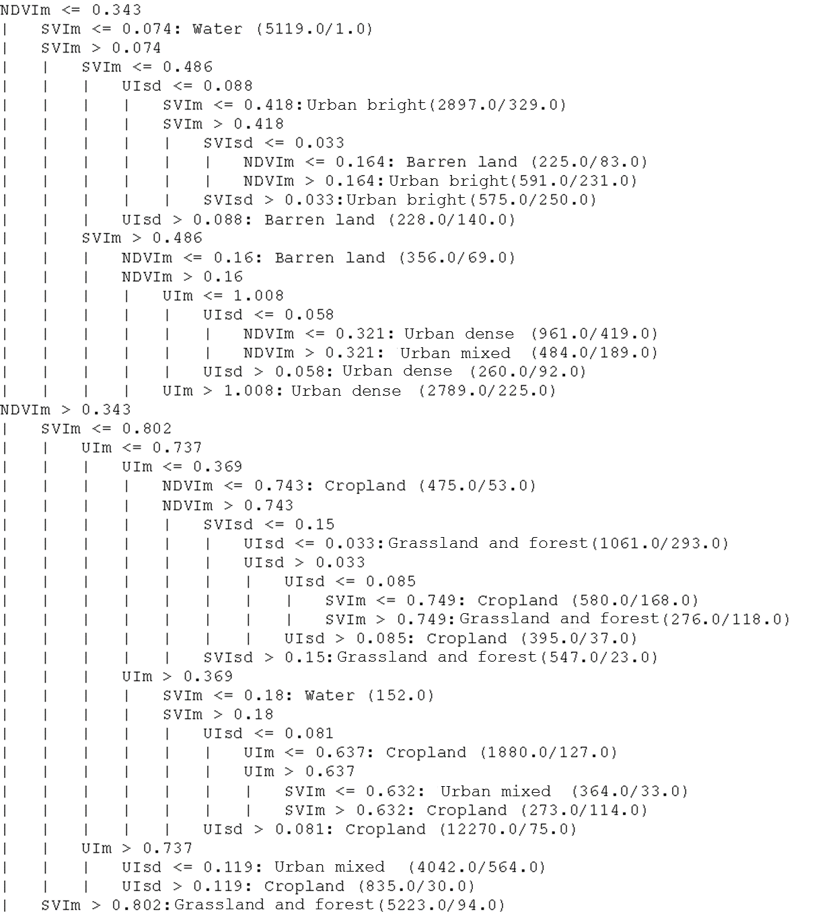
NDVIm = multi-temporal average of NDVI scores; NDVIsd = multi-temporal standard deviation of NDVI scores; SVIm = multi-temporal average of SVI scores; SVIsd = multi-temporal standard deviation of SVI scores; UIm = multi-temporal average of UI scores; UIsd = multi-temporal standard deviation of UI scores.
Figure S1. Classification tree rules used for producing land cover maps starting from multi-temporal Landsat features for each time step investigated, following the approach proposed by Villa et al. (2014).

Satellite-derived land cover maps accuracy
Table S2 shows synthetic accuracy metrics of land cover maps derived from satellite data, calculated through 10-fold cross-validation over the multi-temporal reference sample pooling together all three-time steps (1993, 2003, and 2014). Urban land cover classes score per-class accuracy (CA) in the range 81.9-83.9%, while other classes have higher CA (93.5-98.1%), with the exception of Barren land (mostly confused with Urban dense class, and covering a very limited extension of the study areas). In summary, the OA is 90.0% (Kappa=0.870) and the three urban land cover classes merged together score a CA of 92.3%. Errors in satellite-derived urban feature mapping over urban (and peri-urban) areas are therefore limited to 8%, which are considered generally acceptable in remote sensing classification practice. An example of urban land cover misclassification, falling within this 8% error margin, is shown in Figure S2.
Table S3. Satellite-derived land cover maps accuracy metrics (1993-2003-2014 pooled reference sample).
Land Cover class (1993-2014) | CA  (7 land cover classes) | CA  (Urban-Non urban scheme) | OA (Kappa)
Urban dense | 82.6% | 92.5% | 90.4%  (0.876)
Urban mixed | 84.2% | 92.5% | 90.4%  (0.876)
Urban bright | 83.9% | 92.5% | 90.4%  (0.876)
Cropland | 95.4% | 96.9% | 90.4%  (0.876)
Grassland and forest | 93.8% | 96.9% | 90.4%  (0.876)
Barren land | 37.9% | 96.9% | 90.4%  (0.876)
Water | 98.4% | 96.9% | 90.4%  (0.876)

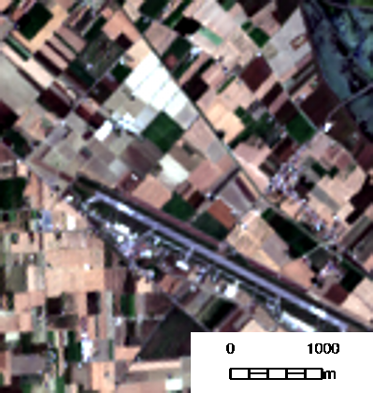a)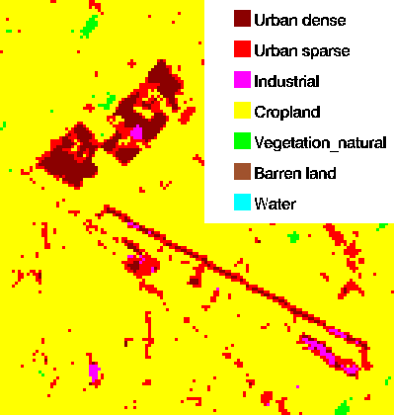b)
Figure S2. Example of land cover classification error, showing the area surrounding Cervia military airport (in SA3: 44°13′29″N, 12°18′25″E): a) true colour composition derived from Landsat 8 OLI scene acquired on July 17th, 2015; b) Land cover map derived for the time step 2013-2015 using the described method. Some fields belonging to a farm that cultivates vegetables and covered with greenhouses and plastic tendons (appearing very bright in colour) are erroneously mapped as Urban dense cover, because of their spectral and temporal features are very different to those typical of cropland.

Land cover maps accuracy assessment was also independently per each time step, to check whether any difference exists in overall or class-specific accuracies for different time steps, compared with the accuracy calculated by pooling together land cover reference sample for all time steps (Table S3). For doing this, we split the land cover multi-temporal reference pooled sample into three different samples, one per each time step. Each time step-specific sample is composed by 14,286 labelled pixels, with 560 points for the smallest class (Barren land) and 5600 points for the largest class (Cropland). Again, for each time step we calculated the land cover maps accuracy metrics, deriving the Overall Accuracy (OA), Kappa coefficient (Kappa), and each class accuracy according to F-measure (CA).
Table S4. Satellite-derived land cover maps accuracy metrics calculated per each time step.
Land Cover class (1993) | CA  (7 land cover classes) | CA  (Urban-Non urban scheme) | OA (Kappa)
Urban dense | 85.4% | 92.7% | 91.2%  (0.886)
Urban mixed | 85.3% | 92.7% | 91.2%  (0.886)
Urban bright | 85.6% | 92.7% | 91.2%  (0.886)
Cropland | 95.3% | 97.0% | 91.2%  (0.886)
Grassland and forest | 93.6% | 97.0% | 91.2%  (0.886)
Barren land | 37.0% | 97.0% | 91.2%  (0.886)
Water | 99.7% | 97.0% | 91.2%  (0.886)
Land Cover class (2003) | CA  (7 land cover classes) | CA  (Urban-Non urban scheme) | OA (Kappa)
Urban dense | 82.3% | 92.6% | 90.3%  (0.875)
Urban mixed | 84.5% | 92.6% | 90.3%  (0.875)
Urban bright | 85.9% | 92.6% | 90.3%  (0.875)
Cropland | 94.9% | 96.9% | 90.3%  (0.875)
Grassland and forest | 94.5% | 96.9% | 90.3%  (0.875)
Barren land | 38.7% | 96.9% | 90.3%  (0.875)
Water | 96.0% | 96.9% | 90.3%  (0.875)
Land Cover class (2014) | CA  (7 land cover classes) | CA  (Urban-Non urban scheme) | OA (Kappa)
Urban dense | 83.5% | 92.4% | 90.9%  (0.883)
Urban mixed | 83.0% | 92.4% | 90.9%  (0.883)
Urban bright | 84.3% | 92.4% | 90.9%  (0.883)
Cropland | 95.9% | 96.9% | 90.9%  (0.883)
Grassland and forest | 94.3% | 96.9% | 90.9%  (0.883)
Barren land | 38.4% | 96.9% | 90.9%  (0.883)
Water | 99.0% | 96.9% | 90.9%  (0.883)

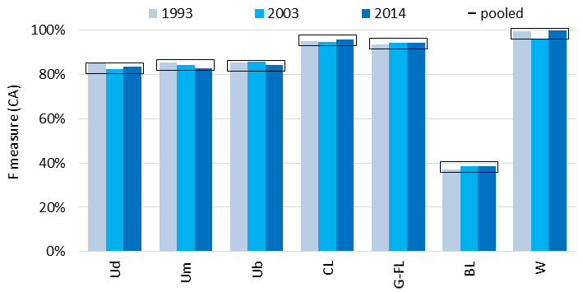
Figure S3. Comparison of Class accuracy metrics derived separately per each time step and with the pooled sample joining 1993-2003-2014 reference data.

Table S4 show that no particular difference in land cover maps accuracy is found at both Level 1 (7 classes) - with OA ranging from 90.3% to 91.2%, Kappa ranging from 0.875 to 0.886, compared to OA and Kappa computed using the pooled 1993-2003-2014 sample of 90.4% and 0.876, respectively – and Level 0 (i.e. Urban-Non urban binary map) - with OA ranging from 95.6 to 95.7%, Kappa ranging from 0.894 to 0.896, compared to OA and Kappa computed using the pooled 1993-2003-2014 sample of 95.6% and 0.893, respectively. Class specific performance too (Figure S3) is similar across the three time steps, and compared to the CA calculated using the pooled sample.

UFC product accuracy at 500 m resolution
A quantitative assessment of the intermediate UFC product error at 500 m resolution was run, after preparation of a reference dataset of UFC at 30 m resolution over the three most representative cities in our study areas (Piacenza for SA1, Reggio Emilia for SA2, and Rimini for SA3). The reference UFC dataset was done by photointerpretation of true colour composites of Landsat images and Google Earth high resolution satellite images acquired within the 2003 time step range (2002-2004), attributing a value of 1 to dense urban fabric and big industrial and commercial instalments and of 0.5 to sparse residential areas of mixed urban fabric. The UFC reference dataset was then resampled at 500m and compared to the UFC product (UFC map) for 2003 time step, derived from satellite data using the approach implemented by Villa et al. (2014).
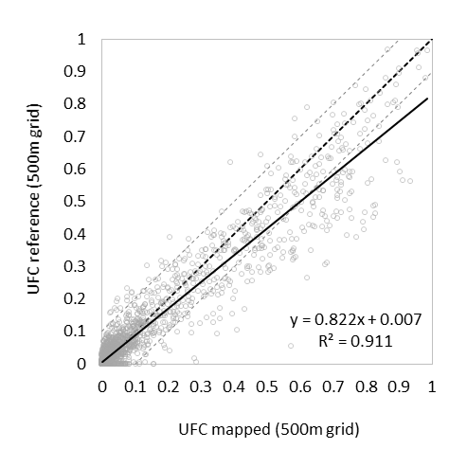
Figure S4. Comparison UFC mapped from satellite data at 500 m resolution with reference UFC derived from photointepretation of true colour composites and Google Earth high resolution images, over the three main cities in our Study Areas (2003 time step).

As the scatter plot in Figure S4 shows, at 500m the UFC mapped and UFC reference are very consistent with each other (R2=0.91). UFC mapped tends to overestimate a little the photointerpreted UFC used as reference, being the reference vs. mapped (ref/map) regression line slope = 0.82. The average bias between UFC mapped and UFC reference calculated as 0.017, but this tendency is mainly due to high UFC values. For UFC values < 0.3, by far the largest part of scores at 500m resolution for this comparison, the overestimation is less accentuated, and overall mismatch between the two UFC is contained within acceptable error values (MAE=0.038, rRMSE=0.582). The tendency towards slightly overestimating UFC is consistent with the error balance of Urban land cover classes that see higher commission than omission errors (10-11% and 4-5%, respectively).

C stocks and land use
C stock specific intensity per land use type was calculated by extracting statistics of Co_soil 2003 and Cc_built-up 2003 mapped values of our three study areas over major land use types identified in the official land use map of Emilia-Romagna region, produced through aerial orthoimages photointerpretation for the reference year 2003. Soil organic carbon stocks are higher in green spaces (55.4±0.9 Mg ha⁻¹) and agricultural areas (54.3±0.5 Mg ha⁻¹), and tend to decrease with increasing soil sealing, going from peri-urban, discontinuous residential fabric (54.2±0.6 Mg ha⁻¹), through service and industrial infrastructure (42.5±0.6 Mg ha⁻¹), up to dense urban fabric (38.7±0.6 Mg ha⁻¹). Conversely, C stocks in concrete and built-up structures follow an inverse trend, increasing from negligible average values over non-urbanized land cover (0.6-1.0 Mg ha⁻¹ on average for cropland, grassland and forest), to peri-urban residential areas (9.4±0.4 Mg ha⁻¹), dense urban areas (33.0±0.6 Mg ha⁻¹), and peaking at 36.2±0.8 Mg ha⁻¹ for industrial and service infrastructure. From box plots shown in Figure S3 it appears that while the distribution of Co_soil values is around normal for all classes, Cc_built-up distributions are in general positively skewed (except for dense urban and industrial areas); deviations from normality is even more marked for Cc/Co scores.
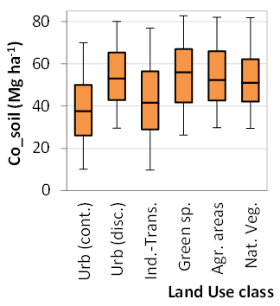 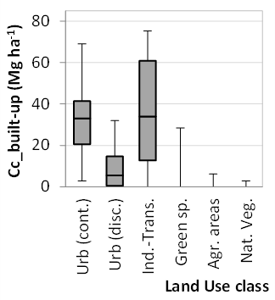 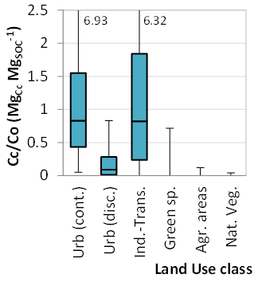Urb (cont.) = continuous urban fabric, Urb (disc.) = discontinuous urban fabric, Ind. Trans. = Industrial, commercial and transport infrastructures, Green sp. = Urban parks and recreational spaces, Agr. areas = Agricultural areas, Nat. veg. = Forest and natural vegetation areas.
Figure S5. Box plots (5-25-50-75-95 percentiles) of modelled C stocks values for different land use types (Emilia-Romagna official land use map) for reference time step 2003.

C stocks for typical urban area structures
C stock specific intensity per land use type was calculated by extracting statistics of Co_soil 2003 In order to ease the visualization of the upscaling process from 30 m Landsat data to 500 m C stock maps and its effect over urban area fabric mixtures, Figure S6 show some examples of satellite data and derived products at different resolutions over three detail areas of 1500m x 1500m within the Piacenza municipality (SA1), representing the structural features of Urban dense, Urban bright and Urban mixed land cover classes.
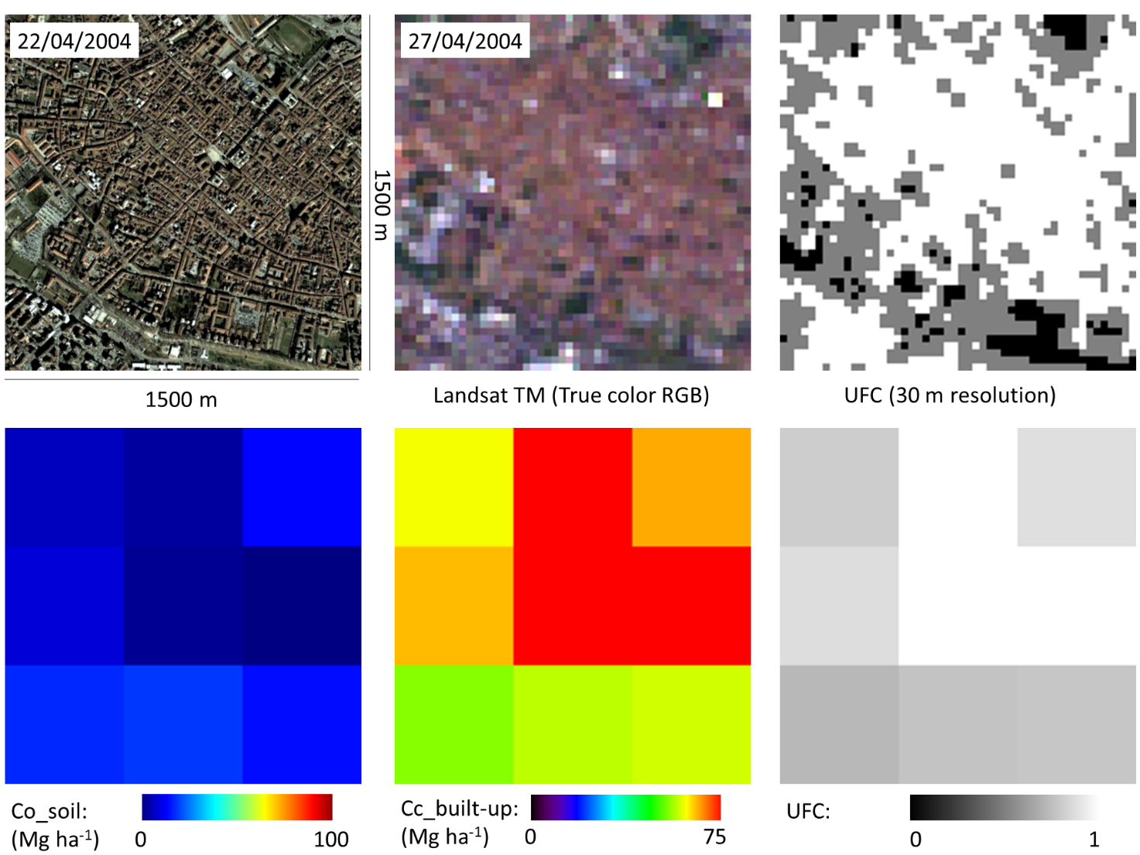a)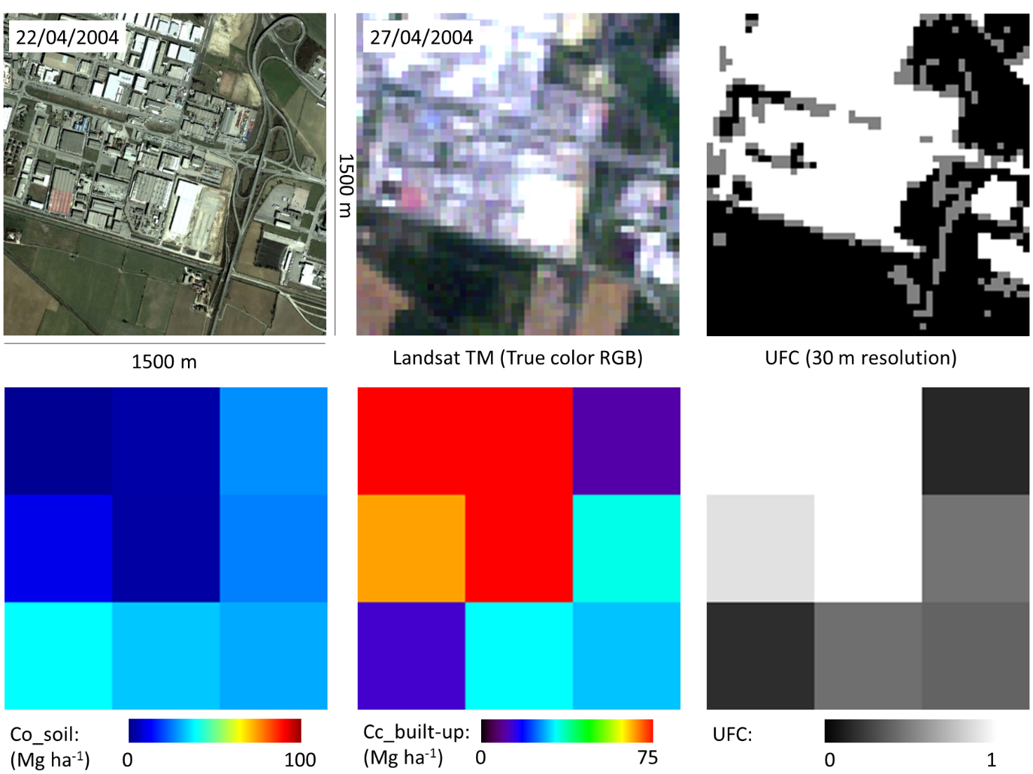b)
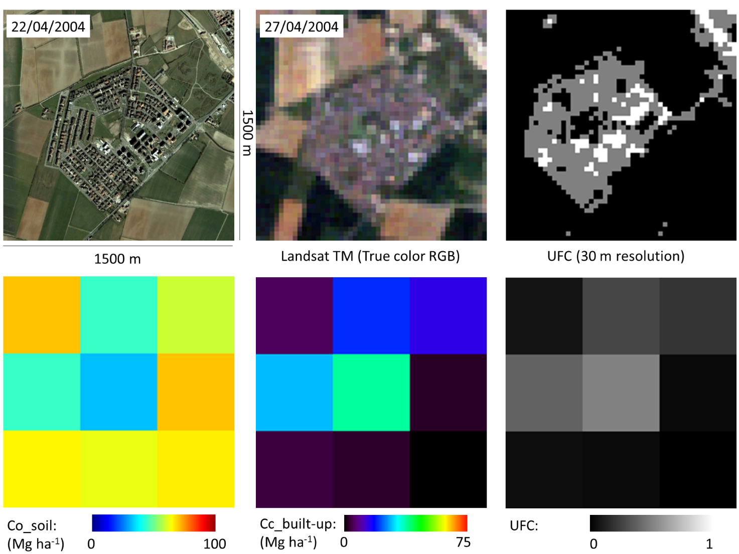c)
Figure S6. Example of satellite data and derived products at different resolutions over the city of Piacenza: a) urban dense fabric, representing the structural features of Urban_dense land cover class (Piacenza city centre: 45°3'11"N, 9°41'50"E); b) industrial and commercial area, representing the structural features of Urban bright land cover class (Caorsana district: 45°02'29"N, 9°44'35"E); c) peri-urban residential area, representing the structural features of Urban mixed land cover class (Besurica district: 45°02'07"N, 9°39'51"E).
Table S5. Soil sealing change and Sprawl/Densification ratio (SDR) scores in 1993-2003 and 2003-2014 for each municipality in the three study areas.
 |  | 1993-2003 |  |  |  |  | 2003-2014
Area | Municipality | NC | NewSU | NewCU | DenU | SDR | NC | NewSU | NewCU | DenU | SDR
SA1 | Cadeo | 96.0% | 2.9% | 0.1% | 1.1% | 2.64 | 95.1% | 3.1% | 0.4% | 1.4% | 2.30
SA1 | Calendasco | 95.7% | 3.5% | 0.2% | 0.7% | 5.30 | 94.7% | 3.2% | 1.0% | 1.1% | 2.91
SA1 | Caorso | 95.2% | 3.3% | 0.3% | 1.3% | 2.62 | 93.8% | 2.7% | 1.1% | 2.4% | 1.11
SA1 | Cortemaggiore | 96.4% | 2.3% | 0.3% | 1.1% | 2.21 | 94.1% | 2.7% | 1.1% | 2.1% | 1.31
SA1 | Gossolengo | 95.7% | 2.7% | 0.3% | 1.4% | 1.97 | 91.3% | 4.3% | 1.7% | 2.7% | 1.59
SA1 | Gragnano Tr. | 94.9% | 3.7% | 0.6% | 0.9% | 4.28 | 94.4% | 2.8% | 0.7% | 2.1% | 1.34
SA1 | Piacenza | 90.3% | 3.8% | 1.5% | 4.4% | 0.85 | 88.8% | 3.4% | 2.1% | 5.7% | 0.61
SA1 | Podenzano | 93.4% | 3.0% | 0.6% | 3.0% | 0.98 | 93.6% | 2.4% | 1.0% | 3.0% | 0.78
SA1 | Pontenure | 94.7% | 2.8% | 0.5% | 2.0% | 1.44 | 91.4% | 3.4% | 1.8% | 3.4% | 0.99
SA1 | Rottofreno | 90.6% | 4.8% | 1.7% | 2.9% | 1.66 | 92.3% | 3.4% | 0.9% | 3.4% | 1.01
SA1 | S. Pietro in C. | 97.8% | 1.8% | 0.0% | 0.4% | 4.08 | 97.0% | 2.3% | 0.3% | 0.5% | 4.92
 | TOT | 93.8% | 3.2% | 0.7% | 2.3% | 1.43 | 92.5% | 3.1% | 1.3% | 3.1% | 0.99
SA2 | Correggio | 95.9% | 2.4% | 0.4% | 1.3% | 1.85 | 94.9% | 2.4% | 0.7% | 2.0% | 1.22
SA2 | Quattro C. | 93.4% | 3.9% | 0.4% | 2.4% | 1.63 | 95.3% | 2.4% | 0.4% | 1.9% | 1.24
SA2 | Reggio Emilia | 94.0% | 3.3% | 0.4% | 2.3% | 1.44 | 94.7% | 2.5% | 0.4% | 2.4% | 1.00
SA2 | Rubiera | 89.7% | 4.7% | 2.1% | 3.6% | 1.30 | 93.4% | 2.2% | 0.3% | 4.1% | 0.53
SA2 | S. Martino R. | 94.4% | 3.5% | 0.3% | 1.8% | 2.02 | 94.9% | 2.5% | 0.3% | 2.3% | 1.07
SA2 | Scandiano | 92.8% | 4.1% | 0.4% | 2.7% | 1.51 | 92.2% | 3.2% | 1.0% | 3.7% | 0.88
SA2 | Bastiglia | 96.7% | 1.0% | 0.2% | 2.1% | 0.50 | 93.7% | 1.9% | 1.1% | 3.4% | 0.56
SA2 | Campogalliano | 94.2% | 3.0% | 0.8% | 2.0% | 1.51 | 95.9% | 1.9% | 0.2% | 2.0% | 0.97
SA2 | Carpi | 95.9% | 2.4% | 0.4% | 1.4% | 1.75 | 93.8% | 2.4% | 1.2% | 2.7% | 0.89
SA2 | Castelnuovo R. | 92.0% | 3.8% | 0.7% | 3.5% | 1.06 | 92.2% | 3.2% | 1.0% | 3.6% | 0.88
SA2 | Formigine | 92.5% | 3.8% | 0.5% | 3.2% | 1.18 | 92.2% | 3.3% | 0.7% | 3.9% | 0.84
SA2 | Albinea | 96.0% | 2.3% | 0.4% | 1.3% | 1.78 | 96.4% | 1.8% | 0.2% | 1.6% | 1.15
SA2 | Bagnolo in P. | 97.5% | 1.6% | 0.1% | 0.8% | 1.87 | 97.5% | 1.2% | 0.3% | 1.0% | 1.22
SA2 | Cadelbosco di S. | 96.5% | 2.0% | 0.3% | 1.1% | 1.80 | 96.3% | 1.9% | 0.5% | 1.3% | 1.42
SA2 | Casalgrande | 89.5% | 4.0% | 1.8% | 4.7% | 0.85 | 89.7% | 3.2% | 1.4% | 5.7% | 0.56
SA2 | Cavriago | 92.1% | 3.5% | 0.7% | 3.7% | 0.94 | 94.1% | 2.0% | 0.8% | 3.1% | 0.65
SA2 | Modena | 90.8% | 4.1% | 0.9% | 4.2% | 0.98 | 90.8% | 2.9% | 1.1% | 5.1% | 0.58
SA2 | Soliera | 96.2% | 1.9% | 0.4% | 1.4% | 1.35 | 95.9% | 1.4% | 0.9% | 1.8% | 0.78
 | TOT | 93.8% | 3.2% | 0.6% | 2.5% | 1.29 | 93.8% | 2.5% | 0.7% | 3.0% | 0.82
SA3 | Cervia | 95.9% | 1.2% | 0.3% | 2.6% | 0.47 | 90.7% | 3.1% | 1.1% | 5.1% | 0.61
SA3 | Bertinoro | 97.9% | 0.8% | 0.1% | 1.3% | 0.63 | 92.8% | 3.3% | 1.0% | 2.8% | 1.18
SA3 | Cesena | 94.4% | 2.6% | 0.3% | 2.8% | 0.94 | 85.7% | 6.2% | 1.4% | 6.6% | 0.93
SA3 | Cesenatico | 95.9% | 1.7% | 0.1% | 2.4% | 0.70 | 84.9% | 7.2% | 0.9% | 7.0% | 1.03
SA3 | Gambettola | 91.9% | 2.1% | 0.2% | 5.7% | 0.36 | 77.5% | 7.8% | 2.0% | 12.7% | 0.62
SA3 | Gatteo | 95.7% | 1.9% | 0.3% | 2.2% | 0.84 | 78.6% | 9.6% | 2.9% | 8.9% | 1.07
SA3 | Longiano | 92.5% | 2.0% | 1.0% | 4.6% | 0.44 | 77.6% | 7.1% | 4.2% | 11.1% | 0.64
SA3 | S. Mauro P. | 94.6% | 2.4% | 0.1% | 2.9% | 0.80 | 83.3% | 7.1% | 1.9% | 7.7% | 0.92
SA3 | Savignano sul R. | 92.9% | 2.5% | 0.7% | 3.8% | 0.67 | 81.3% | 7.3% | 1.4% | 10.0% | 0.74
SA3 | Bellaria-Igea M. | 92.5% | 2.7% | 0.3% | 4.5% | 0.60 | 85.6% | 5.5% | 0.8% | 8.1% | 0.68
SA3 | Riccione | 92.8% | 1.2% | 0.0% | 6.1% | 0.20 | 81.6% | 3.1% | 2.3% | 13.0% | 0.24
SA3 | Rimini | 92.9% | 2.1% | 0.3% | 4.6% | 0.46 | 84.4% | 5.1% | 1.5% | 9.0% | 0.57
SA3 | Santarcangelo R | 93.7% | 3.6% | 0.1% | 2.6% | 1.36 | 87.2% | 6.0% | 1.0% | 5.9% | 1.01
SA3 | Verucchio | 88.3% | 3.3% | 0.2% | 8.3% | 0.40 | 90.2% | 1.4% | 0.6% | 7.7% | 0.18
 | TOT | 94.3% | 2.1% | 0.3% | 3.3% | 0.65 | 85.6% | 5.6% | 1.4% | 7.4% | 0.76

