APPENDIX A

 (A.1)

 (A.2)

 (A.3)

 (A.4)

 (A.5)

 (A.6)

 (A.7)

 (A.8)

 (A.8)

APPENDIX B

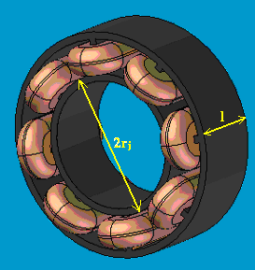

Fig. B.1: Radial active magnetic bearing.

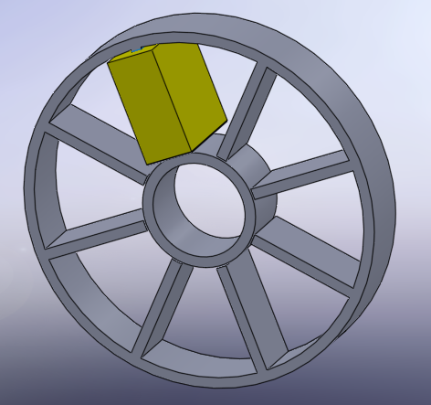

Fig. B.2: Radial active magnetic bearing for .



Fig. B.3: Coil winding, axial length, pole width, pole surface and coil’s cross surface of radial active magnetic bearing for .



Fig. B.4: Variation of inner and outer radius of radial active magnetic bearing when .



Fig. B.5: Changing rate of ironclad magnet and stator volume of radial AMB for.



Fig. B.6: Force versus control current of radial active magnetic bearing with.

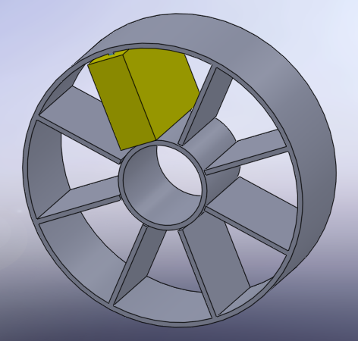

Fig. B.7: Radial active magnetic bearing for .

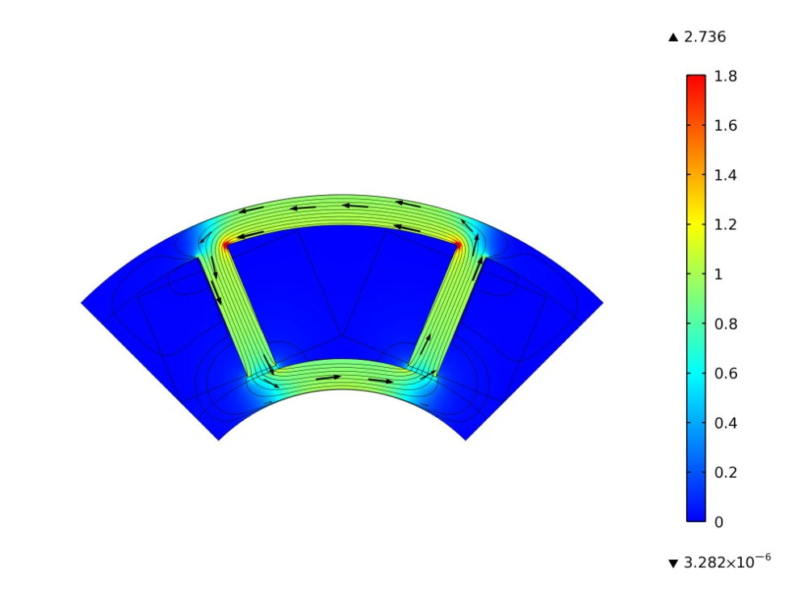

Fig. B.8: Quarter view of radial active magnetic bearing with built up with .

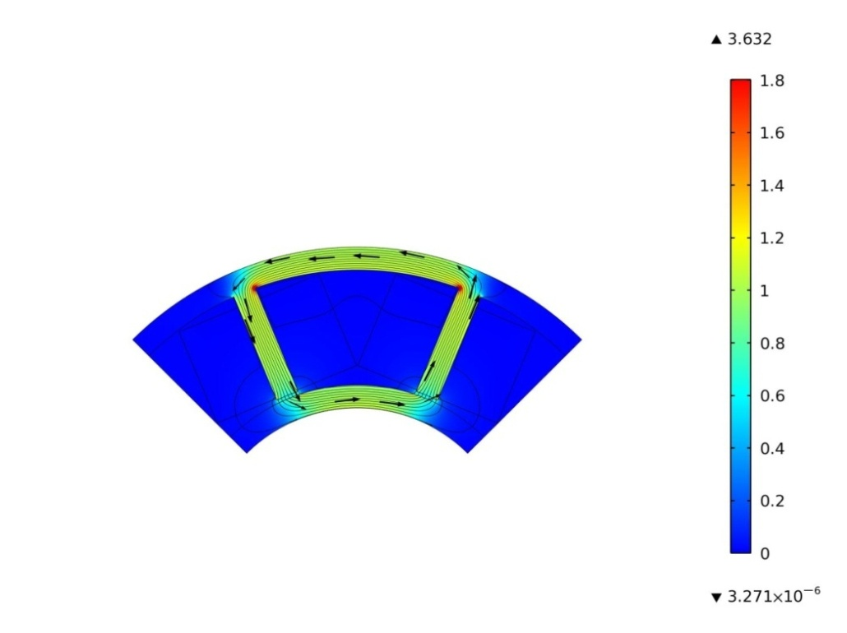Fig. B.9: Quarter view of radial active magnetic bearing with built up with .

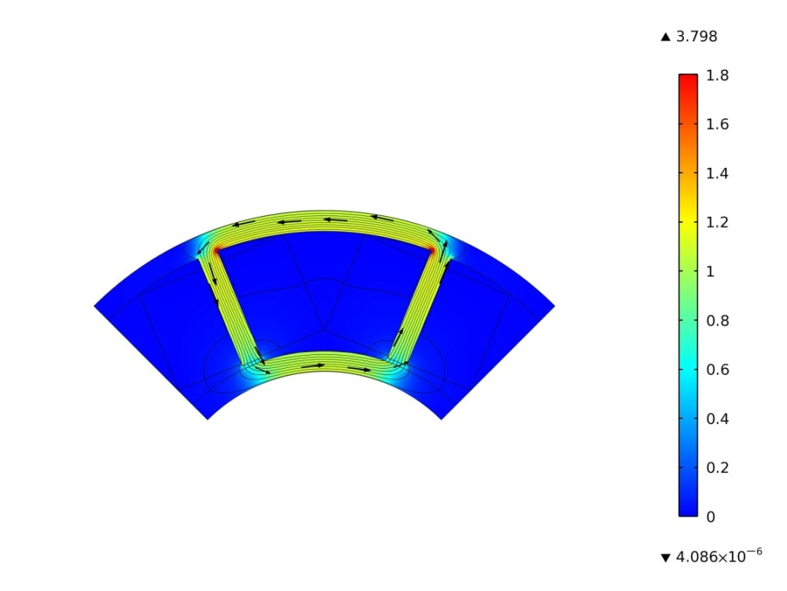

Fig. B.10: Quarter view of radial active magnetic bearing with built up with .

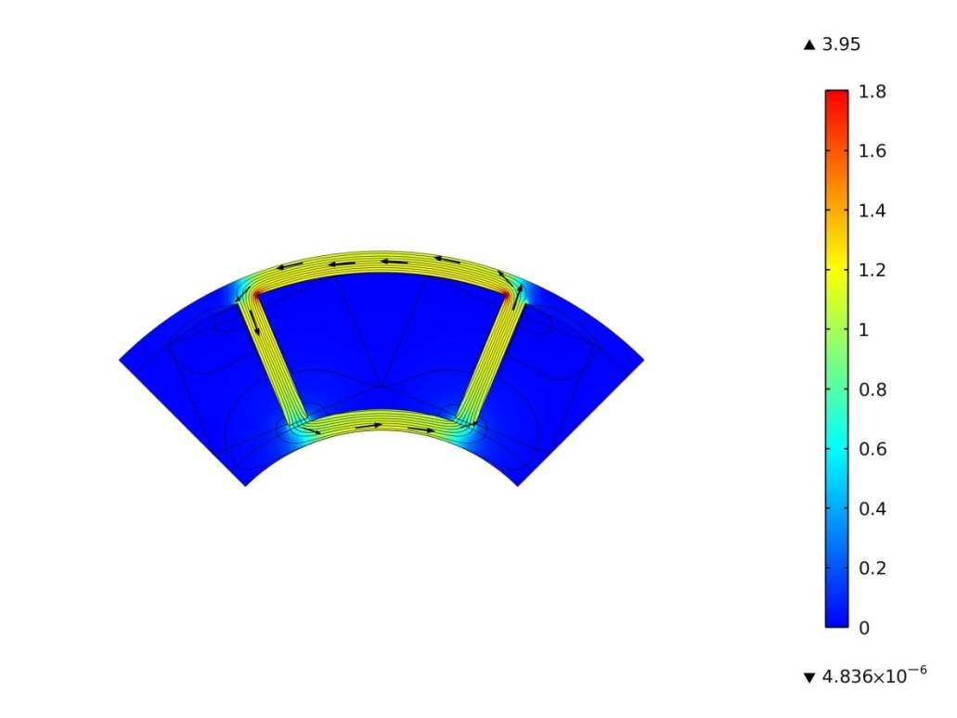

Fig. B.11: Quarter view of radial active magnetic bearing with built up with .

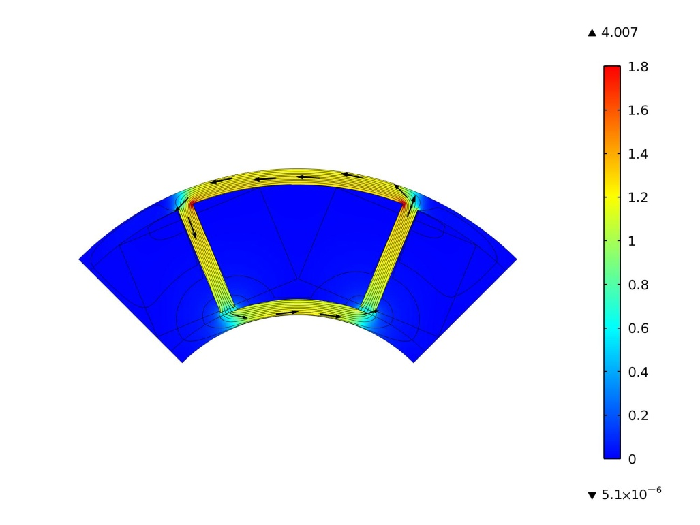

Fig. B.12: Quarter view of radial active magnetic bearing with built up with .

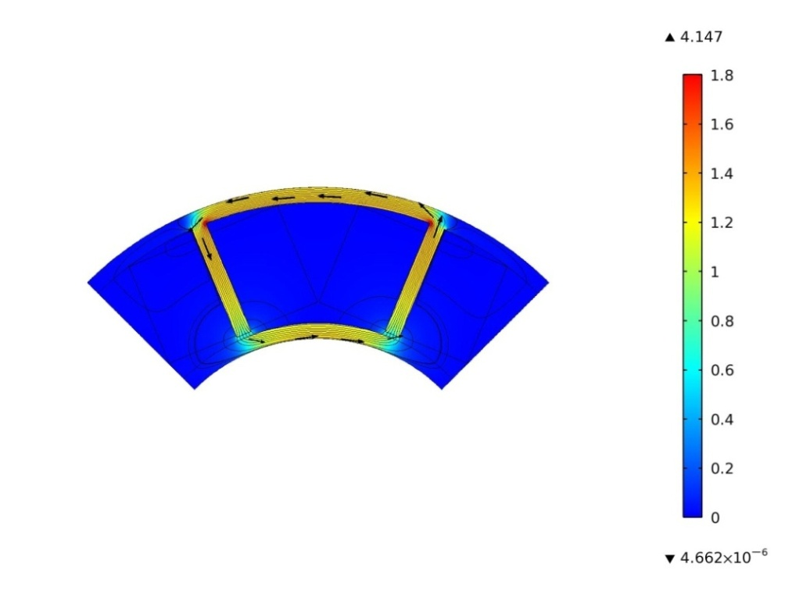

Fig. B.13: Quarter view of radial active magnetic bearing with built up with .