Blue-light-driven photoactivity of L-cysteine-modified Graphene Quantum dots and their antibacterial effects
Mila Milenkovićª, Gabriele Ciasca^{b}, Aurelio Bonasera^{c,d}, Michelangelo Scopelliti^{c,d,e}, Olivera Marković^{f}, Tatjana Verbić^{g}, Biljana Todorović Markovićª , Svetlana Jovanovićª
ª Vinča Institute of Nuclear Sciences-National Institute of the Republic of Serbia, University of Belgrade, P.O. Box 522, 11000 Belgrade, Serbia
^{b} Istituti Biologici –Istituto di Fisica, Università Cattolica del Sacro Cuore, largo Francesco Vito 1, 00168 Roma, Italy
^{c} Department of Physics and Chemistry - Emilio Segrè - University of Palermo, viale delle Scienze 17, 90128 Palermo, Italy
^{d} Consorzio Interuniversitario Nazionale per la Scienza e Tecnologia dei Materiali (INSTM) - Palermo Research Unit, viale delle Scienze 17, 90128 Palermo, Italy
^{e} Laboratorio Superfici, Film Sottili e Dispositivi, ATeN Center, University of Palermo, viale delle Scienze 18/A, 90128 Palermo, Italy
^{f} University of Belgrade – Institute of Chemistry, Technology and Metallurgy, Department of Chemistry, Njegoševa 12, 11000 Belgrade, Serbia
^{g} University of Belgrade – Faculty of Chemistry, Studentski trg 12-16, 11000 Belgrade, Serbia

Abstract
The widespread abuse of traditional antibiotics has led to a global rise in antibiotic-resistant bacteria, which give in return unprecedented health risks. Therefore, there is a large and urgent need for the development of new, smart antibacterial agents able to efficiently kill or inhibit bacterial growth. In this study, we investigated the antibacterial activity of S, N-doped Graphene Quantum Dots (GQDs) as a light-triggered antibacterial agent. Gamma irradiation was employed as a tool to achieve one-step modification of GQDs in the presence of L-cysteine amino acid as a source of heteroatoms. X-ray Photoelectron Spectroscopy (XPS), nuclear magnetic resonance (NMR), and zeta potential measurements provided the necessary data to clarify the structure of modified dots and verify the introduction of both S- and N-atoms in GQDs structure, but also severe changes in the aromatic, sp² domains. Namely, γ-irradiation caused a bonding of S atoms in 1.14 at% mainly as thiol groups, and N in 1.81 at% as amino groups, but sp² contribution in GQD structure was lowered from 63.00 to 4.86 at%, as measured in dots irradiated at a dose of 200 kGy. Fluorescence quenching measurements showed that L-cysteine-modified dots are able to bind to human serum albumin. The antibacterial activity of GQDs combined with 1 and 6 hours of blue light (470 nm) irradiation was tested against 8 bacterial strains. GQD-cys-25 sample provided the best results, with minimum inhibitory concentration (MIC) as low as 125 μg/mL against S. Aureus, E. Faecalis, and E. Coli after only 1 hour of blue light exposure.

Keywords: Graphene quantum dots; antibacterial activity; photodynamic therapy; singlet oxygen production.

1. Introduction
Every year, millions of people are impacted by bacterial infections, which are a significant global health concern due to the more recurring antibiotic-resistant bacterial strains [1]. To address this issue, antibacterial agents such as antibiotics, metal ions, and quaternary ammonium compounds are extensively utilized to inhibit bacterial growth and disrupt their structures [2]. However, the rising antibiotic resistance demands the urgent development of more efficient antibacterial agents. Among others, graphene quantum dots (GQDs) seem to be a promising candidate for antibacterial therapy [3-5].
As a new member of the carbon nanostructures material family, GQDs have funneled unprecedented attention because of their exceptional properties such as tunable photoluminescence [6, 7], diverse possibilities for functionalization [8, 9], photostability [10], biocompatibility [11], nontoxicity [12], high chemical inertness as well as long-term resistivity to photobleaching [13]. These zero-dimensional (0-D) nanostructures consist of single or few-atom-thick sheets of sp² hybridized carbon atoms, with lateral dimensions below 100 nm [6]. GQDs properties are dependent on their size, making them highly adaptable for a wide range of applications. Thus, GQDs are investigated for their applications in a broad range of research fields, such as electronics [14], optoelectronics [15], biomedical imaging [16], drug delivery systems [17], catalysis [18], sensors [19], and others [20, 21]. Compared to graphene, GQDs have distinct advantages such as tunable bandgap, dispersibility in polar organic solvents and water, photoluminescence, and various functional groups available for structural modification [22, 23]. Due to low toxicity, and good dispersibility in water, GQDs are highly suitable for biomedical applications [24-26]. The photostability and tunable photoluminescence (PL) of these nanomaterials position them as highly effective bioimaging agents. To this extent, it has been widely reported the monitoring and visualization of the targeted delivery and release of anticancer drugs [17, 27, 28]. The PL properties of GQDs can be affected by the synthetic method, chemical composition, and surface passivation techniques [29].
In this study, the photo-induced antibacterial activity of S, N-doped GQDs was investigated. Gamma (γ) irradiation was selected to modulate GQD's structure due to the low consumption of chemicals needed for structural modification and avoidance of the use of aggressive chemical reagents for modification, as well as a time-saving approach [30]. Namely, in only one synthetic step, GQDs were doped using exclusively the L-cysteine amino acid as a source of heteroatoms. Furthermore, the reactive radicals formed during γ irradiation were quenched immediately after they were removed from the radiation source, avoiding the need for complex cleaning procedures and high-price storage of reactive residual reagents [31]. Our previous studies showed that both graphene and carbon quantum dots (CQDs) induce the death of bacterial cells when they are exposed to light [3, 32-34]. A notable impact on the viability of Escherichia coli or Staphylococcus aureus was not observed when bacterial cells were exposed to the high GQDs concentration (200 μg/mL) alone or solely to blue light. However, when the bacteria were exposed to both GQDs (200 μg/mL) and light simultaneously, there was a significant reduction in their viability [3]. In another study, it was shown that N-doped CQDs displayed the most potent antibacterial activity against Enterobacter aerogenes, Proteus mirabilis, Staphylococcus saprophyticus, Listeria Monocytogenes, Salmonella typhimurium, Klebsiella pneumoniae compared to graphene oxide (GO), GQDs and CQDs [34]. Thus, γ irradiation was used as a tool to modulate GQDs structure, to achieve doping with S- and N-atoms, and improving the photoinduced antibacterial activity of GQDs. The interactions between GQDs and human serum albumin (HSA) were investigated as well. HSA investigations were developed considering that this is the most abundant transport protein in blood circulation [35]. Understanding HSA-drug interactions is important for pharmacokinetic and pharmacodynamic drug profiling. Furthermore, drug binding to HSA can be altered in certain diseased states. Thus, information about HSA-drug interactions can be a useful tool for establishing optimal therapy.

2. Experimental
2.1. Synthesis of pristine GQDs and γ-irradiated GQDs
GQDs were synthesized by using electrochemical oxidation of graphite electrodes and modified by γ irradiation in the presence of 2 wt% L-cysteine, and 1 vol% isopropyl alcohol (IPA) using procedures described in a previous research paper [36]. Obtained samples were γ irradiated with the dose of γ irradiation 25 kGy, 50 kGy, and 200 kGy, respectively. After irradiation, samples were dialyzed and the remaining solvent was removed to dryness under reduced pressure. These samples are labeled as GQD-cys-25, GQD-cys-50, and GQD-cys-200, respectively to the applied γ irradiated dose. Dots that were not exposed to γ irradiation were named pristine GQDs and cited in the paper as p-GQDs.
2.2. Methods
2.2.1. ζ-potential
ζ-potential was determined using the Zetasizer Nano ZS instrument (Malvern, Herrenberg, Germany). Equipped with a 633 nm He-Ne laser as the light source, the instrument measured particle size at a scattering angle of 173°. ζ-potential of the p-GQDs and γ irradiated samples were obtained by the Z-sizer data-analysis software using the Henry equation with the Smoluchowski approximation [37]. The average number of measurements for zeta-potential investigation per sample was ten and the data are reported as mean ± 95% confidence interval Cl.
2.2.2. X-ray Photoelectron Spectroscopy (XPS)
X-ray Photoelectron Spectroscopy (XPS) technique was used for the chemical analysis of samples and it was conducted on a ULVAC-PHI PHI500 VersaProbe II scanning microprobe (ULVAC-PHI) using an Al Kα source (1486.6 eV), focusing the beam to a diameter of 100 μm (25 W) using both positive (Ar⁺) and negative (e⁻) charge neutralization, using a 45° electron take-off angle.
2.2.3. NMR
¹H- and ¹³C-NMR spectra were recorded on a Bruker Avance II 300 MHz spectrometer. GQD-cys-25, GQD-cys-50, and GQD-cys-200 samples were prepared by dissolution of the corresponding powder sample in DMSO-d₆; 128 scans were recorded for each spectrum acquisition.
2.2.4. Binding to Human Serum Albumin
HSA was purchased from Sigma Aldrich (Merck). Stock solutions of human serum albumin (c=(3.31–4.30)×10⁻⁴ M) were prepared in saline phosphate buffer (ctot=31.8 mM, pH 7.40). Stock solution of p-GQD and GQD–cys–25 (c=0.25 mg/mL) was prepared in Millipore water.
For HSA/p-GQD and HSA/GQD–cys-25 interaction studies, HSA solution (c=5×10⁻⁷ M) was prepared by dilution of HSA stock solution with saline phosphate buffer. After that, the HSA solution was titrated with 0.25 mg/mL GQD-cys-25 solution. During the titration, the solution was thermostated and stirred for 15 min between increment additions. This experiment was performed at three temperatures: 25.0±0.1°C, 30.0±0.1°C and 37.0±0.1°C.
Fluorescence spectra were recorded on Horiba Jobin Yvon Fluoromax-4 spectrometer, equipped with a Peltier thermocouple drive for sample temperature control and magnetic stirrer for quartz cell (1 cm path length, 4 mL volume). The excitation wavelength was 280 nm and fluorescence spectra were recorded in the 300 – 450 nm wavelength range. Integration time was set to 0.1 s. The width of the slits on both excitation and emission monochromators was 5 nm.
UV–Vis spectra were recorded on Amersham Biosciences Ultrospec 6300 pro spectrophotometer in the 200 – 500 nm wavelength range. The scan speed was 1856 nm/min. A quartz cell with a 1 cm path length and 4 mL volume was used.
The Crison pH-Burette 24 2S equipped with a Hach pH electrode 52 09 was used to measure the pH values. The pH electrode was calibrated with standard Hach buffer solutions (pH 4.01, 7.00, and 9.21).
The Stern–Volmer equation (Eq. 1) was used for processing fluorescence quenching data [38]:
$\frac{{\text{F}}_{\text{0}}}{\text{F}}\text{=1+}{\text{K}}_{\text{SV}}\text{[}\text{Q}\text{]}$ Eq. 1
F₀ and F correspond to the fluorescence intensities of HSA in the absence and the presence of the quencher, respectively. The Stern–Volmer quenching constant is represented by K_{SV}, and the concentration of the quencher by [Q].
2.2.5. Antibacterial activity
The minimum inhibitory concentration (MIC) values were determined according to the standard broth micro-dilution assays, recommended by the National Committee for Clinical Laboratory Standards for Bacteria (M07).
The antibacterial activity of two colloids was tested against 8 bacterial strains: Staphylococcus aureus NCTC 6571, Methicillin-resistant Staphylococcus aureus MRSA ATCC 43300, Enterococcus faecalis ATCC 6057, Pseudomonas aeruginosa ATCC 10332, Klebsiella pneumoniae ATCC BAA 2146, Listeria monocytogenes NCTC 11994, Escherichia coli NCTC 9001, and Acinetobacter baumanii ATCC 19606.
The bacterial strains were cultured in Luria-Bertani broth and diluted to a concentration of 5 · 10⁵ colony-forming units (CFU)/mL for bacteria. The colloids were serially diluted in the media to obtain a concentration range of 500-3.91 µg/mL. The plates containing the diluted colloids and bacterial cultures were exposed to blue light for 60 minutes and then incubated in the dark at 37°C for 24 hours. The MIC values were determined by measuring the absorbance at 625 nm using a plate reader (Epoch Microplate Spectrophotometer, BioTek Instruments).
2.2.6. Spectroscopic analysis of photoinduced production of reactive oxygen species
To investigate the ability of γ-irradiated GQDs to produce singlet oxygen during illumination with a blue light (470 nm wavelength), photooxidation of 9,10-anthracenediyl-bis(methylene)dimalonic acid (ABDA) and 1,3-diphenylisobenzofuran (DPBF) was investigated using UV–Vis Spectrophotometer a LLG-uniSPEC 2 (Lab Logistic Group, Meckenheim, Germany). All spectra were recorded at room temperature in the 300 – 600 nm wavelength range.
The photoproduction of singlet oxygen was studied using DPBF (Acros Organics). Herein, 2 mL of DPBF ethanol solution (0.13 mM) was mixed with 2 mL of GQDs samples (1 mg/mL). These mixtures were exposed to the same source of blue light along with the DPBF referent solution. The absorption spectra were recorded every minute for 8 minutes.
ABDA (Sigma Aldrich) was used as received. Considering its low water solubility, ABDA was first dispersed in DMSO at a concentration of 0.595 mM [39] and subsequently diluted with water until solution concentration of 0.101 mM. GQDs samples were added to reach 0.5 mg/mL as a final solution concentration. UV–Vis spectra were recorded during 300 minutes of blue light exposure (3W, 470 nm).

3. Results and discussion
3.1. ζ-potential
Surface charge distribution in all γ-irradiated samples is presented in Figure 1. The figure shows charge distribution on the surface of γ-irradiated GQDs. Negative ζ-potential is measured for all three analyzed samples. ζ-potential for p-GQDs was measured earlier and it was –34.6 mV [40]. For GQD-cys-25, ζ-potential was –21.2 mV, for GQD-cys-50 was –14.9 mV, while –2.3 mV was measured for dots irradiated with a dose of 25 kGy. The average ζ-potential for all analyzed samples is negative (Figure 1d). The verified trend is compatible with the decreasing amount of oxygen-containing functional groups, such as carboxyl [41], however further analysis of modified dots will better enlighten these changes. Due to changes in the surface charges, the size of particles was previously measured as well: for p-GQDs was 14 nm, GQD-cys-25 was 23 nm, GQD-cys-50 was 24 nm, and 27 nm for GQD-cys-200, according to DLS, while AFM showed average diameters were 20.4, 25.5, 28.0, 29.0 nm, respectively [36]. These results suggest that the values of particle charge are correlated with the diameter and revealed particle stability in the water environment.
The lowest value of ζ-potential was measured for the GQD-cys-25 sample. With increasing the irradiation dose, the average ζ-potential increases. The reason for that could be correlated to the reduction of carboxyl groups on the surface of irradiated GQDs and the introduction of new N- and S-functional groups resulting from the L-cysteine scaffold [42].
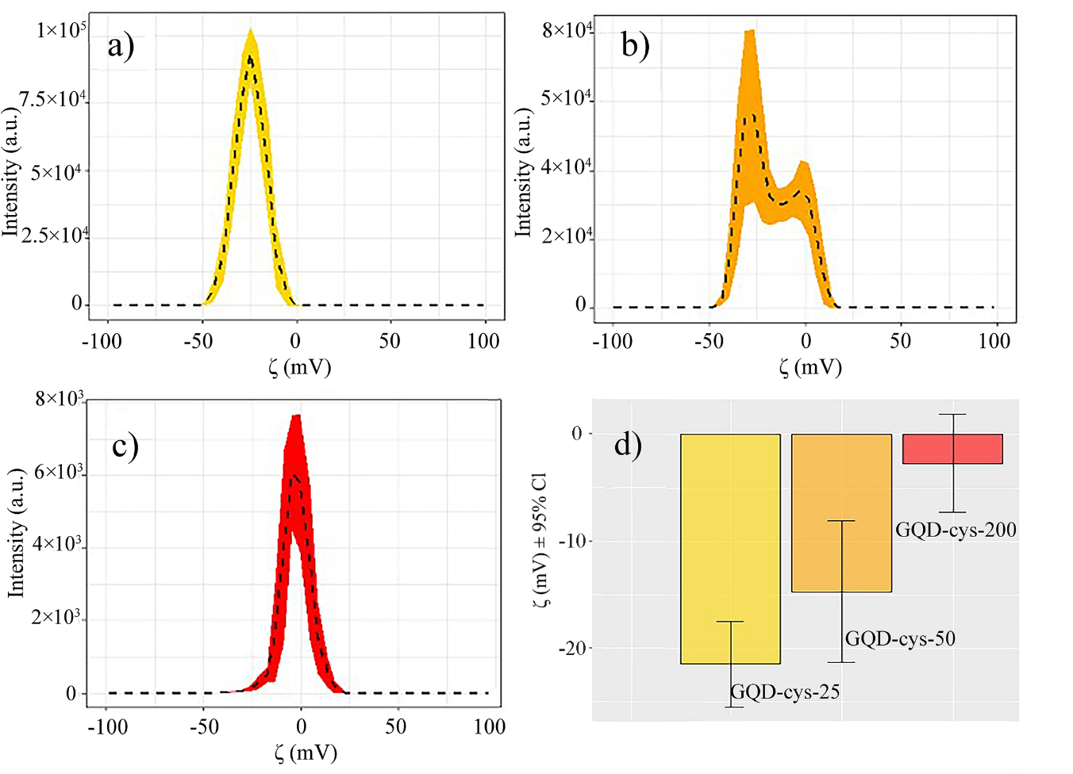
Figure 1. Intensity-weighted ζ distribution for (a) GQD-cys-25, (b) GQD-cys-50, and (c) GQD-cys-200 and (d) ζ-value for all three samples.

3.2. XPS
Further surface characterization was accomplished using XPS. Figure 2 shows representative XPS survey spectra of GQDs-cys-25, GQDs-cys-50, and GQDs-cys-200, which clearly demonstrated the presence of O, N, S, and C atoms in all three samples.
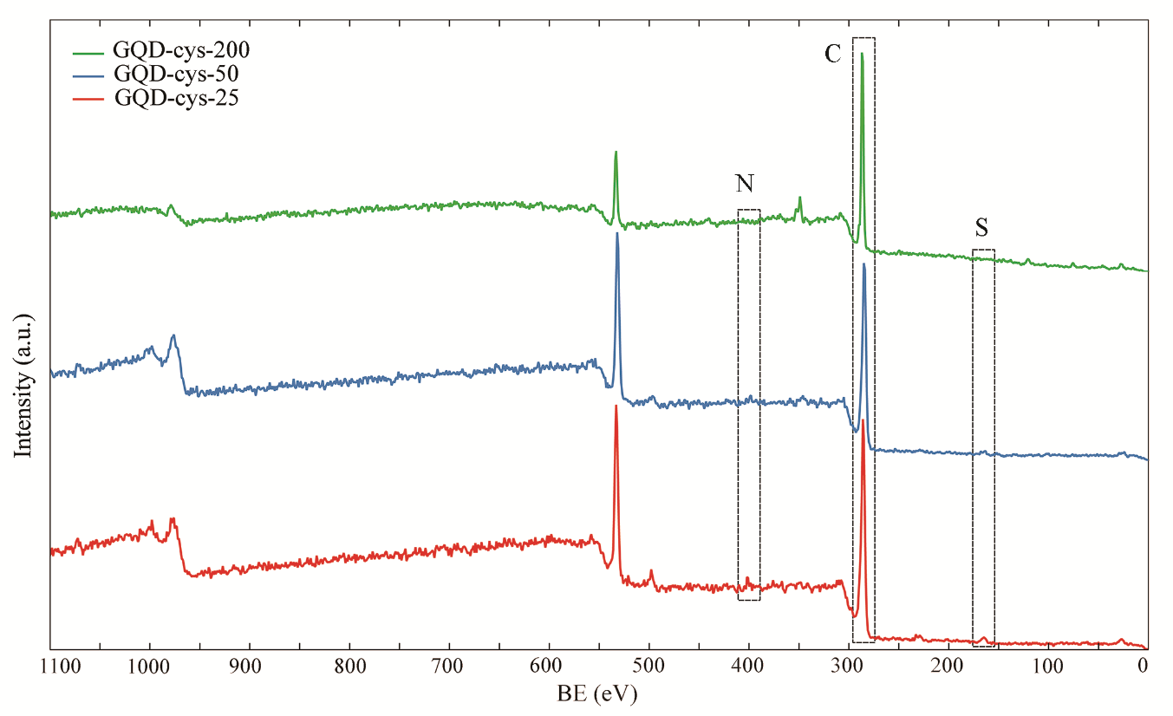
Figure 2. XPS survey for GQDs-cys-25, GQDs-cys-50, and GQDs-cys-200.
The results of the chemical composition analysis for GQD-cys are presented in Table 1. γ-irradiation in the presence of L-cysteine leads to a significant increase in relative C abundance in the dots, from 63.00 at% as measured for p-GQDs [40] to 82.92 at% which was the highest C percentage detected in dots irradiated at 200 kGy, indicating a substantial loss of heteroatoms in the scaffold. Such a loss is mainly attributable to a severe oxygen loss consequence of the irradiation from 37.00 at% as measured in p-GQDs [40] to 15.80 at% for those irradiated at 200 kGy. Nonetheless, after the irradiation, it is still possible to observe the presence of residues of L-cysteine for all samples, where both S and N atoms are detected. The highest abundance was detected in GQD-cys-50 (1.81 at%), while the sample GQD-cys-200 showed only 0.44 at% of S.
These results suggest that γ-irradiation at a moderate dose, such as 25 kGy, induces chemical reduction and doping with heteroatoms, while at higher doses (200 kGy), GQDs tend to lose heteroatoms. To investigate their structure in more detail, XPS spectra were analyzed further.
Table 1. Atomic percent (at%) of detected elements in samples GQD-cys-25, GQD-cys-50, and GQD-cys-200, obtained from XPS spectra.
Samples | C (at%) | O (at%) | N (at%) | S (at%)
p-GQD [40] | 63.00 | 37.00 | 0.00 | 0.00
GQD-cys-25 | 75.39 | 22.32 | 1.15 | 1.14
GQD-cys-50 | 74.01 | 23.30 | 1.81 | 0.89
GQD-cys-200 | 82.92 | 15.80 | 0.84 | 0.44

Figure 3, presents high-resolution spectra of deconvoluted N 1s, C1s, and S 2p peaks for GQD-cys-25, GQD-cys-50, and GQD-cys-200 samples, respectively. It is clear that with changes in dose, the components of C1s and S 2p are largely different, while N 1s is similar at all doses.
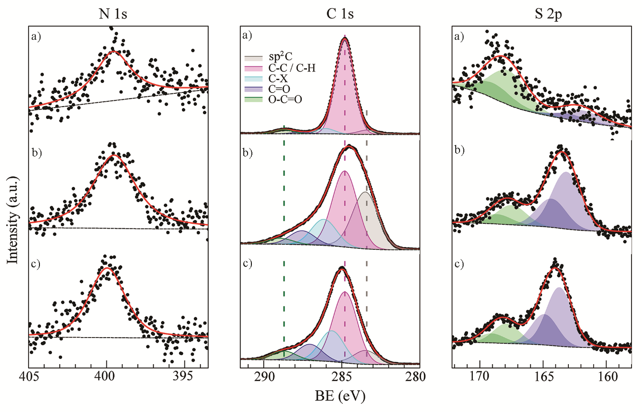
Figure 3. High-resolution XPS spectra of GQD-cys samples: (a) GQD-cys-25, (b) GQD-cys-50, and (c) GQD-cys-200.

Table 2 depicts the quantitative analysis of XPS spectra of GQDs-cys-25, GQDs-cys-50, and GQDs-cys-200 samples where the contributions of graphene-like (sp²) C atoms, C-H/C-C (sp³) bonds, C-S/C-N/C-O or C=O, and O-C=O are listed. Due to the non-stoichiometric nature of the irradiated GQDs, it was not possible to discriminate between the different heteroatom chemical environments without introducing calculus artifacts. In the case of GQD-cys-25, the sp² component was drastically lowered, from 63.00% to only 10.10, while in the sample of GQD-cys-200, only 4.85% of sp² carbon was preserved. On the opposite, sp³ C (C-C or C-H), was dominantly present, up to 85.28 at% in the sample of GQD-cys-200. The highest percentage of S, N, or O functional groups was detected in GQD-cys-25. Similarly, the highest at% of carboxyl groups was detected in GQD-cys-25.
Table 2. Contributions (in at.%) of different functional groups in GQDs-cys samples calculated from XPS C 1s bands.
Sample | sp² | sp³ (C-C/C-H) | C-S/C-N/C-O ª | C=O ^{b} | O-C=O
GQD-cys-25 | 283.47 eV  10.09 % | 284.79 eV  50.21 % | 285.63 eV  21.83 % | 287.04 eV  11.51 % | 288.72 eV  6.37 %
GQD-cys-50 | 283.48 eV  33.15 % | 284.81 eV  41.66 % | 286.14 eV  14.32 % | 287.54 eV  7.63 % | 288.92 eV  3.25 %
GQD-cys-200 | 283.38 eV  4.86 % | 284.81 eV  85.28 % | 286.06 eV  4.83 % | 287.64 eV  1.27 % | 288.73 eV  3.76 %

In all samples, in the N 1s spectrum, only one component was identified, at 399.5-399.9 eV that was assigned to a C-bound aminic N [43].
It was possible to analyze the S 2p region in all three samples, thus confirming the efficient S-doping of GQDs. Even in the less irradiated samples (GQD-cys-25, Figure 3), two distinct components with different oxidation states were identified: thiolic S and sulfonic S, found at 163.7 eV and 167.9 eV, respectively. Thiophenic S comprises positive charges of the carbon matrix [44]. The presence of these functional groups could be a reason for the lowering of the ζ-potential after γ-irradiation. It is also possible to observe that the oxidized/reduced ratio S increases with the irradiation, as indicated in Figure 3 (left).
Based on the above results, it is concluded that γ-irradiation induced large structural changes in GQDs, inducing progressive amorphization of the sp² core of GQDs. Although our previous study proved the presence of aromatic sp² in GQDs [36], XPS analysis revealed that sp² C atoms are present but in lowered at%. At the same time, irradiation at low doses increases the number of N and S groups, particularly amino and thiophene. These results contribute to the understanding of changes in the zeta potential of GQDs. At a dose of 25 kGy, the introduction of amino and thio groups together with the removal of negatively charged carboxyl groups leads to an increase in the zeta potential of GQDs, while at higher γ irradiation doses, the lowering in the at% of all functional groups contributes to further increase in value of the ζ-potential.

3.3. NMR analysis
For further structural characterization, NMR spectroscopic analysis was performed. The obtained results for ¹H and ¹³C NMR spectra are shown in Figures 4 and 5, respectively.
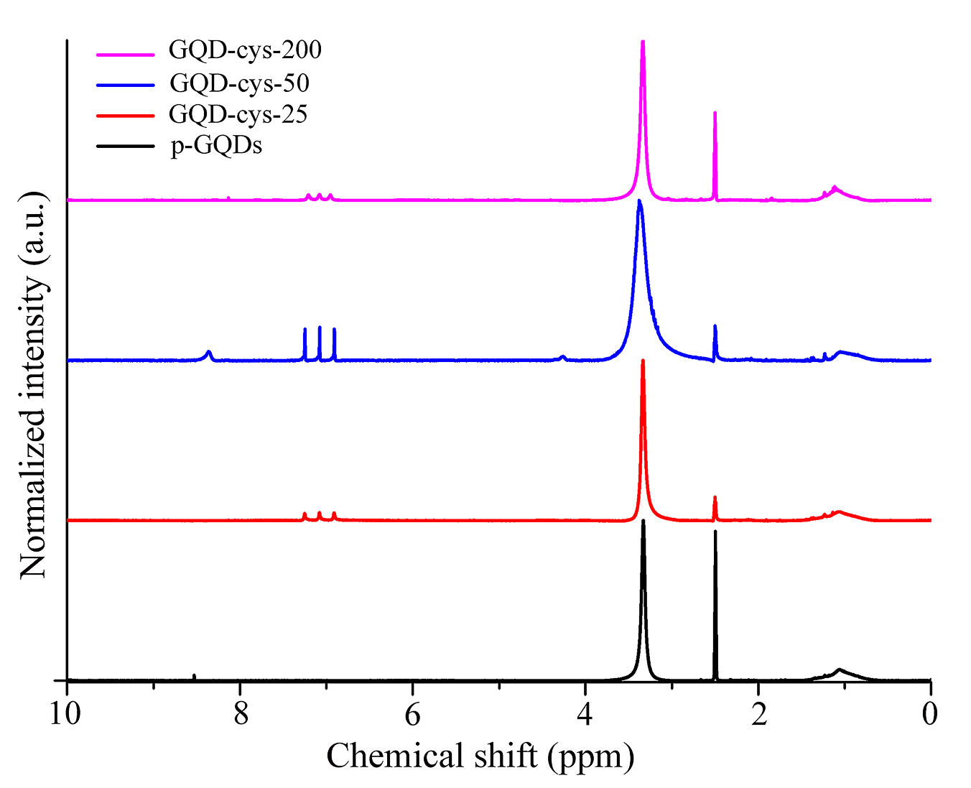
Figure 4. ¹H NMR spectra of p-GQD, GQD-cys-25, GQD-cys-50, GQD-cys-200.
All ¹H spectra present a broad signal at approximately 3.35 ppm, originating from -OH groups at the surface of GQDs. A noticeable decrease in peak intensity for irradiated samples indicates the reduction of hydroxyl groups due to the γ modification. The region around 7–7.5 ppm presents different signals which can be attributed to aromatic hydrogens [45, 46]. Signals in the alkyl region have very low intensity a no specific pattern can be recognized, thus it is assumed that the alkyl groups in GQD-cys are not very abundant.
The weak signal visible in the enlarged 13C NMR spectrum of GQD-cys-200 (Figure 5) around 120 ppm is the result of aromatic carbons and conjugated double bonds [47, 48].
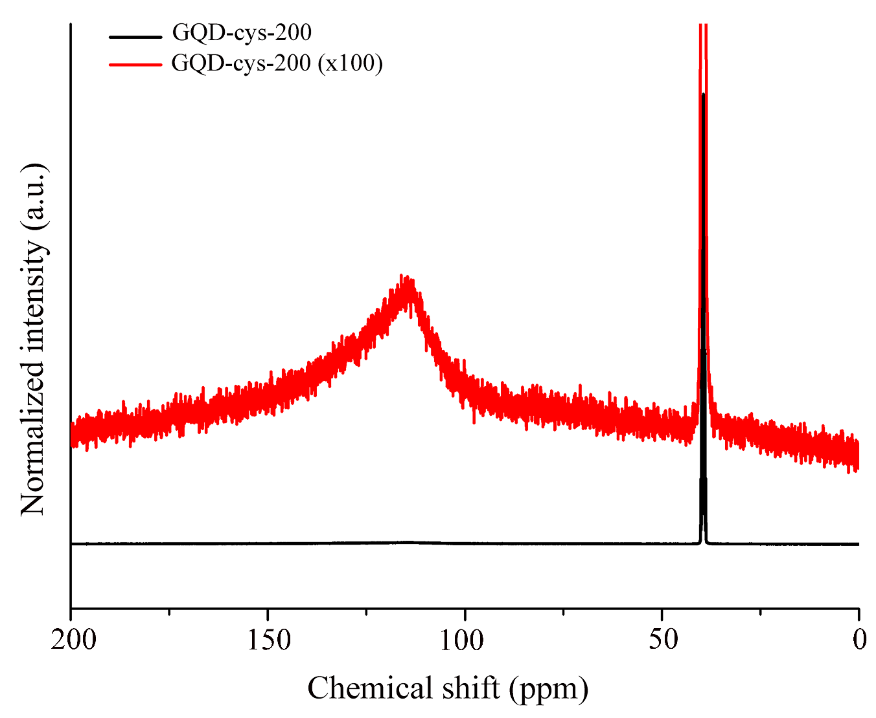
Figure 5. ¹³C NMR spectra of (a) GQD-cys-200 in DMSO-d₆ and (b) enlarged spectra of GQD-cys-200 in DMSO-d₆.
This is another proof that the parts of the aromatic structure of GQD-cys remained after γ irradiation. From this, it could be concluded that the NMR analysis is in good correlation with the previously described results.

3.4. Interactions between human serum albumin and GQD-cys-25
The changes in the fluorescence spectra of HSA upon the addition of GQD-cys-25 at three distinct temperatures (25°C, 30°C, and 37°C) are presented in Figure 6.
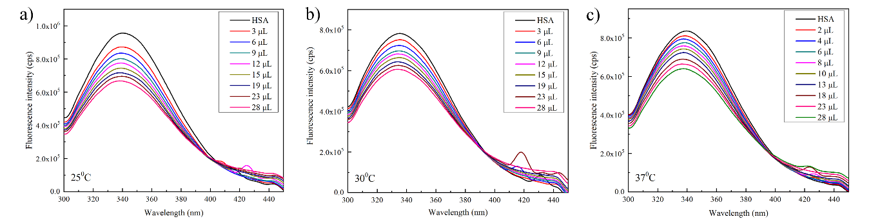
Figure 6. Changes in HSA (c = 5×10⁻⁷ M) fluorescence emission spectra upon addition of the GQD-cys-25 (c=0.25 mg/mL) at (a) 25°C, (b) 30°C, and (c) 37°C, respectively.
The intrinsic fluorescence of HSA primarily arises from its lone tryptophan (Trp214) residue. This fluorescence is highly sensitive to the local microenvironment and can be influenced by other molecules in the protein proximity [49]. Fluorescence emission spectra (Figure 6) show that HSA emitted a clear fluorescence band around 340 nm when the sample is irradiated by 280 nm. The fluorescence intensity of HSA decreased systematically with the addition of GQDs to the solution. The slight blue shift observed in the emission maximum wavelength indicates the formation of a complex between HSA and GQD-cys-25, leading to the creation of a more hydrophobic microenvironment around Trp214 [10].
Due to negligible absorption at both excitation and emission wavelengths used for data processing, fluorescence intensities correction for instrumental inner filter effect is omitted (if the absorbance is below 0.07 at both excitation and emission wavelength, the inner filter effect is negligible [50]).
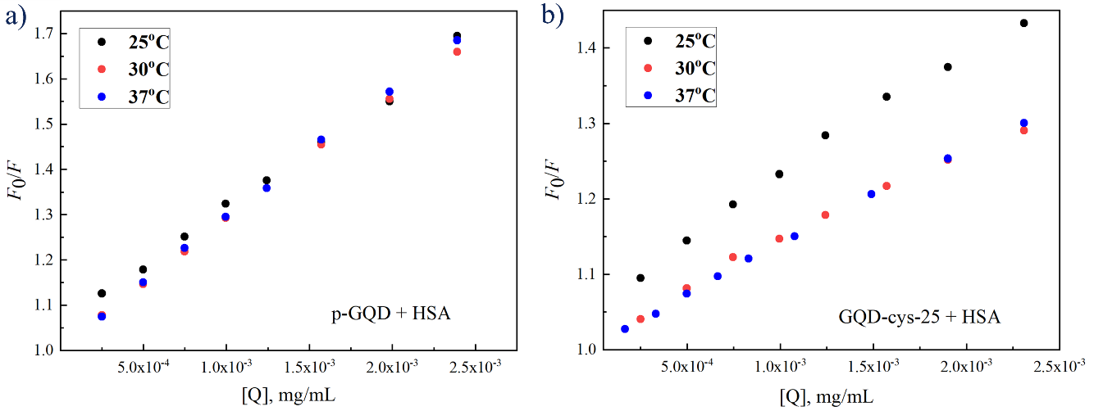
Figure 7. The temperature dependence of Stern–Volmer plots for binding p-GQD and GQD-cys-25 to HSA.
Fluorescence quenching data were processed using the Stern–Volmer equation (Eq 1.). The Stern–Volmer plots for the p-GQD sample are linear in the studied concentration range. The Stern–Volmer plots for the GQD-cys-25 sample show a slight downwardly deviation from linearity at higher quencher concentrations, thus only points within the linear range were used for the Stern–Volmer quenching constants calculation (Table 4).
As can be seen from Figure 7 and Table 4, obtained K_{SV} values for p-GQD are constant within the temperature range of 25-37°C, suggesting a consistent interaction between p-GQD and HSA. Conversely, for the GQD-cys-25 sample, the static quenching mechanism (Figure 7) is proposed due to the observed decrease in K_{SV} values with temperature increasement, indicating the formation of a complex between HSA and GQD-cys-25.

Table 4. Stern–Volmer quenching constant values (K_{SV}) determined at three different temperatures for samples p-GQD and GQD-cys-25.
 | p-GQD | GQD-cys-25
Temperatures (℃) | (K_{SV} ± SD) × 10² (mL/mg) | (K_{SV} ± SD) × 10² (mL/mg)
25.0 ± 0.1 | 2.95 ± 0.08 | 2.43 ± 0.13
30.0 ± 0.1 | 2.83 ± 0.03 | 1.64 ± 0.01
37.0 ± 0.1 | 2.91 ± 0.02 | 1.47 ± 0.02

Interactions between HSA and GQD samples observed by fluorescence spectroscopy indicate that HSA can be an effective carrier of studied quantum dots through blood circulation and provide their transport to the target receptor. Therefore, HSA-dots binding can affect the pharmacological behavior of the dots. This effect must be taken into account during the consideration of potential dots` use in therapy.

3.5. Antibacterial activity
The antibacterial activity for samples p-GQDs and GQD-cys-25 was tested against 8 bacterial strains. The results after exposure to blue light for 60 minutes are presented in Table 5.

Table 5. Antibacterial activity (MIC, μg/mL) of p-GQDs and GQD-cys-25 on different types of bacteria after 60 minutes under blue light.ml
Type of bacteria | p-GQDs | GQD-cys-25
K. pneumoniae | ˃500 | ˃500
S. aureus | 500 | 125
P. aeruginosa | ˃500 | ˃500
MRSA | ˃500 | 500
E. faecalis | 500 | 125
L. monocytogenes | ˃500 | 500
E. coli | ˃500 | 125
- baumani | ˃500 | ˃500

Based on the results, the MIC concentrations for p-GQDs were found to be 500 µg/mL against S. aureus and E. faecalis while for GQD-cys-25 the MIC was 125 µg/mL against E. coli and S. Aureus and 500 µg/mL against L. monocytogenes and MRSA.
The growth inhibition of the bacterial strains was observed compared to the control without treatment, with GQD-cys-25 showing higher activity (Figure 8).

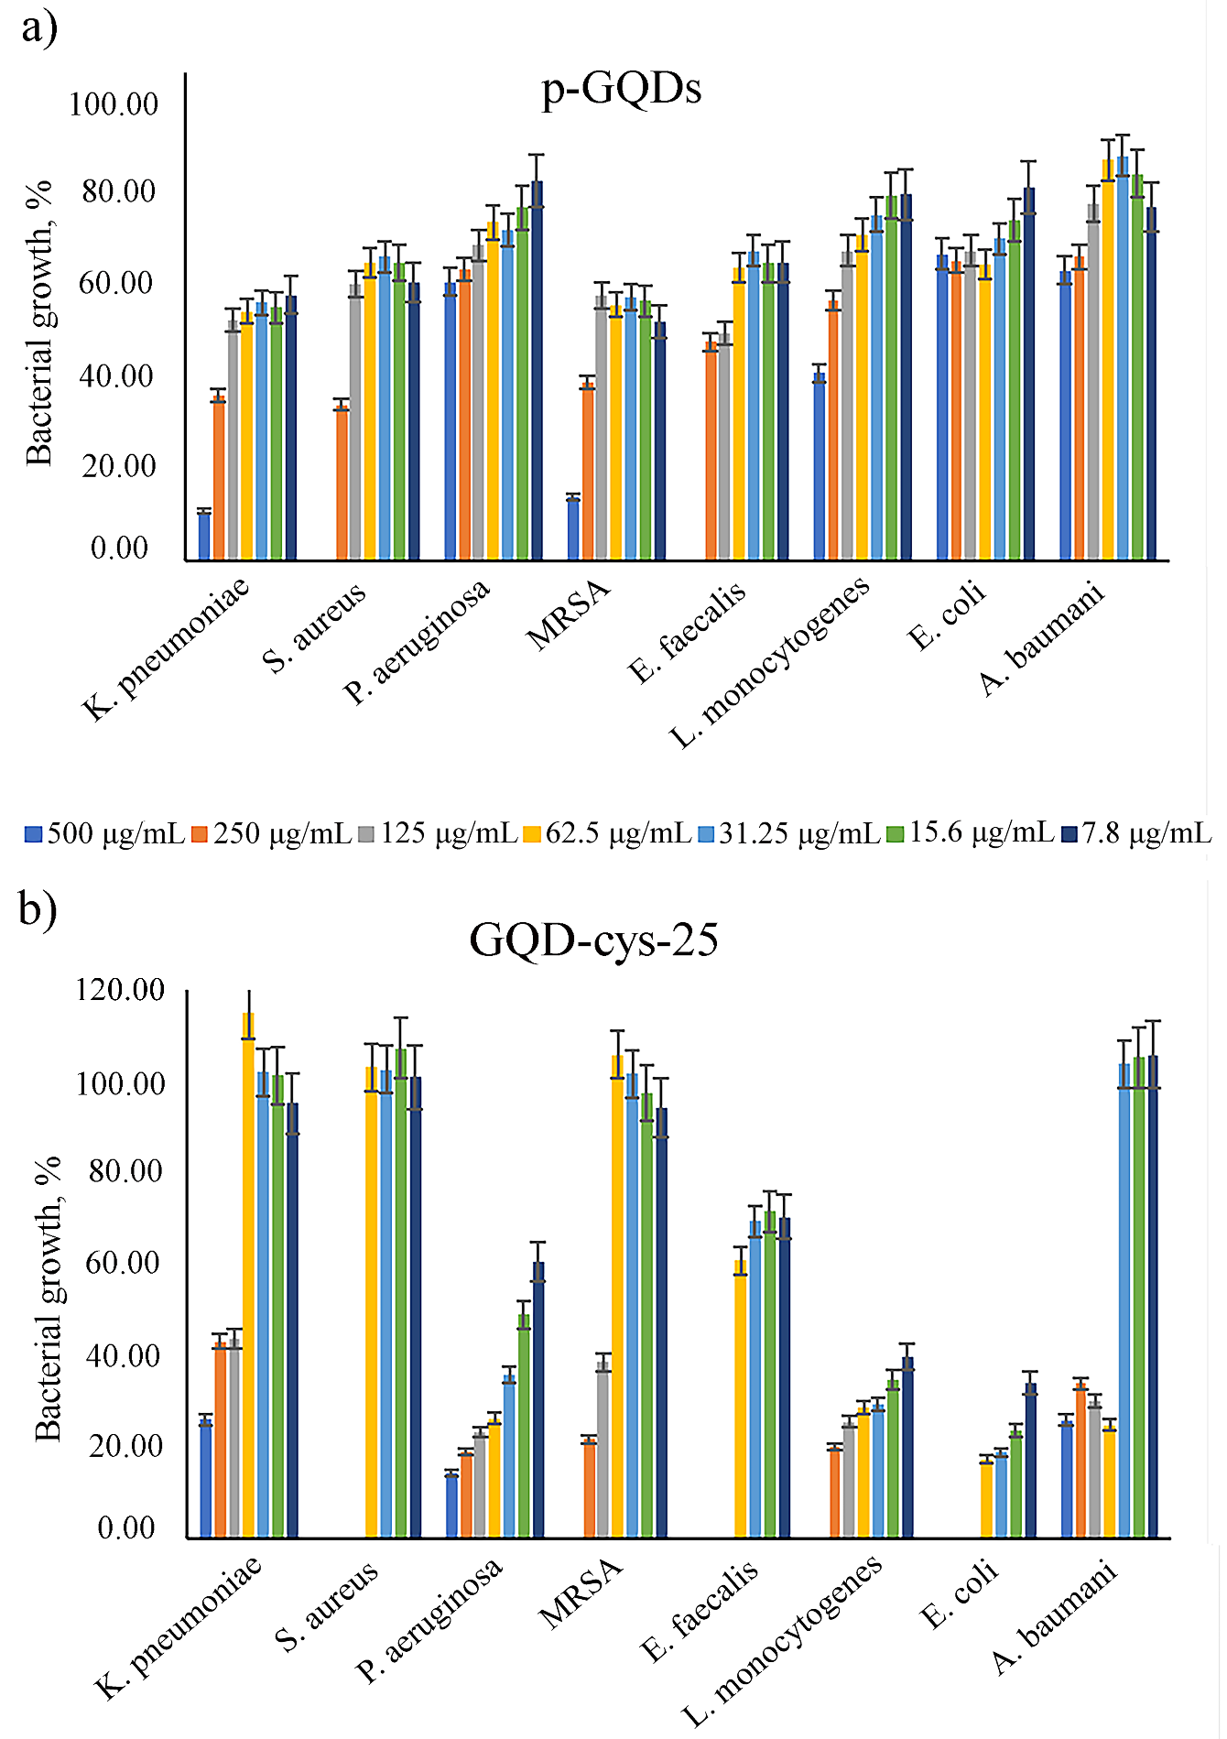
Figure 8. Concentration-dependent bacterial growth in percentages, for samples (a) p-GQDs and (b) GQD-cys-25.
After that, the samples were exposed to blue light for 6 hours and then incubated in the dark at 37°C for 24 hours. The results of antibacterial activity are presented in Table 6.

Table 6. Antibacterial activity (MIC, µg/mL) of p-GQDs and GQD-cys-25 on different types of bacteria after 6 hours under blue light.
Type of bacteria | p-GQDs | GQD-cys-25
K. pneumoniae | ˃500 | ˃500
S. aureus | 500 | 125
P. aeruginosa | ˃500 | ˃500
MRSA | 500 | 250
E. faecalis | 500 | 125
L. monocytogenes | ˃500 | 500
E. coli | ˃500 | 125
- baumani | 500 | 250

From Table 6, it can be seen that p-GQDs demonstrate moderate activity, with MIC values ranging from 500 µg/mL against S. aureus, MRSA, E. faecalis, and A. baumani. It appears to be less effective against K. pneumoniae, P. aeruginosa, and E. coli, as the MIC values are above 500 µg/mL, indicating a higher concentration is required to inhibit their growth.
On the other hand, GQD-cys-25 exhibits stronger antibacterial activity compared to p-GQDs. It demonstrates lower MIC values, such as 125 µg/mL against S. aureus, E. faecalis, and E. coli, and 250 µg/mL against MRSA and A. baumani. This suggests that GQD-cys-25 is more effective in inhibiting the growth of these bacterial strains compared to p-GQDs.
Overall, these results indicated the potential antibacterial application of p-GQDs and GQD-cys-25, with GQD-cys-25 exhibiting stronger efficacy against several bacterial strains.

3.6. Analysis of singlet oxygen photoinduced production
To investigate the ability of γ-irradiated GQDs to produce ¹O₂, under blue light illumination, in the air-saturated dispersions, the decompositions of DPBF and ABDA were followed using UV–Vis spectroscopy (Figures 9 and 10).
First, the production of singlet oxygen during photoexcitation with blue light (470 nm) was studied with DPBF. Air-saturated DPBF (Figure 9a), and mixtures of DPBF and GQDs-cys-25 (Figure 9b), GQDs-cys-50 (Figure 9c), and GQDs-cys-200 (Figure 9d) were exposed to light and UV–Vis spectra were recorded every minute, during 8 minutes. The molecule of DPBF shows an absorption band at 410 nm, while in the presence of ¹O₂, this molecule undergoes 1,4-cycloaddition which is observed as a decreasing intensity band at 410 nm [51]. The photostability of DPBF under selected illumination conditions was inspected first (Figure 9a). The intensity of the band at 410 nm is lowered gradually with light exposure even though any photosensitizer was not present in the system. This is clear evidence that DPBF is undergoing photodegradation under studied conditions. When GQDs were present in the system (Figure 9b-d), the reduction of the band intensity located at 410 nm was also detected. In the absence of light (indicated as 0 minutes of BL exposure in Figure 9a-d), the intensity of the band at 410 nm did not show changes for the mixtures of DPBF and GQDs-cys. With light exposure, the absorption intensity of the DPBF and GQDs-cys mixtures decreases gradually as a function of time under light irradiation. In the case of GQDs-cys-25 (Figure 9b), the intensity of the band at 410 nm was reduced to the intensity of GQDs-cys-25 dispersion after only 5 minutes of irradiation, while in the case of GQDs-cys-50 and GQDs-cys-200 (Figure 9c and d), 7 and 8 minutes, respectively, was necessary to achieve the same response. By comparing GQDs – DPBF mixtures and the solution of DPBF, the band at 410 nm can be clearly observed after 7 minutes of blue light irradiation, while in the GQDs – DPBF mixtures, this band could not be detected. This indicated that GQDs accelerate DPBF photodegradation and prove photoinduced singlet oxygen production.
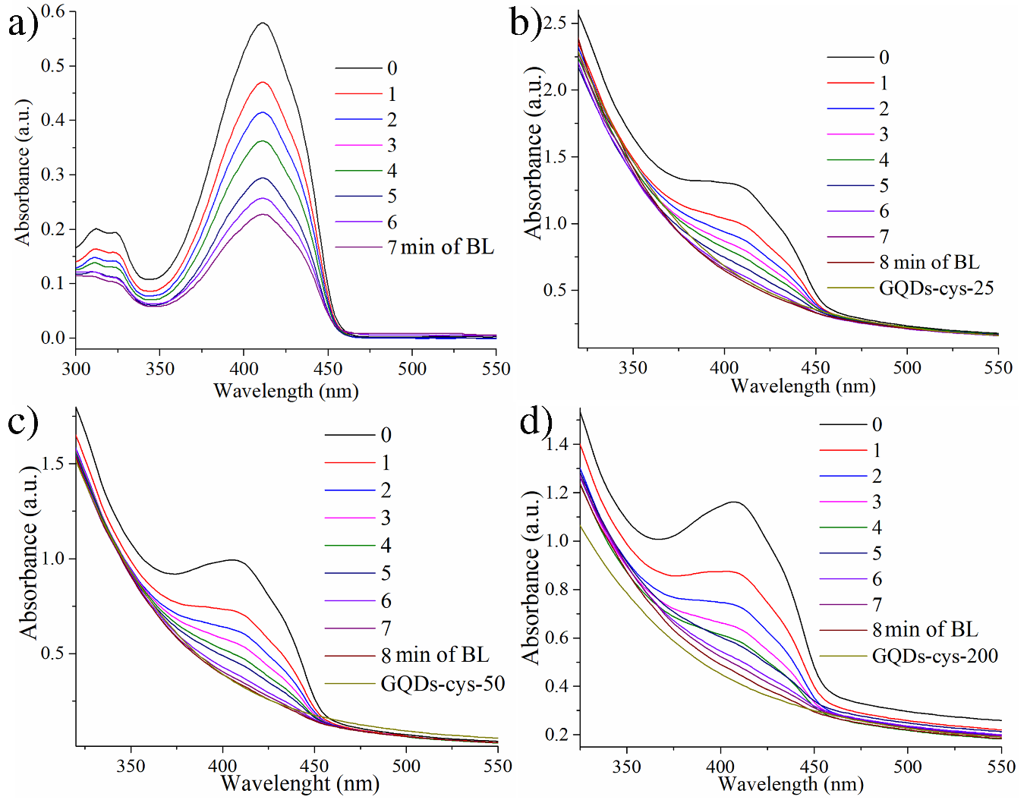
Figure 9. UV–Vis spectra of: (a) DPBF exposed to blue light, (b) DPBF trapping ¹O₂, in the presence of GQDs-cys-25, (c) DPBF trapping ¹O₂, in the presence of GQDs-cys-50, and (d) DPBF trapping ¹O₂, in the presence of GQDs-cys-200.

DPBF proved the ability of GQDs γ-irradiated in the presence of amino acid L-cysteine to produce singlet oxygen in the presence of molecular oxygen and blue light (470 nm). The highest efficiency was observed for sample GQDs-cys-25, considering this sample induces the fastest photodegradation of DFBP.

The photostability of ABDA was studied as well and these results showed that the molecule is stable under selected illumination conditions (Figure 10a). Herein, negligible changes in the intensity of ABDA molecule absorption were observed proving its photostability under studied conditions. In the presence of p-GQDs, the intensity of the band at 378 nm gradually decreased with irradiation time (Figure 10b). The same trend was detected in the case of the GQD-cys-25 sample (Figure 10c). The changes were followed for 300 minutes of irradiation and at the end of the period the higher ABDA decomposition was noticed in the samples GQDs-cys-25.
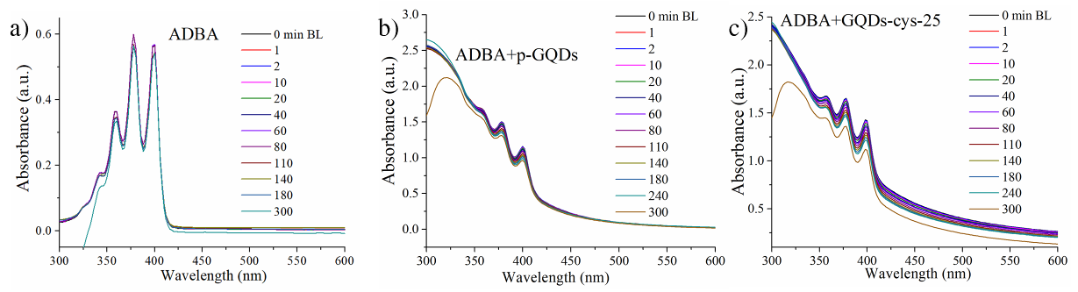
Figure 10. (a) UV–Vis spectra of ABDA exposed to blue light, (b) UV–Vis spectra of the ABDA trapping ¹O₂, in the presence of p-GQDs, and (c) UV–Vis spectra of the ABDA trapping ¹O₂, in the presence of GQDs-cys-25.
These results prove that GQDs-cys are able to convert molecular oxygen into ¹O₂ when they are exposed to blue light irradiation. These results are in agreement with our previous study, where electron paramagnetic resonance spectroscopy showed singlet oxygen production upon blue light irradiation [36]. A slightly higher ¹O₂ production is detected in sample GQDs-cys-25 compared to p-GQDs (Figure 10b and c) after 300 minutes of BL irradiation) which is in correlation with photoinduced antibacterial tests, that showed better antibacterial activity of GQDs-cys-25.

3.7. Discussion
γ-irradiation of air-free IPA-water solution of L-cysteine leads to the generation following main radiolytic products: cystine (Cys)₂S₂, alanine, hydrogen sulfide, and hydrogen (Figure 11) [52].
In the presence of GQDs, which are rich in carboxyl and hydroxyl function groups, radicals produced by the decomposition of L-cysteine, interact with functional groups at the GQDs surface, and form new bonds which are presented by arrows in Figure 11. At a dose of 25 kGy, new groups were detected at GQDs surface, amino, thio and sulphonic, according to the XPS results, while our previous study indicated the presence of amide bonds as well [36]. These results suggest that the carboxyl group of GQDs reacted with the amino bond of L-cysteine and formed amide bonds leaving SH groups on the GQDs surface. Amino groups are originating from the direct nucleophilic attack of cysteine [53, 54] to carbonyl groups of GQDs [55]. Similarly, cystine produced in a radiolized medium could interact in the same manner as L-cysteine (Figure 11, path 1). Amino acid alanine could be responsible for the incorporation of amino groups in the GQDs structure (Figure 11, path 2). Production of hydrogen molecules in irradiation medium led to a reduction of GQDs structure, which resulted in significant lowering in oxygen-containing functional groups which are detected in XPS as lowering at% of O, from 37.00 at% obtained for p-GQDs to 15.80 at% at a dose of 200 kGy, and as the increase in particles charge, from -34.6 mV to -2.3 mV. Large changes in sp² content in GQD structure could be assigned to the direct effect of γ photons [56, 57] and this effect is particularly high at doses of 25 and 200 kGy.
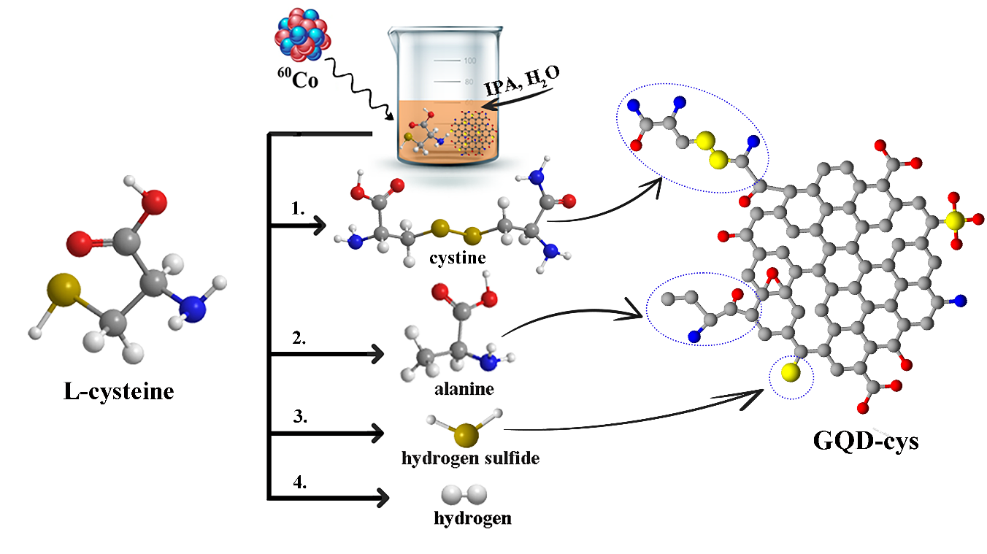
Figure 11. Mechanism of γ irradiation-induced interaction between GQDs and L-cysteine.
Photo-induced antibacterial effect of L-cysteine-modified dots is a consequence of singlet oxygen generation and causes oxidative stress in bacterial cells [58]. Considering increased zeta potential after irradiation, one of the reasons for improved antibacterial activity could be better interaction with negatively charged bacterial cell walls [59].
E. faecalis, classified as a part of the group D Streptococcus system is a Gram-positive, commensal combat bacterium found in the gastrointestinal tracts of humans [60]. These bacteria currently represent one of the extensively distributed drug-resistant strains discovered in hospitals globally. E. faecalis was reported to be the most common pathogen for nosocomial enterococcal bloodstream infections (BSIs) with the ability to provoke diverse infections like endocarditis [61], sepsis [62], infections in post-surgery wounds [62], meningitis [61], and urinary tract infections [63].
The ability of GQD-cys-25 to effectively combat bacterial strains responsible for a wide range of infections highlights its potential to revolutionize the approach to bacterial treatment and infection control. Exploring the underlying mechanisms that enhance its antibacterial effectiveness could provide a vital foundation for innovative strategies against these infections.

4. Conclusion
By employing γ-irradiation in the presence of amino acid L-cysteine, in the GQDs structure both N- and S-atoms were incorporated in only one synthetic step. Due to treatment, the charge of particles changed from –21.2 mV to –2.3 mV, as measured for dots irradiated doses of 25 and 200 kGy, respectively. Furthermore, XPS and NMR analysis showed that upon irradiation GQDs lost a large part of carboxylic functional groups while amino, thiophene, and sulfonic were bonded after irradiation.
These structural changes improve the ability of dots to generate single oxygen upon blue light illumination as well as their photoinduced antibacterial activity towards S. aureus, E. faecalis, and E. coli. Considering E. faecalis is one of the most common nosocomial infections, modified GQDs together with blue light are a good candidate for the treatment of conditions caused by this bacteria but a component of antibacterial plastics for intrahospital usage.

Acknowledgment
This research was supported by the Science Fund of the Republic of Serbia, #7741955, “Are photoactive nanoparticles salvation for global infection threat?”—PHOTOGUN4MICROBES, and by the Ministry of Science, Technological Development and Innovation of Republic of Serbia (grant number 451-03-68/2023-14/200017, 451-03-47/2023-01/200026, 451-03-47/2023-01/200168). The Italian Ministry of University and Research (MURST, ex-MIUR) is acknowledged by A.B. for funding his research activities (PON “AIM: Attrazione e Mobilità Internazionale”, call AIM1809078-2, CUP B78D19000280001).

References

1. Murray, C.J.L., et al., Global burden of bacterial antimicrobial resistance in 2019: a systematic analysis. The Lancet, 2022. 399(10325): p. 629-655.
2. Travlou, N.A., et al., S-and N-doped carbon quantum dots: Surface chemistry dependent antibacterial activity. Carbon, 2018. 135: p. 104-111.
3. Ristic, B.Z., et al., Photodynamic antibacterial effect of graphene quantum dots. Biomaterials, 2014. 35(15): p. 4428-4435.
4. Hui, L., et al., Antibacterial property of graphene quantum dots (both source material and bacterial shape matter). ACS applied materials & interfaces, 2016. 8(1): p. 20-25.
5. Wang, N., et al., Wound therapy via a photo-responsively antibacterial nano-graphene quantum dots conjugate. Journal of Photochemistry and Photobiology B: Biology, 2020. 210: p. 111978.
6. Sk, M.A., et al., Revealing the tunable photoluminescence properties of graphene quantum dots. Journal of Materials Chemistry C, 2014. 2(34): p. 6954-6960.
7. Xu, H., et al., Time-efficient syntheses of nitrogen and sulfur co-doped graphene quantum dots with tunable luminescence and their sensing applications. RSC advances, 2016. 6(43): p. 36554-36560.
8. Iannazzo, D., I. Ziccarelli, and A. Pistone, Graphene quantum dots: multifunctional nanoplatforms for anticancer therapy. Journal of Materials Chemistry B, 2017. 5(32): p. 6471-6489.
9. Mahalingam, S., et al., Functionalized graphene quantum dots for dye-sensitized solar cell: Key challenges, recent developments and future prospects. Renewable and Sustainable Energy Reviews, 2021. 144: p. 110999.
10. Zheng, P. and N.J.C.A.A.J. Wu, Fluorescence and sensing applications of graphene oxide and graphene quantum dots: a review. Chemistry–An Asian Journal, 2017. 12(18): p. 2343-2353.
11. Tabish, T.A., et al., Biocompatibility and toxicity of graphene quantum dots for potential application in photodynamic therapy. Nanomedicine, 2018. 13(15): p. 1923-1937.
12. Mansuriya, B.D. and Z. Altintas, Applications of graphene quantum dots in biomedical sensors. Sensors, 2020. 20(4): p. 1072.
13. Jovanović, S.P., et al., Graphene quantum dots as singlet oxygen producer or radical quencher-The matter of functionalization with urea/thiourea. Materials Science and Engineering: C, 2020. 109: p. 110539.
14. Choi, S.-H., Unique properties of graphene quantum dots and their applications in photonic/electronic devices. Journal of Physics D: Applied Physics, 2017. 50(10): p. 103002.
15. Yoon, H., et al., Toward highly efficient luminescence in graphene quantum dots for optoelectronic applications. Chemical Physics Reviews, 2021. 2(3): p.031303.
16. Zhang, L., et al., Preparation of graphene quantum dots for bioimaging application. Journal of nanoscience and nanotechnology, 2012. 12(3): p. 2924-2928.
17. Qiu, J., et al., Fluorescent graphene quantum dots as traceable, pH-sensitive drug delivery systems. International journal of nanomedicine, 2015. 10: p. 6709-6724.
18. Du, Z., et al., Graphene quantum dots-based heterogeneous catalysts. New Carbon Materials, 2021. 36(3): p. 449-467.
19. Ananthanarayanan, A., et al., Facile synthesis of graphene quantum dots from 3D graphene and their application for Fe3+ sensing. Advanced Functional Materials, 2014. 24(20): p. 3021-3026.
20. Rani, P., B. Ahamed, and K. Deshmukh, Electromagnetic interference shielding properties of graphene quantum‐dots reinforced poly (vinyl alcohol)/polypyrrole blend nanocomposites. Journal of Applied Polymer Science, 2020. 137(45): p. 49392.
21. Wu, W., et al., Dual role of graphene quantum dots in active layer of inverted bulk heterojunction organic photovoltaic devices. ACS omega, 2019. 4(14): p. 16159-16165.
22. Kadian, S., S.K. Sethi, and G. Manik, Recent advancements in synthesis and property control of graphene quantum dots for biomedical and optoelectronic applications. Materials Chemistry Frontiers, 2021. 5(2): p. 627-658.
23. Bacon, M., S.J. Bradley, and T. Nann, Graphene quantum dots. Particle & Particle Systems Characterization, 2014. 31(4): p. 415-428.
24. Kholikov, K., et al., Improved singlet oxygen generation and antimicrobial activity of sulphur-doped graphene quantum dots coupled with methylene blue for photodynamic therapy applications. Photodiagnosis and photodynamic therapy, 2018. 24: p. 7-14.
25. Zheng, X.T., et al., Graphene quantum dots as universal fluorophores and their use in revealing regulated trafficking of insulin receptors in adipocytes. ACS nano, 2013. 7(7): p. 6278-6286.
26. Kumar, Y.R., et al., Graphene quantum dot based materials for sensing, bio-imaging and energy storage applications: a review. RSC advances, 2020. 10(40): p. 23861-23898.
27. Iannazzo, D., et al., Graphene quantum dots for cancer targeted drug delivery. International journal of pharmaceutics, 2017. 518(1-2): p. 185-192.
28. Zhang, X., et al., Shining luminescent graphene quantum dots: Synthesis, physicochemical properties, and biomedical applications. TrAC Trends in Analytical Chemistry, 2019. 116: p. 109-121.
29. Chung, S., R.A. Revia, and M. Zhang, Graphene quantum dots and their applications in bioimaging, biosensing, and therapy. Advanced Materials, 2021. 33(22): p. 1904362.
30. Reddy, K.R., et al., Synthesis of metal (Fe or Pd)/alloy (Fe–Pd)‐nanoparticles‐embedded multiwall carbon nanotube/sulfonated polyaniline composites by γ irradiation. Journal of Polymer Science Part A: Polymer Chemistry, 2006. 44(10): p. 3355-3364.
31. Marković, Z., et al., Graphene nanoribbons synthesis by gamma irradiation of graphene and unzipping of multiwall carbon nanotubes. Graphene Science Handbook: Fabrication Methods, 2016: p. 361-374.
32. Markovic, Z.M., et al., Graphene quantum dots as autophagy-inducing photodynamic agents. Biomaterials, 2012. 33(29): p. 7084-7092.
33. Budimir, M., et al., Enhanced visible light-triggered antibacterial activity of carbon quantum dots/polyurethane nanocomposites by gamma rays induced pre-treatment. Radiation Physics and Chemistry, 2021. 185: p. 109499.
34. Marković, Z.M., et al., Photo-induced antibacterial activity of four graphene based nanomaterials on a wide range of bacteria. RSC advances, 2018. 8(55): p. 31337-31347.
35. Yamasaki, K., et al., Albumin–drug interaction and its clinical implication. Biochimica et Biophysica Acta (BBA)-General Subjects, 2013. 1830(12): p. 5435-5443.
36. Milenković, M., et al., Facile synthesis of L-cysteine functionalized graphene quantum dots as a bioimaging and photosensitive agent. Nanomaterials, 2021. 11(8): p. 1879.
37. Von Smoluchowski, M., Elektrische endosmose und stromungsstrome. Handbuch del Elektrizitat und des Magnetismus, 1921. 2: p. 366.
38. Lakowicz, J.R., Principles of fluorescence spectroscopy, Springer, 2006. p. 262.
39. Entradas, T., et al., The detection sensitivity of commonly used singlet oxygen probes in aqueous environments. Journal of Photochemistry and Photobiology B: Biology, 2020, 204: p. 111787.
40. Jovanović, S., et al., Gamma irradiation of graphene quantum dots with ethylenediamine: Antioxidant for ion sensing. Ceramics International, 2020. 46(15): p. 23611-23622.
41. Roushani, M., M. Mavaei, and H.R.J.J.o.M.C.A.C. Rajabi, Graphene quantum dots as novel and green nano-materials for the visible-light-driven photocatalytic degradation of cationic dye. Journal of Molecular Catalysis A: Chemical, 2015. 409: p. 102-109.
42. Kong, W., et al., Investigation of photoluminescence behavior of reduced graphene quantum dots. Inorganic Chemistry Communications, 2019. 99: p. 199-205.
43. Rahardja, M.R., D. Kurniawan, and W.-H. Chiang, Microplasma-Enabled Sustainable Synthesis of Nitrogen-Doped Graphene Quantum Dots for Sensitive Detection of 4-Nitrophenol. Chemosensors, 2023. 11(7): p. 390.
44. Xu, J., et al., A nitrogen–sulfur co-doped porous graphene matrix as a sulfur immobilizer for high performance lithium–sulfur batteries. Journal of Materials Chemistry A, 2016. 4(44): p. 17381-17393.
45. Boonta, W., et al., The synthesis of nitrogen and sulfur co-doped graphene quantum dots for fluorescence detection of cobalt (II) ions in water. Materials Chemistry Frontiers, 2020. 4(2): p. 507-516.
46. Wang, B., et al., Rational Design of Multi‐Color‐Emissive Carbon Dots in a Single Reaction System by Hydrothermal. Advanced science, 2021. 8(1): p. 2001453.
47. Zhang, M., et al., Facile synthesis of water-soluble, highly fluorescent graphene quantum dots as a robust biological label for stem cells. Journal of materials chemistry, 2012. 22(15): p. 7461-7467.
48. Zhang, Q., et al., Cancer‐targeting graphene quantum dots: fluorescence quantum yields, stability, and cell selectivity. Advanced Functional Materials, 2019. 29(5): p. 1805860.
49. Huang, S., et al., Study on the molecular interaction of graphene quantum dots with human serum albumin: combined spectroscopic and electrochemical approaches. Journal of Hazardous Materials, 2015. 285: p. 18-26.
50. Marković, O.S., et al., Human serum albumin binding of certain antimalarials. Spectrochimica Acta Part A: Molecular and Biomolecular Spectroscopy, 2018. 192: p. 128-139.
51. Fujii, M., et al., Chemical reaction mediated by excited states of Si nanocrystals—Singlet oxygen formation in solution. Journal of Applied Physics, 2004. 95(7): p. 3689-3693.
52. Wilkening, V.G., et al., Cobalt-60. gamma. radiolysis of cysteine in deaerated aqueous solutions at pH values between 5 and 6. The Journal of Physical Chemistry, 1968. 72(1): p. 185-190.
53. Bak, D.W., et al., Cysteine reactivity across the subcellular universe. Current opinion in chemical biology, 2019. 48: p. 96-105.
54. Dos Santos, A.P.A., et al., Nucleophilicity of cysteine and related biothiols and the development of fluorogenic probes and other applications. Organic & Biomolecular Chemistry, 2020. 18(46): p. 9398-9427.
55. Huang, T.-C., L.-Z. Huang, and C.-T. Ho, Mechanistic studies on thiazolidine formation in aldehyde/cysteamine model systems. Journal of agricultural and food chemistry, 1998. 46(1): p. 224-227.
56. Jovanović, S., Gamma rays in carbon-based nanomaterials modification, in Gamma Irradiation: Properties, Effects and Development of New Materials. 2021, Nova Science Publishers, Inc. Hauppauge, NY 11788 USA. p. 65-121.
57. Ansón-Casaos, A., et al., The effect of gamma-irradiation on few-layered graphene materials. Applied Surface Science, 2014. 301: p. 264-272.
58. Dong, X., et al., Carbon dots as potent antimicrobial agents. Theranostics, 2020. 10(2): p. 671.
59. Bing, W., et al., Programmed bacteria death induced by carbon dots with different surface charge. Small, 2016. 12(34): p. 4713-4718.
60. Kau, A.L., et al., Enterococcus faecalis tropism for the kidneys in the urinary tract of C57BL/6J mice. Infection and immunity, 2005. 73(4): p. 2461-2468.
61. Ni, A.H. and M.M. Huycke, Enterococcal disease, epidemiology, and implications for treatment. Massachusetts Eye and Ear Infrmary, Boston, Mass, USA, 20142014 p. 65-69.
62. Olawale, K.O., S.O. Fadiora, and S.S. Taiwo, Prevalence of hospital acquired enterococci infections in two primary-care hospitals in Osogbo, Southwestern Nigeria. African journal of infectious diseases, 2011. 5(2): p. 40-46.
63. Hidron, A.I., et al., Antimicrobial-resistant pathogens associated with healthcare-associated infections: annual summary of data reported to the National Healthcare Safety Network at the Centers for Disease Control and Prevention, 2006–2007. Infection Control & Hospital Epidemiology, 2008. 29(11): p. 996-1011.

Corresponding author, Vinča Institute of Nuclear Sciences, P. O. Box 522, 11000 Belgrade, Serbia, Phone: +381 65 45 35 563. E-mail: mila.milenkovic@vin.bg.ac.rs

