Supplementary Material

Table S1. Characteristics of Cenchrus setaceus sampling sites in Palermo, Sicily……………………….….. 2
Figure S1. Photographs illustrate Cenchrus setaceus plants along roadside margins in edge habitats….……2
Figure S2. Calibration curves obtained from the analysis of the 16 PAHs…………………….………….…3
Table S2. List of native and deuterated PAHs analyzed, indicating ions used for quantification and confirmation, along with retention times (RT)…………………………………………………………………4
Table S3. List of PAHs with their acronyms, LOD and LOQ referring to the plant matrix…………...…....…4
Figure S3. Chromatogram of a solution containing native and deuterated PAH standards…………….….....5
Tables S4. Concentration levels, sum (Σ16 PAHs) and median (𝑥̃) values of PAHs, expressed in ng g⁻¹ wet weight (w.w.), analyzed in C. setaceus samples collected in August……………………………………….….6
Tables S5. Concentration levels, sum (Σ16 PAHs) and median (𝑥̃) values of PAHs, expressed in ng g⁻¹ wet weight (w.w.), analyzed in C. setaceus samples collected in December…………………………………….…7

Table S1. Characteristics of Cenchrus setaceus sampling sites in Palermo, Sicily
Station | Location | Main characteristics
1 | Via Mongerbino | Roadside site along light vehicle traffic; increased flow due to nearby road closures; adjacent to L. Einaudi–Pareto school, high anthropic presence during school hours
2 | Viale Regione Siciliana | Major urban artery; heavy mixed traffic (light and heavy vehicles); near large commercial area, high vehicle flow and anthropic pressure
3 | Corso Calatafimi | Road with slow, intense traffic; frequent congestion due to traffic lights; high commercial activity; additional traffic from parallel fast road
4 | Via del Vespro | Adjacent to university hospital; continuous traffic including ambulances; served by multiple public transport lines, high anthropic presence
5 | Via Buonriposo | Road with near-continuous traffic; frequent parked vehicles; numerous commercial activities contributing to congestion and high anthropic pressure
6 | Via Salvatore Cappello | Near Corso dei Mille; constant light and heavy vehicle flow; regular and high traffic pressure
7 | Via Messina Marine | Coastal road; continuous light and heavy traffic; open morphology favors pollutant dispersion compared to dense urban areas
8 | Via Antonino Laudicina | Wide road connected to major shopping center; traffic varies with commercial hours; increased flow during peak periods
9 | Piazza Figurella (highway junction) | Roundabout acting as urban traffic node; heavy congestion; high vehicular and pedestrian flow; commercial and service presence
10 | Santa Flavia | Coastal site near “100 Gradini” beach; seasonal light vehicle traffic; higher flow in summer, lower in winter; significant green cover
11 | Rotonda di Casteldaccia (highway junction) | Major junction of A19 Palermo–Catania; significant vehicle flow, especially during peak travel and weekends; mixed urban/extra-urban influence
12 | Lascari | Coastal/peri-urban site near Gorgo Lungo beach; less urbanized; seasonal traffic variation, higher in summer, lower in winter; open green areas

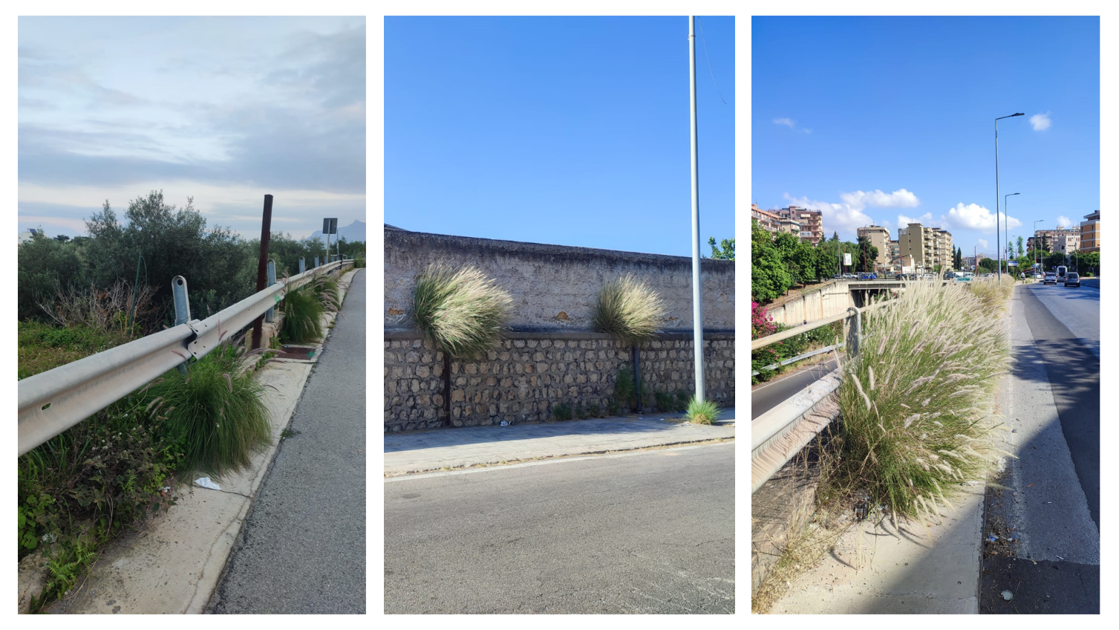
Figure S1. Photographs illustrate Cenchrus setaceus plants along roadside margins in edge habitats.
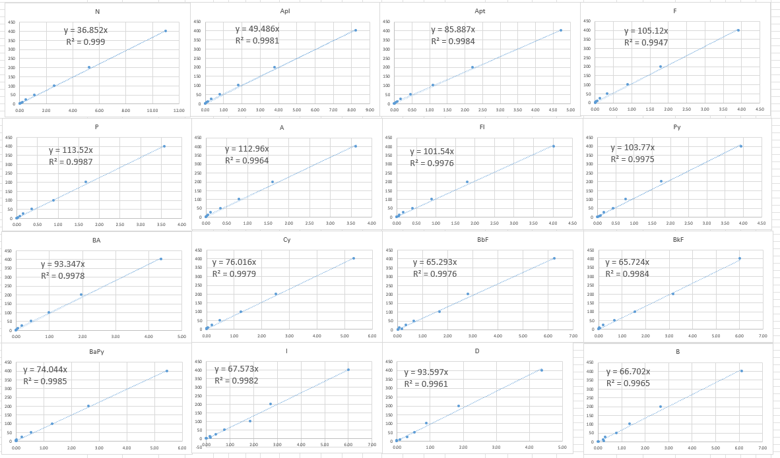
Figure S2. Calibration curves obtained from the analysis of the 16 PAHs.

Table S2. List of native and deuterated PAHs analyzed, indicating ions used for quantification and confirmation, along with retention times (RT). *Deuterated PAH Mix A (3 analytes); **Deuterated PAH Mix B (7 analytes)
Compound | Acronym | Quantification Ion (m/z) | Confirmation Ions (m/z) | RT (min) | % Recovery
naphthalene | N | 128 | 127, 64 | 8.08
*acenaphthylene d₈ |  | 160 |  | 10.23 | 86–102
acenaphthylene | Apl | 152 | 151, 76 | 10.25
**acenaphthene d₁₀ |  | 164 |  | 10.44
acenaphthene | Apt | 154 | 152, 153 | 10.49
fluorene | F | 166 | 164, 165 | 11.19
**phenanthrene d₁₀ |  | 188 |  | 12.48
phenanthrene | P | 178 | 176, 89 | 12.51
anthracene | A | 178 | 176, 89 | 12.58
**fluoranthene d₁₀ |  | 212 |  | 14.50
fluoranthene | Fl | 202 | 101, 200 | 14.54
pyrene | Py | 202 | 101, 200 | 15.07
**benzo[a]anthracene d₁₂ |  | 240 |  | 19.33
benzo[a]anthracene | BA | 228 | 114, 226 | 19.41
*chrysene d₁₂ |  | 240 |  | 19.44 | 71–82
chrysene | Cy | 228 | 114, 226 | 19.53
benzo[b]fluoranthene | BbF | 252 | 126, 250 | 22.14
benzo[k]fluoranthene | BkF | 252 | 126, 250 | 22.19
**benzo[a]pyrene d₁₂ |  | 264 |  | 22.67
benzo[a]pyrene | BaPy | 252 | 126, 250 | 22.71
*indeno[1,2,3-cd]pyrene d₁₂ |  | 288 |  | 24.72 | 73–86
**dibenz[a,h]anthracene d₁₄ |  | 292 |  | 24.75
indeno[1,2,3-cd]pyrene | I | 276 | 138, 277 | 24.77
dibenz[a,h]anthracene | D | 278 | 279, 139 | 24.81
benzo[ghi]perylene | B | 276 | 138, 277 | 25.29
**dibenz[a,i]pyrene d₁₄ |  | 316 |  | 29.41

Table S3. List of PAHs under investigation with their acronyms, LOD and LOQ referring to the plant matrix.
Compound | Acronym | sLOD | sLOQ
naphthalene | N | 0.14 | 0.28
acenaphthylene | Apl | 0.07 | 0.17
acenaphthene | Apt | 0.14 | 0.40
fluorene | F | 0.11 | 0.28
phenanthrene | P | 0.32 | 0.68
anthracene | A | 0.29 | 0.77
fluoranthene | Fl | 0.38 | 0.99
pyrene | Py | 0.40 | 1.04
benzo[a]anthracene | BA | 0.26 | 0.73
chrysene | Cy | 0.43 | 1.22
benzo[b]fluoranthene | BbF | 0.59 | 1.61
benzo[k]fluoranthene | BkF | 0.70 | 1.90
benzo[a]pyrene | BaPy | 0.74 | 2.17
indeno[1,2,3-cd]pyrene | I | 0.72 | 2.02
dibenz[a,h]anthracene | D | 0.65 | 1.87
benzo[ghi]perylene | B | 0.83 | 2.37
Figure S3. Chromatogram of a solution containing native and deuterated PAH standards.

Tables S4. Concentration levels, sum (Σ16 PAHs) and median (𝑥̃) values of PAHs, expressed in ng g⁻¹ wet weight (w.w.), analyzed in C. setaceus samples collected in August at the following sites: 1 = Via Mongerbino; 2 = Viale Regione Siciliana; 3 = Corso Calatafimi; 4 = Via del Vespro; 5 = Via Buonriposo; 6 = Via Salvatore Cappello; 7 = Via Messina Marine; 8 = Via Antonino Laudicina; 9 = Piazza Figurella; 10 = Santa Flavia; 11 = Casteldaccia; 12 = Lascari. Values <LOQ were substituted with LOQ/2 for the calculation of Σ16 PAHs and median values.
August / PAHs | 1 | 2 | 3 | 4 | 5 | 6 | 7 | 8 | 9 | 10 | 11 | 12 | 𝑥̃
N | 15.2 | 21.8 | 33.7 | 44.1 | 24.7 | 30.8 | 45.6 | 38.3 | 25.9 | 10.4 | 20.5 | 9.1 | 25.3
Apl | 0.4 | < | 0.6 | 1.6 | 0.6 | 0.6 | 0.8 | 0.6 | 0.4 | 0.4 | 0.5 | 0.4 | 0.6
Apt | < | 2.5 | 1.7 | 9.3 | 1.4 | 1.6 | 1.8 | 1.1 | 2.9 | 1.8 | 1.7 | 0.8 | 1.7
F | 9.5 | 9.9 | 7.1 | 16.4 | 9.3 | 1.6 | 1.8 | 1.1 | 9.5 | 12.1 | 1.7 | 5.7 | 8.2
P | 31.9 | 36.6 | 19.4 | 72.7 | 49.7 | 24.4 | 72.3 | 28.6 | 43.1 | 48.4 | 19.8 | 19.9 | 34.2
A | < | < | < | 6.1 | < | 1.9 | 2.5 | 3.1 | < | < | < | < | <
Fl | 6.5 | 4.3 | 8.6 | 27.5 | 25.1 | 10.7 | 23.9 | 11.0 | 17.8 | 9.1 | 7.1 | 7.0 | 9.9
Py | 3.1 | < | 6.5 | 19.2 | 14.3 | 6.4 | 8.5 | 8.9 | 8.5 | 4.2 | 4.5 | 5.1 | 6.5
BA | < | 1.6 | 2.2 | 4.7 | 3.1 | 1.7 | 1.6 | 2.4 | < | < | 1.5 | 1.5 | 1.7
Cy | 2.6 | 2.8 | 5.2 | 7.5 | 9.8 | < | 2.9 | 5.1 | 2.8 | < | 4.6 | 5.4 | 4.8
BbF | < | < | 4.5 | 4.4 | 4.2 | < | < | < | < | < | < | 6.2 | <
BkF | < | < | < | 3.4 | < | < | < | < | < | < | < | < | <
BaPy | < | 4.7 | < | 5.5 | 5.1 | < | < | < | 5.7 | < | < | < | <
I | < | < | < | 7.5 | 4.6 | < | < | < | < | < | < | < | <
D | 22.7 | 28.6 | < | 5.8 | < | < | < | < | 4.2 | 27.5 | 21.2 | 30.7 | 5.0
B | < | < | 7.7 | 18.2 | 12.2 | < | 6.3 | < | < | < | < | 7.7 | <
Σ16 PAHs | 98 | 118 | 102 | 254 | 167 | 86.2 | 173 | 106 | 126 | 120 | 88.4 | 103 | 102

Tables S5. Concentration levels, sum (Σ16 PAHs) and median (𝑥̃) values of PAHs, expressed in ng g⁻¹ wet weight (w.w.), analyzed in C. setaceus samples collected in December at the following sites: 1 = Via Mongerbino; 2 = Viale Regione Siciliana; 3 = Corso Calatafimi; 4 = Via del Vespro; 5 = Via Buonriposo; 6 = Via Salvatore Cappello; 7 = Via Messina Marine; 8 = Via Antonino Laudicina; 9 = Piazza Figurella; 10 = Santa Flavia; 11 = Casteldaccia; 12 = Lascari. Values <LOQ were substituted with LOQ/2 for the calculation of Σ16 PAHs and median values.
December / PAHs | 1 | 2 | 3 | 4 | 5 | 6 | 7 | 8 | 9 | 10 | 11 | 12 | 𝑥̃
N | 6.4 | 9.3 | 10.5 | 7.2 | 6.7 | 5.8 | 3.0 | 9.1 | 3.2 | < | 4.9 | 3.5 | 6.1
Apl | 2.3 | 1.4 | 4.7 | 2.1 | 3.0 | 1.5 | 0.5 | 1.9 | 0.5 | < | < | < | 1.5
Apt | 1.2 | 1.0 | 2.4 | 3.5 | 2.8 | 2.7 | < | 1.9 | < | < | 1.3 | < | 1.2
F | 13.3 | 7.3 | 26.1 | 10.1 | 12.7 | 13.9 | 4.7 | 6.9 | 56.7 | 4.3 | 5.8 | 4.6 | 8.7
P | 52.6 | 53.5 | 105 | 41.8 | 92.8 | 106 | 26.5 | 43.1 | 30.4 | 19.0 | 36.7 | 24.2 | 42.4
A | 4.8 | 3.7 | 8.0 | 4.5 | 7.1 | 4.4 | < | 4.6 | < | 1.6 | < | < | 4.0
Fl | 60.2 | 50.3 | 122 | 46.2 | 111 | 80.0 | 20.4 | 44.5 | 18.5 | 3.5 | 18.7 | 4.8 | 45.4
Py | 69.5 | 64.8 | 164 | 56.2 | 157 | 79.9 | 24.0 | 46.0 | 20.3 | < | 13.7 | 4.5 | 51.1
BA | 5.2 | 15.3 | 27.5 | 8.7 | 20.5 | 12.5 | 4.3 | 6.1 | 3.3 | 2.8 | 4.4 | < | 5.7
Cy | 11.2 | 20.9 | 67.2 | 15.3 | 55.2 | 26.4 | 9.8 | 12.0 | 6.4 | < | 7.9 | < | 11.6
BbF | 14.9 | < | 410 | 17.3 | 24.7 | 14.2 | 3.8 | 14.8 | 3.3 | < | 6.7 | < | 10.4
BkF | < | < | 87.6 | < | < | < | < | 4.1 | < | < | < | < | <
BaPy | 5.2 | < | 121 | 7.5 | 5.5 | < | < | 4.7 | < | 11.7 | 80.4 | < | 5.0
I | < | 8.2 | 22.8 | 11.9 | 12.5 | 5.3 | < | < | < | < | 7.3 | < | 3.2
D | 8.6 | 110 | 21.8 | 6.3 | 22.5 | 21.8 | 16.5 | 36.1 | 19.7 | < | 5.6 | < | 18.1
B | < | 13.1 | 16.1 | 8.8 | 17.1 | 7.4 | < | 5.1 | < | < | < | < | 3.1
Σ16 PAHs | 259 | 362 | 1217 | 248 | 551 | 384 | 119 | 242 | 167 | 49.4 | 196 | 49.1 | 218

