Supplementary materials
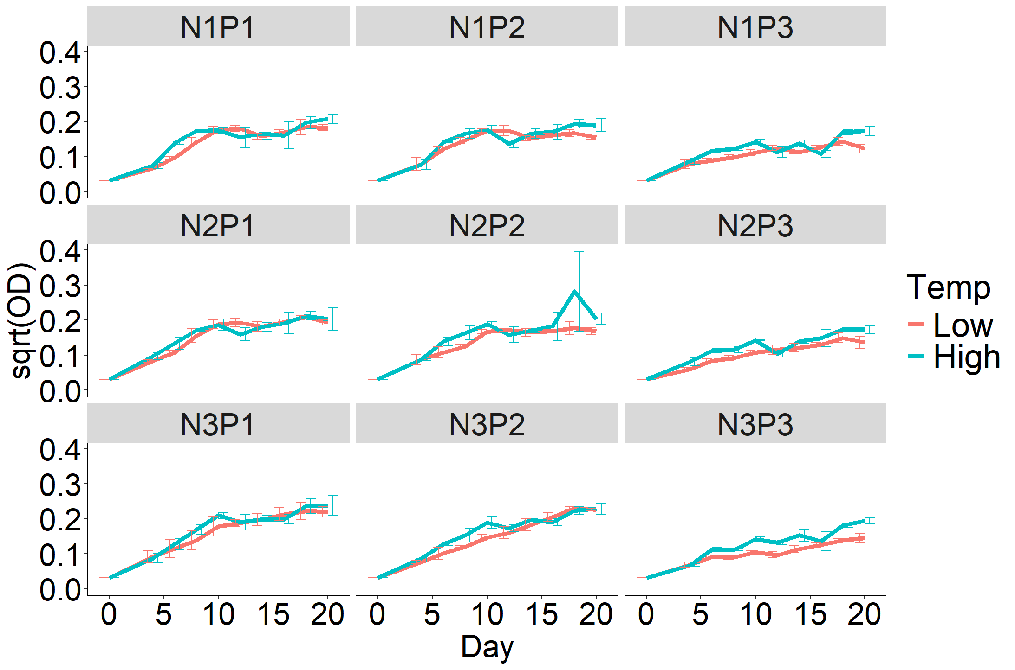
Fig. S1 Growth curve of phytoplankton in each treatment under low (red line) and high (blue line) temperatures (sqrt(OD): square root of optical density at 680 nm).

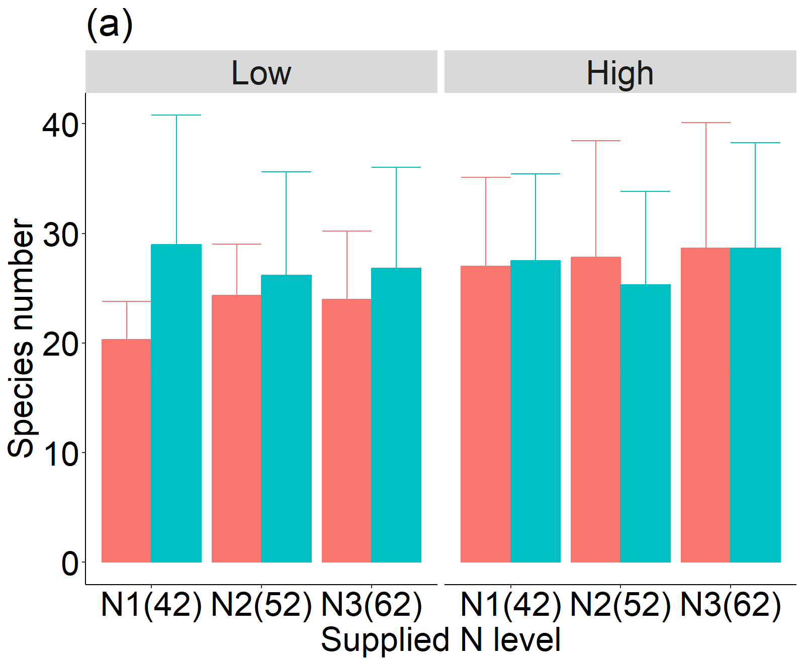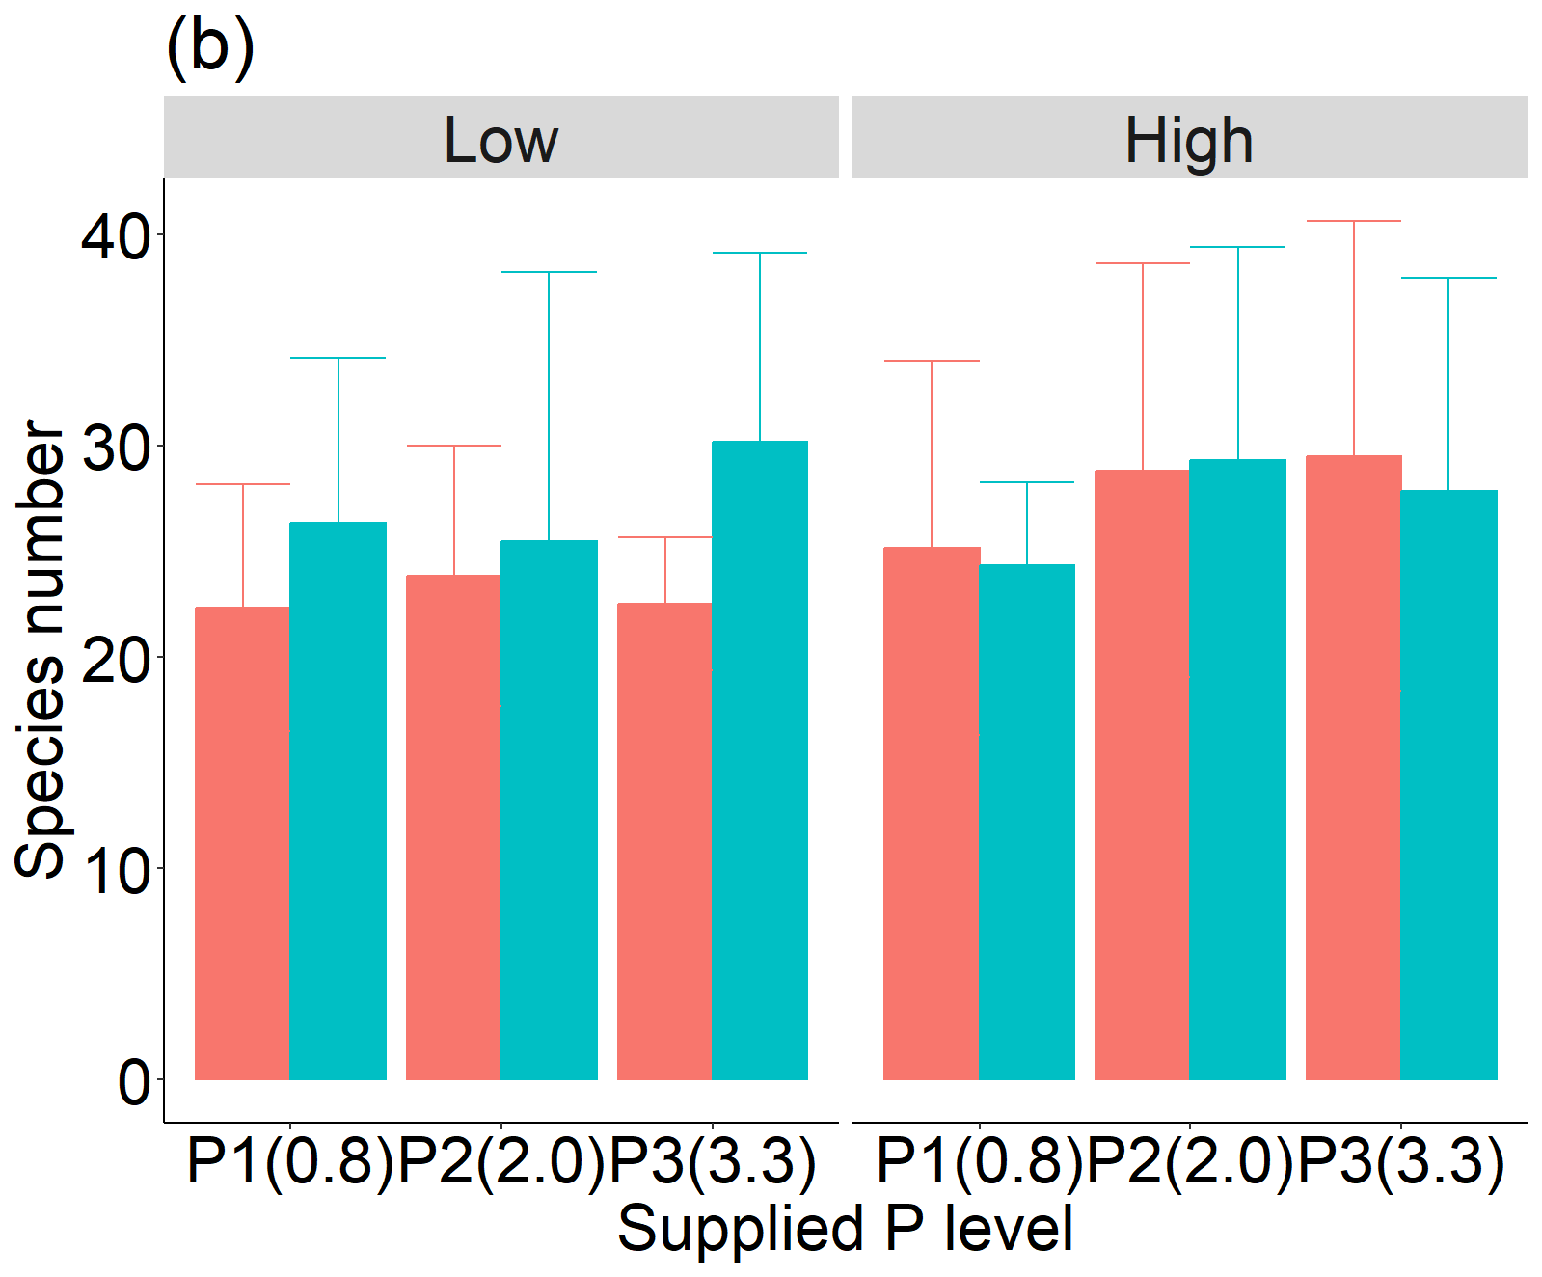
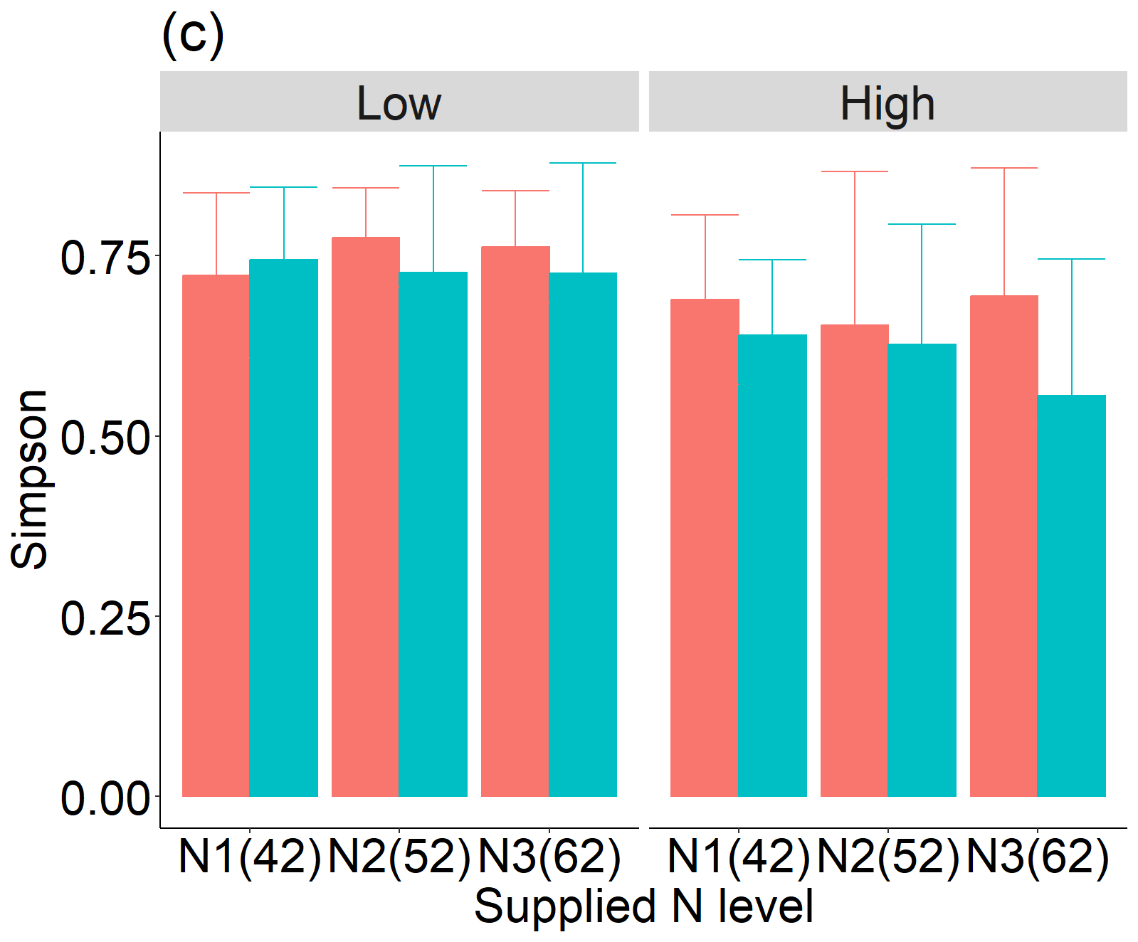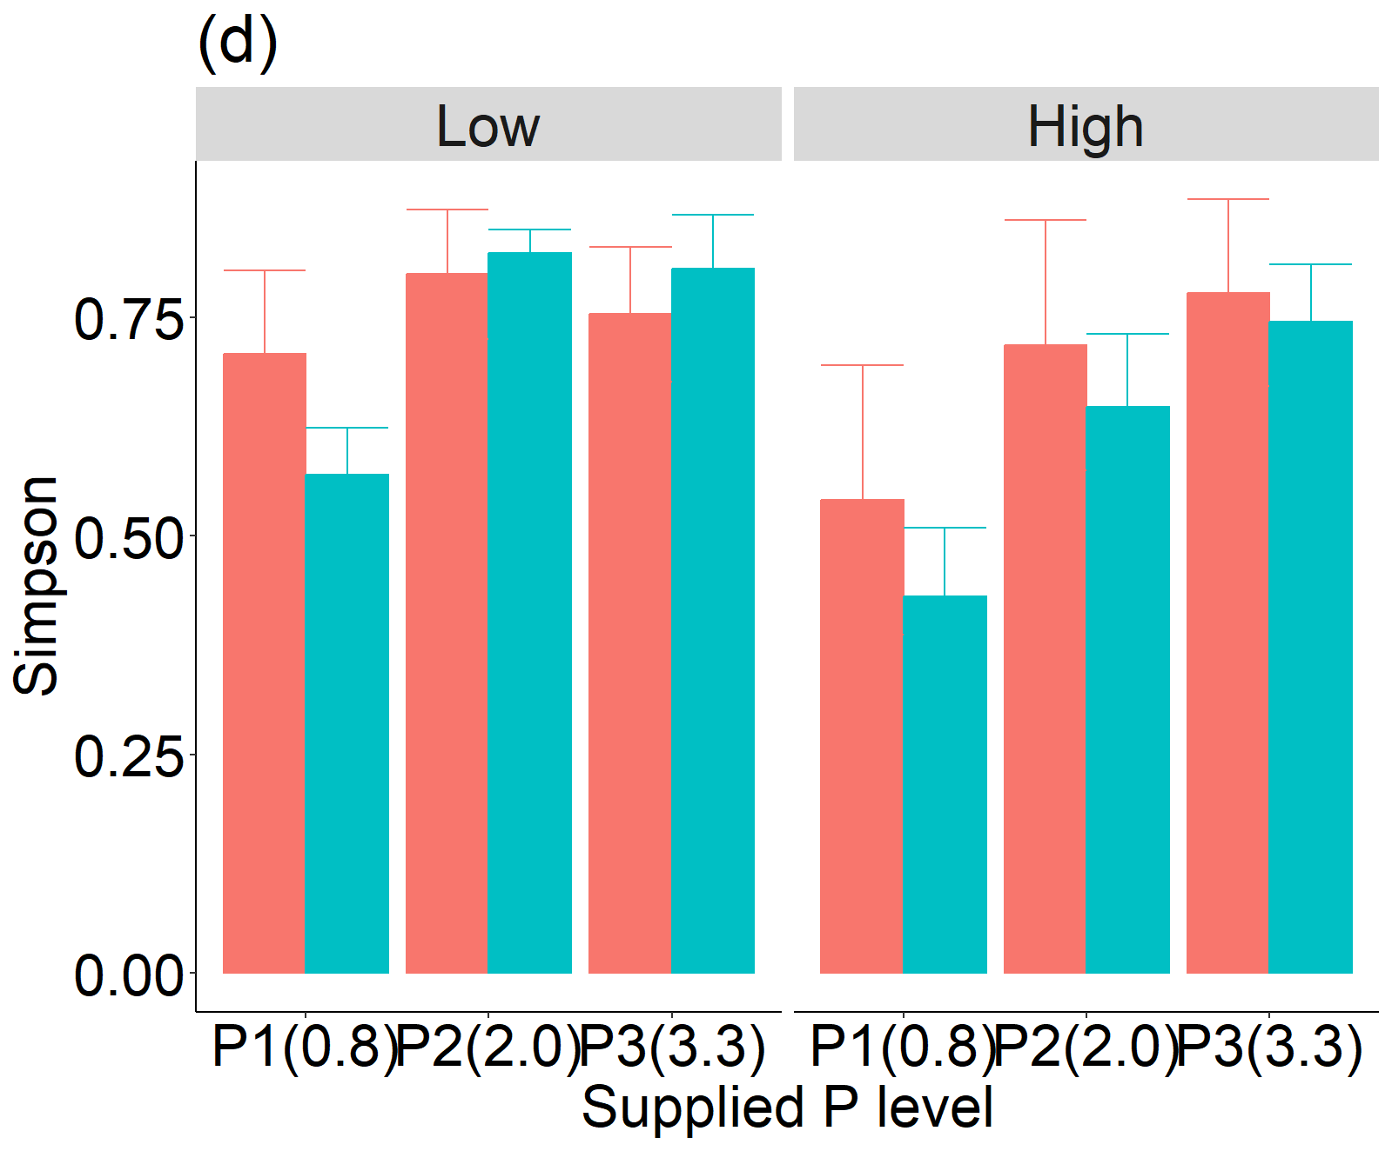
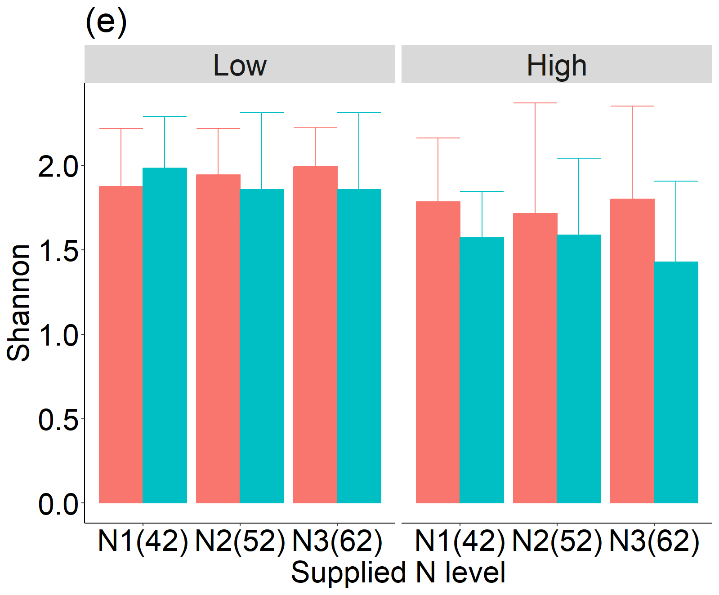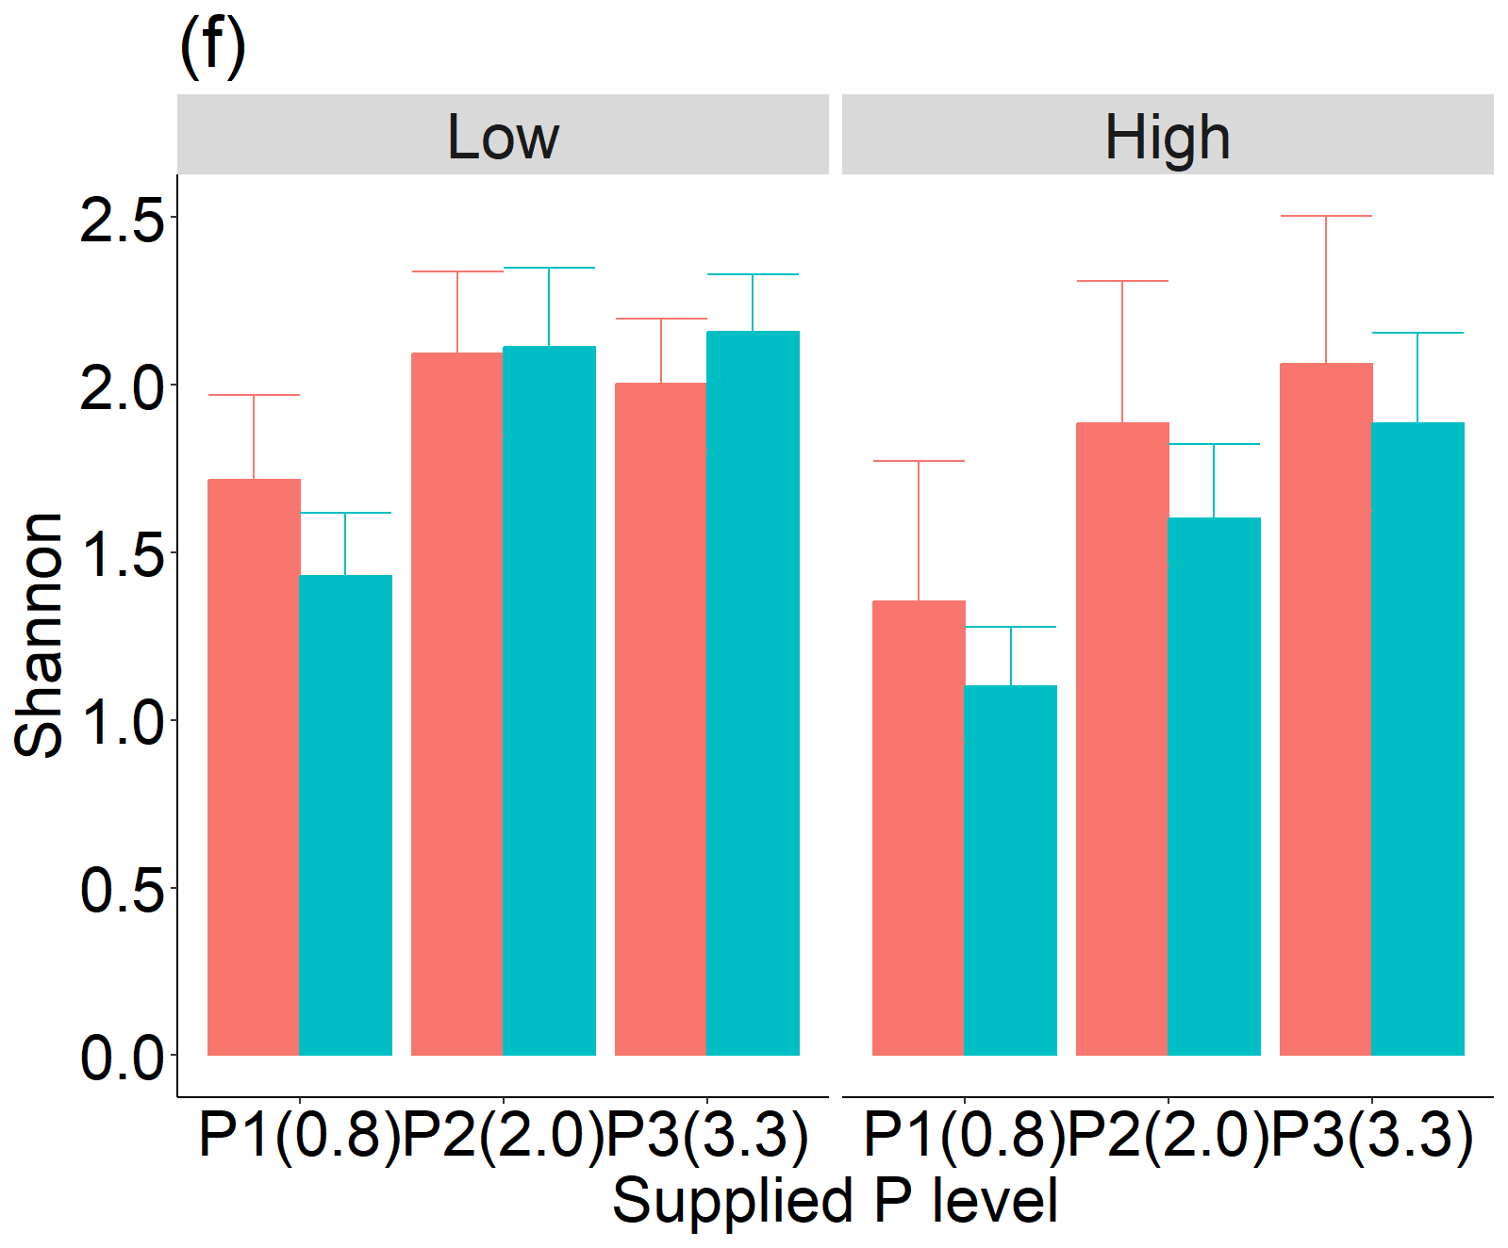
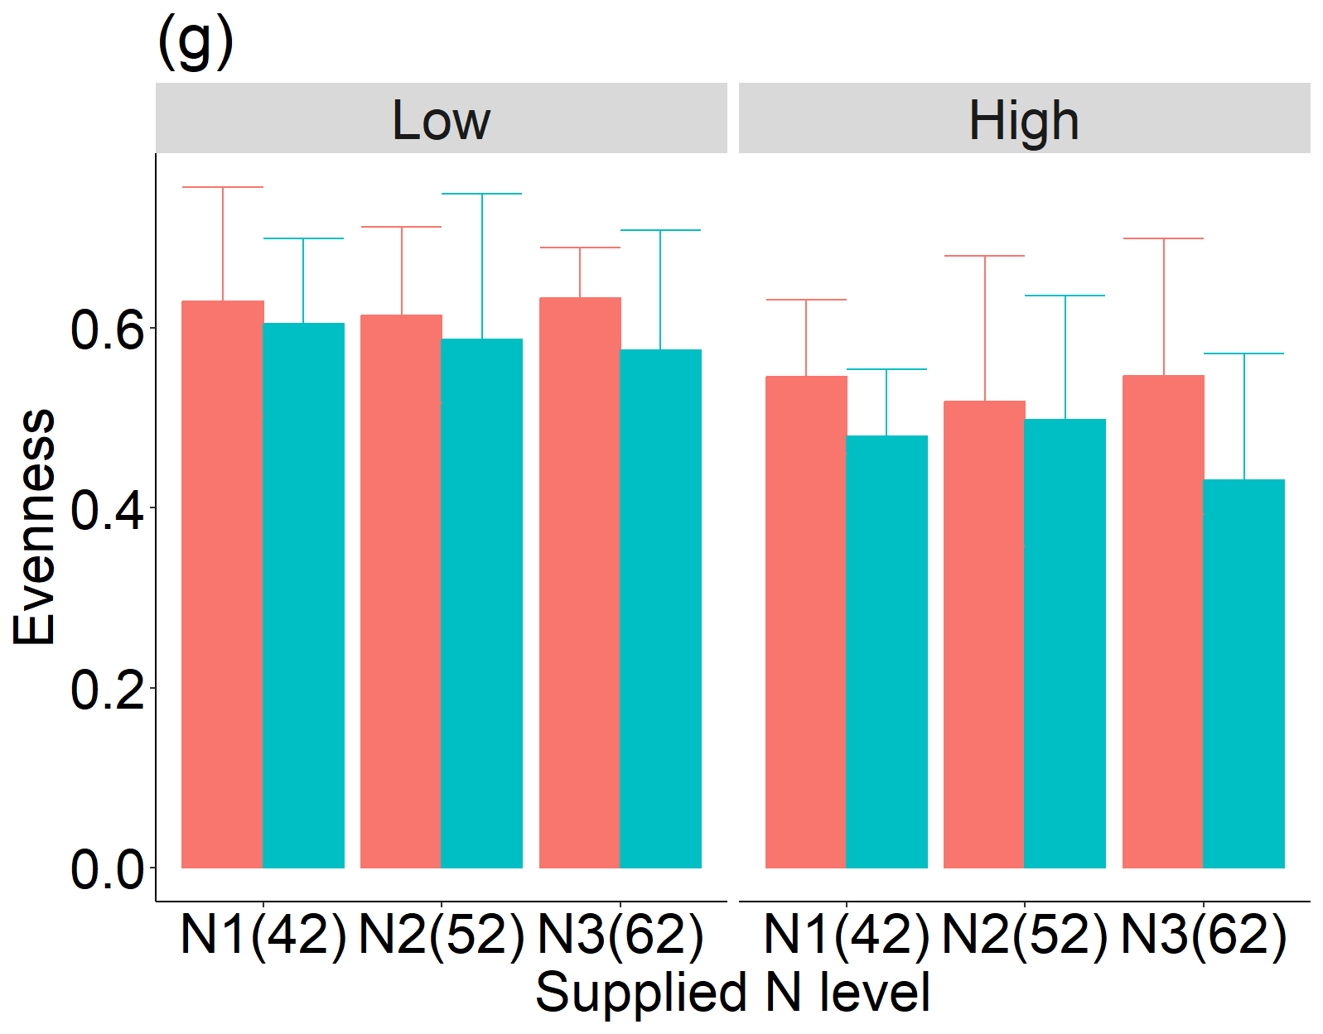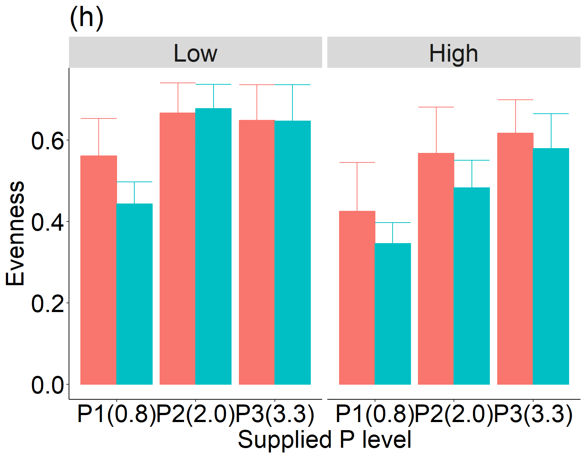
Fig. S2 diversity indices (a-b: species number; c-d: Simpson index; e-f: Shannon index; g-h: Evenness index) along the supplied N and P levels in exponential (red) and stationary (blue) phase under low and high temperatures.

