Oleochemical Сarbonates: a Comprehensive Characterization of an Emerging Class of Organic Compounds
Alessandro Triolo^{1,*}, Vitaly V. Chaban², Fabrizio Lo Celso^{1,3}, Francesca Leonelli⁴, Michael Vogel⁵, Elisa Steinrücken⁵, Alessandra Del Giudice⁴, Carlo Ottaviani¹, James A. Kenar⁶ and Olga Russina^{1,4}.

¹ Istituto Struttura della Materia (ISM), Consiglio Nazionale delle Ricerche (CNR), Rome, Italy
² Yerevan State University, Yerevan, Armenia
³ Department of Physics and Chemistry, Università di Palermo, Palermo, Italy
⁴ Department of Chemistry, University of Rome Sapienza, Rome, Italy
⁵ Institute of Condensed Matter Physics, Technische Universität Darmstadt, Darmstadt, Germany
⁶ USDA, Agricultural Research Service, National Center for Agricultural Utilization Research, Peoria, Illinois, USA

Abstract.
Dialkyl carbonates (DAC) with short-medium alkyl length - oleochemical carbonates – are attracting attention because of their appealing properties, including low viscosity, flammability, toxicity, environmental impact and wide range of applications: lubricants, personal care, fuel additives etc. However, not much is known on their chemical physical properties and, more importantly on the nature of microscopic correlations that eventually determine bulk performances. In view of this paucity, here, we present a large exploration of a series of chemical physical properties of a set of DACs ranging from dimethyl up to didodecyl carbonate. This study extends previously determined data bases, thus providing a complete picture of the temperature dependence of chemical physical properties around room temperature. Furthermore, we explored the microscopic morphology of DACs, by synergic exploitation of X-ray scattering and Molecular Dynamics techniques. These tools allow detecting the existence of a distinct degree of mesoscopic spatial segregation between polar carbonate moieties and apolar alkyl chains domains. The role of first neighbour carbonate moieties in driving the corresponding molecules towards weak hydrogen bonding interactions and alkyl chain alignment is described. Such an effect is related to the overall mesoscopic segregation of alkyl tails that isolate small droplets formed by stacked carbonate groups. Such a highly compartmentalised morphology can explain and potentially suggest applications of DACs in fields as relevant as separation, catalysis, lubrication etc.

- Introduction.
Carbonates are esters of carbonic acid (HO-C(O)-OH). Their aliphatic dialkyl derivatives with short chains such as dimethyl and diethyl carbonate find applications considering their interesting reactivity and solvent properties[1–4], low volatility, low ecotoxicity, and good biodegradability. Dialkyl carbonates (DACs) with medium length alkyl chains (with three to eight carbon atoms per chain) are often indicated as oleochemical carbonates. They can be prepared from animal- or plant- derived feedstocks, thus enabling sustainable chemistry based on these compounds. Their properties, including low viscosity and appreciable thermal stability, allow their use as lubricants, as fuel additives and in cosmetics and personal care. DACs are safe non-corrosive compounds that find a huge number of applications, especially as environmentally responsible additives or as non-toxic replacements for phosgene.[5–8] Dimethylcarbonate (D1C, hereinafter we indicate DACs bearing two symmetric chains containing n carbon atoms as DnC) is among the most well-known DACs, considering the recently developed green synthetic approaches to prepare it and its interesting chemistry.[1–4] D1C and D2C, together with cyclic ethylene and propylene –carbonates find applications in electrochemistry as solvent for electrolytes, taking advantage of their low viscosity and dielectric constant.[9–11]Medium- or long chain DACs have been less studied, despite their interesting applications as lubricants, plasticisers, oil additives, personal care and cosmetic components and, more recently, phase change materials.[6,12–14] In the past, their exploitation has been limited because the main synthesis route required the use of phosgene; however there are now several environmentally sustainable synthetic routes that allow high yield production of DACs, thus enabling technologies based on these compounds. They typically show low density, viscosity and melting points and the introduction of branched alkyl chains allows to further expand the liquid phase where they can find applications. Their chemical physical properties have been explored in the past, providing basic information concerning their range of applications.[15–19]
A recent safety assessment of DACs as used in cosmetics has been published, dealing with a series of DACs, including D1C, D3C, D15C and some branched DACs. It includes an overview of use, toxicokinetic, toxicological effects of the studied DACs and the conclusion is that these DACs “are safe in the present practices of use and concentration”.[20]
As mentioned, different routes exist for their synthesis [5,6,15] apart from the phosgene route, including reaction of alcohols with CO₂, in the presence of a strong water adsorbent or, as in the present study, the reaction of alcohols with short DAC members (e.g. dimethyl or diethyl carbonates (DMC or DEC, respectively).
Recently, alternative methods for preparation of long alkyl chains DACs have been proposed such as the work of Lopinti et al., where wood ashes have been used as a starting component.[21]
Here we exploited the protocol used by Kenar et al. [6,15] on the basis of the study from Sivaram and coworkers [22], and, using a dibutyltin oxide catalyst, we achieved the replacement of the methyl groups in DMC with longer side alkyl chains.
The high polarity of DACs is exploited in a number of applications, including lubrication (due to the enhanced tendency to adhere to metal surfaces), metal ion (e.g. Au, Pt etc.) extraction etc. On the other hand, such a feature can lead to substantial structural effects. The coexistence in DACs of two different kinds of moieties, namely the polar carbonate group CO₃⁻ and the apolar alkyl chains, can be expected to deliver a structural micro separation between mutually incompatible molecular portions, similarly to what has been observed in other molecular systems such as alcohols[23,24], dialkyl sulfoxides[25,26] and aldehydes[27,28] or ionic liquid[29] compounds. In these compounds, the spatial segregation between polar and apolar moieties occurs over a mesoscopic spatial scale, manifesting itself as a low Q scattering feature in X-ray and/or neutron diffraction patterns. In these situations, a careful description of experimental diffraction data can be successfully achieved when using state of the art interatomic potentials and decomposition of scattering contributions in terms of polar and apolar alternations fully account for such a diffraction feature.
Furthermore, different studies have highlighted the presence and structural relevance of hydrogen bonding interactions in these kind of compounds[30–32]: although weak, the C-H··O interaction has been characterised and considered influential to determine the short range coordination in the liquid state.
In this work, we present original results on the preparation of new oleochemical carbonates, we describe several important chemical physical properties for the series of DACs ranging from D1C up to D12C, including a branched DAC. Finally, taking advantage of the synergy between x-ray scattering and atomistic Molecular Dynamics simulations, we describe the microscopic to mesoscopic structural correlations in the DAC family. We highlight the important role of electrostatic correlation between neighbour carbonates to drive the formation of C-H··O hydrogen bond, the mingling of side alkyl chains and, eventually, the microphase separation between polar domains and apolar domains formed by segregated alkyl chains. Such mesoscopic features are of fundamental importance to applications in the fields of separation, catalysis and other high impact fields.

2. Material and methods
2.1 Experimental
2.1.1 Chemical samples and preparation.
DACs (see Scheme 1) (CH₃-(CH₂)_{n-1}O)₂C=O with n=8-10, 12 as well as bis(2-butyloctyl) carbonate (D84C) were prepared and provided by Kenar et al.[15]; D1C and D2C are Sigma Aldrich products and were used as received.
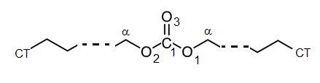
Scheme 1. Schematic representation of the structure and nomenclature of di-alkyl-carbonates.
Dialkyl carbonates 3a-d (n=3-6) (scheme 2) were synthetized as illustrated on Scheme 2 slightly modifying a procedure already known in the literature using dibutyltin oxide as catalyst, linear alcohols 1a-d and diethyl carbonate 2.[15] The reaction yields were very low (around 30%) with the exception of dibutyl carbonate (79%). The low yields resulted from difficult chromatographic purification of the symmetric carbonate 3 from asymmetric carbonate byproduct 4, which were present in small quantity during the reaction..
Scheme 2. Dialkyl carbonate 3a-d (D3C to D6C) preparation. Reaction conditions: alcohols 1a-d (8 equivalents), diethyl carbonate (D2C) 2 (1 equivalent), Bu₂SnO (0.01 equivalent), temperature from 95°C to 145°C, yields from 27 to 79 % (yields calculated on the purified compounds).
Materials and Methods
All the alcohols 1a-d, diethyl carbonate 2 and dibutyltin oxide were purchased from Tokyo Chemical Industry Company or Sigma-Aldrich and used without further purification. Column Chromatography (CC): silica gel 60, 70-230 mesh ASTM. ¹H NMR and ¹³C NMR spectra were recorded through a Bruker AVANCE™-400 spectrometer at 400.13 MHz and 100.61 MHz respectively. NMR spectra were determined in CDCl₃, and chemical shifts were expressed in ppm (δ) relative to the residual solvent peak (respectively 7.26 ppm for ¹H-NMR and 77.2 ppm for ¹³C-NMR).
General procedure for the synthesis of carbonates 3a-d
In a two neck round bottom flask previously flamed under Ar the alcohol 1 (1 equivalent) and the catalyst Bu₂SnO (0.01 equivalent) were added. The mixture was stirred at 95°C for the time necessary for the dissolution of the solid. Diethyl carbonate 2 was so added to the reaction mixture by a dropping funnel for 30 minutes. After that time the temperature was raised until 145 °C and the stirring was continued until the Gas Cromatography-Mass Spectroscopy analysis displayed the disappearance of compound 2. After that time the reaction was cooled to room temperature and the solution was diluted with CH₂Cl₂, washed with brine, and dried over anhydrous Na₂SO₄. The organic phase was finally filtered and evaporated to dryness under reduced pressure. The residue was purified by silica gel CC (n-hexane/diethylether 1:1 as eluent mixture) to give compound 3.
Dipropylcarbonate 3a The NMR spectra are consistent with the literature. [33]. The product was isolated as a colorless oil in 27% yield. ¹H-NMR (J coupling constant in Hz): 0.95 (t, 6H, J = 7.2), 1.69 (sextet, 4H, J = 7.2), 4.08 (t, 4H, J = 7.2). ¹³C NMR: 10.3, 22.2, 69.6, 156.0.
Dibutylcarbonate 3b The NMR spectra are consistent with the literature. [34]. The product was isolated as a colorless oil in 79% yield. ¹H NMR: 0.92 (t, 6H, J = 7.4), 1.33-1.44 (m, 4H), 1.63 (ddt, 4H, J = 8.9, 7.9, 6.7), 4.11 (t, 4H, J = 6.7). ¹³C NMR: 13.8, 19.0, 30.8, 67.8, 156.0.
Dipentylcarbonate 3c The NMR spectra are consistent with the literature. [33]. The product was isolated as a colorless oil in 30% yield. ¹H NMR: 0.90 (t, 6H, J = 7.2), 1.33-1.37 (m, 8H), 1.63-1.70 (m, 4H), 4.12 (t, 4H, J = 6.7). ¹³C NMR: 14.1, 22.4, 28.0, 28.5, 68.2, 156.0.
Dihexylcarbonate 3d The NMR spectra are consistent with the literature. [34]. The product was isolated as a colorless oil in 31% yield. ¹H NMR: 0.89 (pt, 6H, J = 7.2), 1.21-1.44 (m, 12H), 1.66 (dq, 4H, J = 8.3, 6.7), 4.12 (t, 4H, J = 6.7). ¹³C NMR: 14.1, 22.7, 25.5, 28.8, 31.6, 68.2, 156.0.

Samples were kept at 60°C for 12 hours and then maintained at inert atmosphere (Ar) before measurements.

2.1.2. Calorimetry.
The differential scanning calorimetry (DSC) measurements were performed in a Perkin Elmer 8000 DSC equipped with a liquid nitrogen cooling system. The samples were sealed in hermetic aluminum pans from TA-Instruments. The heat flow of the samples in comparison with an empty sample pan was measured from room temperature down to 170 K and back to room temperature. Heating and cooling rates were 5 K/min and identical for each run. The melting temperatures were obtained from the melting peak positions.

2.1.3. Density.
Density data were obtained using a DM45 Mettler-Toledo densimeter equipped with a vibrating tube with a resolution of 10⁻⁵ g/cc. Measurements were taken as a function of temperature that was controlled to within 10⁻² °C by means of a Peltier module. The instrument was calibrated with dry air and degassed-distilled water, before performing the experiments.

2.1.4. Refractive index.
Refractive index data, n_{D}, were obtained using an Abbe refractometer (mod. 2WAJ – Optika) equipped with an amber led illuminating device (λ=589 nm). Measurements were taken as a function of temperature between 10 and 60°C by using a thermostating bath that allowed temperature control to within 0.2 °C. The instrument was calibrated with naphthalene bromide at 20°C.

2.1.5. Dynamic viscosity.
The dynamic viscosity was measured by means of an Anton Paar Lovis 2000 ME microviscometer based on the falling ball principle. The viscosity was measured using a steel ball and two capillaries with internal diameters of 1.59 or 1.8 mm (depending on the viscosity range of the samples). The instrument was preliminarily calibrated by ultrapure water and A. Paar standards. The repeatability and standard uncertainty of viscosity measurements are claimed as 0.1% and ± 0.5%, respectively. The temperature was maintained by an internal thermostat with the standard uncertainty of ± 0.02 °C. The DAC samples were measured as a function of temperature in their liquid state between 10 and 60°C.
2.1.6. ¹H NMR diffusion.
To obtain self-diffusion coefficients of the DACs, we performed ¹H static field gradient (SFG) NMR measurements. Here, a magnetic field with a static gradient g along the z axis is applied so that the Larmor frequency of a nuclear spin depends on the z position ω_{L}(z)=-γ B(z) with γ being the gyromagnetic ratio of the observed nucleus and B(z)= B₀ + γz. This way, molecular diffusion leads to a change of the resonance frequency, which can be detected by employing a stimulated-echo (STE) pulse sequence: 90° - t_{e} - 90° - t_{m} - 90° - t_{e}. The evolution times t_{e} serve to encode the respective resonance frequencies, while the mixing time t_{m} allows for diffusion in the meantime. The resulting STE signals decay due to free diffusion according to [35,36]:
(Eq. 1) S(t_{m}, t_{e}) ~ exp [-q² D (t_{m}+2/3 t_{e})] .
Here, D is the self diffusion coefficient and q = γ g t_{e} can be considered as a generalized scattering vector, which determines the inverse length scale of the experiment and amounts in the present measurements to q⁻¹≈20 μm. We record SFG STE decays for several fixed evolution times t_{e} as a function of the mixing time t_{m} at 298 K and fit these data globally to Eq. 1 using a single value of D.
For the NMR experiments, all samples were sealed in glass tubes.
¹H NMR diffusion measurements were carried out in the stray field of an NMR spectrometer resulting in a field gradient of g = 8.8 T/m and a ¹H Larmor frequency of 2 π· 79.4 MHz at the position of the sample. The 90° pulse length was about 1 μs. Temperature was controlled by using a passive cooling cryostat, stabilizing the temperature to ± 0.1 K.

2.1.7. Wide Angle X-ray scattering.
Wide Angle X-ray Scattering (WAXS) data for DC1 and DC4 samples were collected at room temperature using the non-commercial Energy Dispersive X-ray Diffractometer (EDXD) built in the Department of Chemistry, Rome University “Sapienza” (Italian Pat. Appl. no. 1126484 - 23 June 1993, Caminiti et al.) White Bremsstrahlung radiation emitted by a tungsten tube (50 kV, 40 mA) was used. The scattering variable Q (transferred momentum) is given by: Q (Å⁻¹)=4π/λ_{i} sinθ = E_{i} sinθ, where E_{i} is the beam component energy (in keV) and θ is the scattering angle. Using a white beam, data were collected at different θ values (namely: 1°, 3°, 8° and 22°) with an energy sensitive, high purity, solid state Ge detector. Data were corrected for absorption and background and white beam scattering using in house developed software[37,38] and eventually were merged to yield the total static structure factor, I(Q):
$$I\left(Q\right)=I_{e.u.}\left(Q\right)-\sum_{i=1}^{n}{{ x}_{i}{{ f}_{i}(Q)}^{2}}$$

where f_{i}(Q) are the interpolated atomic scattering factors, x_{i} are the number concentrations of i-type atoms in the stoichiometric unit, and I_{eu}(Q) is the observed intensity in electron units. The latter quantity has been used to confront with Molecular Dynamics computed I(Q). Samples were contained in quartz capillaries of 2 mm diameter and kept at ambient temperature during the measurements.

2.1.8. Small Angle X-ray Scattering
Small Angle X-ray Scattering (SAXS) measurements were performed at the SAXSLab Sapienza with a Xeuss 2.0 Q-Xoom system (Xenocs SA, Sassenage, France), equipped with a micro-focus Genix 3D X-ray source (λ = 0.1542 nm), a two-dimensional Pilatus3 R 300K detector which can be placed at variable distance from the sample. Calibration of the scattering vector Q range, where Q=(4π sinθ)/λ, 2θ being the scattering angle, was performed using a silver behenate standard.
Measurements with different sample-detector distances were performed so that the overall explored Q region was 0.03 < Q < 3.3 Å^{–1}. The samples were loaded into a disposable quartz capillary with nominal thickness 1.0 mm and sealed with hot glue before placing them in the instrument sample chamber at reduced pressure (∼0.2 mbar). The beam size was defined through the two-pinhole collimation system equipped with scatterless slits to be 0.25 mm x 0.25 mm.
The two-dimensional scattering patterns were subtracted for the dark counting, and then masked, azimuthally averaged and normalized for transmitted beam intensity, exposure time and subtended solid angle per pixel, by using the FoxTrot software developed at SOLEIL. The one-dimensional S(Q) vs. Q profiles were then subtracted for the capillary contribution.
The measurements were conducted at ambient temperature (ca. 20°C) and the samples maintained liquid and homogeneous during the whole length of the experiment.

2.2. Computational methods.
2.2.1. Molecular Dynamics simulations.
Computer simulations of periodic systems (bulk phase) were carried out by using classical MD based on the pairwise non-bonded interaction potentials and phenomenological bonded potentials. The functional forms suggested in the Generalized Amber Force Field (GAFF)[39] were parameterized using ab initio electronic-structure calculations and further corrected versus selected experimental data. The non-bonded interactions were represented as a sum of the Coulombic and Lennard-Jones-12-6 terms. The bonded interactions were represented as a sum of the harmonic bond, harmonic angle, and GAFF-style dihedral terms.[39] In particular, most dihedrals were simulated according to the Ryckaert-Bellemans functional form.[40] Some harmonic improper dihedral functions were additionally defined to help a dialkyl carbonate molecule preserve its planarity. The atoms belonging to the same molecule but separated by more than three covalent bonds interacted in the same way as the atoms belonging to different molecules. The scaling factors of 1.0000 (for the Coulombic term) and 0.8333 (for the Lennard-Jones-12-6 term) were applied to the so-called one-four interactions in addition to the dihedral parameters. [39] Such a form of the bonded part of the force field is used in GAFF to better reproduce equilibrium dihedral values and account for the immediate molecular environment.
Every atom of the DACs including hydrogens was simulated as a separate interaction center. The lengths of covalent bonds involving hydrogen atoms, i.e., carbon-hydrogen bonds, were kept constant using the LINCS algorithm of the eighth order.[41] Freezing of carbon-hydrogen covalent bonds allowed us to keep the Verlet integration timestep as large as 2.0 fs. The frozen C-H bonds are chemically and physically inert in the considered systems. Simulation of their inherent thermal dynamics explicitly does not add effects relating to any of the studied physicochemical properties.
The electrostatic interactions were simulated directly via the Coulomb law for all pairs of atoms the distance between which was inferior to 1.50 nm. For more distant atoms, the Particle-Mesh-Ewald method was used.[42] The Lennard-Jones-12-6 interactions were simulated directly for interparticle distances smaller than 1.1 nm. For the distances from 1.1 to 1.2 nm, the interaction function was modified according to the shifted force algorithm to smoothly approach zero at 1.20 nm. The energy and pressure corrections for dispersion forces were applied. The list of atomic neighbors was updated every ten timesteps during the course of the MD simulation. The systems containing liquid DACs were represented as cubic boxes, whereas the periodic boundary conditions were applied in all three directions.
The initial geometries of the MD systems containing arbitrarily positioned molecules were optimized using the steepest descent algorithm to eliminate all forces exceeding 100 kJ mol⁻¹ nm⁻¹. Next, the equilibration stage at the respective temperature (from 283.15 to 333.15 K with a step of 5 K) and 1 bar was performed to mimic the experimental conditions. The equilibrating simulations lasted from 250 000 timesteps, 0.5 ns, for dimethyl carbonate to 1 000 000 timesteps, 2.0 ns, for dodecyl carbonate. Each composition was first simulated at 333.15 K first to overcome all potential barriers and then cooled down to the specific temperature. Ultimately, the necessary physicochemical properties (heats of vaporization, specific density, shear viscosity, self-diffusion coefficients) were computed by sampling the system’s phase space for 10 ns. Overall, over two microseconds of molecular dynamics of DACs at given conditions were sampled.
The simulations were carried out in the constant-temperature constant-pressure ensemble. The constant temperature in the range of 283.15-333.15 K was maintained using the Bussi-Donadio-Parrinello velocity rescaling thermostat[43] with a characteristic time of 100 fs. The constant pressure was maintained by adjusting the length of the simulation cube’s side according to the Parrinello-Rahman pressure coupling procedure.[44] The reference pressure value was equal to 1.0 bar in all simulations. The barostat’s relaxation time was set to 2.0 ps.
The coordinate frames were saved every 0.01 ps during the equilibrium stage of MD simulation. The linear velocities and forces were not recorded and analyzed. Due to conformational flexibility, relatively slow inherent dynamics of the higher-molecular-weight DACs, and the necessity to get accurate energy, the gas phase simulations used to evaluate heats of vaporization were extended to 50 ns each.
The specific densities were obtained from the averaged values of the system volumes at a given combination of temperature and pressure. The heat of vaporization is a difference between the system’s potential energy in the liquid phase and the system’s energy in the gaseous phase plus the R×T product. The self-diffusion coefficients were calculated from the mean-squared displacement evolution of the target group of interaction centers over time. The shear viscosities were derived from the off-diagonal stress tensor elements using a trajectory from the equilibrium MD simulation. This approach is sometimes referred to as the Einstein method.
The electronic-structure calculations were used to (1) obtain equilibrium geometries of DACs in the liquid phase and in vacuo; (2) investigate the impact of the molecular environment on the equilibrium geometrical structures of condensed DACs and their charge density distributions; (3) identify strong-binding patterns to be captured by the classical force field as well. The ab initio calculations were performed at the hybrid density functional level of theory (DFT) and highly-accurate electron-correlation coupled-cluster method CCD. The exchange-correlation DFT functionals known as B3LYP[45,46] and M11[47] were employed. For the case of B3LYP, the empirical correction for the dispersion attraction was applied,[48] whereas M11 includes such a correction implicitly. The atom-centered split-valence triple-zeta polarized basis set 6-311++G** was used. The basis set includes diffuse and polarization functions for all atoms present in the simulated chemical structures. The point charges were obtained according to the Merz-Singh-Kollman method[49] employing the electronic density of the ground-state optimized geometry at the respective level of theory. Only global minimum structures of DACs were used as input configurations in the coupled-cluster calculations due to the high cost of the method. The global minima were obtained at the M11 DFT level of theory using the method described elsewhere.[50–52] Note that, where reported, the global minimum configurations were additionally optimized using the coupled-cluster method before deriving geometrical, thermodynamical, and charge density properties.
All molecular dynamics calculations were conducted in GROMACS 4.[53,54] All quantum-chemical calculations were conducted in GAMESS.2020,[55] and the respective output files were inspected in Gabedit 2.5.1.[56] The global minimum configurations of the DACs were searched by the in-home code developed by V.V.C. The initial structures of the molecules were drawn in Avogadro 1.2.0.[57] The molecular dynamics trajectories were visualized in VMD (Visual Molecular Dynamics) 1.9.3.[58] For the sake of extending the range of definition of the pair distribution functions and, hence, properly evaluating the computed static structure factors at low Q values, in order to compare with experimental data sets, we also conducted molecular dynamics calculations at 25°C with GROMACS 2021.4 (10.5281/zenodo.5636567), using the same protocol as above. Such simulations were done using a box size of approximately 80 Å, for all the DACs. Various quantities, including pair distribution functions (pdfs or g(r)), spatial distribution functions and static structure factors were computed using the Travis software.[59–61]

2.2.2. Force Field development.
O-C-O-X moieties (where X is another element) represent a relatively common pattern in organic and inorganic structures. The respective covalent and non-covalent parameters are available in some data sets for classical molecular dynamics simulations. We tried some of the arbitrarily chosen parameters for the carbonate head group and hydrocarbon chains of DACs but obtained a systematically overestimated molecule-molecule coupling. This resulted in higher densities and heats of vaporization as compared to the respective experimental data for low-molecular-weight DACs, such as D1C, D2C, and D3C, at room conditions. To combat the inaccurately estimated properties, we developed ad hoc models for DACs. In particular, the parameters representing the carbonate polar moiety and adjacent atoms were recomputed in view of the particular molecular structures. Electronic-structure calculations were used to obtain the most viable structure and electron distribution patterns for the global minimum configurations of DACs. GAFF was used as a source of interaction parameters in those cases where our calculations did not reveal discrepancies with the existing models.
The bond lengths and equilibrium planar angles were computed at the electron-correlation CCD level of theory. The computed data reveals moderate differences from the parameters in the General Amber FF.[39] Table 1 enumerates the obtained results. All electronic-structure methods that we hereby employed to investigate covalent descriptors of the DAC molecules provide fairly similar results. Since our coupled-cluster calculations with a significantly large basis set including polarization and diffuse primitive functions were fulfilled at a higher level of theory than ever before, it was decided to substitute all existing parameters of the force field for the oxygen-carbon-oxygen-carbon structural pattern in DACs by these new constants. In the meantime, the harmonic force constants were kept unchanged and the dihedral angles were taken from GAFF as no cardinal discrepancies in these parameters were detected.

Table 1. Equilibrium bonded parameters obtained from the ground-state structures of DACs using electron-correlation CCD and hybrid DFT methods. The molecular wave functions were constructed out of the primitive functions supplied by the 6-311++G** basis set. The geometries of the configurations were optimized independently from scratch. The computations correspond to a molecule in vacuo.

 | CCD | M11 | B3LYP | Comment
C=O(carbonyl) | 0.1202 | 0.1205 | 0.1212 | Important distance for electrostatics.
C-O(ether) | 0.1331 | 0.1330 | 0.1341 | —
O(ether)-C(CH₂) | 0.1438 | 0.1444 | 0.1436 | —
C(CH₂)-C(CH₂) | 0.1517 | 0.1513 | 0.1514 | Determines the geometry of alkyl moiety.
C-H(CH₃) | 0.1094 | 0.1096 | 0.1093 | —
∠O-C=O | 126.0 | 125.3 | 126.1 | Determines the rigidity of the polar head.
∠O-C-O | 108.3 | 109.3 | 107.9 | —
∠C-O-C | 114.7 | 115.0 | 114.5 | Determines orientation of the side chains.
∠O-C-C | 107.1 | 107.2 | 107.1 | —
∠O-C-H | 108.8 | 108.4 | 110.7 | Determines the geometry of alkyl moiety.

The effect of the neighboring DAC molecules on their geometry and charge distribution must be investigated. Table 2 summarizes covalent distances, angles, and selected partial charges describing the carbonate head, α- and β-methylene groups. We compared an isolated molecule in vacuo, a molecule in the implicit solvent, and the isolated molecular dimer. The solvation was done using the polarizable continuum model with dibutyl ether as an implicit solvent. Dibutyl ether features very similar physicochemical properties to the low-molecular-weight DACs, particularly, a very similar dielectric permittivity.
The ab initio results indicate the absence of any drastic solvation/non-covalent interaction effects, although the partial charges are sensitive to the chosen model of the DAC system. Interestingly, the polarized-continuum implicit solvation model increased most of the head group charges, whereas the explicit representation of an additional DAC molecule has the opposite effect. In such a case, the explicit-particle simulations must be preferred. Note that the effect of the molecular environment is commensurate with the absolute value of the partial atomic charge. The force field development procedure based on the molecule-in-vacuo approximation can be used to derive all bonded parameters of the new model and the electrostatic partial charges must be carefully adjusted. In the following, we exemplify the applied procedures step-by-step.

Table 2. Bonded parameters and partial charges in a dialkyl carbonate molecule in vacuo, implicit solvent (dibutyl ether), and a dimer cluster. The calculations were carried out at the M11/6-311++G** level of theory.

 | Monomer | Solvated | Dimer | Comment
C=O(carbonyl) | 0.1202 | 0.1206 | 0.1201 | The effect of the polar head solvation is very modest in the low polar implicit solvent.
C-O(ether) | 0.1331 | 0.1329 | 0.1326
O(ether)-C(CH₂) | 0.1438 | 0.1437 | 0.1439
C-H(CH₃) | 0.1094 | 0.1091 | 0.1096 | —
∠O-C=O | 126.0 | 125.4 | 125.6 | The geometry of the carbonate moiety changes insignificantly due to the environment.
∠O-C-O | 108.3 | 109.2 | 109.4
∠C-O-C | 114.7 | 115.1 | 114.7
∠O-C-H | 108.8 | 109.5 | 109.3 | —
q(C-carbonyl) | +1.20 | +1.24 | +1.00 | A mediocre alteration of partial atomic charges both due to implicit solvation and an explicit account for an adjacent dialkyl carbonate molecule.
q(O-carboxyl) | -0.67 | -0.71 | -0.58
q(O-ether) | -0.50 | -0.52 | -0.44
q(α-C-side chain) | -0.10 | -0.09 | -0.06

In the context of the new force field development, it is important to figure out how significant the effect of the adjacent DAC molecule on the electronic density distribution is. Different electronic-structure methods were applied to minimize the chance of facing undesirable artifacts and translating them to a new empirical model. The calculations were conducted completely independently, i.e., the geometries were optimized using arbitrary starting molecular configurations at every level of theory. Next, the electrostatic potentials were computed from the converged-geometry-converged-wave function systems. The proposed distribution of the atom-centered point charges was fitted to the ab initio-derived electrostatic potential. The partial charges of hydrogen atoms were obtained according to the same procedure as those of heavy atoms. The generated charge distributions (Table 3) indicate a medium role of the adjacent DAC molecule, which still cannot be neglected. In a dimer, the positive charges somewhat decrease. In turn, the negative charges somewhat increase. The delocalization of the carbonate’s electron density has been, therefore, detected. The electrostatic charge of the α-carbon atom is close to zero. Due to its small absolute value, the change due to the molecular environment expressed in percentages is larger compared to all other interaction centers.

Table 3. The comparison of partial charges in the isolated dialkyl carbonate and dialkyl carbonate dimer depending on the electronic-structure method employed. The respective charges for dialkyl carbonates in dimers are given as percentages from the analogous charges in vacuo. The calculations were conducted without the effect of implicit solvation. Only a monomer was fully simulated using CCD/6-311++G** due to a very high inherent cost and relatively poor parallelization of the underlying coupled-cluster algorithms.
 | CCD | M11 |  | B3LYP
 | monomer | monomer | Dimer | monomer | Dimer
q(C, carbonyl) | +1.15 | +1.20 | -17% | +1.14 | -12%
q(O, carbonyl) | -0.66 | -0.67 | +13% | -0.65 | +11%
q(O, ether) | -0.54 | -0.50 | +12% | -0.48 | +6%
q(α-C, side chain) | -0.08 | -0.10 | +40% | -0.03 | -33%

Figure 1 exemplifies a planar geometry of the polar moiety of organic carbonates and a propeller-like orientation in the dimer. The two interacting DAC molecules tend to minimize their total potential energy. As a result, the rigid carbonate head of the former molecule gets rotated relative to the latter molecule. The corresponding oxygen-carbon-carbon-oxygen dihedral angle equals 33 degrees. It does not depend on the length of the side alkyl chains. The propeller-like structures were found in the dimer structures of all DACs. Since carbon-carbon and oxygen-oxygen pairwise interactions are strongly repulsive, the molecules adopt an orientation in which four carbon-oxygen interactions, which are attractive, are maximized.
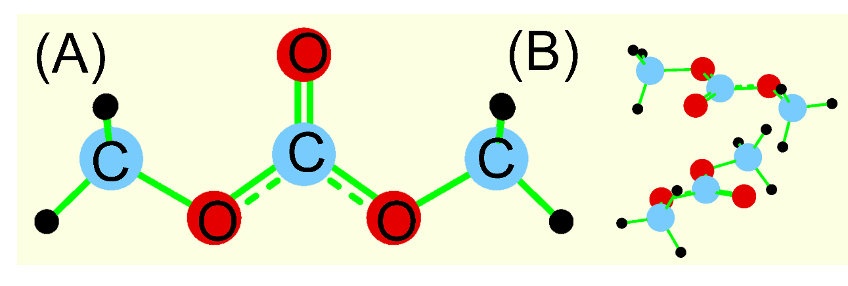
Figure 1. The optimized molecular structures of dimethyl carbonate (A) in vacuo and (B) the propeller-like orientation in its dimer. The optimizations of the geometries were performed at the M11/6-311++G** level of theory.

We combined the Lennard-Jones-12-6 parameters of the GAFF data set with the above-derived electrostatic charges and ab initio-based covalent descriptors. We initially attempted to simulate the density and heats of vaporization of the three smaller DACs and again obtained overestimated specific density and heats of vaporization. The discrepancy with the experiment was two and more percent indicating that the attractive part of the employed Hamiltonian is stronger than needed. A fair performance of the partial charges derived directly from in-vacuo electronic-structure calculations is a known issue since the condensed-phase effects are generally important. The major origin of the observed discrepancies is the neglect of electronic density redistribution due to the coupling of electron-rich and electron-poor interaction centers. The central carbon atom of the carbonate group is a strongly electron-deficient center, whereas the three surrounding oxygen atoms are electron-rich centers. The neglected condensed-phase effects can lead to significant inaccuracies, particularly, in the simulated transport properties and phase behavior. Indeed, the stepwise decrease of the absolute values of the partial charges of the carbonate head group resulted in a gradually better agreement with the experiment. The procedure was repeated until the structure and energetics of the liquid dimethyl carbonate, diethyl carbonate, and dipropyl carbonate were decently captured by the model.
The decrease of charges localized on one carbon and three oxygen atoms of the head group was performed uniformly. The best-performing set of charges is +0.88e (central carbon atom), -0.528e (carbonyl oxygen), and -0.368e (two ether oxygen atoms). Interestingly, the difference between carboxyl and ether oxygen atoms in terms of the excessive electron density localized on them is fairly small. Furthermore, the iterative procedure was performed to somewhat adjust Lennard-Jones-12-6 parameters. Stepwise alterations of the parameters were introduced and short MD simulations were fulfilled to record the corresponding changes in density, key interatomic distances, and heat of vaporization. The most successful set of parameters was used in the new force field. The specific simulated physicochemical properties are provided along with the discussion of our experimental results below.
Density is a central property of the condensed molecular system. It drastically influences the structure and transport properties irrespective of the peculiar atom-atom interactions. Density can be quickly computed in molecular dynamics and it should be thus used cautiously to parameterize the emerging model. In our force field development procedure, density is used to assess the accuracy of non-covalent interatomic interactions and the soundness of the conformational changes of the large flexible molecules.
During the course of the force field development, specific densities and shear viscosities of the low-molecular-weight DACs were routinely compared to the experimental data (vide infra). The final set of parameters provided the simulated density of 1.052 versus the experimental value of 1.063 g cm⁻³ at 298.15 K and 1.004 versus the experimental value of 1.017 g cm⁻³ at 333.15 K for D1C. Similarly, 0.976 versus 0.969 (298.15 K) and 0.931 versus 0.930 g cm⁻³ (333.15 K) were obtained for D2C. For D3C, 0.937 versus 0.938 (298.15 K) and 0.896 versus 0.902 g cm⁻³ (333.15 K) are in a very good agreement. The experimental standard heats of vaporization are 38.0 kJ mol⁻¹ (D1C)[19], 44.4 kJ mol⁻¹ (D2C) [19], 53.2 kJ mol⁻¹ (D3C) [19], 62.9 kJ mol⁻¹ (D4C) [19]. The simulated data are fairly similar, viz. 39.9, 44.9, 51.5, and 59.1 kJ mol⁻¹, respectively. Assuming that heats of vaporization often differ substantially in different sources, the hereby obtained consistency is an additional solid sign of the force field’s accuracy.
Table 4 provides the electrostatic and Lennard-Jones-12-6 parameters that were adapted in the new force field. The ultimately employed charges are significantly smaller than obtained from the coupled-cluster method. In turn, sigmas and epsilons are similar to the corresponding values in GAFF for the oxygen-carbon-oxygen-element moiety with a few important exceptions. The epsilon parameter of the alkyl-chain hydrogen was increased to 0.07 kJ mol⁻¹. The α-methylene hydrogen atom type was disregarded. Instead, all hydrogens are simulated as the same atom type in the new force field. The sigma parameter of such a hydrogen atom was set to 0.250 nm. This simplification made force field derivation more straightforward and we did not face any difficulty with getting trustworthy thermodynamics, structure, and dynamics. The carbon atom of the carbonyl group got epsilon of 0.46 kJ mol⁻¹, whereas the traditional carbon’s sigma was retained, 0.340 nm. The charges on the alkyl side chains, -0.12e for methylene carbon and +0.06e for methylene hydrogen, were adjusted to obtain better specific densities and heats of vaporization. The α-carbon charge is close to zero according to ab initio calculations. It was deliberately used in the force field to neutralize each DAC molecule. For instance, in dimethyl carbonate, the α-carbon charge equals -0.048e, whereas in larger DACs, it is +0.032e. The hydrogens bonded to the discussed α-carbon carry +0.08e each. These and very similar partial charges were also successfully used in the previous force fields for organic matter developed by one of us. [62–65]

Table 4. The Coulombic and Lennard-Jones-12-6 parameters (sigma and epsilon) used for the simulation of nonbonded interactions in the new force field for DACs.
Interaction site | Charge, e | Sigma, nm | Epsilon, kJ mol⁻¹
C(carbonyl) | +0.880 | 0.340 | 0.46
O(carbonyl) | -0.528 | 0.304 | 0.88
O(ether) | -0.368 | 0.304 | 0.71
C(methylene) | -0.120 | 0.340 | 0.36
H(methylene) | +0.060 | 0.250 | 0.07

No explicit cross-sigma and cross-epsilon parameters are included in the force field. These values are computed using the conventional combination rules. Particularly, cross-sigma is an arithmetic mean of the two interacting atoms’ sigmas. Cross-epsilon is a geometric mean of the two interacting atoms’ epsilons provided in Table 4.
3. Results and Discussion.
The dialkyl carbonates (DACs) probed in this study are characterised by the symmetric distribution of two short alkyl tails connected to the carbonate group. Samples in the range from dimethyl carbonate up to di-dodecylcarbonate have been studied and an additional sample with a branched alkyl group has been studied as well, namely, di(2-butyl-octyl)carbonate (D84C).
Apart from D12C, all these samples are liquid at ambient temperature (20°C). The solid-liquid equilibrium has been characterised for selected samples in the series, aiming at validating/establishing the melting point of the whole series.
In the literature, short chained DACs have been thoroughly characterised in their calorimetric properties, so we limited our exploration to samples from D4C to D12C. Figure 2 reports
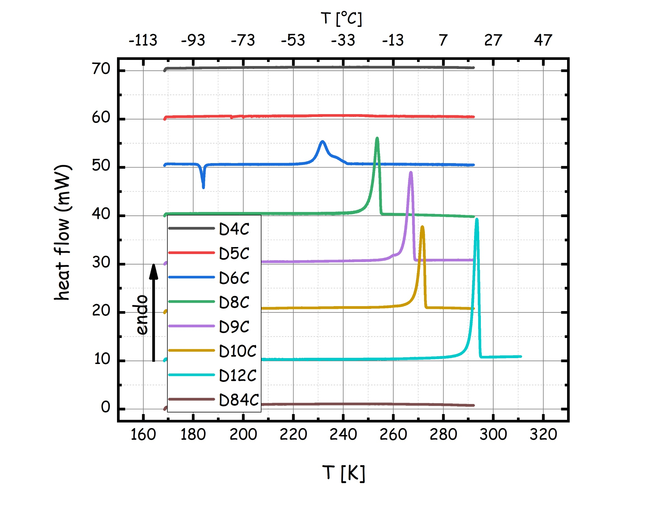 | 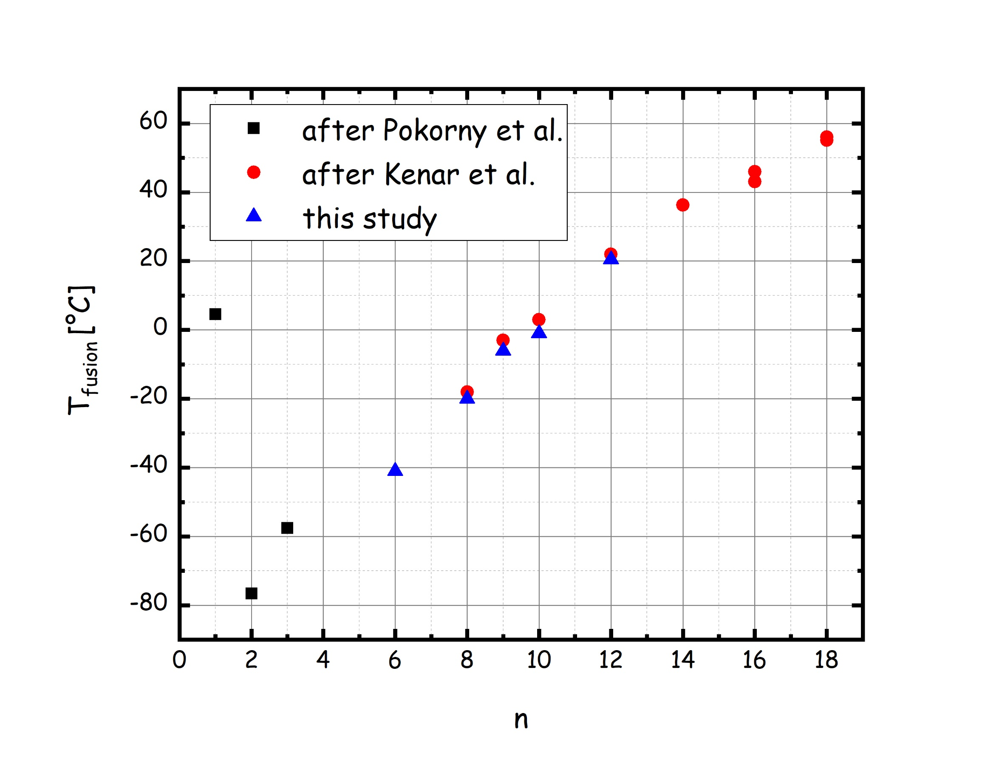

Figure 2. (left) Heating calorimetric characterization for the series of di-alkyl-carbonates (DnC, 4≤n≤12 &84, excluded n=7 and 11) as a function of temperature. The data curves are shifted in height for better visibility. (right) Dependence of the melting point on the alkyl chain length for the series of di-alkyl-carbonates (DnC, 1≤n≤12 & 84, excluded n=7 and 11) (blue symbols). Data from the literature have also been included: DnC (n=1-3): ref. [66,67] and references therein; DnC (n=8, 9): ref. [16]; DnC (n=10, 12, 14, 16, 18): ref. [6,13,14]

heating thermograms and corresponding melting points (data reported in the ESI: Table S1) for the DAC family. Overall, we notice a very good agreement with previous determinations and we stress that for samples D4C, D5C and D84C it was not possible to detect a solid-liquid phase transition, suggesting that these samples are good glass formers.
Upon increasing the side chain length, we detect an increase of the melting point temperature, apart from the case of D1C that shows a higher melting point than D2C. In agreement with preliminary observations, only sample D12C shows a melting point higher than 20°C.

The experimental densities of the probed DACs are shown in Figure 3 left), as a function of temperature (data are listed in Table S2 of the ESI). Upon increasing the side chain length, a progressive decrease of density at a given temperature is observed; data for long chain lengths are in good agreement with literature data reported for T=22°C.[16] Data for each DAC in the format of ln(ρ) have been described in terms of a polynomial:
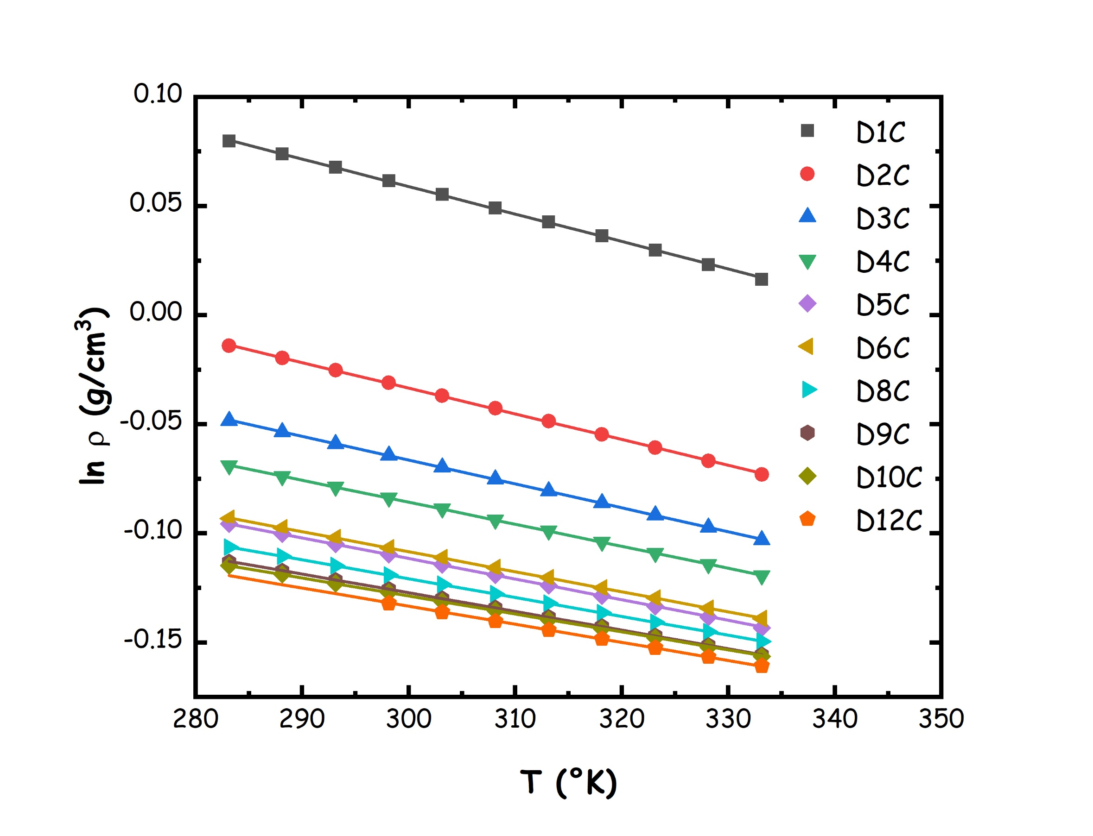 | 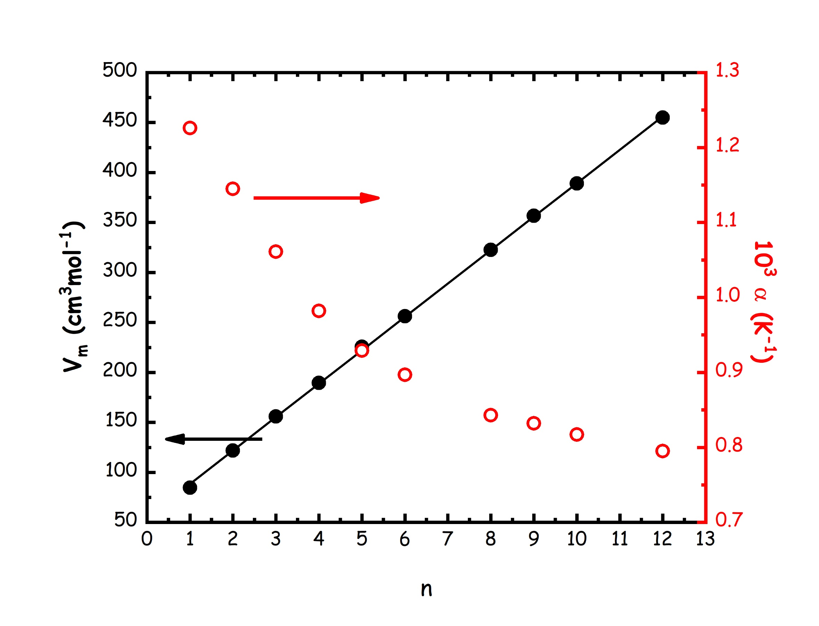

Figure 3. (left) Experimental density for the series of di-alkyl-carbonates (DnC, 1≤n≤12, excluded n=7 and 11) as a function of temperature. The lines correspond to a model fitting as described in the main text. (right) Alkyl chain length dependence for molar volume, V_{m}, and isobaric thermal expansion coefficient (α) for the series of di-alkyl-carbonates (DnC, 1≤n≤12, excluded n=7 and 11) at 25°C. The line corresponds to the linear fit described in the main text.
ρ (T [K]) = a+ b*T + c*T²;
where a, b and c are fitting parameters (Table S3 of the ESI). These fits have been exploited to extract the molar volume (V_{m}=ρ/MW) and the isobaric thermal expansion coefficient (α=1/ρ·∂ρ/∂T) at 25°C. In particular one finds that upon increasing the side alkyl chain lengths (passing from DnC to Dn+1C, i.e. adding two methylene groups), the molar volume of dialkyl carbonates grows linearly with a trend of 33.5 cm³/mol (inset of Figure 3 right)), in agreement with the value obtained for twice the observed value for the addition of a methylene group to alkanesdissolved in CHCl₃ (16.58 cm³/mol).[68] Moreover, this trend is in line with what is found for other symmetric compounds bearing pairs of side alkyl chains, such as a representative ionic liquids, such as dialkylimidazolium bistriflamide, [Cn,Cn-im][Tf2N][69], dialkyl-sulfoxides [70–72] and dialkyl-ketones [73]. Moreover we find a distinct chain length dependence for the isobaric thermal expansion coefficient that decreases with n, as shown in Figure 3 (right), with a non-linear trend resembling similar behaviour observed e.g. for the case of linear alkanes (see e.g. ref. [74] and references therein) or alcohols[75].
Figure 4 reports refractive index data, n_{D}, collected for the whole set of samples as a function of temperature (data are listed in Table S4 of the ESI). n_{D} data follow a linear trend with temperature across the probed range and the observed values span a range from 1.36 up to 1.45 for the different members of the DAC family. The presently reported data are in excellent agreement with previously reported data from Kenar et al., for DACs with n=8-10.[16] Table S5 of the ESI reports fits for the experimental data in terms of linear trends with temperature. In the inset of Figure 4 we report the dependence of the refractive index on the alkyl chain length at 30°C, where all samples are liquid. One can observe a progressive increase of refractive index value upon increasing alkyl chain length in the DAC; it seems at high enough values for n, a saturation could be reached, but this regime is not included in the present choice of DACs.
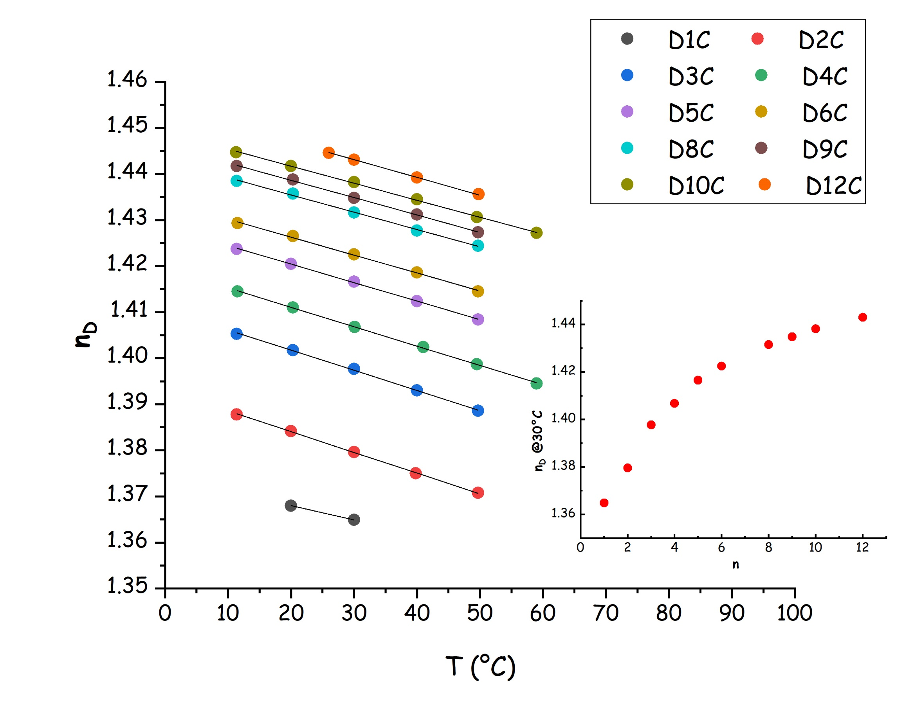
Figure 4. Experimental refractive index for the series of di-alkyl-carbonates (DnC, 1≤n≤12, excluded n=7 and 11) as a function of temperature. The lines correspond to linear fitting as described in the main text. (inset) Alkyl chain length dependence for refractive index for the series of di-alkyl-carbonates (DnC, 1≤n≤12, excluded n=7 and 11) at 30°C.

Figure 5 reports dynamic viscosity data collected for the whole set of samples as a function of temperature (data are listed in Table S6 of the ESI).
The log (η) vs. 1000/T viscosity data follow a non-Arrhenius temperature trend across the probed range and the observed values span from 0.4 up to ca. 20 mPa·s for the different members of the DAC family. The presently reported data are in good agreement with previously reported kinematic viscosity data from Kenar et al., for DACs with n=8-10.[16] In the inset the alkyl chain length dependence of dynamic viscosity is reported at 25°C: it clearly emerges that, upon increasing the chain length a progressive increase of viscosity occurs. We notice that no clear change in the observed trend can be appreciated across the explored chain length range and a rather continuous increase in viscosity occurs upon increasing chain length.
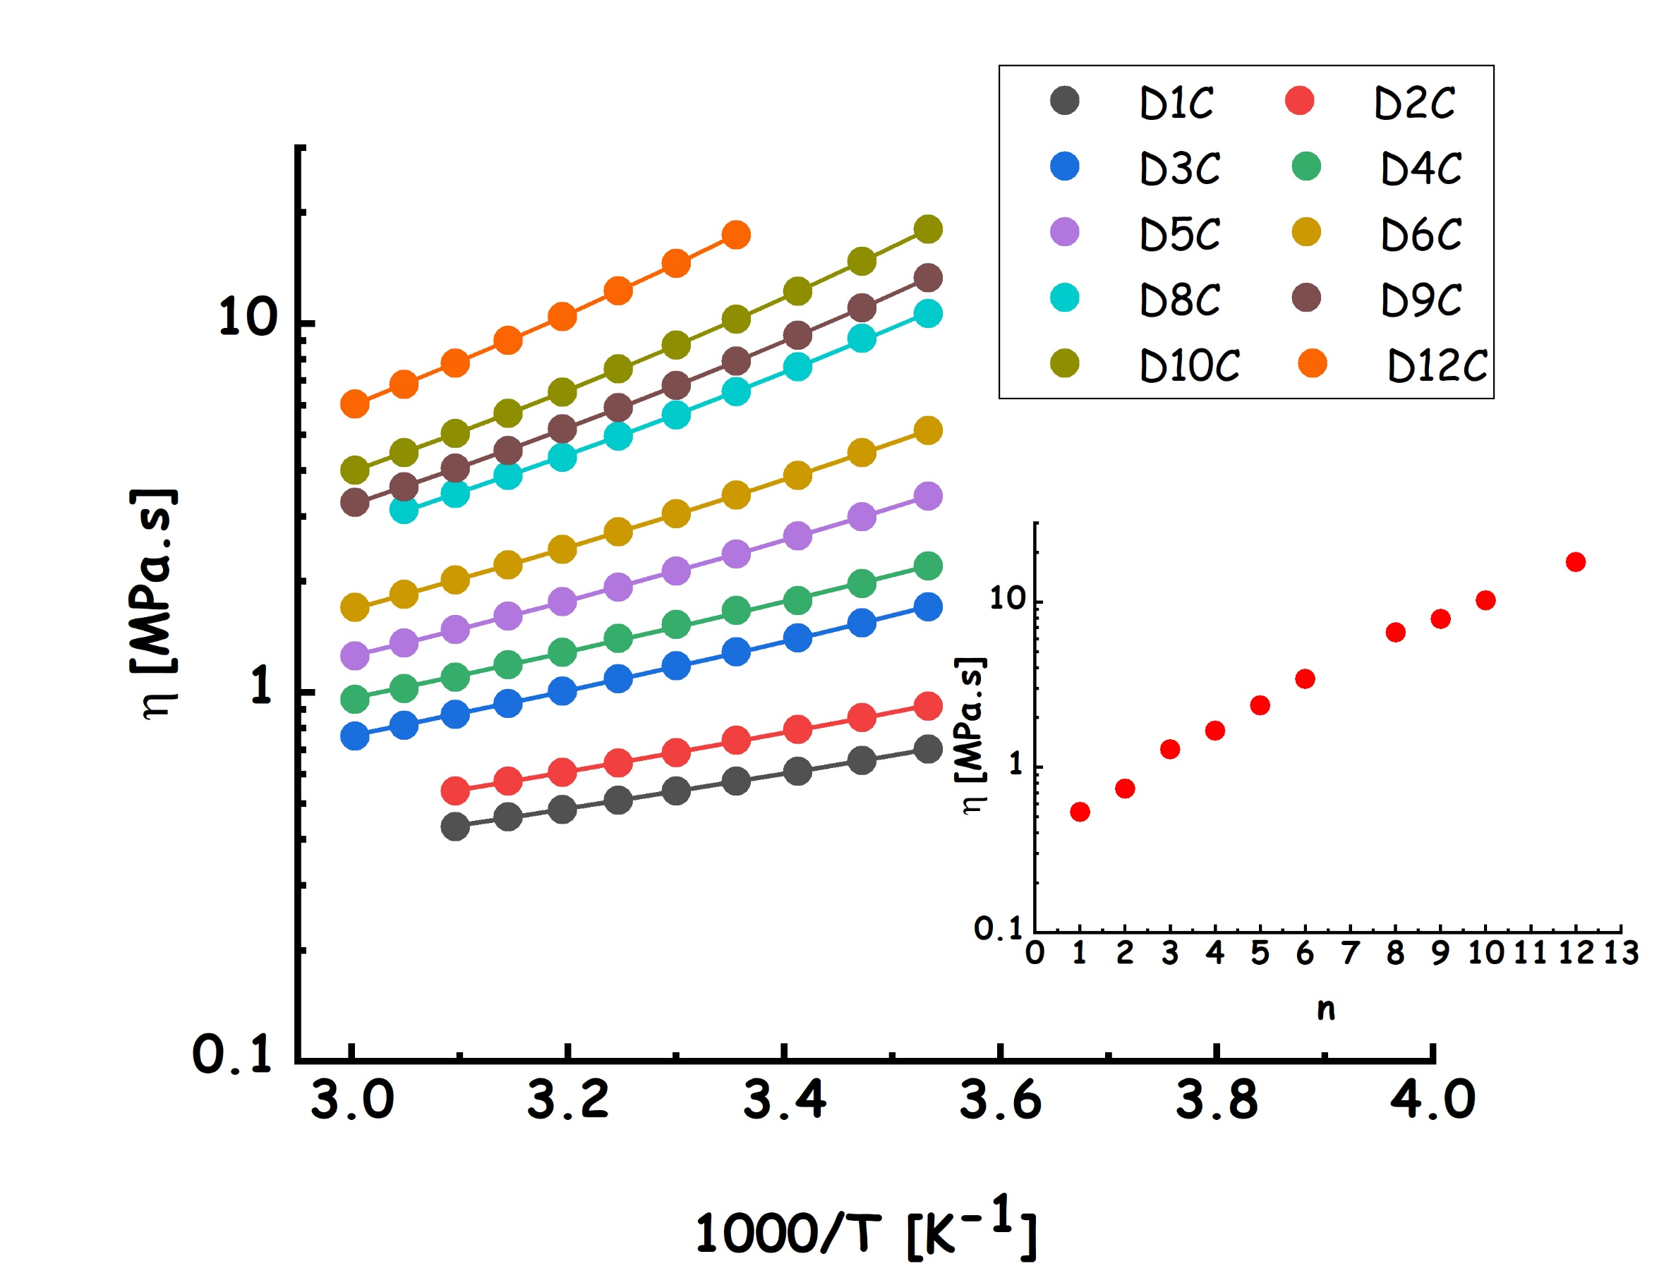
Figure 5. Experimental dynamic viscosity, η, for the series of di-alkyl-carbonates (DnC, 1≤n≤12, excluded n=7 and 11) as a function of temperature, in an Arrhenius format. The lines correspond to model fitting as described in the main text. (inset) Alkyl chain length dependence for dynamic viscosity for the series of di-alkyl-carbonates (DnC, 1≤n≤12, excluded n=7 and 11) at 25°C.

Data have been modelled using the Vogel-Fulcher-Tammann relation[76–78], accounting for deviations from Arrhenius behaviour (fitting parameters are reported in Table S7 of the ESI): ln(η)=ln(η_{o}) + B/(T-T₀), where η_{o}, B and T₀ are fitting parameters. To better characterise the viscosity behaviour of the DACs family, we also determined the activation energy to flow at 50°C, as given by: E^{323 K} = R_{gas} · ∂[ln(η)]/∂(1/T) = R_{gas} · B/[(T₀/323)²-2(T₀/323)+1]. Despite the limited accessible temperature range, the model nicely accounts for the observed behaviour, as evidenced in Figure 5. The fitting parameters, including E^{293K}, are shown in Figure 6, as a function of the alkyl side chain length.
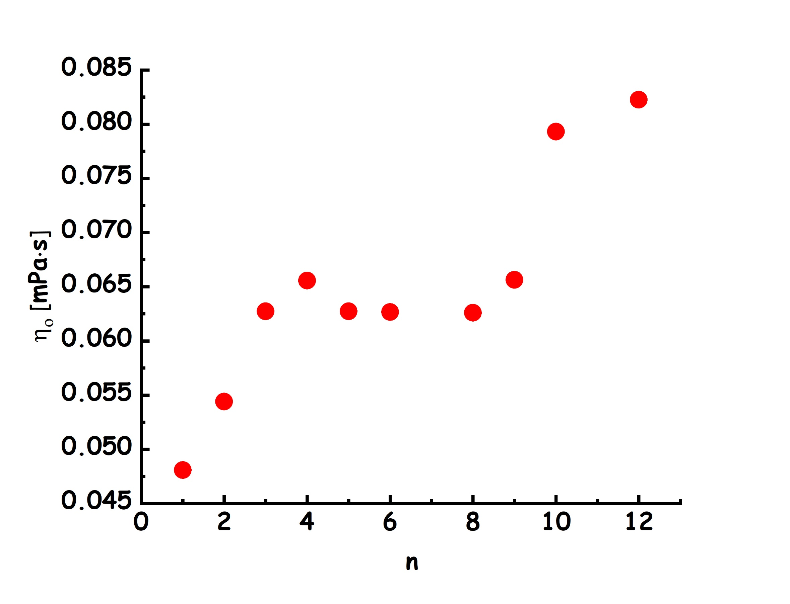 | 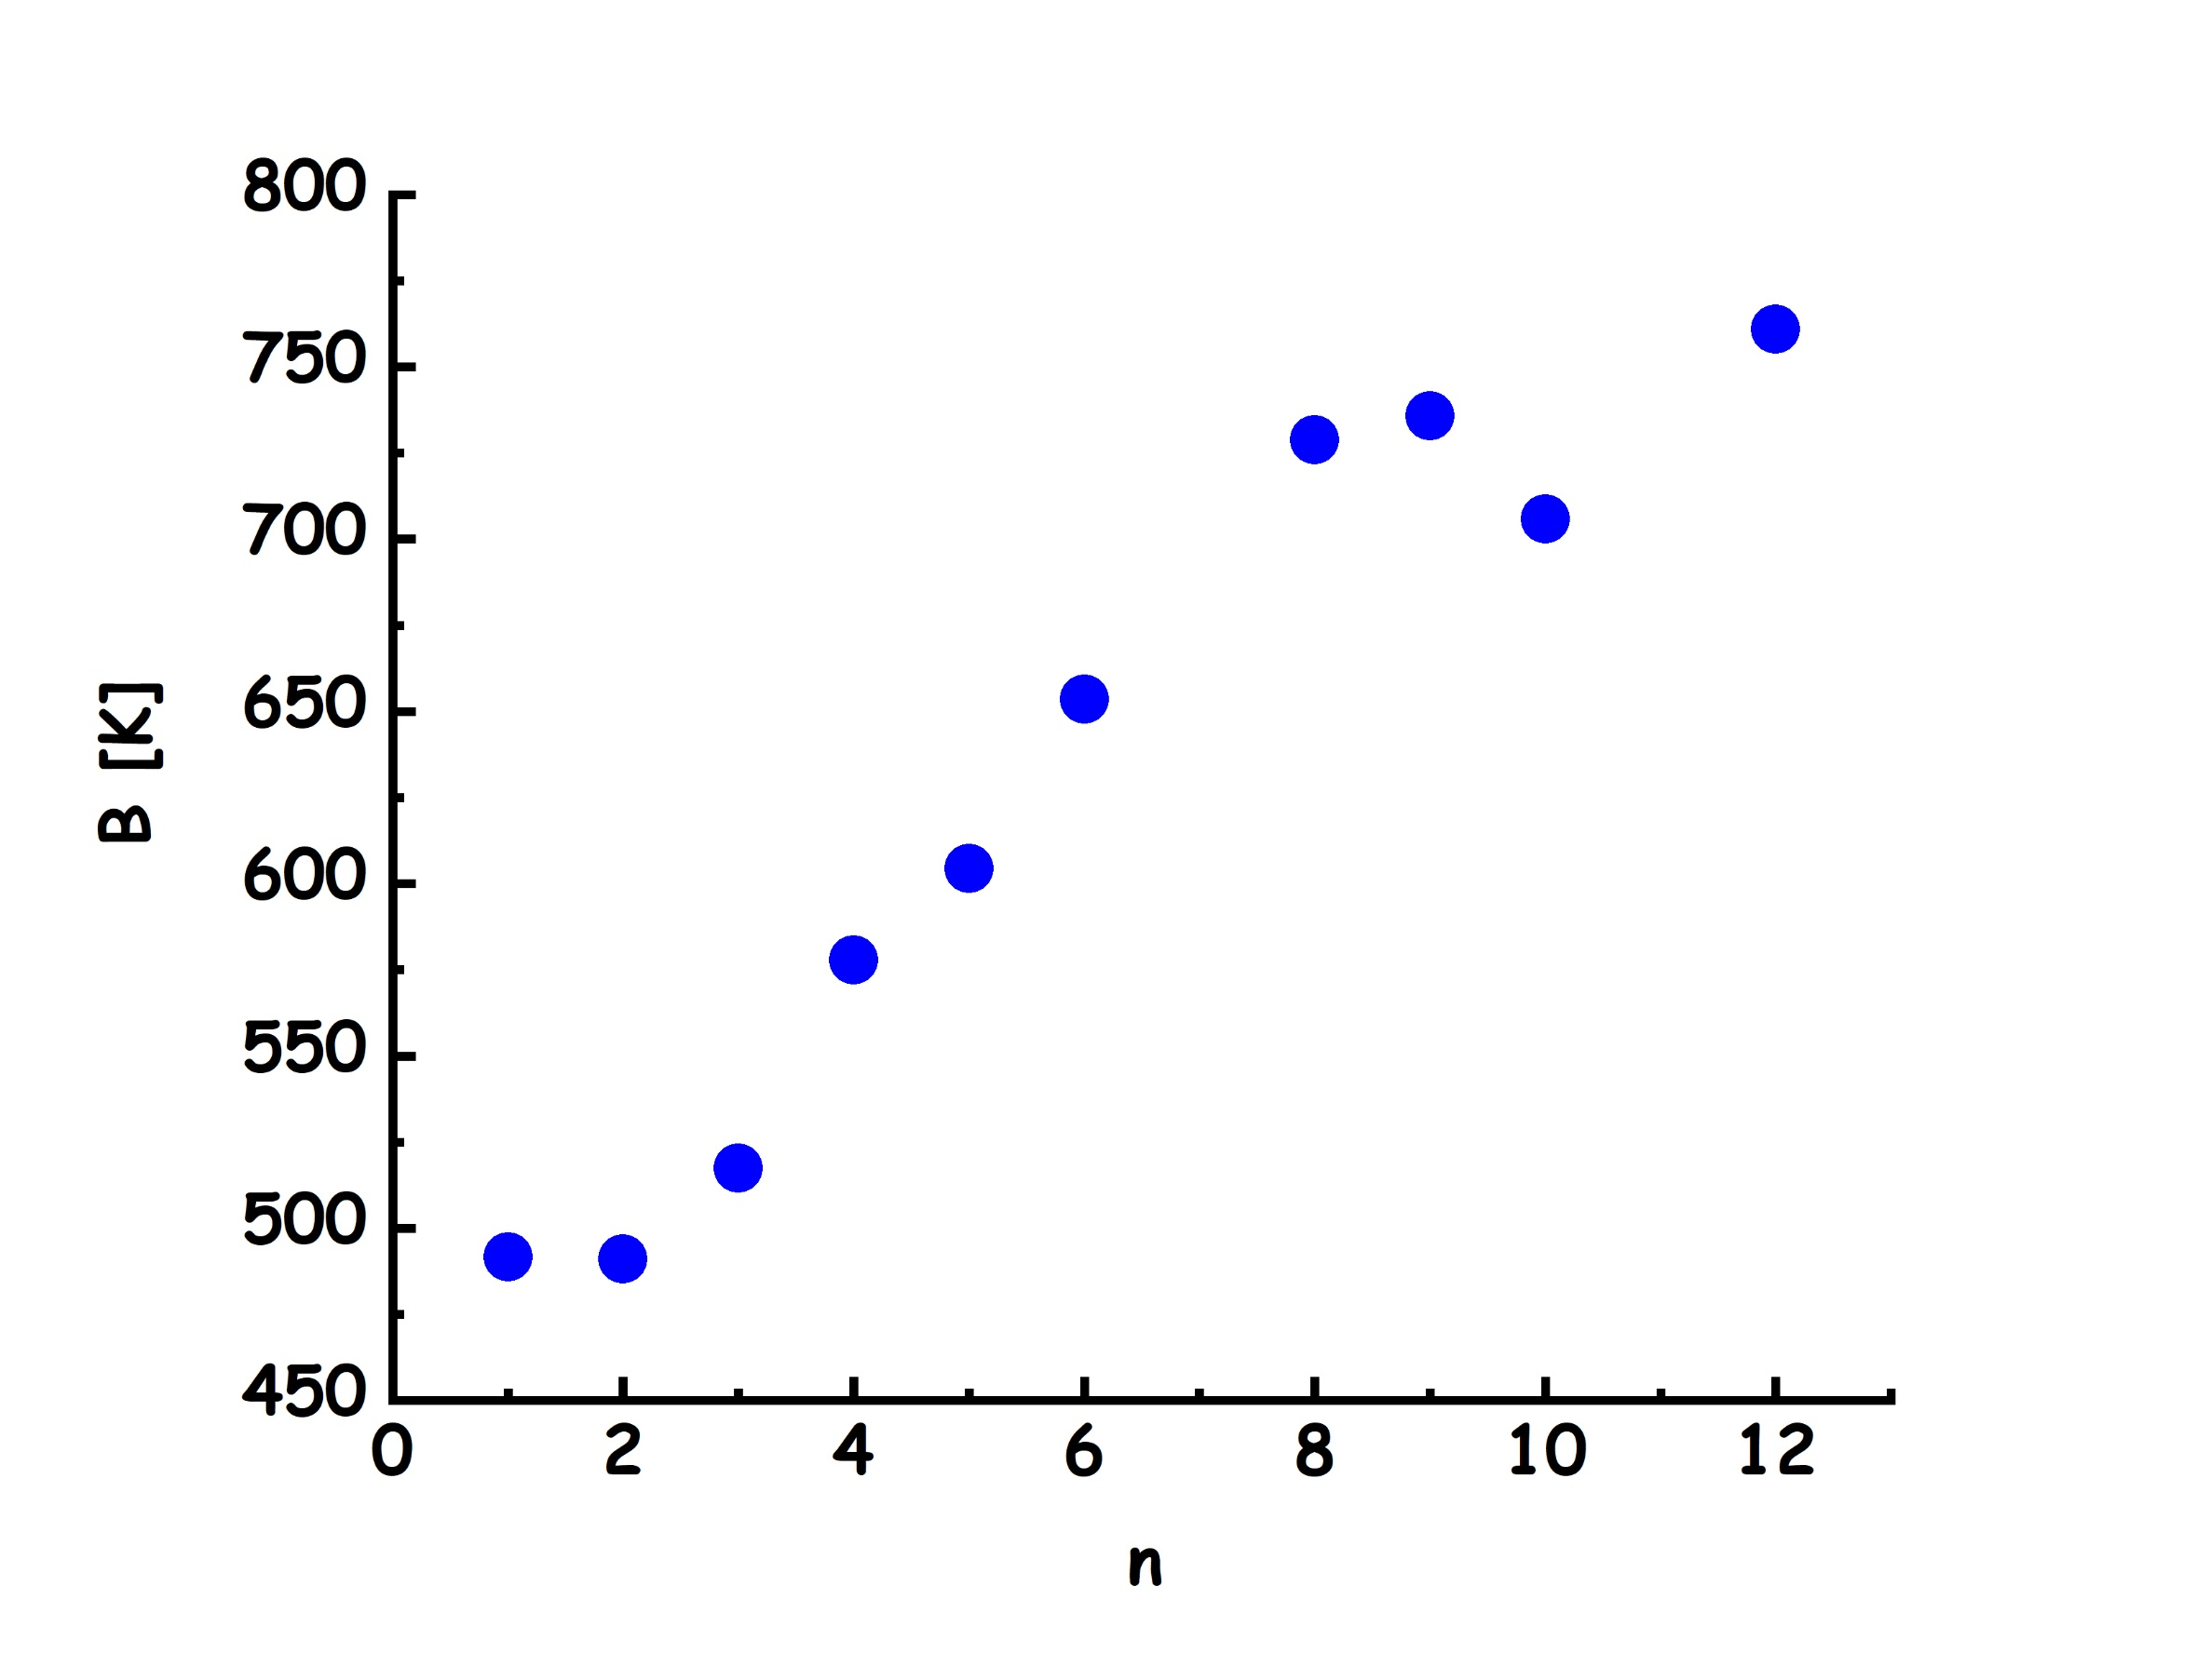
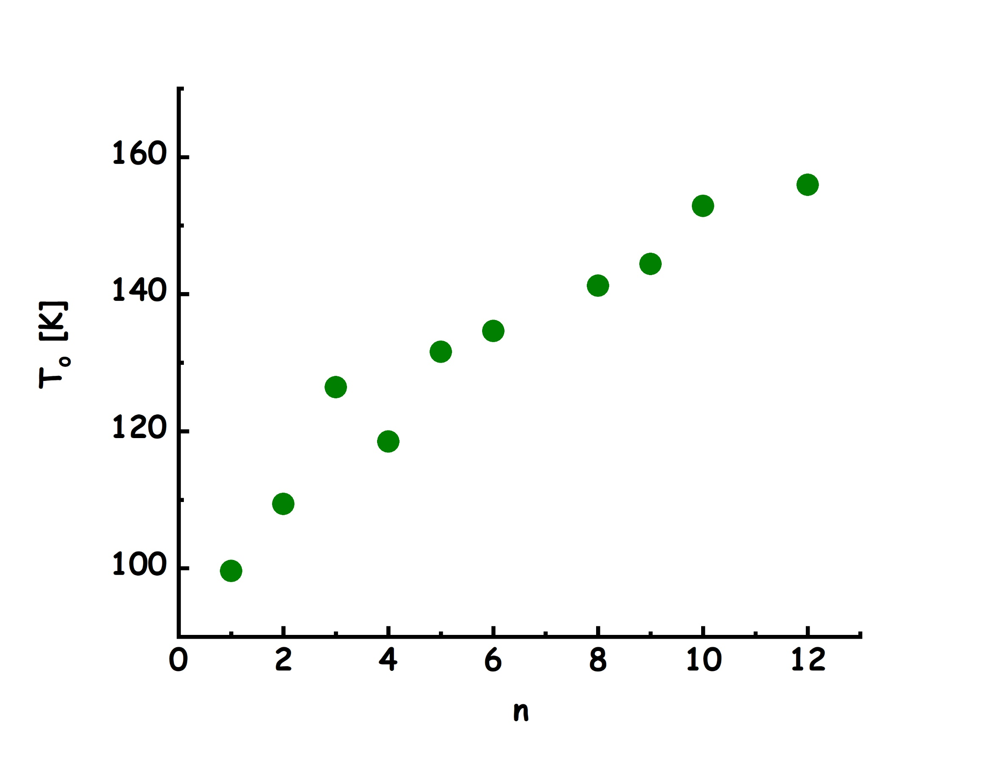 | 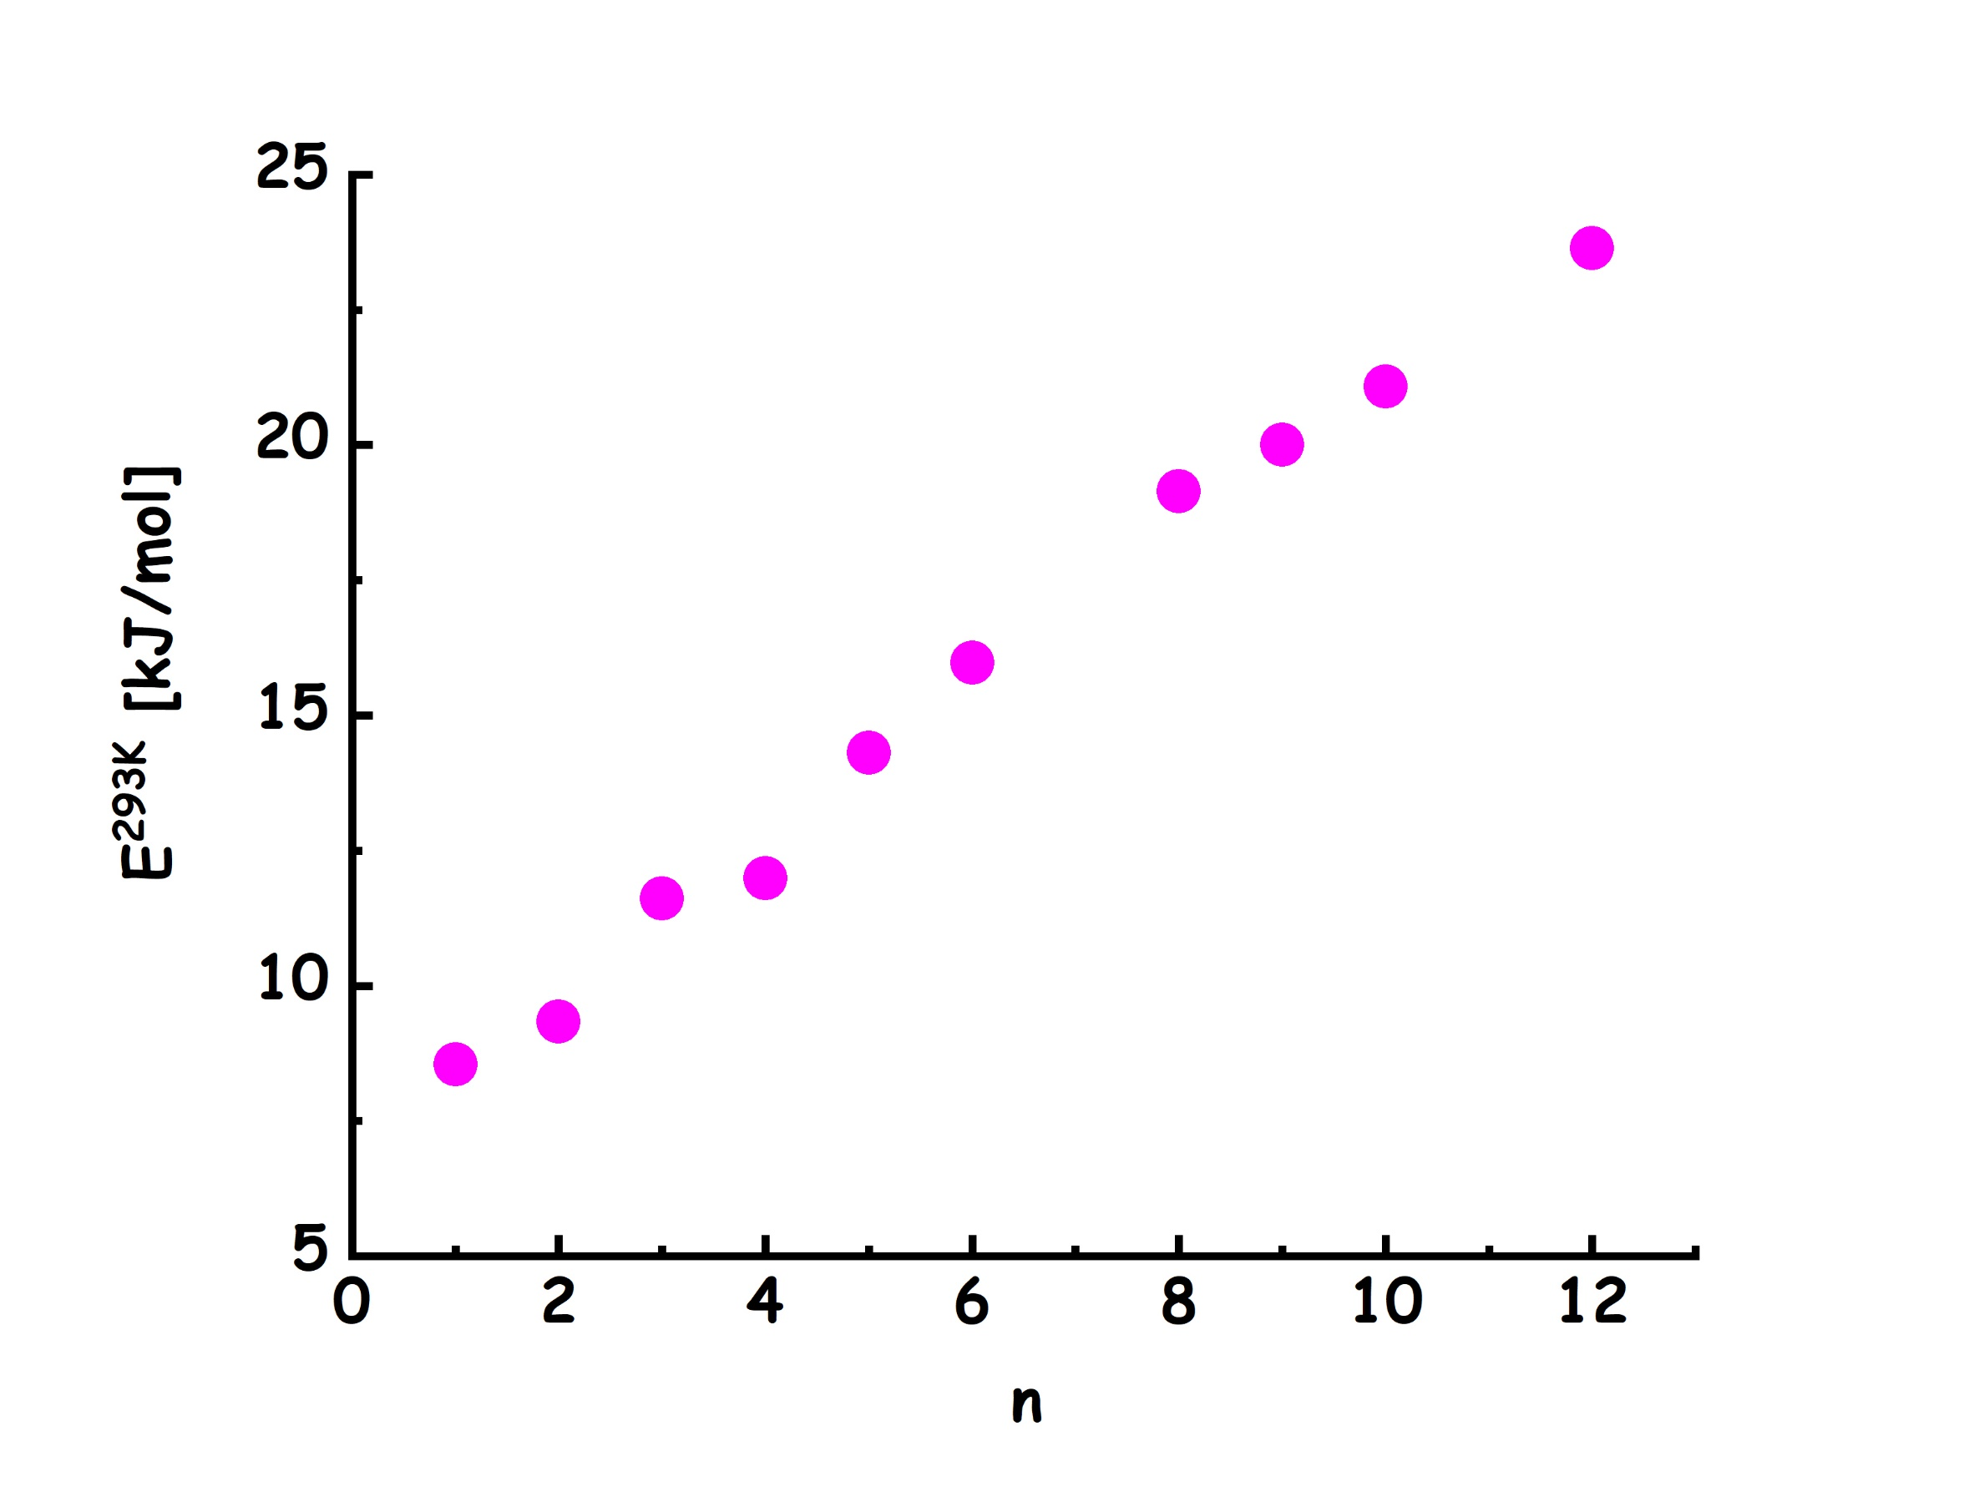

Figure 6. Fitting parameters from the modelling of the experimental dynamic viscosity, η, for the series of di-alkyl-carbonates (DnC, 1≤n≤12, excluded n=7 and 11) as a function of temperature, in terms of the Vogel-Fulcher-Tamman formalism. From the top, left and then clockwise the parameters are η_{o}, B, E^{323K} and T₀.

The fitting parameters seem to indicate a change in the trend when the chain length crosses n=2-3, as both η_{o} and B show a change in slope across this threshold; however the two other parameters (T₀ and E^{323K}) do not seem to indicate major changes in this chain length regime. On the other hand, the temperature range where the viscosity has been probed is perhaps too limited to robustly interpret these fitting parameters.

The ¹H NMR diffusion coefficients for the probed DAC series at 298 K are reported in Figure 7, while the numeric data are reported in Table S8 of the ESI. Therein, the experimentally determined data are compared with the corresponding diffusion coefficients extracted from the presently reported (vide infra) MD simulations, reflecting a good agreement between the two sets and thus validating the used interatomic potential used for the simulations. It is noteworthy the distinct molecular weight (MW) dependence of the diffusion coefficient that eventually scales in the form D^{298K} = a·MW^{-2.5}, see Figure S9 of the ESI. The Stokes and Enskog theories for simple liquid dynamics of spherical particles predict much weaker mass dependencies of MW^{-1/3} and MW^{-1/2}, respectively, whereas, depending on temperature, power-law exponents between -1.9 and -2.7 were reported for short oligomeric n-alkanes and attributed to free-volume effects, which are associated with the chain ends and dominate at low molecular weights.[79,80] Furthermore, MW^{-2.0} and MW^{-2.3} behaviours are obtained by reanalysing data for monoalcohols [81] and 1-alkyl-3-methylimidazolium cations in ionic liquids[82], respectively, see Figure S1 of the ESI. For the latter liquids and the present DACs, the highly non-spherical shapes and micro-phase segregated structures developing for longer alkyl tails can be expected to contribute to a high MW dependence of the diffusion coefficients.
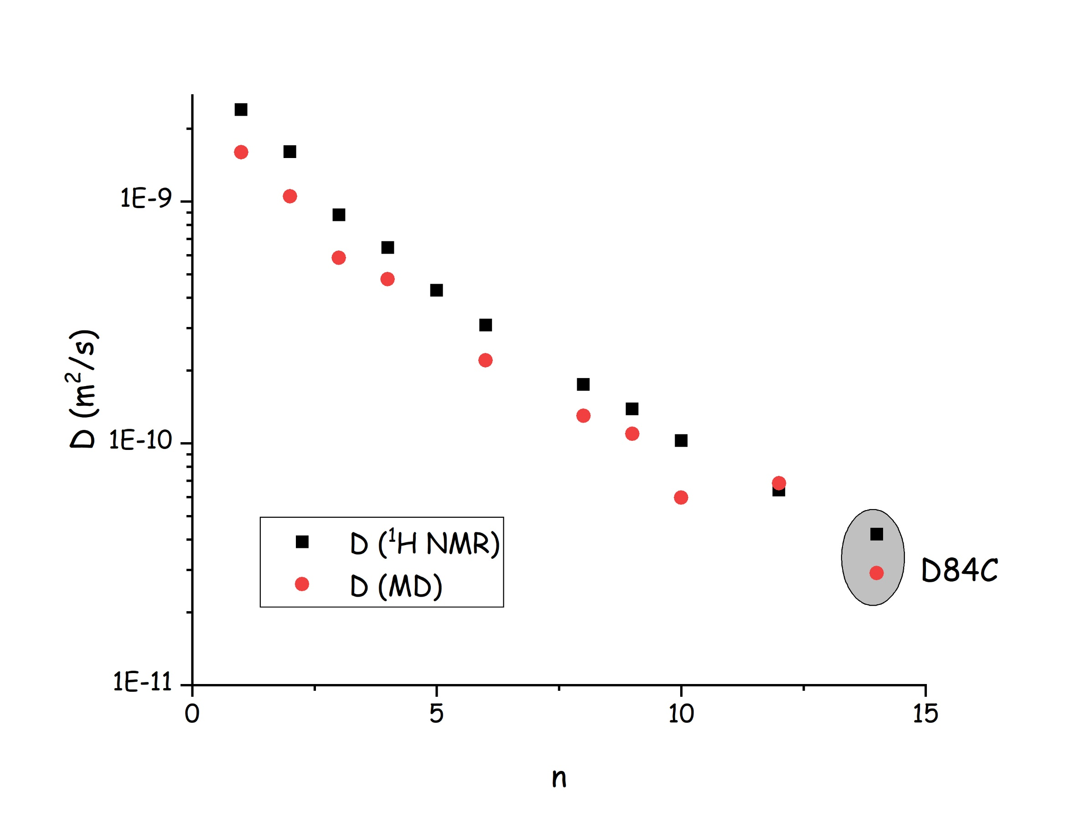
Figure 7. ¹H NMR diffusion coefficients for the whole DAC series at 298 K and its comparison with corresponding computed quantities.

Figure 8 shows the comparison between the experimentally derived Wide Angle X-ray Scattering (WAXS) pattern and the corresponding quantity derived from Molecular Dynamics calculations for the two representative cases of D1C and D4C, over the Q range between 0.5 and 20 Å⁻¹, at 20°C. In the past, similar comparison was presented only for the case of D1C[83], while the good agreement between experimental and MD computed quantities is original for the case of D4C. While a detailed discussion on MD derived information will be provided in a subsequent section, here we note that the diffraction patterns are very similar above ca. 5 Å⁻¹, while they largely differ at lower Q values. In particular, both samples show a diffraction pattern characterised by the presence of two low Q features that are almost superimposed for D1C, while they are distinctly separated for the case of D4C. In order to better characterise this feature we specifically collected Small Angle X-ray Scattering data (SAXS), which allows us to access explicitly the Q range where different members of the DAC family strongly differ.
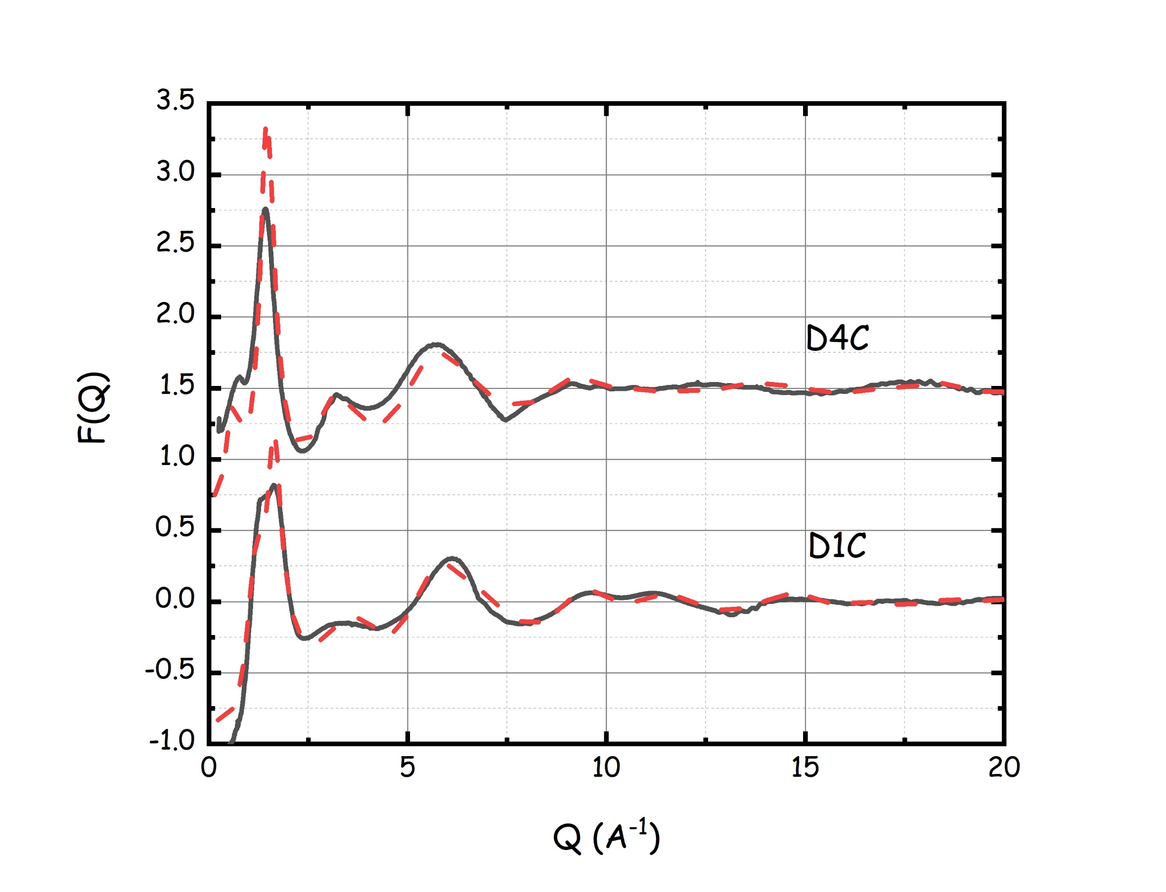
Figure 8. Static X-ray diffraction patterns (continuous lines) for the dimethyl carbonate (bottom) and dibutyl carbonate (top), at 20°C. The dashed lines are to the corresponding quantities obtained from Molecular Dynamics simulation (vide infra).

Figure 9 shows the experimental SAXS data sets for all the probed DACs that are liquid at ambient conditions (i.e. up to D10C), at 20°C. The relevant Q range between 0.03 and 3.3 Å⁻¹ (that covers the low Q portion of data reported in Figure 8) is characterised by the presence of two peaks for all the probed samples. Even in the case of the shortest member of the family, Dimethyl Carbonate (D1C) the existence of the mentioned features is apparent, as previously shown by some of us[83]. In that study, however, as only D1C was studied, it was not possible to highlight the specific nature of the low Q peak that is ubiquitous for DACs and whose position so markedly shifts with increasing chain length. Other reports of X-ray/neutron scattering data for related cyclic DAC compounds (namely ethylene carbonate[84], propylene carbonate[32,84] and glycerol carbonate[32]) do not show such a feature, that is a unique feature for linear alkane DACs. The peak appearing at higher values (between 1.5 and 2.0 Å⁻¹ , depending on the alkyl chain length) is ubiquitous in liquid samples and corresponds to adjacencies alternations, as due to neighbour intermolecular moieties that are typically separated by a distance of the order of 4 Å.[85] As such, its presence does not deliver much relevant information on the spatial organization in DACs. On the other hand, the Q range below this part of the spectrum is characterised by a low Q peak whose amplitude and position strongly depend on the side alkyl chain length. This behaviour is common to other classes of compounds including alcohols[23,24,86,87], aldehydes[27,28], dialkylsulfoxides[25], mono[29,88,89]- and di[69]- alkylimidazolium based Ionic Liquids (ILs) as well as other kinds of ILs[90–94].
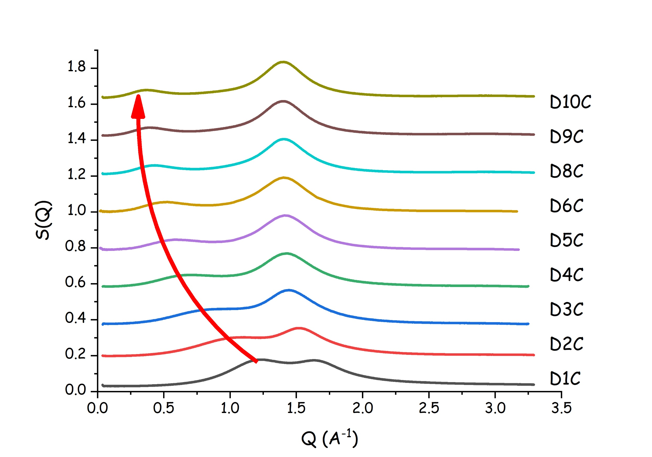
Figure 9. Small Angle X-ray Scattering (SAXS) patterns for the series of di-alkyl-carbonates (DnC, 1≤n≤10, excluded n=7) at 20°C. The red arrow indicates that upon increasing side chain length (from bottom to top), a progressive shift of the low Q peak is observed, as a fingerprint of the progressively increase in size of structural heterogeneities.

Typically, SAXS patterns such as the ones plotted in Figure 9 are modelled in terms of a background and two peaks, hereinafter indicated as peak 1 and 2, in order of growing peak position. Here we modelled the SAXS patterns in terms of two Gaussian contributions that although not describing in a precise way the whole experimentally accessible Q range, on the other hand can efficiently account for the evolution of the peaks positions upon increasing the side chains lengths. Peaks positions have then been converted into characteristic sizes of the corresponding structural heterogeneities, using the relationship: D=2π/Q_{p}, where Q_{p} is the peak position. Figure 10 reports the alkyl chain length dependence for the two characteristic sizes D₁ and D₂ at ambient conditions. While D₂ shows only a mild dependence from n, as it grows slightly with increasing n to reach soon a plateau at n=4, D₁ shows a much clearer and distinct trend as it grows linearly with n, showing a slope dD/dn=1.40 Å/(CH₂)₂ units. This trend is identical to the one detected by some of us in the case of symmetric ILs, [C_{N}, C_{N}-imidazolium][Tf2N][69,95], as indicated by the dashed line in Figure 10 that has the same slope and nicely accounts for the observed D1 values for the dialkyl imidazolium-based ILs. It is noteworthy that even in the case of D1C the low Q peak centered at Q₁= 1.23 Å⁻¹ is clearly present In the original contribution[83] where the X-ray diffraction pattern from D1C had been shown, the fact that such a peak corresponds to the polar-apolar alternation signature had not been appreciated, given the quite high position of such a peak. In the case of linear alcohols, methanol, the only existing case of a methyl group delivering a low Q peak associated to such an alternation, such a X-ray diffraction feature is not so well defined at it appears as a shoulder (at ca. 1.2 Å⁻¹) to the main peak 2 centred at 1.7 Å⁻¹ [24,96,97], but only in the case of ethanol such a feature becomes fully discernible and centred at ca. 0.8 Å⁻¹. For example, in the case of ILs, the record compound with such a low Q feature and shortest side chain is Ethylammonium Nitrate, where the chain is an ethyl moiety.[94] No evidence of such a behaviour has been found in Methylammonium Nitrate, as it is a solid compound at ambient conditions. While information on asymmetric DACs (such as methyl, alkylcarbonate: CH₃-O-C(O)-O-(CH₂)_{n-1}-CH₃) do not exist, the information existing on the comparison between asymmetric and symmetric dialkylimidazolium based ILs can be useful to rationalise the behaviour observed in DACs. In Reff. [69,93,95] some of us explored the X-ray diffraction patterns from asymmetric and symmetric dialkylimidazolium bistriflamide ILs and directly compared the D₁ values for the two classes of compounds. In Ref. [69], it is clear that the two classes of ILs show a distinct slope for the trends of D₁ vs n. In particular asymmetric compounds had a value of dD₁/dn=1.80 Å/CH₂ units, while symmetric compounds had dD₁/dn=1.42 Å/C₂H₄ units.¹² It is remarkable the difference in the effect of adding a methylene unit to the side chain in the two different (asymmetric and symmetric) classes of compounds. In the case of symmetric ILs or DACs the change corresponds to addition of two methylene groups at the two sides of the compound and yet such a change results in smaller change on the characteristic size of the structural heterogeneties. Such an occurrence must reflect a specific feature in the way these materials are organized at mesoscopic level.
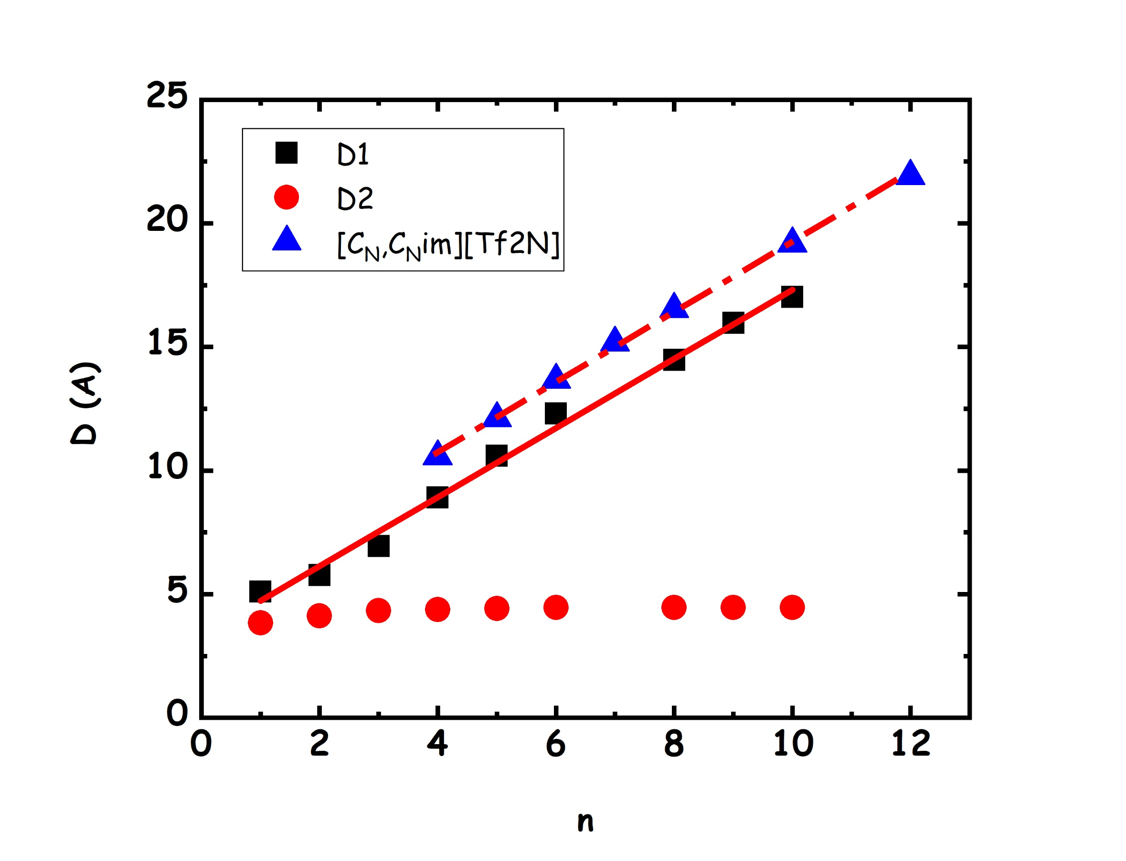
Figure 10. Alkyl chain length dependence of the characteristic sizes D₁ (squares) and D₂ (circles), as obtained from the Bragg’s law applied to the two low Q peaks in the SAXS patterns from the series of di-alkyl-carbonates (DnC, 1≤n≤10, excluded n=7) at 20°C. The D₁ data are compared with the corresponding quantities for the case of di-alkyl-imidazolium bistriflamide ionic liquids (triangles). The continuous and dashed lines refer to the linear fits for the two D1 (for DACs and ILs) data sets.

In order to better account for the described properties, including structural features, we developed an extended set of Molecular Dynamics simulations of the DACs family.

MD simulations were validated by comparison with different experimental quantities. Figure 11 reports how the computed heat of vaporization, ΔH_{vap}, increases in response to the elongation of the side alkyl chain. The data generated with the new force field perfectly agree with the available experimental data for DnC, with n=1-4.[19] The larger size of the DAC molecule naturally results in a larger heat of vaporization per mole, whereas the effect of additional methylene groups is rather uniform. The property changes from 39.9 kJ mol⁻¹ in D1C up to 117.7 kJ mol⁻¹ in D12C. This trend is in line with the uniform density decrease in higher-molecular-weight organic carbonates. The heats of vaporization reflect a stronger contribution of the carbonate head group to the non-covalent interaction energy in the liquid phase of DACs. A noteworthy case is bis(2-butyloctyl) carbonate: its computed standard heat of vaporization amounts to 101.4 kJ mol⁻¹ that is significantly smaller than those of D12C, 117.7 kJ mol⁻¹, and D10C, 108.3 kJ mol⁻¹. One can conclude that grafting non-linear side alkyl chains is an interesting route to modulate the physical properties of DACs. The lower heat of vaporization correlates with the lower freezing temperature of bis(2-butyloctyl) carbonate than that of D12C, while their molecular weights are equal.
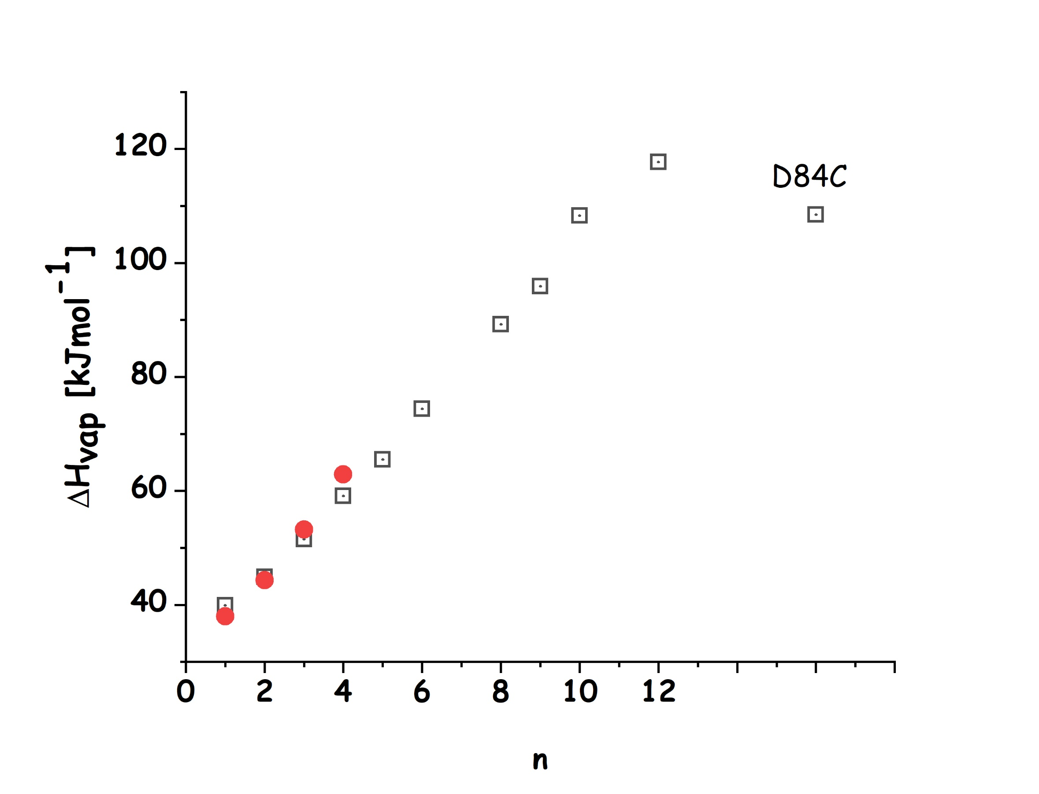
Figure 11. Standard heats of vaporization of liquid DACs, ΔH_{vap}, as a function of the size of their symmetric alkyl chains. Data are compared with experimental values for short DACs (filled red symbols, from ref. [19]). Data for branched bis(2-butyloctyl) carbonate (D84C) are also included.
Comparisons between density and dynamic viscosity for the simulated systems and the data reported in Figure 3 and Figure 5 are shown in ESI (Figure S2 and Figure S3, respectively) and a good agreement is confirmed for these properties, on the basis of the presently developed interatomic potential. MD simulations also efficiently account for the mesoscopic morphology in DACs, as witnessed by the above mentioned low Q peak. While Figure 8 depicts two representative cases (D1C and D4C), the level of description of the whole static X-ray diffraction pattern, Figure S4 in the ESI shows the computed SAXS patterns for the whole DAC family. In the same figure, the corresponding neutron weighted diffraction patterns are shown for both the cases of fully hydrogenated (protiated) and fully deuterated samples, as well as the n dependence of the D1 parameter accounting for the mesoscopic structure fingerprinted by the low Q SAXS peak. It is clear the simulations efficiently account for the experimental scattering patterns. We also notice that while X-ray scattering efficiently can detect the low Q peak, use of deuterated samples with neutron scattering reduces the amplitude of this peak, due to contrast reasons. Accordingly, only hydrogenated samples can efficiently detect evidence forstructural heterogeneities when dealing with neutron scattering.
In view of the successful validation against different sets of experimental data (density, dynamic viscosity, diffusion coefficient (Figure 7) and SAXS-WAXS), we can consider the present set of simulations of the DAC family as robust descriptions of their structural and dynamic properties. Accordingly, as a preliminary characterization, aiming at extracting information on the structural organization in DACs, we report in Figure 12, the pair distribution function (pdf) related to the central Carbon (C₁) mutual correlation (C₁-C₁). In agreement with previous classical and ab initio MD simulations, the first member of the DAC family is characterised by the occurrence of two peaks centred at ca. 4 and 6 Å, the latter being stronger in amplitude.[31,83,84] The first peak (at ca. 4 Å) corresponds to a structural correlation with ca. two C₁ atoms surrounding the reference one, on average. The next DAC members, from D2C to D12C, including D84C, are also characterised by two peaks at approximately the same positions. For all these systems, there is a clear minimum separating the two solvation shells at ca. 4.9 Å: the number of C1 atoms solvating the reference one in the first shell (as obtained from the integration of the C1-C1 pdf up to 4.9 Å) progressively decreases upon increase of the chain length, shifting from ca. 2 for D1C down to 0.5 for D12C. The peak at 4 Å has been interpreted as the correlation between first neighbour molecules of D1C, whose O-C(O)-O planes lay parallel. Figure 13 reports the C1-C1 distance dependence of the angular distribution functions for the planes including the three oxygen atoms of the neighbouring carbonyl groups for three selected DAC members (namely, D1C, D6C and D12C). Our analysis confirms that the first C1-C1 pdf peak corresponds to a parallel distribution of stacked carbonates separated by a distance of ca. 3.8 Å, for the different members of the DAC family. Upon increasing the chain length, the occurrence of this correlation decreases, but the local order maintains unaltered. We will show in the following that this specific correlation plays a fundamental role in dictating an overall degree of order that encompasses much larger, mesoscopic, spatial scales: this is interesting evidence for a limited range (4 Å) correlation that drives the establishment of order over up to 2 nm (in D12C).
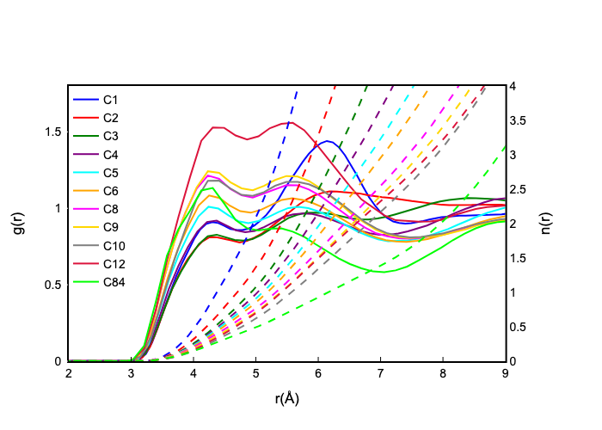
Figure 12. Pair distribution functions of neighbour C1-C1 atoms for the different members of the DAC family (continuous lines) and corresponding number of neighbours (dashed lines).
We next evaluated the combined distribution functions (cdf) with the same abscissa (the C1-C1 mutual distance) and having as an ordinate the angular distribution function (adf) for the C1-O3 vectors (hereinafter indicated as d vectors, see Scheme 1) of the two neighbour carbonyl groups for three selected DAC members (namely, D1C, D6C and D12C, as representative for the whole DAC family). Figure 14 shows such cdfs: these plots indicate that the C1-C1 correlation at 4 Å , corresponds to perpendicular d vectors (spot centred at 90°); on the other hand the larger distance correlation (between 5 and 6 Å ) corresponds to parallel/antiparallel (hot spots centred at 0° and 180°) correlations for the d vectors in DAC members longer than D1C (for the latter there is also a population of perpendicular d vectors (warm spot at 90°C)). These results support the view that the close correlations between neighbour carbonate groups are consistent with a highly structured organization of the neighbour molecules. Upon increasing chain length, the correlation number decreases (see Figure 12), but the specific orientations associated to the mutual correlations are mantained. These specific orientations relate to two further effects. Figure 15 shows the cdf with abscissa the C1-C1 distance and ordinate related to the O3-H1-4 (hydrogen atoms at the α position) distances of the neighbour DACs for three selected DAC members (namely, D1C, D6C and D12C). It appears that neighbour DACs interact through weak, but appreciable hydrogen bonds between the carbonyl oxygen and hydrogen atoms in α position. As a matter of fact both the C1-C1 correlations at 4 and 5-6 Å (the latter at a higher extent) are associated to O···Hα distances of the order of 2.5 Å and angles C-Hα···O between 140 and 180°, thus prompting for medium-weak hydrogen bonding between these neighbour species.[98,99]
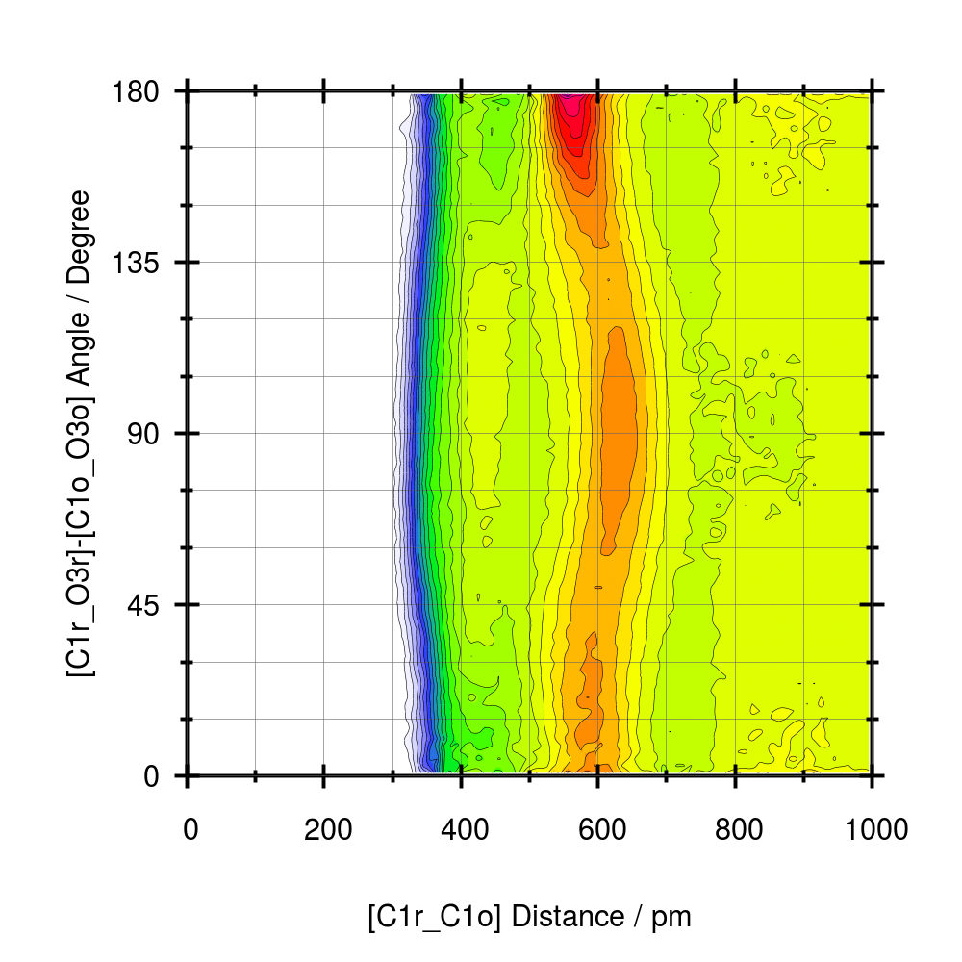 | 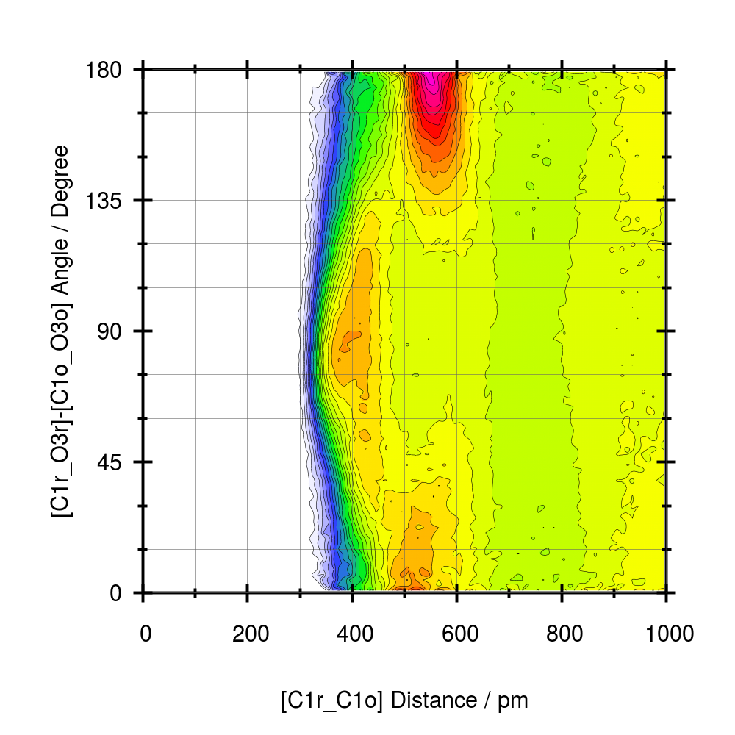 | 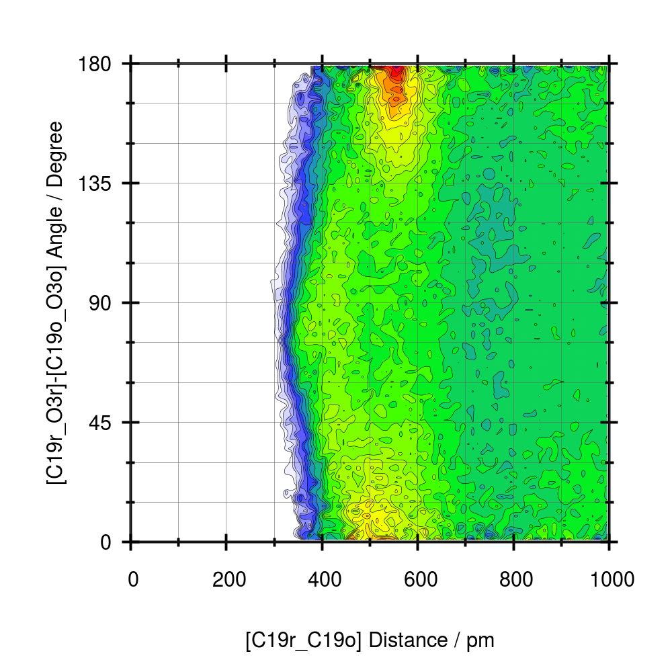
Figure 14. Combined distribution function for D1C, D6C and D12C reporting the joint probability for the pdf C1-C1 and the angle distribution function between neighbour d vectors. The two latter plots are representative for all the members of the DAC family.

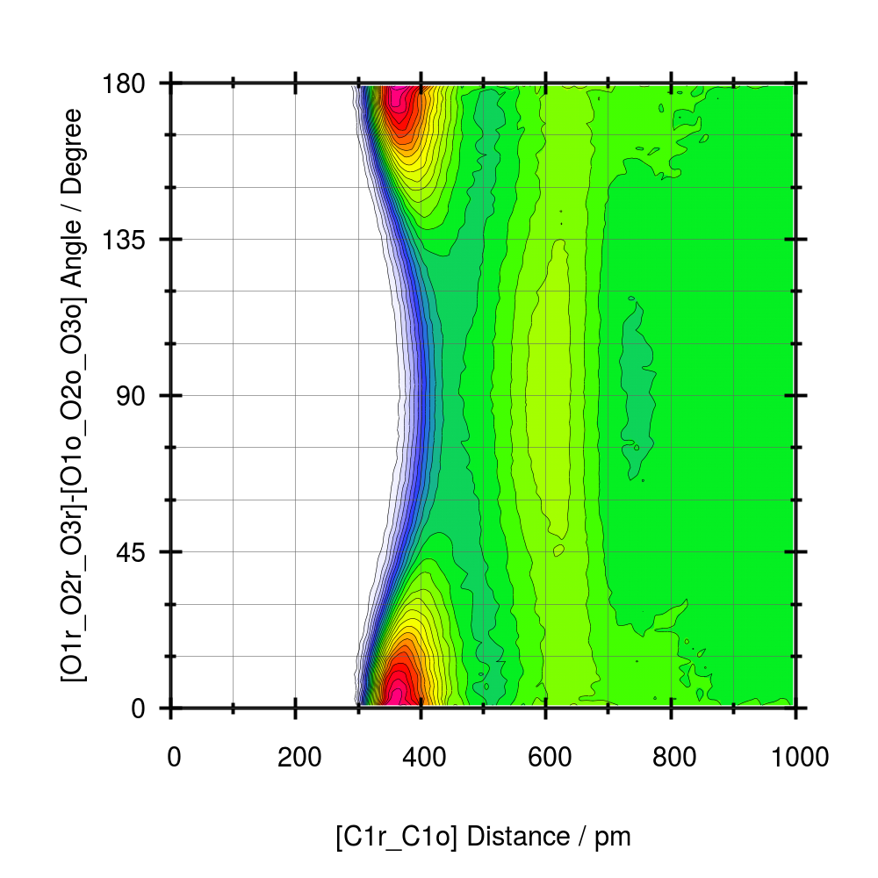 | 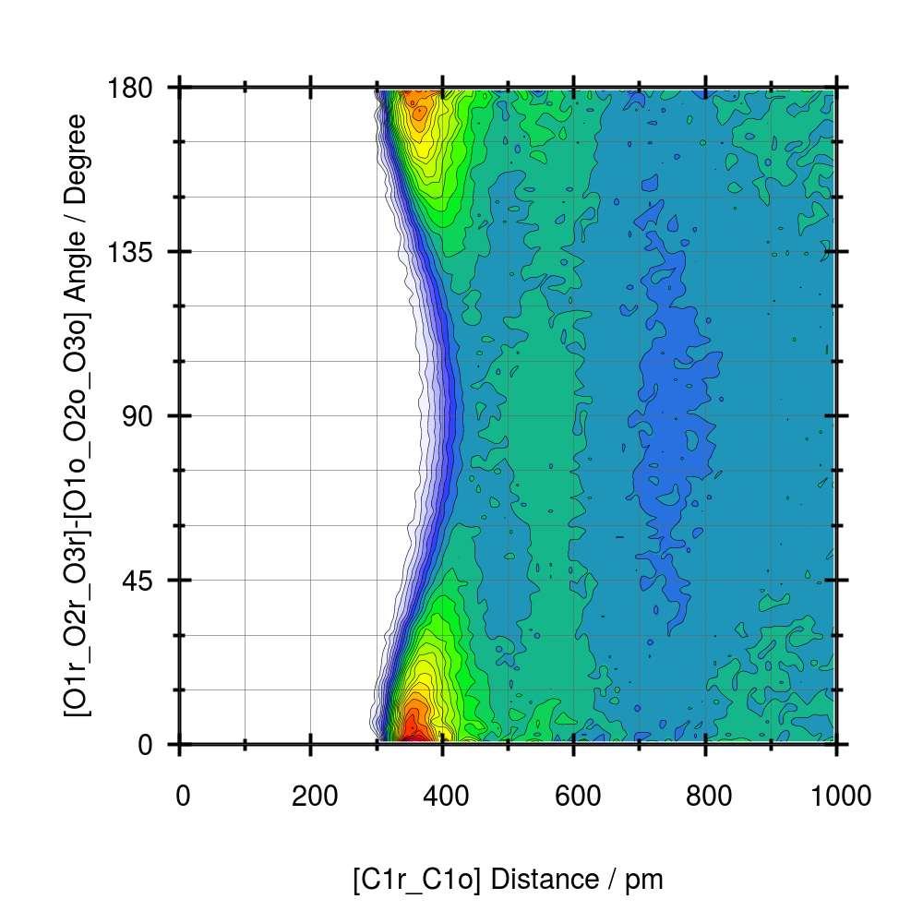 | 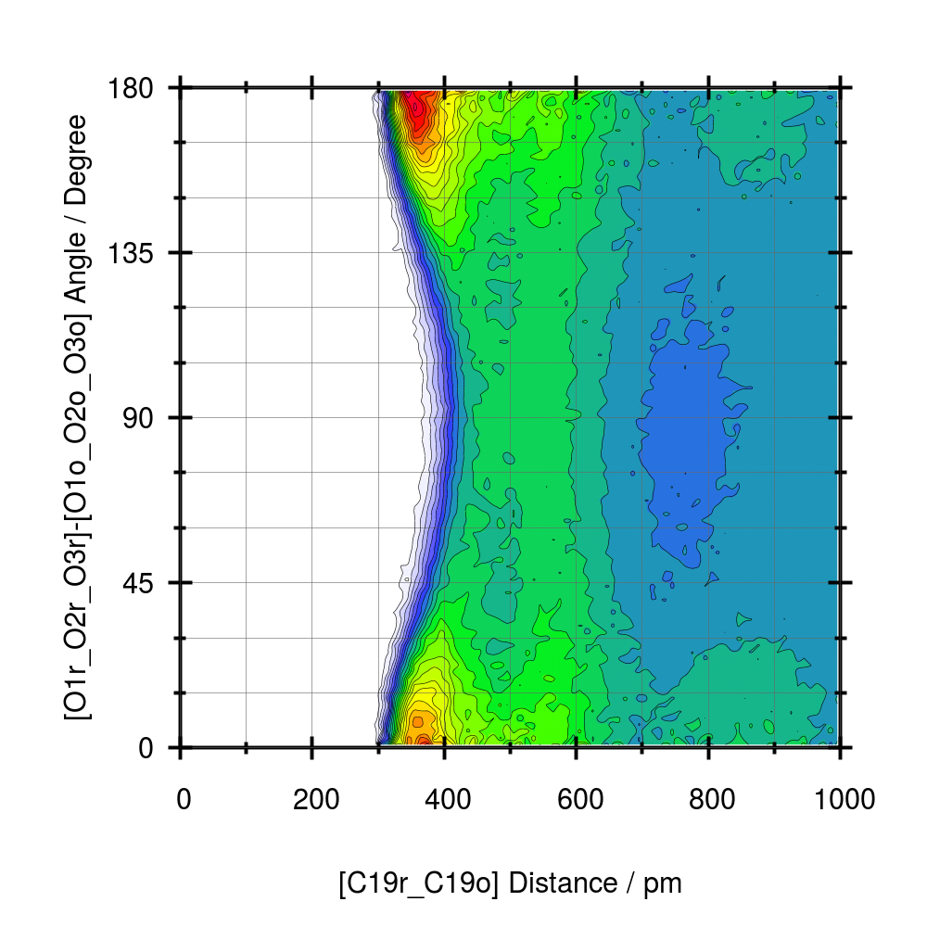
Figure 13. Combined distribution function for D1C, D6C and D12C reporting the joint probability for the pdf C1-C1 and the angle distribution function between neighbour carbonates planes as defined by the O-O-O triangles. The two latter plots are representative for all the members of the DAC family.

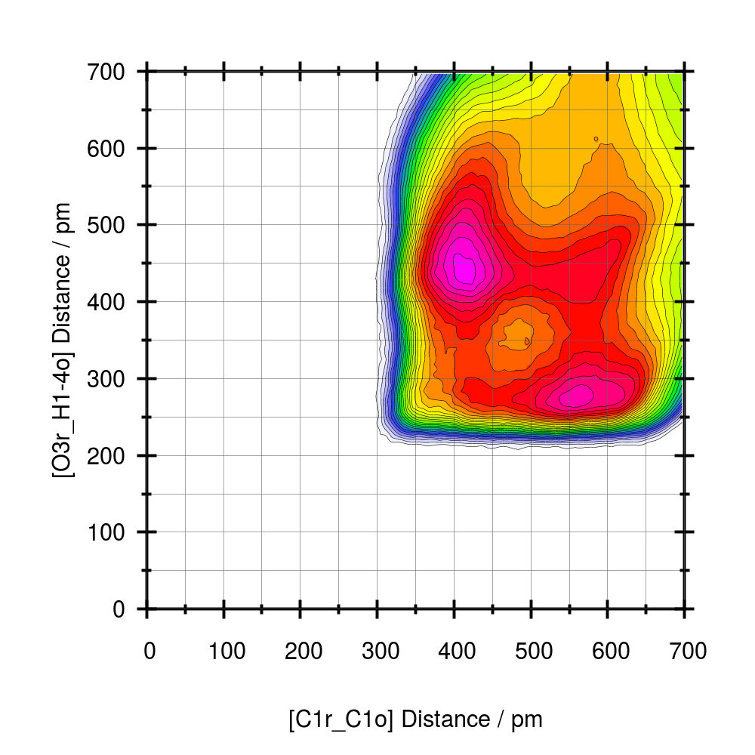 | 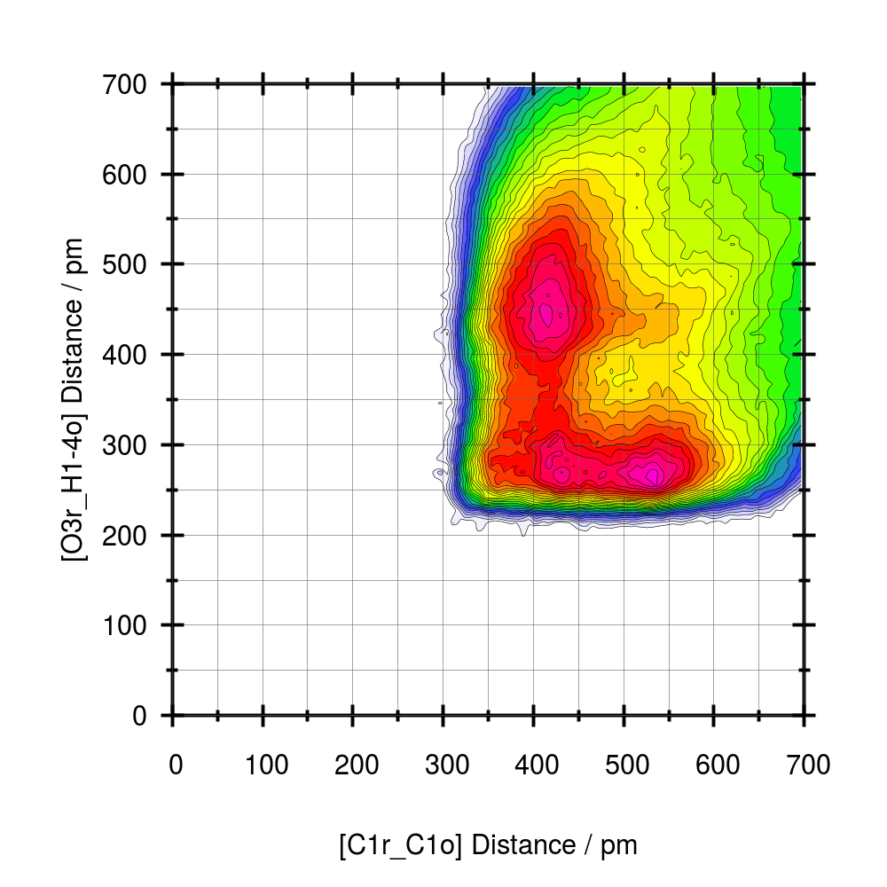 | 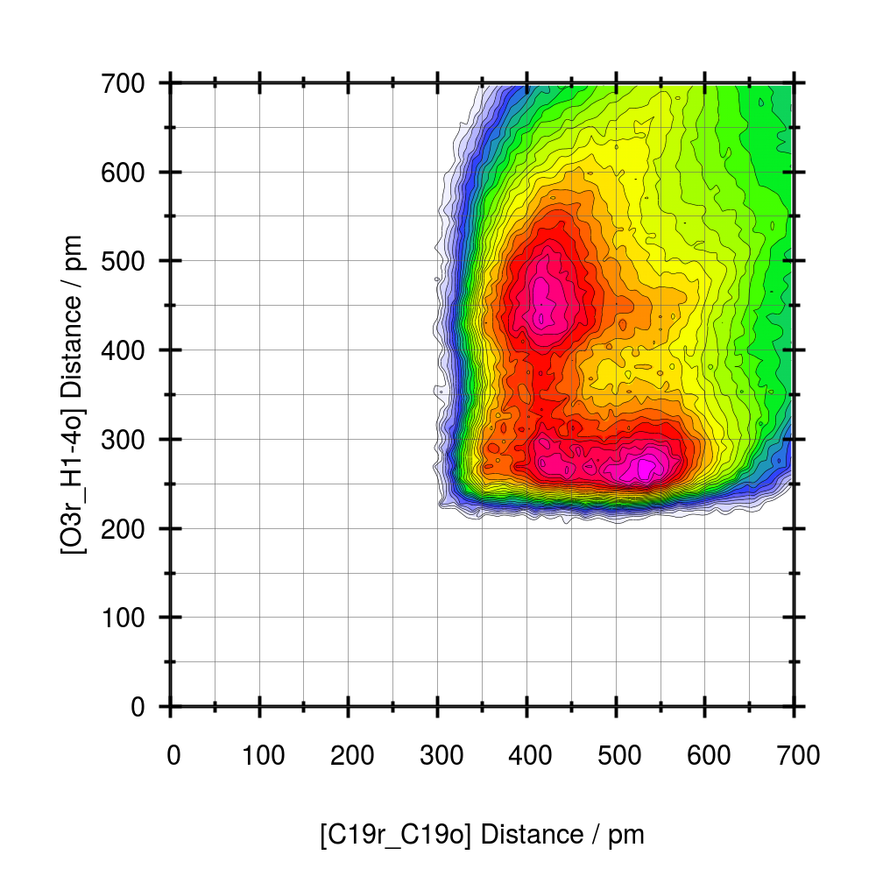
Figure 15. Combined distribution function for D1C, D6C and D12C reporting the joint probability for the pdf C1-C1 and the pdf O3-H1-4 (hydrogen atoms at the α position) distances. The two latter plots are representative for all the members of the DAC family.

The other effect originating from the specific correlations between first neighbour carbonate groups is represented in the snapshot of Figure 16. This shows a representative configuration of two D9C molecules whose C1 are separated by a distance of ca. 5.5 Å and whose d vectors are parallel. It appears that these two geometrical conditions are often consistent with both the establishment of a weak O···Hα hydrogen bonding and the partial/extended coalescence of long side chains. The latter effect is an important one, as the formation of alkyl chain domains can be considered as a fundamental step for the formation of the segregated morphology fingerprinted by the SAXS low Q peak discussed in the previous section. Alkyl chain segregation is a fundamental structural leitmotif when dealing with several class of materials, including normal alcohols[100,101], aldehydes[28], dialkyl sulfoxides[102] and ILs (in these compounds, the alkyl chain may be connected either to the cation[29,88,89] or to the anion[38,103]), to name a few classes. When dealing with materials bearing two different kinds of moieties, one the apolar alkyl side chain, the other a polar one, such as hydroxyl groups or ionic moiety, one assists to the development of a mesoscopic spatial segregation of the different polarity moieties into two (or even three[104,105]) mesoscopic domains. These are characterised by an irregular shape[106], e.g., a bicontinous morphology with worm-like apolar domains was reported [107], are unstable upon increase of temperature[29] and respond to pressure[108,109] and when the alkyl chain is replaced with an isoelectronic polar chain (e.g. a CH₂ group is replaced by an O atom) the structural heterogeneities do not form[110,111]. As shown in Figure S4 in the ESI the present MD simulations succeed in accounting for the existence of the low Q peaks in DACs and are consistent with a morphology characterised by a characteristic size that linearly scale with the increase with alkyl chain length. In the past, driven by the research on ILs, where this effect is prominent, low Q peaks in the SAXS patterns have been accounted for in terms of polar/apolar alternations.[85,112] In other words, the apolar alkyl chains tend to segregate forming an apolar domain that maintains separate polar domains built up by the electrostatic/hydrogen bonding interactions between the polar moieties. In such situation, the linear n dependence of the characteristic size may result from alkyl-chain arrangements resembling those in cylindrical micelles. [107] In the present case, a strong correlation between carboxyl groups has been detected as fingerprinted by the two C1-C1 correlations at 4 and 5.5 Å. Such polar clusters are surrounded by a sheath of apolar moieties whose thickness, maintaining separated the polar clusters, grows with increasing alkyl chain length. Accordingly, the structural leitmotiv in DAC can be proposed as composed by the stacked carbonyl moieties kept separated by a sheath of alkyl chains (an alternative model has been proposed by some of us [107]). It looks then reasonable to imagine that the periodicity of such a leitmotiv corresponds to the average distance between adjacent carbonyl moieties. In view of such a proposal, we then evaluated the static structure factor S_{pp}(Q) associated to the mutual correlation between carbonyl moieties, excluding then from the S(Q) calculation the carbonyl-alkyl chains correlations and alkyl chain-alkyl chain correlations. Such S_{pp}(Q) is shown for the DAC family in Figure 17. It appears that it is characterised by a low Q peak whose position depends on the side chain length, similarly to the experimental S(Q). The parameter D_{1,pp} was then evaluated as given by D_{1,pp} =2π/Q_{pp}, where Q_{pp} is the peak position in S_{pp}(Q) and its comparison with experimental D₁ is shown in the inset of Figure 17. One finds that the agreement between the two characteristic sizes is excellent, strongly prompting for a straightforward correlation between the observed scattering features and the carbonyl-carbonyl correlation, mediated by the apolar domain sheath.
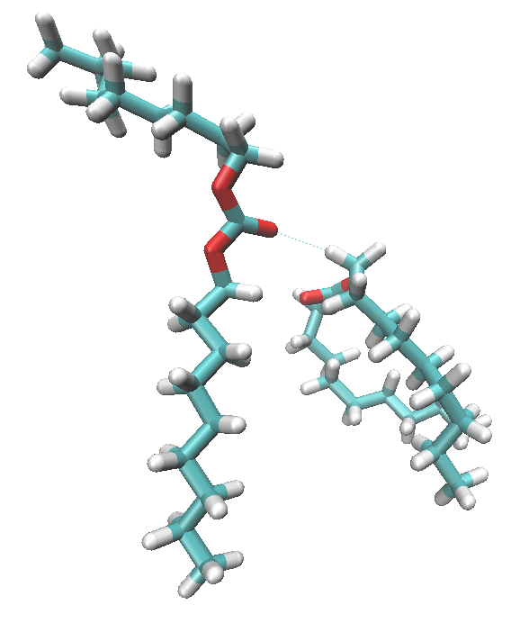
Figure 16. Representative snapshot of neighbour D9C molecules whose C1-C1 distance is ca. 5.5 Å and whose d vectors are parallel. Such conditions can deliver the formation of a weak O···Hα hydrogen boding (highlighted in the Figure) and the formation of alkyl domains where neighbour side chains overlap.

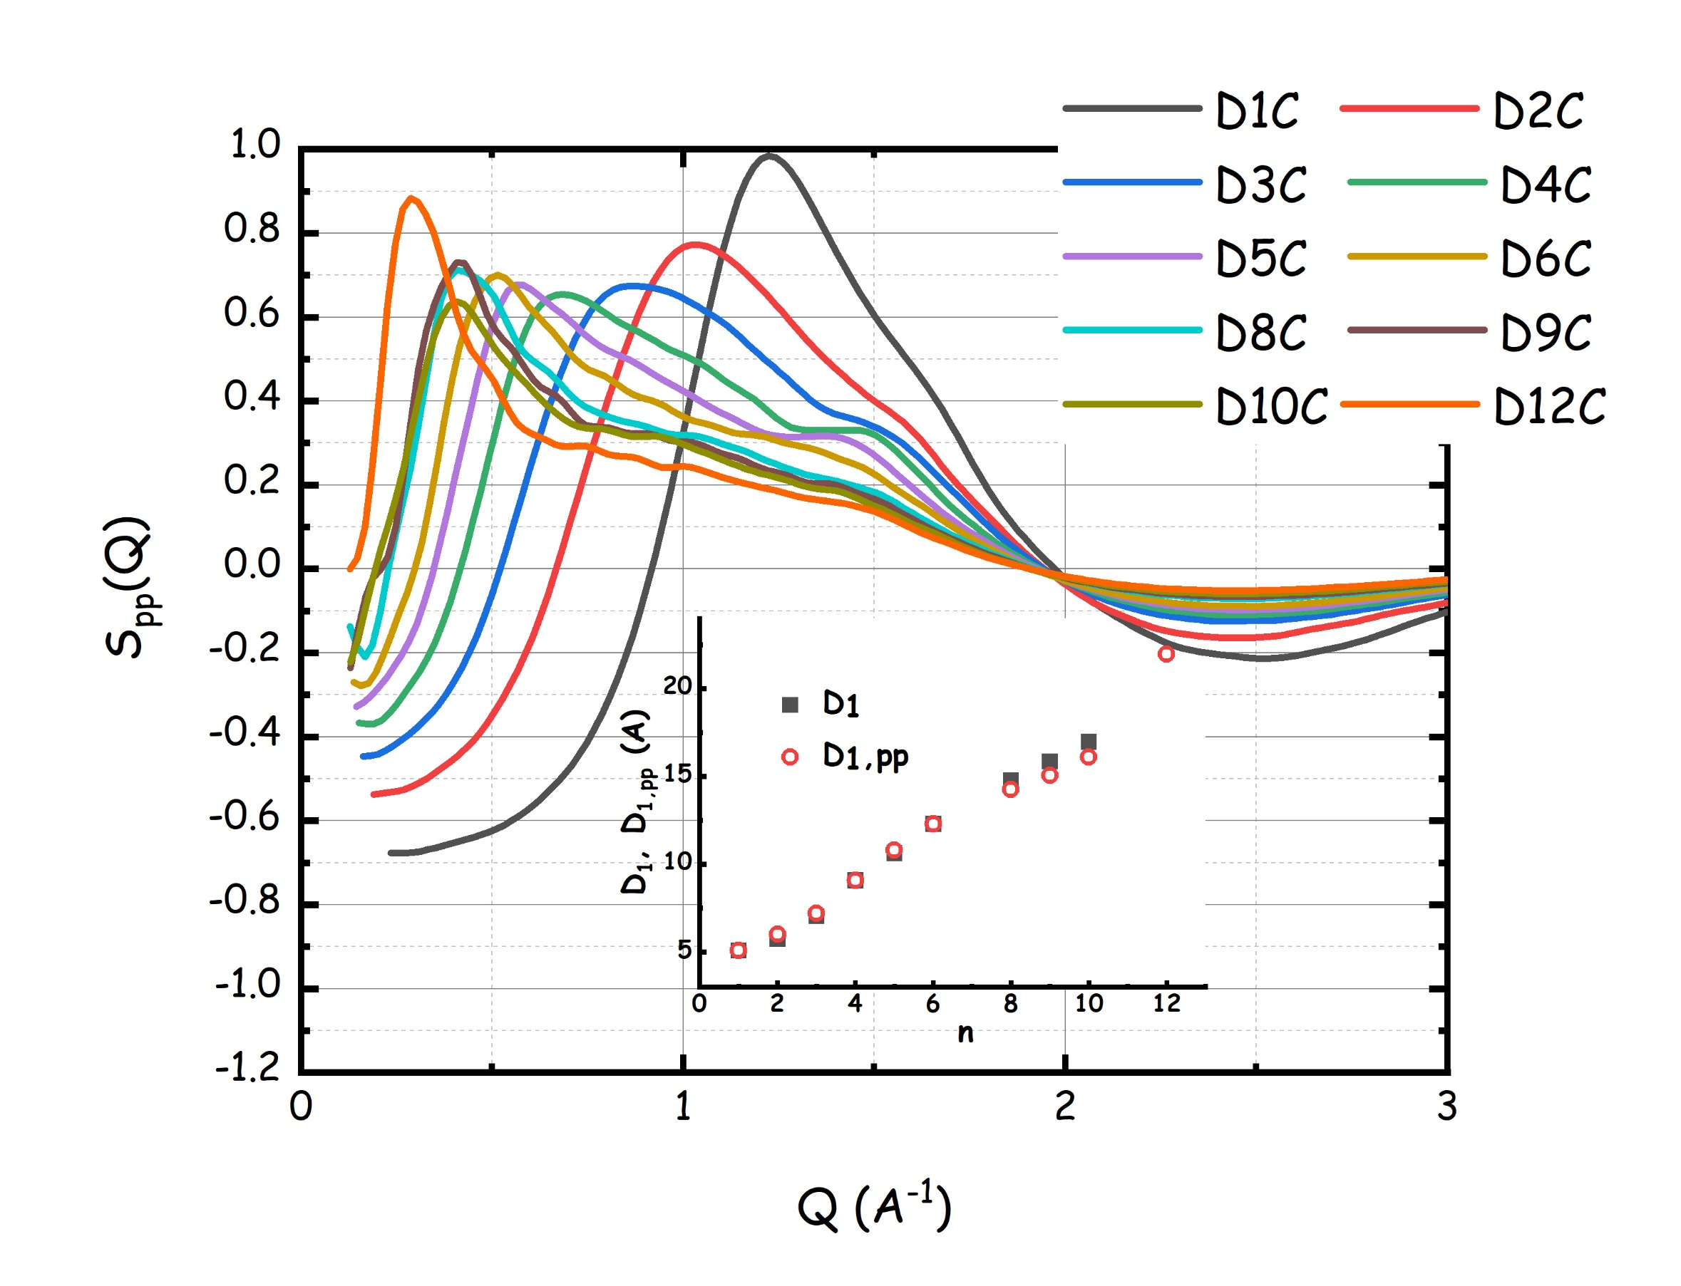
Figure 17. MD-computed static structure factor for the carbonyl-carbonyl correlations for the DAC family. In the inset, the characteristic size D_{1,pp} =2π/Q_{pp} (with Q_{pp} the peak position) is compared with the experimental D₁ data, obtained from SAXS data.

Such a structural scenario finds its manifestation in the representative snapshot reported in Figure 18 for D6C. Therein, attention is focused on two D6C molecules separated by a distance of ca. 13 Å, the distance corresponding to the characteristic size of the structural leitmotiv in D6C (see Figures 10 and 17). Each of the carbonate groups appears stacked with a neighbour carbonate group from another D6C molecule, with a characteristic distance between these stacked parallel carbonates of ca. 4 Å. As mentioned, occasionally such stacked molecules can interact through weak, though discernible, hydrogen bonds and an example of such an interaction is shown. The stacking of adjacent carbonate groups induces the alignment and partial overlapping of side alkyl chains (e.g. the blue and the green tails). Such chains tend to further mingle with the corresponding chains belonging to a neighbour stack of carbonates (e.g. the yellow and the grey tails), thus leading to the formation of an alkyl sheath, with size D₁ (in this case equal to 12.8 Å), keeping apart the carbonate moieties.
Figure 18. MD snapshot from the system D6C, encompassing 6 different molecules and highlighting the structural feature of the morphological leitmotiv in DACs. Selected distances are indicated: black line: characteristic distance between two carbonates belonging to different polar domains; red lines: characteristic distance between two carbonates belonging to the same stacking cluster; green lines: hydrogen bonded C-H··O entities. This snapshot is representative of the situation encountered in the other DACs.

4. Conclusion.
Here, we reported a rich set of experimentally determined chemical-physical parameters on a family of dialkyl carbonates, some of them originally prepared in this work, ranging from dimethyl carbonate up to didodecyl carbonate. Together with a thorough characterisation of macroscopic properties, we also accounted for structural and dynamic properties of DACs, by means of Molecular Dynamics simulations, based on an interatomic force field developed originally for this work.
Solid-liquid transition temperatures, density, viscosity, refractive index and diffusion coefficient were reported for the whole family of DnC with n between 1 and 12, including a branched member of the family D84C. The experimental data show systematic trends that were tabulated and discussed.
Static Wide and Small Angle X-ray Scattering data were presented as well for these materials, highlighting the existence of a distinct degree of structural heterogeneities, whose characteristic size strongly depends on the alkyl chain length.
Molecular Dynamics simulations provided a fundamental insight into the structural features characterising these compounds. After validating the simulations, by critical comparison with density, viscosity, diffusion coefficient and X-ray static structure factors, we exploited them to extract structural information at an atomistic level of detail.
The experimentally validated MD simulations indicate that a strong correlation exists between neighbour carbonyl groups that induces a specific orientation of the neighbour molecules. Such correlations have also the effect of triggering weak, but nonetheless common, hydrogen bonding correlations between carbonyl O and hydrogens in the α position . Moreover, the carbonyl correlation induces a privileged alignment of the side alkyl chains, thus providing ideal orientational conditions for the development of apolar domains composed of alkyl chains. Such effects all converge in determining a highly segregated morphology, whose characteristic spatial scale is highlighted by the existence of low Q peaks in the experimental SAXS patterns. Accordingly, the synergic interpretation of experimental SAXS data and MD simulations drives to the conclusion that the polar domains composed by staked carbonyl groups are kept separated by a sheath of alkyl chains, whose thickness grows with increasing alkyl chain length.
Overall, we presented a detailed and careful description for chemical physical properties of an important class of compounds, with the goal to extend the range of their applications.
5. Acknowledgements.
We wish to thank Dr. Sara Tabanella for her support in samples preparation and characterization at a preliminary stage of the work. This work has been supported by the University of Rome Sapienza Projects: "Microscopic and mesoscopic organization in ionic liquid-based systems." (RG11715C7CC660BE) and “Green solvents for simple and complex carbohydrates” (RM120172B2165468). This research was supported in part by the U.S. Department of Agriculture, Agricultural Research Service. Access to the SAXS-Lab at the University of Rome Sapienza is acknowledged. The findings and conclusions in this publication are those of the author(s) and should not be construed to represent any official USDA or U.S. Government determination or policy. Mention of trade names or commercial products in this publication is solely for the purpose of providing specific information and does not imply recommendation or endorsement by the U.S. Department of Agriculture. USDA is an equal opportunity provider and employer.

5. Credit.
Triolo: Conceptualization, Investigation, Formal Analysis; Writing.
Chaban: Investigation, modellization.
Lo Celso: Investigation.
Leonelli: Investigation.
Vogel: Investigation.
Steinrücken: Investigation.
Del Giudice: Investigation.
Ottaviani: Investigation.
Kenar: Investigation.
Russina: Investigation, Funding acquisition, Writing.

6. References
[1] P. Tundo, M. Selva, The chemistry of dimethyl carbonate, Acc. Chem. Res. 35 (2002) 706–716. https://doi.org/10.1021/ar010076f.
[2] F. Aricò, P. Tundo, Dimethyl carbonate as a modern green reagent and solvent, Russ. Chem. Rev. 79 (2010) 479–489. https://doi.org/10.1070/RC2010v079n06ABEH004113.
[3] P. Tundo, M. Musolino, F. Aricò, The reactions of dimethyl carbonate and its derivatives, Green Chem. 20 (2018) 28–85. https://doi.org/10.1039/c7gc01764b.
[4] B. Schäffner, J. Holz, S.P. Verevkin, A. Börner, Organic Carbonates as Alternative Solvents for Palladium-Catalyzed Substitution Reactions, ChemSusChem. 1 (2008) 249–253. https://doi.org/10.1002/cssc.200700142.
[5] A.-A.G. Shaikh, S. Sivaram, Organic Carbonates, Chem. Rev. 96 (1996) 951–976. https://doi.org/10.1021/cr950067i.
[6] J.A. Kenar, Current perspectives on oleochemical carbonates, Inf. - Int. News Fats, Oils Relat. Mater. 15 (2004) 580–582.
[7] C. Vriet, Z. Mouloungui, Les carbonates organiques: une famille de composés méconnue, Actual. Chim. 315 (2008) 19–27.
[8] J.P. Parrish, R.N. Salvatore, K.W. Jung, Perspective on alkyl carbohydrates in organic synthesis, Tetrahedron. 56 (2000) 8207–8237. https://doi.org/10.1016/S0040-4020(00)00671-2.
[9] K. Xu, Nonaqueous liquid electrolytes for lithium-based rechargeable batteries, Chem. Rev. 104 (2004) 4303–4417. https://doi.org/10.1021/cr030203g.
[10] D. Guyomard, J.M. Tarascon, Rechargeable Li1 + x Mn2 O 4 / Carbon Cells with a New Electrolyte Composition: Potentiostatic Studies and Application to Practical Cells, J. Electrochem. Soc. 140 (1993) 3071–3081. https://doi.org/10.1149/1.2220987.
[11] J.M. Tarascon, D. Guyomard, New electrolyte compositions stable over the 0 to 5 V voltage range and compatible with the Li1+xMn2O4/carbon Li-ion cells, Solid State Ionics. 69 (1994) 293–305. https://doi.org/10.1016/0167-2738(94)90418-9.
[12] M. Dierker, Oleochemical Carbonates – An Overview, Lipid Technol. 16 (2004) 130–133.
[13] J.A. Kenar, Latent heat characteristics of biobased oleochemical carbonates as potential phase change materials, Sol. Energy Mater. Sol. Cells. 94 (2010) 1697–1703. https://doi.org/10.1016/j.solmat.2010.05.031.
[14] J.A. Kenar, Thermal characteristics of oleochemical carbonate binary mixtures for potential latent heat storage, Eur. J. Lipid Sci. Technol. 114 (2012) 63–70. https://doi.org/10.1002/ejlt.201100043.
[15] J.A. Kenar, G. Knothe, A.L. Copes, Synthesis and characterization of dialkyl carbonates prepared from mid-, long-chain, and guerbet alcohols, J. Am. Oil Chem. Soc. 81 (2004) 285–291. https://doi.org/10.1007/s11746-004-0897-4.
[16] J.A. Kenar, G. Knothe, R.O. Dunn, T.W. Ryan, A. Matheaus, Physical properties of oleochemical carbonates, JAOCS, J. Am. Oil Chem. Soc. 82 (2005) 201–205. https://doi.org/10.1007/s11746-005-5173-5.
[17] S.P. Verevkin, V.N. Emel’yanenko, S.A. Kozlova, Organic carbonates: Experiment and ab initio calculations for prediction of thermochemical properties, J. Phys. Chem. A. 112 (2008) 10667–10673. https://doi.org/10.1021/jp8024705.
[18] B. Schäffner, F. Schäffner, S.P. Verevkin, A. Börner, Organic carbonates as solvents in synthesis and catalysis, Chem. Rev. 110 (2010) 4554–4581. https://doi.org/10.1021/cr900393d.
[19] S.A. Kozlova, V.N. Emel’yanenko, M. Georgieva, S.P. Verevkin, Y. Chernyak, B. Schäffner, A. Börner, Vapour pressure and enthalpy of vaporization of aliphatic dialkyl carbonates, J. Chem. Thermodyn. 40 (2008) 1136–1140. https://doi.org/10.1016/j.jct.2008.02.012.
[20] W.F. Bergfeld, F.A.C.P.; Donald, V. Belsito, R.A. Hill, C.D. Klaassen, D.C. Liebler, J.G. Marks, R.C. Shank, T.J.; Slaga, P.W. Snyder, W. Johnson, I. Boyer, B. Heldreth, Safety Assessment of Dialkyl Carbonates as Used in Cosmetics Status: Tentative Report for Public Comment Release, 2016.
[21] K. Lopinti, M. Sharma, M. Chakradhar, A.K. Arora, V. Kagdiyal, S.K. Majumdar, Ash Catalyzed Synthesis of Long-Chain Dialkyl Carbonates Through Carbonyl Exchange Reaction, Catal. Letters. 150 (2020) 1163–1175. https://doi.org/10.1007/s10562-019-03004-1.
[22] A.A.G. Shaikh, S. Sivaram, Dialkyl and diaryl carbonates by carbonate interchange reaction with dimethyl carbonate, Ind. Eng. Chem. Res. 31 (1992) 1167–1170. https://doi.org/10.1021/ie00004a028.
[23] M. Tomsic, A. Jamnik, G. Fritz-Popovski, O. Glatter, L. Vlcek, Structural properties of pure simple alcohols from ethanol, propanol, butanol, pentanol, to hexanol: comparing Monte Carlo simulations with experimental SAXS data., J. Phys. Chem. B. 111 (2007) 1738–51. https://doi.org/10.1021/jp066139z.
[24] A. Vrhovšek, O. Gereben, S. Pothoczki, M. Tomšič, A. Jamnik, S. Kohara, L. Pusztai, An approach towards understanding the structure of complex molecular systems: the case of lower aliphatic alcohols, J. Phys. Condens. Matter. 22 (2010) 404214. https://doi.org/10.1088/0953-8984/22/40/404214.
[25] F. Lo Celso, B. Aoun, A. Triolo, O. Russina, Liquid structure of dibutyl sulfoxide, Phys. Chem. Chem. Phys. 18 (2016) 15980–15987. https://doi.org/10.1039/C6CP02335E.
[26] V. V Chaban, Binary mixtures of novel sulfoxides and water: intermolecular structure, dynamic properties, thermodynamics, and cluster analysis, Phys. Chem. Chem. Phys. 20 (2018) 23754–23761. https://doi.org/10.1039/C8CP04012E.
[27] A. Lajovic, M. Tomsic, G. Fritz-Popovski, L. Vlcek, A. Jamnik, Exploring the structural properties of simple aldehydes: a Monte Carlo and small-angle X-ray scattering study., J. Phys. Chem. B. 113 (2009) 9429–35. https://doi.org/10.1021/jp9028485.
[28] I. Pethes, L. Temleitner, M. Tomšič, A. Jamnik, L. Pusztai, X-Ray Diffraction and Computer Simulation Studies of the Structure of Liquid Aliphatic Aldehydes: From Propanal to Nonanal, Phys. Status Solidi Basic Res. 255 (2018) 1–7. https://doi.org/10.1002/pssb.201800127.
[29] A. Triolo, O. Russina, H.J. Bleif, E. Di Cola, Nanoscale segregation in room temperature ionic liquids, J. Phys. Chem. B. 111 (2007) 4641–4644. https://doi.org/10.1021/jp067705t.
[30] L. Gontrani, O. Russina, F.C. Marincola, R. Caminiti, An energy dispersive x-ray scattering and molecular dynamics study of liquid dimethyl carbonate, J. Chem. Phys. 131 (2009) 1–9. https://doi.org/10.1063/1.3273847.
[31] S.K. Reddy, S. Balasubramanian, Liquid dimethyl carbonate: A quantum chemical and molecular dynamics study, J. Phys. Chem. B. 116 (2012) 14892–14902. https://doi.org/10.1021/jp309374m.
[32] Y.M. Delavoux, M. Gilmore, M.P. Atkins, M. Swadźba-Kwaśny, J.D. Holbrey, Intermolecular structure and hydrogen-bonding in liquid 1,2-propylene carbonate and 1,2-glycerol carbonate determined by neutron scattering, Phys. Chem. Chem. Phys. 19 (2017) 2867–2876. https://doi.org/10.1039/c6cp07790k.
[33] S. Wu, J. Huang, Y. Wang, H. Tao, Z. Yu, Y. Zhang, Bisimidazolium Tungstate Ionic Liquids: Highly Efficient Catalysts for the Synthesis of Linear Organic Carbonates by the Reaction of Ethylene Carbonate with Alcohols, Catal. Letters. (2022). https://doi.org/10.1007/s10562-022-03969-6.
[34] Y.R. Jorapur, D.Y. Chi, Synthesis of symmetrical organic carbonates via significantly enhanced alkylation of metal carbonates with alkyl halides/sulfonates in ionic liquid, J. Org. Chem. 70 (2005) 10774–10777. https://doi.org/10.1021/jo051722h.
[35] P.T. Callaghan, Principles of Nuclear Magnetic Resonance Microscopy, Clarendon Press, 1993. https://global.oup.com/academic/product/principles-of-nuclear-magnetic-resonance-microscopy-9780198539971?cc=it&lang=en&#.
[36] R. Kimmich, NMR: Tomography, Diffusometry, Relaxometry, Springer Berlin Heidelberg, Berlin, Heidelberg, 1997. https://doi.org/10.1007/978-3-642-60582-6.
[37] R. Caminiti, V.R. Albertini, The kinetics of phase transitions observed by energy-dispersive x-ray diffraction, Int. Rev. Phys. Chem. 18 (1999) 263–299. https://doi.org/10.1080/014423599229965.
[38] M. Macchiagodena, F. Ramondo, A. Triolo, L. Gontrani, R. Caminiti, Liquid Structure of 1-Ethyl-3-methylimidazolium Alkyl Sulfates by X-ray Scattering and Molecular Dynamics, J. Phys. Chem. B. 116 (2012) 13448–13458. https://doi.org/10.1021/jp306982e.
[39] J. Wang, R.M. Wolf, J.W. Caldwell, P.A. Kollman, D.A. Case, Development and Testing of a General Amber Force Field, J. Comput. Chem. 56531 (2004) 1157–1174.
[40] J.-P. Ryckaert, A. Bellemans, Molecular dynamics of liquid n-butane near its boiling point, Chem. Phys. Lett. 30 (1975) 123–125. https://doi.org/10.1016/0009-2614(75)85513-8.
[41] B. Hess, H. Bekker, H.J.C. Berendsen, J.G.E.M. Fraaije, LINCS: A linear constraint solver for molecular simulations, J. Comp. Chem. 18 (1997) 1463.
[42] T. Darden, D. York, L. Pedersen, Particle mesh Ewald: An N·log(N) method for Ewald sums in large systems, J. Chem. Phys. 98 (1993) 10089–10092. https://doi.org/10.1063/1.464397.
[43] G. Bussi, D. Donadio, M. Parrinello, Canonical sampling through velocity rescaling, J. Chem. Phys. 126 (2007) 014101. https://doi.org/10.1063/1.2408420.
[44] M. Parrinello, A. Rahman, Polymorphic transitions in single crystals: A new molecular dynamics method, J. Appl. Phys. 52 (1981) 7182–7190. https://doi.org/10.1063/1.328693.
[45] A.D. Becke, Density-functional exchange-energy approximation with correct asymptotic behavior, Phys Rev A Gen Phys. 38 (1988) 3098–3100. https://doi.org/10.1103/physreva.38.3098.
[46] C. Lee, W. Yang, R.G. Parr, Development of the Colle-Salvetti correlation-energy formula into a functional of the electron density, Phys Rev B Condens Matter. 37 (1988) 785–789. https://doi.org/10.1103/physrevb.37.785.
[47] R. Peverati, D.G. Truhlar, Improving the Accuracy of Hybrid Meta-GGA Density Functionals by Range Separation, J. Phys. Chem. Lett. 2 (2011) 2810–2817. https://doi.org/10.1021/jz201170d.
[48] S. Grimme, J. Antony, S. Ehrlich, H. Krieg, A consistent and accurate ab initio parametrization of density functional dispersion correction (DFT-D) for the 94 elements H-Pu, J. Chem. Phys. 132 (2010) 154104. https://doi.org/10.1063/1.3382344.
[49] U.C. Singh, P.A. Kollman, An approach to computing electrostatic charges for molecules, J. Comput. Chem. 5 (1984) 129–145. https://doi.org/10.1002/jcc.540050204.
[50] V. V Chaban, N.A. Andreeva, Mutual miscibility of diethyl sulfoxide and acetonitrile: Fundamental origin, J. Mol. Liq. 349 (2022) 118110. https://doi.org/10.1016/j.molliq.2021.118110.
[51] H. Haghani, M. Behrouz, V. V Chaban, Triethylsulfonium-based ionic liquids enforce lithium salt electrolytes, Phys Chem Chem Phys. 24 (2022) 9418–9431. https://doi.org/10.1039/d2cp00275b.
[52] V. Chaban, Annealing relaxation of ultrasmall gold nanostructures, Chem. Phys. Lett. 618 (2015) 46–50. https://doi.org/10.1016/j.cplett.2014.10.070.
[53] H.J.C. Berendsen, D. van der Spoel, R. van Drunen, GROMACS - A message-passing parallel molecular-dynamics implementation, Comput. Phys. Commun. 91 (1995) 43–56.
[54] D. Van Der Spoel, E. Lindahl, B. Hess, G. Groenhof, A.E. Mark, H.J.C. Berendsen, GROMACS: Fast, flexible, and free, J. Comput. Chem. 26 (2005) 1701–1718. https://doi.org/10.1002/jcc.20291.
[55] M.W. Schmidt, K.K. Baldridge, J.A. Boatz, S.T. Elbert, M.S. Gordon, J.H. Jensen, S. Koseki, N. Matsunaga, K.A. Nguyen, S. Su, T.L. Windus, M. Dupuis, J.A. Montgomery, General atomic and molecular electronic structure system, J. Comput. Chem. 14 (1993) 1347–1363. https://doi.org/10.1002/jcc.540141112.
[56] A.R. Allouche, Gabedit-A Graphical User Interface for Computational Chemistry Softwares, J. Comput. Chem. 32 (2011) 174–182. https://doi.org/10.1002/jcc.21600.
[57] M.D. Hanwell, D.E. Curtis, D.C. Lonie, T. Vandermeersch, E. Zurek, G.R. Hutchison, Avogadro: an advanced semantic chemical editor, visualization, and analysis platform, J. Cheminform. 4 (2012) 17. https://doi.org/Artn 1710.1186/1758-2946-4-17.
[58] W. Humphrey, A. Dalke, K. Schulten, VMD: Visual molecular dynamics, J. Mol. Graph. 14 (1996) 33–38. https://doi.org/10.1016/0263-7855(96)00018-5.
[59] M. Brehm, B. Kirchner, TRAVIS - A Free Analyzer and Visualizer for Monte Carlo and Molecular Dynamics Trajectories, J. Chem. Inf. Model. 51 (2011) 2007–2023. https://doi.org/10.1021/ci200217w.
[60] O. Hollóczki, M. Macchiagodena, H. Weber, M. Thomas, M. Brehm, A. Stark, O. Russina, A. Triolo, B. Kirchner, Triphilic Ionic-Liquid Mixtures: Fluorinated and Non-fluorinated Aprotic Ionic-Liquid Mixtures, ChemPhysChem. 16 (2015) 3325–3333. https://doi.org/10.1002/cphc.201500473.
[61] M. Brehm, M. Thomas, S. Gehrke, B. Kirchner, TRAVIS—A free analyzer for trajectories from molecular simulation, J. Chem. Phys. 152 (2020) 164105. https://doi.org/10.1063/5.0005078.
[62] V. Chaban, Polarizability versus mobility: atomistic force field for ionic liquids, Phys. Chem. Chem. Phys. 13 (2011) 16055. https://doi.org/10.1039/c1cp21379b.
[63] E.E. Fileti, V. V. Chaban, The scaled-charge additive force field for amino acid based ionic liquids, Chem. Phys. Lett. 616–617 (2014) 205–211. https://doi.org/10.1016/j.cplett.2014.10.049.
[64] I. V Voroshylova, V. V Chaban, Atomistic Force Field for Pyridinium-Based Ionic Liquids: Reliable Transport Properties, J. Phys. Chem. B. 118 (2014) 10716–10724. https://doi.org/10.1021/jp5054875.
[65] V. V. Chaban, Force field development and simulations of senior dialkyl sulfoxides, Phys. Chem. Chem. Phys. 18 (2016) 10507–10515. https://doi.org/10.1039/c5cp08006a.
[66] M.S. Ding, Liquid-solid phase equilibria and thermodynamic modeling for binary organic carbonates, J. Chem. Eng. Data. 49 (2004) 276–282. https://doi.org/10.1021/je034134e.
[67] V. Pokorný, V. Štejfa, M. Fulem, C. Červinka, K. Růžička, Vapor Pressures and Thermophysical Properties of Dimethyl Carbonate, Diethyl Carbonate, and Dipropyl Carbonate, J. Chem. Eng. Data. 62 (2017) 3206–3215. https://doi.org/10.1021/acs.jced.7b00295.
[68] J.T. Edward, P.G. Farrell, F. Shahidi, Partial molal volumes of organic compounds in carbon tetrachloride. 1. Alkanes. Conformational effects, J. Phys. Chem. 82 (1978) 2310–2313. https://doi.org/10.1021/j100510a012.
[69] M.A.A. Rocha, C.M.S.S. Neves, M.G. Freire, O. Russina, A. Triolo, J.A.P. Coutinho, L.M.N.B.F. Santos, Alkylimidazolium Based Ionic Liquids: Impact of Cation Symmetry on Their Nanoscale Structural Organization, J. Phys. Chem. B. 117 (2013) 10889–10897. https://doi.org/10.1021/jp406374a.
[70] J.F. Casteel, P.G. Sears, Dielectric constants, viscosities, and related physical properties of 10 liquid sulfoxides and sulfones at several temperatures, J. Chem. Eng. Data. 19 (1974) 196–200. https://doi.org/10.1021/je60062a001.
[71] S.A. Markarian, L.S. Gabrielyan, S. Bonora, The volumetric and thermochemical properties of dipropylsulfoxide in water, J. Solution Chem. 39 (2010) 591–602. https://doi.org/10.1007/s10953-010-9536-7.
[72] F. Lo Celso, B. Aoun, A. Triolo, O. Russina, Liquid structure of dibutyl sulfoxide, Phys. Chem. Chem. Phys. 18 (2016) 15980–15987. https://doi.org/10.1039/C6CP02335E.
[73] U. Domańska, J. Łachwa, T.M. Letcher, Densities, Excess Molar Volumes, and Excess Molar Enthalpies of ( N -Methyl-2-pyrrolidinone + Ketone) at T = 298.15 K, J. Chem. Eng. Data. 47 (2002) 1446–1452. https://doi.org/10.1021/je020068p.
[74] D. Huang, S.L. Simon, G.B. McKenna, Chain length dependence of the thermodynamic properties of linear and cyclic alkanes and polymers, J. Chem. Phys. 122 (2005) 084907. https://doi.org/10.1063/1.1852453.
[75] B. Lorenzo, J.A. Yánez, J. Ortega, A. Sosa, L. Fernández, Liquid-State Volumetric Properties of a Set of Alcohols with Up to Five Carbon Atoms, Liquids. 2 (2022) 1–13. https://doi.org/10.3390/liquids2010001.
[76] H. Vogel, Das Temperaturabhaengigkeitsgesetz der Viskositaet von Fluessigkeiten, Phys. Zeitschrift. 22 (1921) 645.
[77] G.S. Fulcher, Analysis of Recent Measurements of the Viscosity of Glasses, J. Am. Ceram. Soc. 8 (1925) 339–355. https://doi.org/10.1111/j.1151-2916.1925.tb16731.x.
[78] G. Tammann, W. Hesse, Die Abhängigkeit der Viscosität von der Temperatur bie unterkühlten Flüssigkeiten, Zeitschrift Für Anorg. Und Allg. Chemie. 156 (1926) 245–257. https://doi.org/10.1002/zaac.19261560121.
[79] E. Von Meerwall, S. Beckman, J. Jang, W.L. Mattice, Diffusion of liquid n-alkanes: Free-volume and density effects, J. Chem. Phys. 108 (1998) 4299–4304. https://doi.org/10.1063/1.475829.
[80] E. Von Meerwall, R. Ozisik, W.L. Mattice, P.M. Pfister, Self-diffusion of linear and cyclic alkanes, measured with pulsed-gradient spin-echo nuclear magnetic resonance, J. Chem. Phys. 118 (2003) 3867–3873. https://doi.org/10.1063/1.1539044.
[81] M. Iwahashi, Y. Ohbu, T. Kato, Y. Suzuki, K. Yamauchi, Y. Yamaguchi, M. Muramatsu, The Dynamical Structure of Normal Alcohols in Their Liquids as Determined by the Viscosity and Self-Diffusion Measurements, Bull. Chem. Soc. Jpn. 59 (1986) 3771–3774. https://doi.org/10.1246/bcsj.59.3771.
[82] M. Becher, E. Steinrücken, M. Vogel, On the relation between reorientation and diffusion in glass-forming ionic liquids with micro-heterogeneous structures, J. Chem. Phys. 151 (2019). https://doi.org/10.1063/1.5128420.
[83] L. Gontrani, O. Russina, F.C. Marincola, R. Caminiti, An energy dispersive x-ray scattering and molecular dynamics study of liquid dimethyl carbonate, J. Chem. Phys. 131 (2009) 1–9. https://doi.org/10.1063/1.3273847.
[84] J.C. Soetens, C. Millot, B. Maigret, I. Bakó, Molecular dynamics simulation and x-ray diffraction studies of ethylene carbonate, propylene carbonate and dimethyl carbonate in liquid phase, J. Mol. Liq. 92 (2001) 201–216. https://doi.org/10.1016/S0167-7322(01)00192-1.
[85] J.C. Araque, J.J. Hettige, C.J. Margulis, Modern Room Temperature Ionic Liquids , a Simple Guide to Understanding Their Structure and How It May Relate to Dynamics, J. Phys. Chem. B. 119 (2015) 12727−12740. https://doi.org/10.1021/acs.jpcb.5b05506.
[86] N.P. Franks, M.H. Abraham, W.R. Lieb, Molecular Organization of Liquid n-Octanol: An X-ray Diffraction Analysis, J. Pharm. Sci. 82 (1993) 466–470. https://doi.org/10.1002/jps.2600820507.
[87] J.L. MacCallum, D.P. Tieleman, Structures of neat and hydrated 1-octanol from computer simulations, J. Am. Chem. Soc. 124 (2002) 15085–15093. https://doi.org/10.1021/ja027422o.
[88] O. Russina, A. Triolo, L. Gontrani, R. Caminiti, Mesoscopic structural heterogeneities in room-temperature ionic liquids, J. Phys. Chem. Lett. 3 (2012) 27–33. https://doi.org/10.1021/jz201349z.
[89] O. Russina, A. Triolo, New experimental evidence supporting the mesoscopic segregation model in room temperature ionic liquids, Faraday Discuss. 154 (2012) 97–109. https://doi.org/10.1039/C1FD00073J.
[90] L. Gontrani, O. Russina, F. Lo Celso, R. Caminiti, G. Annat, A. Triolo, Liquid structure of trihexyltetradecylphosphonium chloride at ambient temperature: An x-ray scattering and simulation study, J. Phys. Chem. B. 113 (2009) 9235–9240. https://doi.org/10.1021/jp808333a.
[91] A. Triolo, O. Russina, B. Fazio, G.B. Appetecchi, M. Carewska, S. Passerini, Nanoscale organization in piperidinium-based room temperature ionic liquids, J. Chem. Phys. 130 (2009) 164521. https://doi.org/10.1063/1.3119977.
[92] C.S. Santos, N.S. Murthy, G. a Baker, E.W. Castner, Communication: X-ray scattering from ionic liquids with pyrrolidinium cations., J. Chem. Phys. 134 (2011) 121101. https://doi.org/10.1063/1.3569131.
[93] D. Xiao, L.G. Hines Jr., S. Li, R.A. Bartsch, E.L. Quitevis, O. Russina, A. Triolo, Effect of cation symmetry and alkyl chain length on the structure and intermolecular dynamics of 1,3-dialkylimidazolium bis(trifluoromethanesulfonyl) amide ionic liquids, J. Phys. Chem. B. 113 (2009) 6426–6433. https://doi.org/10.1021/jp8102595.
[94] R. Atkin, G.G. Warr, The smallest amphiphiles: nanostructure in protic room-temperature ionic liquids with short alkyl groups., J. Phys. Chem. B. 112 (2008) 4164–6. https://doi.org/10.1021/jp801190u.
[95] W. Zheng, A. Mohammed, L.G. Hines, D. Xiao, O.J. Martinez, R. a Bartsch, S.L. Simon, O. Russina, A. Triolo, E.L. Quitevis, Effect of cation symmetry on the morphology and physicochemical properties of imidazolium ionic liquids., J. Phys. Chem. B. 115 (2011) 6572–84. https://doi.org/10.1021/jp1115614.
[96] E. Galicia-Andrés, L. Pusztai, L. Temleitner, O. Pizio, Microscopic structure of methanol-water mixtures: Synchrotron X-ray diffraction experiments and molecular dynamics simulations over the entire composition range, J. Mol. Liq. 209 (2015) 586–595. https://doi.org/10.1016/j.molliq.2015.06.045.
[97] O. Russina, A. Sferrazza, R. Caminiti, A. Triolo, Amphiphile Meets Amphiphile: Beyond the Polar–Apolar Dualism in Ionic Liquid/Alcohol Mixtures, J. Phys. Chem. Lett. 5 (2014) 1738–1742. https://doi.org/10.1021/jz500743v.
[98] G.R. Desiraju, The C-H ‚‚‚ O Hydrogen Bond : Structural Implications and, Acc. Chem. Res. 4842 (1996) 441–449.
[99] A. Triolo, F. Lo Celso, N. V. Plechkova, F. Leonelli, S. Gärtner, D.S. Keeble, O. Russina, Structure of anisole derivatives by total neutron and X-ray scattering: Evidences of weak C H⋯O and C H⋯π interactions in the liquid state, J. Mol. Liq. 314 (2020) 113795. https://doi.org/10.1016/j.molliq.2020.113795.
[100] B.Y. Kaarlo, S. Vahvaselk, R. Serimaa, M. Torkkeli, Determination of Liquid Structures of the Primary Alcohols Methanol , Ethanol , l-Propanol , 1-Butanol and 1-Octanol by X-ray Scattering, (1995) 189–195.
[101] M. Tomšič, A. Jamnik, G. Fritz-Popovski, O. Glatter, L. Vlček, Structural Properties of Pure Simple Alcohols from Ethanol, Propanol, Butanol, Pentanol, to Hexanol: Comparing Monte Carlo Simulations with Experimental SAXS Data, J. Phys. Chem. B. 111 (2007) 1738–1751. https://doi.org/10.1021/jp066139z.
[102] F. Lo Celso, B. Aoun, A. Triolo, O. Russina, Liquid structure of dibutyl sulfoxide, Phys. Chem. Chem. Phys. 18 (2016) 15980–15987. https://doi.org/10.1039/c6cp02335e.
[103] O. Russina, L. Gontrani, B. Fazio, D. Lombardo, A. Triolo, R. Caminiti, Selected chemical–physical properties and structural heterogeneities in 1-ethyl-3-methylimidazolium alkyl-sulfate room temperature ionic liquids, Chem. Phys. Lett. 493 (2010) 259–262. https://doi.org/10.1016/j.cplett.2010.05.042.
[104] F. Lo Celso, Y. Yoshida, F. Castiglione, M. Ferro, A. Mele, C.J. Jafta, A. Triolo, O. Russina, Direct experimental observation of mesoscopic fluorous domains in fluorinated room temperature ionic liquids †, Phys. Chem. Chem. Phys. 19 (2017) 13101–13110. https://doi.org/10.1039/C7CP01971H.
[105] F. Lo Celso, G.B. Appetecchi, E. Simonetti, M. Zhao, E.W. Castner, U. Keiderling, L. Gontrani, A. Triolo, O. Russina, Microscopic Structural and Dynamic Features in Triphilic Room Temperature Ionic Liquids, Front. Chem. 7 (2019) 1–14. https://doi.org/10.3389/fchem.2019.00285.
[106] K. Shimizu, C.E.S. Bernardes, J.N. Canongia Lopes, Structure and aggregation in the 1-alkyl-3-methylimidazolium Bis(trifluoromethylsulfonyl)imide ionic liquid homologous series, J. Phys. Chem. B. 118 (2014) 567–576. https://doi.org/10.1021/jp409987d.
[107] S. Kloth, M.P. Bernhardt, N.F.A. Van Der Vegt, M. Vogel, Coarse-grained model of a nanoscale-segregated ionic liquid for simulations of low-temperature structure and dynamics, J. Phys. Condens. Matter. 33 (2021). https://doi.org/10.1088/1361-648X/abe606.
[108] O. Russina, F. Lo Celso, A. Triolo, Pressure-responsive mesoscopic structures in room temperature ionic liquids, Phys. Chem. Chem. Phys. 17 (2015) 29496–29500. https://doi.org/10.1039/C5CP04682C.
[109] F. Lo Celso, A. Triolo, L. Gontrani, O. Russina, Communication: Anion-specific response of mesoscopic organization in ionic liquids upon pressurization, J. Chem. Phys. 148 (2018) 211102. https://doi.org/10.1063/1.5036588.
[110] A. Triolo, O. Russina, R. Caminiti, H. Shirota, H.Y. Lee, C.S. Santos, N.S. Murthy, E.W. Castner, Comparing intermediate range order for alkyl- vs. ether-substituted cations in ionic liquids, Chem. Commun. 48 (2012) 4959–4961. https://doi.org/10.1039/c2cc31550e.
[111] O. Russina, F. Lo Celso, N. V. Plechkova, A. Triolo, Emerging Evidences of Mesoscopic-Scale Complexity in Neat Ionic Liquids and Their Mixtures, J. Phys. Chem. Lett. 8 (2017) 1197–1204. https://doi.org/10.1021/acs.jpclett.6b02811.
[112] H.K. Kashyap, J.J. Hettige, H.V.R. Annapureddy, C.J. Margulis, SAXS anti-peaks reveal the length-scales of dual positive–negative and polar–apolar ordering in room-temperature ionic liquids, Chem. Commun. 48 (2012) 5103. https://doi.org/10.1039/c2cc30609c.

