Skills for competitiveness: an empirical analysis of the educational provision for oenologists offered by Italian universities

Abstract
Purpose: Whilst operating in the context of a high income economy, the Italian labour market is affected by the considerable challenges of a vertical mismatch, skill gaps and skill shortages. In such a context, the aim of this study is to explore current university provision regarding the formal qualifications of the oenologist in order to assess its alignment to the demand of professionalism by the wine sector.
Design/Methodology/Approach: The following was deployed to analyse university provision with a mixed method including social network analysis, cluster analysis and an analysis of stakeholder consultation reports.
Findings: The results clearly demonstrated that some Italian universities are slowly tailoring their educational provision in response to the challenges of wine entrepreneurship.
Practical implications: The authors hope that the evidence-based suggestions proffered herein can assist curriculum writers at university level to improve the oenological educational provision of the future.
Theoretical implications: This research might contribute to the scientific debate relating to the educational background of graduates and the university-employability according to the requirements of the professional world of wine.
Originality/Values: To the best of our knowledge, this research is an initial attempt in the scientific literature to offer a methodological framework to improve students’ skill sets and their employability in today’s competitive labour market.
Keywords: wine sector; competence; skills mismatch; social network analysis; cluster analysis; stakeholders.

1. Introduction

According to the Organisation for Economic Co-operation and Development (OECD) “skills have become the key drivers of individual well-being and economic success in the 21st century” (OECD 2017a). Whilst it is considered a high-income, industrialised economy, Italy can be said to have low levels of education and skills: graduate employment rates lag behind the average values for many OECD countries and contemporaneously many companies fail to recruit employees with suitable skills (Marconi and Trapasso 2017; Istat 2018).
The Italian labour market is considered by many scholars to be facing the daunting challenges of vertical and horizontal mismatches, skills gaps and skill shortages (Mcguinness, Pouliakas, and Redmond 2017). These are highlighted by the presence of under-skilled (6% of the national workforces) and under-qualified (21%) employees on the one hand, and over-skilled (12%) and over-qualified (18%) employees on the other. Moreover, a large percentage of employees (35%) are employed in a field which is unrelated to their educational background as a consequence of a weak demand for technical skills by firms. The latter often include small companies, which are associated with less diversified and innovative production (OECD 2017b). Developing skills and overcoming skill mismatches is a key priority for the growth across the Italian economy (OECD 2017b). Thus, the role of universities and their effectiveness in the development of relevant skills is critical in encouraging growth.
The existing academic literature has generally demonstrated that the role of universities is closely tied to human and intellectual capital (Lehmann et al. 2009; Bejinaru 2017). In many cases, this role significantly contributes to sustainable regional development by linking stakeholders in the fields of: research, knowledge transfer, technological development, the dissemination of information, education and innovation (Zilahy and Huisingh 2009). However, the success of institutions such as universities depends to a great extent on their organisational and financial stability (Chalker-Scott and Tinnemore 2009), in addition to their capability to foster internal and external collaboration with all interested parties (Lukman, Krajnc, and Glavič 2009).
The current state of the health of the Italian university system appears particularly vulnerable (Osservatorio Talents Venture 2018; Osservatorio Talents Venture 2020). According to the OECD (2019), investment in university education in Italy in 2016 was 0.89% of Gross Domestic Product (GDP), while average investment throughout the European Union (EU23) was 1.24%, and 1.47% in the OECD area. An even more unequal comparison can be obtained by benchmarking the USA and Canada, where investment in tertiary education was equal to 2.46% and 2.35% respectively in 2016. Furthermore, private spending does not seem to be relevant: Italian families spend only 1.86% of their total expenditure of non-essential items on tertiary education. This is even more evident when it is compared to their proportion of expenditure on alcoholic beverages and tobacco (5.42%) (Osservatorio Talents Venture 2020).
Italy is still considered as one of the European countries in which the enrolment in universities is relatively inexpensive (OECD 2017b). However, over the past decade there has been a constant increase in tuition fees, which in the academic year 2017-2018 ranged from between €629 and €2,241 for public universities (Osservatorio Talents Venture 2018). However, university degrees in Italy are too often not indicative of a student’s skills. This, therefore, hinders the job-matching process for graduates, thereby increasing the employer’s risk of hiring the least suitable candidates (OECD 2017a). Much can be achieved by universities in ensuring that employment-relevant skills are provided to students according to the requisites of the labour market.
The general aim of this study is to explore how Italian universities have designed their educational provision in the wine sector. The latter is facing the increasing competition of a globalised market and managing the ever greater diversification of consumers’ demands and preferences. Such dynamics inevitably elicit more competent and performing human capital to successfully service businesses in the wine sector (Winemonitor Nomisma 2018). Specifically, the study will ascertain whether in Italy there exists an alignment between the university education, and the skills required by wine entrepreneurship. The study programmes of vine growers and oenologists in various Italian universities were, therefore, examined. In this regard, an innovative methodology for evaluating the effectiveness of the degree courses has been developed; it differs considerably from the official methodologies adopted by the Italian National Agency for the Evaluation of Universities and Research Institutes (ANVUR) (Decataldo 2018). The research questions included: What are the main differences and similarities between wine-related undergraduate courses at Italian universities? Have these degree courses been designed according to the skills required by stakeholders?
This paper is structured as follows: Section 2 below will focus on the theoretical framework of the study, describing: the concept of competence, the role of universities and skill development, the demand for skills by wineries, and the tertiary educational provision for the Italian wine sector. Section 3 will outline the Materials and Methodology used in this study, while Section 4 will present the Main Findings and Discussion. The Sections will then conclude with remarks and implications.

2. Background

2.1 The challenging concept of competence
The term competence came into prominence in the 1980s and 1990s in France and other European countries. It can be defined as a key concept to which the evolution and change in institutional education and training systems can be anchored. This also includes human resource management and development within companies and guidance services, as provided by employment agencies (Bresciani 2012). There are two issues which merit our attention. The first is linked to the fact that the term competence, in its singular form, has a very different transversal meaning from the analytical and operational competences. The second is linked to the fact that the use of the two terms varies from country to country and between differing cultures. The lack of consensus regarding the definition of the concept has resulted in challenges relating to the designing of competence-based educational principles at the curriculum level, in addition to the field of competence development in the workplace (Mulder, Weigel, and Collins 2007; Le Deist and Winterton 2005; Ellström and Kock 2008; Manuti et al. 2015).
As stated by Le Boterf (2008), the term competence is associated with the three following factors: that which permits individuals to mobilise, integrate and transfer resources, knowledge and skills (the so-called ability to act and interact), their personal motivation (the willingness to act), and the existence of a specific context which facilitates and legitimates their assumption of responsibility and risk. Frega (2012), in commenting on the assumptions by Le Boterf, reiterated that “the concept of competence designates a dynamic reality, a process rather than a state”, a responsible and socially recognised being capable of taking action, which presupposes the existence of a plurality of ways of being competent, “according to the different biographical, training and work-related vicissitudes which lead individuals to build their own competence”. Indeed, competence can be acquired by individuals in all learning contexts, whether they are formal (inside schools and colleges), non-formal (within other kind of organisational frameworks) and informal environments (at work and in everyday life) (Commission of the European Communities 2000; Bresciani 2012; Manuti et al. 2015).
Competent behaviour can characterise a routine or sudden situation. Hence, the attention of analysts has gradually shifted from competence as an outcome of vocational education and training to the efficacy demonstrated on performance, be that individually and collectively (Drago 2000; Le Boterf 2008). According to Pérez-Capdevila (2012), even in entrepreneurial environments, competence should be understood as: the totality of attitudes (knowledge, abilities, dexterity, etc.) and mannerisms (motivation, beliefs, values, behaviour, etc.), which enable one to perform successfully. It is of note that Le Boterf himself reflected on the fact that competence and competition share the same Latin root (Treccani 2020). Accordingly, his reflections on competence, understood as professionalism, were based on two key points (Le Boterf 2008):
- the belief that “the third millennium enterprise can only function and develop if it is relying on the expertise of professionals”; and
- the need to identify skills requirements to meet the challenges of competitiveness in today’s business landscape (quality, variety, responsiveness, innovation).
Both these considerations were particularly useful in conducting the study outlined in this paper. And as the definitions found in the literature were not always unambiguous, the two terms skill and competence will be hereinafter deployed as synonyms.

2.2 The role of universities in skill development
Throughout the last decade, the attention of European governments and stakeholders has been particularly focused on the construction of national systems of educational and professional standards, with related evaluation, audit and accreditation. The issue of skills is crucial for the achievements of these standards; they could indeed be metaphorically thought as: the currency of exchange, the element of interoperability between vocational, educational and training systems, labour centres, companies and other organisations (Bresciani 2011).
Skills could also be considered as:
- the purposes and outcomes of the educational curricula (learning by studying);
- that which individuals need in order to perform different work activities, and contemporaneously the product of such activities (learning to work and working to learn);
- that which businesses need to succeed in line with their mission and vision statement (learning to navigate markets); and
- that which job centres require to improve matching labour to business requirements (learning to navigate the labour market).
Recalling the milestones contained in the Economics of Education tome (Dell’Aringa and Lucifora 2002), academics have engaged in a robust debate regarding the performance and function of education, particularly secondary and tertiary education.
In a given labour market, which is typically characterised by information asymmetry (Passaretta 2020), the educational level is the credential most frequently used by applicants for signalling (Spence 1973) their competence to potential employers. Several positive points regarding the role of universities in transmitting knowledge to successive generations have been formulated in a work by Boulton and Lucas (2011). According to these authors, universities create new knowledge and, together with the previously-accumulated knowledge, they hand this down to future generations for reappraisal. Boulton and Lucas have argued that “in research, in teaching and in learning it is not only important that universities address and train for current needs, but equally important that they develop the thinking and the mental and conceptual skills and habits that equip their graduates to adapt to change and even steer it if circumstances permit”. Thus, regarding the role of higher education in meeting international business demands, the authors are keen to emphasise that “the individual qualities embodied in university graduates, developed through the classical educational processes (…) and leavened by appropriate technical skills, are crucial contributions from universities”.
Finally, it seems appropriate at this juncture to call attention to another theoretical perspective, known as academic capitalism (Slaughter and Leslie 1997; Bejinaru 2017); this stands in opposition to the image of a university as a temple of knowledge, conceiving it more as a supermarket. Indeed, the marketization of the educational and scientific services offered to customers is of increasing urgency due to a demand overload from stakeholders on different levels. In recent decades this phenomenon has been revolutionizing the nature of patterns of work in university faculties; this includes the design of study programmes in public universities, which tend to be the least dynamic by nature. Embedded in societies, these institutions are managing the processes of continuous change in a globalised arena. And it is now quite evident that globalisation not only involves the chance to take advantage of ample opportunities but it also presents challenges or even threats to the future.

2.3. The emerging skills requirement for competitive wine businesses
The wine sector is governed by very distinctive rules and conventions, which require highly specialized preparation in terms of its market, distribution characteristics and regulatory features. In addition, the management of wine businesses today necessitate a series of critical requisites in terms of the development/acquisition of resources and the bounds of knowledge, which can withstand the test of time (Gilinsky et al. 2019). Some of these include: marketing, effective communicating practices, establishing alliances and business networks (for exchanging knowledge, contacts, experiences and best practices), strategic and operational planning, entrepreneurial thinking, negotiation/bargaining, sales and ambidexterity capabilities, human resources management, in addition to the capacity to invest in product quality and the sustainability of production process. Developing such skills appears to be of fundamental importance to professionals (and educators) in forming the next generation of wine entrepreneurs (Lanfranchi et al. 2020; Gilinsky et al. 2019; Calderón, Fayos, and Frasquet 2019; Mattiacci et al. 2019; Kulesza 2019; Francioni, Vissak, and Musso 2017; Santos, Marques, and Ratten 2019; Fuentes Fernández 2019).
Moving onto the international scene, in which Italian wine market dynamics have developed, there have been profound changes in recent decades. This situation is expected to evolve due to processes of globalization and consequent changes in people’s lifestyles. Italy is a world leader in wine production but its level of competitiveness is heavily dependent on exports. Indeed, Italian wine is one of the most representative products of the Made in Italy agro-food industry, recording the highest value (€5.858 million) on the 2018 national trade balance (ISMEA 2019).
On the supply side, dramatic changes in the global wine market have been observed by the growth in the competitiveness of non-European production and distribution wine businesses (for example, the USA, Argentina, Australia, Chile, South Africa and the People’s Republic of China), in addition to the markedly positive trend in the value of global wine exports (OIV 2020). The demand side has witnessed a migration of consumption from European markets to emerging and more distant markets, distinct by geography, language and culture, with a keen interest from consumers from Asian (for example, China, Japan, etc.) (Lu, Chi, and Zou 2019; Lee et al. 2018; Anderson and Wittwer 2015; OIV 2020; Anderson 2020). In the last decade wine consumption worldwide has stabilised at approximately 240-245 million hectoliters (OIV 2020). This has been accompanied by complex changes in the variables of market segmentation (socio-demographic, psychographic, behavioral), which are characterised by the growing importance of the millennial market (Atkin and Thach 2012; Mehta and Bhanja 2018; Castellini and Samoggia 2018; Fuentes Fernández 2019; Nassivera et al. 2020) and by greater attention paid to organic and sustainable wines (Pomarici and Vecchio 2014; Capitello and Sirieix 2019; Lanfranchi et al. 2019; Szolnoki and Hauck 2020) and the spread of wine-tourism (Lee K. (Ed.) 2016; Dressler 2017; V. R. Santos et al. 2019; Fuentes Fernández 2019; Crespi-Vallbona and Mascarilla-Miró 2020).
Considering the complexity and dynamism of such a competitive scenario, it is essential for firms in the wine-making business to rely on competently skilled professionals. According to the recent survey by Winemonitor Nomisma (2018), the actually crucial skill requisites and professionalism are related to the following specific business goals: the access to foreign markets and new distribution channels, sales direct from the cellar, the development of wine and food tourism, and the optimisation of resources and costs. For instance, the professional figure of the Export Manager and related marketing functions were indicated as “strategic factors for the company” in 62% of the survey sample. This contrasts with other more traditional technical figures, such as the agronomist (indicated as “essential” by 31% of the companies), the winemaker, the cellar technician and the warehouse manager (of the total indicated by 30% of firms surveyed), administrative operators with accounting, control and finance functions (29% of the survey sample) and, finally, experts in new technologies (16%).

2.4 The educational provision in Italy of the fields of viticulture and Oenology
The International Organisation of Vine and Wine (OIV) has recommended “guidelines for the establishment of training programs” (OIV 2016) in order to train experts in viticulture and Oenology “during a specific multi-year academic training course at university graduate level” (OIV 2013). Furthermore and according to the OIV (2013), the oenologist should be “able to carry out most if not all of the duties relating to the subsequent phases:
I: Grape production;
II: Grape processing, wine production;
III: Production control;
IV: Marketing and adapting products to the market; and
V: Analysis”.
The educational provision in Italy for experts in the wine sector consists of short-cycle degree courses (L) and second-cycle degree courses (LM), as governed by the Ministerial Decree of October 22, 2004, No. 270 (MD 270/04) , and the Ministerial Decree of March 16, 2007. In compliance with the MD 270/04, the aim of an L degree course is to provide students with an effective command of general scientific methods and contents, in addition to specific professional skills. The aim of an LM degree course is to provide students with an advanced level of education for the exercise of highly qualified activities in specific areas. The same degree course may consist of several curricula (or fields of study), including specific educational activities.
There are two classes of short-cycle degrees in Viticulture and Oenology: L-25 Agricultural and Forestry Sciences and Technologies and L-26 Agri-Food Sciences and Technologies (Table 1). Both types of degree classes lead to the formal qualification of oenologist in accordance with the standards of the OIV. Overall, there are 19 short-cycle degree courses in Italy, 10 of which are of the L-25 class, 8 of the L-26 class and 1 is an interclass degree course (L-25 and L-26).
Table 1. Short-cycle degree courses (academic year 2018/19)
ID | University | Course title | Degree class | Location | Max admissible students
01 | Milan (UniMI) | Viticulture and Oenology | L-25 | Milan | 100
02 | Naples "Federico II" (UniNA) | Viticulture and Oenology | L-25 | Avellino | 40
03 | Palermo (UniPA) | Viticulture and Oenology | L-25 | Marsala | 42*
04 | Salento (UniSA) | Viticulture and Oenology | L-25 | Lecce | 100
05 | Trento (UniTN) | Viticulture and Oenology | L-25 | San Michele all'Adige | 75
06 | Udine (UniUD) | Viticulture and Oenology | L-25 | Udine | -
07 | Padua (UniPD) | Viticulture and Oenology Science and Technology | L-25 | Conegliano Veneto | 75
08 | Verona (UniVR) | Viticultural and Oenological Science and Technology | L-25 | San Pietro in Cariano | 56
09 | Cattolica del Sacro Cuore (UniCATT) | Agricultural Sciences and Technologies, curriculum Viticulture and Oenology | L-25 | Piacenza | 90⁑
10 | Marche Polytechnic University (UniPM) | Agricultural Sciences and Technologies, curriculum Viticulture and Oenology | L-25 | Ancona | -
11 | Bologna (UniBO) | Viticulture and Oenology | L-26 | Cesena | 78
12 | Pisa (UniPI) | Viticulture and Oenology | L-26 | Pisa | -
13 | Teramo (UniTE) | Viticulture and Oenology | L-26 | Teramo | -
14 | Turin (UniTO) | Viticulture and Oenology | L-26 | Grugliasco | 78
15 | Sassari (UniSS) | Viticultural, Oenological and Food Technologies, curriculum Viticulture and Oenology | L-26 | Oristano | 75⁑
16 | Tuscia (UniTUS) | Food and Wine Technologies, curriculum Viticulture and Winemaking | L-26 | Viterbo | -
09 | Cattolica del Sacro Cuore (UniCATT) | Food Science and Technology, curriculum Viticulture and Oenology | L-26 | Piacenza | 75⁑
17 | Perugia (UniPG) | Food Science and Technology, curriculum Viticulture and Oenology | L-26 | Perugia | -
18 | Florence (UniFI) | Viticulture and Oenology | L-25/L-26 | Florence | -
* 35 Italian students plus 2 Chinese and 5 non-EU students are admitted.
⁑ Maximum number for the entire course, not only for the curriculum

Second-cycle degree courses in Viticulture and Oenology consist of two degree classes: LM-69 Agricultural Sciences and Technologies and LM-70 Degrees in Food Sciences and Technologies (Table 2). There are available a total of four courses, two of which belong to the LM-69 class (one is an inter-University Master’s degree offered in cooperation with the universities of Udine, Padua, Verona and Bolzano), and two belong to the LM-70 class (1 is an inter-University Master’s degree offered in cooperation with the universities of Turin, Milan, Palermo, Foggia and Sassari).

Table 2. Second-cycle degree courses (academic year 2018/19)
ID | University | Course title | Degree class | Location | Max admissible students
02 | Naples “Federico II” (UniNA) | Wine Science | LM-69 | Avellino | 25
06 | Udine (UniUD) | Viticulture, Oenology and Wine marketing | LM-69 | Conegliano Veneto* | -
07 | Padua (UniPD) | Italian Food and Wine | LM-70 | Legnaro | -
14 | Turin (UniTO) | Viticulture and sciences | LM-70 | Asti⁑ | -
* Lessons in the 1st year take place in Conegliano Veneto, a field office of Padua University; lessons in the 2nd year take place in Udine, Verona, or Bolzano, depending on the students’ choices.
⁑ Lessons in the 1st year take place in Asti, a field office of Turin University. Lessons in the 2nd year take place in Asti, Alba, Milan, Palermo, Foggia, or Sassari, depending on the students’ choices.

The geographical distribution of the educational provision of Oenology courses in Italy appears to be quite heterogeneous, reflecting different territorial specifities (Figure 1). Moreover, an examination of the totality of the educational provision in this field reveals several differences regarding the criteria for accessing degree courses, even within the same degree class. Access to the degrees in Tables 1 and 2 above is limited in 13 cases.
In order to complete an outline of the educational provision in the wine-related area in Italy, some of the main features of the 2015-2018 graduates, obtained from the AlmaLaurea annual survey on graduate profile and employment conditions, will be briefly presented (www.almalaurea.it). As shown in Figure 2 below, there exists a substantial difference between universities and the number of graduates on short-cycle degree courses. For example, the minimum number of students at the University of Naples was 8 in 2015, 8 at Palermo in 2016, and 83 at the University of Udine in 2018. This was probably due to different methods of course access: for example, the University of Udine does not limit student numbers to its wine-related degree courses. It can be seen that there is a general postive trend in the number of graduate students, and this is most marked at the universities of Udine, Milan and Padua.
As stated by those graduates interviewed by AlmaLaurea in 2019, the effectiveness of the degree course in obtaining employment one year after graduating was generally quite high for the majority of courses; peaks of graduate satisfaction of over 66% were recorded from the Universities of Teramo, Udine and Perugia (Figure 3). Rates of dissatisfaction of over 50% were registered at the Universities of Naples and the Marche but by the AlmaLaurea findings did not probe this observation.

Figure 1. Map of short-cycle and second-cycle degree courses (academic year 2018/19)
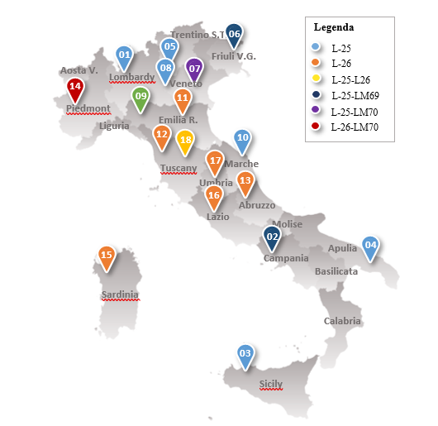

Figure 2. Number of graduates – short-cycle degree (2015-2018)*
Source: own elaboration on AlmaLaurea, 2019
*Data of UniSA, UniTN and UniCatt are not currently available.

Considering only data relating to second-cycle degree courses, the reduced number of graduates reveals a low propensity for students to continue their studies in Viticulture and Oenology (Figure 4). On the other hand, very high peaks of graduate satisfaction were recorded from the universities of Udine (81.3%) and Turin (73.7%).
Figure 3. Effectiveness of degree to employment (short-cycle degree), 2019 year (%)*
Source: own elaboration on AlmaLaurea, 2019
*Data of UniSA, UniTN and UniCatt are not currently available.
Figure 4. Number of graduates – second-cycle degree courses (2015-2018)*
Source: own elaboration on AlmaLaurea, 2019
*Data of UniNA are not currently available.

3. Materials and methods
The research described in this paper focuses on the two types of short-cycle degree courses (L-25 and L-26), which were available in the academic year 2018/19; they will be dealt with separately in this paper. Second-cycle degree courses (LM-69 and LM-70) have not been taken into consideration, given their reduced number of students and considering that the three-year academic course is the minimum requirement to become an oenologist. The effectiveness of educational provision was defined by means of two different analytical criteria: the first was the internal effectiveness in planning the educational course according to a given university’s autonomy and compliance with Ministerial Decrees; and the second concerned the external effectiveness or fit for purpose criterion (Loreti 2004; Harvey and Green 1993), namely the ability to satisfy the requirements and expectations of students and businesses.
In brief, in a preliminary phase the research focused on an analysis of the educational provision, which was performed by examining the distribution of the UECs of all disciplines, apprenticeships and other educational activities. All these UECs had been planned within short-cycle degree courses in compliance with the core curriculum (the minimum set of compulsory, scientific-disciplinary fields) imposed by the MD 270/04 and the subsequent updating of documents by the Italian National University Council (NUC) (Consiglio Universitario Nazionale 2017). This analysis was performed by collating and summarising copious amounts of secondary data, which was principally extracted for each university from the open-access database Universitaly (www.universitaly.it). Whilst the latter is not always complete and exhaustive, this data was integrated with that taken from the official web pages of degree courses and other academic documentation (e.g. the Annual Study Prospectus for degree courses). Thereafter, a combination of social network analysis (SNA) and cluster analysis (CA) was applied to the data, bearing in mind the interconnections between educational activities and universities, as described in paragraph 3.1 below.
In order to identify lacunae in the educational provision of wine-related degree courses in Italy and ideal improvements requested from the world of work, the second part of the research focused on a qualitative desk analysis regarding opinions, needs and expectations, as documented by the official minutes of the consultation processes of stakeholders (2009-2018).

3.1 Combining SNA and CA
Since the early 1970s a myriad of technical reports and specialist applications have revealed the great potential of SNA in examining and interpreting relational data (Borgatti 2002; Scott 2017). The power of SNA has been leveraged in this study in order to investigate the connections between educational activities and the degree courses, which have been implemented by various Italian universities in preparing students for a career as an oenologist. Following the suggestions of Trobia and Milia (2011, p. 80), clustering algorithms were also used to deal with the complexity of networks, which were derived from co-membership matrices.
The processing of SNA plus CA for investigating the position of the university degree courses derives from the fact that “the occupants of clearly specified and institutionalised cultural roles comprise structurally equivalent categories of agents: they do similar things in relation to similar others” (Scott 2017, p. 138). It is worth noting that the SNA nodes are structurally equivalent in function of their ties to the same third-parties (Borgatti and Grosser 2015).
The starting point of the applied methodology was the fact that university degree courses have arranged the majority of their educational activities with the same UEC values, which must be equal or greater than the minimum imposed by national regulations.
The processing data was organised into case-by-affiliation matrices (i.e. L-25: 15x11; L-26: 15x9), in which educational activities were represented in rows, universities were in columns, and the specific values of UECs occurred at the intersections, as a measure of the strength of ties. Each matrix was subsequently dichotomised by using a cut-off threshold, which was distinct for each educational activity provided by the universities and equal to the mean value of UECs. A value of 1 was attributed when a specific educational activity envisaged a number of UECs at or above the mean, and 0 was attributed with a number of UECs lower than the mean. The subsequent processing of the binary two-mode networks relating to L-25 and L-26 was performed using UCINET 6 software (version 6.713), while the two-mode networks were visualised using the Netdraw program (version 2.166).
Thus, normalized scores of degree centrality were obtained for rows and columns by applying the specific 2-mode centrality routine, which was offered by the UCINET software. On the one hand, the results should be considered as measures of the relevance (beyond the mean value of UECs) of educational activities and, on the other hand, as measures of improvement chosen by universities for some activities rather than others.
Moreover, an analysis of the profile structural equivalence (Borgatti and Grosser 2015; Khansa, Zobel, and Goicochea 2012; Scott 2017) was applied to the affiliation-by-affiliation matrices (i.e. L-25: 11x11; L-26: 9x9). The Matches parameter was calculated as a measure of the profile similarity, and clusters of universities, sufficiently similar in terms of their educational offer, were obtained by means of a single-link hierarchical clustering dendrogram, relating to the structural equivalence matrices.

4. Results and Discussion
Tables 4 and 5 show the variability of the educational paths available by Italian universities involved in this research. The educational provision appears to embrace all fields of knowledge relating to the production processes of viticulture and Oenology. Whilst adhering to the minimum requirement, the distribution of the UECs among the various educational activities reveals how these universities have been more autonomous in their choices relating to Other activities regarding the L-25 and L-26 degree courses. However, higher values of standard deviation (σ), which are associated with a greater tendency of universities to diversify the educational provision, were observed for: Plant production disciplines (7.1), the disciplines of Agricultural Engineering, Forestry and Technical Design (6.9) for L-25, and Food Science and Technology (6.7) for L-26. Nonetheless, in terms of degree centrality, the disciplines which most frequently obtained an above-average number of UECs were: Digital skills (0.636), Training and Orientation Apprenticeships (0.545) for L-25, Law studies and Agricultural Economics (0.778), the Disciplines of Chemistry (0.667), Food Science and Technology, and Knowledge of at least one foreign language (both 0.556) for L-26.

Table 3. The educational provision of L-25 degree courses (academic year 2018/19)
Educational activities | UECs |  |  |  |  | Degree centrality
Educational activities | Requirement | Min. | Max. | μ | σ | Degree centrality
Basic educational activities | 30 | 32 | 45 | 39.5 | 4.8
Disciplines of Biology | 8 | 8,0 | 20 | 12.5 | 4.2 | 0.273
Disciplines of Chemistry | 8 | 12 | 18 | 13.1 | 2.1 | 0.273
Mathematics, Physics, Informatics and Statistics | 8 | 12 | 18 | 13.9 | 2.5 | 0.364
Core educational activities | 60 | 72 | 96 | 86.9 | 6.5
Law studies, agricultural economics and appraisal | - | 8 | 18 | 12.8 | 3.2 | 0.364
Plant Production disciplines | - | 24 | 48 | 36.6 | 7.1 | 0.455
Plant Health disciplines | - | 9 | 18 | 12.6 | 3.0 | 0.455
Agricultural Engineering, Forestry and Technical Design | - | 15 | 39 | 24.8 | 6.9 | 0.455
Educational activities in similar or additional educational areas | 18 | 18 | 28 | 21.4 | 3.6 | 0.364
Other activities | - | 27 | 37 | 32.3 | 3.1
Activities chosen by the student | 12 | 12 | 15 | 12.3 | 0.9 | 0.091
Final exam | - | 3 | 6 | 4.5 | 1.4 | 0.455
Knowledge of at least one foreign language | - | 3 | 6 | 4.2 | 1.3 | 0.364
Further linguistic knowledge | - | 0 | 3 | 0.3 | 0.9 | 0.091
Digital skills | - | 0 | 5 | 2.2 | 1.8 | 0.636
Training and orientation apprenticeships | - | 4 | 12 | 7.9 | 2.5 | 0.545
Other useful knowledge for entering the world of work | - | 0 | 10 | 1.0 | 3.0 | 0.182
Internships and traineeships in companies, public or private organization, professional associations | - | 0 | 0 | 0.0 | 0.0 | -
Minimum credits reserved by the University | - | 0 | 0 | 0.0 | 0.0 | -

Table 4. The educational provision of L-26 degree courses (academic year 2018/19)
Educational activities | UECs
Educational activities | Requirement | Min. | Max. | μ | σ | Degree centrality
Basic educational activities | 30 | 30 | 40 | 34.4 | 3.4
Disciplines of Biology | 8 | 8 | 12 | 9.6 | 1.9 | 0.333
Disciplines of Chemistry | 8 | 8 | 15 | 11.6 | 2.7 | 0.667
Mathematics, Physics, Informatics and Statistics | 8 | 8 | 18 | 13.3 | 3.3 | 0.444
Core educational activities | 60 | 80 | 95 | 86.7 | 5.8
Law studies, Agricultural Economics | 8 | 8 | 14 | 11.9 | 2.1 | 0.778
Food Science and Technology | 30 | 44 | 63 | 53.2 | 6.7 | 0.556
Food Safety and Evaluation disciplines | 20 | 20 | 24 | 21.6 | 1.5 | 0.333
Educational activities in similar or additional educational areas | 18 | 18 | 27 | 21.2 | 3.2 | 0.333
Other activities | - | 31 | 46 | 37.7 | 5.2
Activities chosen by the student | 12 | 12 | 18 | 13.0 | 2.1 | 0.222
Final exam | - | 3 | 12 | 5.3 | 2.8 | 0.444
Knowledge of at least one foreign language | - | 2 | 10 | 5.0 | 2.4 | 0.556
Further linguistic knowledge | - | 0 | 0 | 0.0 | 0.0 | -
Digital skills | - | 0 | 3 | 0.9 | 1.4 | 0.333
Training and orientation apprenticeships | - | 6 | 14 | 9.2 | 2.9 | 0.333
Other useful knowledge for entering the world of work | - | 0 | 9 | 2.7 | 3.6 | 0.444
Internships and traineeships in companies, public or private organization, professional associations | - | 0 | 5 | 0.6 | 1.7 | 0.111
Minimum credits reserved by the University | - | 0 | 9 | 1.0 | 3.0 | 0.111

Generally, the above findings demonstrate that there is still room for improvement in developing specific skills, such as those linguistic, digital (particularly for L-26) and other skills required to enter the world of work. These skills are recognised by a small number of UECs although they have much impact in connecting wine companies to new markets and new consumers (Winemonitor Nomisma 2018). These findings are confirmed by the matrices and graphic representation of both the two-mode networks (Figures 5, 6, 7 and 8). For instance, the item Further linguistic knowledge was present in the L-25 degree courses, and specifically only in the provision of the University of Palermo. Similarly, only the UniTE has planned Internships and traineeships in companies, public or private organization, professional associations relating to the L-26 degree courses.
Figure 5. The dichotomised case-by-affiliation matrix of the L-25 degree courses (cut-off = μ)
Figure 6. The dichotomised case-by-affiliation matrix of the L-26 degree courses (cut-off point = μ)

Figure 7. Two-mode network of the L-25 degree courses (academic year 2018/19)
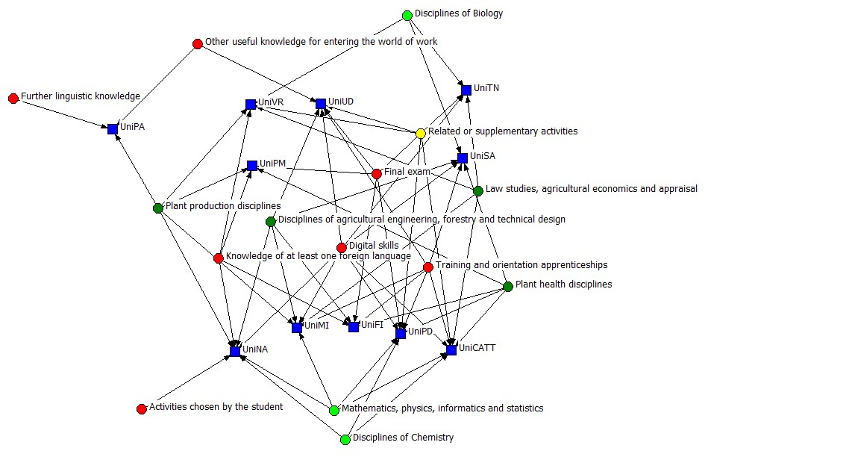

Basic educational activities
Educational activities in similar or additional educational areas activities
Core educational activities
Other activities

Figure 8. Two-mode network of L-26 degree courses (academic year 2018/19)
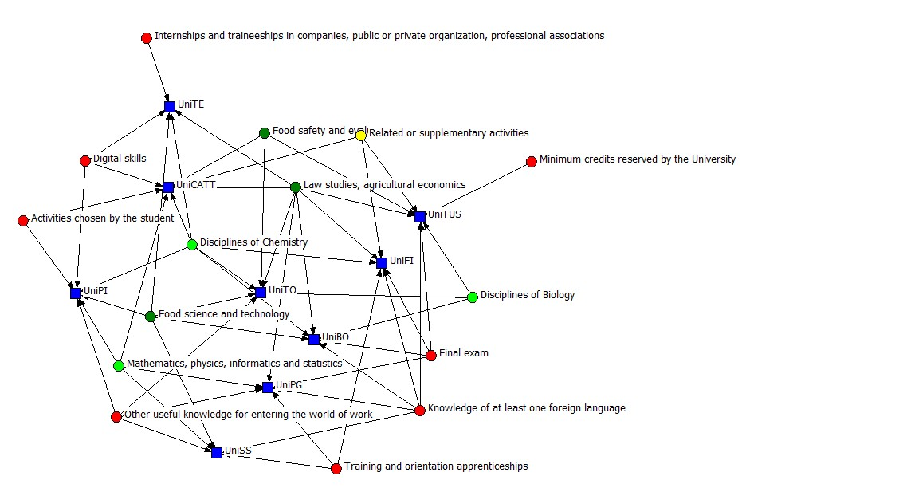

Other activities
Basic educational activities
Educational activities in similar or additional educational areas activities
Core educational activities

Figure 9 below shows the entirety of the representation of the points of the structural equivalence matrix regarding L-25 degree courses. These latter were ordered by means of a hierarchical clustering algorithm in an agglomerative way, according to decreasing levels of similarity. Reading the dendrogram from left to right, a close similarity is evident in terms of educational provision at levels above the mean: this is, between UniSA and UniUD on the one hand, and UniCATT e UniMI on the other. UniPD displays similarities with both aforementioned couples of universities having chosen to improve: Digital skills and Training and Orientation Apprenticeships. There is also a similarity between UniPD and the couple UniCATT and UniMI regarding Mathematics, Physics, Informatics and Statistics. The University of Palermo might be considered an ‘outlier’ for having provided educational activities with a number of UECs below the national average, to the exclusion of Plant production disciplines, Further linguistic knowledge and Other useful knowledge for entering the world of work.
Figure 9. Hierarchical clustering dendrogram of the structural equivalence matrix for L-25
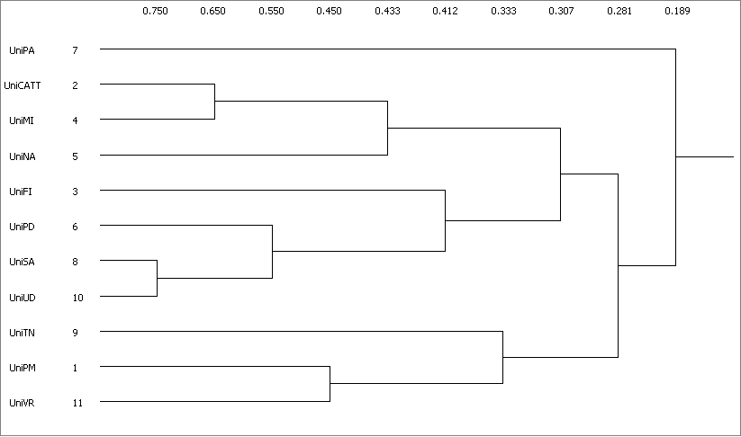

Compared with L-25, L-26 degree courses are characterized by marked similarity (Figure 10). UniPI and UniCATT share the greatest profile similarity whilst UniPI and UniTUS are dissimilar since the former has opted to reinforce Basic educational activities while the latter has enhanced Educational activities in similar or additional educational areas and Other activities.
Figure 10. Hierarchical clustering dendrogram of the structural equivalence matrix for L-26
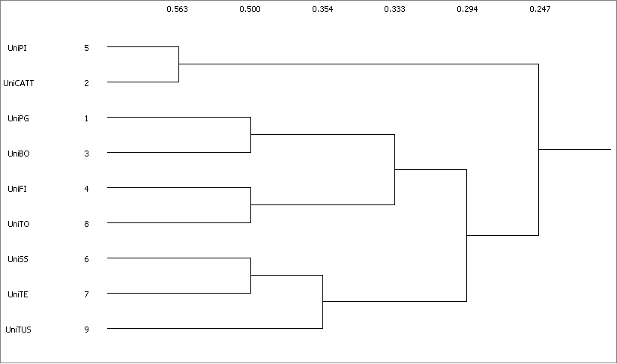
The results presented thus far have afforded an insight into the internal effectiveness of the educational provision at university level in Italy. Moving on to its external effectiveness, the desk analysis of the document, deriving from the consultation processes of stakeholders, has highlighted several shortcomings in terms of its completeness, clarity, uniformity and the updating of these sources of information. Indeed, it is worth noting that a well-defined framework regarding the procedures for defining key stakeholders and their consultation process (timetable, methodologies, tools, results assessment and reporting) is absent at national and individual university levels.
Considering the considerable variability in the minutes of meetings, a degree of aggregation and simplification has been performed in order to highlight the main stakeholders’ suggestions regarding skills to be inserted or improved in the L-25 and L-26 degree courses. Findings suggest that the universities involved in this research should improve the L-25 courses in the following fields: the law relating to the wine sector (36%); technical skills, including laboratory activities and seminars with high profile experts (36%); soft skills, such as organizational capacity, and the ability to work autonomously (27%); and foreign language skills (27%) (Figure 11). The following are suggested improvements relating to L-26: marketing, advertising and communication (44%); management/economics (33%); knowledge relating to the foreign trade sector, including internationalisation (33%); and soft skills (33%).
These results are approximately in line with the relevant literature (Winemonitor Nomisma 2018) relating to the demand for linguistic, digital, legal, economic and managerial skills. All of these can be considered critical in stimulating the internationalisation of firms, considering the increasing importance of wine exports in the global arena.
Figure 11. The demand for specific skills by stakeholders

6. Conclusion
Whilst being in line to a great extent with the OIV guidelines, many Italian universities offer a wide range of educational activities in also seeking to adapt their study programmes to the requirements of the labour market. Within the boundaries of the national regulations governing degree courses, the main differences among degree courses regard the distribution of the UECs within different fields of knowledge. Specifically, the L-25 degree courses are more oriented towards providing practical skills in the field, whilst the L-26 degree courses seek to develop skills more suited to cellar management. According to the comparative analysis outlined in the research, some university degree courses would appear to be interchangeable according to the distribution of UECs among different educational activities: students could prefer one place of study rather than another on the basis of the similarity profile, as highlighted in this research, selecting that degree course most appropriate to their educational and employment aspirations.
It is a truism that universities have “… become more diverse in their missions, mode of educational provision and cooperation, including growth of internationalisation, digital learning and new forms of delivery” and that study programmes “… provide students with both academic knowledge and skills including those that are transferable, which may influence their personal development and may be applied in their future careers” (ESG 2015). The authors of this study hope that the analysis of the educational provision required to become an oenologist can assist curriculum writers at university level to improve the oenological educational provision of the future. Ideally, the content should be governed by the skilful management of relationships with stakeholders. Indeed, if appropriately consulted, they can provide authoritative information to facilitate the precise identification of educational needs. On the other hand, there is a paucity of codified procedures for effectively managing stakeholders’ consultations relating to each study programme. Currently, existing transversal guidelines at the individual university level do not permit the identification of suitable degree courses for specific professional activities. It can be said that in many cases, consultations have not been appropriately performed and reported. It would, therefore, be opportune to improve the documenting and the standardisation of the consultation process of the various stakeholders. Indeed, the desk analysis relating to the consultation reports of stakeholders, as expounded in this study, has been limited by a paucity of sources of information. Nevertheless, it has been observed that the main skills required by stakeholders in the wine-making business are: linguistic, digital, legal-economic and managerial, all of which are attributed to a lower number of UECs within current educational provision.
It is hoped that this paper will contribute to the debate relating to the educational background of graduates and the university-employability in relationship in a twofold manner. On the one hand, this study aspires to offering a methodological framework which will encourage future research with the purpose of assessing the matching of university-level competencies to the requirements of the professional world of wine. To the best of our knowledge, the research outlined in this paper is an initial attempt in the scientific literature to compare results from different methodologies and techniques such as the SNA, the CA and the consultation analysis of stakeholders. On the other hand, the authors of this study believe that it can proffer suggestions about how degree courses should be developed and implemented to include complementary activities and tasks. Indeed, the role of these latter is to improve students’ skill sets and thus their employability as oenologists in today’s competitive labour market.
Referring to study limitations, a weakness of the study can be said to be the exclusion of the fit for purpose criterion of the various degree courses in terms of the satisfaction of undergraduates, graduates and firms in the wine-production sector; further research is, therefore, warranted in these fields. Bearing in mind that professional expertise is a key driver for the development of wine businesses, it is necessary to know which skills are required by oenologists in facing the challenges of competition. Thus, future research in this field should regard the opinions of stakeholders (oenologists, wine entrepreneurs, graduates and universities responsible for related educational provision), particularly relating to the acquisition of relevant skill sets.
Moreover, investigating the link between the educational provision of wine-related degrees and the specificities of outstanding wine-growing regions would be useful in broadening the educational provision of the oenologist, according to specific geographical contexts and products (e.g., sparkling wines, liqueur wines, different types of grappa and spirits, etc.). Finally, a refinement of the analysis of the similarity profile of study programmes would regard the distribution of UECs by subjects rather than educational activities. Another avenue of research in the field of oenology could be a comparison among the educational provision at degree level of the OIV member states.

Disclosure statement
No potential conflict of interest was reported by the authors

References

Akerlof, George A. 1970. “The Market for ‘Lemons’: Quality Uncertainty and the Market Mechanism.” The Quarterly Journal of Economics 84 (3): 488. doi:10.2307/1879431.
Akerlof, George A. 2001. Behavioral Macroeconomics and Macroeconomic Behavior. Prize Lecture. https://www.nobelprize.org/uploads/2018/06/akerlof-lecture.pdf.
Anderson, Kym. 2020. Asia’s Emergence in Global Beverage Markets: The Rise of Wine. CEPR Discussion Paper No. DP14389. https://papers.ssrn.com/sol3/papers.cfm?abstract_id=3535475.
Anderson, Kym, and Glyn Wittwer. 2015. “Asia’s Evolving Role in Global Wine Markets.” China Economic Review 35 (September): 1–14. doi:10.1016/j.chieco.2015.05.003.
Arrow, Kenneth J. 1973. “Higher Education as a Filter.” Journal of Public Economics 2 (3): 193–216. doi:10.1016/0047-2727(73)90013-3.
Atkin, Thomas, and Liz Thach. 2012. “Millennial Wine Consumers: Risk Perception and Information Search.” Wine Economics and Policy 1 (1): 54–62. doi:10.1016/j.wep.2012.08.002.
Becker, Gary S. 1964. Human Capital: A Theoretical and Empirical Analysis with Special Reference to Education. Third edit. Chicago: The University Of Chicago Press.
Bejinaru, Ruxandra. 2017. “Universities in the Knowledge Economy.” Management Dynamics in the Knowledge Economy 5 (2): 251–271. doi:10.25019/MDKE/5.2.05.
Borgatti, S. P., and Travis J. Grosser. 2015. “Structural Equivalence: Meaning and Measures.” In International Encyclopedia of the Social & Behavioral Sciences, 621–625. Elsevier. doi:10.1016/B978-0-08-097086-8.43120-X.
Borgatti, S.P. 2002. Netdraw Network Visualization. Analytic Technologies. Lexington, KY: Harvard, MA.
Boulton, Geoffrey, and Colin Lucas. 2011. “What Are Universities For?” Chinese Science Bulletin 56 (23): 2506–2517. doi:10.1007/s11434-011-4608-7.
Bresciani, Pier G. 2011. “Valutare Le Competenze: Presupposti e Implicazioni.” In Piano Nazionale Orientamento Risorsa per l’innovazione e per Il Governo Della Complessità, 134–135:247–271. studi e documenti degli annalidella pubblica istruzione. https://www.orientamentoirreer.it/sites/default/files/materiali/2011 MIUR orientamento testo.pdf.
Bresciani, Pier G. 2012. Capire La Competenza. Teorie, Metodi, Esperienze Dall’analisi Alla Certificazione. Milano: FrancoAngeli.
Calderón, Haydeé, Teresa Fayos, and Marta Frasquet. 2019. “The Transition of Small Spanish Wineries toward Multi-Channel Distribution.” International Journal of Wine Business Research 32 (1): 139–158. doi:10.1108/IJWBR-12-2018-0071.
Capitello, and Sirieix. 2019. “Consumers’ Perceptions of Sustainable Wine: An Exploratory Study in France and Italy.” Economies 7 (2): 33. doi:10.3390/economies7020033.
Castellini, Alessandra, and Antonella Samoggia. 2018. “Millennial Consumers’ Wine Consumption and Purchasing Habits and Attitude towards Wine Innovation.” Wine Economics and Policy 7 (2): 128–139. doi:10.1016/j.wep.2018.11.001.
Chalker-Scott, Linda, and Rod Tinnemore. 2009. “Is Community-Based Sustainability Education Sustainable? A General Overview of Organizational Sustainability in Outreach Education.” Journal of Cleaner Production 17 (12): 1132–1137. doi:10.1016/j.jclepro.2009.02.022.
Commission of the European Communities. 2000. A Memorandum on Lifelong Learning. Commission Staff Working Paper. http://arhiv.acs.si/dokumenti/Memorandum_on_Lifelong_Learning.pdf [accessed April 5, 2015].
Consiglio Universitario Nazionale. 2017. Guida Alla Scrittura Degli Ordinamenti Didattici (A.A. 18/19). https://www.cun.it/uploads/4088/GUIDA_18-19_finale.pdf.
Crespi-Vallbona, Montserrat, and Oscar Mascarilla-Miró. 2020. “Wine Lovers: Their Interests in Tourist Experiences.” International Journal of Culture, Tourism and Hospitality Research 14 (2): 239–258. doi:10.1108/IJCTHR-05-2019-0095.
Decataldo, Alessandra. 2018. “Valutare La Didattica Universitaria: Considerazioni Sui Principi Ispiratori e Sui Processi.” In . https://pdfs.semanticscholar.org/41c6/008b64f10f42a4c8c1bf44dc90a5347daf19.pdf.
Dell’Aringa, Carlo, and Claudio Lucifora. 2002. Salari, Incentivi e Mobilità Nell’economia Italiana. Edited by Vita e pensiero.
Drago, Rosaria. 2000. La Nuova Maturità. Aggiornamento 2000. Edited by Centro Studi Erickson.
Dressler, Marc. 2017. “Strategic Profiling and the Value of Wine &amp; Tourism Initiatives.” International Journal of Wine Business Research 29 (4): 484–502. doi:10.1108/IJWBR-04-2017-0026.
Ellström, Per-Erik, and Henrik Kock. 2008. “Competence Development in the Workplace: Concepts, Strategies and Effects.” Asia Pacific Education Review 9 (1): 5–20. https://files.eric.ed.gov/fulltext/EJ811091.pdf.
ESG. 2015. Standards and Guidelines for Quality Assurance in the European Higher Education Area. Bruxelles, Belgium. doi:10.32388/z5vv0t.
Francioni, Barbara, Tiia Vissak, and Fabio Musso. 2017. “Small Italian Wine Producers’ Internationalization: The Role of Network Relationships in the Emergence of Late Starters.” International Business Review 26 (1): 12–22. doi:10.1016/j.ibusrev.2016.05.003.
Frega, Roberto. 2012. “Dalla Competenza Alla Navigazione Professionale. Riflessioni Su Alcune Tesi Di Guy Le Boterf.” In Capire La Competenza. Teorie, Metodi, Esperienze Dall’analisi Alla Certificazione, edited by FrancoAngeli, 1st ed. Milano.
Fuentes Fernández, Rosana. 2019. “Finding Common Ground: The Need for Cooperation and Collaboration in the Spanish Natural Wine Industry.” Wine Business Case Research Journal, 65–93. doi:10.26813/wbcrj/2019.03.01/finding.
Gilinsky, Armand, Robert Eyler, Sandra Newton, and James A. Downing. 2019. “Environmental Perceptions on Entrepreneurial Thinking in the Wine Industry.” Small Enterprise Research 26 (1): 105–116. doi:10.1080/13215906.2019.1570319.
Harvey, Lee, and Diana Green. 1993. “Defining Quality.” Assessment & Evaluation in Higher Education 18 (1): 9–34. doi:10.1080/0260293930180102.
ISMEA. 2019. La Bilancia Commerciale Agroalimentare Nazionale Nel 2018. Roma.
Istat. 2018. Rapporto Sulla Conoscenza 2018 Economia E Società. doi:10.1481/Istat.Rapportoconoscenza.2018.
Khansa, Lara, Christopher W. Zobel, and Guillermo Goicochea. 2012. “Creating a Taxonomy for Mobile Commerce Innovations Using Social Network and Cluster Analyses.” International Journal of Electronic Commerce 16 (4): 19–52. doi:10.2753/JEC1086-4415160402.
Kulesza, Marie G. 2019. “Revenue Management Strategies for Long-Term Survival of Small-Farm Wineries” 22623477: 153. https://uoelibrary.idm.oclc.org/login?url=https://www.proquest.com/docview/2316838667?accountid=10792 http://resolver.ebscohost.com/openurl?ctx_ver=Z39.88-2004&ctx_enc=info:ofi/enc:UTF-8&rfr_id=info:sid/ProQuest+Dissertations+%26+Theses+Global&rft_val_fmt.
Lanfranchi, Maurizio, Angela Alibrandi, Agata Zirilli, Georgia Sakka, and Carlo Giannetto. 2020. “Analysis of the Wine Consumer’s Behavior: An Inferential Statistics Approach.” British Food Journal 122 (3): 884–895. doi:10.1108/BFJ-08-2019-0581.
Lanfranchi, Maurizio, Emanuele Schimmenti, Maria Gabriella Campolo, and Carlo Giannetto. 2019. “The Willingness to Pay of Sicilian Consumers for a Wine Obtained with Sustainable Production Method: An Estimate through an Ordered Probit Sample-Selection Model.” Wine Economics and Policy 8 (2): 203–215. doi:10.1016/j.wep.2019.11.001.
Le Boterf, Guy. 2008. Costruire Le Competenze Individuali e Collettive. Agire e Riuscire Con Competenza. Le Risposte a 100 Domande. Edited by Alfredo Guida Editore. Napoli.
Le Deist, Françoise Delamare, and Jonathan Winterton. 2005. “What Is Competence?” Human Resource Development International 8 (1): 27–46. doi:10.1080/1367886042000338227.
Lee K. (Ed.). 2016. Strategic Winery Tourism and Management: Building Competitive Winery Tourism and Winery Management Strategy. CRC Press.
Lee, Won Fy, William C. Gartner, Haiyan Song, Byron Marlowe, Jong Woo Choi, and Bolormaa Jamiyansuren. 2018. “Effect of Extrinsic Cues on Willingness to Pay of Wine.” British Food Journal 120 (11): 2582–2598. doi:10.1108/BFJ-01-2017-0041.
Lehmann, Martin, Per Christensen, Mikkel Thrane, and Tine Herreborg Jørgensen. 2009. “University Engagement and Regional Sustainability Initiatives: Some Danish Experiences.” Journal of Cleaner Production 17 (12): 1067–1074. doi:10.1016/j.jclepro.2009.03.013.
Loreti, Claudia. 2004. “Gli Indicatori Di Valutazione Del Sistema Universitario Italiano: Un’analisi Critica.” Quaderni Di Sociologia, no. 35 (August): 81–102. doi:10.4000/qds.1112.
Lu, Lu, Christina Geng-Qing Chi, and Rong Zou. 2019. “Determinants of Chinese Consumers’ Organic Wine Purchase.” International Journal of Contemporary Hospitality Management 31 (9): 3761–3778. doi:10.1108/IJCHM-02-2019-0118.
Lukman, Rebeka, Damjan Krajnc, and Peter Glavič. 2009. “Fostering Collaboration between Universities Regarding Regional Sustainability Initiatives – the University of Maribor.” Journal of Cleaner Production 17 (12): 1143–1153. doi:10.1016/j.jclepro.2009.02.018.
Manuti, Amelia, Serafina Pastore, Anna Fausta Scardigno, Maria Luisa Giancaspro, and Daniele Morciano. 2015. “Formal and Informal Learning in the Workplace: A Research Review.” International Journal of Training and Development 19 (1): 1–17. doi:10.1111/ijtd.12044.
Marconi, Gabriele, and Raffaele Trapasso. 2017. “L’Università Italiana Nel Contesto Internazionale: I Dati OCSE.” Rivista Economica Del Mezzogiorno 3: 565–584.
Mattiacci, Alberto, Attilio Bruni, Francesca Magno, and Fabio Cassia. 2019. “Sales Capabilities in the Wine Industry: An Analysis of the Current Scenario and Emerging Trends.” British Food Journal 121 (12): 3380–3395. doi:10.1108/BFJ-04-2019-0231.
Mcguinness, Seamus, Konstantinos Pouliakas, and Paul Redmond. 2017. “Discussion Paper Series How Useful Is the Concept of Skills Mismatch ?,” no. 10786: 1–30.
Mehta, Ritu, and Nivedita Bhanja. 2018. “Consumer Preferences for Wine Attributes in an Emerging Market.” International Journal of Retail & Distribution Management 46 (1): 34–48. doi:10.1108/IJRDM-04-2017-0073.
Mulder, Martin, Tanja Weigel, and Kate Collins. 2007. “The Concept of Competence in the Development of Vocational Education and Training in Selected EU Member States: A Critical Analysis.” Journal of Vocational Education & Training 59 (1): 67–88. doi:10.1080/13636820601145630.
Nassivera, Federico, Gianluigi Gallenti, Stefania Troiano, Francesco Marangon, Marta Cosmina, Paolo Bogoni, Barbara Campisi, and Matteo Carzedda. 2020. “Italian Millennials’ Preferences for Wine: An Exploratory Study.” British Food Journal 122 (8): 2403–2423. doi:10.1108/BFJ-05-2019-0306.
OECD. 2017a. Diagnostic Report Italy.
OECD. 2017b. Getting Skills Right: Italy. Getting Skills Right. OECD. doi:10.1787/9789264278639-en.
OECD. 2019. Digital Opportunities for Better Agricultural Policies. Digital Opportunities for Better Agricultural Policies. OECD. doi:10.1787/571a0812-en.
OIV. 2013. Resolution OIV-ECO 492-2013. Evolution of the Oiv Definition (Ljubljana 7/76) of the Oenologist and His/Her Role. http://www.oiv.int/public/medias/1920/oiv-eco-492-2013-en.pdf.
OIV. 2016. Resolution OIV-ECO 563-2016. Training Programs for Oenologists. http://www.oiv.int/public/medias/4928/oiv-eco-563-2016-en.pdf.
OIV. 2020. State of the World Vitivinicultural Sector in 2019. http://www.oiv.int/public/medias/7298/oiv-state-of-the-vitivinicultural-sector-in-2019.pdf.
Osservatorio Talents Venture. 2018. “Istruzione: È Arrivata La Fine Del Welfare State?” https://www.talentsventure.com/wp-content/uploads/2019/01/Istruzione-E-arrivata-la-fine-del-welfare-state.pdf.
Osservatorio Talents Venture. 2020. Studiare Diventa Sempre Più Un Privilegio. Una Panoramica Sui Costi Relativi All’Università in Italia. https://www.talentsventure.com/wp-content/uploads/2020/03/Studiare-diventa-sempre-più-un-privilegio_-una-panoramica-sui-costi-relativi-all’Università-in-Italia.pdf.
Passaretta, Giampiero. 2020. 9788855262149. Ledizioni.
Pérez-Capdevila, Javier. 2012. “Medición de Competencias e Impacto Monetario Sobre El Pago Del Salario.” Ciencia En Su PC [Online] 2: 114–128. https://www.redalyc.org/articulo.oa?id=181324082009.
Pomarici, Eugenio, and Riccardo Vecchio. 2014. “Millennial Generation Attitudes to Sustainable Wine: An Exploratory Study on Italian Consumers.” Journal of Cleaner Production 66 (March): 537–545. doi:10.1016/j.jclepro.2013.10.058.
Santos, Gina, Carla Susana Marques, and Vanessa Ratten. 2019. “Entrepreneurial Women’s Networks: The Case of D’Uva – Portugal Wine Girls.” International Journal of Entrepreneurial Behavior & Research 25 (2): 298–322. doi:10.1108/IJEBR-10-2017-0418.
Santos, Vasco Ribeiro, Paulo Ramos, Nuno Almeida, and Enrique Santos-Pavón. 2019. “Wine and Wine Tourism Experience: A Theoretical and Conceptual Review.” Worldwide Hospitality and Tourism Themes 11 (6): 718–730. doi:10.1108/WHATT-09-2019-0053.
Schultz, Theodore W. 1961. “Investment in Human Capital.” American Economic Review 51: 1–17.
Scott, John. 2017. Social Network Analysis. 4th editio. SAGE Publications Ltd.
Slaughter, Sheila, and Larry L. Leslie. 1997. Academic Capitalism. Politics, Policies and the Entrepreneurial University. 2715 North Charles Street, Baltimore, MD: The Johns Hopkins University Press.
Spence, Michael. 1973. “Job Market Signaling.” The Quarterly Journal of Economics 87 (3): 355. doi:10.2307/1882010.
Spence, Michael. 2001. Signaling in Retrospect and the Informational Structure of Markets, Prize Lecture. https://www.nobelprize.org/uploads/2018/06/spence-lecture.pdf.
Stiglitz, Joseph E. 2001. Information and the Change in the Paradigm in Economics. Prize Lecture. https://www.nobelprize.org/uploads/2018/06/stiglitz-lecture.pdf.
Szolnoki, Gergely, and Katharina Hauck. 2020. “Analysis of German Wine Consumers’ Preferences for Organic and Non-Organic Wines.” British Food Journal 122 (7): 2077–2087. doi:10.1108/BFJ-10-2019-0752.
Treccani. 2020. “Vocabolario on Line.” https://www.treccani.it/vocabolario/competenza/.
Trobia, Alberto, and Veronica Milia. 2011. Social Network Analysis. Approcci, Tecniche e Nuove Applivazioni. Edited by Carocci Editore. Rome.
Villanueva, Emiliano C., and Juan R. Ferrer. 2020. “Rhode Island and Connecticut Wineries Business Strategy, Performance, and Management Capabilities: A Survey of Managerial Practices.” Journal of Wine Research 31 (2): 124–140. doi:10.1080/09571264.2020.1780574.
Winemonitor Nomisma. 2018. La Formazione per La Competitività Delle Imprese Vitivinicole Italiane. http://www.enapra.it/wp-content/uploads/2018/04/pubblicazione-vino.pdf.
Zilahy, Gyula, and Donald Huisingh. 2009. “The Roles of Academia in Regional Sustainability Initiatives.” Journal of Cleaner Production 17 (12): 1057–1066. doi:10.1016/j.jclepro.2009.03.018.

. For instance, the language and mathematical skills of Italian adults are among the lowest in OECD countries: there are no substantial differences regarding the 20-24 and 25-64 age groups (Minister for Economic Affairs and Finance, 2018).
. ANVUR, the Italian National Agency for the Evaluation of the University and Research Systems, oversees the national quality evaluation system for universities and research bodies.
. Particular reference is made to the Human Capital Theory by Schultz (1961) and (Becker 1964), the Signalling Theory by Arrow (1973) and Spence (1973), and the analysis of markets with information asymmetry by Akerlof (1970; 2001), Stiglitz (2001) and Spence (2001).
4. A short-cycle degree consists of 180 University Educational Credits (UECs), distributed approximately equally over three years; a second-cycle degree equates to 120 UECs, distributed over two years. UECs are used to measure the ‘quantity’ of learning, including individual study, which is required of a student in order to acquire the knowledge and skills in the learning activities envisaged in the degree programme. One UEC usually corresponds to 25 hours of work, including lessons, exercises, laboratory practicals, etc in addition to home study. It is transferable through the European Credit Transfer and Accumulation System (ECTS), thereby assisting students to move between countries and to have their academic qualifications and study periods abroad recognised.
. A degree class is a group of study programmes with the same educational objectives, as defined by law, i.e. the knowledge and skills which characterise the cultural and professional profile of the study programme. The class is indicated by a number prefaced with L or LM.
. Interclass degree courses satisfy the requirements of two different degree classes L (MD 16 March 2007).
. Italian universities regulate each study programme in accordance with University Teaching Regulations, which are compiled in compliance with the MD 270/04 and subsequent amendments and additions.
. The NUC is an elected body of 58 members representing the Italian University System. It performs consultative functions as specified by the Ministry of University and Research on relevant matters such as the classification and definition of academic fields and disciplines for the purposes of teaching and research.
. UCINET is a software package distributed by Analytic Technologies (https://sites.google.com/site/ucinetsoftware/home); it includes the Netdraw program for visualising social network data.

