OXIDATIVE STRESS MARKERS ASSOCIATED WITH MIDDLE DISTANCE RUNNING PERFORMANCE
Patrizia Proia, Marcello Giaccone, Valentina Contrò, Antonino Bianco, Marcello Traina, Antonio Palma
Dipartimento di Scienze Giuridiche, delle Societa’ e dello Sport, Università degli Studi di Palermo
Corresponding author: Patrizia Proia, Via Duse, 1 Patrizia.proia@unipa.it, +393385911303
The aim of this study was to understand the mechanism underlying the physiological adaptation of a kind purely aerobic workout. Particular attention has also been given to the analysis of oxidative stress by detecting some enzymatic blood parameters.
We investigate the effect of 2 months of training on middle distance running (800 meters and 1500 meters) agonistic athletes; nine active specifically trained males of mean (± SD) age 19,9 years.
The physiological characteristics of middle runners are different from those sprinters and long distance runners because include a variety of aerobic and anaerobic capabilities.
Two weeks prior to the 2 months period of exercise, subjects were tested for VO_{2max} during a graded, treadmill test with the Cosmed FitMate metabolic device (Cosmed, Italy). Antropometric parameters were detected used a Bioimpedance analyzer (BF 302 Ormon BIA). A blood sample was collected in the morning and were collected by a clinical specialized center to analyze: triglycerides, total cholesterol, G.O.T. and G.P.T. transaminase, γ-GT, CPK and CK-MB, as well as lipid profile.
All these tests were performed before and after the two months of training period.
The results obtained suggest that the endurance training, as it is high oxygen consumption, should increase reactive oxygen species (ROS), but it has been shown that exercise leads to increased activation of antioxidant defenses. Infact, serum levels of gamma-glutamyltransferase (GGT) enzyme, which plays a key role in the metabolism of extracellular reduced glutathione (2) was not increased. However, a classic cardiac biomarkers (1), CK-MB as well as total CK was analyzed and while the total CK after two months of training increased, the CK-MB isoform decrease, in a significant statistical way.
Even the emathological parameters were analyzed and there were the variations overall on neutrophils and monocytes value. These two cell type are involved in the infection respons.
An antropometric parameter that changed after two months of training, was the weight. Infact after statistical analysis, the P value was < 0,0001, considered extremely significant (59,3±5,4 Kg before training; 58,1±5,2 Kg after training).
Finally, put together all the results, we can say that middle distance runners are subject at not high oxidative and biological stress; infact there were no change in γ-GT value, that usually is involved in the oxidative stress as well as a decrease of CK-MB value, that usually associated with cardiac injury. These are preliminary results that need to confirm with other studies using a larger sample of subjects or comparing with the runners that are involved in a different running distance (sprinters or long distance runners).

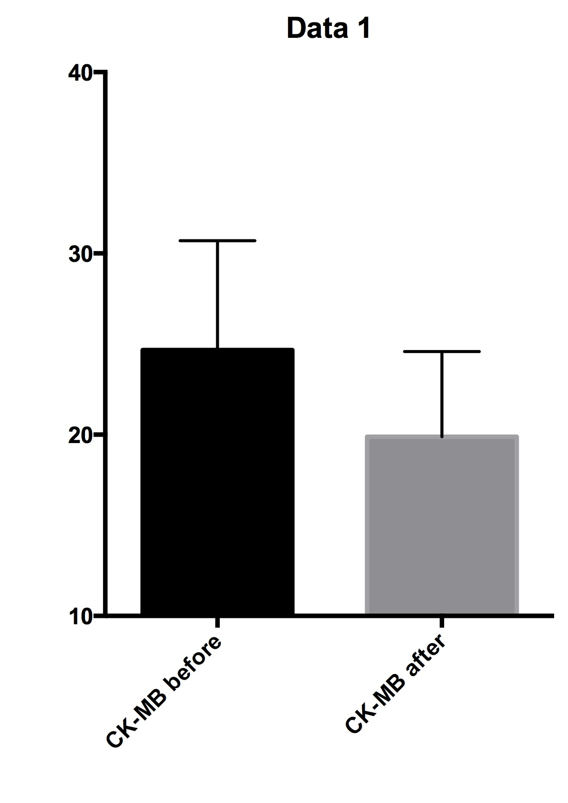
Tab1
Changes in CK-Mb value after two months of training

¹Nursalim A, Suryaatmadja M, Panggabean M. Potential clinical application of novel cardiac biomarkers for acute myocardial infarction. Acta Med Indones. 2013 Jul;45(3):240-50.
²Danielsson J, Kangastupa P, Laatikainen T, Aalto M, Niemelä O. Individual and Joint Impacts of Ethanol Use, BMI, Age and Gender on Serum Gamma-Glutamyltransferase Levels in Healthy Volunteers. Int J Mol Sci. 2013 Jun 4;14(6):11929-41. doi: 10.3390/ijms140611929.

