Investigating the changes in extreme rainfall in Sicily

F. Viola, E. Arnone, L.V. Noto, A. Francipane

Dipartimento di Ingegneria Civile, Ambientale e Aerospaziale, Università degli Studi di Palermo, Palermo, Italy.

Abstract
Changes in extreme rainfall are one of the most relevant sign of current climate alterations. Many studies have demonstrated an increase in rainfall intensity and a reduction of frequency in several areas of the world. This could be probably due to an acceleration of the hydrological cycle caused by temperature increase and could have, as consequence, the increase of flooding hazard.
In the past, Sicily has been screened for several signals of possible climate change. Annual, seasonal and monthly rainfall data in the entire Sicilian region have been analyzed, showing a global reduction of total annual rainfall, which is mainly due to the winter reduction. Moreover, some annual maximum rainfall series of different durations have been analyzed in order to detect the presence of linear and non-linear trends. Results indicated that for short durations, historical series generally exhibit increasing trends while for longer durations the trends are mainly negative.
Starting from these previous assessments, the aim of this study is to investigate and quantify changes in extreme rainfall in Sicily. Here the entire regional database of annual maximum rainfall series relative to different durations has been analyzed in order to identify the presence of significant trends at site.
Moreover, in this study also the daily rainfall series, recorded in the whole Sicily, have been analyzed. This study classifies the daily rainfall in six classes as function of the intensity and then analyzes how the events relative to each class change in time in terms of occurence and intensity.

- Introduction

Effects of climate changes on environment are considerable because of the coupled influence on global environment system and on human health and safety.
It is likely that the frequency of heavy precipitation events or proportion of total rainfall from heavy falls has increased over most areas (Trenberth et al. 2007). This climate modification implies an increase of flood phenomena, exacerbating their role on human safety as well. While thee primary effects of floods are evident, secondary effects on human health are less evident. Confalonieri et al. (2007) analyzed some of these effects while the World Health Organization estimates that the warming and precipitation trends due to anthropogenic climate change of the past 30 years already claim over 150,000 lives annually. There is a growing evidence that climate-health relationships pose increasing health risks under future projections of climate change and that the warming trend over recent decades has already contributed to increase mortality in many regions of the world.
The reason of such enhanced precipitation rates must be sought in the increased concentrations of greenhouse gases in the atmosphere. These, in turns increase downwelling infrared radiation, and this global heating at the surface not only acts to increase temperatures but also increases evaporation which enhances the atmospheric moisture content. An acceleration of the hydrological cycle is the immediate consequence of this alteration which often results in increased heavy and extreme rainfall and, consequently, in increased runoff and flooding hazard. It follows that increased attention should be given to trends in atmospheric moisture content, and datasets on hourly precipitation rates and frequency need to be developed and analyzed as well as total accumulation (Trenberth et al. 2003). Particularly, several studies have been carried out for investigating changes of extreme rainfall all over the world by developing different methodologies. Trenberth et al. (2007) give a comprehensive view of such studies. Groisman et al. (1999) applied a simple statistical model of daily precipitation based on the gamma distribution to summer data from Canada, United States, Mexico, former Soviet Union, China, Australia, Norway, and Poland. They showed that the shape parameter of this distribution remains relatively stable, while the scale parameter is most variable spatially and temporally. They argued that the changes in mean monthly precipitation totals tend to have the most influence on the heavy precipitation rates in these countries. Observations showed that in all analyzed country, except China, mean summer precipitation has increased by at least 5% in the past century. In the USA, Norway, and Australia the frequency of summer precipitation events has also increased, but there is little evidence of such increases in any of the countries considered during the past fifty years.
Manton et al. (2001) analyzed trends in extreme daily temperature and rainfall from 1961 to 1998 for Southeast Asia and the South Pacific, using high-quality data from 91 stations in 15 countries. They found that the number of rain days has decreased significantly throughout Southeast Asia and the western and central South Pacific, but increased in the north of French Polynesia, in Fiji, and at some stations in Australia. The proportion of annual rainfall coming from extreme events has increased at a majority of stations. The frequency of extreme rainfall events has declined at most stations (but not significantly), although significant increases were detected in French Polynesia. Trends in the average intensity of the wettest rainfall events each year were generally weak and not significant.
Frich et al. (2002) analyzed a global dataset of derived indicators to clarify whether frequency and/or severity of climatic extremes changed during the second half of the 20th century. The indicators were based on daily totals of precipitation and time series span 40 years or more. Indicators based on daily precipitation data showed significant increases in the extreme amount derived from wet spells and number of heavy rainfall events. The same authors concluded that a significant proportion of the global land area was increasingly affected by a significant change in climatic extremes during the second half of the 20th century.
Zhai et al. (2005) assessed trends in annual and seasonal total precipitation and in extreme daily precipitation, defined as those larger than its 95th percentile for the year, summer, and winter half years, for the period 1951-2000. Possible links between changes in total precipitation and frequency of extremes have also been explored. The results. indicate that there is little trend in total precipitation for China as a whole, but there are distinctive regional and seasonal patterns of trends. The summer precipitation trend is very similar to that of annual totals. Autumn precipitation has generally decreased throughout eastern China. In winter, precipitation has significantly decreased over the northern part of eastern China but increased in the south.
Alexander et al. (2006) computed and analyzed a suite of climate change indices derived from daily precipitation data, with a primary focus on extreme events. By setting an exact formula for each index and using specially designed software, analyses done in different countries have been combined seamlessly. Seasonal and annual indices for the period 1951-2003 were gridded. Trends in the gridded fields were computed and tested for statistical significance. Precipitation changes showed a widespread and significant increase, but the changes are low spatially coherent. Probability distributions of indices derived from approximately 600 precipitation stations, with near-complete data for 1901-2003 and covering a very large region of the Northern Hemisphere midlatitudes were analyzed for the periods 1901-1950, 1951-1978 and 1979-2003. Precipitation indices showed a tendency toward wetter conditions throughout the 20th century.
With regard to Mediterranean area Alpert et al. (2002) conducted a coherent study of the full-scale of daily rainfall categories over a relatively large subtropical region- the Mediterranean- in order to assess the paradoxical behavior increase of extreme rainfall in spite of decrease in the totals. The authors showed that the torrential rainfall in Italy exceeding 128 mm/d has increased percentage-wise by a factor of 4 during 1951–1995 with strong peaks in El-Nino years. In Spain, extreme categories at both tails of the distribution (light: 0-4 mm/d and heavy/torrential: 64 mm/d and up) increased significantly. No significant trends were found in Israel and Cyprus. The consequent redistribution of the daily rainfall categories -torrential/heavy against the moderate/light intensities - is of utmost interest particularly in the semi-arid sub-tropical regions for purposes of water management, soil erosion and flash floods impacts.
Finally with regard to Italy Brunetti et al. (2001) analyzed 67 sites of daily precipitation records over the 1951-1996 period for Italy. Seasonal and yearly total precipitation (TP), number of wet days (WDs) and precipitation intensity (PI) are investigated, and the trends both for the single station records, and for some different area average series are studied. PI is analyzed by attributing precipitation to ten class-intervals, removing the influence of variations in the number of WDs to yield changes in the underlying shape of the WD amount distribution. The results show that the trend for the number of WDs in the year is significantly negative throughout Italy, stronger in the north than in the south: this trend is mainly a result of the winter. Moreover, they show that there is a tendency toward an increase in PI. This increase is globally less strong and significant than the decrease in the number of WDs. It is not concentrated in one specific season, but changes from area to area, and is generally weak in winter, due to a significant decrease of winter TP. In northern Italy, the increase in PI is mainly owing to a strong increase in the heaviest events, while in central-southern Italy, it depends on a larger part of the distribution of WD amounts. The analysis of the evolution of the class-interval contributions shows that the positive trend of the heaviest events starts in the 1970s, as does the negative trend of lightest events.
In the past, Sicily has been screened for several climate change signals. Cannarozzo et al. (2006) analyzed annual, seasonal and monthly rainfall data in the entire Sicilian region, showing a global reduction of total annual rainfall, which is mainly due to the winter reduction. Aronica et al. (2002) analyzed the series of maximum intensity for fixed duration (1, 3, 6, 12, 24 hrs) and annual daily maxima in eight station located in Palermo finding a global reduction of rainfall intensities, in disagreement with the results obtained by other authors. Bonaccorso et al. (2005) assessed the presence of linear and non linear trends in annual maximum rainfall series of different durations observed in Sicily. Results of this study indicate that for short durations, historical series generally exhibit increasing trends while for longer durations the trends are mainly negative.
Starting from these previous founding, this study attempts to provide a further contribution to the analysis of trend detection by investigating and quantifying the changes in extreme rainfall in Sicily. Daily rainfall series and annual maximum rainfall for fixed duration were analyzed in order to identify the presence of significant trends at site. The daily rainfalls were classified according to two classifications (six classes and three classes) as function of the intensity. The number and the magnitude of rainfall events belonging to each class have been analyzed for assessing signals of trend using the Mann-Kendall test. The same methodology has been applied to the time series of annual maximum rainfall for fixed duration (1, 3, 6, 12 an 24h) in order to investigate the presence of tendencies of extremes.

- Methodology

Several statistical procedures can be used for trends detection, in particular parametric and non-parametric tests. In this study, the non-parametric Mann-Kendall test for trend detection (Mann 1945, Kendall 1962) has been used. This test identifies the presence of a trend, without making an assumption about the distribution properties. Moreover, non-parametric methods are less influenced by the presence of outliers. In a trend test, the null hypothesis H₀ is that there is no trend in the population from which the data is drawn, while hypothesis H₁ is that there is a trend in the records. The test statistic, Kendall’s S (Kendall 1962), is calculated as:
(1)
where x_{i} and x_{j} are the data values at times i and j, n is the length of the dataset and
(2)
Under the null hypothesis that x_{i} are independent and randomly ordered, the statistic S is approximately normally distributed when n≥8, with zero mean and variance as follows: (3)
The standardized test statistic Z_{s} is computed by:
(4)
and compared with a standard normal distribution at the required level of significance. In this analysis confidence level at 90, 95 and 99 percent were considered (α =0.1, 0.05, 0.01 respectively). If the significance level α is set equal to 0.05, the null hypothesis is verified when . A positive value of Z_{s} indicates an increasing trend and vice-versa. Local significance levels (p-values) for each trend test can be obtained from the fact that
(5)
where denotes the cumulative distribution function of a standard normal variate. The magnitude of trends was evaluated using a non-parametric robust estimate determined by Hirsch et al. (1982):
(6)
where x_{l} is the l-th observation antecedent to the j-th observation x_{j}.
The Mann-Kendall test has been applied in this study to two kinds of time series: extreme rainfall data (annual maximum rainfalls with 1, 3, 6, 12 and 24 hours duration) and daily rainfall data. Daily rainfall series have been analyzed in order to verify if and how rainfall events have changed over time in number and intensity. With this aim, a rainfall classification as a function of intensity was made using thresholds. Firstly a classification based on six daily rainfall categories was used following Alpert et al. (2002), who classified rainfall intensity as power of 2 (see table 1, classification 1). The choice of such a classification arises from the possibility to analyze several rainfall categories and make it easy to compare the results with other studies. However, due to the moderate characteristics of precipitations in Sicily, this study considers also a further classification based on 3 daily rainfall categories (see table 1, classification 2).

Table 1. Daily rainfall categories according to Alpert et al. (2002) (classification 1) and here proposed (classification 2).

Classification 1 |  |  | Classification 2
Class | Intensity [mm/d] | Description | Class | Intensity [mm/d] | Description
1 | 0.1≤ I < 4 | Light | 1 | 0.1≤ I < 4 | Light
2 | 4 ≤ I < 16 | Light-Moderate | 2 | 4 ≤ I < 20 | Moderate
3 | 16 ≤ I < 32 | Moderate-Heavy | 3 | I ≥ 20 | Heavy-Torrential
4 | 32 ≤ I < 64 | Heavy
5 | 64 ≤ I < 128 | Heavy-Torrential
6 | I ≥ 128 | Torrential

Starting from these two classifications, two different variables have been derived at annual scale; these same variables will be then analyzed with the Mann – Kendall trend test. The first variable, called annual occurrence is given by the ratio (expressed as percentage) between the events occurrences from each class and the total number of annual occurrences. The second variable, called annual volume, is equal to the ratio (expressed as percentage as well) between the annual rainfall volume relative to each class and the total annual rainfall.

- Study case: regional dataset

Region of Sicily is the largest island in the Mediterranean Sea, which extends over an area of 25,700 km². Rainfall dataset has been selected from the regional database published by Osservatorio delle Acque – Agenzia Regionale per i Rifiuti e le Acque (OA-ARRA) which consists of the annual maximum rainfalls with 1, 3, 6, 12 and 24 hours duration and annual maximum daily precipitation. The annual maximum rainfalls data were recorded at 365 raingauges in the period (1929-2009). The sample size varies from 9 to 63 years and the mean sample size equals 28.5 years. The annual maximum daily precipitation data were recorded at 282 raingauges in the period (1916-2009). The sample size varies from 8 to 80 years and the mean sample size equals 34.3 years.
A preliminary analysis was made in order to identify the time window with the highest number of running gauge stations. Figure 1a shows the observation matrix relative to the whole annual maximum rainfalls dataset; black pixels denotes ‘running’ raingauges while grey pixels are used for “out of service” raingauges. In the same figure the two vertical black lines define the time window of the selected subset shown in Figure 1b (a 50 years period ranging between 1956 and 2005).

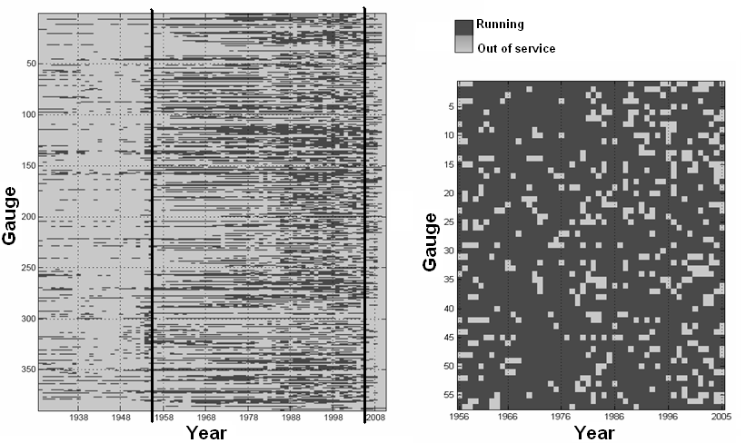
b)
a)
Figure 1. Entire regional dataset (a) and selected dataset (b).

This subset, formed by data coming from 57 raingauge stations with an average sample size of about 48 years and distributed over the whole region, has been used to identify signals of possible climate change both for daily data an for annual maxima.

- Analysis and discussion of results

  - Extreme rainfall analysis

The Mann-Kendall test (Mann, 1945; Kendall, 1962) was applied to the five annual maximum series to detect trend in extreme rainfall. Results were evaluated at three different significance levels α (0.01, 0.05, 0.1). Figure 2 provides the percentage of stations, which have shown a positive trend (red), a negative trend (green) or no trend (gray) for each duration, and for each significance level α. As it is expected, the percentage of raingauges showing a trend, either positive or negative, increases with the level α. It is worth to emphasize the positive significant trend of the annual maximum rainfall occurred for short duration (1 h), whose percentage reaches the 25% of total events for α=0.1. The longer the duration, the lower the percentage of stations with positive trend (except for d=6 hr and α=0.05). This finding suggests that there could be an increasing in volume of precipitation for the extreme events relative to sub-hourly durations. On the other hand, of the number of raingauges, which have shown a negative trend in precipitation, even at low significance level, increases for longer durations (12 and 24 hr). However, the percentage never overcomes a value of 10% and its correlation with the duration is less pronounced.
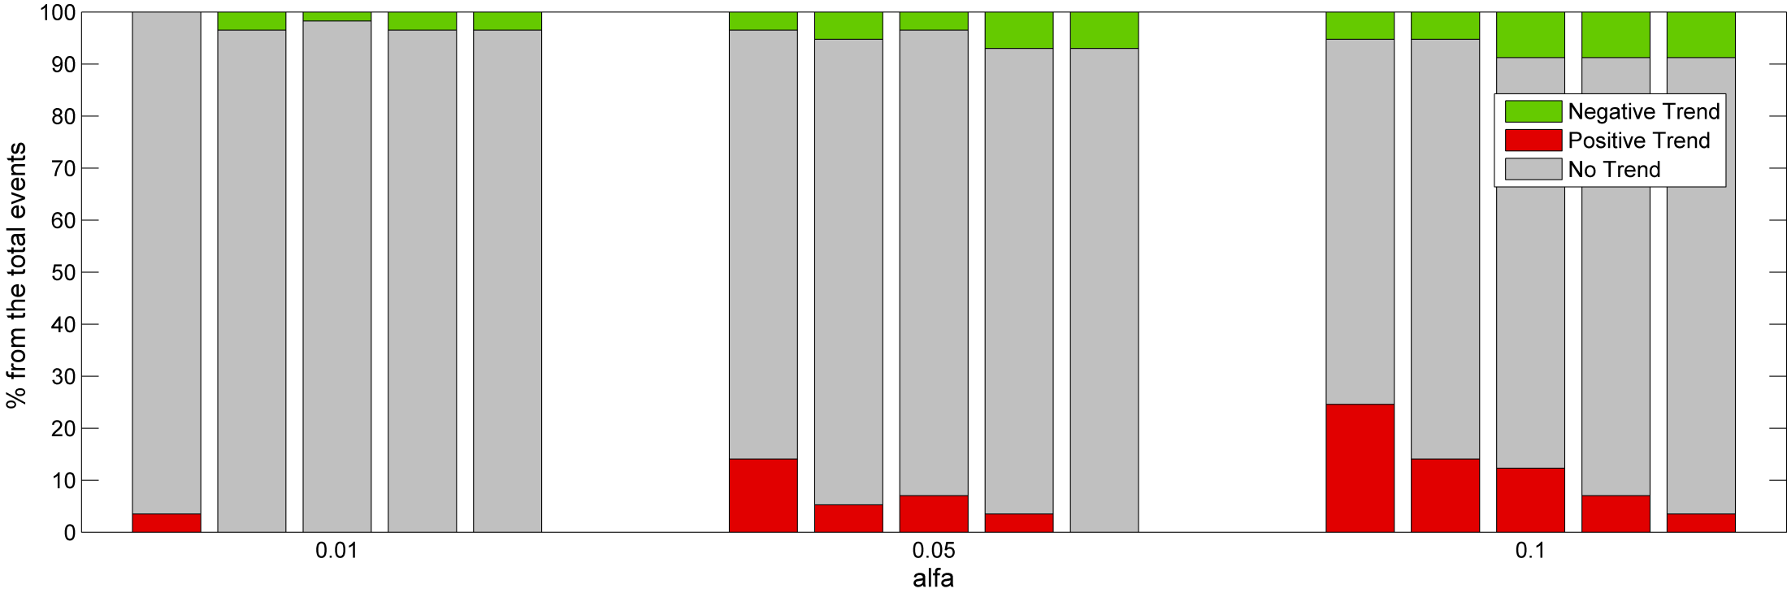 Figure 2. Percentage of raingauges from the total events showing a trend, at different durations and for three significance levels.
d [hours]
1
3
6
12
24
d [hours]
1
3
6
12
24
d [hours]
1
3
6
12
24

Spatial distribution of the Mann-Kendall trend test outcomes for the 5 durations is shown in figure 3 for a significance level α=0.05. Dots indicate raingauge sites while circles indicate the presence of a statistical significant trend, circle colors stand for trend sign and circle size is proportional to the trend magnitude (slope given by Eq. 6) observed at each stations. The top left panel of figure 3 localizes the 15% of the raingauges which have shown a positive trend for annual maximum rainfall with 1h duration (see figure 2).
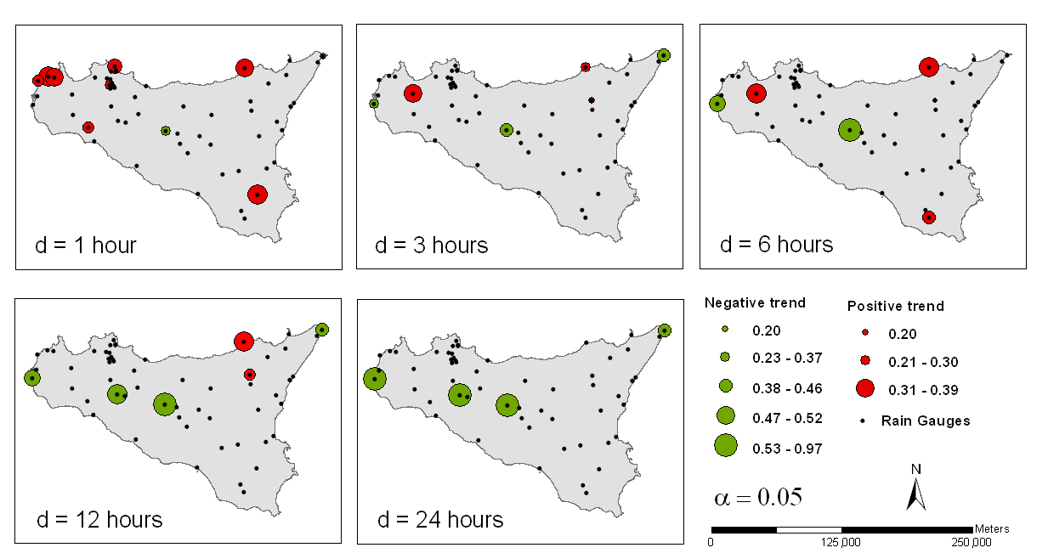 Figure 3. Trend sign, magnitude and spatial distribution for the five rainfall durations and fixed significance level α=0.05.

Most of these stations are located in the western Sicily, two stations in the eastern, one in the north and one in the south and almost all of them are placed close to the coast, being only one station located in the central Sicily. Results suggest that the increase in short duration precipitation can be assumed as a general behavior over the region, especially along the coastline. Moving from first panel (1 hr) to the last (24hr), the number of station exhibiting a positive trend gradually decreases. At the same time different stations showing negative trend appear, whose magnitude increase with the duration. However, no spatial pattern seems to be outlined by these results.

  - Daily rainfall analysis

Results of this analysis have been summarized in figure 4 for both classification 1 (panel a and b) and classification 2 (panel c and d), and for both the stochastic variables, namely the annual occurrences arising from each class and the annual volume arising from each class.
Each point of figure 4 represents the regional average of the values (percentage of annual occurrences from each class and the percentage of annual volume arising from each class) registered at site. Observations from figure 4a suggest, as expected, that most of the annual occurrences belong to the class of light precipitation (class 1) with an average frequency of 60% over the entire time window. The higher the intensity (i.e. rainfall category), the lower the frequency of occurrence. Indeed, class 2 has an average frequency of 30% and class 3 of about 10%. Average frequency of the last three classes is less than 5%. The Mann-Kendall test, applied to each time series at a significance level equal to 0.05, have demonstrated that no trend exists for such series, denoting an average behavior time invariant. However, it is important to highlight how such a regional analysis, based on values averaged among the different raingauges, probably hides any tendency.
The rainfall contributions to the total annual volume from each class are shown in figure 4b. Class 2 is here the most important in terms of rainfall contribution to the total volume (an average of 40%), given its ‘compromise’ between high frequency and low intensity. Class 3 is one exhibiting a positive statistically significant trend, suggesting that the intensity of the events belonging to this class increases. Classes 1, 4, 5 and 6 show homogeneous behaviors, contributing with small rates to the total volume, given their low frequency, and not showing significant trends.
Similar observations can be gathered from figures 4c and 4d. Pattern in term of annual occurrence is the same up to the classes 4, 5 and 6, whose contributions are re-distributed between class 2 and 3 of classification 2. This re-distribution involves a different behavior in term of contribution to the total annual volume for which no trend is detected.
As previously mentioned, changes over time of the two considered stochastic variables have been also investigated at a local level, i.e. for each station. Figure 5 shows the obtained results for classification 2 that is easier to understand and provides similar results of classification 1. A number of stations, mainly located in the north-western Sicily, exhibits a negative significant trend in term of annual occurrences from class 1: this means that there is a decrease tendency in the number of events leading light precipitation. Only two stations, far from each other, have shown a positive trend. However, moving from class 1 to class 3, several stations distributed over the region exhibits a positive trend, suggesting an increase tendency in the number of heavy-torrential precipitation events.
In term of annual volume, the contribution of light precipitation (class 1) tends to decrease in some stations (negative trend) and to increase in some others (positive trend). Again, the north-western Sicily is the most interested by this change. Moderate precipitation (class 2), instead, shows a decrease in contribution to the total annual volume. Lastly, heavy-torrential precipitations tend to increase their contribution to the annual volume in most of the stations showing a statistically significant trend. This could be explained as a consequence of the heavy-torrential occurrences increase.
Figure 4. Contribution to annual occurrences from each class (a and c) and rainfall contribution to the total annual volume from each class (b and d) as regional average over all the stations, based on classification 1 (a and b) and classification 2 (c and d). The presence of straight line indicated the trend existence at significance level α=0.05.
a)
c)
b)
d)

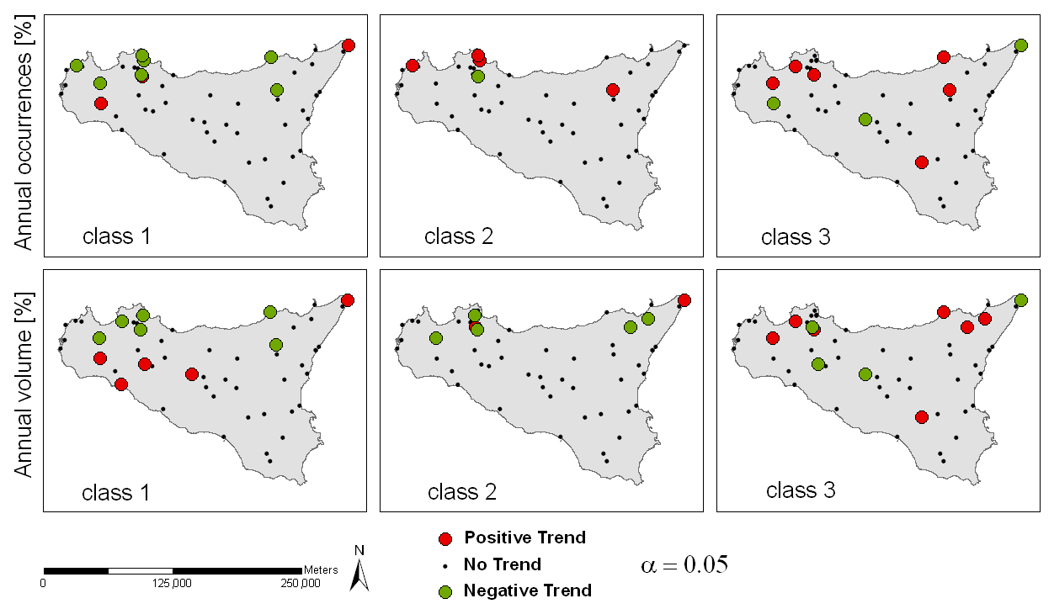 Figure 5. Trend analysis results at significance level α=0.05 from single rain-gauge station for the two considered stochastic variables (contribution to annual occurrences and rainfall contribution to the total annual volume from each class). Here only the presence, either positive (red circles) or negative (green circles), and the absence of trend are depicted.

Conclusions

Changes in extreme rainfall in Sicily have been investigated and quantified in this study. Trend in annual maximum rainfalls with 1, 3, 6, 12 and 24 hours duration have been analyzed using the Mann-Kendall test. Short duration events (1h) show significant increase in 15% of the considered station. No spatial pattern emerged from this analysis, even if coastal areas seem to be much more affected by positive trends than internal areas. As the rainfall duration increase, the number of positive trends decreases while, at the same time, negative trends appear. This result leads to important implications in flood risk management for Sicilian catchments, where the concentration time is often lower than one hour.
This paper also investigated daily rainfall time series using two different threshold-based classifications and analyzing the annual occurrences arising from each class and the percentage of the annual volume arising from each class. Results at sites show that heavy-torrential precipitations tend to increase in terms of number of annual occurrences and in terms of contribution to the annual volume. Conversely, light events have diminished at sites their frequencies and consequently their contribution to the total volume. When the results are averaged at regional scale, the strength of local outcomes vanishes, not showing significant trend as well.

References

Alexander, L.V., Zhang, X., Peterson, T.C., Caesar, J., Gleason, B., Tank, A., Haylock, M., Collins, D., Trewin, B., Rahimzadeh, F., Tagipour, A., Kumar, K.R., Revadekar, J., Griffiths, G., Vincent, L., Stephenson, D.B., Burn, J., Aguilar, E., Brunet, M., Taylor, M., New, M., Zhai, P., Rusticucci, M. and Vazquez-Aguirre, J.L. (2006) Global observed changes in daily climate extremes of temperature and precipitation. Journal of Geophysical Research-Atmospheres 111(D5).
Alpert, P., Ben-Gai, T., Baharad, A., Benjamini, Y., Yekutieli, D., Colacino, M., Diodato, L., Ramis, C., Homar, V., Romero, R., Michaelides, S. and Manes, A. (2002) The paradoxical increase of Mediterranean extreme daily rainfall in spite of decrease in total values. Geophysical Research Letters 29(11).
Aronica, G., Cannarozzo, M. and Noto, L. (2002) Investigating the changes in extreme rainfall series recorded in an urbanised area. Water Science and Technology 45(2), 49-54.
Bonaccorso, B., Cancelliere, A. and Rossi, G. (2005) Detecting trends of extreme rainfall series in Sicily. Advances in Geosciences 2, 7-11.
Brunetti, M., Colacino, M., Maugeri, M. and Nanni, T. (2001) Trends in the daily intensity of precipitation in Italy from 1951 to 1996. International Journal of Climatology 21(3), 299-316.
Cannarozzo, M., Noto, L.V. and Viola, F. (2006) Spatial distribution of rainfall trends in Sicily (1921-2000). Physics and Chemistry of the Earth 31(18), 1201-1211.
Confalonieri, U., B. Menne, R. Akhtar, K.L. Ebi, M. Hauengue, R.S. Kovats, Revich, B. and A. Woodward (2007) Climate Change 2007: Impacts, Adaptation and Vulnerability. Contribution of Working Group II to the Fourth Assessment Report of the Intergovernmental Panel on Climate Change. M.L. Parry, O.F.C., J.P. Palutikof, P.J. van der Linden and C.E. Hanson (ed), pp. 391-431, Cambridge University Press, Cambridge, UK.
Frich, P., Alexander, L.V., Della-Marta, P., Gleason, B., Haylock, M., Tank, A. and Peterson, T. (2002) Observed coherent changes in climatic extremes during the second half of the twentieth century. Climate Research 19(3), 193-212.
Groisman, P.Y., Karl, T.R., Easterling, D.R., Knight, R.W., Jamason, P.F., Hennessy, K.J., Suppiah, R., Page, C.M., Wibig, J., Fortuniak, K., Razuvaev, V.N., Douglas, A., Forland, E. and Zhai, P.M. (1999) Changes in the probability of heavy precipitation: Important indicators of climatic change. Climatic Change 42(1), 243-283.
Kendall, M.G. (1962) Rank correlation methods, Hafner Publishing Company, New York.
Mann, H.B. (1945) Non parametric tests again trend. Econometrica 13, 245-259.
Manton, M.J., Della-Marta, P.M., Haylock, M.R., Hennessy, K.J., Nicholls, N., Chambers, L.E., Collins, D.A., Daw, G., Finet, A., Gunawan, D., Inape, K., Isobe, H., Kestin, T.S., Lefale, P., Leyu, C.H., Lwin, T., Maitrepierre, L., Ouprasitwong, N., Page, C.M., Pahalad, J., Plummer, N., Salinger, M.J., Suppiah, R., Tran, V.L., Trewin, B., Tibig, I. and Yee, D. (2001) Trends in extreme daily rainfall and temperature in Southeast Asia and the South Pacific: 1961-1998. International Journal of Climatology 21(3), 269-284.
Trenberth, K.E., Dai, A., Rasmussen, R.M. and Parsons, D.B. (2003) The changing character of precipitation. Bulletin of the American Meteorological Society 84(9), 1205-+.
Trenberth, K.E., P.D. Jones, P. Ambenje, R. Bojariu, D. Easterling, A. Klein Tank, D. Parker, F. Rahimzadeh, J.A. Renwick, M. Rusticucci, Soden, B. and Zhai, P. (2007) Climate Change 2007: The Physical Science Basis. Contribution of Working Group I to the Fourth Assessment Report of the Intergovernmental Panel on Climate Change. Solomon, S., D. Qin, M. Manning, Z. Chen, M. Marquis, K.B. Averyt, M. Tignor and H.L. Miller (ed), Cambridge University Press, Cambridge, United Kingdom and New York, NY, USA.
Zhai, P.M., Zhang, X.B., Wan, H. and Pan, X.H. (2005) Trends in total precipitation and frequency of daily precipitation extremes over China. Journal of Climate 18(7), 1096-1108.

