Fabrication of thermally annealed NiFeS ternary alloy for green hydrogen production
Bernardo PATELLA¹, Salvatore GERACI¹, Roberto Luigi OLIVERI¹, Rosalinda INGUANTA¹
Name presenting Bernardo PATELLA^{*1,} …….
¹IUniversity of Palermo, Department of Engineering, Viale delle Scienze, Palermo, Italy
* e-mail corresponding: bernardo.patella@unipa.it

Significance and Relevance
In this work, we have studied and optimized the fabrication of a ternary alloy of Ni, Fe and S for H₂ evolution reaction in an alkaline electrolyzer. Particularly, the alloy was deposited using a template electrosynthesis method using a deposition bath made of Fe, Ni and S ions. The composition of the deposition bath was optimized as well as the deposition parameters (such as potential and time) in order to obtain a stable and durable alloy. Moreover, the effect of a thermal annealing in a controlled environment (after alloy deposition) has been studied. The optimized electrode has been tested as both anode and cathode and preliminary results showed a constant potential of -0.4 and 1.6 V vs RHE by applying a fixed current of ±50 mA cm⁻².

Preferred and 2nd choice for the topic: H2 storange andtransportation, green H2 production, hydrogen vectors; sustainable and clean energy production and trasport
Preferred presentation: Oral preferred or Short Oral

Introduction and Motivations
In recent years, the use of renewable energy sources is increasing more and more¹. The main drawbacks of these kind of energy sources is the lack of predictability that make an energy storage system mandatory. The production of green hydrogen using water electrolysis can solve this problem².
In this work, we have studied the performance of a new and novel catalyst for both H₂ and O₂ production in an alkaline electrolyzer. The cataltys was fabricated with nanostructured morphology using cheap and highly active catalysts, such as iron, nickel and sulphur³

Materials and Methods

The alloy was prepared by template electrosynthesis, using a polycarbonate membrane as a template⁴. To make it conductive, a thin gold layer was sputtered. In the same membrane face, a nickel current collector was electrodeposited. Then, the NWS were deposited into the other membrane face using a Watt's bath modified with FeSO₄∙7 H₂O and Na₂S₂O₃ 5H₂O using a pulsed electrodeposition. Different concentration of S and Fe were studied. Finally, the membrane has been etched using pure dichloromethane. The annealing process was carried out in a N₂ saturated environment at different temperatures and time. The electrodes were characterized using SEM, EDS and XRD analysis. The performances of the electrode for both O₂ and H₂ evolution were evaluated using a solution of 30% KOH.

Results and Discussion
The electrode fabrication was optimized in order to obtain a stable array of vertically standing NWs. This kind of morphology allow to obtain extremely high surface area and thus higher current density for both H₂ and O₂ production. As mentioned in the materials and method section, the concentration of Fe, S and Ni were optimized in order to obtain this goal. Particularly, the best results have been obtained using a deposition bath made of 0.44 M of Fe, 15 g/L of S in the Ni Watt bath. The annealing process was optimized as well and the best results have been obtained annealing at 500°C for 3 minutes. Figure 1a shows the SEM image of the electrode after the annealing process and the electrode shows the presence of vertically standing NWs with an average length of about 15 µm. The EDS analysis (Figure 1b) confirmed the deposition of the ternary alloy. Similar results were obtained using XRD analysis.
The optimized electrode has then been tested as both anode and cathode in an alkaline electrolyzer. The counter electrode was a Pt mesh and a Hg/HgO as reference electrode. The electrochemical surface area was evaluated by carrying out CVs at different scan rate. This experiment was carried out using the optimized electrode and a planar Ni strip. Results showed that the proposed electrode have a 10 time higher capacitance compared to the planar one. The same electrodes (NiFeS NWs and Ni strip) were used in a quasi-steady state polarization and results were fitted with Tafel regression. Results showed that the modification of the alloy with sulfur leads to an improvement in both O₂ and H₂ evolution reaction with a much more remarkable effect on the O₂evolution reaction .
Finally, the electrodes were used in a short time polarization (6h) using a fixed current density of ±50 mA cm⁻² (Figure 1c, d). Excellent preliminary results were obtained, with an outstanding stability of potential over time which is around 1.62 and -0.38V vs RHE for O₂ and H₂ production, respectively.

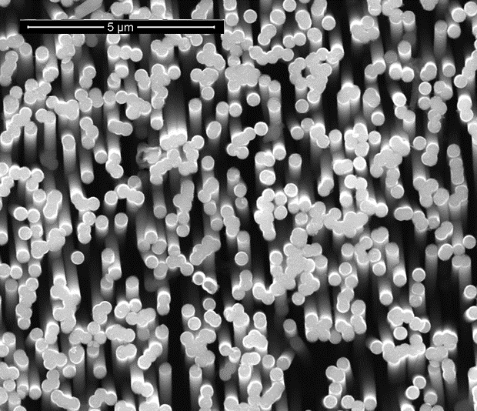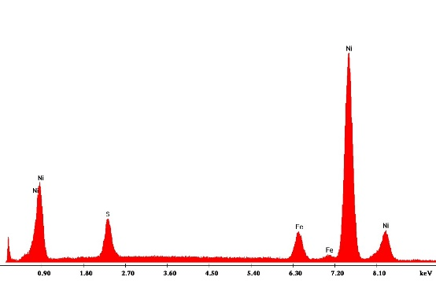
C
D
B
A
Figure 1 a) SEM image of NiFeS NWs after annealing and corresponding (b) EDS analysis. Galvanostatic step at ±50 mA cm⁻² for (C) H2 and (D) O2 evolution reaction ……...

Concluding, in the present work we have optimized the fabrication process of a ternary alloy of NiFeS NWs. The electrode was used for O₂ and H₂ production, showing excellent results. Indeed, compared to planar electrodes, the proposed one has a 10 times higher surface area and preliminary galvanostatic experiments showed a very stable potential over 6h of production.

References
- A.T.D. Perera, R.A. Attalage, K.K.C.K. Perera, V.P.C.Dassanayake, Energy, 54, 2013, 237-248.
- D. Guilbert, G. Vitale, Clean Technologies, 2021, 881-909,
- F. Safizadeh, E. Ghali, G. Houlachi, International Journal of Hydrogen Energy, 40, 2015, 256–274.
- S. Carbone, F. Proietto, F. Bonafede, R.L. Oliveri, B. Patella, G. Ganci, G. Aiello, P. Mandin, M. Kim, M. Scopelliti, R. Inguanta, Electrochimica Acta, 2023, 467

Acknowledgements
This work was supported by the Sustainable Mobility Center (Centro Nazionale per la Mobilità Sostenibile—CNMS) under Grant CN00000023 CUP B73C22000760001 Piano Nazionale di Ripresa e Resilienza, Missione 4 - Componente ½

