Seismotectonic setting of the eastern margin of Adria plate

R. Cassataro^{1,2}, G. Pezzo², M. Palano¹, A. Sulli¹, C. Chiarabba²

¹ Dipartimento di Scienze della Terra e del Mare, Università degli studi di Palermo, Italy

² Istituto Nazionale di Geofisica e Vulcanologia, Italy

The continental Adria microplate occupies the central Mediterranean and is covered by the Adriatic Sea, for the largest part. Since late Mesozoic time, the margins of Adria have been progressively involved in the long-lasting tectonic processes connected with the Africa-Eurasia convergence (van Hinsbergen et al., 2014). The kinematic relationship of Adria with respect to both Africa and Eurasia plates has been debated for decades, since most of the plate has been subducted (van Hinsbergen et al., 2014) but also because the eastern and western margins of Adria have been highly deformed (Carminati & Doglioni, 2012). Early studies of a stratigraphic and paleomagnetic nature regarding the Meso-Cenozoic evolution (Channell et al, 1979) framed Adria plate as a kind of rigid promontory in continuity with Africa. It was only through subsequent geological and geophysical investigations that Adria was identified as a distinct microplate, exhibiting an anticlockwise rotation relative to Europe. Independent motion and fragmentation of Adria is also suggested by the present-day GNSS velocities (Sani et al., 2016) and the lithospheric seismic velocity structure across the Adriatic recently imaged by the 3D full waveform tomography in Magnoni et al. (2022).
Here we provide a novel picture on the current seismotectonic pattern of the eastern Adriatic margin by considering recent geological, geodetic and seismological observations (Fig.1).

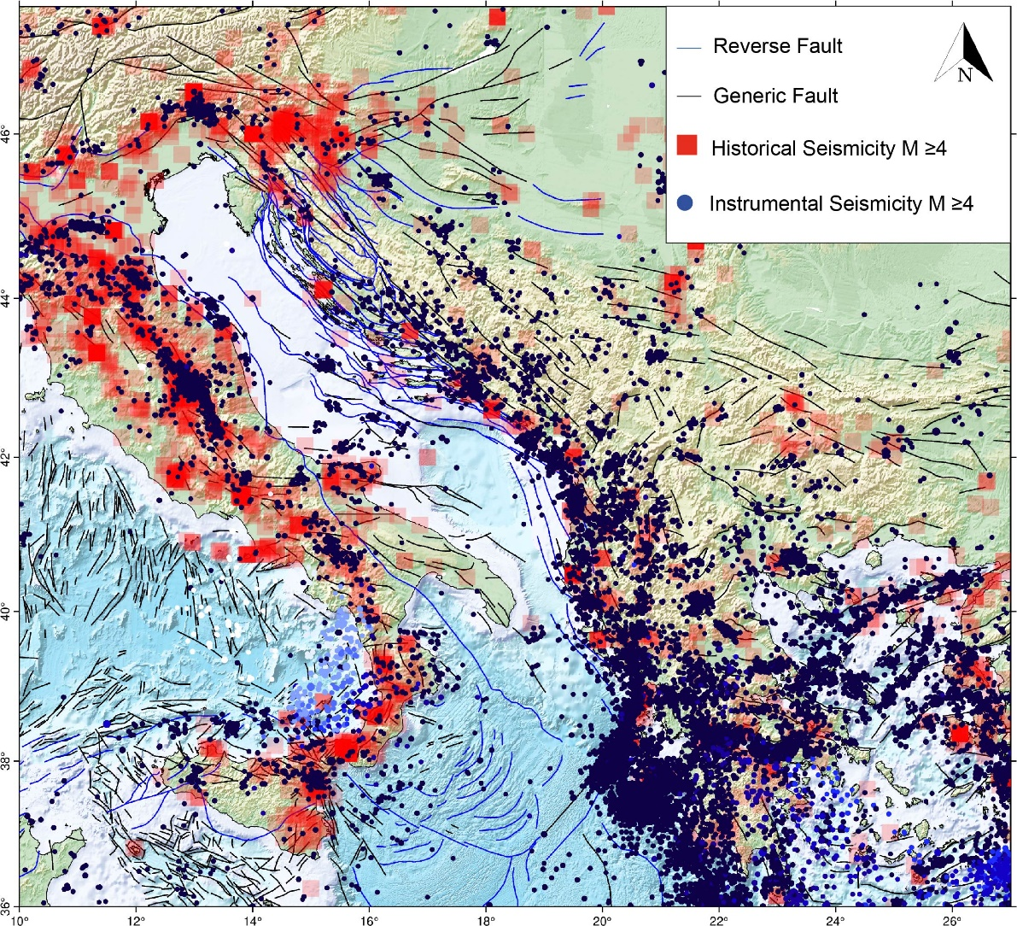
Fig. 1 Seismicity of the study area; with red square historical data (from 1000 B.C to 1903 B.C) and with blue dots instrumental data (from 1903 B.C. to 2024 B.C.); the datasets were downloaded from https://doi.org/10.31905/D808B830 and https://www.emidius.eu/SHEEC/ respectively. Generic faults and thrusts are reported in black and blue, respectively.

References
Carminati E., C Doglioni C.; 2012; Earth-Science Reviews
Channell J.E.T, d'Argenio B, Horvath F.; 1979; Earth-Science Reviews
Magnoni F., Casarotti E., Komatitsch D., Di Stefano R., Ciaccio M.G., Tape C., Melini D., Michelini A., Piersanti A.; Tromp J.; 2022; Communications Earth & Environment
Sani F., Vannuci G., Boccaletti M., Bonini M., Corti G., Serpelloni E.; 2016; Journal of Geodynamics
Van Hinsbergen D.J.J., Vissers R.M.L, Spakman W.; 2014; Tectonics

Corresponding author: riccardo.cassataro@unipa.it

