Liquid structure of a water-based, hydrophobic and natural deep eutectic solvent: The case of thymol-water. A Molecular Dynamics study.

Alessandro Triolo^{1,*}, Fabrizio Lo Celso^{1,2} and Olga Russina^{1,3,*}

¹ Istituto Struttura della Materia (ISM), Consiglio Nazionale delle Ricerche (CNR), Rome, Italy
² Department of Physics and Chemistry, University of Palermo, Palermo, Italy
³ Department of Chemistry, University of Rome Sapienza, Rome, Italy

* Corresponding Authors: A.T. (alessandro.triolo@cnr.it); O.R. (olga.russina@uniroma1.it)

Abstract.

The structural organization of the first example of a water-based, type V, hydrophobic, natural deep eutectic solvent (DES) is investigated in this work, exploiting the synergy of X-ray scattering and computational techniques. The stoichiometric mixture of thymol:water (4.8:1) has been recently reported to behave as a DES, with a melting point at -6 °C, well below the one foreseen for the ideal liquid mixture. Our study provides an atomistic insight into the structural correlations in this system, highlighting the major role played by hydrogen bonding (HB) correlations in affecting morphology as well as the solid-liquid equilibrium. Thymol engages HB-mediated interactions with both thymol and water molecules: evidences of conventional HB interactions involving the hydroxyl group are found, together with indications of π···H-O hydrogen bonding correlations with both thymol and water. Overall, in the mixture, thymol is involved in a larger number of HB interactions than in its neat liquid state. Such a strong interference of water into thymol structural organization strongly hinders the development of HB-mediated thymol hexamers that is the structural leitmotif in crystalline thymol. On the other hand, only 30% of the present water molecule can engage into correlations with at least another water molecule, thus preventing the formation of an extended HB network among water molecules that would result incompatible with the otherwise hydrophobic environment. Evidences of mesoscopic organization are observed experimentally and confirmed by simulations: these are related to the clustering of thymol hydroxyl groups with water molecules, leading to the formation on polar nano-pools embedded into the apolar matrix. This new solvent extends the range of water based, type V, hydrophobic DES, and represents an additional contribuition to the development of sustainable technologies, with appealing properties.

Keywords: hydrogen bonding; hydrophobic; X-ray Scattering; Molecular Dynamics; mesoscopic; sustainable

1. Introduction.
Type V Deep Eutectic Solvents (DES) [1,2] have been recently proposed as a further class of DES[3–5]. DES are composed by the combination of two or more components, whose eutectic mixture is characterised by a melting point lower that of an ideal liquid mixture. Of course, the nature of interactions between components will strongly affect the formation of the DES, as dispersive and electrostatic interactions, hydrogen-bonding (HB) correlations and, last but not least, entropic terms will determine the overall thermodynamic behaviour of the mixture and the depth of the eutectic melting point [4,6,7]. Since their original discovery, different classes of DES have been classified, according to the nature of their components. The first three classes are composed by a salt (e.g. those formed by ammonium, phosphonium, or sulfonium cations and a halide anion, the most common salt being choline chloride) and a complexing agent, such as metal halides in anhydrous (type I) or hydrated (type II) form, or a neutral hydrogen bonding donor species (such as amides or alcohols) (type III). Type IV DES involve metal salts mixed with a neutral HB donor (e.g. urea). Type V DES are prepared using non-ionic components and, as such, they show limited viscosity and wide tunability of hydrophilicity. Among them, menthol-thymol mixtures received great attention and careful studies revealed the importance of HB in strongly influencing the overall interaction balance in these mixtures, with a specific role played by the non-negligible positive character of hydroxyl groups in phenolic compounds (e.g. phenol and thymol) in enhancing the hetero-molecular HB interactions. Recently great attention has also been paid to hydrophobic DES, which were originally proposed in 2015. [8–12] Their impact is expected to be large, considering that they extend the conventional range of applications of hydrophilic DES to the realm of liquid-liquid or gas-liquid (micro-)extraction, catalysis, etc. It is interesting to note that despite the suggestion inspired by the term “hydrophobic”, a hydrophobic DES can indeed be prepared using compounds, such as acetic or lactic acids[12], which show non negligible solubility in water.[10]
Recently, in the kaleidoscopic spectrum of existing DES, it has been highlighted the existence of an hydrophilic type IV DES, where the role of HB donor is played by water, which then represents no longer an impurity or a deliberately added compound to influence chemical physical properties of a DES, but it is rather a mere component of the DES. The melting point of the 1:4 mixture of choline chloride and water could not be detected in different studies and accordingly this system has been proposed as a DES.[13–17] Such studies paved the way to a potentially new class of Natural DES, where one of the component is water, thus further reducing the environmental impact of DES exploitation. These characterizations are also very important in the framework of rationalising and, potentially, optimising, properties of hydrated DES: as mentioned water can often either an impurity or a deliberate addition to a conventional DES. The role of water as an additive to DES has been recently explored in several studies (e.g. [18–26]) and its effects as a viscosity dampener and even structure disruptive have been reported.
Even more recently, the first example of a water-based, hydrophobic, natural, type V DES has been proposed by Tiecco and coworkers, who showed that thymol-water mixtures at a 4.8:1 ratio are liquid and show a melting point of ca. -6 °C, much below the foreseen ideal mixture melting point.[27] This system (hereinafter indicated as the thymol-water mixture), when put in contact with water leads to a biphasic mixture, where the DES floats, having a density below the water one. This DES shows appealing phenol extraction properties and its structural features are the focus of the present study, where, using computational techniques, validated by experimental data, we aim at accessing details in the structural organization of this thymol-water mixture at atomistic level.

2. Material and methods
2.1 Experimental
2.1.1 Chemical samples and preparation.
Thymol (Scheme 1) was a TCI product with purity >99%; water was milliQ water. Chemicals were used without additional preliminary treatment. Following indications by Tiecco et al.,[27] an excess of water was added to thymol; upon heating at ca. 80°C, an upper phase separated and was extracted from the flask, corresponding to a molar ratio thymol:water 4.8:1. [27]
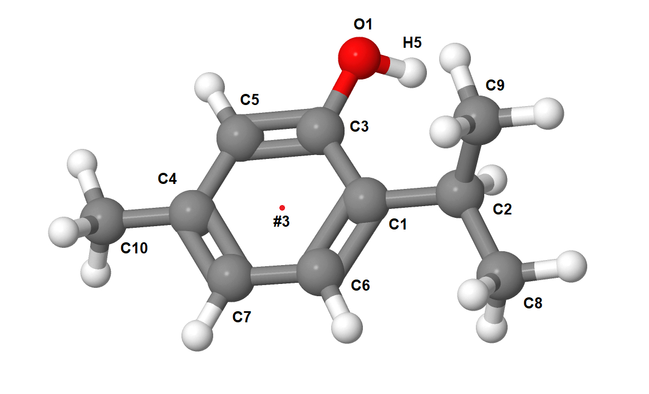Scheme 1. Schematic representation of the structure of thymol, with indication of atomic indexes, as well as the explanation of virtual site #3, representing the ring center.

2.1.2. Wide Angle X-ray scattering.
Wide Angle X-ray Scattering (WAXS) data for the thymol-water mixture were collected at room temperature using the non-commercial Energy Dispersive X-ray Diffractometer (EDXD) built in the Department of Chemistry, Rome University “Sapienza” (Italian Pat. Appl. no. 1126484 - 23 June 1993, Caminiti et al.) White Bremsstrahlung radiation emitted by a tungsten tube (50 kV, 40 mA) was used. The scattering variable Q (transferred momentum) is given by: Q (Å⁻¹)=4π/λ_{i} sinθ = E_{i} sinθ, where Ei is the beam component energy (in keV) and θ is the scattering angle. Using a white beam, data were collected at different θ values (namely: 1°, 3°, 8° and 22°) with an energy sensitive, high purity, solid state Ge detector. Data were corrected for absorption and background and white beam scattering using in house developed software[28,29] and eventually were merged to yield the total static structure factor, I(Q):
$$I\left(Q\right)=I_{e.u.}\left(Q\right)−\sum_{i=1}^{n}{x_{i}{f_{i}\left(Q\right)}^{2}}$$

where f_{i}(Q) are the interpolated atomic scattering factors, x_{i} are the number concentrations of i-type atoms in the stoichiometric unit, and I_{eu}(Q) is the observed intensity in electron units. The latter quantity has been used to confront with Molecular Dynamics computed I(Q). The sample was contained in a quartz capillary of 2 mm diameter and kept at ambient temperature during the measurements.

2.1.3. Small Angle X-ray Scattering
Small Angle X-ray Scattering (SAXS) measurements were performed at the SAXS-Lab Sapienza with a Xeuss 2.0 Q-Xoom system (Xenocs SA, Sassenage, France), equipped with a micro-focus Genix 3D X-ray source (λ = 0.1542 nm), a two-dimensional Pilatus3 R 300K detector which can be placed at variable distance from the sample. Calibration of the scattering vector Q range, where Q=(4π sinθ)/λ, 2θ being the scattering angle, was performed using a silver behenate standard.
Measurements with different sample-detector distances were performed so that the overall explored Q region was 0.03 < Q < 3.3 Å^{–1}. The samples were loaded into a disposable quartz capillary with nominal thickness 1.0 mm and sealed with hot glue before placing them in the instrument sample chamber at reduced pressure (∼0.2 mbar). The beam size was defined through the two-pinhole collimation system equipped with scatterless slits to be 0.25 mm x 0.25 mm.
The two-dimensional scattering patterns were subtracted for the dark counting, and then masked, azimuthally averaged and normalized for transmitted beam intensity, exposure time and subtended solid angle per pixel, by using the FoxTrot software developed at SOLEIL. The one-dimensional S(Q) vs. Q profiles were then subtracted for the capillary contribution.
The measurements were conducted at ambient temperature (ca. 20°C) and the sample maintained liquid and homogeneous during the whole length of the experiment.

2.2. Computational methods.
2.2.1. Molecular Dynamics simulations.
Molecular dynamic simulations were performed using the GROMACS 5.1.1 package [30,31] . Bonded and non-bonded parameters for the two systems, pure thymol and its mixture with water were described using an all-atoms potential OPLS-AA force field [32]. The simulations were performed using a cubic box containing 1000 molecules for the case of neat thymol and 2400 thymol and 500 water molecules were considered the case of the thymol-water mixture (with molar ratio 4.8:1); periodic boundary conditions were applied. Force field parameter files were created by LipParGen webserver[33–35]; initial configurations were created by Packmol software [36]. The starting density was fixed 10% higher than the experimental one. The equilibration procedure was done in several steps, starting from a 2 ns NVT simulation at 400 K, followed by a series of 2 ns NPT runs lowering progressively the temperature to 353 K at 1 bar. After the equilibration phase, the system was run for 50 ns for a production run, and then the trajectory of the last 4 ns was saved at a frequency of 1 ps for calculation of the structural properties. The simulations were always checked versus the experimental density and the energy profile. During the production runs for the temperature coupling, we used a velocity rescaling thermostat [37] (with a time coupling constant of 0.1 ps), while for the pressure coupling, we used a Parrinello–Rahman barostat [38] (1 ps for the relaxation constant). The Leap-Frog algorithm with a 1.0 fs time step was used for integrating the equations of motion. Cut-offs for the Lennard-Jones and real space part of the Coulombic interactions were set to 16 Å. For the electrostatic interactions, the Particle Mesh Ewald (PME) summation method [39,40] was used, with an interpolation order of 6 and 0.08 nm of FFT grid spacing.
X-ray and neutron weighted structure factors were computed together with selected pair correlation functions, angular distribution functions and spatial distribution functions using TRAVIS [41–43] .

3. Results and Discussion.

We initially verified that the computed density of the thymol-water mixture is 0.9540 g/cc is reasonable agreement with the literature data of 0.94 g/cc.[27]
Next, X-ray weighted static structure factors have been determined both experimentally and computationally for the thymol-water mixture. We characterised the sample at room temperature using both the SAXS and WAXS techniques and Figure 1 shows such data sets. The SAXS data reveal the existence of a complex peak centred at ca. 1.25 Å⁻¹ that appears as the superposition of different peaks. Moreover a distinct feature appears at ca. 0.6 Å⁻¹ that resembles the peak observed by some of us in the archetypal Thymol:Menthol (1:1) type V DES, whose SAXS pattern is characterised by the presence of two peaks at 1.25 and, indeed, 0.6 Å⁻¹. [44] We will further discuss this feature in the following. The SAXS data set indicates that no further degree of structural organization at longer spatial scale can be detected in the present system, as witnessed by the lack of further scattering features at lower Q values. The WAXS pattern shown in Figure 1 (right) covers a wider Q range and allows validating the Molecular Dynamics simulation, due to the good agreement between experimental and computed patterns. Therein, the Q range related to the low Q feature is not accessed experimentally, but it appears that our MD simulation identifies the existence of a distinct shoulder centred at 0.6 Å⁻¹, in agreement with the experimental SAXS data. In order to further extend the information that can be extracted by MD simulations, we also evaluated the neutron weighted diffraction patterns for the different case of either no deuteration or selective deuteration of one or the other or both species. These data sets are reported in figure S-1 of the ESI and indicate that only the mixture containing deuterated water and natural thymol shows a clear evidence of the low Q feature that appears in the SAXS pattern. This information can turn out to be useful for future neutron scattering experiments planned on this system.
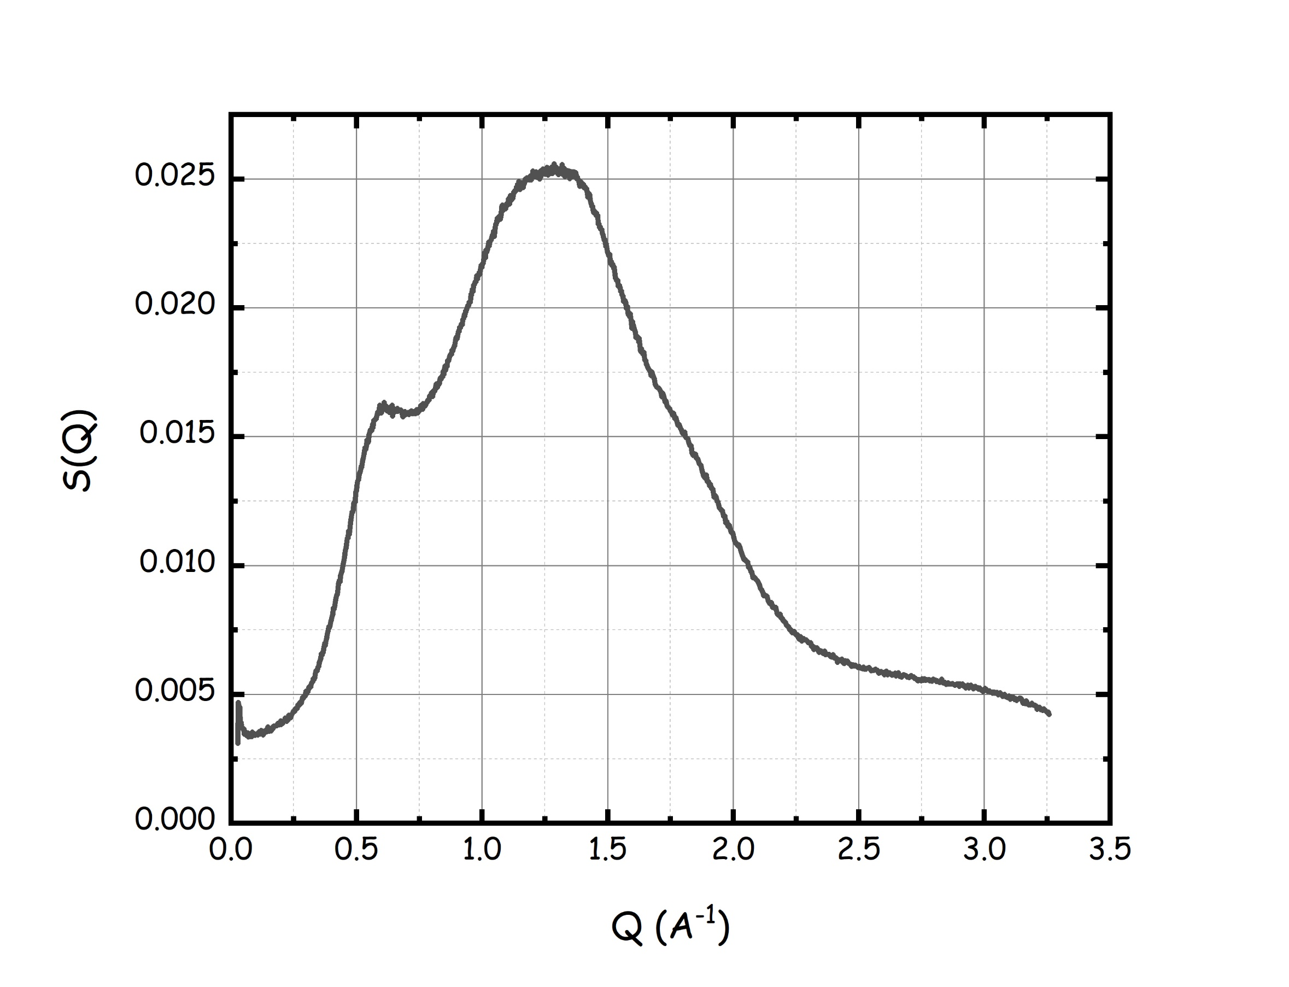 | 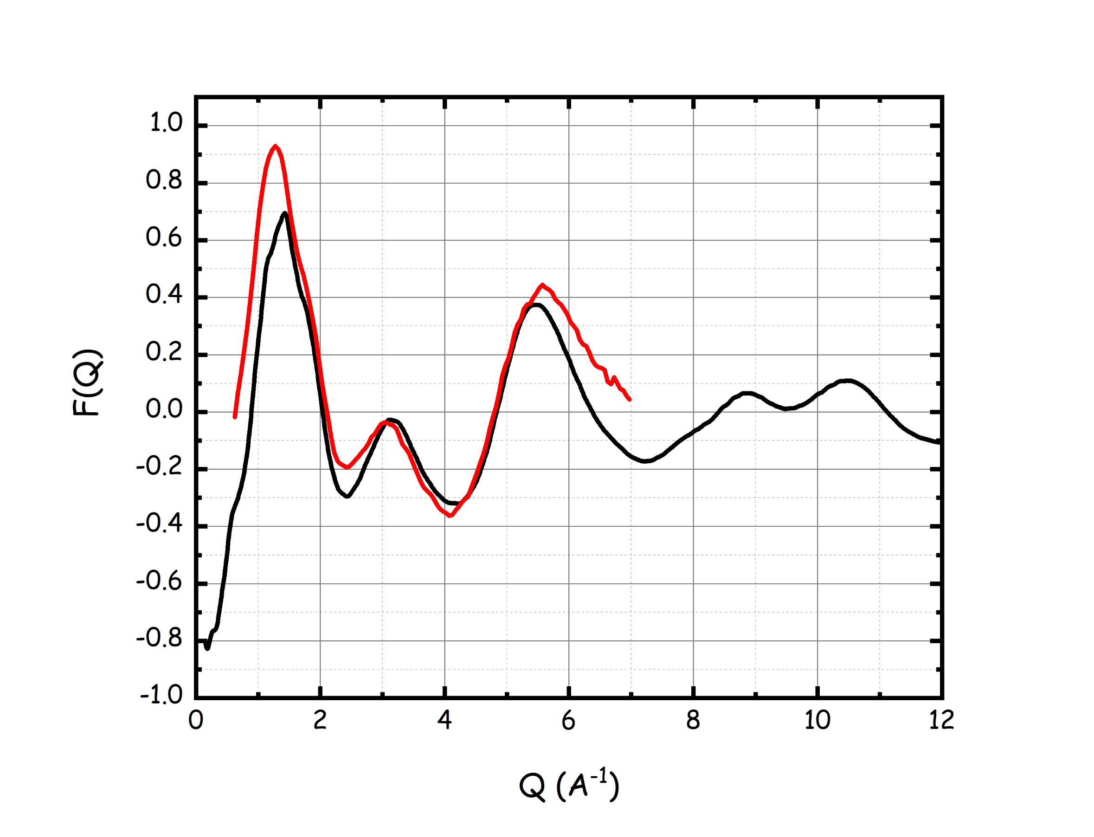

Figure 1. (left) Experimental Small Angle X-ray Scattering pattern, S(Q), for thymol-water mixture at 20°C. (right) Comparison between experimental (red line) and Molecular Dynamics computed (black line) X-ray weighted static structure factor, F(Q), for thymol-water mixture at 20°C.
The main structural correlations in the system were characterised using pair distribution functions (pdf) and Figure 2 reports the pdf for the centers of mass (#2, CoM) of the different components, including also the thymol center of ring (#3, CoR)) auto correlations. It emerges that the graph is dominated by water-water correlations, with an average of one neighbour molecule surrounding a reference one into its first solvation shell by a distance of 3.5 Å (to be compared with a much larger value of 5.3 for bulk water [45]). Less evident, though yet strong, correlations can be observed for thymol-water and thymol-thymol species. Thymol-water correlations are characterised by a low amplitude, though discernible, peak between 3 and 4 Å that is followed by a larger amplitude peak at ca. 4.7 Å. This situation corresponds to a dual short-range water interaction with thymol, as we will describe in the following. Thymol-thymol correlations look quite entangled, as can be appreciated from the highly structured peak covering between 4 and 9 Å in the corresponding pdfs: it emerges that up to the first clear minimum of their pdf (at ca. 10 Å), up to 14 thymol molecules surround the reference one.
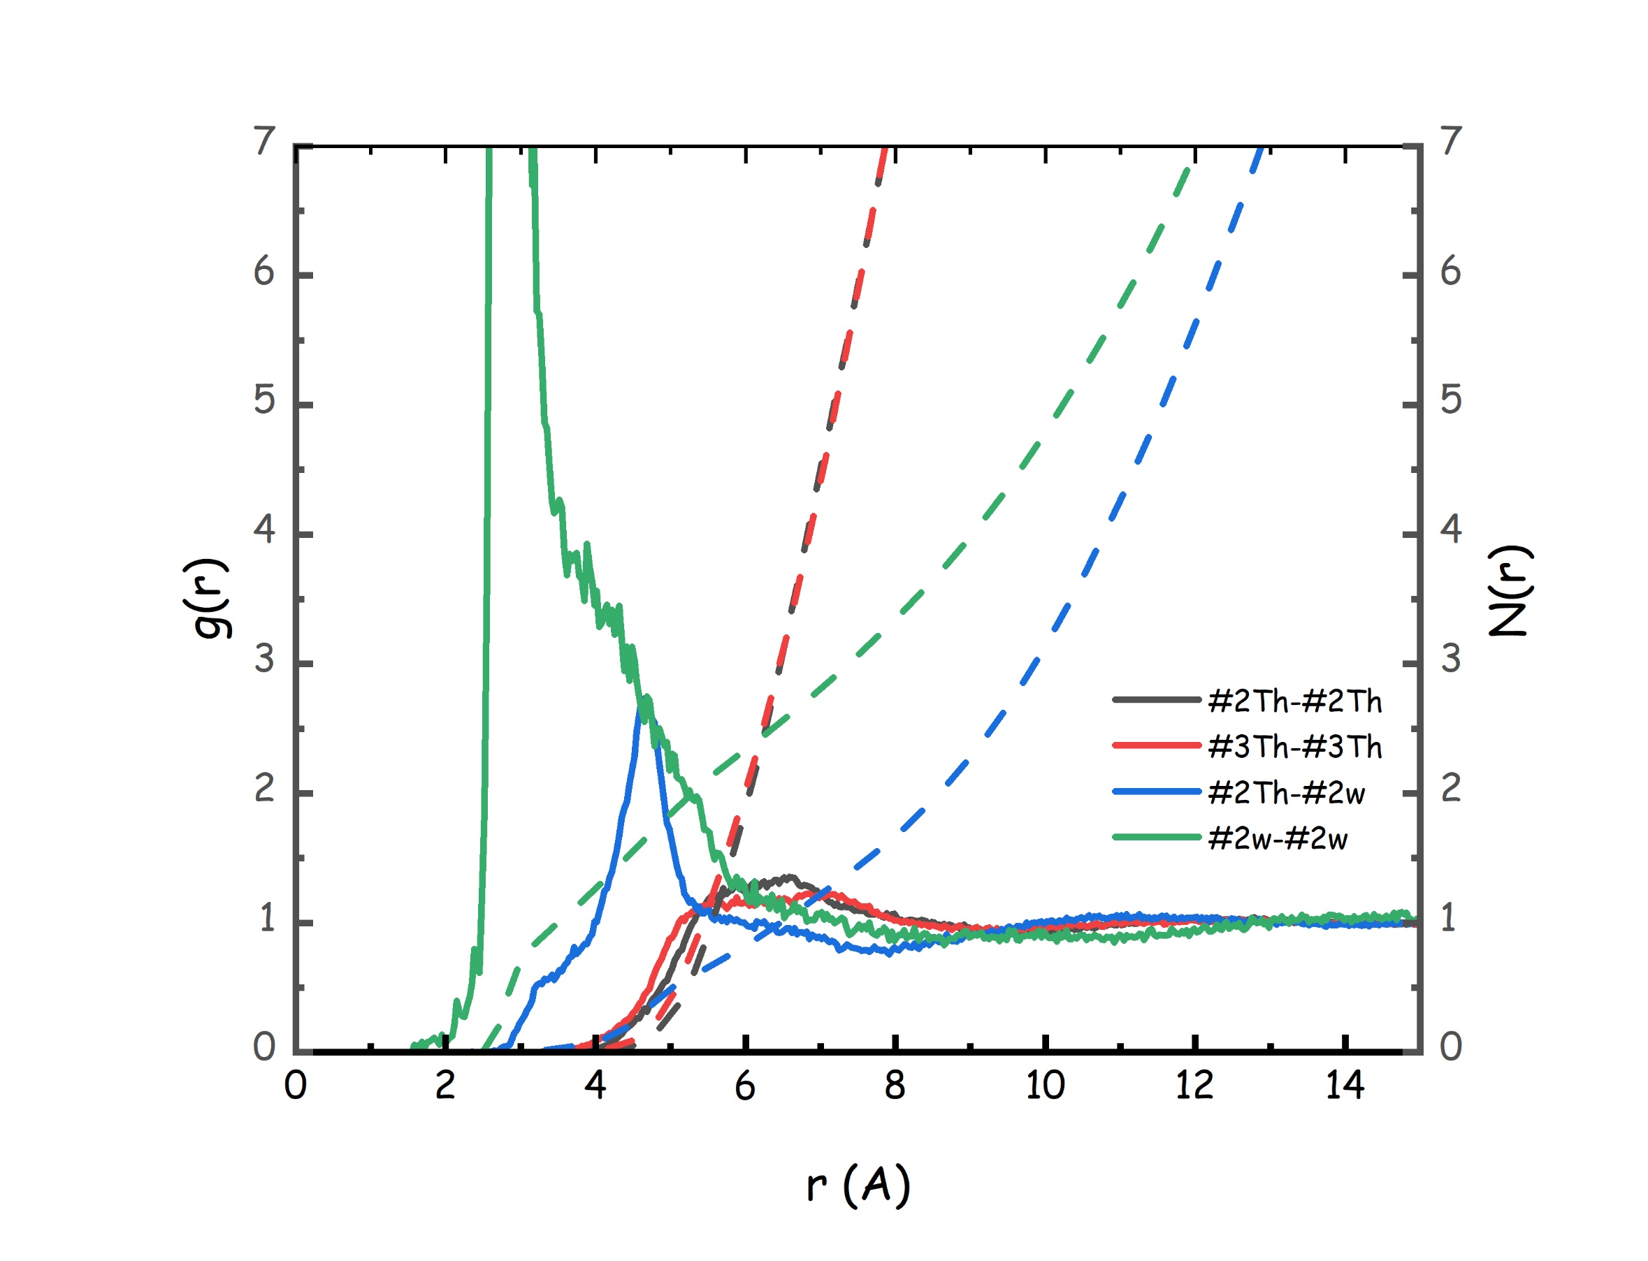
Figure 2. MD-computed pair distribution functions (continuous lines) and corresponding running neighbour numbers (dashed lines) of Center of Mass (#2) or of Ring (for the case of thymol, #3) for the different components of the thymol-water mixture. The water-water correlation peak has been cut (the corresponding peak would reach an amplitude of 27).
We will now discuss in detail the different kinds of correlations taking place between the different components.

3.1 Thymol-thymol correlations.
In order to better rationalise thymol-thymol correlations, a series of combined distribution functions (cdf) has been evaluated and their analysis will provide a clear understanding on the nature of these correlations. Figure 3 (left) shows the cdf reporting the Center of Ring (CoR)-CoR distance as an abscissa and the angle between ring perpendiculars as an ordinate. It clearly appears that the strongest correlation occurs for a distance CoR-CoR of ca 6.5 Å, with neighbour thymol rings perpendicular to each other. On the other hand, shorter-range correlations can occur and correspond to distances CoR-CoR between 4 and 5 Å, with a preference for parallel or antiparallel orientation. Such a situation accounts for the complex pdf associated to the #3-#3 distance that corresponds to a progressive evolution of the orientation of neighbour thymol molecules with respect to the reference one, upon increasing their reciprocal distance. This organization reminds of similar arrangement in other aromatic molecular liquids, such as benzene and toluene[46,47] and anisole[48]. In the presently studied case, the presence of the hydroxyl group acts as an additional orienting moiety: figure 3 (right) shows the cdf with #3-#3 distance as abscissa and the angle between vectors C7-O1 (see Scheme 1) of neighbour thymol molecules. Therein, it emerges a tendency toward perpendicular alignment between C7-O1 vectors belonging to neighbour (and perpendicular) thymol rings. Only at larger distance (between 7 and 8 Å), a distinct propensity towards anti-parallel orientation is detected. Additional correlations between neighbour thymol molecules may stem either by interaction involving the hydroxyl group or the methyl groups. The latter correlations are reported in Figure 4. Similarly to related correlations in other aromatic liquids (such as toluene and 2,3,5-trimethyl-anisole)[46,48], short range correlation is detected with quite strong amplitude for all the methyl-methyl correlations between neighbour molecules: typically, close correlations between methyl groups C8 and C9 occur between 3 and 5 Å, corresponding to two neighbours surrounding the reference methyl group. C10 methyl groups that are presumably less hindered by the presence of the hydroxyl group extend their shell of solvation up to ca. 6 Å, with four surrounding C10 groups. These correlations can be better understood by inspection of the spatial distribution functions shown in Figure 5. Therein, one notices that methyl groups tend to create a cage (violet lobes) surrounding the reference thymol, with holes in this distribution where the reference hydroxyl group is protruding. They are mostly distributed above and below the ring, but a distribution similar to the lantern-like organization observed in benzene can also occur, although less organised than therein. The closest thymol CoR is also distributed above and below the reference ring, leading to the formation of stacked rings mentioned above, together with a lantern-like distribution (orange lobes). At larger distances, thymol’s CoR distribute in a ring (yellow lobe) surrounding the reference hydroxyl group. Such an organization leads to surrounding hydroxyl groups creating two distribution locations: the closest one is both above and below the ring (cyano lobe), most likely related to π··H-O hydrogen bonding correlations; the one occurring at larger distance creates a close ring of solvation surrounding the reference hydroxyl group, with a clear conventional hydrogen bonding correlation (blue lobe). This description accounts for the thymol-thymol solvation, where there is a clear close contact solvation of each relevant solvating moiety (#3, methyl groups and hydroxyl groups) distributed above and below the reference molecule and some more specific correlations related to HB interactions.
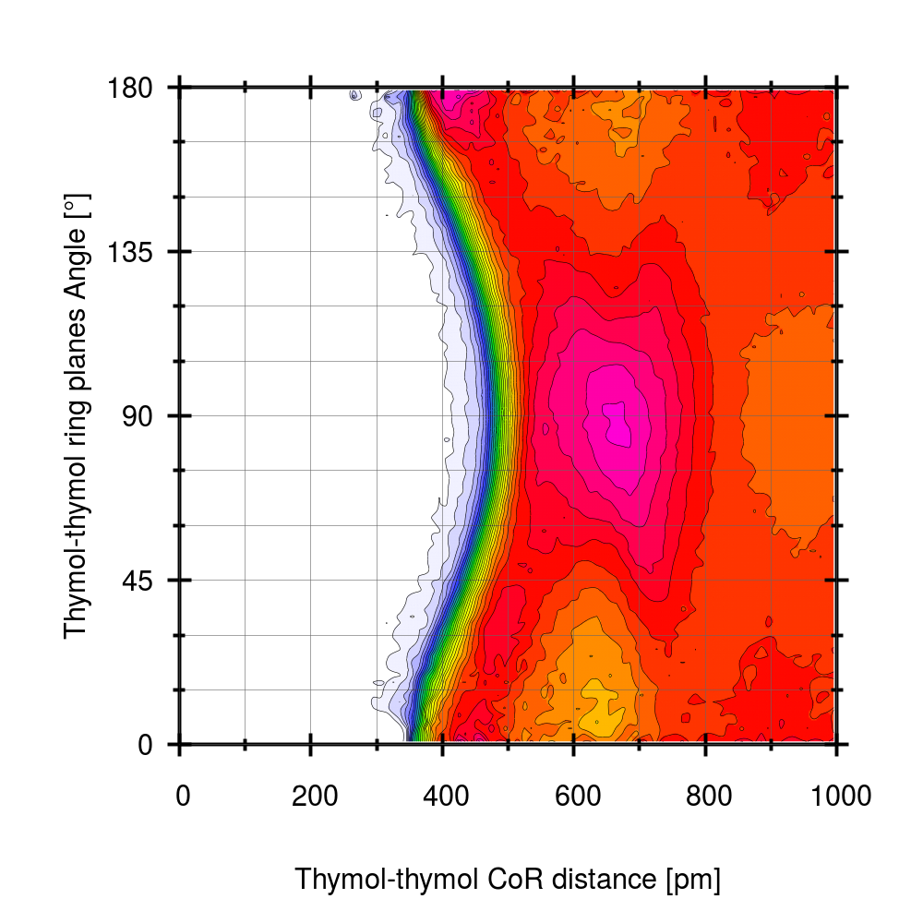 | 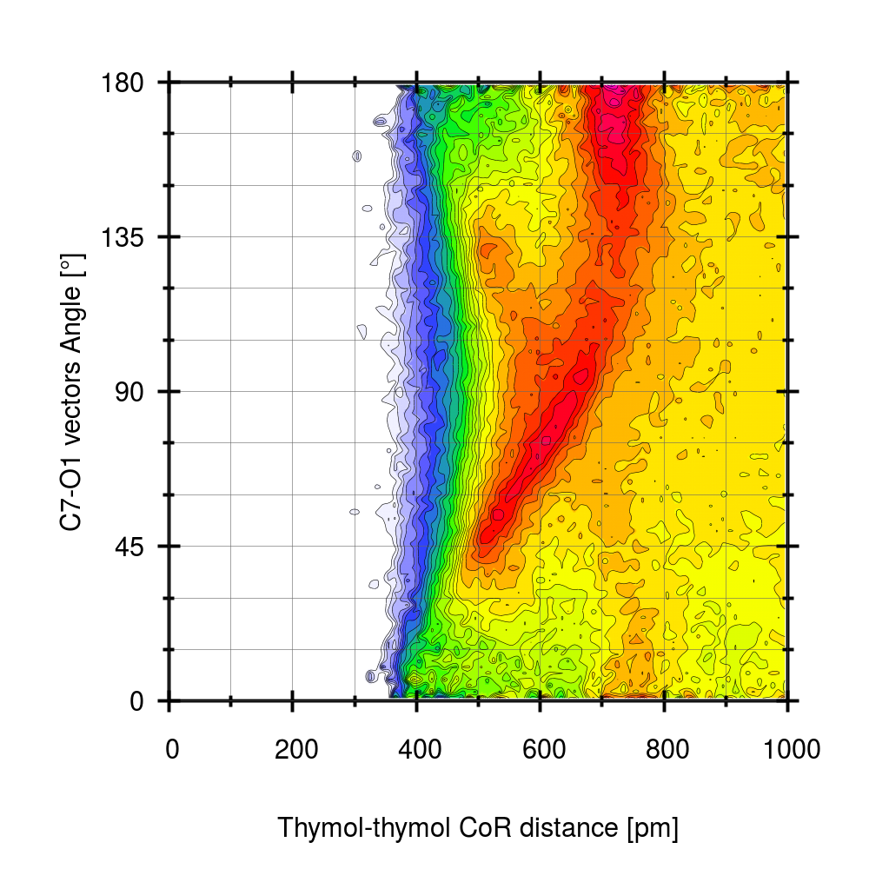

Figure 3. (left) MD-computed combined distribution function with CoR-CoR as an abscissa and the angle between ring perpendiculars as an ordinate. (right) MD-computed combined distribution function with CoR-CoR as an abscissa and the angle between vectors C7-O1 as an ordinate.
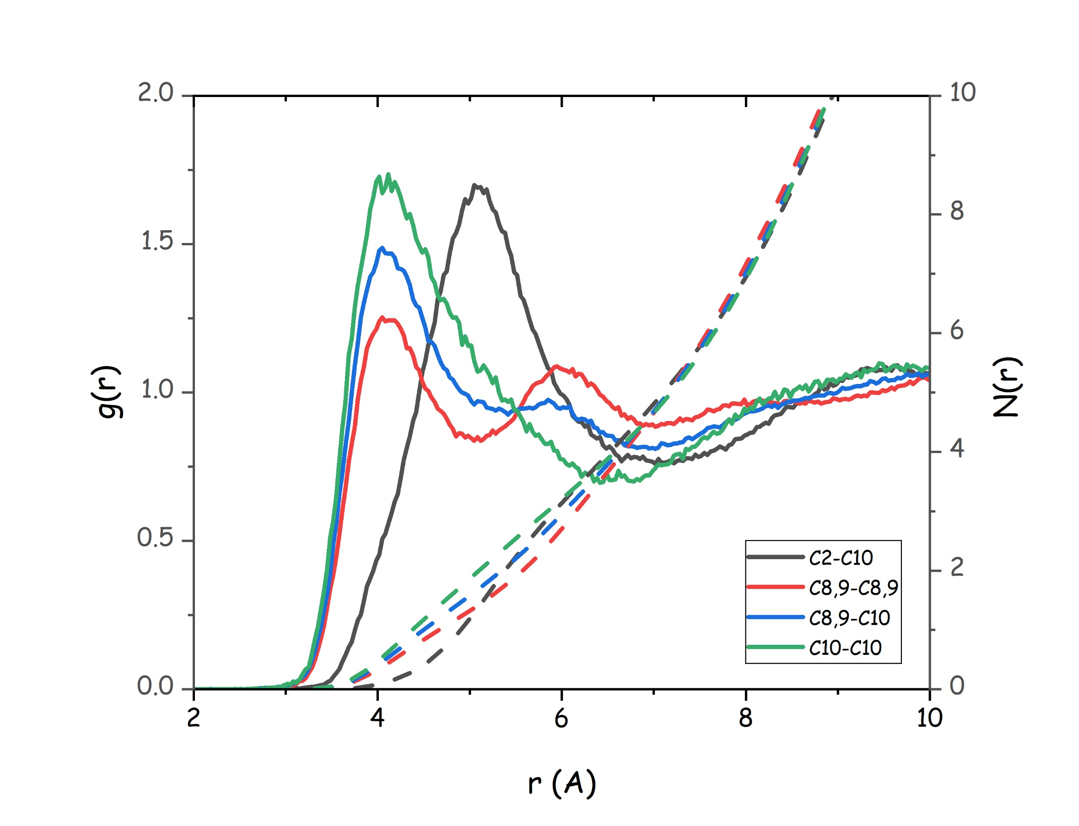
Figure 4. MD-computed pair distribution functions (continuous lines) and corresponding running neighbour numbers (dashed lines) of methyl groups correlations in the thymol-water mixture. Also included the C2-C10 correlation.
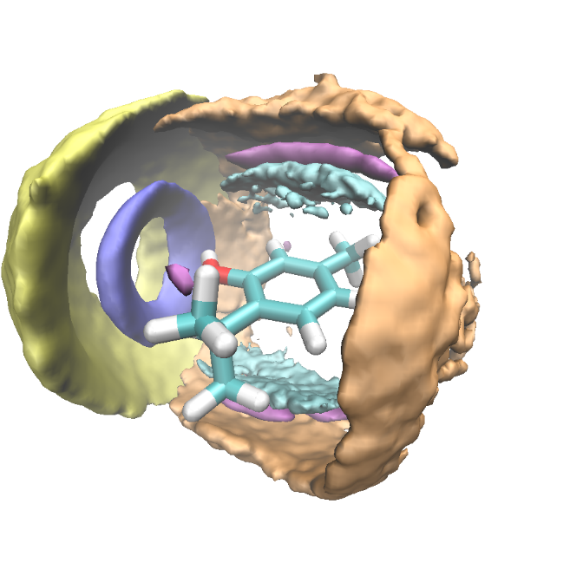
Figure 5. MD-computed spatial distribution function of thymol CoR (orange (close) and yellow (far) lobes), hydroxyl (cyano (close) and blue (far) lobes) and methyl (violet lobes) groups surrounding a reference thymol molecule.
Thymol hydroxyl groups are involved in hydrogen bonding interactions either with the π system or with the reference hydroxyl group. Such scenarios are further illustrated in the two cdfs, reported in Figure 6. Therein, it clearly appears the existence not only of an hydrogen bonding correlation between neighbour thymol hydroxyl groups, but also the existence of a distinct π···H-O hydrogen bonding correlation between neighbour thymol hydroxyl group and aromatic cloud. Figure S-2 in the ESI, illustrates the pdfs and corresponding running coordination numbers related to HB correlations involving thymol-thymol species. While the former is a short and monodisperse correlation, the latter is characterised by a wider distribution of H5-#3 distances. In particular, it appears that the distance H5-#3 is of the order of 2.8 Å, while the angle #3···H-O is >150°, in agreement with the literature existing for π···H-O HB.[49] A comparison with the corresponding pdfs for the case of neat thymol (at 353 K) shows a slightly larger number of oxygen atoms around H5 in the thymol –water mixture than in neat thymol and a slightly higher number of #3 around H5 in neat thymol than in the mixture.
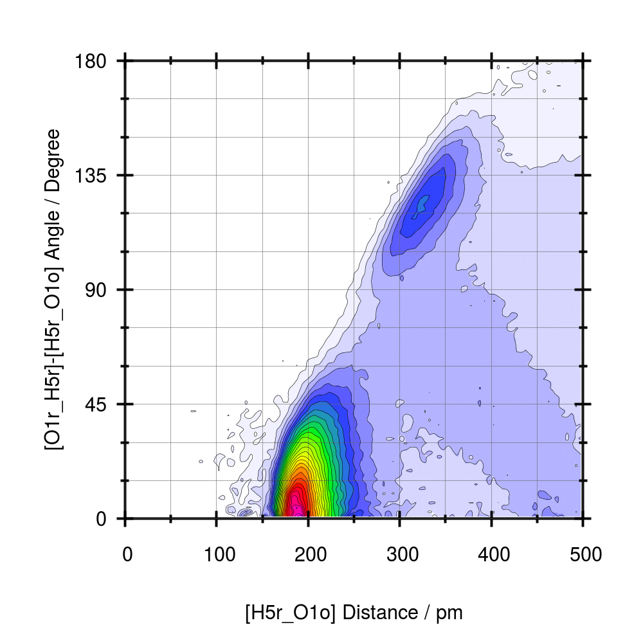 | 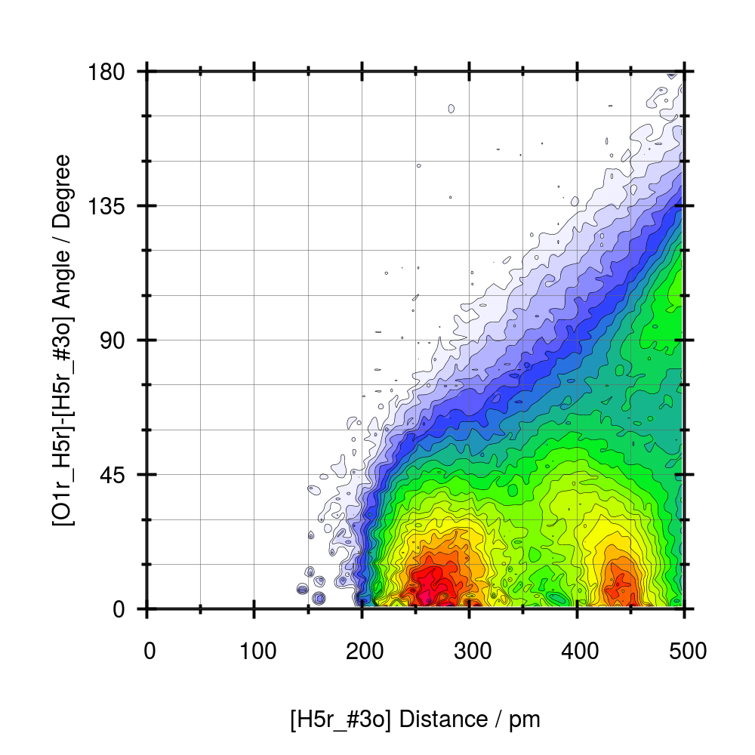
Figure 6. MD-computed combined distribution function concerning hydrogen bonding interactions between neighbour thymol/thymol molecules. (left) cdf referred to O1-H5···O1 with H5···O1 distance as abscissa and the angle between vectors : O1-H5 and H5···O1, respectively as ordinate. (right) cdf referred to O1-H5···#3 with H5···#3 distance as abscissa and the angle between vectors : O1-H5 and H5···#3, respectively as ordinate.
The overall results for the different HB related pairs are reported in Table 1. Therein values corresponding to thymol-thymol correlations are compared with corresponding quantities obtained for a simulation of neat thymol at 80°C. It can be noticed that thymol-thymol correlations via HB interactions are almost unchanged upon water addition, as a total of 0.66 thymol hydroxyl hydrogen atoms in HB related to thymol acceptor sites (either the oxygen atom or the center of the aromatic ring). We detect that in liquid thymol, each H5 is involved in interactions with 0.40 O1 and 0.33 #3 sites (for a total of 0.73 coordinating sites); in thymol-water, each H5 is coordinated by 0.44 O1, 0.22 #3 and 0.19 Ow (for a total of 0.85 sites). In thymol-water, we detect then an increased amount of hydrogen bonding mediated interactions around H5, as compared to neat thymol. Overall, then the presence of water, leads to a substantial increase of the total number of hydrogen bonding mediated interactions involving the thymol hydroxyl group.

Donor Atom (DA) | Acceptor Atom (AA) | Peak pos. (Å) | C.N. (No. Hs around reference AA) | C.N. (No. Os around reference DA) | C.N. in thymol (No. Hs around reference AA)
H5 (th) | O1 (thymol) | 1.95 | 0.44 | 0.44 | 0.40
H5 (th) | #3 (thymol) | 2.81 | 0.22 | - | 0.33
H5 (th) | Ow | 1.85 (1.81)ª | 0.19 | 0.9 | -
Hw | O1 (thymol) | 1.92 (1.95)ª | 0.09 | 0.435 | -
Hw | #3 (thymol) | 2.66 | 0.07 | - | -
Hw | Ow | 1.85 | 0.42 | 0.2 | -

Table 1. Coordination numbers of hydrogen atoms (either belonging to thymol hydroxyl group, H5, or to water, Hw) around reference acceptor sites (either water oxygen, Ow, or thymol hydroxyl oxygen, Oth, or center of aromatic ring (#3)). (ª) results from DFT calculations by Tiecco et al.[27]

3.2 Thymol-water correlations.
Despite being a minor component, water is supposed to play a role in influencing the structural organization of the present thymol-water mixture, considering the drop in in melting point and the possibility to establish hydrogen bonding mediated interactions with thymol hydroxyl group. In Figure 7, we report the pdf related to the potential establishment of HB interactions between thymol and water. In particular we show: a) the O1-H5···Ow (left) correlation that is characterised by a strong peak centred at 1.85 Å and corresponds to a number of 0.19 hydrogens surrounding water’s oxygen; b) the Ow-Hw···O1 (center) correlation that is characterised by a peak centred at 1.92 Å and corresponds to a number of 0.09 surrounding hydrogens and c) the Ow-Hw···#3 (left) correlation that is characterised by a weak though appreciable peak centred at 2.7 Å and corresponds to a number of 0.07 surrounding hydrogens, correlated to the thymol ring centred through π···Hw-Ow hydrogen bonding (see Table 1). It appears that in the present mixture, thymol is involved not only in HB interaction with other thymol molecules, with essentially unaffected coordination numbers with respect to the neat thymol case, but it also interacts with water through HB interactions. In particular, thymol hydroxyl H5 interacts with water oxygen, so that a total of 0.85 H5 are involved in HB interactions with different acceptor sites, either belonging to thymol or to water: such a figure can be compared with the corresponding number of 0.73 H5 involved in HB interactions in neat thymol. Moreover, thymol can act as a HB acceptor entity, interacting with water hydrogen atoms, for a total of 0.16 Hw involved. Overall then we observe a higher content of HB interactions involving thymol in the mixture than in neat thymol. We also monitored more complex, HB-mediated interactions between water and thymol. Figure 8 (top) shows the pdf between Ow and O1; in agreement with related results from other pdfs, a clear correlation can be detected at ca. 3 Å that corresponds to a number of thymol molecules around a reference water molecule of ca. 2. Driven by this evidence we monitored the nature of such a kind of interaction and detected a common structural feature across the simulated system, which is represented in Figure 8 (bottom). Therein, it clearly emerges that water can efficiently correlate with two neighbour thymol molecules, through HB interactions (we notice that this finding agrees with those reported in Tiecco et al. [27]). These figures indicate the role of water that, although a largely minor component of the present mixture, yet is able to interact with the thymol hydroxyl group both through conventional hydrogen bonding and π···H-O hydrogen bonding. This latter feature is further illustrated by the spatial distribution function of water hydrogen atoms around a reference thymol molecule: Figure 9 reports such a distribution. Therein the presence of conventional Ow-Hw···O_{thymol} HB is evident, as indicated by the circularly symmetric distribution around the thymol oxygen atom (blue lobe). However, the clear presence of water distribution both above and below the thymol ring plane can be observed (cyano lobe), highlighting the complex coordination of water towards thymol that was earlier anticipated in view of CoM pdf analysis. Together with a conventional interaction, our simulation detects the presence of a distinct Ow-Hw···π correlation that further enables thymol solvation by water.
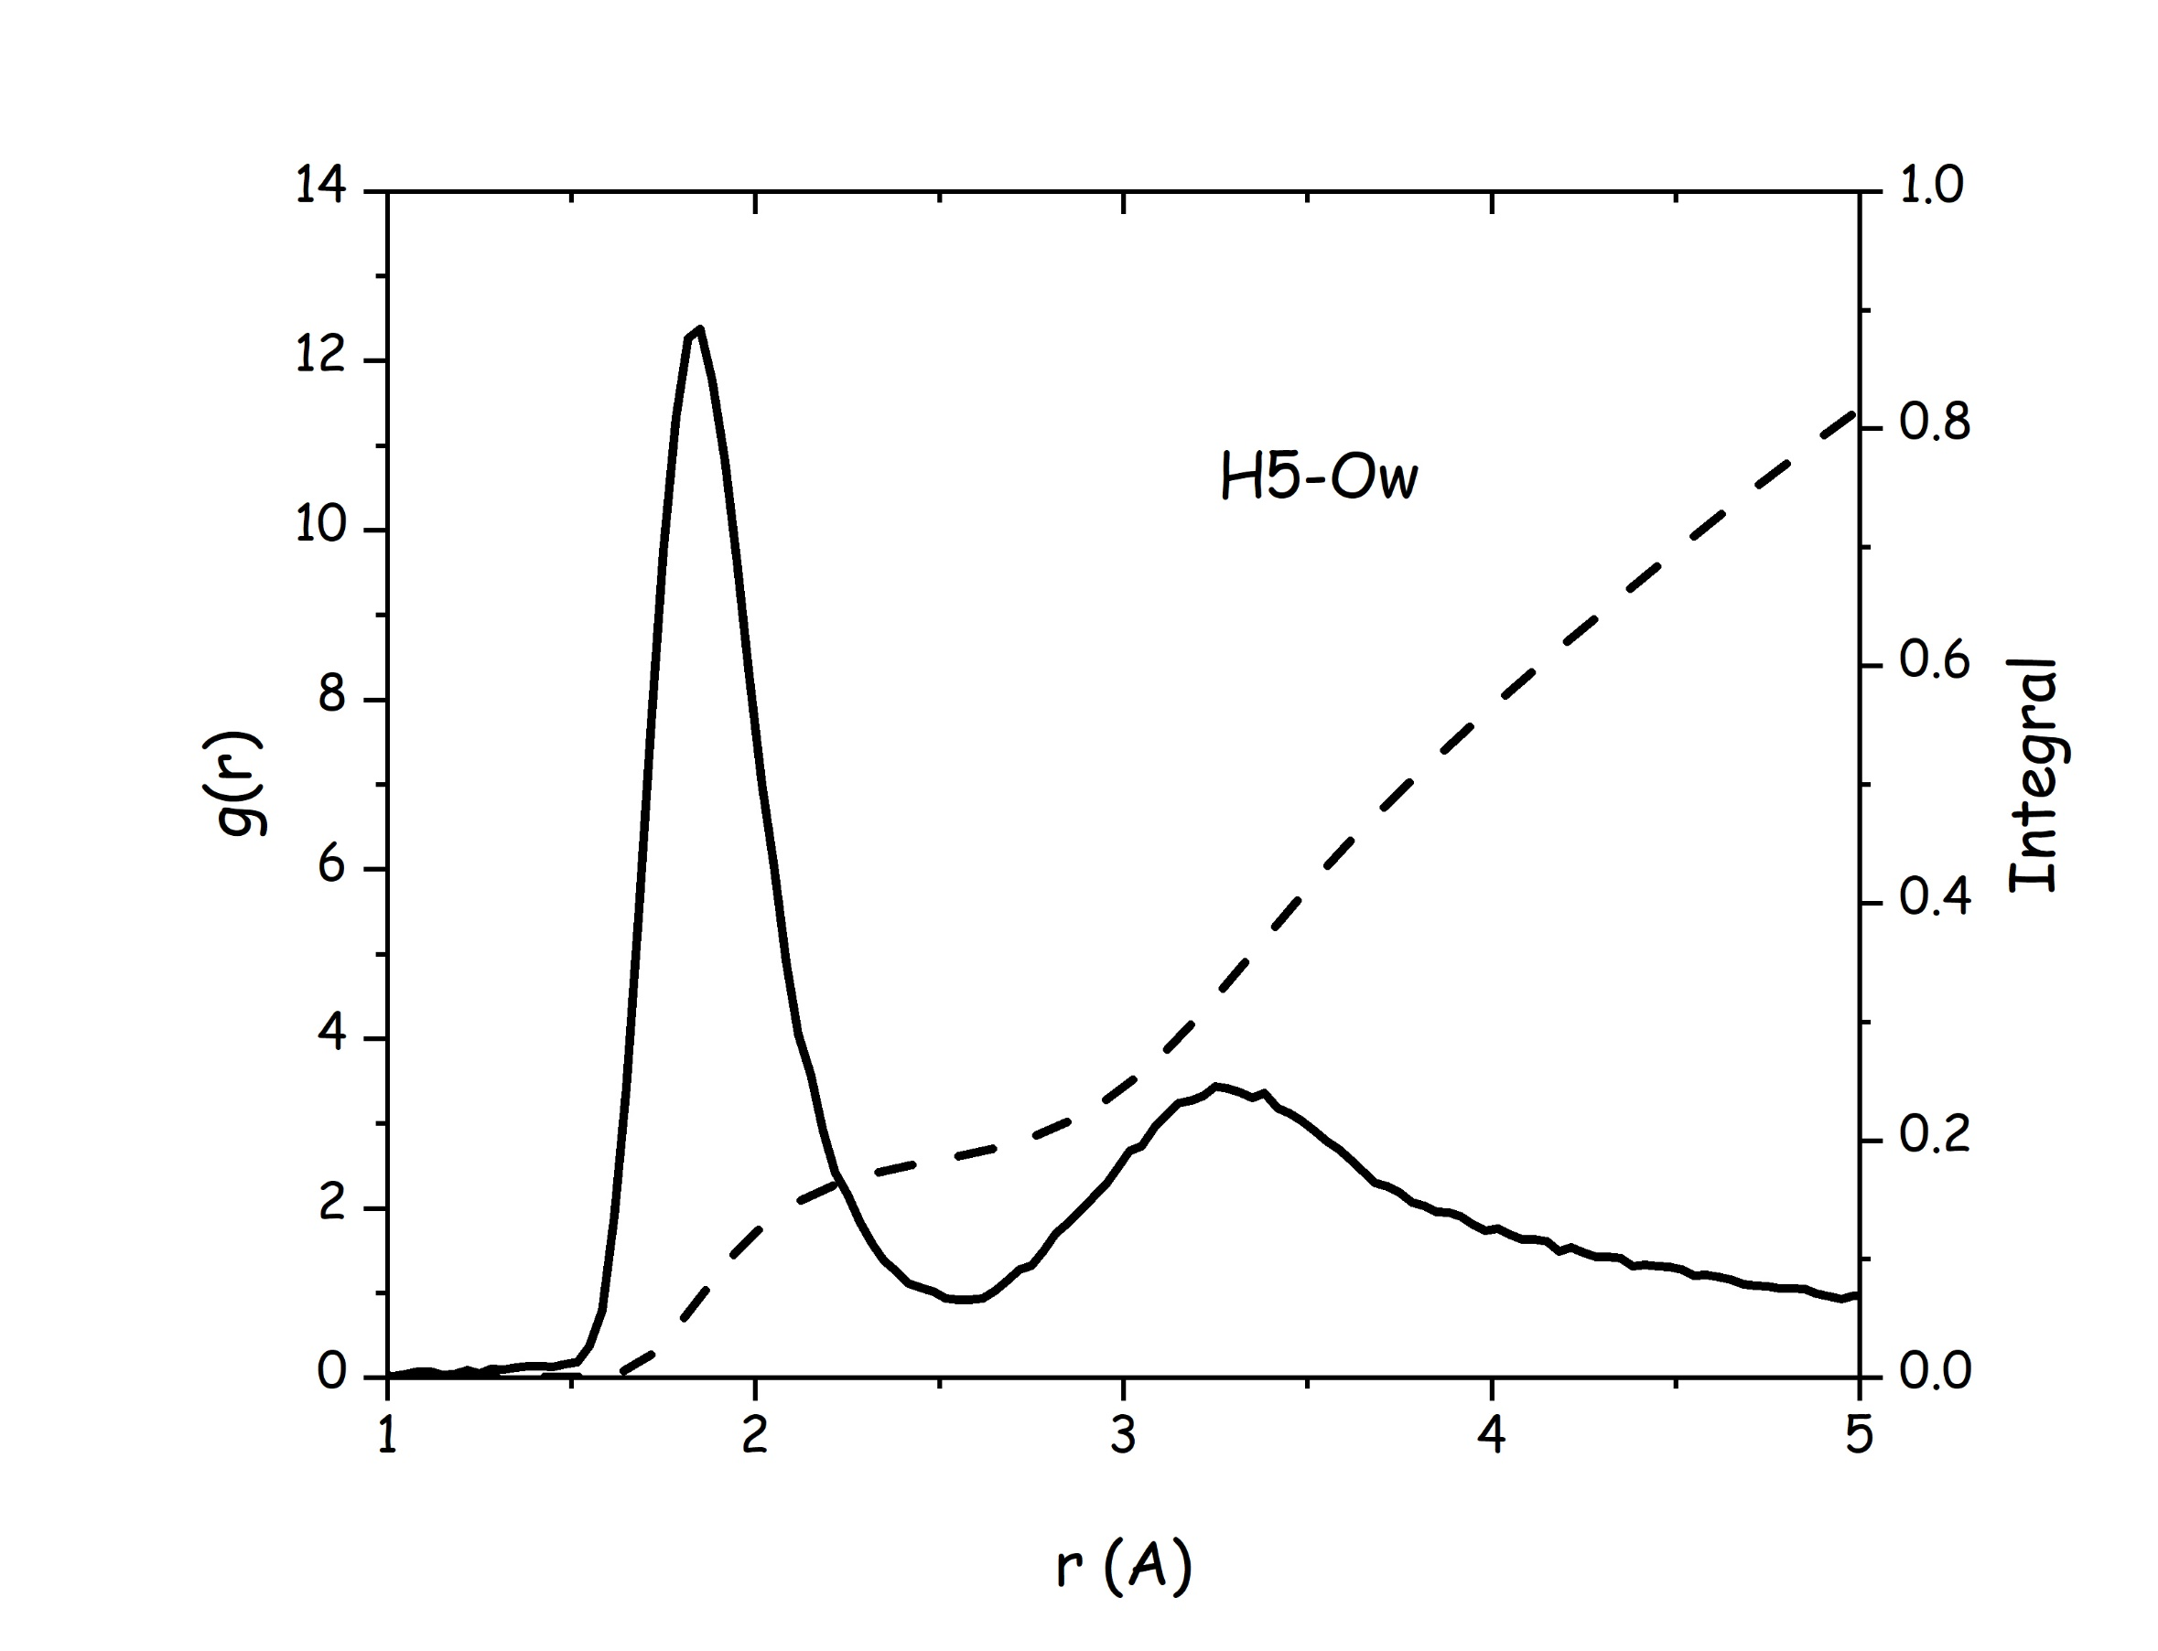 | 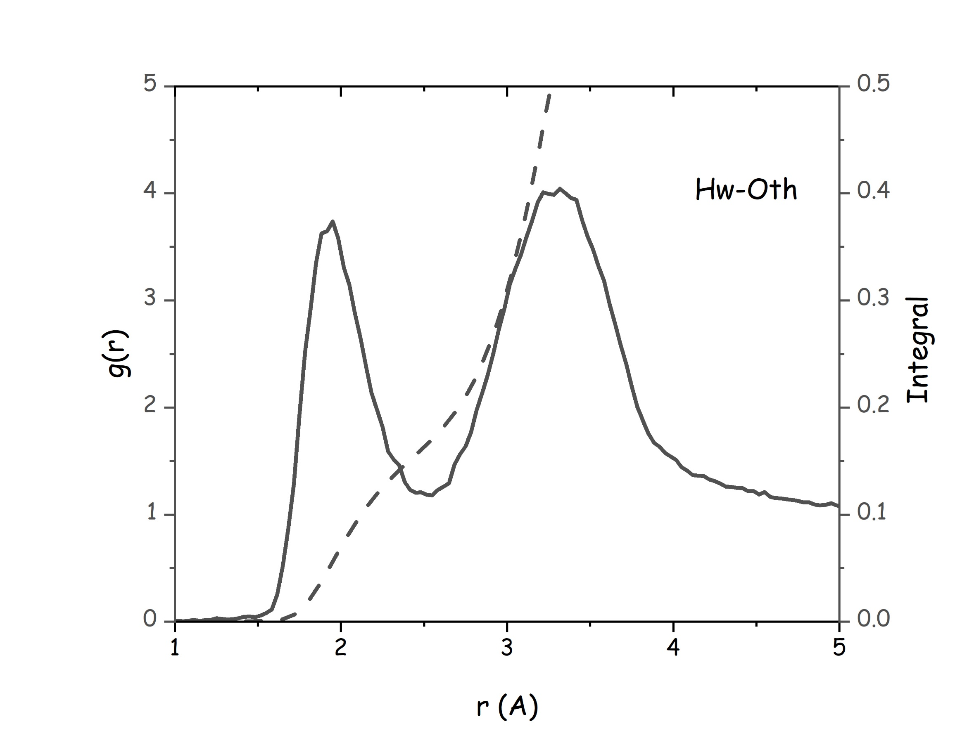 | 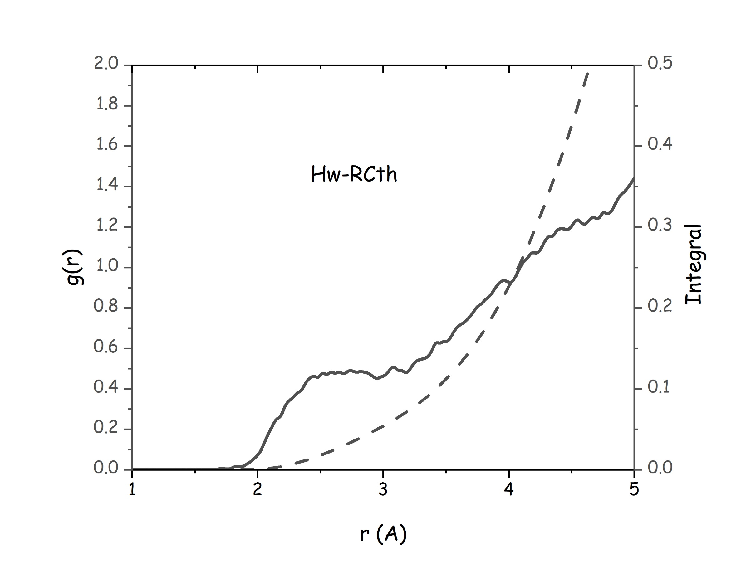
Figure 7. MD-computed pair distribution functions (continuous lines) and corresponding running neighbour numbers (dashed lines) related to thymol-water HB correlations in the thymol-water mixture: (left) thymol H5- water oxygen; (center) water hydrogen- thymol oxygen and (right) water hydrogen – thymol center of ring.

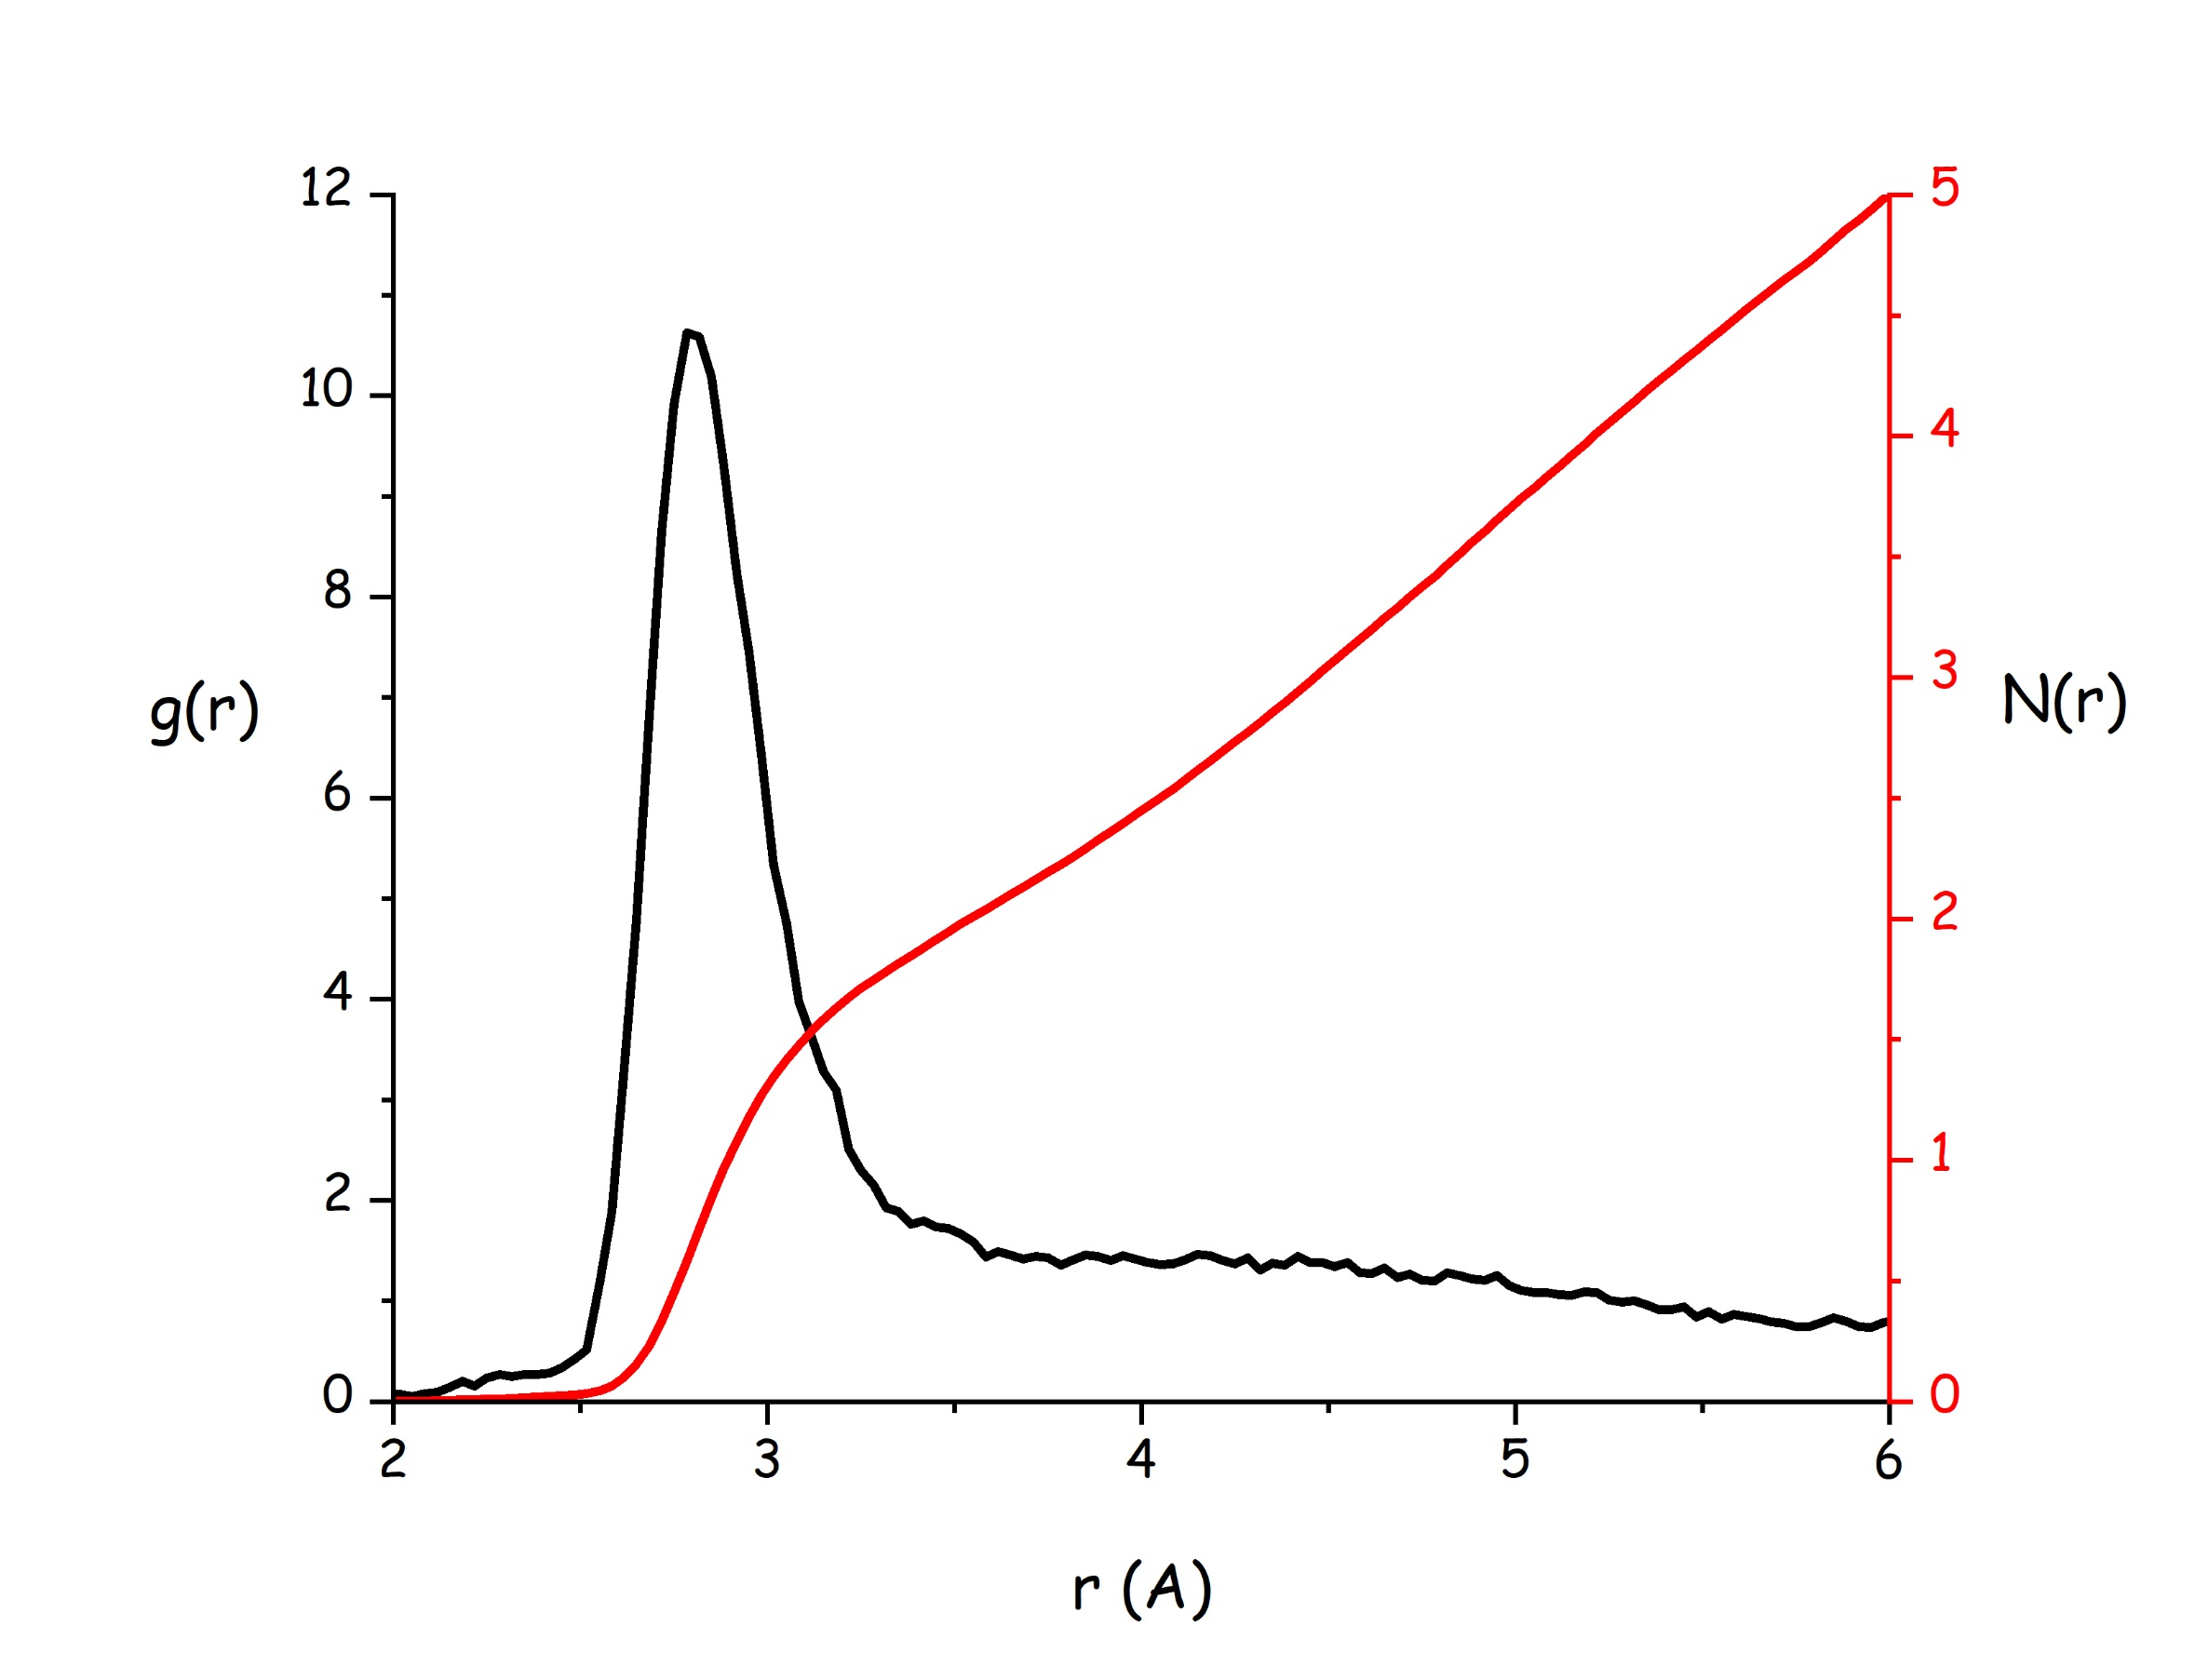
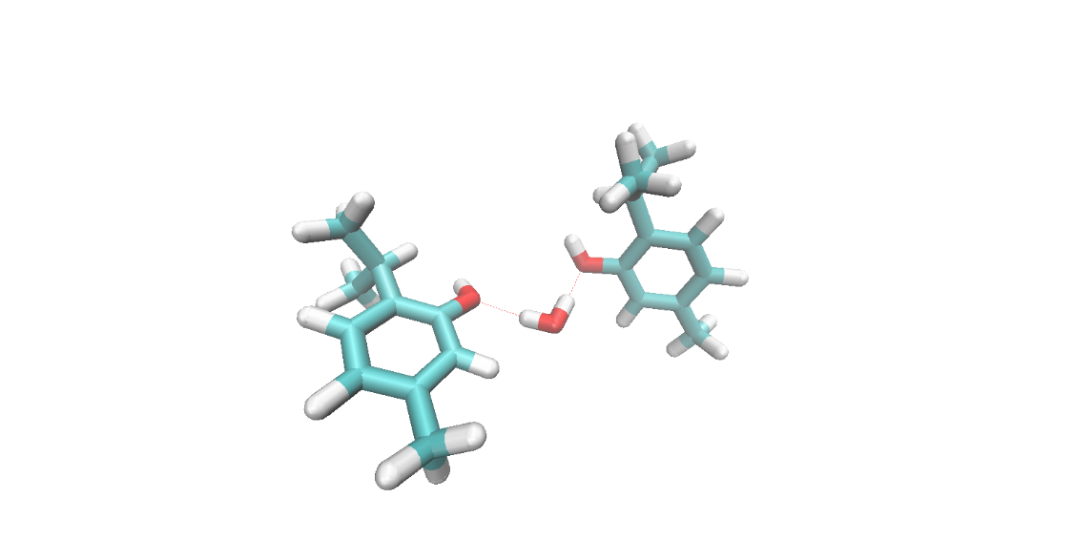

Figure 8. (top) MD-computed pdf of water oxygen- thymol oxyge in thymol-water mixture. (bottom) representative snapshot isolating two neighbour thymol molecules that are hydrogen bnding correlated with a coordinating water molecule.
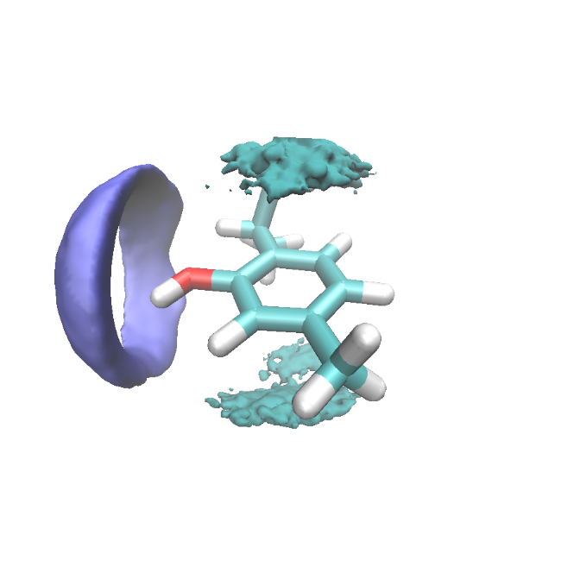Figure 9. MD-computed spatial distribution function of water hydrogen (cyano (close) and blue (far) lobes) surrounding a reference thymol molecule.

3.3 Water-water correlations.
The limited number of water molecules in the thymol-water mixture most likely hinders the formation of an extended HB-based network among water molecules; nevertheless, residual evidences of tetrahedral order in water-water correlations can be detected, at least on the basis of the presence of peaks in the Ow-Ow rdf (see Figure 10), with a first peak at 2.8 Å and the presence of a feature centred at 4.5 Å. The first Ow-Ow correlation involves one first neighbour at 3.5 Å distance from the reference one, to be compared with the value of n_{Ow-Ow}=4.24 proposed by Skinner et al. for bulk water.[50] Ow-Hw rdf is characterised by a distinct peak centred at 1.8 Å, with a number of first neighbours of 0.42 hydrogens surrounding the reference water oxygen. Evidences of water-water correlations can also be detected by means of a statistical tool that determines the existence and extent of water molecule chains, on the basis of the hydrogen bonding geometrical criteria to determine the connection between neighbour molecules (d_{O··H}<2.5 Å and angle_{O··H-O}>150°). Such a chain length distribution is shown in Figure 11. While ca. 75% of water molecules are not interacting with any other water molecule (n=0), one appreciates the remaining water molecules are bound to a maximum of ca. three water molecules and longer chains have very small occurrence in the system. As an example, the case of n=1 (just one water molecule connected to the reference one) has a population of ca. 15%. Of course then this information indicates that water molecules are mostly correlated to thymol molecules, with different possible topologies, including the one previously indicated with one water molecule bridging two neighbour thymol molecules. Accordingly, no HB driven pure water network can get established in this system, as only a few water molecules can connect with each other, due to the large dilution of this system, where water can also efficiently interact with thymol.
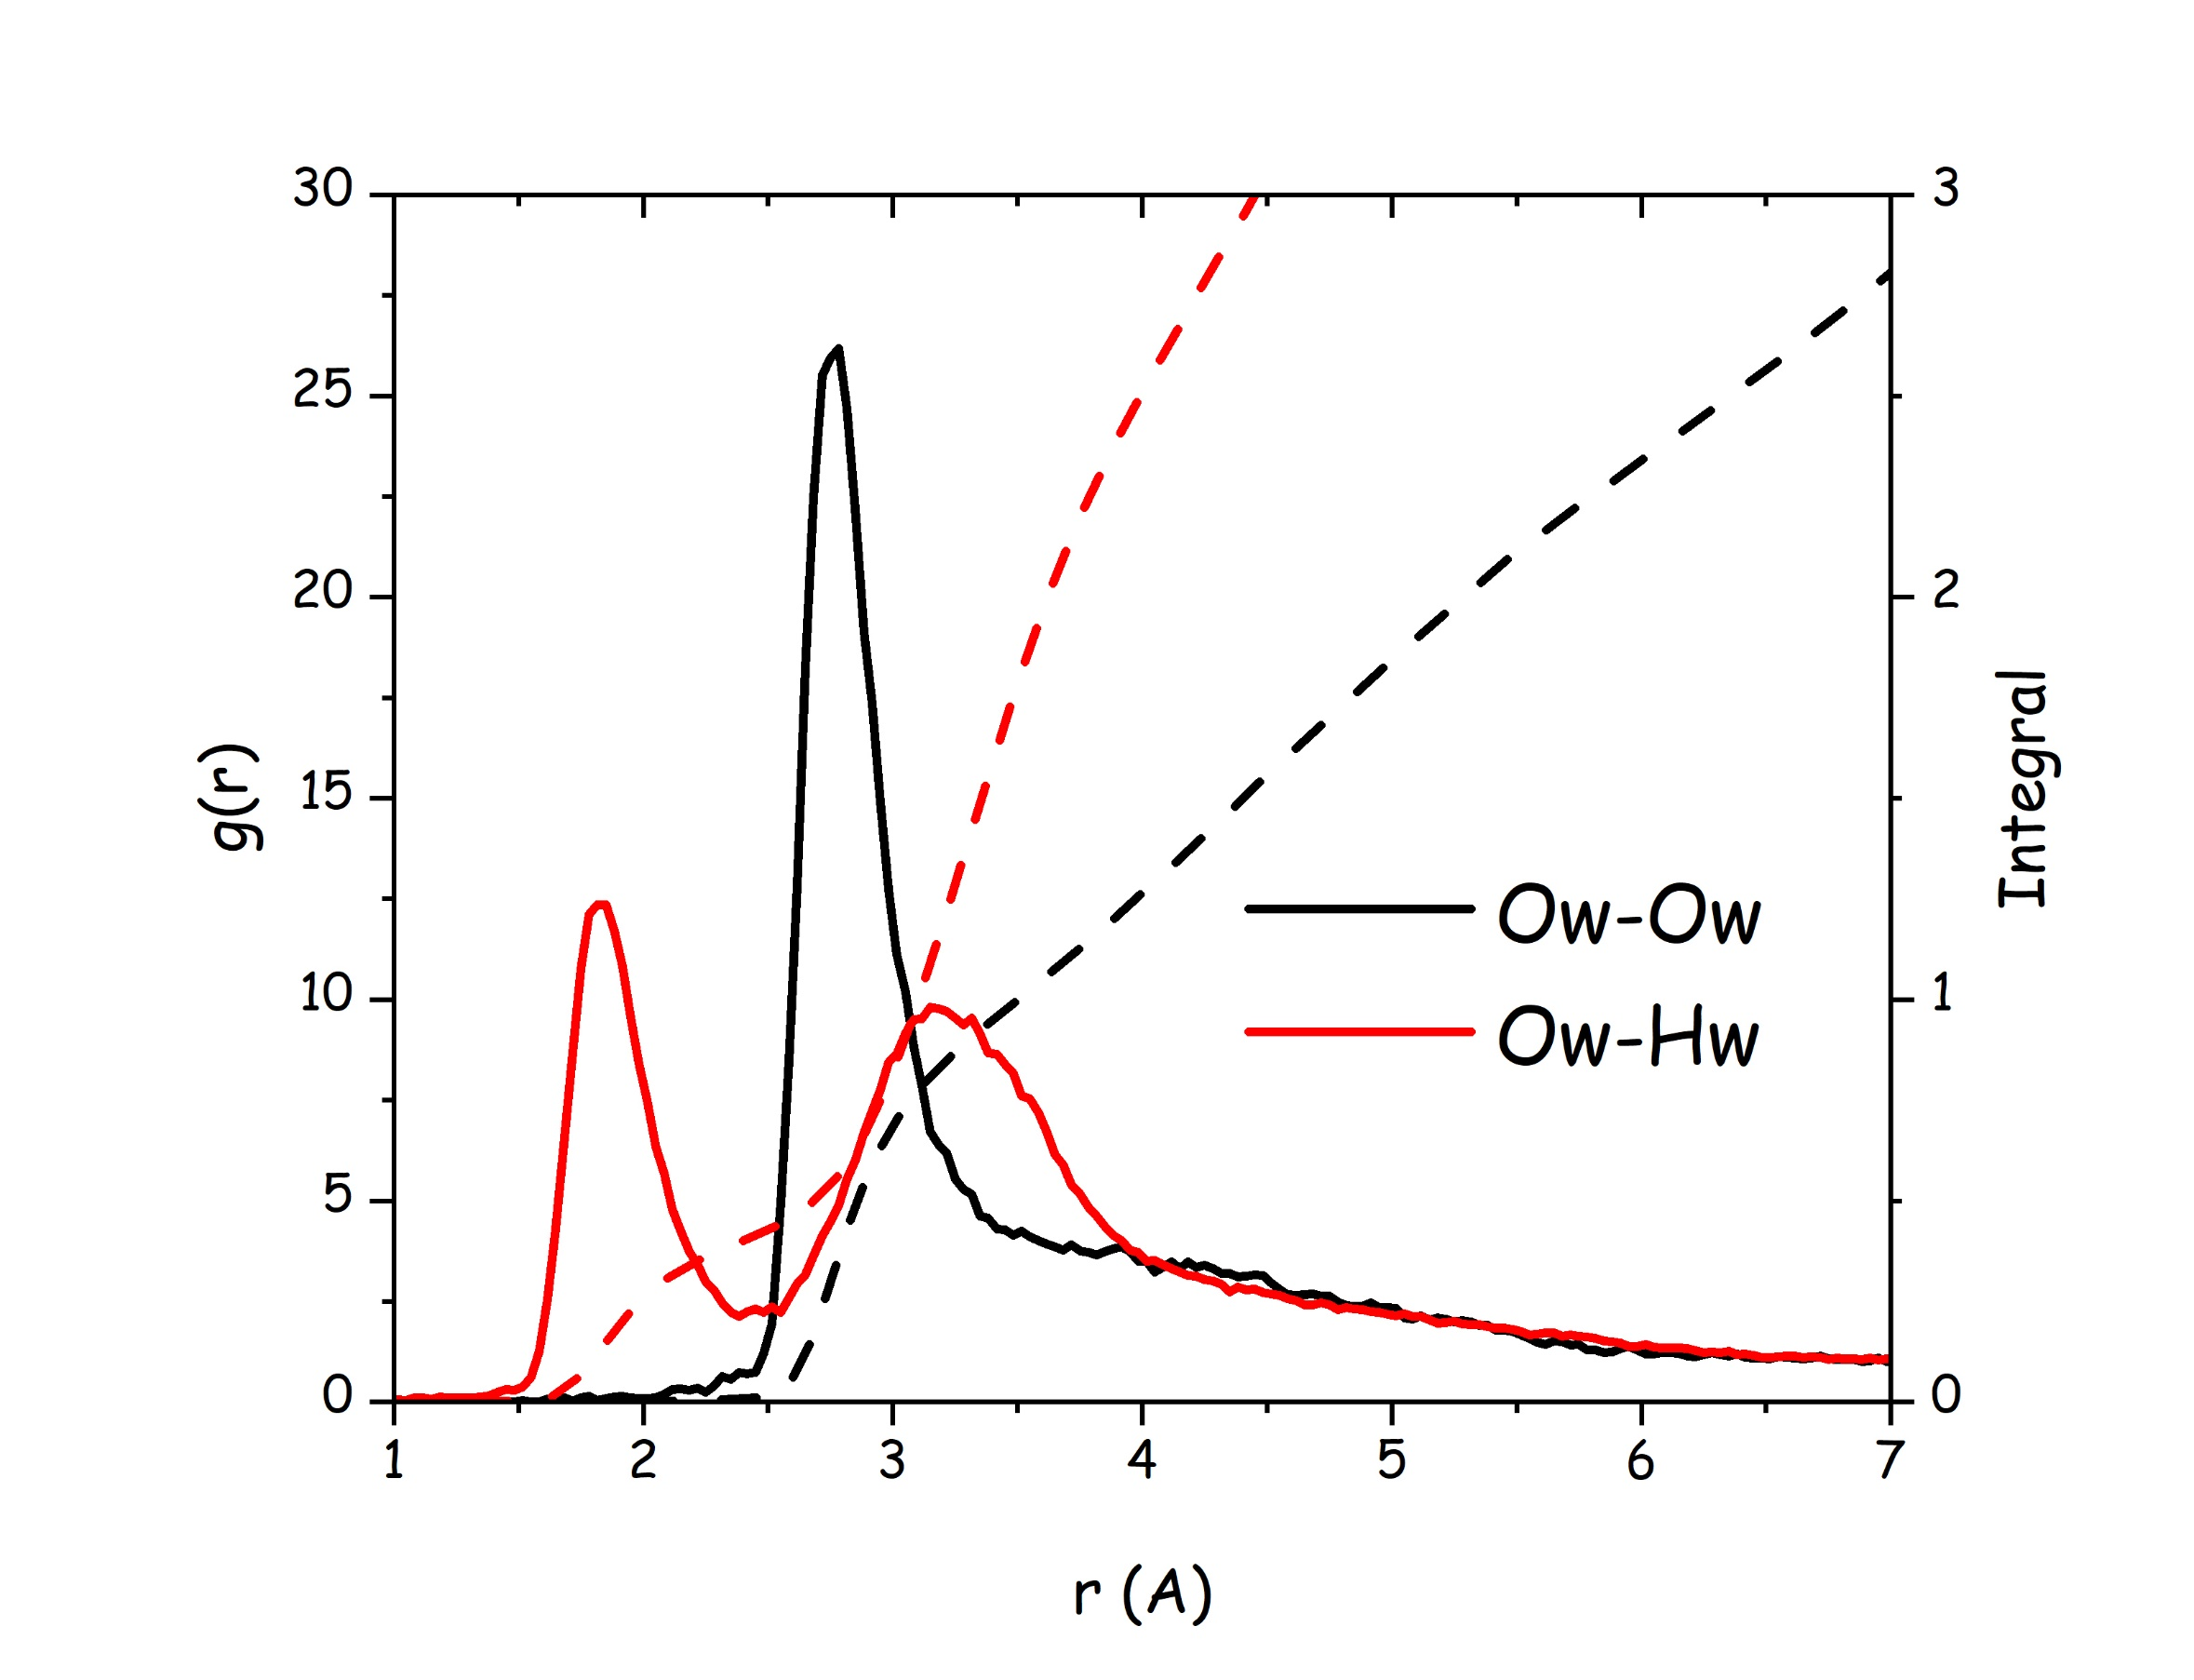
Figure 10. MD-computed radial distribution function of water-water correlations, namely Ow-Ow and Ow-Hw pairs and the corresponding coordination running numbers.
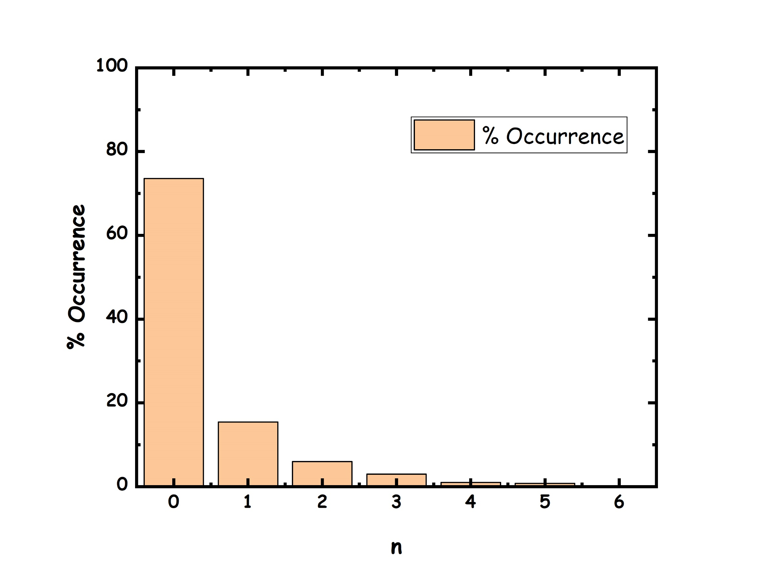
Figure 11. Chain length distribution of water molecules connected through hydrogen bonding interaction.
3.4 An overview of hydrogen bonding interactions.
In order to better clarify matters concerning the hydrogen bonding mediated interactions, we applied the cmat (connection matrix analysis) analysis[43] to the thymol-water system and the corresponding results that are reported in Figure 12 illustrate such an exercise. Therein, pdfs related to HB interactions between donor atoms (H5 from thymol and Hw from water) and acceptor ones (O1 from thymol and Ow from water) are analysed and a graphical description is shown accounting for the pdf peak position and height. It clearly emerges how water oxygen is characterised by short (r<1.9 Å) and intense (height >15 nm⁻³) pdf peaks with both kind of hydrogen atoms, but with stronger interaction with H5. Thymol oxygen interacts in equivalent ways with both water H and thymol H. All these hydrogen bonding interactions look short and relatively straight, as indicated by the combined distribution functions reported in Figure 13.
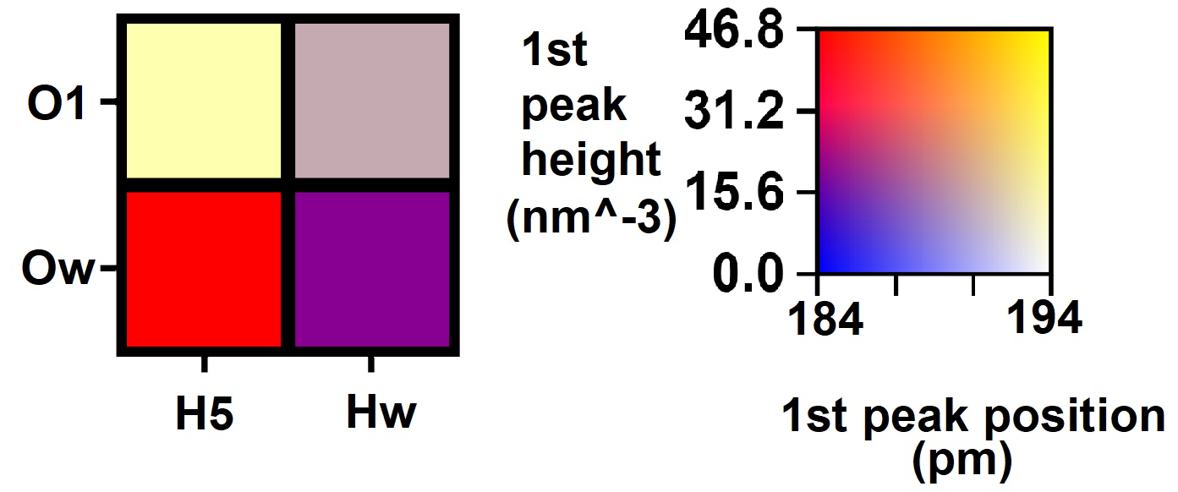
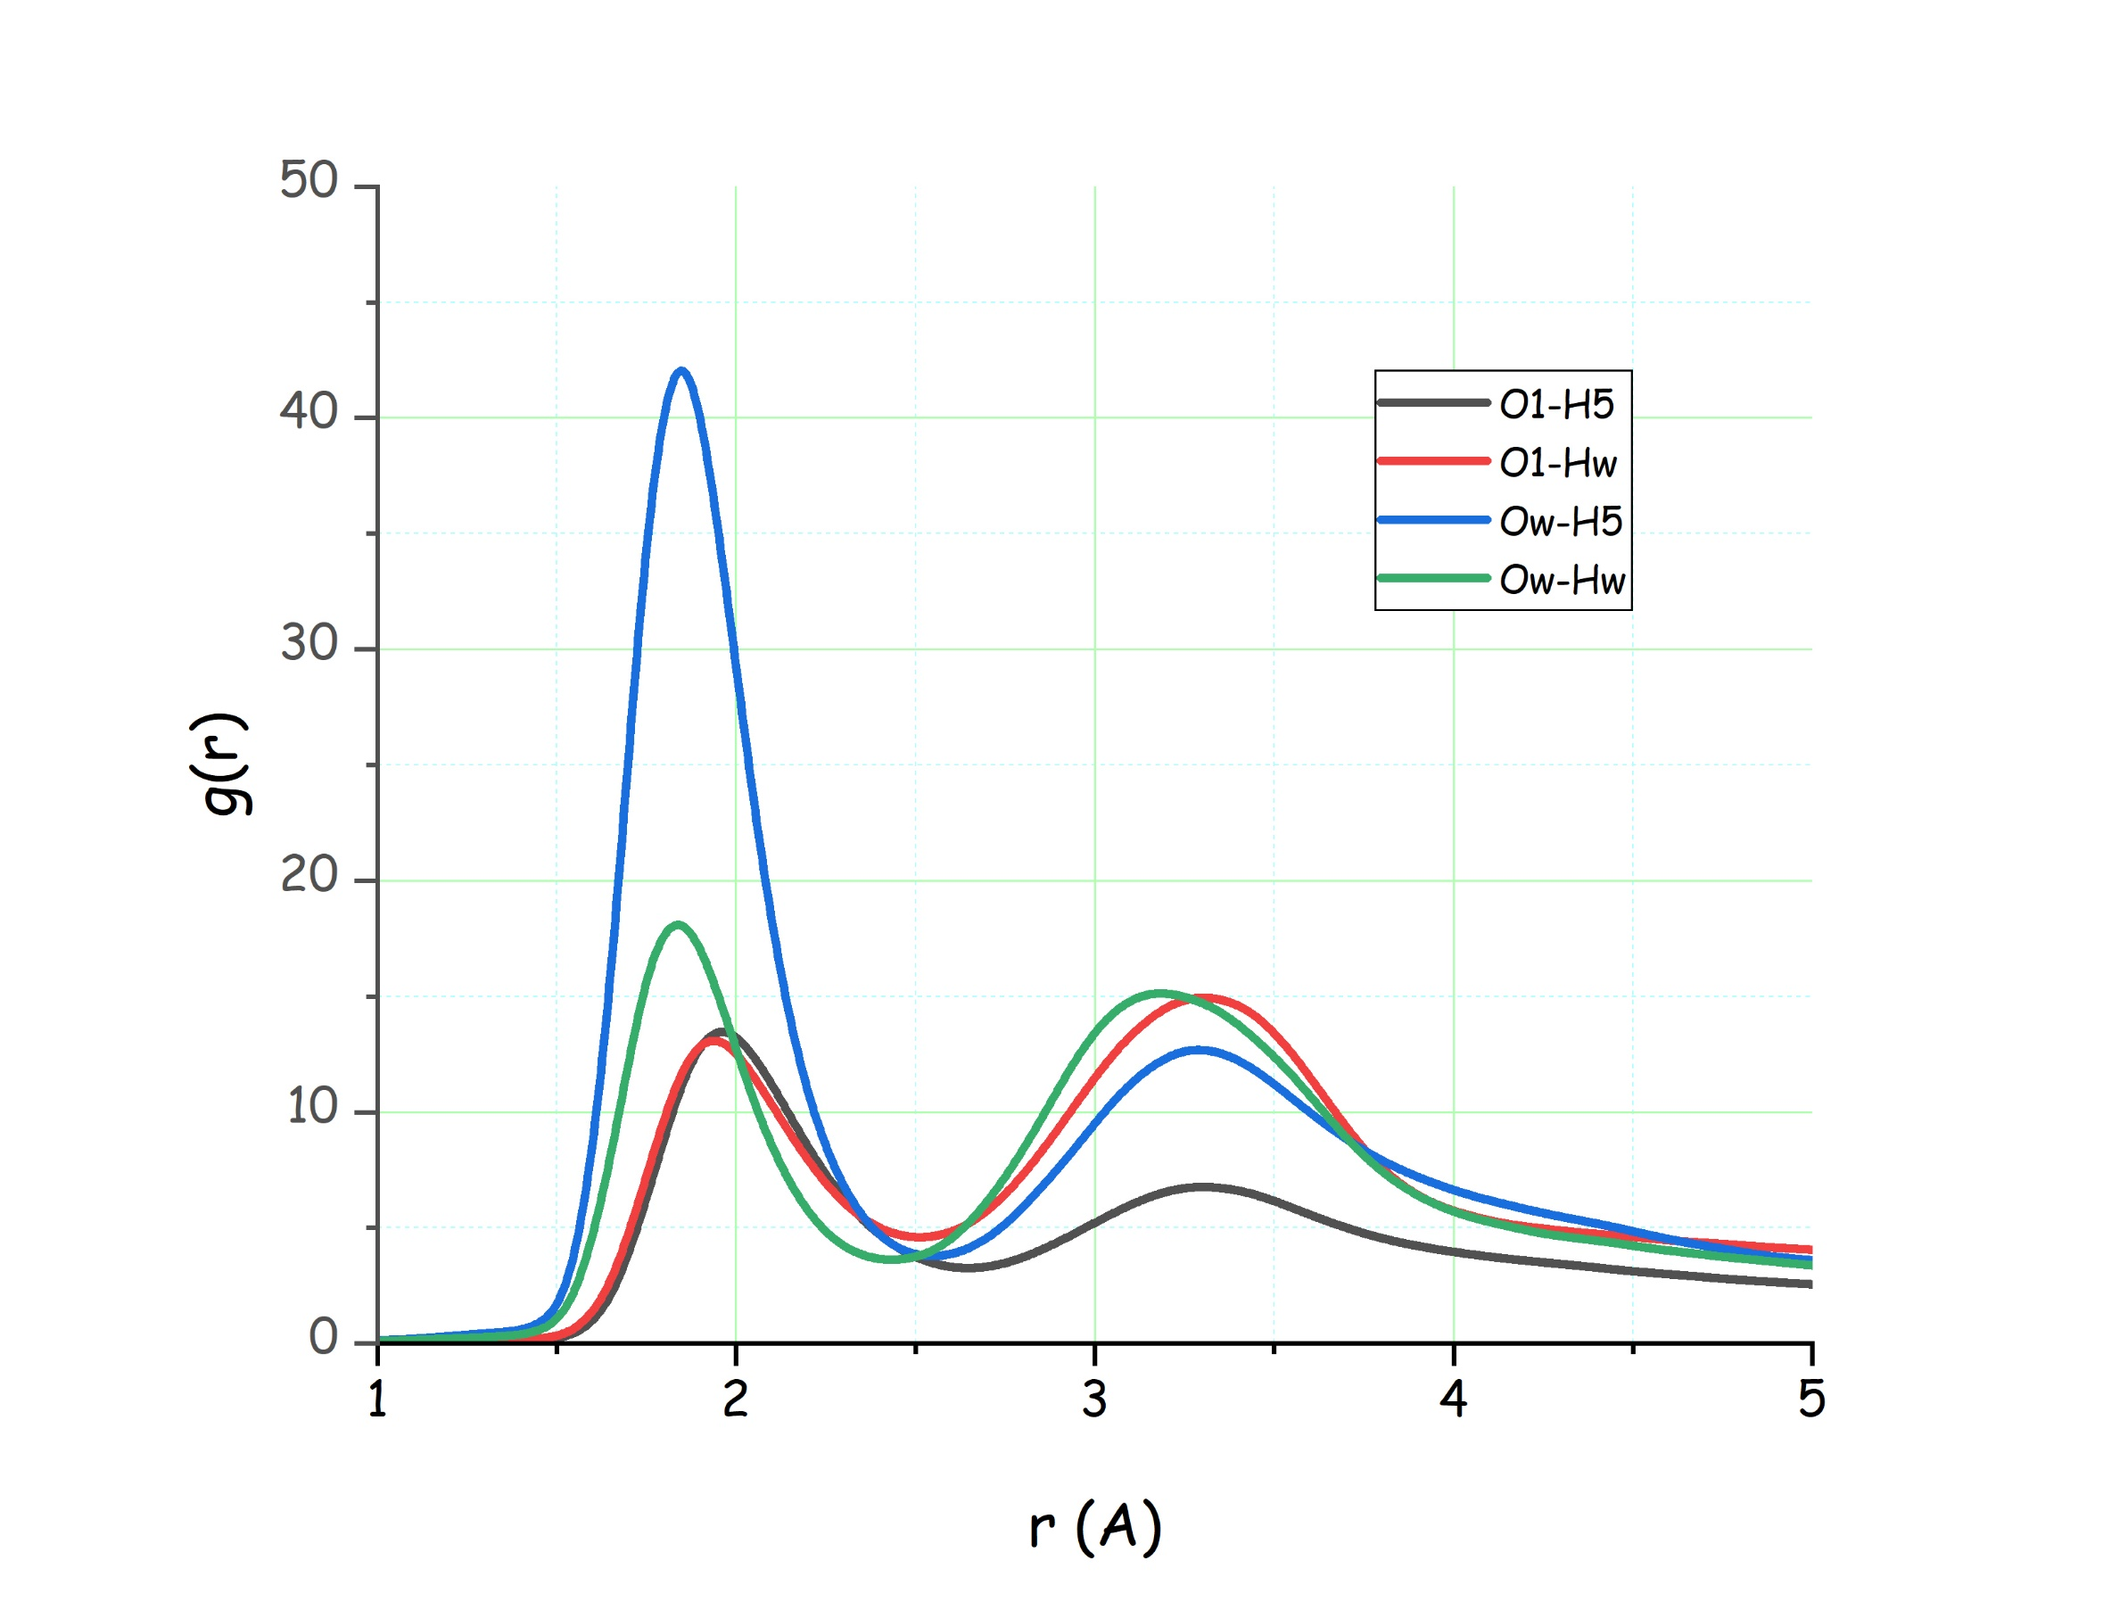

Figure 12. (top) Connection matrix analysis accounting for HB interactions in thymol-water mixture. Rows refer to HB acceptor atoms (O1 from thymol and Ow from water); lines refer to HB donor atoms (H5 from thymol and Hw from water). The colour map at right helps in determining position and height of the peak of the corresponding pdf. (bottom) Pdfs related to the analysis reported in the top figure.
The overall observations on the major role played by water in engaging different HB-mediated correlations with thymol are particularly interesting also in order to rationalise the liquid behaviour of thymol-water mixture. The solid state of thymol is characterised by an ordered configuration where a thymol hexamer is strongly connected by hydrogen bonding correlation between the hydroxyl groups.[51] It then appears that water succeeds in deeply interpenetrating the thymol structure, establishing the formation of HB mediated correlations with thymol and strongly hindering the formation of homomolecular, ordered HB correlations that would lead to the development of thymol crystalline phase and, correspondingly, facilitating the persistence of the liquid state for the mixture even at relatively low temperatures, as compared to neat thymol melting point. Experimentally, one observes that further addition of water leads to phase separation between the DES and the extra water, hence the hydrophobicity of this DES. It can be argued that the limited amount of water present in the mixture is enough to deconstruct the neat thymol HB network, through the water intrusion; additional water, however, would structurally organise by developing water-water HB-mediated interactions and water clusters would progressively develop and eventually phase separate from the hydrophobic eutectic.
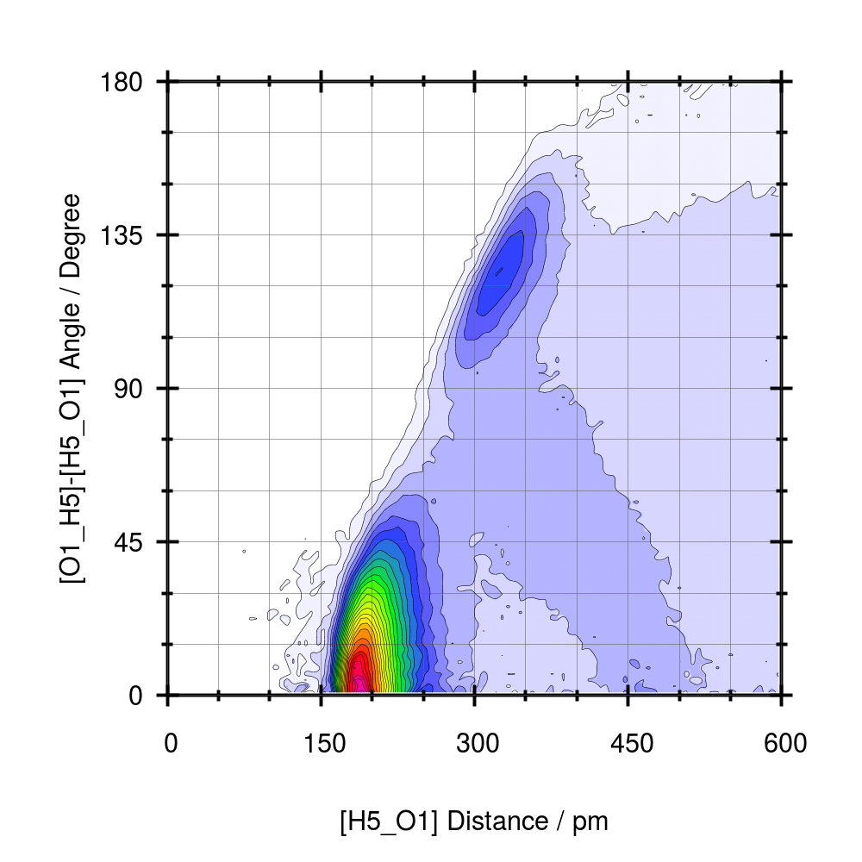  a) | 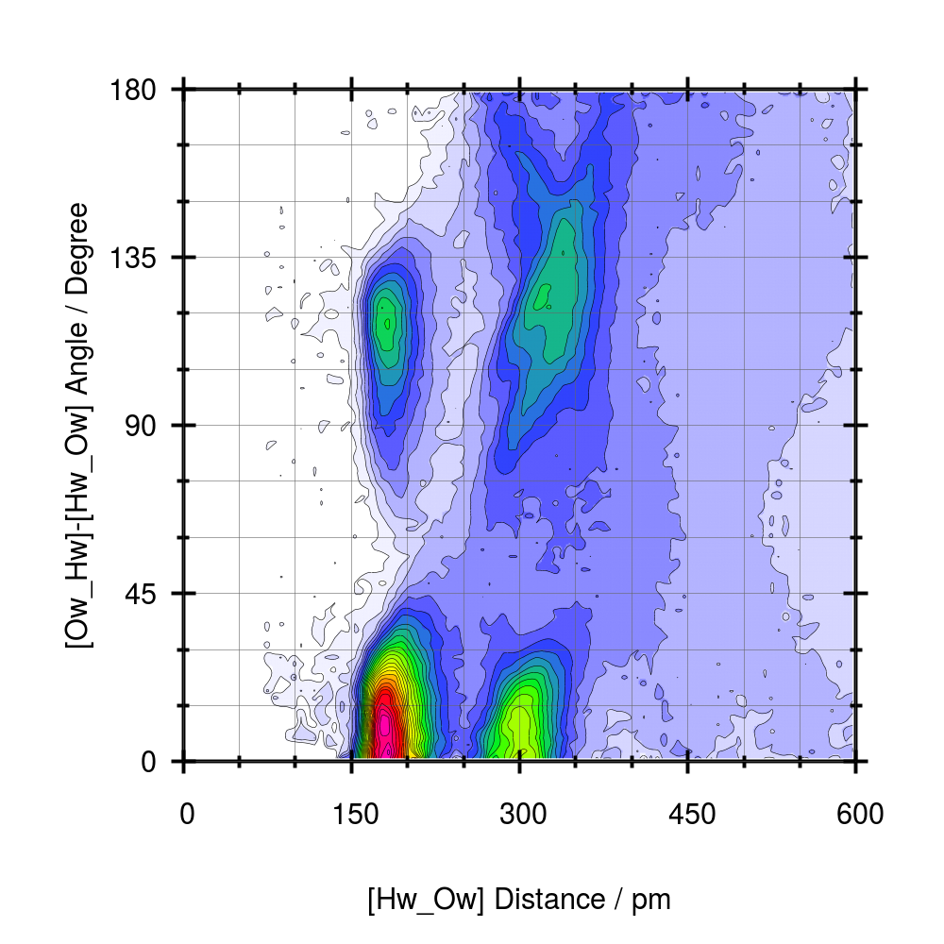  b)
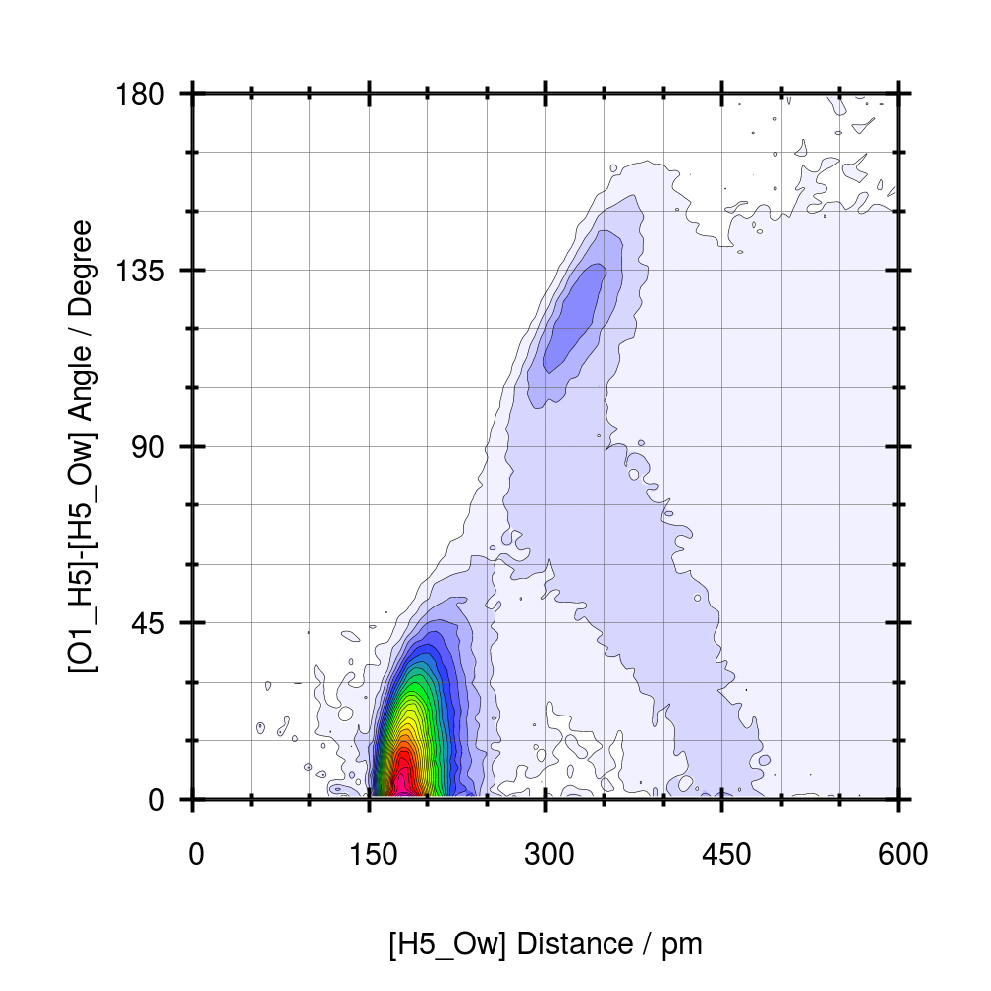  c) | 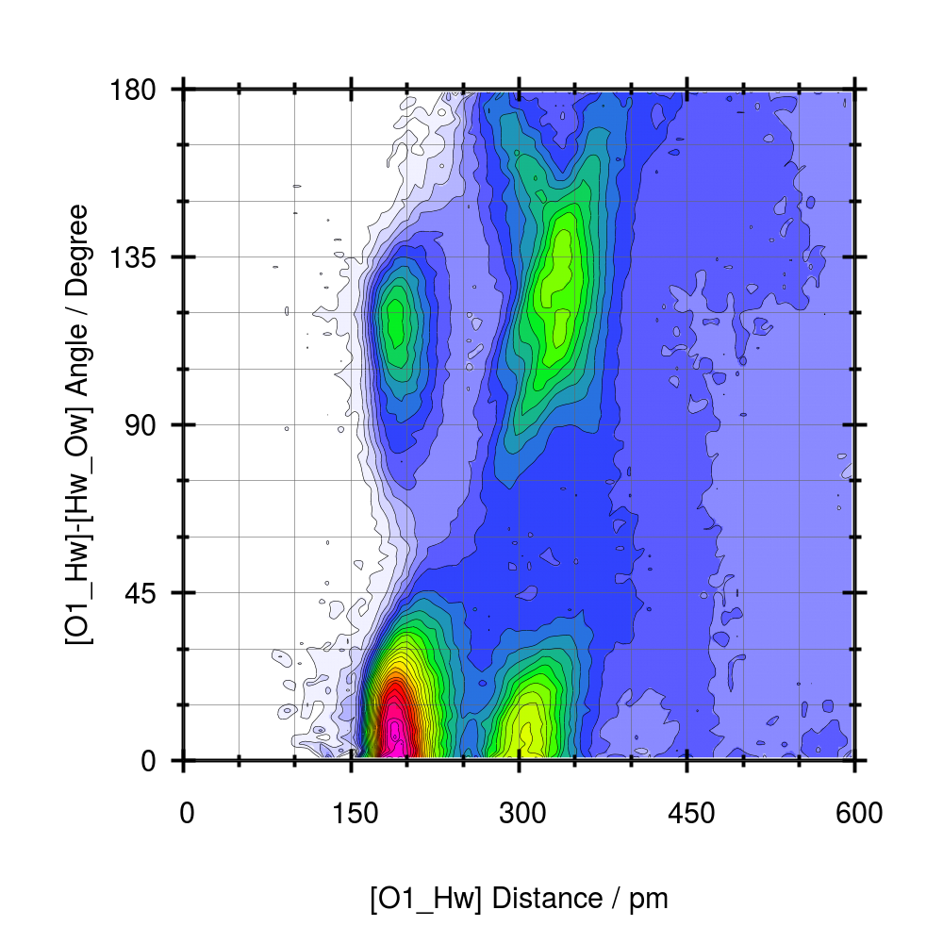  d)

Figure 13. Combined distribution functions related to Hydrogen Bonding interactions in thymol-water mixture. The plots refer to the following donor-acceptor pair: A) thymol-thymol; b) water-water; c) thymol-water; d) water-thymol.
3.4 Mesoscopic order.
The presence of the low Q peak highlighted in the discussion on the X-ray scattering patterns at ca. 0.6 Å⁻¹ represents the fingerprint of structural correlations encompassing multiple molecular entities, considering that Bragg’s law suggest a correlated spatial extent of ca. 10 Å.[52–54] The existence of such a level of order deserves then further exploration, similarly to analogous studies conducted on other systems. Accordingly, we decomposed the MD computed static structure factor (that nicely accounts for the experimental equivalent) in terms of its polar-polar, apolar-apolar and polar-apolar components, where we defined as polar the thymol hydroxyl group and water molecules, while we identified all the rest of thymol molecule as apolar component. The corresponding decomposition is shown in Figure 14. Therein, one can observe that the low Q peak originates from a peak associated to the correlation of polar domains separated by a distance of 2π/Q_{peak}~10 Å. This structural scenario is consistent with recent observations in DES (e.g. in menthol/thymol mixtures[44], in phenol-cyclohexanol mixtures [55] and in menthol-carboxylic acids[56]), where the low Q peak is associated to the segregation of polar (hydroxyl) groups. Overall, we can model the mesoscopic organization in the present thymol-water DES as characterised by the presence of polar clusters composed by hydrogen bonding interacting thymol hydroxyl groups and water molecules. Such clusters are surrounded by strongly apolar sheaths composed by the aromatic rings and methyl groups that form an apolar domain, whose quasi-periodic alternation with the polar one leads to the periodicity fingerprinted by the low Q X-ray peak.
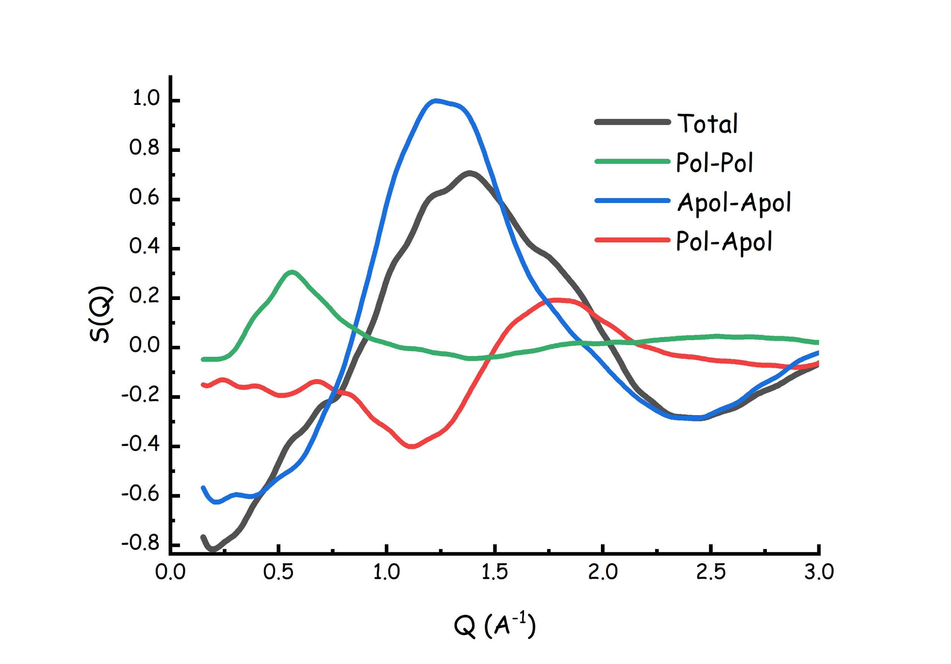
Figure 14. Decomposition of the MD computed static structure factor in terms of its polar-polar, apolar-apolar and polar-apolar components.

4. Conclusion.

Here we described the structural organization of the first example of natural, water-based, type V, hydrophobic DES, namely a mixture of thymol and water at 4.8:1 molar ratio, based on both experimental and computational tools. The computed density and static structure factor nicely agree with experimental data and SAXS data indicate the existence of a distinct degree of mesoscopic order.
Molecular Dynamics simulations allow then extracting fundamental information on the mutual interactions between the mixture components at atomistic level.
Results from the thymol-thymol observations show that together with typical correlations detected in aromatic compounds (such as short range parallel and, at higher distance, orthogonal alignments between aromatic rings), also signatures of hydroxyl-hydroxyl HB interactions are found. Notably we also detect indications of π··H-O hydrogen bonding correlations.
Thymol-water correlations are found to be bimodal and are dominated by HB interactions. A clear detection of a competition between water’s hydrogen towards either thymol’s hydroxyl group or the ring electronic cloud (through π··H-O hydrogen bonding correlations) is found. Overall, we find that in the mixture, thymol is engaged in a larger number of hydrogen bonding correlations that in neat liquid thymol.
Water-water correlations, despite the limited water content, are nevertheless present and although not enough water molecules are present to develop an extended water-water HB network, yet 30% of water population is engaged in HB-mediated interactions with at least another water molecule. Otherwise, water is engaged in solvating thymol, either around its hydroxyl group or at the two sides of the ring, though π··H-O hydrogen bonding correlations. The low amount of water molecules involved in water-water interactions is fundamental in depressing the melting point of the mixture, as water-thymol correlations would hinder the development of the HB-based thymol hexamer that builds up the structure leitmotif in crystalline thymol. Furthermore, we envisage that increasing amount of water would lead to its progressive involvement into HB-mediated water clusters that would result incompatible with the overall hydrophobic environment, hence the phase separation.
Finally, our analysis allows interpreting the experimental detection of a low Q peak centred at ca. 0.6 Å⁻¹. It clearly appears that this feature is due to the pseudo-periodicity (typical of the liquid state) induced by the alternation of a polar cluster, which is formed by HB interacting thymol hydroxyl group and water, and the apolar matrix build up by thymol’s aromatic and aliphatic moieties.
We believe that these information can provide the path to rationalise the nature of water-based hydrophobic DES, thus paving the way to new solvent media for sustainable development.

5. Acknowledgements.
This work has been supported by the University of Rome Sapienza Projects: "Microscopic and mesoscopic organization in ionic liquid-based systems." (RG11715C7CC660BE), “Green solvents for simple and complex carbohydrates” (RM120172B2165468) and “Role of Water as an active component of neoteric solvents” (RM12117A80DF27DF). Expert support from Dr. A. Del Giudice and access to the SAXS-Lab at the University of Rome Sapienza is acknowledged.
6. VCREDIT:
Triolo: Conceptualization, Formal Analysis; Writing – review and editing; Lo Celso: Investigation; Russina: Conceptualization, Funding acquisition, Writing - review & editing.

References
[1] D.O. Abranches, M.A.R. Martins, L.P. Silva, N. Schaeffer, S.P. Pinho, J.A.P. Coutinho, Phenolic hydrogen bond donors in the formation of non-ionic deep eutectic solvents: The quest for type v des, Chem. Commun. 55 (2019) 10253–10256. https://doi.org/10.1039/c9cc04846d.
[2] D.O. Abranches, J.A.P. Coutinho, Type V deep eutectic solvents: Design and applications, Curr. Opin. Green Sustain. Chem. 35 (2022) 100612. https://doi.org/10.1016/j.cogsc.2022.100612.
[3] E.L. Smith, A.P. Abbott, K.S. Ryder, Deep Eutectic Solvents ( DESs ) and Their Applications, (2014).
[4] M.A.R. Martins, S.P. Pinho, J.A.P. Coutinho, Insights into the Nature of Eutectic and Deep Eutectic Mixtures, J. Solution Chem. 48 (2019) 962–982. https://doi.org/10.1007/s10953-018-0793-1.
[5] B.B. Hansen, S. Spittle, B. Chen, D. Poe, Y. Zhang, J.M. Klein, A. Horton, L. Adhikari, T. Zelovich, B.W. Doherty, B. Gurkan, E.J. Maginn, A. Ragauskas, M. Dadmun, T.A. Zawodzinski, G.A. Baker, M.E. Tuckerman, R.F. Savinell, J.R. Sangoro, Deep Eutectic Solvents: A Review of Fundamentals and Applications, Chem. Rev. 121 (2021) 1232–1285. https://doi.org/10.1021/acs.chemrev.0c00385.
[6] L.J.B.M. Kollau, M. Vis, A. Van Den Bruinhorst, A.C.C. Esteves, R. Tuinier, Quantification of the liquid window of deep eutectic solvents, Chem. Commun. 54 (2018) 13351–13354. https://doi.org/10.1039/c8cc05815f.
[7] A. van den Bruinhorst, M.C. Gomes, Is there depth to eutectic solvents?, Curr. Opin. Green Sustain. Chem. (2022) 100659. https://doi.org/10.1016/j.cogsc.2022.100659.
[8] D.J.G.P. Van Osch, L.F. Zubeir, A. Van Den Bruinhorst, M.A.A. Rocha, M.C. Kroon, Hydrophobic deep eutectic solvents as water-immiscible extractants, Green Chem. 17 (2015) 4518–4521. https://doi.org/10.1039/c5gc01451d.
[9] D.J.G.P. Van Osch, C.H.J.T. Dietz, J. Van Spronsen, M.C. Kroon, F. Gallucci, M. Van Sint Annaland, R. Tuinier, A Search for Natural Hydrophobic Deep Eutectic Solvents Based on Natural Components, ACS Sustain. Chem. Eng. 7 (2019) 2933–2942. https://doi.org/10.1021/acssuschemeng.8b03520.
[10] D.J.G.P. Van Osch, C.H.J.T. Dietz, S.E.E. Warrag, M.C. Kroon, The Curious Case of Hydrophobic Deep Eutectic Solvents: A Story on the Discovery, Design, and Applications, ACS Sustain. Chem. Eng. 8 (2020) 10591–10612. https://doi.org/10.1021/acssuschemeng.0c00559.
[11] C. Florindo, L.C. Branco, I.M. Marrucho, Quest for Green-Solvent Design: From Hydrophilic to Hydrophobic (Deep) Eutectic Solvents, ChemSusChem. 12 (2019) 1549–1559. https://doi.org/10.1002/cssc.201900147.
[12] B.D. Ribeiro, C. Florindo, L.C. Iff, M.A.Z. Coelho, I.M. Marrucho, Menthol-based eutectic mixtures: Hydrophobic low viscosity solvents, ACS Sustain. Chem. Eng. 3 (2015) 2469–2477. https://doi.org/10.1021/acssuschemeng.5b00532.
[13] H. Zhang, M.L. Ferrer, M.J. Roldán-Ruiz, R.J. Jiménez-Riobóo, M.C. Gutiérrez, F. Del Monte, Brillouin Spectroscopy as a Suitable Technique for the Determination of the Eutectic Composition in Mixtures of Choline Chloride and Water, J. Phys. Chem. B. 124 (2020) 4002–4009. https://doi.org/10.1021/acs.jpcb.0c01919.
[14] M. Sajjadur Rahman, J. Kyeremateng, M. Saha, S. Asare, N. Uddin, M.A. Halim, D.E. Raynie, Evaluation of the experimental and computed properties of choline chloride-water formulated deep eutectic solvents, J. Mol. Liq. 350 (2022) 118520. https://doi.org/10.1016/j.molliq.2022.118520.
[15] M.S. Rahman, D.E. Raynie, Thermal behavior, solvatochromic parameters, and metal halide solvation of the novel water-based deep eutectic solvents, J. Mol. Liq. 324 (2021) 114779. https://doi.org/10.1016/j.molliq.2020.114779.
[16] A. Triolo, F. Lo Celso, M. Brehm, V. Di Lisio, O. Russina, Liquid structure of a choline chloride-water natural deep eutectic solvent: A molecular dynamics characterization, J. Mol. Liq. 331 (2021) 115750. https://doi.org/10.1016/j.molliq.2021.115750.
[17] A.I.M.C. Lobo Ferreira, S.M. Vilas-Boas, R.M.A. Silva, M.A.R. Martins, D.O. Abranches, P.C.R. Soares-Santos, F.A. Almeida Paz, O. Ferreira, S.P. Pinho, L.M.N.B.F. Santos, J.A.P. Coutinho, Extensive characterization of choline chloride and its solid–liquid equilibrium with water, Phys. Chem. Chem. Phys. 24 (2022) 14886–14897. https://doi.org/10.1039/D2CP00377E.
[18] O.S. Hammond, D.T. Bowron, K.J. Edler, The Effect of Water upon Deep Eutectic Solvent Nanostructure: An Unusual Transition from Ionic Mixture to Aqueous Solution, Angew. Chemie - Int. Ed. 56 (2017) 9782–9785. https://doi.org/10.1002/anie.201702486.
[19] C. Ma, A. Laaksonen, C. Liu, X. Lu, X. Ji, The peculiar effect of water on ionic liquids and deep eutectic solvents, Chem. Soc. Rev. 47 (2018) 8685–8720. https://doi.org/10.1039/c8cs00325d.
[20] T. El Achkar, S. Fourmentin, H. Greige-Gerges, Deep eutectic solvents: An overview on their interactions with water and biochemical compounds, J. Mol. Liq. 288 (2019) 111028. https://doi.org/10.1016/j.molliq.2019.111028.
[21] N. López-Salas, J.M. Vicent-Luna, S. Imberti, E. Posada, M.J. Roldán, J.A. Anta, S.R.G. Balestra, R.M. Madero Castro, S. Calero, R.J. Jiménez-Riobóo, M.C. Gutiérrez, M.L. Ferrer, F. Del Monte, Looking at the “water-in-Deep-Eutectic-Solvent” System: A Dilution Range for High Performance Eutectics, ACS Sustain. Chem. Eng. 7 (2019) 17565–17573. https://doi.org/10.1021/acssuschemeng.9b05096.
[22] V. Alizadeh, F. Malberg, A.A.H. Pádua, B. Kirchner, Are There Magic Compositions in Deep Eutectic Solvents? Effects of Composition and Water Content in Choline Chloride/Ethylene Glycol from Ab Initio Molecular Dynamics, J. Phys. Chem. B. 124 (2020) 7433–7443. https://doi.org/10.1021/acs.jpcb.0c04844.
[23] M.E. Di Pietro, M. Tortora, C. Bottari, G. Colombo Dugoni, R.V. Pivato, B. Rossi, M. Paolantoni, A. Mele, In Competition for Water: Hydrated Choline Chloride:Urea vs Choline Acetate:Urea Deep Eutectic Solvents, ACS Sustain. Chem. Eng. (2021). https://doi.org/10.1021/acssuschemeng.1c03811.
[24] S. Rozas, C. Benito, R. Alcalde, M. Atilhan, S. Aparicio, Insights on the water effect on deep eutectic solvents properties and structuring: The archetypical case of choline chloride + ethylene glycol, J. Mol. Liq. 344 (2021) 117717. https://doi.org/10.1016/j.molliq.2021.117717.
[25] F. Gabriele, M. Chiarini, R. Germani, M. Tiecco, N. Spreti, Effect of water addition on choline chloride/glycol deep eutectic solvents: Characterization of their structural and physicochemical properties, J. Mol. Liq. 291 (2019) 111301. https://doi.org/10.1016/j.molliq.2019.111301.
[26] H.M. Booth, D.D. Moran, J. Gonzalez, J. Luna-Uribe, J.C. Goeltz, Cooperative Demolition: Water’s Disruption of Structures in Deep Eutectic Solvents, J. Phys. Chem. B. 125 (2021) 3850–3854. https://doi.org/10.1021/acs.jpcb.0c11147.
[27] M. Tiecco, A. Grillo, E. Mosconi, W. Kaiser, T. Del Giacco, R. Germani, D. Giacco, R. Germani, Advances in the development of novel green liquids: thymol/water, thymol/urea and thymol/phenylacetic acid as innovative hydrophobic natural deep eutectic solvents, J. Mol. Liq. 364 (2022) 120043. https://doi.org/10.1016/j.molliq.2022.120043.
[28] R. Caminiti, V.R. Albertini, The kinetics of phase transitions observed by energy-dispersive x-ray diffraction, Int. Rev. Phys. Chem. 18 (1999) 263–299. https://doi.org/10.1080/014423599229965.
[29] M. Macchiagodena, F. Ramondo, A. Triolo, L. Gontrani, R. Caminiti, Liquid Structure of 1-Ethyl-3-methylimidazolium Alkyl Sulfates by X-ray Scattering and Molecular Dynamics, J. Phys. Chem. B. 116 (2012) 13448–13458. https://doi.org/10.1021/jp306982e.
[30] B. Hess, C. Kutzner, D. van der Spoel, E. Lindahl, GROMACS 4: Algorithms for Highly Efficient, Load-Balanced, and Scalable Molecular Simulation, J. Chem. Theory Comput. 4 (2008) 435–447. https://doi.org/10.1021/ct700301q.
[31] D. Van Der Spoel, E. Lindahl, B. Hess, G. Groenhof, A.E. Mark, H.J.C. Berendsen, GROMACS: Fast, flexible, and free, J. Comput. Chem. 26 (2005) 1701–1718. https://doi.org/10.1002/jcc.20291.
[32] W.L. Jorgensen, D.S. Maxwell, J. Tirado-Rives, Development and Testing of the OPLS All-Atom Force Field on Conformational Energetics and Properties of Organic Liquids, J. Am. Chem. Soc. 118 (1996) 11225–11236. https://doi.org/10.1021/ja9621760.
[33] W.L. Jorgensen, J. Tirado-Rives, Potential energy functions for atomic-level simulations of water and organic and biomolecular systems, Proc. Natl. Acad. Sci. 102 (2005) 6665–6670. https://doi.org/10.1073/pnas.0408037102.
[34] L.S. Dodda, I.C. De Vaca, J. Tirado-Rives, W.L. Jorgensen, LigParGen web server: An automatic OPLS-AA parameter generator for organic ligands, Nucleic Acids Res. 45 (2017) W331–W336. https://doi.org/10.1093/nar/gkx312.
[35] L.S. Dodda, J.Z. Vilseck, J. Tirado-Rives, W.L. Jorgensen, 1.14∗CM1A-LBCC: Localized Bond-Charge Corrected CM1A Charges for Condensed-Phase Simulations, J. Phys. Chem. B. 121 (2017) 3864–3870. https://doi.org/10.1021/acs.jpcb.7b00272.
[36] L. Martínez, R. Andrade, E.G. Birgin, J.M. Martínez, PACKMOL: A package for building initial configurations for molecular dynamics simulations, J. Comput. Chem. 30 (2009) 2157–2164. https://doi.org/10.1002/jcc.21224.
[37] G. Bussi, D. Donadio, M. Parrinello, Canonical sampling through velocity rescaling, J. Chem. Phys. 126 (2007) 014101. https://doi.org/10.1063/1.2408420.
[38] M. Parrinello, A. Rahman, Polymorphic transitions in single crystals: A new molecular dynamics method, J. Appl. Phys. 52 (1981) 7182–7190. https://doi.org/10.1063/1.328693.
[39] T. Darden, D. York, L. Pedersen, Particle mesh Ewald: An N·log(N) method for Ewald sums in large systems, J. Chem. Phys. 98 (1993) 10089–10092. https://doi.org/10.1063/1.464397.
[40] U. Essmann, L. Perera, M.L. Berkowitz, T. Darden, H. Lee, L.G. Pedersen, A smooth particle mesh Ewald method, J. Chem. Phys. 103 (1995) 8577–8593. https://doi.org/10.1063/1.470117.
[41] M. Brehm, B. Kirchner, TRAVIS - A Free Analyzer and Visualizer for Monte Carlo and Molecular Dynamics Trajectories, J. Chem. Inf. Model. 51 (2011) 2007–2023. https://doi.org/10.1021/ci200217w.
[42] O. Hollóczki, M. Macchiagodena, H. Weber, M. Thomas, M. Brehm, A. Stark, O. Russina, A. Triolo, B. Kirchner, Triphilic Ionic-Liquid Mixtures: Fluorinated and Non-fluorinated Aprotic Ionic-Liquid Mixtures, ChemPhysChem. 16 (2015) 3325–3333. https://doi.org/10.1002/cphc.201500473.
[43] M. Brehm, M. Thomas, S. Gehrke, B. Kirchner, TRAVIS—A free analyzer for trajectories from molecular simulation, J. Chem. Phys. 152 (2020) 164105. https://doi.org/10.1063/5.0005078.
[44] N. Schaeffer, D.O. Abranches, L.P. Silva, M.A.R. Martins, P.J. Carvalho, O. Russina, A. Triolo, L. Paccou, Y. Guinet, A. Hedoux, J.A.P. Coutinho, Non-Ideality in Thymol + Menthol Type v Deep Eutectic Solvents, ACS Sustain. Chem. Eng. 9 (2021) 2203–2211. https://doi.org/10.1021/acssuschemeng.0c07874.
[45] A.K. Soper, An asymmetric model for water structure, J. Phys. Condens. Matter. 17 (2005). https://doi.org/10.1088/0953-8984/17/45/012.
[46] T.F. Headen, C.A. Howard, N.T. Skipper, M.A. Wilkinson, D.T. Bowron, A.K. Soper, Structure of π−π Interactions in Aromatic Liquids, J. Am. Chem. Soc. 132 (2010) 5735–5742. https://doi.org/10.1021/ja909084e.
[47] M. Falkowska, D.T. Bowron, H.G. Manyar, C. Hardacre, T.G.A. Youngs, Neutron Scattering of Aromatic and Aliphatic Liquids, ChemPhysChem. 17 (2016) 2043–2055. https://doi.org/10.1002/cphc.201600149.
[48] A. Triolo, F. Lo Celso, N. V. Plechkova, F. Leonelli, S. Gärtner, D.S. Keeble, O. Russina, Structure of anisole derivatives by total neutron and X-ray scattering: Evidences of weak C H⋯O and C H⋯π interactions in the liquid state, J. Mol. Liq. 314 (2020) 113795. https://doi.org/10.1016/j.molliq.2020.113795.
[49] S. Suzuki, P.G. Green, R.E. Bumgarner, S. Dasgupta, W.A. Goddard, G.A. Blake, Benzene forms hydrogen bonds with water, Science (80-. ). 257 (1992) 942–945. https://doi.org/10.1126/science.257.5072.942.
[50] L.B. Skinner, C.J. Benmore, J.C. Neuefeind, J.B. Parise, The structure of water around the compressibility minimum, J. Chem. Phys. 141 (2014) 214507. https://doi.org/10.1063/1.4902412.
[51] A. Thozet, M. Perrin, Structure of 2-isopropyl-5-methylphenol (thymol), Acta Crystallogr. Sect. B Struct. Crystallogr. Cryst. Chem. 36 (1980) 1444–1447. https://doi.org/10.1107/s0567740880006243.
[52] A. Triolo, O. Russina, H.J. Bleif, E. Di Cola, Nanoscale segregation in room temperature ionic liquids, J. Phys. Chem. B. 111 (2007) 4641–4644. https://doi.org/10.1021/jp067705t.
[53] O. Russina, A. Triolo, L. Gontrani, R. Caminiti, Mesoscopic structural heterogeneities in room-temperature ionic liquids, J. Phys. Chem. Lett. 3 (2012) 27–33. https://doi.org/10.1021/jz201349z.
[54] F. Lo Celso, Y. Yoshida, F. Castiglione, M. Ferro, A. Mele, C.J. Jafta, A. Triolo, O. Russina, Direct experimental observation of mesoscopic fluorous domains in fluorinated room temperature ionic liquids, Phys. Chem. Chem. Phys. 19 (2017) 13101–13110. https://doi.org/10.1039/c7cp01971h.
[55] S. Di Muzio, A. Paolone, O. Russina, F. Ramondo, Phenol-cyclohexanol eutectic mixtures: Phase diagram and microscopic structure by experimental and computational studies, J. Mol. Liq. 360 (2022) 119492. https://doi.org/10.1016/j.molliq.2022.119492.
[56] A. Malik, H.K. Kashyap, Heterogeneity in hydrophobic deep eutectic solvents: SAXS prepeak and local environments, Phys. Chem. Chem. Phys. 23 (2021) 3915–3924. https://doi.org/10.1039/d0cp05407k.

