ARTICLE TYPE: LETTER
TITLE
Mediterranean sharks and rays need action
AUTHORS
Marco Milazzo^{1,*}, Carlo Cattano², Sara A.A. Al Mabruk³, Ioannis Giovos⁴
¹Department of Earth and Marine Sciences, University of Palermo. Via Archirafi 20, I-90123 Palermo, Italy. Ph.: +39.091.23862863; email: marco.milazzo@unipa.it
²Department of Integrative Marine Ecology, Stazione Zoologica Anton Dohrn (SZN), Lungomare Cristoforo Colombo, I-90149 Palermo, Italy. Ph: +39.328.2350581; email: carlo.cattano@szn.it
³Omar Almukhtar University, Al Beida, Green Mountain, Libya. Ph.: +189.13651949; email: sara.almabruk@omu.edu.ly
⁴iSea (Non Profit Non-Governmental Organisation), Kritis 12, GR-54645 Thessaloniki, Greece. Ph.: +30.231.3090696; email: ioannis.giovos@isea.com.gr
*Corresponding author.
TEXT (331 words)
Social networks quickly spread the recent news that endangered sharks are openly being sold off in chunks in market places in Tunisia. A heartfelt appeal by over 30 NGOs (1) led the Tunisian authority to circulate a note to fishery officials at ports to enforce the ban on catching, landing and marketing 21 species of sharks and rays listed on Annex II of the Barcelona Convention, pending the inclusion of these species in the national legislation. This is big news, as Tunisia has the largest North African fishing fleet, second only to Libya for shark fishing in the Mediterranean, and North African countries land 70% of Mediterranean elasmobranch catches (2). This issue concerns all Mediterranean countries, whose governments have turned a blind eye to mislabelled products and food frauds (3,4), and to illegal, unreported, and unregulated (IUU) fishing of sharks and rays (5).
More than a half of these fished species are either Critically Endangered [CR, 27%], Endangered [EN, 15%] or Vulnerable [VU, 11%] in the Mediterranean, a conservative estimate as an additional 20% of species are ‘data deficient’ (6). Those caught deliberately or as bycatch include a grim gallows list that are in danger of being wiped-out, such as the spiny butterfly ray, sandbar shark, blue shark, angel shark as well as the majestic shortfin mako and iconic great white shark.
Although this was a positive step by the Tunisian authority towards shark conservation, this is a regional emergency as the fishing of endangered elasmobranchs is out of control. All Mediterranean countries must take action before these species are exterminated. The time has come to effectively fight IUU, increase controls in markets and processing industries, and promote the creation of sanctuaries in birthing and nursery grounds where many of the endangered sharks and rays aggregate in the Mediterranean. These are key priorities for EU policy-makers tasked with the success of the European Green Deal and the international community’s efforts to meet sustainable targets on biodiversity and healthy oceans by 2030.
REFERENCES AND NOTES
(1) bit.ly/TunisiaWSNov20
(2) FAO Fisheries and Aquaculture Information and Statistics Branch (2020) http://www.fao.org/fishery/statistics/gfcm-capture-production/en accessed 09/12/2020
(3) V. Ferrito, A. Raffa, L. Rossitto, C. Federico, S. Saccone, A.M. Pappalardo (2019) Swordfish or Shark Slice? A Rapid Response by COIBar–RFLP. Foods, 8(11): 537. https://doi.org/10.3390/foods8110537
(4) I. Giovos, M. Arculeo, N. Doumpas, D. Katsada, M. Maximiadi, Ε. Mitsou, V. Paravas, R.N. Aga-Spyridopoulou, V.-O. Stoilas, F. Tiralongo (2020) Assessing multiple sources of data to detect illegal fishing, trade and mislabelling of elasmobranchs in Greek markets. Marine Policy, 112, 103730 https://doi.org/10.1016/j.marpol.2019.103730
(5) WWF Mediterranean Marine Initiative (2020) Shark and rays: a deadly harvest. 3 pp. https://wwfeu.awsassets.panda.org/downloads/wwf_iuu_sharks_and_rays_briefing_2020_v6__1_.pdf
(6) F. Serena, A. J. Abella, F. Bargnesi, M. Barone, F. Colloca, F. Ferretti, F. Fiorentino, J. Jenrette & S. Moro (2020) Species diversity, taxonomy and distribution of Chondrichthyes in the Mediterranean and Black Sea, The European Zoological Journal, 87:1, 497-536. https://doi.org/10.1080/24750263.2020.1805518

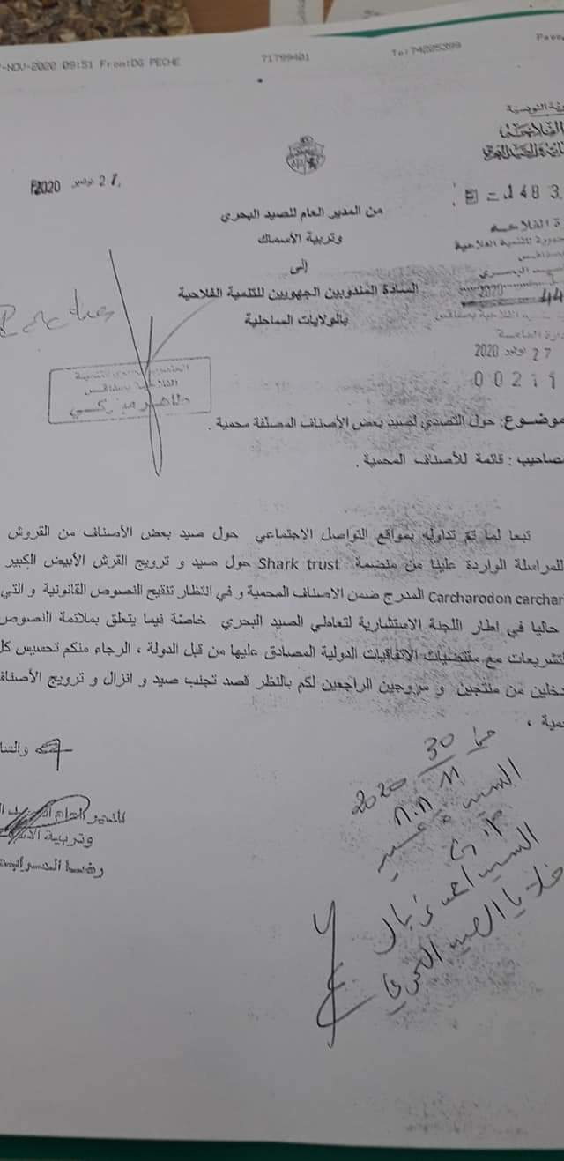
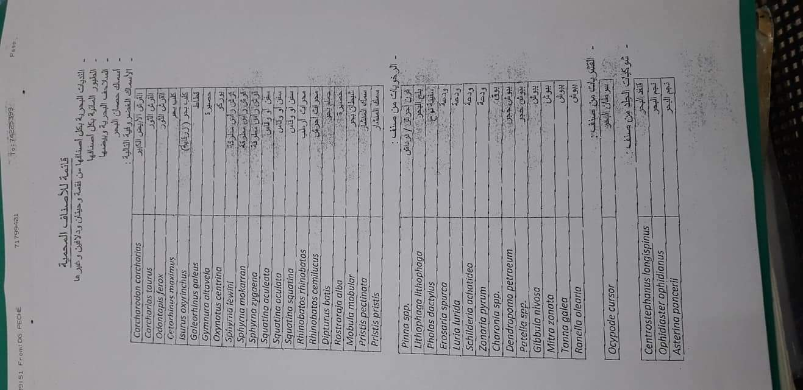

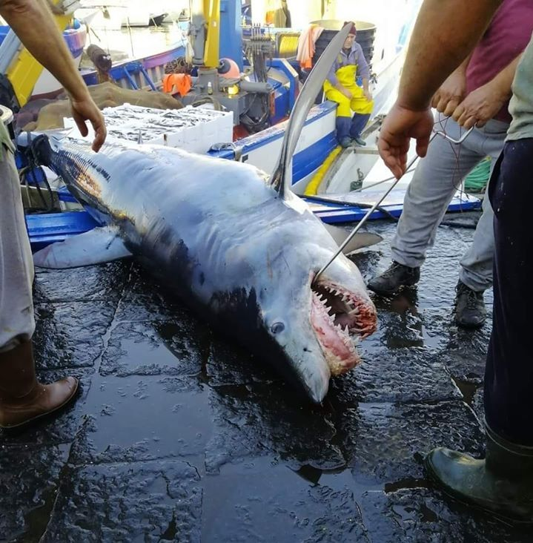
23 May 2020 - Ognina (Catania, Italy). Shortfin mako shark Isurus oxyrinchus (Critically Endangered). (1) lasiciliaweb on Twitter: "Catania: squalo Mako di quesi quattro metri ad Ognina #sicilia #catania #sicily #italia #italy https://t.co/ADi6NKszgv" / Twitter

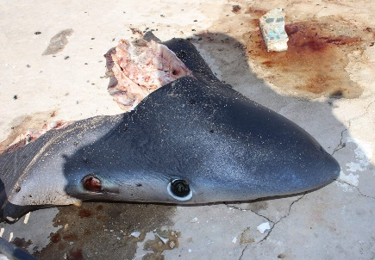
15 November 2020 – Lybia. Blue shark Prionace glauca (Critically Endangered). (1) Sara Almabruk on Twitter: "During the tour in fishes market with @Abdulghani_1973 to follow the angel shark project in Libya ,under supported by @saveourseas, we found the head of #blue shark Prionace glaucaa discarded after selling the rest of its parts. https://t.co/aijliJeCt5" / Twitter

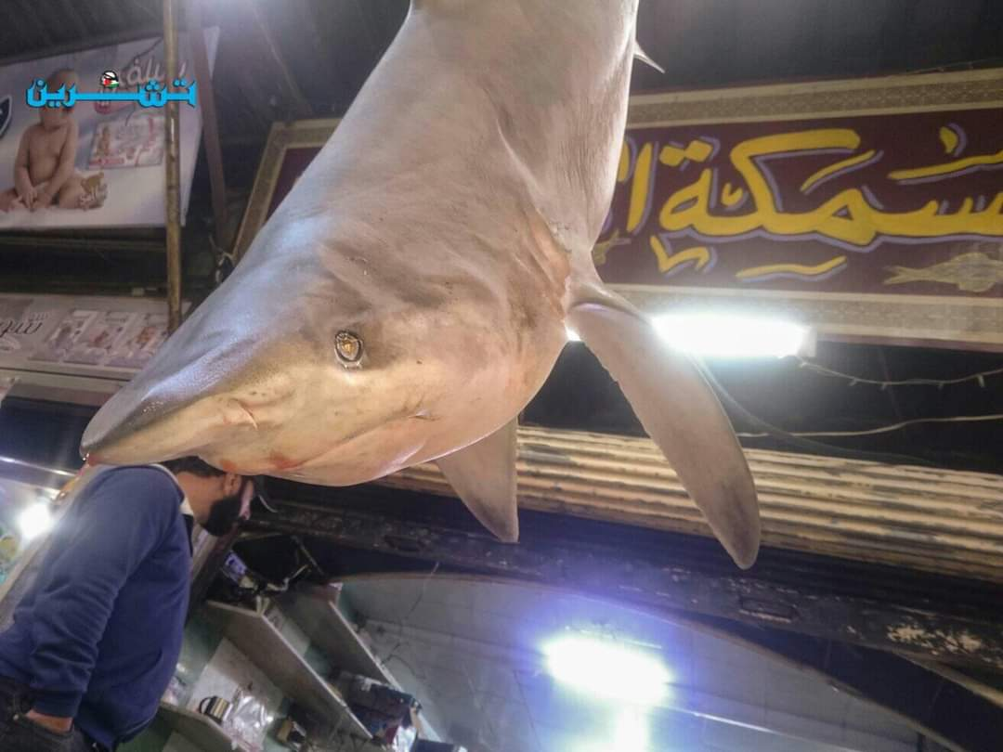
24 November 2020 - Fish market in Bab Srije (Damascus, Syria). (1) Mohamed Al Neser 🦅 on Twitter: "Isn't this shark of the protected shark species in the mediterranean? The picture is at the fish market in Bab Srije #Damascus/#Syria. Source: https://t.co/FQqNFx2neJ https://t.co/ZzP2RArzw8" / Twitter

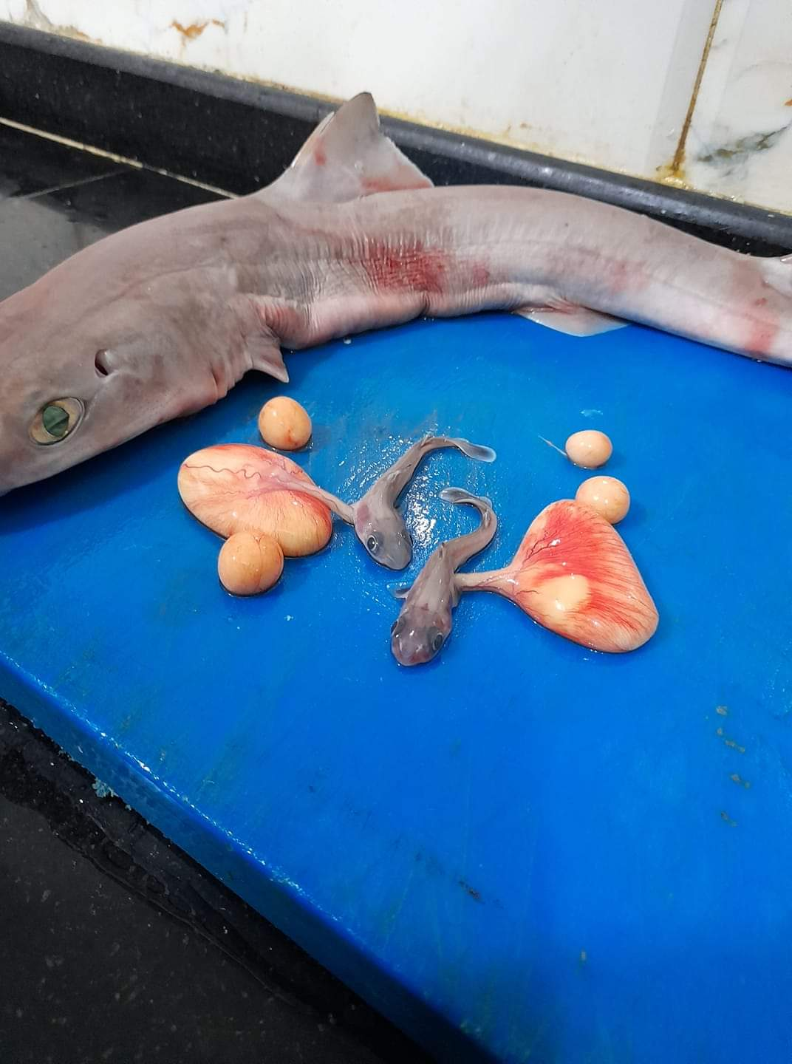
30 November 2020 – S. blainvillei (Data Deficient) female (Lybia). (1) Sara Almabruk on Twitter: "The fishing season of Elasmobranchii, starting here by using many fishing gear especially set gillnets are placed at certain known locations to target Carcharhinus sp , picture send to our FB account for apparently S.blainvillei female https://t.co/GmXrXwMi1S" / Twitter

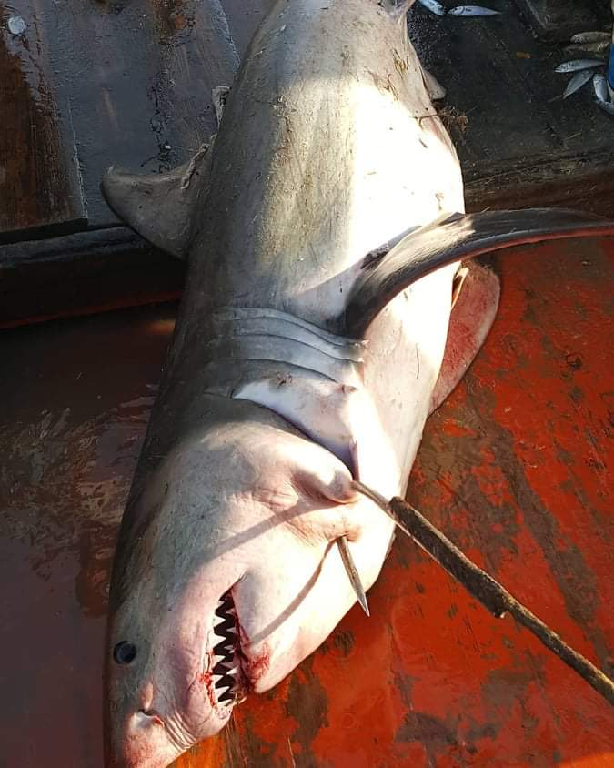
16 August 2020 - Female White shark Carcharodon carcharias (Critically Endangered) caught in Tunisia. (1) Sara Almabruk on Twitter: "16August 2020 Female White shark caught at depth 60 meter in #Tunisia water Photo by Bejaoui https://t.co/mRgtW7VU8P" / Twitter

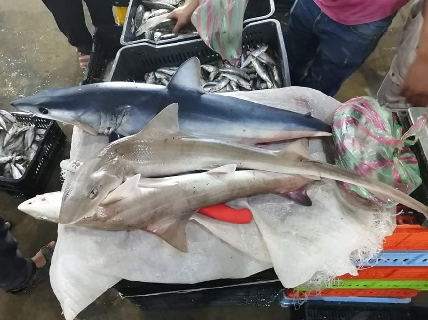
7 October 2020 – Lybia. Shortfin mako shark Isurus oxyrinchus (Critically Endangered). (1) Sara Almabruk on Twitter: "Local name of Shortfin mako shark in Libya is "zargaia" and its refered to the dark blue color of mako skin , unfortunately mako exposure to bycatch and offered to sell in fishmarket , low price encourage people to buy it #MakeorBreak4Makos https://t.co/4FofsedANy" / Twitter

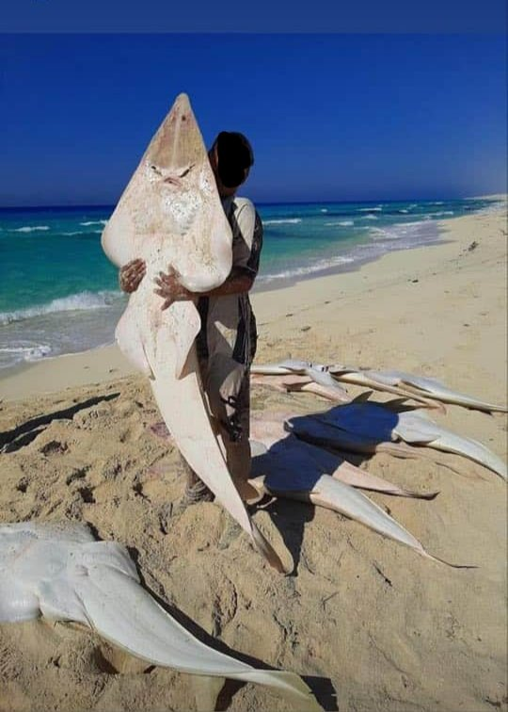
25 July 2020 – Egypt. Common guitarfish Rhinobatos rhinobatos (Endangered). (1) Sara Almabruk on Twitter: "Huge one Commen guitarfish caught near Marsa Matrouh city in north-western Mediterranean coast, Egypt https://t.co/zBz7Vw7xSL" / Twitter

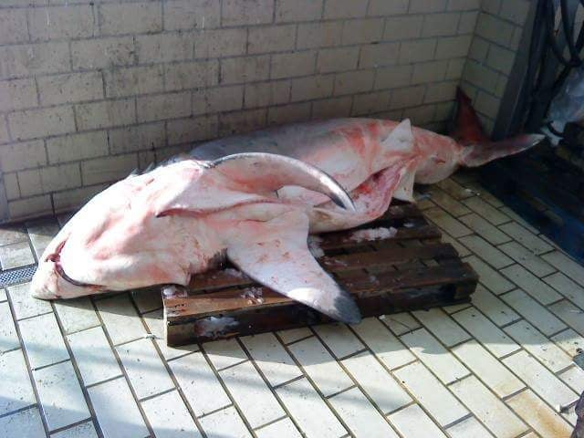
2017 – Greece. Carcharodon carcharias (Critically Endangered)

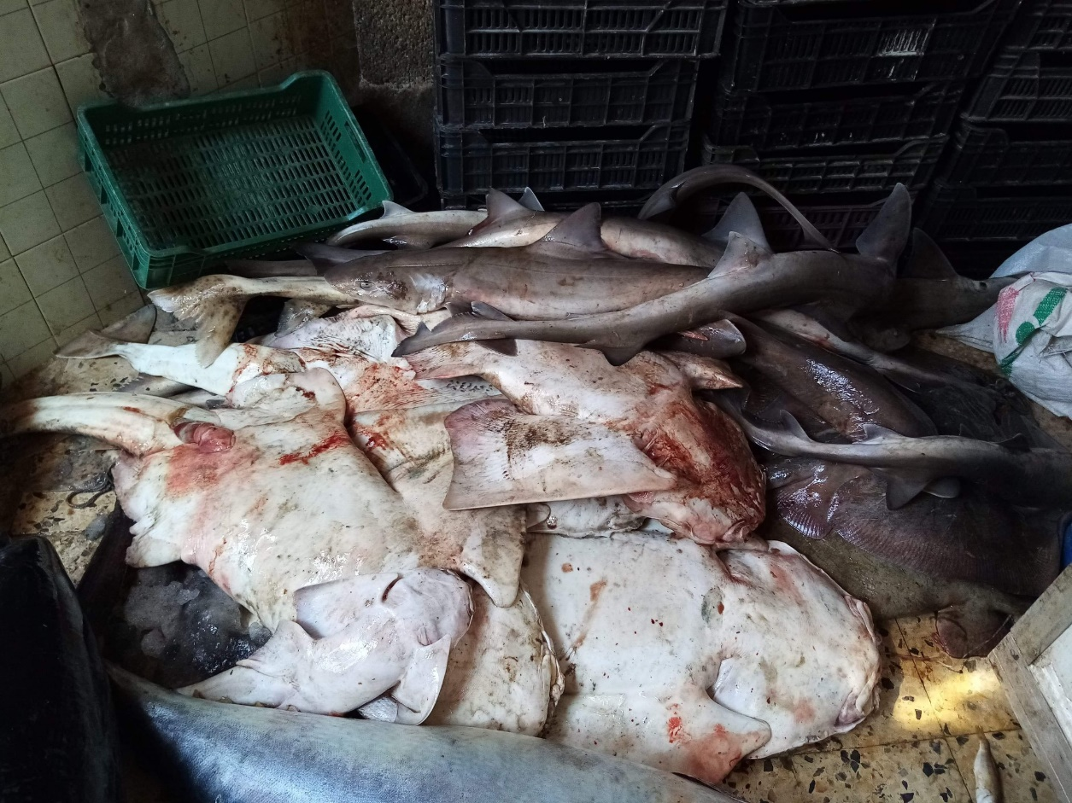
27 May 2020 – Lybia. Angel sharks caught by trawling. (1) Sara Almabruk on Twitter: "unfortunately ,40 kg from #Angelshark had caught yesterday by Trawl net in #Libya 37 days separate us from release our project to conservation Angelsharks in Libya #elasmoinLibya #AngelsharkinLibya #Mediterranean https://t.co/v1Mqb6A9YQ" / Twitter

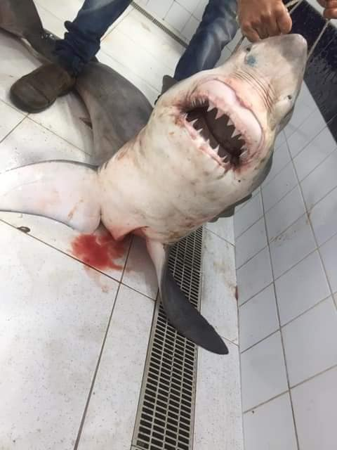
November 2020 – Tunisia. White shark Carcharodon carcharias (Critically Endangered)

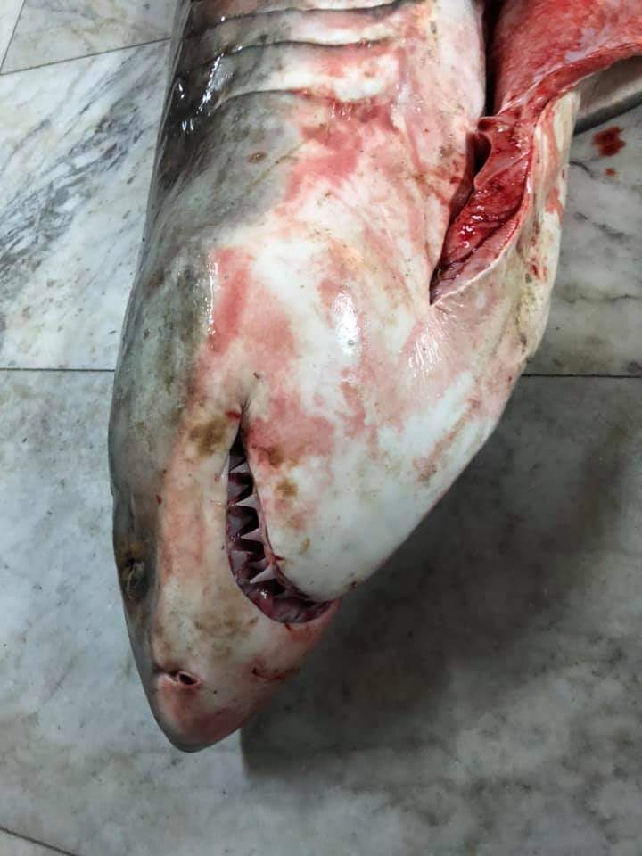
27 October 2020 - White shark Carcharodon carcharias (Critically Endangered). (1) Sara Almabruk on Twitter: "again! 😔 https://t.co/6oDvZo3JPV" / Twitter

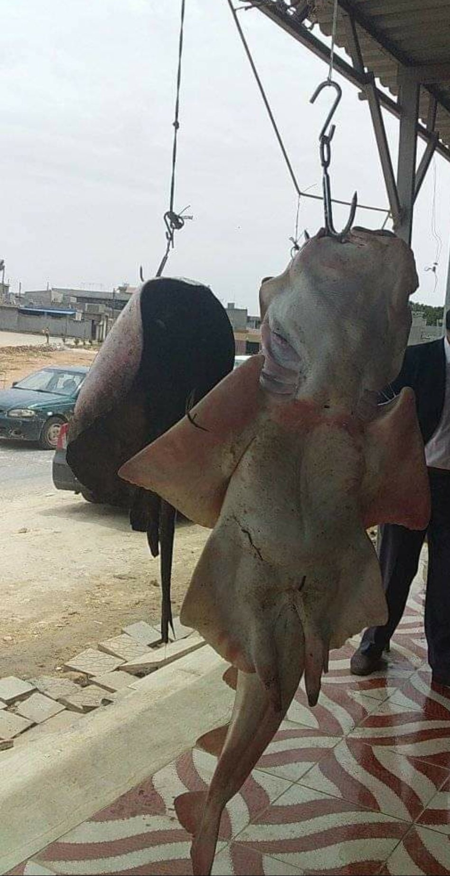
30 September 2020 – Lybia. Squatina sp (Critically Endangered). (1) Sara Almabruk on Twitter: "Squatina sp offered to sell ,this scene is ordinary to see it in all fish market in #Libya and nobody from fishermen known that the Angelshark is threatened species , and when we told them ,the usual answer was :How could be a threatened sp ,we see it &amp; fishing it constantly?!! https://t.co/fcGYGtBstE" / Twitter

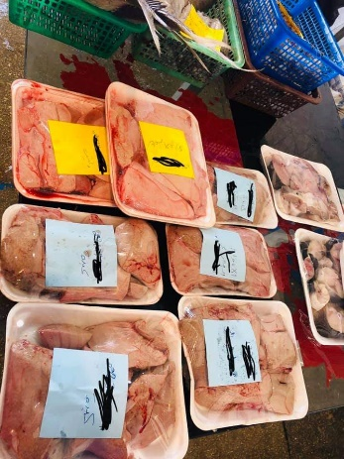
12 November 2020 – Lybia. Shark livers in a fish market store. (1) Sara Almabruk on Twitter: "#Shark liver is offered for sale or given for free recently there is an increasing belief that it is a successful treatment for cancer diseases Picture for Sharks liver offered for sale in fishmarket store in Tripoli #Libya https://t.co/Oex0ulVYvH" / Twitter

