Deep traps in InGaN/GaN single quantum well structures grown with and without InGaN underlayers
A.Y. Polyakov ª, C. Haller ^{b}, R. Butte ^{b}, N.B. Smirnov ª, L.A. Alexanyan ª, A.I. Kochkova ª,
S.A. Shikoh ª, I.V. Shchemerov ª, A.V. Chernykh ª, P.B. Lagov ^{a, c}, Yu S. Pavlov ^{c}, J.-F. Carlin ^{b}, M. Mosca ^{b, d}, N. Grandjean ^{b}, S.J. Pearton ^{e, *}
a National University of Science and Technology MISiS, Moscow, 119049, Russia
b Institute of Physics, Ecole Polytechnique Federale de Lausanne (EPFL), CH-1015, Lausanne, Switzerland
c Laboratory of Radiation Technologies, A. N. Frumkin Institute of Physical Chemistry and Electrochemistry Russian Academy of Sciences (IPCE RAS), Moscow, 119071, Russia
d Department of Engineering, University of Palermo, I-90128, Palermo, Italy
e Department of Materials Science and Engineering, University of Florida, Gainesville, FL, 32611, USA

Abstract

The electrical properties and deep trap spectra were compared for near-UV GaN/InGaN quantum well (QW) structures grown on free-standing GaN substrates. The structures differed by the presence or absence of a thin (110 nm) InGaN layer inserted between the high temperature GaN buffer and the QW region. Capacitance-voltage profiling with monochromatic illumination showed that in the InGaN underlayer (UL), the density of deep traps with optical threshold near 1.5 eV was much higher than in the QW and higher than for structures without InGaN. Irradiation with 5 MeV electrons strongly increased the concentration of these 1.5 eV traps in the QWs, with the increase more pronounced for samples without InGaN ULs. The observations are interpreted using the earlier proposed model explaining the impact of In-containing underlayers by segregation of native defects formed during growth of GaN near the surface and trapping of these surface defects by In atoms of the InGaN UL, thus preventing them from infiltrating the InGaN QW region. Deep level transient spectroscopy (DLTS) also revealed major differences in deep trap spectra in the QWs and underlying layers of the samples with and without InGaN ULs. Specifically, the introduction of the InGaN UL stimulates changing the dominant type of deep traps. Irradiation increases the densities of these traps, with the increase being more pronounced for samples without the InGaN UL. It is argued that light emitting diodes (LEDs) with InGaN UL should demonstrate a higher radiation tolerance than LEDs without InGaN UL.

Introduction
InGaN/GaN quantum well (QW) structures comprise the active region of GaN-based light-emitting diodes (LEDs) operating in near-UV, blue, green parts of the spectrum and white light emitters for general lighting applications [1,2]. There has been tremendous progress in increasing the efficiency and reliability of such devices [3e5], but a much better understanding of the nature of physical processes limiting the efficiency is still necessary. Initially the main obstacle in achieving high efficiency of GaN-based LEDs was related to poor crystalline quality of the material grown on heavily lattice mismatched sapphire substrates and having a high dislocation density above 10⁹ cm². Since dislocations in GaN are efficient centers of local non-radiative recombination [6e8] they were naturally held responsible. Rapid progress in growth technology involving various versions of epitaxial lateral overgrowth (ELO) [9,10] or growth on native GaN substrates [11] allowed to decrease the dislocation density below 10⁶ cm² [12e14] at which point it became clear that dislocations decrease the radiative recombination efficiency only when their density is above ~ 10⁸ cm². This is a manifestation of a limited radius of the region with enhanced nonradiative recombination activity surrounding dislocations [8]. For lower dislocation densities, the lifetime of non-equilibrium charge carriers and the radiative recombination efficiency are mainly determined by the type and concentration of point defects forming deep levels in the bandgap and serving as lifetime killers [15e17].
The properties and nature of such defects have been extensively studied theoretically and experimentally. Recently developed theory allowed to calculate, ab initio, the electron and hole capture coefficients for various deep centers in n-GaN and in InGaN ternaries, to pinpoint carbon on nitrogen site C_{N} acceptors and gallium vacancy V_{Ga} related acceptor complexes as important hole trapping centers that can become effective non-radiative recombination centers in narrow-bandgap high-In-contents InGaN ternaries, and to understand the role of excited states making Fe acceptors effective lifetime killers in n-GaN [18e20]. Experimentally, a series of studies in which positron annihilation spectroscopy (PAS) was combined with lifetime measurements in GaN and AlGaN ternaries, attributes the dominant non-radiative recombination centers in IIINitrides to divacancies V_{Ga}-V_{N} [21,22]. Combined studies of deep level transient spectroscopy (DLTS) and diffusion lengths of nonequilibrium charge carriers in variously grown n-GaN films and crystals pointed to a close correlation between the lifetimes of charge carriers and the density of electron traps with levels near E_{c}0.6 eV or, in electron irradiated material, with traps near E_{c}-1 eV [15e17]. For LED structures emitting in the near-UV (NUV), blue, green spectral range, some dominant electron and hole traps in the QWs whose levels are aligned in respect to the level of vacuum have been detected [23]. Electron irradiation experiments on such LEDs show that the changes in efficiency often correlate with the increase in concentration of certain deep electron and hole traps in the QWs and in the quantum barriers (QBs) of the structures owing to the changes these traps induce in recombination within the QWs, trapping and recombination in the barriers, and in leakage current [24e26]. Some of these traps have been found responsible for the degradation of NUV LEDs characteristics after electric stress [27,28].
Of particular importance is understanding how variations in the design of the LEDs active region structure affect the type and concentration of non-radiative recombination centers. Deep level optical spectroscopy (DLOS) and capacitance-voltage profiling under monochromatic illumination (LCV) experiments revealed a close link between the decrease in the density of deep traps with optical ionization threshold near 1.8 eV in the QWs as caused by the introduction of InGaN underlayer beneath the QW region of blue LEDs and the increase of LEDs’ efficiency [29]. Among other beneficial effects of InGaN underlayers it has been suggested that they can improve the electron injection efficiency into the QWs, decrease the dislocation density, facilitate the formation of V-defects, alleviate the negative impact of quantum confined Stark effect (see representative references in Ref. [30e35]). The matter still remains very much under debate, but detailed studies performed in our earlier papers [30e32,36,37] clearly indicate that in today’s state-of-the-art GaN-based QW LEDs the main improvements produced by the introduction of In-containing underlayers (InGaN or InAlN) are due to the decrease of the density of point defects in the QW region serving as efficient non-radiative recombination centers. In this series of papers combining structural properties studies, analysis of impurity contamination, quantum efficiency, and recombination lifetimes of NUV QW LEDs with InGaN or InAlN underlayers (ULs) a model explaining the effects of In-containing underlayers has been proposed assuming that native defects in growing GaN barriers are segregated near the growing surface and are inherited by the QW region where interaction with In stabilizes these defects and converts them into effective non-radiative recombination centers. The role of the InGaN or InAlN underlayer is then to trap the surface defects via interaction with In and to prevent them from infiltrating the QW region and compromising the radiative recombination efficiency. It is interesting to trace the changes in deep traps spectra in the QWs to the presence or absence of the In-containing ULs and to the deep trap spectra in the ULs. Such analysis has been performed for NUV LEDs with underlayer of GaN/InAlN superlattice (SL) [33e38].In that work, we showed that the presence of SL ULs suppressed compensation of Mg acceptors by nitrogen vacancy V_{N} related donors and the formation of deep hole traps in the QW region.
In this paper, we present the results of similar studies for NUV GaN/InGaN QW structures grown with and without InGaN ULs. These structures were grown on free-standing (FS) lowdislocation-density n-GaN substrates to minimize possible effects due to dislocations.

Experimental
The samples were grown as discussed in detail in earlier papers [39,40]. The structures were grown on basal plane 2-inch-diameter FS nþ-GaN substrates with dislocation density 10⁶ cm² by metalorganic chemical vapor deposition (MOCVD) in a vertical Aixtron (Germany) CCS system. For films with InGaN UL the growth started with 1-mm-thick n-GaN buffer deposited at 1000 C and doped with Si to ~10¹⁸ cm³. Then followed 110-nm-thick nþ-In_{0.03}Ga_{0.97}N underlayer and nþ-GaN (20 nm), both deposited at 770 C and doped to ~10¹⁸ cm³. The QW structure on top consisted of 5 nm unintentionally doped (UID) n-GaN barrier, 2.7 nm In_{0.12}Ga_{0.88}N QW capped by 50 nm of UID n-GaN, all deposited at 755 C.
Control structures without the InGaN UL had the same design but for the lack of the InGaN UL. For characterization, Ni Schottky diodes, 30 nm thick and 1.2 mm in diameter, were prepared on the top surface using e-beam evaporation through a shadow mask. The back Ohmic contact to the FS substrate was prepared by e-beam deposition of Ti/Al/Ti/Au. Preliminary measurements [39,40] showed that the QW photoluminescence (PL) spectra peaked near 2.9 eV, with the PL decay time of 16.8 ns for the samples with the InGaN UL and 170 ps for the samples without the InGaN UL.
Electrical characterizations of the Schottky diodes involved capacitance-versus frequency (C-f), capacitance versus voltage (CeV), current versus voltage (IeV), and DLTS spectra measurements in the temperature range 77Ke400K. CeV profiling was carried out in the dark and under illumination with a set of highpower LEDs with peak wavelength in the range 940e365 nm with optical power of 250 mW. Such measurements were performed before and after irradiation with 5 MeV electrons with fluences 7 10¹⁵ cm² and 3 10¹⁶ cm² using the linear electron accelerator Linac UELV-10-10-C-70 [41,42] at the Center of Collective Use “Physical Measurements Investigations” (CCU PMI) of the Institute of Physical Chemistry and Electrochemistry of the Russian Academy of Sciences. Detailed descriptions of experimental setups can be found elsewhere [36e38,41].

Results
Room temperature IeV characteristics of the Schottky diodes with InGaN UL and without UL are compared in Fig. 1(a). The characteristics were not significantly different for both types of samples and were characterized by a rather high (and strongly dependent on voltage) reverse current and ideality factor in forward direction close to 1.5. This is the result of high concentrations of dopants and considerable impact of tunneling in our Schottky diodes. Electron irradiation had no serious effect on current flow for both types of structures. Fig.1(b) illustrates this for the sample with InGaN UL. For the sample without UL the changes were even less pronounced.

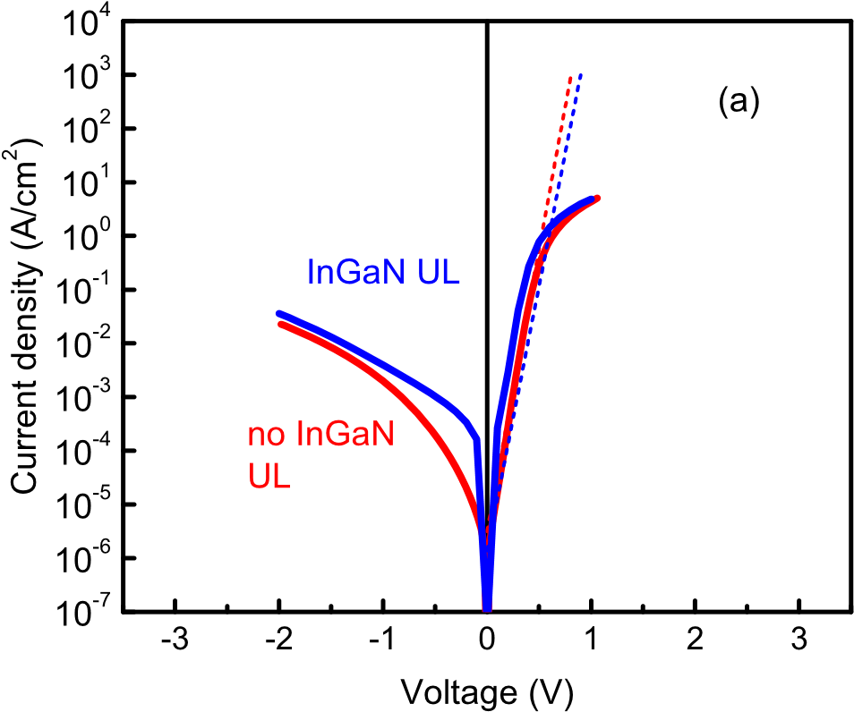
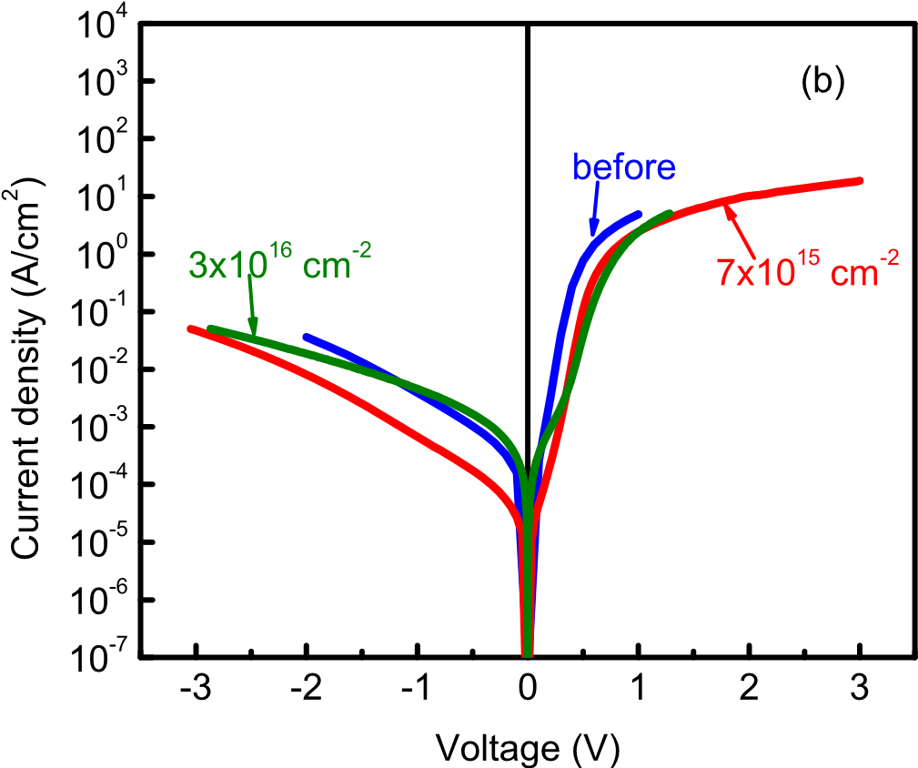
Fig. 1. a) Room temperature current-voltage characteristics for the sample without InGaN UL (red line) and with InGaN UL (blue line); (b) room temperature IeV characteristics measured for the sample with InGaN UL before electron irradiation (blue curve), after irradiation with 7 10¹⁵ cm⁻² 5 MeV electrons (red curve), and after irradiation with the fluence of 3 10¹⁶ cm⁻² of 5 MeV electrons

Fig. 2 (a) presents the charge concentration dependence on depth as obtained from room temperature profiling of the two types of samples. In the QW region, the peak charge concentration is somewhat higher for the structure with InGaN UL and, in this latter sample, one can also observe the peak in concentration due to the InGaN UL near the depth of 110 nm. Fig. 2(b) shows the charge concentration dependences as a function of applied voltage. This figure provides a guide for setting the bias voltage and pulse amplitude for DLTS spectra measurements discussed below. For probing the QW region, one needs to set the bias near -1 V and pulse the voltage to 0 V to recharge the states in the QW. In order to probe the InGaN UL region in the sample with UL, the bias should be set at -4 V and pulsed to -2 V. To probe the deep traps in the GaN layer in the sample without the InGaN UL, one has to set the voltage to -3 V and pulse it to 2 V.

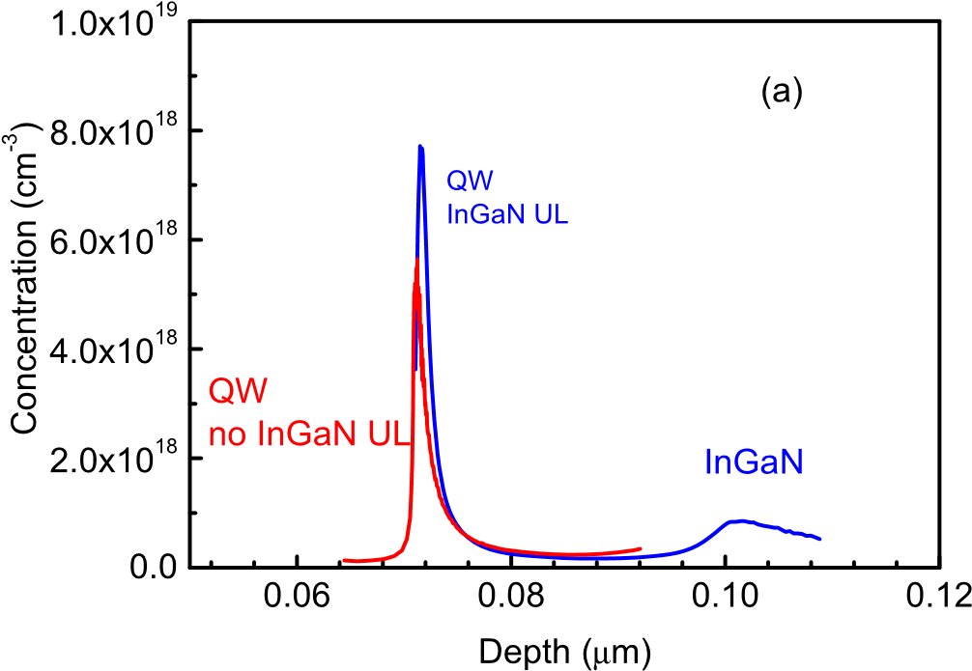
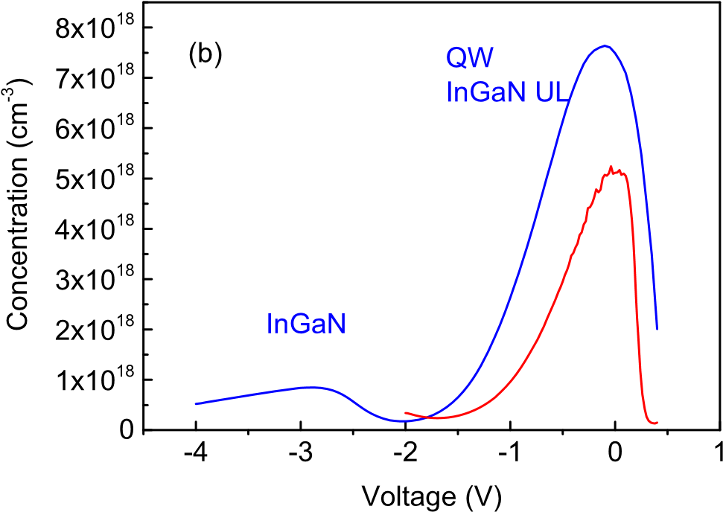
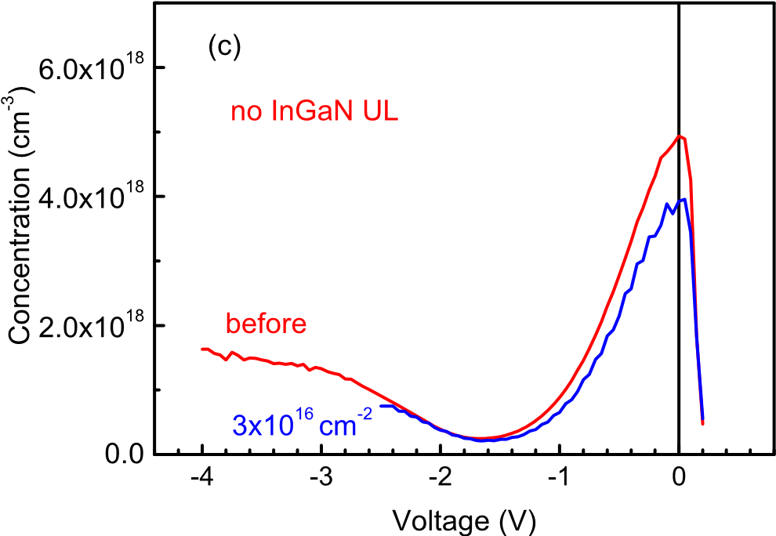
Fig. 2. (a) Concentration versus depth profiles calculated from CeV characteristics measured at 100 kHz at room temperature for the sample without InGaN UL (red line) and with InGaN UL (blue line); (b) concentration versus applied voltage profile for the same structures; (c) concentration versus voltage profile measured before irradiation (red line) and after irradiation with 3 10¹⁶ cm² 5 MeV electrons (blue line).

Irradiation with 5 MeV electrons slightly decreased the peak charge concentration in the QWs of both types of structures and the net donor concentration in the GaN layer underlying the QW region in the sample without InGaN UL, as shown in Fig. 2(c). For the sample with InGaN UL, the net donor concentration in the InGaN UL was slightly increased. This could be a consequence of the In presence in the layer. It has been noticed that in InN, electron irradiation actually increases the donor density [43].
We compared the optical thresholds and concentrations of the centers that contribute to charge concentration in the QW region and in the InGaN underlayer by measuring CeV profiles in the sample with InGaN UL under monochromatic illumination. The photoinduced concentration, DN_{ph}, at each photon energy was taken as the difference between the concentration under illumination and in the dark. The spectra for the QWs were built using the DN_{ph} values in the peak of CeV profile. For the InGaN UL, we also used the peak value in this region. From the results of such light CeV (LCV) measurements, the spectra of photoinduced charge density in the QW and InGaN UL could be built. These spectra are presented in Fig. 3 (a). The light induced charge concentration DN_{ph} calculated from these measurements started to grow for photons with energy close to 1.5 eV and reached a plateau for photon energy close to 2 eV, after ionization of another center could be observed. If the concentration of the 1.5 eV centers is estimated from the value at the plateau at photon energy at 2 eV, the concentration of the 1.5 eV defects is found to be much higher in the InGaN UL than in the QW of the sample with InGaN UL. For the sample without the InGaN UL, the LCV spectrum in the QW was qualitatively similar, but the concentration of the 1.5 eV centers was much higher than in the QWof the sample with InGaN and approached that in the InGaN UL (Fig. 3(a)).
After irradiation with 5 MeV electron fluence of 3 10¹⁶ cm², the concentrations of the centers in the QWs of both types of samples strongly increased (Fig. 3(b)). In the irradiated sample without InGaN, we also observed a build-up of the concentration of centers with optical threshold near 2.3 eV in the GaN underlayer in the vicinity of the interface with the InGaN QW (Fig. 3(c)).
DLTS spectra for the InGaN UL and the GaN regions of the two types of structures are compared in Fig. 4(a), while Fig. 4(b) presents the results for the QW regions of respective structures. In the spectra in Fig. 4(a), deep electron traps with levels near E_{c}-0.3 eV (electron capture cross section s_{n} ¼ 1.6 10²⁰ cm²) and E_{c}-0.8 eV (s_{n} ¼ 7.6 10¹⁵ cm²) in the GaN layer underlying the QW could be clearly seen. In the InGaN UL portion of the sample with InGaN UL, deep electron traps near E_{c}-0.18 eV (2.4 10²⁰ cm²), E_{c}-0.65 eV (10¹⁶ cm²), and E_{c}-1 eV (1.5 10¹³ cm²) were observed. For the QWs, the spectra were dominated by electron traps with level near E_{c}-0.7 eV for the sample without InGaN UL and E_{c}-1 eV for the sample with InGaN UL (Fig. 4(b)).
Irradiation with a low electron fluence of 7 10¹⁵ cm² had little effect on the spectra of deep traps. For the high fluence of 3 10¹⁶ cm², we detected a several times increased concentration of the E_{c}-0.8 eV traps and the emergence of prominent E_{c}-1.2 eV traps in the GaN layer of the sample with no InGaN UL and a strong increase of concentration of the E_{c}-0.65 eV traps and the E_{c}-1 eV traps in the InGaN UL portion of the sample with InGaN UL (Fig. 5(a)). DLTS spectra in the QWs were dominated for both types of samples by the E_{c}-1 eV electron traps, with the concentration considerably higher for the sample without InGaN UL (Fig. 5(b)).

Discussion
Our results show the deep traps spectra measured in the QWs and in underlying regions of NUV MQW structures differ significantly for structures with and without an InGaN underlayer.

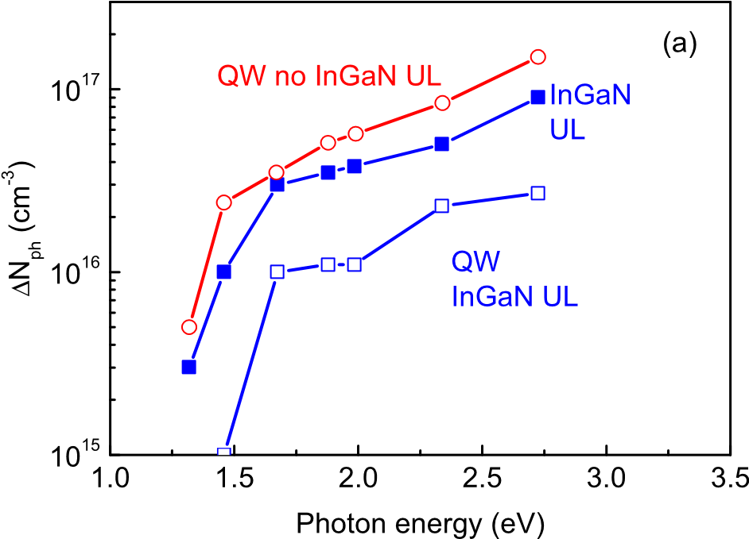
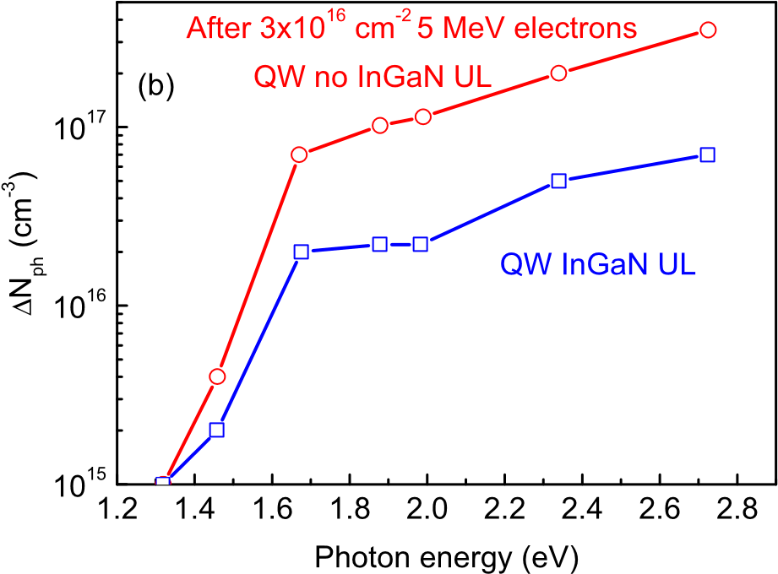
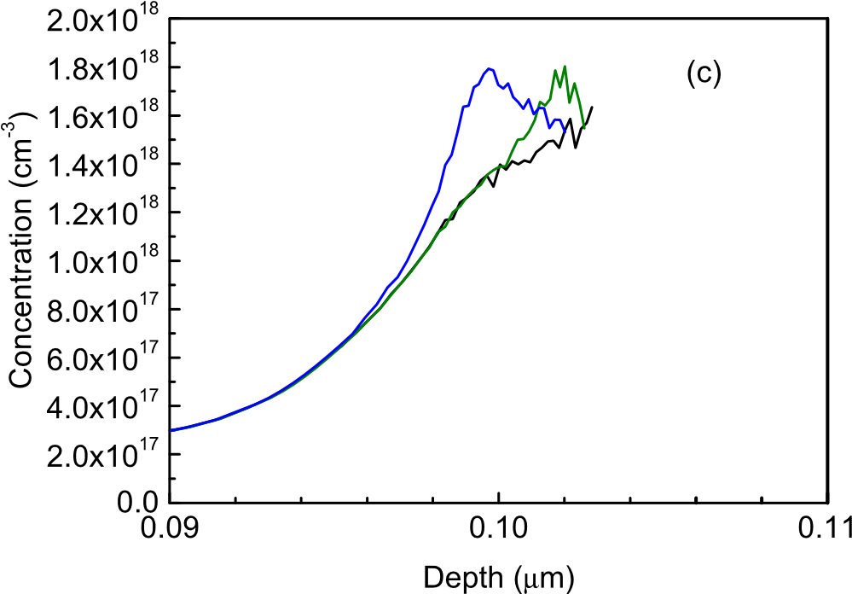
Fig. 3. (a) Concentration of charge centers induced by monochromatic illumination minus dark concentration, DN_{ph}, calculated from LCV measurements in the QW of the sample with InGaN UL (open blue squares), in the InGaN UL of this sample (solid blue squares), and DN_{ph} in the QW of the sample without InGaN UL(red open circles); (b) DN_{ph} spectra measured after irradiation with 3 10¹⁶ cm² 5 MeV electrons in the QW of the sample with InGaN UL (open blue squares) and in the QW of the sample without InGaN; (c) Concentration profile in the GaN portion of the sample without InGaN irradiated with 3 10¹⁶ cm² 5 MeV electrons; black line-dark, olive line-illumination with LED with peak photon energy of 2.3 eV, blue line-illumination with 2.8 eV LED, no signal observed for photon energies below 2.3 eV.

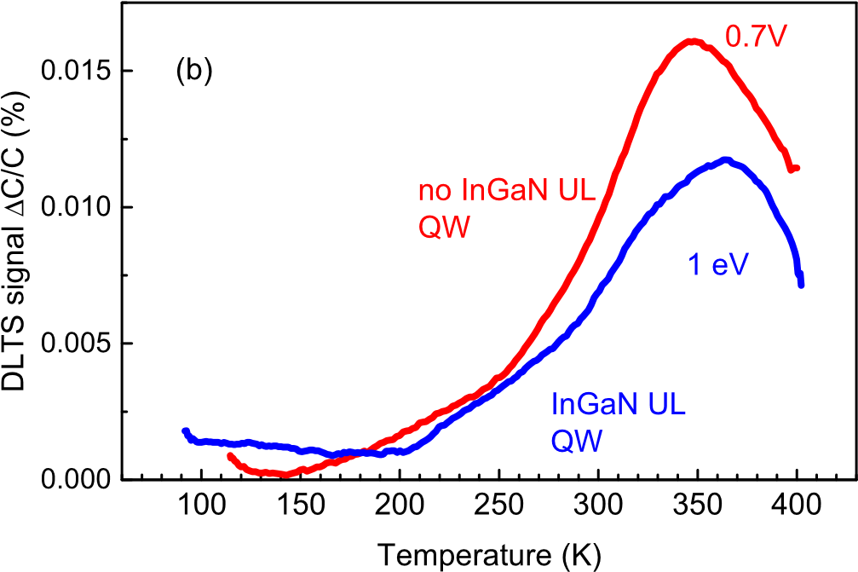
Fig. 4. (a) DLTS spectra obtained from the GaN underlayer (pulsing from -4 V to -2 V) of the sample without InGaN UL (red line) and from the InGaN UL of the sample with InGaN UL (pulsing from -4 V to -2 V); (b) DLTS probing of the QW regions of the sample without InGaN UL (red line) and with InGaN UL (blue line); (pulsing in both cases from -1 V to 0 V); measurement frequency 100 kHz, time windows 1.5 s/ 15 s, pulse length 3 s.
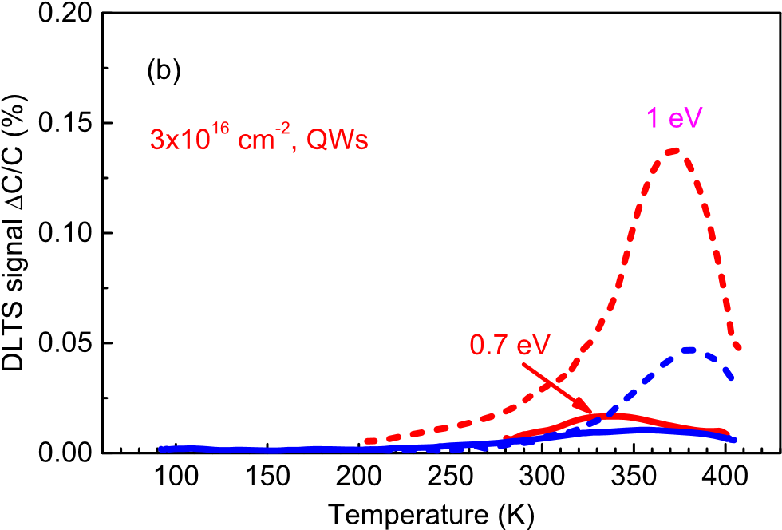
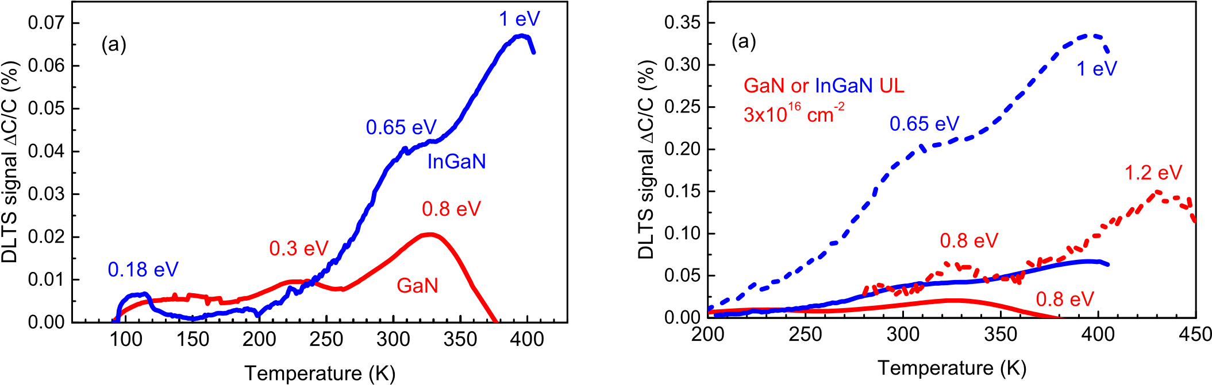
Fig. 5. (a) DLTS spectra measured before (solid lines) and after (dashed lines) irradiation with 3 10¹⁶ cm² 5 MeV electrons for the GaN underlayer region of the sample without InGaN UL (red lines) and for the InGaN UL region for the sample with InGaN UL (blue lines); (b) same for the QW regions of respective structures before and after irradiation; measurements conditions the same as in Fig. 4.

In the former, the deep electron trap spectra in the UL are dominated by traps with levels near E_{c}-1 eV, with some contribution from traps near E_{c}-0.65 eV. In the QW region, the E_{c}-1 eV traps dominate. For samples without InGaN, the electron traps in the underlying GaN region are mainly centers near E_{c}-0.8 eV, whereas the QW region is dominated by the E_{c}-0.7 eV centers. The absolute concentrations of the traps are hard to accurately compare in these systems with very strong spatial variations of charged centers density (Fig. 2). Given the similarity of the charge concentration profiles in respective regions of the samples with and without InGaN UL, the relative magnitudes of DLTS peaks in the QW regions and in the underlayer regions approximately reflect the changes in the density of traps in these regions for the two types of samples studied. Thus, it can be stated that switching to growth with InGaN UL strongly suppresses in the QWs regions, the contribution of the E_{c}-0.7 eV traps in favor of E_{c}-1 eV traps. In the underlying regions, switching from GaN to InGaN favors the increased contribution of the E_{c}-1 eV traps versus the E_{c}-0.8 eV traps in GaN.
LCV spectra observed in the QW and InGaN UL regions of the sample with InGaN UL are qualitatively similar to those reported previously [29]. The optical thresholds of the centers observed are close to 1.5 eV and 2.3 eV, the concentrations determined from LCV measurements are much higher in the InGaN UL compared to the QW region. The concentration of LCV centers in the QW region of the samples with InGaN UL is much lower than for the samples without the InGaN UL (Fig. 3 (a)). This behavior of the centers observed in LCV spectra is expected for the model proposed in Refs. [39,40,44]. Indeed, the model assumes that native defects in the growing GaN layer segregate towards the surface and are stabilized by interaction with In atoms in InGaN of the QW to form deep defect complexes in InGaN affecting the non-radiative recombination rate. Using InGaN or InAlN underlayers helps to trap the surface defects in these underlayers and prevents them from infiltrating the InGaN QW region [39,40,44,45]. After irradiation with the fluence of 3 10¹⁶ cm² of 5 MeV electrons, we detected in LCV spectra of irradiated QWs a strong increase of the concentration of centers with optical ionization threshold near 1.5 eV and 2.3 eV (Fig. 3(b)). In the irradiated samples without the InGaN UL, there was a strong build-up of the concentration of centers with optical threshold near 2.3 eV towards the interface with the InGaN QW (Fig. 3 (c)). These observations suggest that native defects induced by high-energy electrons can produce similar centers in the QW regions as the ones formed during hightemperature growth. Moreover, for the samples without the InGaN UL, at least some of the defects created in underlying GaN can be segregated near the interface with InGaN QW (Fig. 3 (c)) and such defects have the optical ionization threshold near 2.3 eV.
The irradiation also strongly increased the concentration of the E_{c}-0.8 eV centers and introduced a high density of new E_{c}-1.2 eV centers in the GaN underlayer of the sample without InGaN UL. These centers are well known radiation defects in n-GaN, often attributed to respectively interstitial Ga donors, Ga_{i}, and interstitial nitrogen acceptors, N_{i} [43,46]. This attribution is based on comparison of the level positions of such radiation defects with charge transfer level positions calculated for Ga interstitials and N interstitials [47]. Note also that for low-dislocation-density n-GaN crystals, the introduction rate of the N_{i} acceptors was much higher than for Ga_{i} donors [17]. This explains the predominance of the latter in our irradiated GaN underlayers (Fig. 5(a)). For the QW region of irradiated sample without InGaN UL, DLTS spectra were dominated by the E_{c}-1 eV centers instead of the E_{c}-0.7 eV centers (Fig. 5(b)). Given that the bandgap of the QW is lower than for GaN and that the levels of the traps in III-Nitrides tend to be aligned in respect to the level of vacuum [23], the E_{c}-1 eV centers in the QW are most likely the same N_{i} acceptors as in the GaN underlayer, whilst the E_{c}-0.7 eV centers dominant in DLTS of pristine samples are due to the Ga_{i} donors.
The E_{c}-1 eV traps also dominate the spectra of deep centers in the InGaN UL and in the QW of the sample with InGaN UL (Fig. 5(a and b)). It seems reasonable to assume that these are the same N_{i} defects as in the sample with InGaN UL.
The nature of the centers observed in LCV requires further study. In earlier work on effects of InGaN, InAlN ULs [39,40,44] it has been demonstrated that these centers are most likely complexes of native defects. A series of recent papers [21,22] present evidence in favor of such centers being due to V_{Ga}-V_{N} divacancies. The centers with optical threshold near 2e2.3 eV in LCV spectra in Fig. 3(a and b) have been associated with Ga vacancy, V_{Ga}, complexes and were held responsible for the yellow luminescence band and the dominant E_{v}þ(1e1.2) eV hole traps in DLTS with optical excitation [17]. Such defects are clearly being formed in GaN underlayers under electron irradiation and are accumulated in the vicinity of the GaN/ InGaN interface in our irradiated structures without InGaN (Fig. 3(c)). However, such defects, whilst they are very prominent hole traps, are not expected to be effective recombination centers [19]. The centers with optical threshold near 1.5 eV in LCV spectra look more promising as candidates for the role of lifetime killers and they could be the divacancy complexes reported in Refs. [21,22]. Such defects are likely candidates for the role of lifetime killers in NUV QW LEDs with InAlN underlayer [33]. However, the N_{i} E_{c}-1 eV centers have also been shown to be effective nonradiative recombination defects [17] and the question remains which of the centers detected are more detrimental to the performance of GaN/InGaN QW LEDs. For GaN/InGaN NUV QW LEDs with InAlN UL, before and after irradiation with low fluence of 5 MeV electrons of 7 10¹⁵ cm², the electroluminescence efficiency is determined by the changes in the density of the 1.5 eV centers [45]. For structures with InGaN UL, determination of lifetimes or diffusion lengths of nonequilibrium charge carriers and with measurements of electroluminescence efficiency of true LED structures for pristine and irradiated samples are required. The introduction rates of the centers that are expected to adversely affect the radiative recombination efficiency in the structures in the present work are considerably lower for the samples with the InGaN UL which suggests that, as for the NUV LEDs with InAlN UL [45], the radiation tolerance of the LEDs with InGaN UL will be higher than for those without such an underlayer.

Conclusions
The introduction of an InGaN underlayer in GaN/InGaN QW NUV structures leads to a marked increase of the density of deep states with optical ionization threshold near 1.5 eV in the InGaN UL while strongly decreasing the concentration of these centers in the InGaN QWs. This correlates with the increase of QW photoluminescence efficiency in such LEDs and supports a model [39,40,44] which explains the phenomenon by trapping of the native surface defects formed in GaN buffer by complexing with In atoms in the InGaN UL, thus preventing their further penetration into the QW region. 5 MeV electron irradiation further promotes this process and in addition, enhances the density of E_{c}-1 eV traps ascribed to nitrogen interstitial acceptors both in the QWs and InGaN ULs. In the samples without InGaN, electron irradiation leads to switching of the dominant electron traps from Ga interstitial donors near E_{c}-0.7 eV to N_{i}-related E_{c}-1 eV centers. The amount of change in the density of deep traps is much higher for samples without the InGaN UL which suggests that the radiation tolerance of NUV GaN/InGaN LEDs can be significantly improved by the introduction of InGaN UL, as already demonstrated for the case of NUV with GaN/InAlN superlattice underlayers [45].

References
- Steven P. DenBaars, Daniel Feezell, Katheryn Kelchner, Siddha Pimputkar, ChiChen Pan, Chia-Chen Yen, Shinichi Tanaka, Yuji Zhao, Pfaff Nathan, Robert Farrell, Mike Iza, Stacia Keller, Umesh Mishra, James S. Speck, Shuji Nakamura, Development of gallium-nitride-based light-emitting diodes (LEDs) and laser diodes for energy-efficient lighting and displays, Acta Mater. 61 (2013) 945e951.
- S. Nakamura, M.R. Krames, “History of galliumenitride-based light-emitting diodes for illumination”, Proc. IEEE 101 (2013) 2211.
- S.H. Oh, B.P. Yonkee, M. Cantore, R.M. Farrell, J.S. Speck, S. Nakamura, S.P. DenBaars, “Semipolar IIIenitride light-emitting diodes with negligible efficiency droop up to ~1 W”, APEX 9 (2016) 102102.
- Michael Kneissl, A brief “review of III-nitride UV emitter technologies and their applications, in: M. Kneissl, J. Rass (Eds.), III-nitride Ultraviolet Emitters”, Springer International Publishing, Switzerland, 2016 (Chapter 1).
- Yang Jiang, Yangfeng Li, Yueqiao Li, Zhen Deng, Taiping Lu, Ziguang Ma, Peng Zuo, Longgui Dai, Lu Wang, Haiqiang Jia, Wenxin Wang, Junming Zhou, Wuming Liu, Hong Chen, “Realization of high-luminous efficiency InGaN light-emitting diodes in the “green gap” range”, Sci. Rep. 5 (2015) 10883.
- D. Cherns, S.J. Henley, F.A. Ponce, Edge and screw dislocations as nonradiative centers in InGaN/GaN quantum well luminescence, Appl. Phys. Lett. 78 (2001) 2691e2693.
- S.J. Rosner, E.C. Carr, M.J. Ludowise, G. Girolami, H.I. Erikson, Correlation of cathodoluminescence inhomogeneity with microstructural defects in epitaxial GaN grown by metalorganic chemical-vapor deposition, Appl. Phys. Lett. 70 (1997) 420e422.
- Eugene B. Yakimov, Alexander Y. Polyakov, In Hwan Lee, Stephen J. Pearton, “Recombination properties of dislocations in GaN”, J. Appl. Phys. 123 (16) (2018) 161543.
- E.B. Yakimov, P.S. Vergeles, A.Y. Polyakov, N.B. Smirnov, A.V. Govorkov, InHwan Lee, Cheul Ro Lee, S.J. Pearton, Spatial variations of doping and lifetime in epitaxial laterally overgrown GaN, Appl. Phys. Lett. 90 (2007) 152114.
- T. Zheleva, S.A. Smith, D.B. Thomson, K.J. Linthicum, P. Rajagopal, R.F. Davis, Pendeo-epitaxy: a new approach for lateral growth of gallium nitride films, J. Electron. Mater. 28 (4) (1999) L5eL8.
- A.Y. Polyakov, N.B. Smirnov, A.V. Govorkov, Z.-Q. Fang, D.C. Look, S.S. Park, J.H. Han, Deep electron and hole traps in freestanding n-GaN grown by hydride vapor epitaxy”, J. Appl. Phys. 92 (#9) (2002) 5241e5247.
- E.B. Yakimov, P.S. Vergeles, A.Y. Polyakov, N.B. Smirnov, A.V. Govorkov, InHwan Lee, Cheul Ro Lee, S.J. Pearton, Donor doping non-uniformity in undoped and Si doped n-GaN prepared by epitaxial lateral overgrowth, Appl. Phys. Lett. 92 (4) (2008) 42118, https://doi.org/10.1063/1.2840190.
- A.Y. Polyakov, N.B. Smirnov, E.B. Yakimov, In-Hwan Lee, S.J. Pearton, “Electrical, luminescent, and deep trap properties of Si doped n-GaN grown by pendeo Epitaxy”, J. Appl. Phys. 119 (2016), 015103.
- In-Hwan Lee, A.Y. Polyakov, N.B. Smirnov, A.S. Usikov, H. Helava, Yu N. Makarov, S. J Pearton, Deep hole traps in undoped n-GaN films grown by hydride vapor phase epitaxy, J. Appl. Phys. 115 (2014) 223702.
- A.Y. Polyakov, N.B. Smirnov, E.B. Yakimov, S.A. Tarelkin, A.V. Turutin, I.V. Shemerov, S.J. Pearton, In-Hwan Lee, Deep traps determining the nonradiative lifetime and defect band yellow luminescence in n-GaN, J. Alloys Compd. 686 (2016) 1044e1052.
- In-Hwan Lee, A.Y. Polyakov, N.B. Smirnov, E.B. Yakimov, S.A. Tarelkin, A.V. Turutin, I.V. Shemerov, S.J. Pearton, Studies of deep level centers determining the diffusion length in epitaxial layers and crystals of undoped n-GaN, J. Appl. Phys. 119 (2016) 205109.
- In-Hwan Lee, A.Y. Polyakov, E.B. Yakimov, N.B. Smirnov, I.V. Shchemerov, S.A. Tarelkin, S.I. Didenko, K.I. Tapero, R.A. Zinovyev, S.J. Pearton, Defects responsible for lifetime degradation in electron irradiated n-GaN grown by hydride vapor phase epitaxy, Appl. Phys. Lett. 110 (2017) 112102.
- Audrius Alkauskas, Qimin Yan, G. Chris, Van de Walle, First-principles theory of nonradiative carrier capture via multiphonon emission, Phys. Rev. B 90 (2014), 075202.
- Cyrus E. Dreyer, Audrius Alkauskas, John L. Lyons, James S. Speck, Chris G. Van de Walle, Gallium vacancy complexes as a cause of Shockley-Read-Hall recombination in III-nitride light emitters, Appl. Phys. Lett. 108 (2016) 141101.
- Darshana Wickramaratne, Jimmy-Xuan Shen, Cyrus E. Dreyer, Manuel Engel, Martijn Marsman, Georg Kresse, Saulius Marcinkevicius, Audrius Alkauskas, G. Chris, Van de Walle, Iron as a source of efficient Shockley-Read-Hall recombination in GaN, Appl. Phys. Lett. 109 (2016) 162107.
- S.F. Chichibu, A. Uedono, K. Kojima, H. Ikeda, K. Fujito, S. Takashima, M. Edo, K. Ueno, S. Ishibashi, The origins and properties of intrinsic nonradiative recombination centers in wide bandgap GaN and AlGaN, J. Appl. Phys. 123 (2018) 161413.
- A. Uedono, S. Ishibashi, S. Keller, C. Moe, P. Cantu, T.M. Katona, D.S. Kamber,
Y. Wu, E. Letts, S.A. Newman, S. Nakamura, J.S. Speck, U.K. Mishra,
S.P. DenBaars, T. Onuma, S.F. Chichibu, Vacancy-oxygen complexes and their optical properties in AlN epitaxial films studied by positron annihilation, J. Appl. Phys. 105 (2009), 054501.
- In-Hwan Lee, A.Y. Polyakov, N.B. Smirnov, R.A. Zinovyev, Kang-Bin Bae, TaeHoon Chung, Sung-Min Hwang, J.H. Baek, S.J. Pearton, Changes in electron and hole traps in GaN-based light emitting diodes from near-UV to green spectral ranges, Appl. Phys. Lett. 110 (2017) 192107.
- In-Hwan Lee, A.Y. Polyakov, N.B. Smirnov, I.V. Shchemerov, P.B. Lagov, R.A. Zinov’ev, E.B. Yakimov, K.D. Shcherbachev, S.J. Pearton, Point defects controlling non-radiative recombination in GaN blue light emitting diodes: insights from radiation damage experiments, J. Appl. Phys. 122 (2017) 115704.
- In-Hwan Lee, A.Y. Polyakov, N.B. Smirnov, I.V. Shchemerov, N.M. Shmidt,
N.A. Talnishnih, E.I. Shabunina, Han-Su Cho, Sung-Min Hwang, R.A. Zinovyev, S.I. Didenko, P.B. Lagov, S.J. Pearton, Changes induced in near-UV GaN/InGaN light emitting diodes by electron irradiation, Phys. Status Solidi (2017) 1700372.
- A.Y. Polyakov, N.M. Shmidt, N.B. Smirnov, I.V. Shchemerov, E.I. Shabunina, N.A. Tal’nishnih, P.B. Lagov, Yu S. Pavlov, L.A. Alexanyan, S.J. Pearton, Defect states induced in GaN-based green light emitting diodes by electron irradiation, ECS J. Solid State Sci. Technol. 7 (6) (2018) P323eP328.
- M. Meneghini, C. de Santi, N. Trivellin, K. Orita, S. Takigawa, T. Tanaka, D. Ueda, G. Meneghesso, E. Zanoni, Investigation of the deep level involved in InGaN laser degradation by deep level transient spectroscopy, Appl. Phys. Lett. 99 (2011), 093506.
- In-Hwan Lee, A.Y. Polyakov, Sung-Min Hwang, N.M. Shmidt, E.I. Shabunina,
N.A. Tal’nishnih, N.B. Smirnov, I.V. Shchemerov, R.A. Zinovyev, S.A. Tarelkin, S.J. Pearton, Degradation-induced low frequency noise and deep traps in GaN/ InGaN near-UV LEDs, Appl. Phys. Lett. 111 (2017), 062103.
- A.M. Armstrong, B.N. Bryant, M.H. Crawford, D.D. Koleske, S.R. Lee, J.J. Wierer, Defect-reduction mechanism for improving radiative efficiency in InGaN/GaN light-emitting diodes using InGaN underlayers, J. Appl. Phys. 117 (2015) 134501.
- Y. Xia, W. Hou, L. Zhao, M. Zhu, T. Detchprohm, C. Wetzel, “Boosting green GaInN/GaN light-emitting diode performance by a GaInN underlying layer “, IEEE Trans. Electron. Dev. 57 (2010) 2639.
- J.-Y. Park, J.-H. Lee, S. Jung, T. Ji, “InGaN/GaN-based green-light-emitting diodes with an inserted InGaN/GaN-graded superlattice layer”, Phys. Status Solidi 213 (2016) 1610.
- J.-W. Ju, E.-S. Kang, H.-S. Kim, L.-W. Jang, H.-K. Ahn, J.-W. Jeon, I.-H. Leea, Metal-organic chemical vapor deposition growth of InGaN/GaN high power green light emitting diode: effects of InGaN well protection and electron reservoir layer, J. Appl. Phys. 102 (2007), 053519.
- P.T. To€rma€, O. Svensk, M. Ali, S. Suihkonen, M. Sopanen, M.A. Odnoblyudov, V.E. Bougrov, Effect of InGaN underneath layer on MOVPE-grown InGaN/GaN blue LEDs, J. Cryst. Growth 310 (2008) 5162.
- Y. Chen, T. Takeuchi, H. Amano, I. Akasaki, N. Yamada, Y. Kaneko, S.Y. Wang, Pit formation in GaInN quantum wells, Appl. Phys. Lett. 72 (1998) 710.
- N. Nanhui, W. Huaibing, L. Jianping, L. Naixin, X. Yanhui, H. Jun, D. Jun, S. Guangdi, Improved quality of InGaN/GaN multiple quantum wells by a strain relief layer, J. Cryst. Growth 286 (2006) 209.
- A.Y. Polyakov, N.B. Smirnov, E.B. Yakimov, Han-Su Cho, Jong Hyeob Baek, A.V. Turutin, I.V. Shemerov, E.S. Kondratyev, In-Hwan Lee, “Deep electron traps responsible for higher quantum efficiency in improved GaN/InGaN light emitting diodes embedded with SiO₂ nanoparticles”, ECS Solid State Sci. Technol. 5 (10) (2016) Q274eQ277.
- A.Y. Polyakov, N.B. Smirnov, I.V. Shchemerov, E.B. Yakimov, E.E. Yakimov, Kyu cheol kim, and in-hwan lee, “quantum barrier growth temperature affects deep traps spectra of InGaN blue light emitting diodes”, ECS J. Solid State Sci. Technol. 7 (5) (2018) Q80eQ84.
- A.Y. Polyakov, N.M. Shmidt, N.B. Smirnov, I.V. Shchemerov, E.I. Shabunina, N.A. Tal’nishnih, In-Hwan Lee, L.A. Alexanyan, S.A. Tarelkin, S.J. Pearton, Deep trap analysis in green light emitting diodes: problems and solutions, J. Appl. Phys. 125 (2019) 215701.
- C. Haller, J.-F. Carlin, G. Jacopin, D. Martin, R. Butte, N. Grandjean, Burying nonradiative defects in InGaN underlayer to increase InGaN/GaN quantum well efficiency, Appl. Phys. Lett. 111 (2017) 262101.
- C. Haller, J.-F. Carlin, G. Jacopin, W. Liu, D. Martin, R. Butte, N. Grandjean, GaN surface as the source of non-radiative defects in InGaN/GaN quantum wells, Appl. Phys. Lett. 113 (2018) 111106.
- Y.S. Pavlov, A.M. Surma, P.B. Lagov, Y.L. Fomenko, E.M. Geifman, Acceleratorbased electron beam technologies for modification of bipolar semiconductor devices, J. Phys. Conf. 747 (1) (2016), 012085, https://doi.org/10.1088/17426596/747/1/012085.
- Y.S. Pavlov, P.B. Lagov, Magnetic buncher accelerator for radiation hardness research and pulse detector characterization, in: Proceedings of the European Conference on Radiation and its Effects on Components and Systems, RADECS, 2015, https://doi.org/10.1109/RADECS.2015.7365629. 2015-December, art. no. 7365629.
- A.Y. Polyakov, In-Hwan Lee, “Deep traps in GaN-based structures as affecting the performance of GaN devices” (a review), Mat. Sci& Eng. (R) 94 (2015) 1e56.
- Camille Haller, Jean-François Carlin, Mauro Mosca, Marta D. Rossell, Rolf Erni, Nicolas Grandjean, InAlN underlayer for near ultraviolet InGaN based light emitting diodes, APEX 12 (2019), 034002.
- A.Y. Polyakov, C. Haller, N.B. Smirnov, A.S. Shiko, I.V. Shchemerov,
S.V. Chernykh, L.A. Alexanyan, P.B. Lagov, Yu S. Pavlov, J.-F. Carlin, M. Mosca, R. Butte, N. Grandjean, S.J. Pearton, Effects of InAlN underlayer on deep traps detected in near-UV InGaN/GaN single quantum well light-emitting diodes, J. Appl. Phys. 126 (2019) 125708.
- S.J. Pearton, F. Ren, Erin Patrick, M.E. Law, Alexander Y. Polyakov, “Reviewdionizing radiation damage effects on GaN devices”, ECS J. Solid State Sci. Technol. 5 (2) (2016) Q35eQ60.
- G. Van de Walle, J. Neugebauer, First-principles calculations for defects and impurities: applications to III-nitrides, J. Appl. Phys. 95 (2004) 3851e3879.

