Dottorato di Ricerca dell'Energia - Fisica Tecnica Ambientale
Dipartimento di Energia, Ingegneria dell'Informazione e Modelli Matematici (D.E.I.M.)
ING-IND/11

ASSESSING LIGHTING QUALITY IN INDOOR ENVIRONMENTS

IL DOTTORE IL COORDINATORE
Arch. Alessia Pedace Prof. Aldo Orioli

IL TUTOR
Prof.ssa Rita Maria Antonietta Mastrullo

CICLO XXVI
ANNO CONSEGUIMENTO TITOLO 2016

Summary
1. Introduction 3
2. Eye level measurements: development and application of a methodology 9
2.1. Circadian phototransduction model 10
2.2. Case study: University classroom 11
2.2.1 Measurements performed on 26th January 2012 (clear sky day) 12
2.2.2 Measurements performed on 2nd February 2012 (overcast sky day) 15
2.2.3 Electric lighting system 18
2.2.4 Discussion 20
2.3. Case study: Offices 21
2.3.1. Data related to clear sky days 24
2.3.2. Data related to intermediate sky days 28
2.3.3. Data related to overcast sky days 33
2.3.5. Electric lighting system 37
2.3.4. Discussion 39
3. Eye level measurements: analysis of the impact of the optical characteristics of an environment's surfaces 39
3.1. Impact of a "neutral" environment 42
3.2. Impact of colored surfaces 46
3.2.1. Impact of colored surfaces: studies on people's perception 58
3.3. Discussion 70
4. Energy saving - Prediction of daylight availability 70
4.2. Focus on weather data files and software 72
4.3. Impact of using different weather data files on daylight simulations' results 78
4.3.1. Results of dynamic daylight simulations carried out for a North oriented office located in five different European locations using four weather data files 79
4.3.2. Results of dynamic daylight simulations carried out for an office located in two European locations using three weather data files and varying its exposure 90
4.4. Impact of the choice of the software on daylight simulations' results 99
4.5. Discussion 113
5. Conclusions 114
6. List of Figures and Tables 117
7. References 121
8. Nomenclature 129
Ringraziamenti 130

1. Introduction
In recent years one of the main goals in the construction industry has been the reduction of energy consumptions which also involved the lighting field since, depending on the use classifications, it can represent a significant share of the global amount of electricity consumptions (see Figure 1) [1].

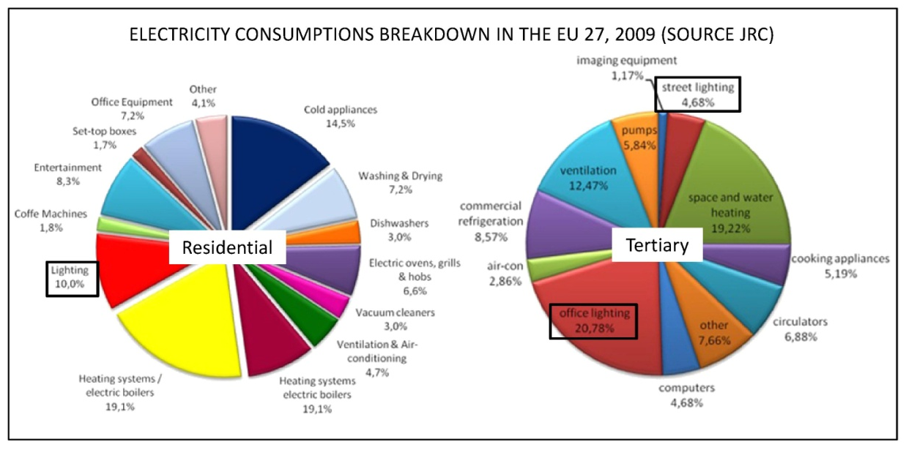
Figure 1. Electricity consumptions breakdown in the EU.

Therefore the current lighting design practice is mainly based on reducing energy consumptions and verifying the compliance with standards related to the performance of visual tasks (for example the EN 12464-1 [2]). However there is a missing element, which is the evaluation of the so called non-image-forming (NIF) or non-visual responses to light. Indeed a relevant number of researches demonstrated that light is strongly linked to humans' health and wellbeing, since it determines responses that are not linked to vision and therefore called non-visual responses or NIF responses. For example, light is capable of affecting performances, mood, the perception of an environment and the circadian system [3,4,5]. The latter is a biological clock located in our brain which controls several processes, known as circadian rhythms, such as hormones production, brain wave patterns, body temperature and heart rate trends and many others, that take place in our body and repeat themselves about every 24 hours [6,7] (see Figure 2).

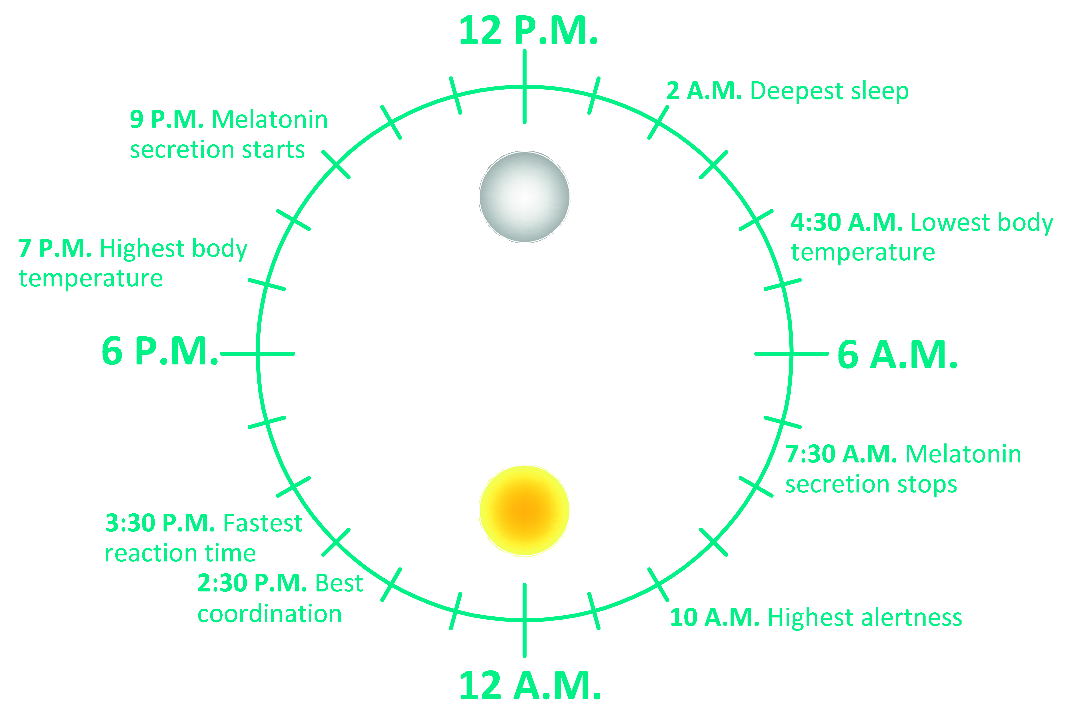
Figure 2. Circadian rhythms.

An adequate exposure to light everyday allows to keep this 24h cycle [8]; it is extremely important to avoid the alteration of the circadian system's inner period, known as circadian disruption, because it has been linked to several medical disorders such as depression, diabetes, obesity, cardiovascular diseases and even cancer [9,10,11] (Figure 3).
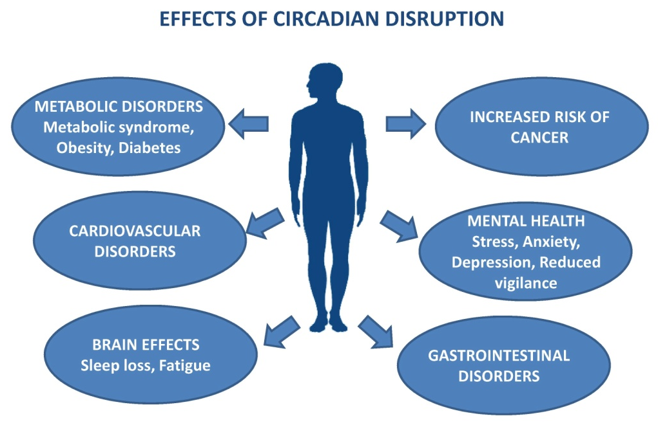
Figure 3. Effects of circadian disruption on humans' health.

Since daylight has been the main light source available until the introduction of electric light, the circadian system is mostly adapted to the former. Indeed it is interesting to highlight that circadian rhythms are present, with different characteristics, in almost all living creatures on Earth as the result of the adaptation to the light/dark pattern on this planet [12,13]. The diffusion of electric light, by extending the day, caused an alteration of the natural light/dark pattern the consequence of which is a modification of humans' sleep pattern [14]. Indeed, before the Industrial Age, people used to have a "first sleep" and a "second sleep" each about four hours long and separated by a wakefulness period [15].
Moreover, in modern societies, people spend most of their life indoors and thus the amount of daylight to which they are exposed to is not sufficient to guarantee the entrainment of the circadian system; in addition electric light is not designed to help the synchronization of this system and avoid any alteration [16,17]. Therefore, nowadays, people are more prone to develop circadian disruption, with the previously reported consequences on health. The present knowledge about NIF responses is not yet complete but it is clear that the impact of a light stimulus on the circadian system depends on the timing and duration of the exposure, on the spectral distribution and intensity of the stimulus [18,19,20,21,22] (Figure 4).

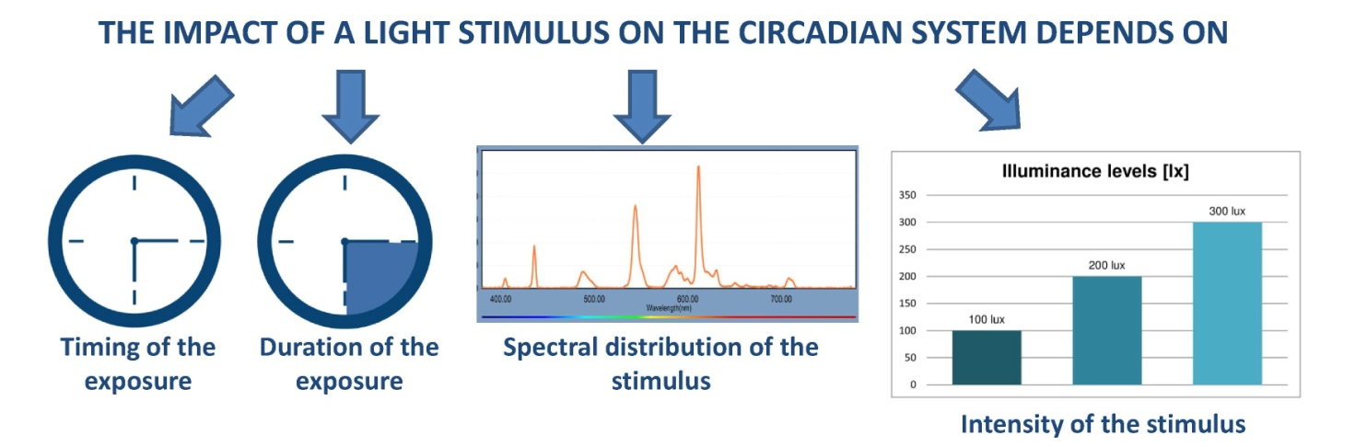
Figure 4. Parameters affecting the impact of a light stimulus on the circadian system.

Over the years several models of circadian phototransduction, which allow to quantify the impact on the circadian system of a given light stimulus, were proposed and most of them require the light stimulus' spectral distribution measured at users' eye level as input. The majority of these models were developed starting from Brainard et al. [23] and Thapan et al. [24] action spectra for melatonin suppression in humans. Melatonin is frequently used as a marker of the circadian impact of light since it is the hormone responsible of the regulation of the sleep-wake cycle, which is a circadian rhythm, indeed when its levels in our body start to increase we feel the need to sleep. In addition, the trends of melatonin levels in humans' body are affected by the exposure to light (see Figure 5) and are also thought to provide input for the synchronization of the other circadian rhythms [25,26].

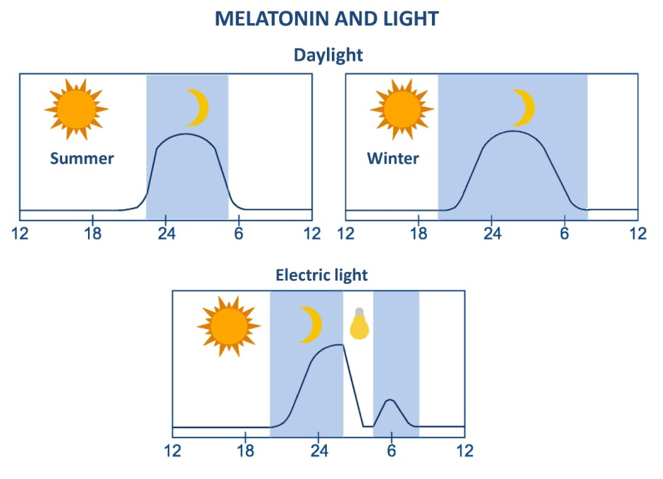
Figure 5. Relationship between melatonin trends and light.

Some of the proposed models of circadian phototransduction consist in the development of a circadian sensitivity function C(λ) similar to what was done for the visual system with the V(λ) function [27,28,29,30]. This approach is certainly very easy to understand and apply, but it probably simplifies too much the working of the circadian system.
Other models follow a different approach, taking into account the contributions of the different photoreceptors in the human eye [31,32,33,34]. Indeed it was discovered that non-visual responses originate in the retina and that intrinsically photosensitive retinal ganglion cells (ipRGCs), a class of photoreceptors, are directly photosensitive and play a relevant role in the working of the circadian system [35,36,37,38,39]. It is also probable that cones and rods also provide input to the circadian system but so far there are still doubts about that.
From these premises the importance of starting to evaluate non-visual responses is clear and the introduction of such analysis will also determine a change in the lighting design practice. Indeed, variables such as timing and duration of the exposure are not usually considered. Moreover, designers are used to calculate parameters such as, for example, illuminances on tasks which are usually horizontal surfaces whereas, for the evaluation of non-visual responses to light, it is fundamental to know the characteristics of the light at users' eye level in indoor environments (spectral distribution, illuminance levels, etc). When considering daylight, such characteristics vary depending on the environment's location, dimensions, time of the day and moment of the year and also on the optical characteristics of the environment's surfaces and furniture. When taking into account electric lighting they depend on the light source's characteristics, on the environment's dimensions and on surfaces' and furniture's optical characteristics.
Some researches already proposed methodologies to introduce the evaluation of non-visual responses in lighting design. For example Pechacek et al. [28], Andersen, Mardaljevic et al. [40,41] tried to take into account influencing parameters such as the light stimulus' SPD and intensity and also the timing of exposure. In more detail, Pechacek et al. [28] considered the sky's SPD during the morning/evening, at noon and during overcast days as respectively represented by D55, D65 and D75 CIE standard illuminants. Andersen, Mardaljevic et al. [40,41] also adopted a similar approach by considering the direct solar beam radiation, the overcast sky and clear blue sky as respectively represented by D55, D65 and D75 standard illuminants. Morever they also took into account timing by defining three "non-visual effects" periods:
- 6:00 to 10:00: when sufficient daylight helps the synchronization of the circadian system;
- 10:00 to 18:00: when daylight may increase alertness without determining a phase shifting;
- 18:00 to 6:00: when daylight exposure has to be avoided.
Therefore in both studies D series illuminants were used to represent daylight's spectral distribution but, in order to generalize the proposed methodologies, the authors did not consider that the spectral distribution of the light that reaches users' eyes in an indoor environment depends, as previously reported, on the environment's characteristics.
Hence to investigate if it is possible to use a similar approach by developing standard eye level spectral distributions, it is important to start acquiring data about light's characteristics at users' eye level by performing measurements in indoor environments with both daylight and electric light.
To do so, it is fundamental to establish a common methodology which will allow to compare the results obtained from different researches. Such comparison is necessary to investigate if there are similarities in eye level spectral distribution detected in different environments and/or locations. If this approach will turn out to be feasible then these standard eye level spectral distributions could be used to calculate NIF responses using one of the abovementioned models or others that will be developed in the future.
Therefore the main goal of the research project carried out during the PhD course was the development and application of a methodology to perform eye level measurements.
In more detail, the developed methodology was first applied in a educational environment (chapter 2, paragraph 2.2) [42]. Then, basing on this first experience, it was improved and used to perform measurements during summer, autumn, winter and spring in three offices with different exposures: West, East and South (chapter 2, paragraph 2.3) [43,44,45]. The acquired data were analyzed and a circadian phototransduction model was applied in both cases to calculate the impact on the circadian system. As previously stated, the characteristics of the light at users' eye level depend also on the optical characteristics of an environment's surfaces, therefore the research project also involved the analysis of the effects of changing the color of a test room's wall (chapter 3, paragraphs 3.1 and 3.2) [46,47].
Moreover, since the choice of a walls' color and light sources' SPD (and consequently CCTs) may significantly affect users' perception of an environment, two studies on the perception of colored objects lit by different light sources were also carried out (chapter 3, subparagraph 3.2.1) [48,49].
From what has been previously reported, in a near future the lighting design practice should balance between different requirements related to the reduction of energy consumptions, the comfortable performance of visual tasks and the control of lighting parameters to help the circadian system's entrainment (Figure 6). The choices made to satisfy these needs affect lighting quality in indoor environments.

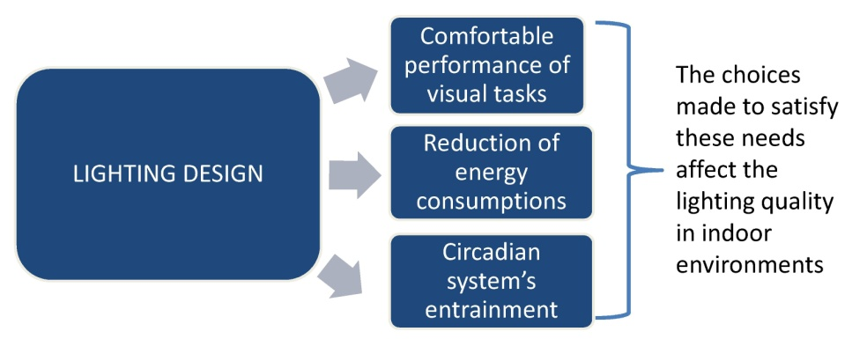
Figure 6. Elements to be considered in the lighting design practice.

These different needs are not necessarily in conflict, indeed an efficient strategy to reduce energy consumptions is to maximize the use of daylight while avoiding discomfort phenomena (glare, overheating, etc.); this also helps both the performance of visual tasks and the circadian system's entrainment since our visual and circadian systems are mostly adapted to daylight as it was previously reported.
However it is important to highlight that, in some cases, when daylight is insufficient it may be necessary to increase the level of illumination provided by electric lighting beyond the standard values set for visual tasks in order to help the circadian system's regulation. This will of course determine an increase in energy consumptions but the increase of costs is only apparent because helping the circadian system's entrainment, positively affects people's health and wellbeing and it results in less absence from work, an increase in performances and less health problems [50].
Therefore it is clear that the evaluation of daylight availability in indoor environments during the design phase is important for both energy saving, visual tasks performance and circadian system's entrainment purposes. Usually to perform such task designers run software simulations and, at the present date, there are two approaches to daylight simulations, respectively called static and dynamic. The static one is based on the calculation of the Daylight Factor (DF), which is the ratio of the indoor illuminance at a given point to the unshaded, external horizontal illuminance under a CIE overcast sky [51]. The DF does not take into account a building's orientation and the direct component of daylight, therefore it has been criticized and this led to the development of the dynamic one [52]. This new approach is based on the calculation of dynamic daylight performance metrics and several indices were proposed during the years: they are listed in Table 1 together with their definitions.

Index | Definition
Daylight Autonomy (DA) | Annual percentage of the occupied time during which the minimum required illuminance is achieved only with daylight [53,54].
Continuous Daylight Autonomy (DAcon) | It is an extension of the DA, it is the ratio of the daylight-related illuminance at a point to the minimum required illuminance [55].
Useful Daylight Illuminances (UDI) | Percentage of occupied time in a year during which the illuminance at a point falls in one of the following ranges: below 100 lx (insufficient daylight levels), between 100 lx and 2000 lx (useful daylight levels, i.e. adequate to perform a visual task), over 2000 lx (uncomfortable daylight levels) [56,57].
Spatial Daylight Autonomy (sDA) | Percentage of the workplane for which the required illuminance is achieved only with daylight during 50% of the occupied hours in a year [58].
Annual Sunlight Exposure (ASE) | Percentage of the workplane for which illuminances related only to the direct component of daylight exceed 1000 lx for at least 250 hours in a year [58].
Annual Light Exposure | Cumulative amount of visible light falling on a point during a year.
Table 1. Dynamic daylight performance metrics and their definitions.

All these indices are calculated after performing a yearlong dynamic daylight simulation using a reference weather data file of the design location.
Weather data files are developed by processing historical sets of annual measurements using a statistical method, they contain hourly values related to several meteorological variables that characterize the climate of a given location, such as for example irradiance, relative humidity, etc. There are several types of weather data files that differ for the meteorological data included, for the statistical method used to develop them and for the sets of annual measurements used. Therefore one of the problems connected with daylight simulations is the effect of using one weather file or another on the results obtained. Such effects have not been widely studied yet.
Another problem is linked to the choice of the software to perform daylight simulations. Indeed there are several ones available and they differ for the calculation engine, for the method used to calculate indoor daylight levels, etc. [59]. For these reasons there may be significant differences in the results obtained for the same simulation when using different software.
Therefore a part of the research carried out during the PhD course also involved the analysis of the impact of using different weather data files and different software on dynamic daylight simulations' results (chapter 4) [60,61,62].
In conclusion, hopefully in a near future, the lighting design workflow could be organized as illustrated in Figure 7.

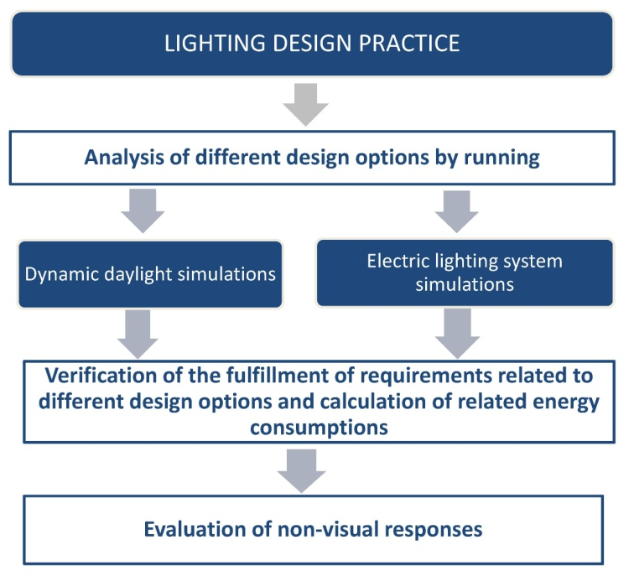
Figure 7. Lighting design workflow.

In more detail, the first design stages should include the comparison of different design options by performing both daylight and electric lighting system simulations. The results obtained will allow to calculate the energy consumptions related to each option and also to verify the fulfillment of requirements related to visual tasks performance; the simulations' results should also include eye level illuminances. These data are fundamental for the following step, which is the evaluation of non-visual responses.
Indeed, if the approach based on the development of standard eye level spectral distributions will turn out to be feasible, such eye level spectra could be scaled to correspond to the illuminances calculated through simulations and used as input in a circadian phototransduction model.
However, there are still many steps to be done to make this workflow applicable and the PhD research project illustrated in this thesis aimed at providing the starting point.
First of all it establishes a methodology to carry out eye level measurements, which is fundamental to compare results obtained from different researches in order to investigate the possibility of developing standard eye level spectral distributions. Moreover it also provides the first results of the application of this methodology, with both daylight and electric light, which represent the basis for the development of a database containing data obtained from measurements carried out in different environments and/or locations.
Since the evaluation of daylight availability is also a fundamental point in the workflow illustrated in Figure 7, during the PhD project the topic of dynamic daylight simulations was also dealt with. In more detail, the effects of using different weather data files and software on simulations' results were analyzed.

2. Eye level measurements: development and application of a methodology
In this chapter the methodology developed to carry out eye level measurements will be explained and the results obtained by using it will be reported. In more detail, the methodology was used the first time to perform measurements in a University classroom during two typical winter days [42] (subparagraphs 2.2, 2.2.1 and 2.2.2). Later some modifications were made to the methodology to improve it and it was used to carry out measurements in three offices (East, West and South exposed) during several days for each season [43,44,45] (subparagraphs 2.3 and 2.3.1 to 2.3.3).
Moreover the model of circadian phototransduction used to calculate the circadian impact of the light measured in the abovementioned environments is also explained in detail (subparagraph 2.2.1).
The optical characteristics of the environments' surfaces and furniture were acquired using a Konica Minolta CM 2600d spectrophotometer (the technical specifications are reported on the manufacturer's website [63]), in order to fully characterize them.
Eye level measurements were performed by placing a Konica Minolta CS 2000 spectroradiometer at the same height of a person's head (1.20 m), the technical specifications of the instrument can be found on the manufacturer's website [64]. It was decided to perform these measurements with different tilt angles of the spectroradiometer to take into account that the position of a person's head is never fixed. Figure 8 shows the angles used to perform eye level measurements, which are respectively 0°, 15° and 45° on the vertical plane and 45° left and right on the horizontal plane. In more detail, for the University classroom, only measurements on the vertical plane were performed and the ones on the horizontal plane were later added as an improvement to the methodology before starting to perform measurements in the three offices.

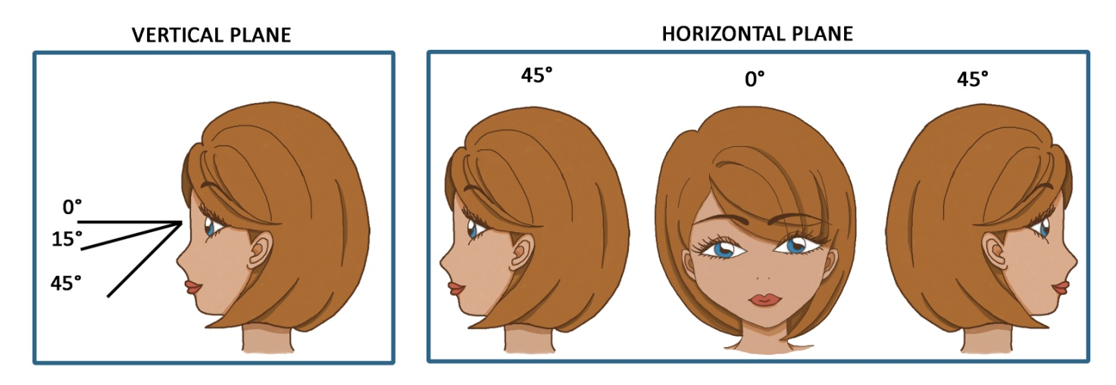
Figure 8. Angles used to perform eye level measurements.

During each day of measurement, both for the classroom and the offices, the following data were acquired every hour using the abovementioned spectroradiometer and a Konica Minolta T10 illuminance meter (the technical specifications can be found in the Konica Minolta's website [65]):
- indoor illuminances on a horizontal plane (height 0.80 m);
- sky correlated color temperatures (CCTs) and spectral power distributions (SPDs);
- eye level CCTs and spectral irradiance distributions (with each tilt angle of the spectroradiometer);
- eye level illuminances;
- outdoor illuminances on an horizontal unobstructed surface.
Eye level CCTs, illuminances and spectral irradiances detected each hour with the different tilt angles of the spectroradiometer were averaged and the latter were used as input in the circadian phototransduction model that will be illustrated in detail in the following subparagraph.
Moreover D series standard illuminants' SPDs were converted into spectral irradiances to compare them with the measured eye level spectral irradiances. This comparison is important to investigate if one or more D series illuminants can be considered as representative of eye level spectral irradiances in a given environment; this can be extremely helpful for the evaluation of non-visual effects of light during the design phase, as it was stated in the introduction.
To transform the D series illuminants' SPDs into spectral irradiances the spectral irradiance at the observer's eye was considered as proportional to the luminaires’ or lamps’ spectral radiance and thus:

$E_{λ}= αL_{λ}$ (Eq.1)

where
E_{λ} is the light source spectral irradiance distribution [W/m² nm];
L_{λ} is the light source spectral radiance distribution [W/m² sr nm];
α is a constant dimensional value [sr], which depends on the SPD of the light source.
The eye level illuminance can be calculated by considering that:

$E_{vcor}= K_{max}\int{E_{λ}}V_{λ}dλ= K_{max} α \int{L_{λ}}V_{λ}dλ$ (Eq.2)

where
E_{vcor} is the eye level illuminance [lux];
K_{max} is equal to 683 lm/W
V_{λ} is the photopic luminous efficiency function [-].

2.1. Circadian phototransduction model
The term circadian phototransduction indicates a process for which a cell absorbs light and produces a given response related to the circadian system. As it was previously stated in the introduction there are several circadian phototransduction models available in the scientific literature. The most recent one was developed by Lucas et al. [66] and it allows to calculate equivalent illuminances for the photopigments in the human eye; i.e. it weights a given spectral irradiance distribution according to the sensitivity functions of the photopigments secreted by S cones (cyanolabe), ipRGCs (melanopsin), rods (rhodopsin), M cones (chlorolabe) and L cones (erythrolabe) (Figure 9).
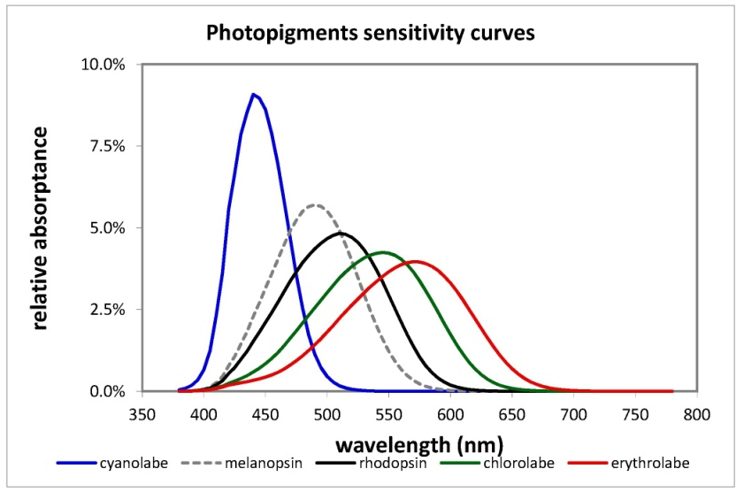
Figure 9. Photopigments sensitivity functions.

Therefore this tool allows to calculate the "degree of stimulation" of each photopigment but it does not translate it into a given non-visual response. For this reason in the research project here illustrated it was decided to use the model proposed by Rea et al. [33]. This one, starting from eye level spectral irradiance distributions, allows to calculate circadian light (CL_{A}) which is spectrally weighted irradiance for the circadian system and expressed in weighted W/m². After that it is possible to calculate the circadian stimulus (CS) which represents melatonin suppression percentages and therefore a precise NIF response.
The equations used to calculate CL_{A} e CS are reported below:

if $\int{\frac{S_{λ}}{{mp}_{λ}}}E_{λ}dλ-k \int{\frac{V_{λ}}{{mp}_{λ}}} E_{λ}dλ ≥0$
then
${CL}_{A}=1622 \left[\int{{Mc}_{λ}E_{λ}}dλ+ \left(a_{b-y}\left(\int{\frac{S_{λ}}{{mp}_{λ}}}E_{λ}dλ-k \int{\frac{V_{λ}}{{mp}_{λ}}}E_{λ}dλ\right)- a_{rod}\left(1- e^{\frac{- \int{{V'}_{λ}E_{λ}dλ}}{rodSat}}\right)\right)\right]$ (Eq.3)

if $\int{\frac{S_{λ}}{{mp}_{λ}}}E_{λ}dλ-k \int{\frac{V_{λ}}{{mp}_{λ}}} E_{λ}dλ <0$
then
${CL}_{A}=1622 \int{{Mc}_{λ}E_{λ}}dλ$ (Eq.4)

where
CL_{A} = circadian light [weighted W/m²];
Mc_{λ} = melanopsin sensitivity (corrected for crystalline lens transmittance);
S_{λ} = S cones sensitivity;
mp_{λ} = macular pigment transmittance;
E_{λ} = eye level spectral irradiance;
V_{λ} = photopic luminous efficiency function;
V'_{λ} = scotopic luminous efficiency function;
rodSat = Half-saturation constant for bleaching rods= 6.5 W/m²;
k = 0.2616;
a_{b-y} = 0.6201;
a_{rod} = 3.2347.
The constant, 1622, is used to normalize CL_{A} so that to a 2856K blackbody radiation at 1000 lux correspond a CL_{A} value of 1000.
$CS=0.75- \frac{0.75}{1+ {\left(\frac{{CL}_{A}}{215.75}\right)}^{0.864}}$ (Eq. 5)
It is important to notice that CS is not a linear function of CL_{A} and its maximum value is 0.75 (75%).

2.2. Case study: University classroom
The first application of the proposed methodology was in a University classroom located in Naples (Italy), on the sixth floor of one of the buildings of the University of Naples "Federico II". Measurements were carried out every hour from 9:30 to dusk on 26th January 2012, which was a clear sky day, and on 2nd February 2012, which was an overcast sky day. Figure 10 shows the measured plan of the classroom, its orientation, pictures of its interior and of the external obstructions and it also points out where measurements were performed (desk, seat 1,2 and 3).
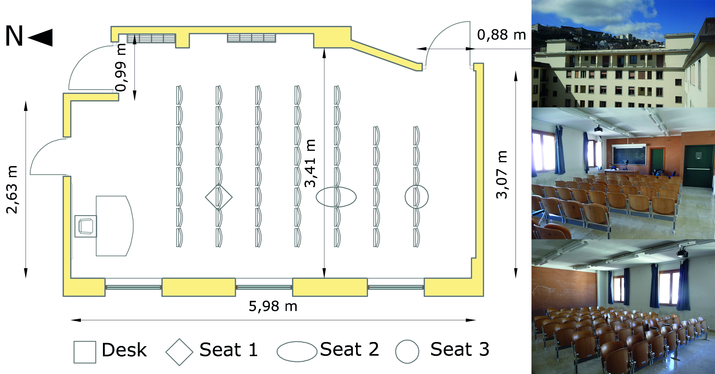
Figure 10. Measured plan of the classroom and pictures of the external obstructions and of its interior.

The classroom is equipped with a fluorescent lighting system and measurements were also performed with only the electric lighting system. Figure 11 reports the spectral reflectances and the reflectances with the specular component included (SCI) and excluded (SCE) of the classroom's surfaces and furniture, which were all detected with the spectrophotometer.

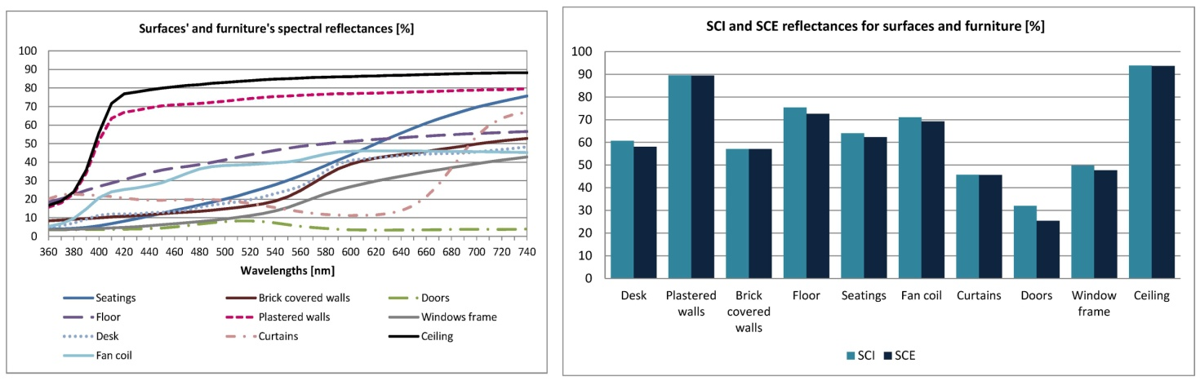
Figure 11. Spectral, SCI and SCE reflectances for the classroom's surfaces and furniture.

It can be observed that for the majority of surfaces and furniture the specular component is negligible.
In the following subparagraphs the results of the measurements performed on 26th January and on 2nd February will be illustrated.

2.2.1 Measurements performed on 26th January 2012 (clear sky day)
Figure 12 reports sky SPDs and CCTs and also global outdoor illuminances measured on 26th January 2012 (clear sky day).

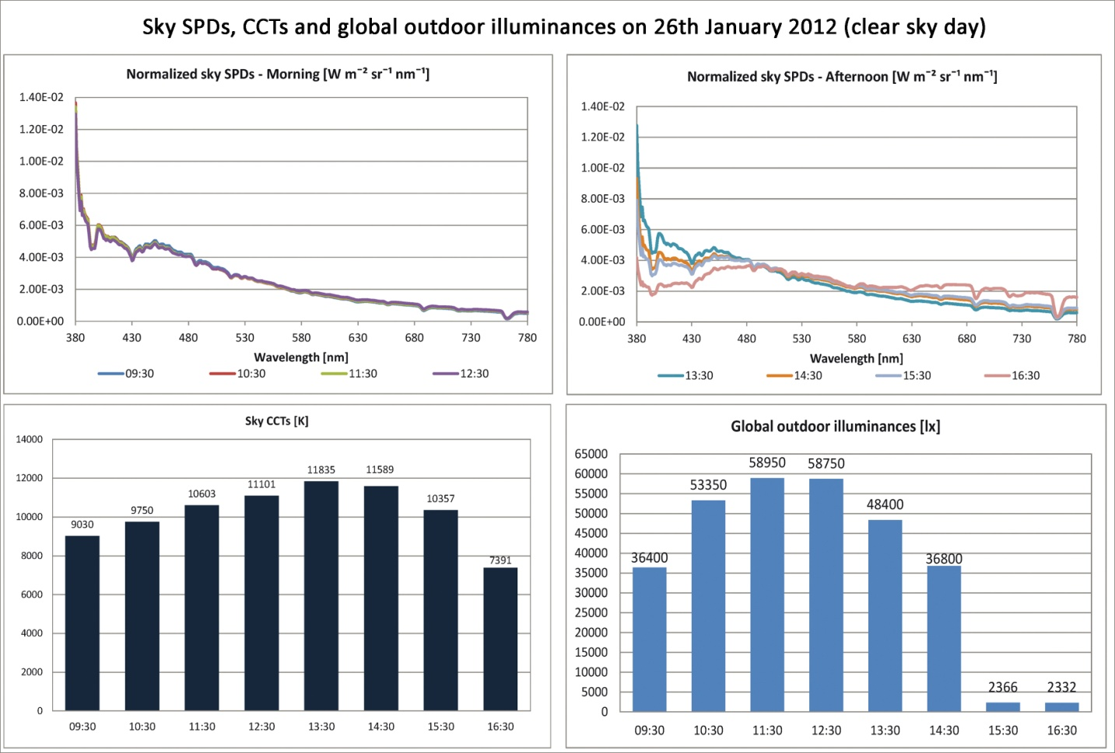
Figure 12. Sky SPDs and CCTs, global outdoor illuminances on 26th January 2012.

It is interesting to highlight that between 09:30 and 12:30 sky SPDs show nearly undetectable changes and there is a greater emission in the short wavelengths. On the contrary, between 13:30 and 16:30 sky SPDs' trends differ and the emission in the short wavelengths decreases while that in the medium and long wavelengths increases; this finding is also reflected by sky CCTs values which tend to decrease between 13:30 and 16:30, thus meaning that the sky's color tone tends to get gradually "warmer".
As regards global outdoor illuminances, it can be observed that they increase between 09:30 and 11:30, when they reach their highest value, then they decrease until the minimum value at 16:30.
Figure 13 shows illuminance values measured on a horizontal plane for each one of the positions reported in Figure 8; it also reports average eye level CCTs and illuminances calculated as a mean of the ones detected with each angle of the spectroradiometer and also CS values.

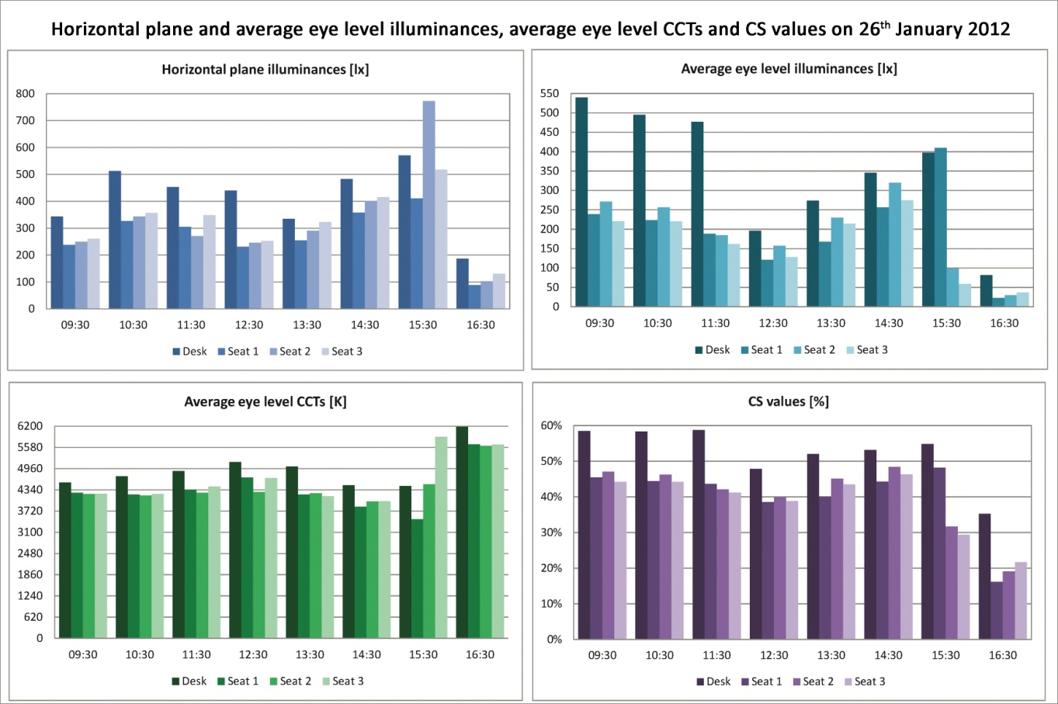
Figure 13. Horizontal plane illuminances, average eye level illuminances and CCTs, CS values on 26th January 2012.

It is interesting to observe that usually for horizontal plane and average eye level illuminances the highest values are those related to the desk; the only exception is at 15:30. The other positions (seat 1, seat 2 and seat 3) generally show similar values.
Concerning average eye level CCTs, the desk is also in this case the position for which the highest values are registered (again with the only exception at 15:30). CCT values are comprised between 3800 K and 5000 K, except at 15:30 and 16:30 where they reach values above 6000 K. This difference may be explained by the incoming sunset. Moreover eye level CCTs are considerably lower than those measured for the sky and they also show a completely different trend.
Regarding CS values, the maximum ones are again those related to the desk but the most interesting finding is the similarity between average eye level illuminances' trends and CS values' ones. Indeed the impact of a light stimulus on the circadian system also depends on the light stimulus's intensity.
As it was explained in the method section, average eye level spectral irradiances were compared with those derived from transforming D series standard illuminants' SPDs into spectral irradiances. For readability reasons Figure 14 shows an example of this comparison performed with the data related to the clear sky day only for one hour for each position. Table 2 lists, for each hour, which illuminant is the closest to the average eye level spectral irradiance.

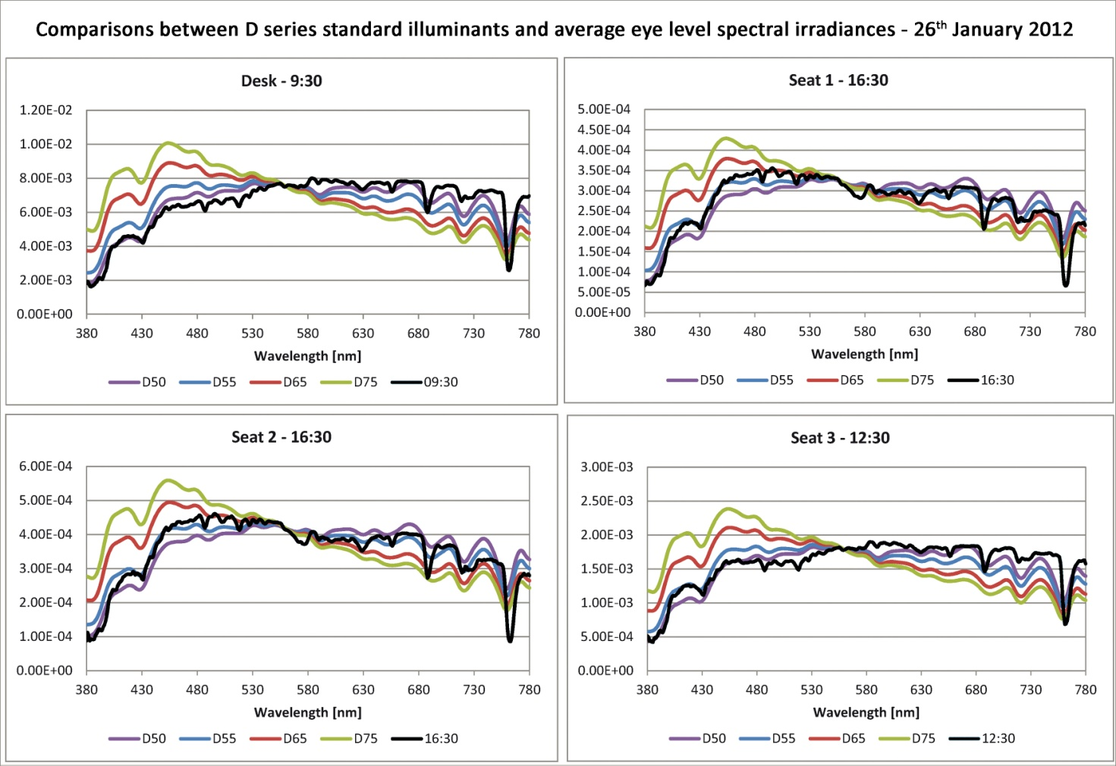
Figure 14. Comparison between D series standard illuminants and average eye level spectral irradiances for 26th January 2012.

D series standard illuminants closest to average eye level spectral irradiances
for 26th January 2012 (clear sky day)
 | Desk | Seat 1 | Seat 2 | Seat 3
9:30 | D50 | D50 | D50 | D50
10:30 | D50 | D50 | D50 | D50
11:30 | D50 - D55 | D50 | D50 | D50
12:30 | D55 | D50 - D55 | D50 | D50
13:30 | D50 | D50 | D50 | D50
14:30 | D65 | D50 | D50 | D50
15:30 | D50 | D50 | D50 | D55-D65
16:30 | D55 | D55 | D55 | D55
Table 2. D series standard illuminants closest to average eye level spectral irradiances for 26th January 2012 (clear sky day)

It is really interesting to observe that in most cases the D50 standard illuminant matches average eye level spectral irradiances.

2.2.2 Measurements performed on 2nd February 2012 (overcast sky day)
In this subparagraph the results of measurements carried out on 2nd February 2012 (overcast sky day) will be reported. Figure 15 shows sky SPDs and CCTs and also global outdoor illuminances measured during this day.

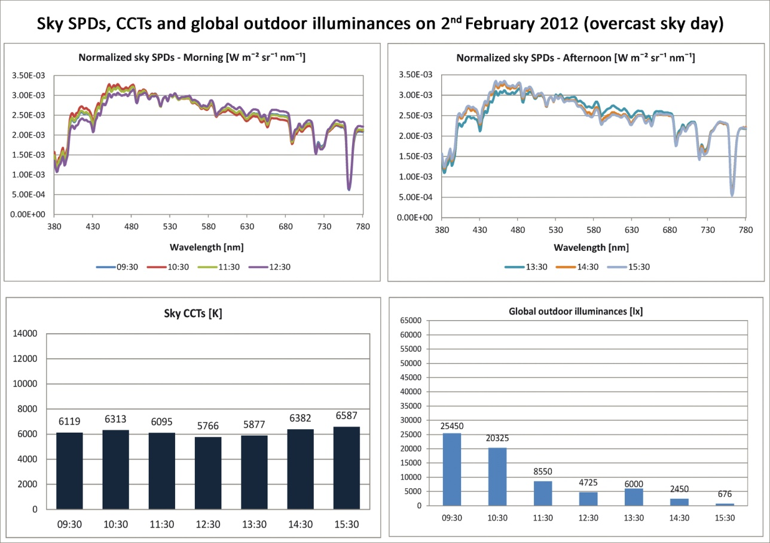
Figure 15. Sky SPDs and CCTs, global outdoor illuminances on 2nd February 2012.

Concerning sky SPDs, it can be observed that their trends are completely different from those detected on 26th January 2012, moreover there is also little variation during the day. Looking at sky CCTs it can be noted that their values are considerably lower than those related to the clear sky day and they do not vary much during the day. Global outdoor illuminances are also lower than clear sky day ones.
Figure 16 shows illuminance values measured on a horizontal plane for each one of the positions reported in Figure 8; it also reports average eye level CCTs and illuminances calculated as a mean of the ones detected with each angle of the spectroradiometer and CS values.

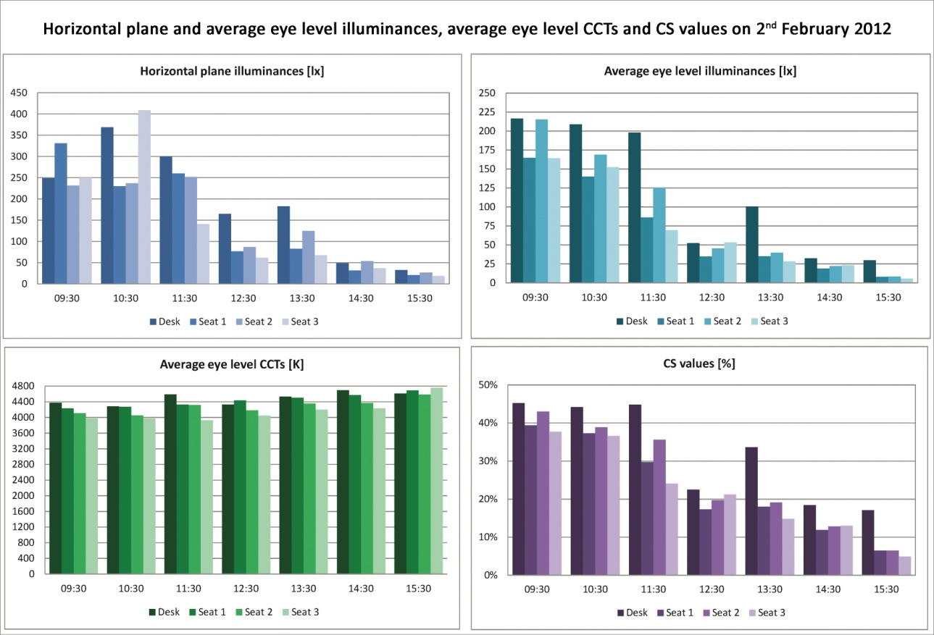
Figure 16. Horizontal plane illuminances, average eye level illuminances and CCTs, CS values on 2nd February 2012.

As regards horizontal plane and average eye level illuminances their values are lower than those measured during the clear sky day but also in this case the desk is usually the position for which the highest values were detected.
Average eye level CCTs show little variation during the day and their values are lower than those reported for the clear sky day (comprised between 4000 K and about 4800 K).
The maximum CS values calculated for the overcast sky day is about 45%, whereas during the clear sky day it was about 60%. Also in this case there is a similarity between CS values' trends and average eye level illuminances' ones.
Concerning the comparison between D series standard illuminants and average eye level spectral irradiances, Table 3 lists, for each hour, which illuminant is the closest to the average eye level spectral irradiance while Figure 17 reports an example of this comparison performed with the data related to the overcast sky day only for one hour for each position.

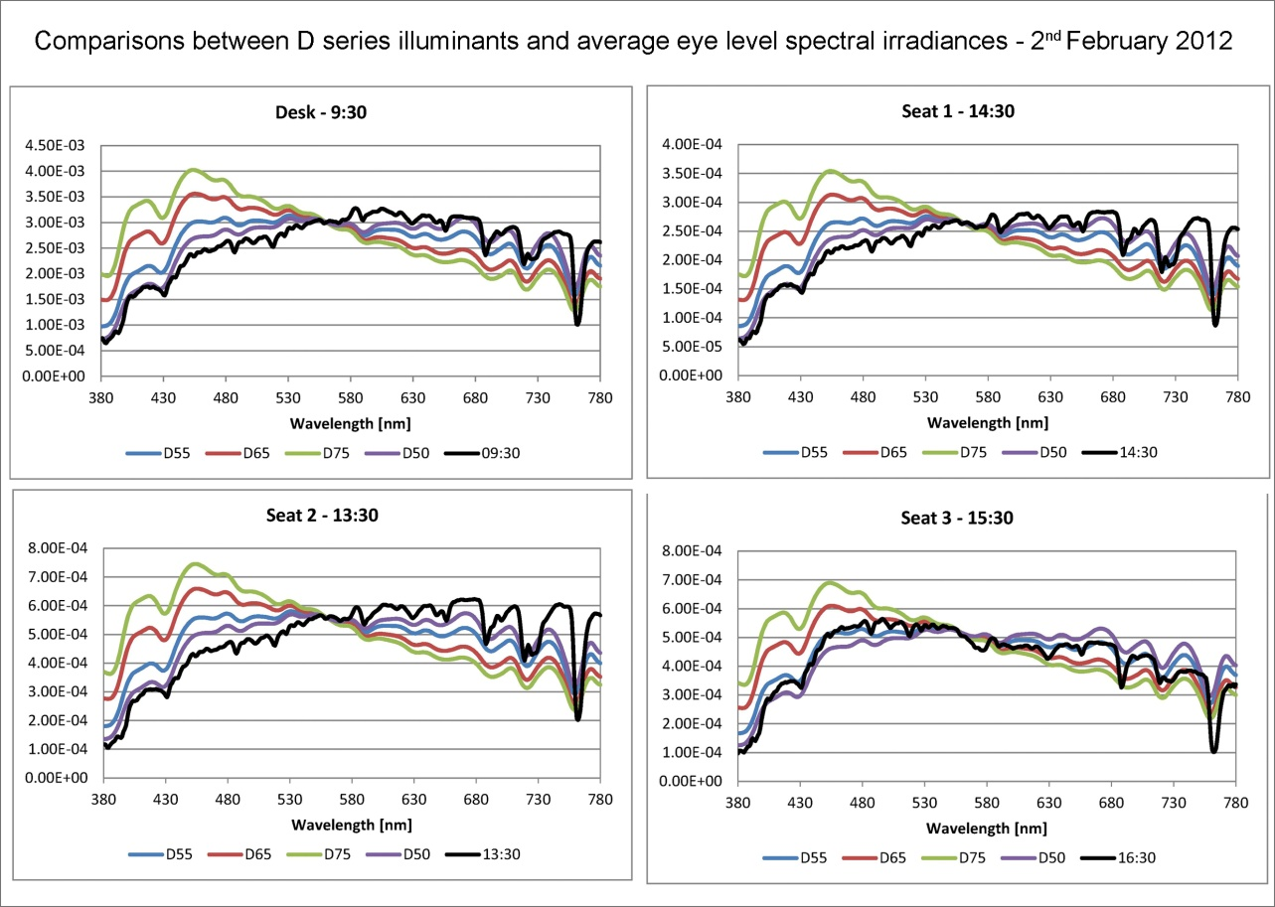
Figure 17. Comparison between D series standard illuminants and average eye level spectral irradiances for 2nd February 2012.

D series standard illuminants closest to average eye level spectral irradiances
for 2nd February 2012 (overcast sky day)
 | Desk | Seat 1 | Seat 2 | Seat 3
9:30 | D50 | D50 | D50 | D50
10:30 | D50 | D50 | D50 | D50
11:30 | D50 | D50 | D50 | D50
12:30 | D50 | D50 | D50 | D50
13:30 | D50 | D50 | D50 | D50
14:30 | D50 | D50 | D50 | D50
15:30 | D50 | D50 | D50 | D50
Table 3. D series standard illuminants closest to average eye level spectral irradiances for 2nd February 2012 (overcast sky day).

In this case the D50 standard illuminants is always the one matching average eye level irradiances' trends.

2.2.3 Electric lighting system
Measurements were also performed with the electric lighting system switched on, they were carried out after twilight and with the curtains closed to exclude the light coming from the outside. The classroom is equipped with a fluorescent lighting system, Figure 18a and Table 4 respectively report the luminaires' SPD and the CCT, CRI and ∆uv values, all measured with the spectroradiometer. The ∆uv value represents the distance of a light source's chromatic point from the Planckian locus in the CIE 1960 UCS color space, a negative value indicates a point that is located under the locus (see Figure 18b).

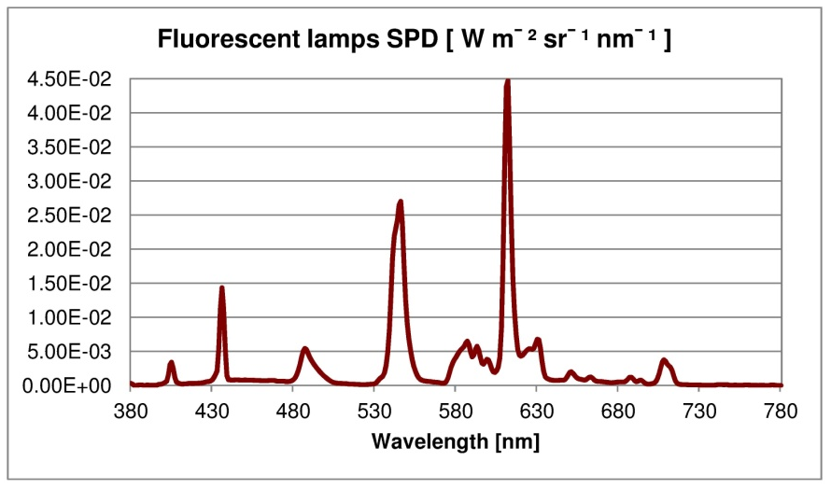
Figure 18a. Fluorescent luminaires' SPD.

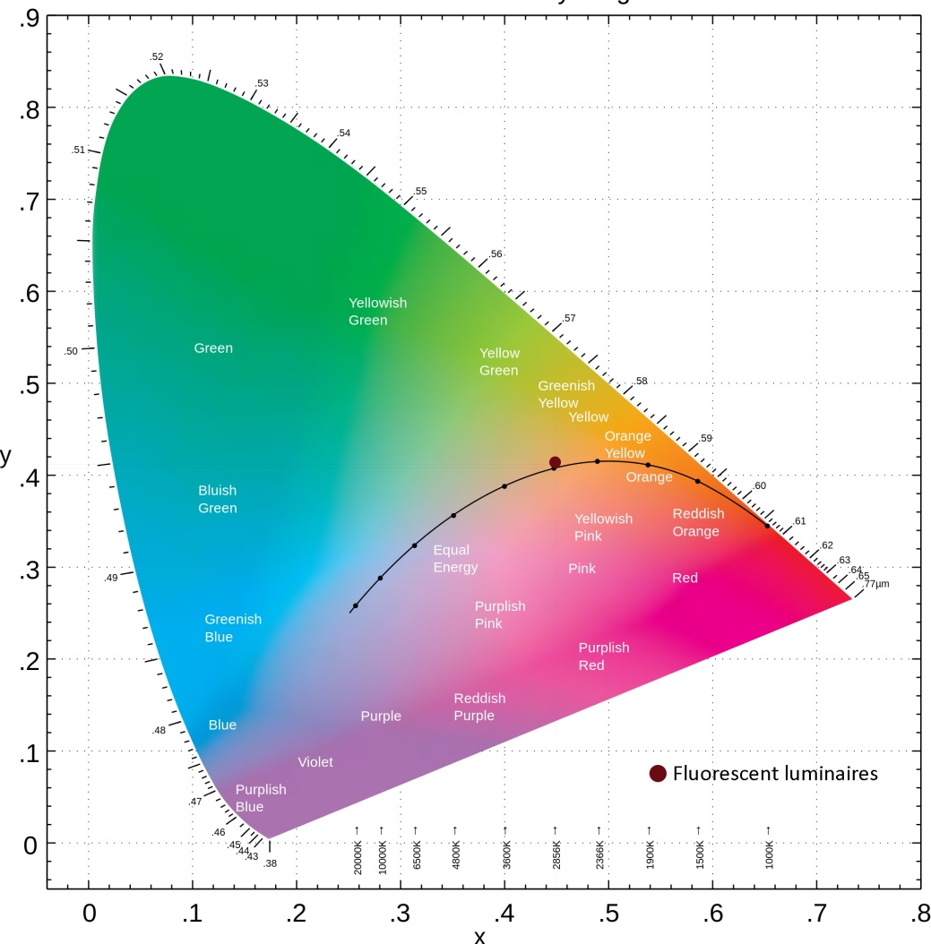
Figure 18b. Planckian locus.

Measured CCT, CRI and ∆uv values related to the electric lighting system
CCT [K] | CRI | ∆uv
2929 | 83 | 0.003
Table 4. Measured CCT, CRI and ∆uv values related to the fluorescent luminaires.

From the data reported in Table 4 it can be observed that the color tone of the installed electric lighting system is warm, the CRI value is high (above 80) and complies with the requirements of the EN 12464-1 standard for the type of visual task carried out in this environment [2].
Figure 19 reports the values of illuminances measured on horizontal planes, average eye level CCTs and illuminances and also of CS related to the electric lighting system.

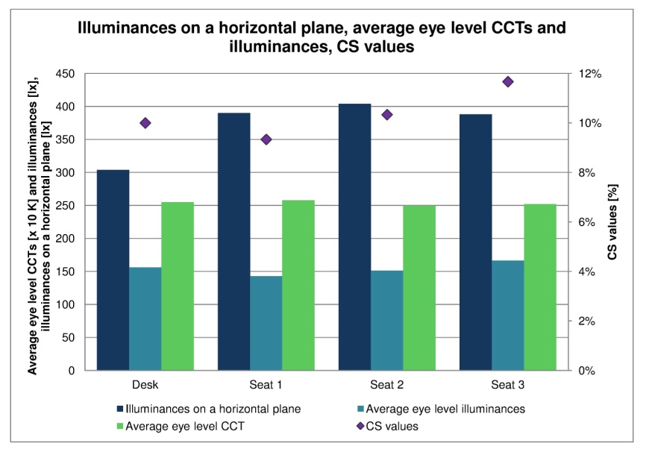
Figure 19. Illuminances on a horizontal plane, average eye level CCTs and illuminances, CS values.

Illuminances on horizontal planes are for all positions comprised between 300 lx and 400 lx whereas average eye level illuminances are in all cases equal to about 150 lx. Average eye level CCTs are not so different from luminaires' CCT (2929 K) and equal to about 2500 K for all positions.
It is interesting to observe that CS values are really low (comprised between 9% and 12%), which means that there is no risk of them causing circadian disruption but they probably do not provide enough stimulation to help the circadian system's entrainment during the morning, especially when daylight is not sufficient.
Figure 20 reports the average eye level spectral irradiances detected with the electric lighting system.

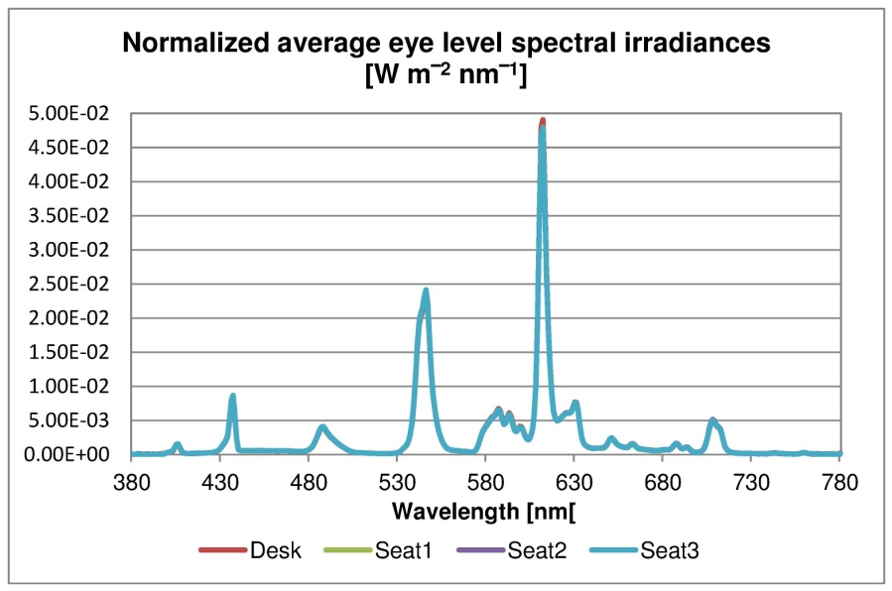
Figure 20. Normalized eye level spectral irradiances detected with the electric lighting system.

It is interesting to observe that there is no significant difference in the trends of eye level spectral irradiances.

2.2.4 Discussion
The graphs reported in the previous subparagraphs show some interesting findings. First of all, looking at Figures 12 and 14, it can be observed how sky SPDs' trends are really different from eye level spectral irradiances' ones whereas, for the overcast sky day (Figures 15 and 17) this difference is greatly reduced.
It is also important to highlight that the CS values calculated with the electric lighting system are really low (between 9% and 12%), which means that they cannot cause circadian disruption. However when daylight levels are not sufficient, the current lighting system fails to provide an adequate stimulation to help the circadian system's entrainment.
As regards the comparison between average eye level spectral irradiances and D series standard illuminants, in most cases the former resulted as similar to the D50.
These measurements also highlighted that educational environments, given that several visual tasks are carried out at the same time (reading on desk, on the blackboard, etc.), require to carry out simultaneous measurements. This is almost impossible to achieve with standard instruments and therefore a small part of the PhD was also dedicated to the study of the High Dynamic Range (HDR) imaging technique [67,68]. This technique allows to obtain luminance maps and also illuminance values on several visual tasks with a single take and it works by acquiring different images of the same scene.
To use the HDR technique a system composed by a digital reflex camera Canon EOS 20D, equipped with a photopic filter and a Matlab-based software for data management and processing was developed at the Photometry and Lighting Laboratory of the University of Naples "Federico II" [69].

2.3. Case study: Offices
The measurements carried out in the University classroom served as the first test of the proposed methodology, in order to investigate possible improvements. Therefore it was decided to repeat the study using a more complex experimental setup; indeed the same measurements were carried out in three offices located at the 7th floor of the same building in Naples during several days in each season. Moreover, following the first case study, the methodology was improved by adding the tilt angles on the horizontal plane reported in Figure 8 (page 9) to perform eye level measurements.
During each season measurements were repeated in different days, so the data related to days with the same sky condition were averaged in order to obtain a "typical" clear, overcast and intermediate sky day in each season. Measurements were performed between 10:00 and 18:00 which is the usual occupied time of the offices, however in seasons like spring and winter they stopped earlier since the levels of daylight were too low due to the incoming sunset and there was the need to switch on the electric lighting system.
As stated in the introduction the offices have different exposures, Office 1 has a westerly exposure, Office 2 an easterly one and Office 3 is South exposed.
Figures 21, 22 and 23 report the measured plans of the offices, photos of the external obstructions and of the interior of the three environments.
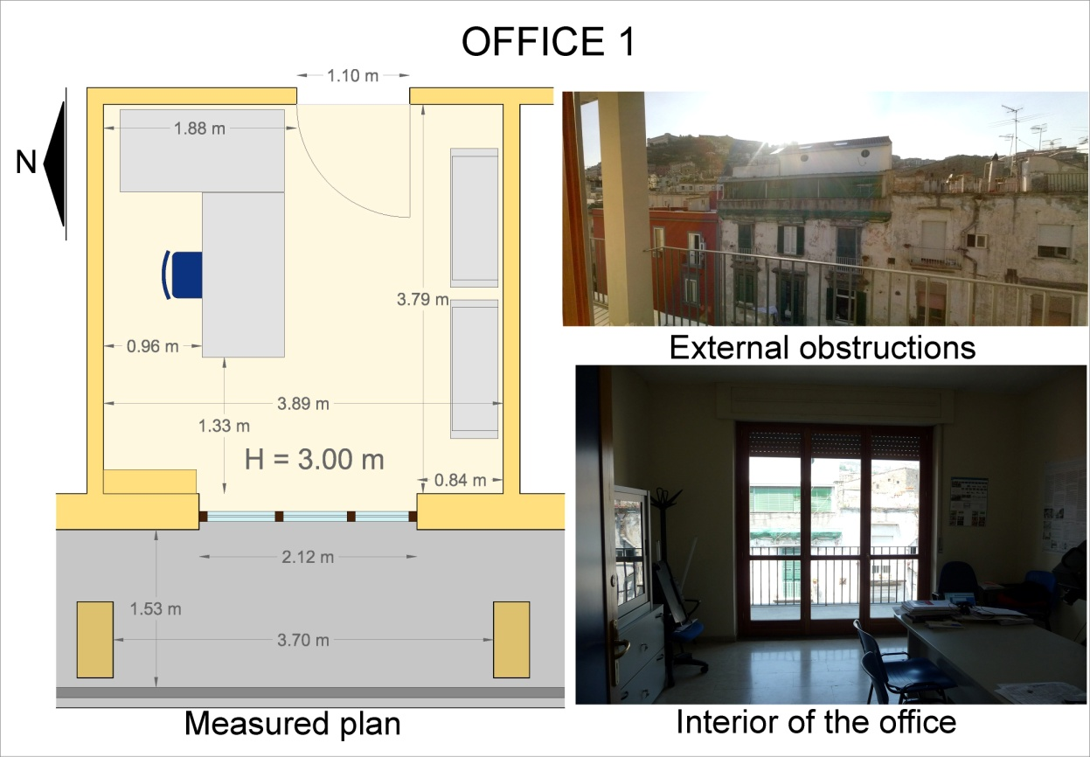
Figure 21. Office 1's measured plan, interior and external obstructions' photos.
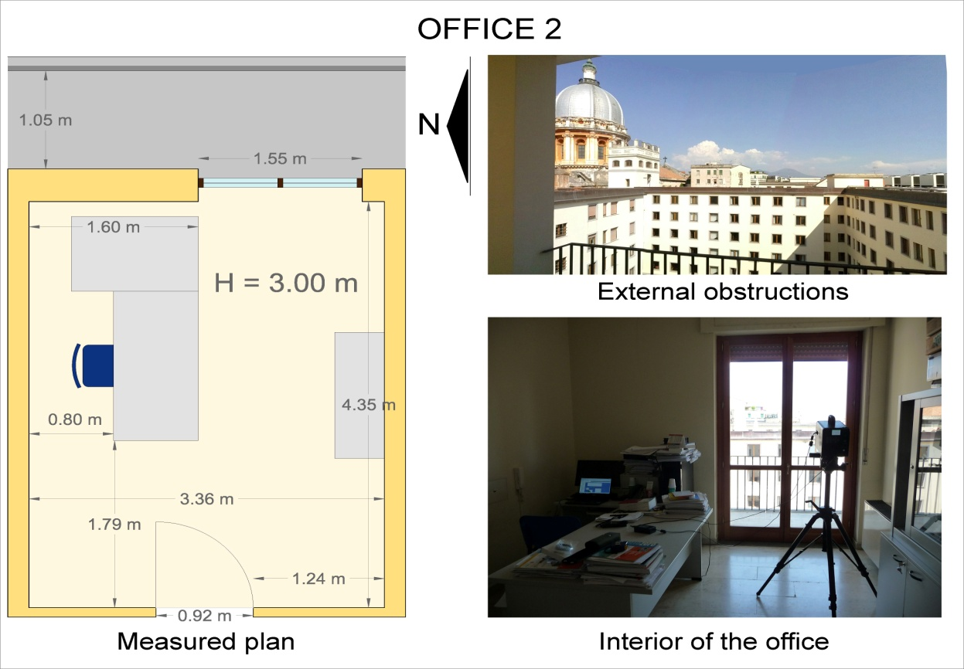
Figure 22. Office 2's measured plan, interior and external obstructions' photos.

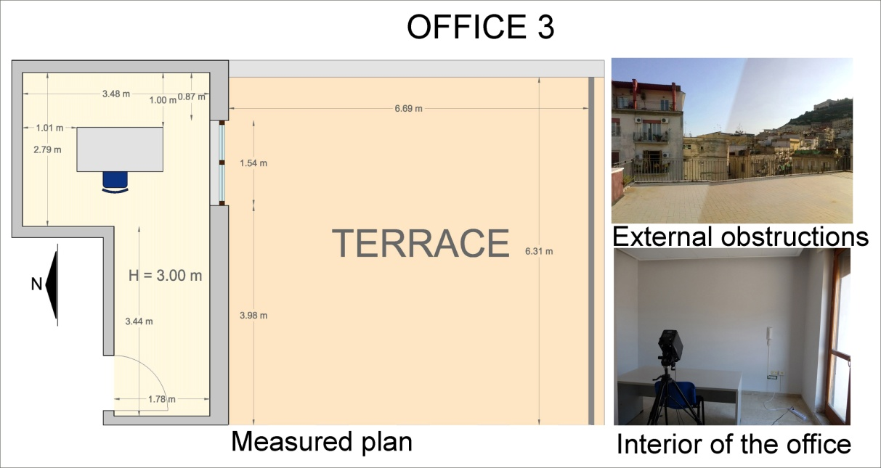
Figure 23. Office 3's measured plan, interior and external obstructions' photos.

Figure 24 shows the spectral reflectances of the offices' surfaces and furniture measured with the spectrophotometer.

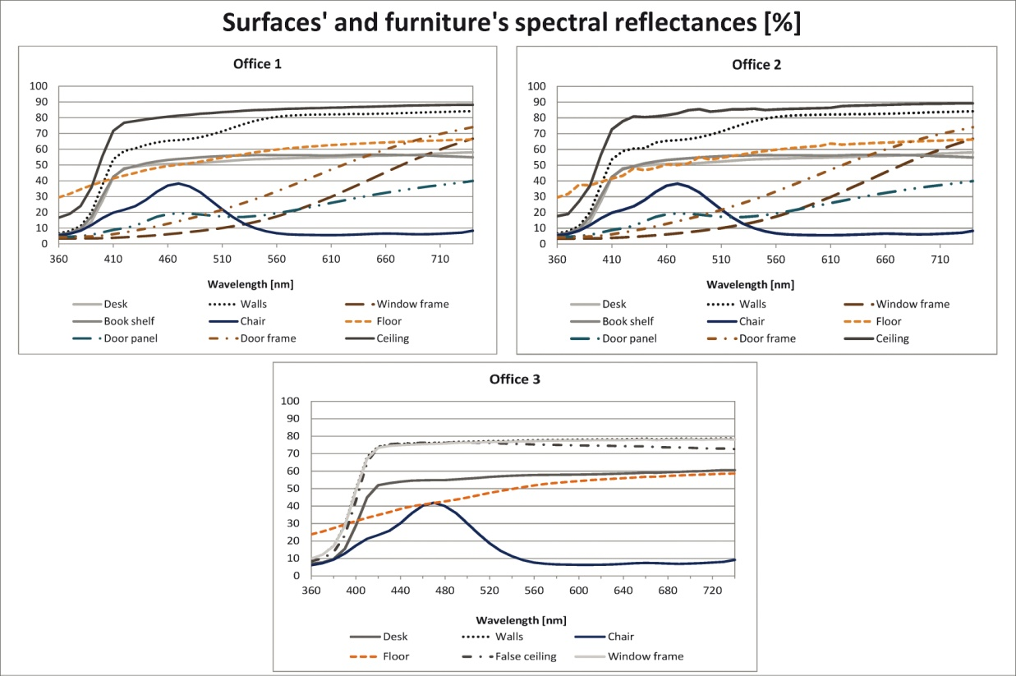
Figure 24. Spectral reflectances of the offices' surfaces and furniture.

It can be observed that some objects and surfaces included in the offices have the same optical characteristics, for example the chairs and the desks. The following subparagraphs will report the data related to clear sky days (subparagraph 2.3.1), intermediate sky days (subparagraph 2.3.2) and overcast sky days (subparagraph 2.3.3).

2.3.1. Data related to clear sky days
This subparagraph will report, for each office, the data related to clear sky days in each season. Figure 25 reports global outdoor illuminances for clear sky days during each season; there is a graph for each office since the days during which measurements were performed in each environment are not the same.
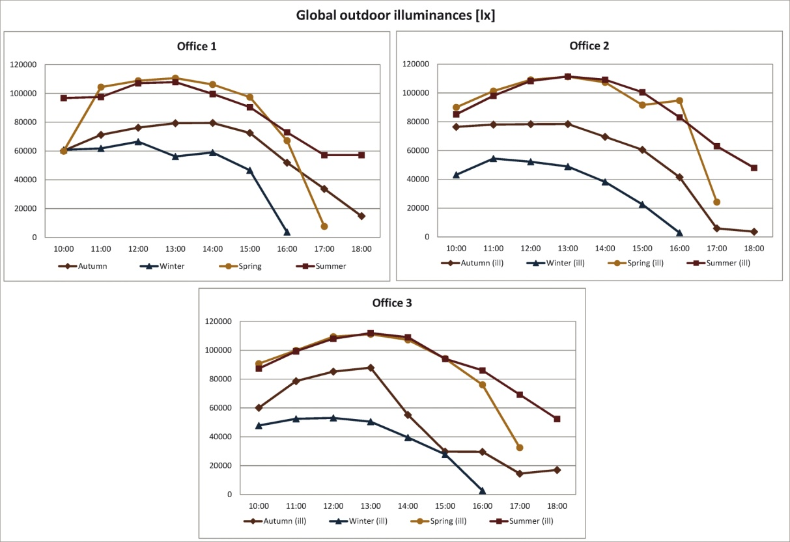
Figure 25. Global outdoor illuminances on clear sky days.

Looking at the graphs reported in Figure 25 it can be observed that the highest outdoor illuminances were always detected during spring and summer and the trends related to the two seasons are also almost coincident, the lowest values were measured in all cases during winter.
Sky CCTs during each season are reported in Figure 26.

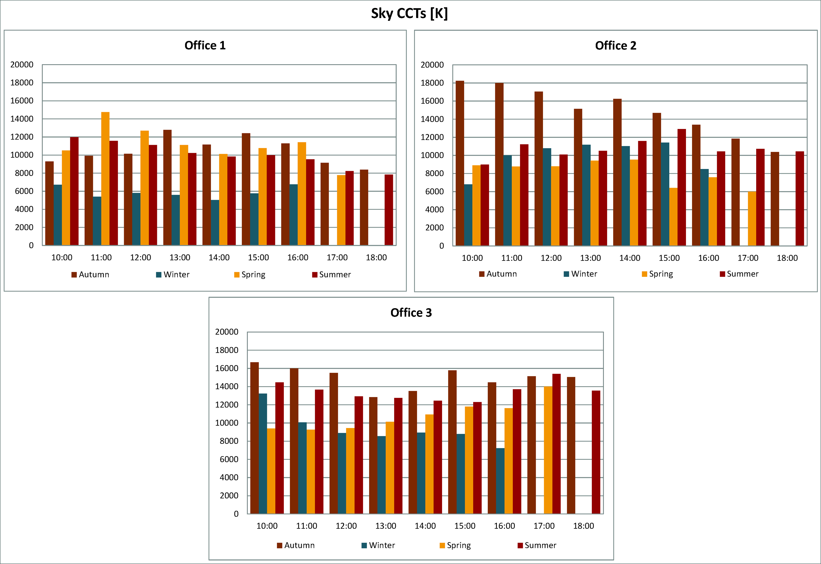
Figure 26. Sky CCTs on clear sky days.

As regards sky CCTs, for Office 1 the highest values were detected during spring and autumn whereas for Office 2 and 3 the latter shows the maximum CCTs. Moreover for Office 1 and 3 the lowest values were measured during winter whereas for Office 2 during spring.
Figure 27 shows desk illuminances on clear sky days in each season.

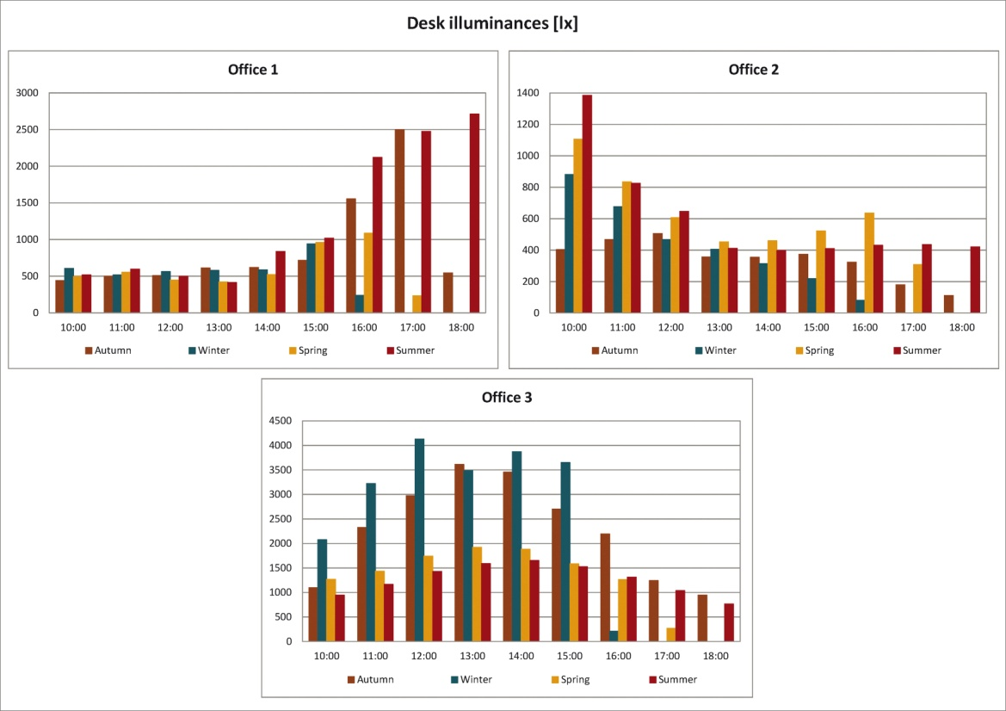
Figure 27. Desk illuminances on clear sky days.

The graphs related to desk illuminances show that the highest values were detected for Office 3 during winter and autumn, in some cases illuminances are even above 4000 lx which means that there is a high probability of discomfort in this office. Office 1 also shows a high risk of discomfort since really high values (above 2000 lx) were registered during summer and autumn. There is also a probability of discomfort for Office 2 but only at 10:00 since, during that hour in summer, spring and winter, values above 800 lx were detected.
The reason why Offices 1 and 3 show really high values during autumn for the former and also during winter for the latter lies in the office's exposure and in the sun's altitude during these seasons. Indeed during winter and autumn the sun's altitude is low and therefore light enters deeply into the rooms.
Not surprisingly, desk illuminances' trends reflect the offices' exposure, indeed the highest values were registered during the afternoon for Office 1, during the morning for Office 2 and during the central part of the day for Office 3.
Average eye level CCTs are reported in Figure 28.

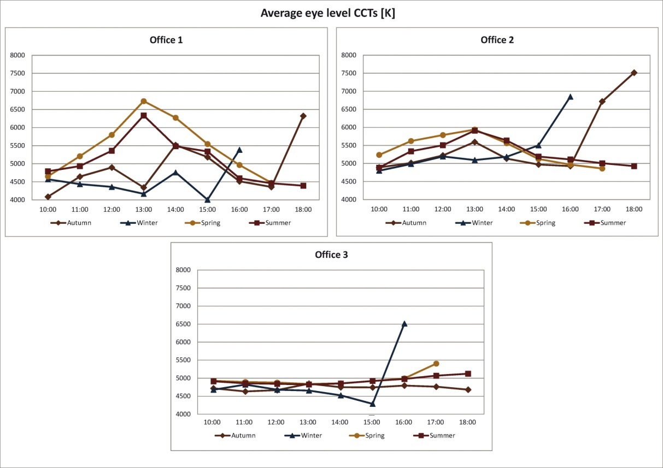
Figure 28. Average eye level CCTs on clear sky days.

It can be observed that Office 1 shows great variation in the values detected during the different hours of the day in the same season and there is also great difference in the trends related to the different seasons, whereas those related to Office 2 and 3 show less variation.
Average eye level CCTs detected in Office 3 are comprised in a small range, indeed they vary between 4200 K and 5500 K with the only exception at 16:00 during winter when they reach 6500 K. The values detected in Office 1 and 2 vary in a greater range (4000 K - 6600 K for the former and 4700 K - 7500 K for the latter), however they show the same great increase in the values at 16:00 in winter, the reason for this finding may lie in the incoming sunset.
Figure 29 shows average eye level illuminances for each office and season during clear sky days.

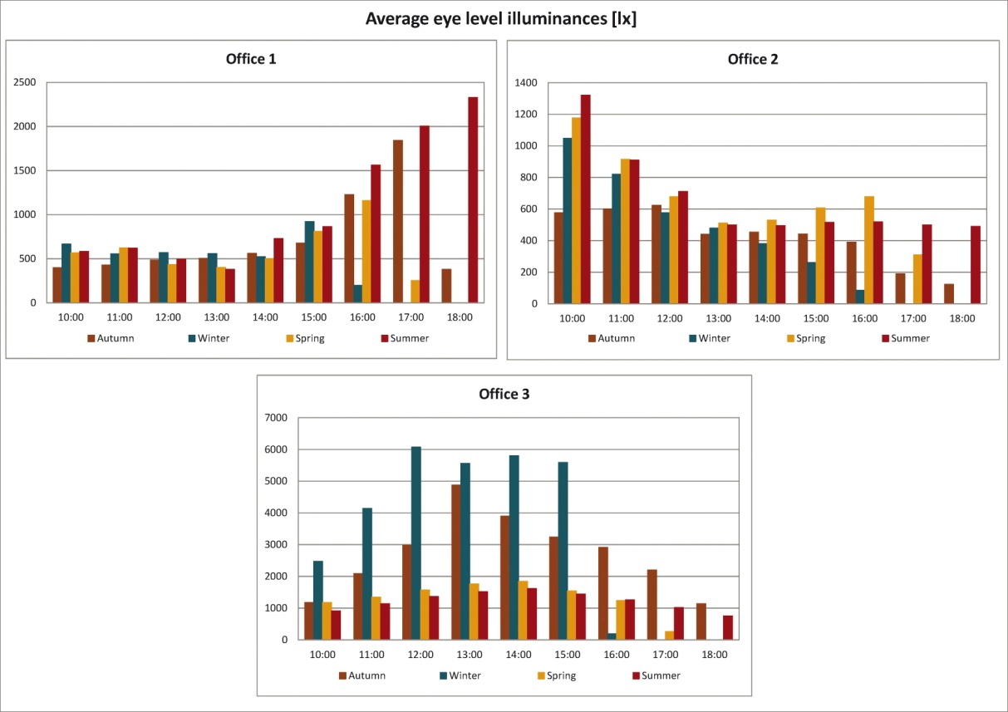
Figure 29. Average eye level illuminances on clear sky days.

It can be observed from Figure 29 that average eye level illuminances' trends are similar to desk illuminances' ones, so the same conclusions apply.
Figure 30 shows CS values calculated for each office.

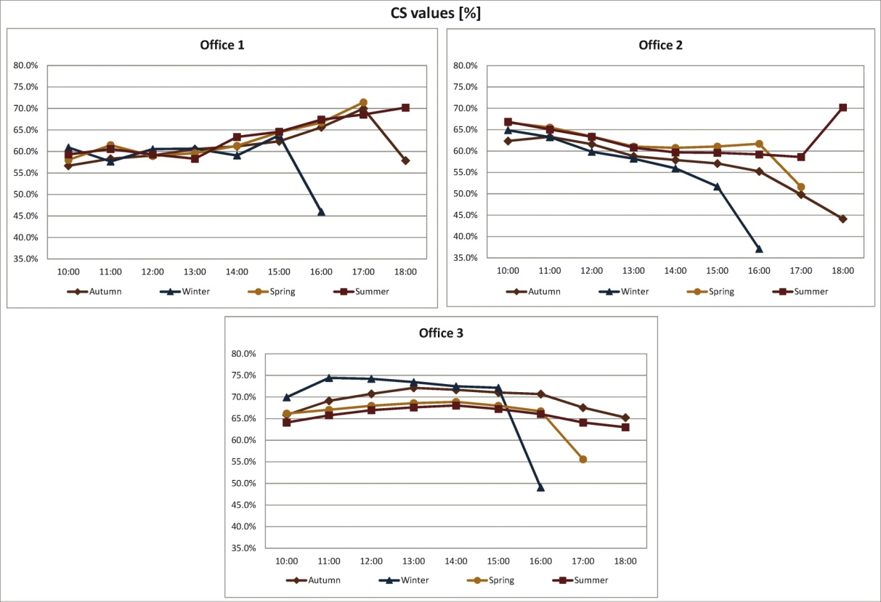
Figure 30. CS values on clear sky days.

CS values calculated for Office 1 for the different seasons are really close whereas those calculated for Office 2 and 3 show greater differences. The lowest CS value is at 16:00 during winter for Office 2 (37.1%) and generally CS values calculated for this environment are lower than those related to Office 1 and 3.
The comparison between average eye level spectral irradiances and D series illuminants was performed the same way it was carried out for the University classroom and the results are reported in Table 5. For readability reasons Offices 1,2 and 3 will be respectively referred to as OF1, OF2 and OF3; moreover the cells containing a "-" symbol indicate that a correspondence between D series illuminants' trends and average eye level spectral irradiances' ones was not found.

D series standard illuminants closest to average eye level spectral irradiances for clear sky days
 | Autumn |  |  | Winter |  |  | Spring |  |  | Summer
 | OF1 | OF2 | OF3 | OF1 | OF2 | OF3 | OF1 | OF2 | OF3 | OF1 | OF2 | OF3
10:00 | - | - | D50 D55 | D50 | D50 D55 | D50 D55 | - | D50 D65 | D50 D55 | - | D50 D55 | D50 D55
11:00 | - | - | - | - | D50 D55 | D50 D55 | D50 D55 | D55 D65 | D50 D55 | D55 | D55 D65 | D50 D55
12:00 | - | D55 D65 | D55 D65 | D55 D50 | D50 D75 | D50 D55 | D55 D65 | D55 D75 | D50 D55 | D55 D65 | D55 D65 | D50 D55
13:00 | - | D55 D65 | D50 D55 | D55 D50 | D50 D55 | D50 | D65 D75 | D55 D65 | D50 D55 | D65 D75 | D65 D75 | D50 D55
14:00 | D55 D65 | D55 D65 | D50 D55 | D50 D65 | D55 | D50 | D65 D75 | D55 D75 | D50 D55 | D55 D65 | D55 D65 | D50 D55
15:00 | D55 | D50 D55 | D65 D75 | D50 | D55 | D50 | D55 D65 | D50 D55 | D50 D55 | D55 D65 | D55 D65 | D50 D55
16:00 | D50 | D50 D55 | D75 | D55 | D65 D75 | D65 D75 | D50 D55 | D50 D55 | D50 D55 | D50 | D50 D55 | D50 D65
17:00 | D50 | D65 D75 | - |  |  |  | - | - | - | D50 | - | D75
18:00 | D65 D75 | D65 D75 | D50 |  |  |  |  |  |  | - | - | D50 D55
Table 5. D series standard illuminants closest to average eye level spectral irradiances for clear sky days.

The data reported in Table 5 show that in most cases average eye level spectral irradiances are at once similar to both D50 and D55 standard illuminants (33 times), in many cases they are also similar to only D50 (14 times) or D55 (20 times).
There are also some cases in which average eye level spectral irradiances are at once similar to D55 and D65 (16 times), or D65 and D75 standard illuminants (10 times).
It can be also observed that the number of cases when no correspondence was found is limited as well as those when eye level spectral irradiances resulted similar to D75 or to D50 and D65 at once.

2.3.2. Data related to intermediate sky days
In this subparagraph the data related to intermediate sky days in each season will be reported.
Figure 31 shows outdoor illuminances detected in each season with this type of sky condition for each office.

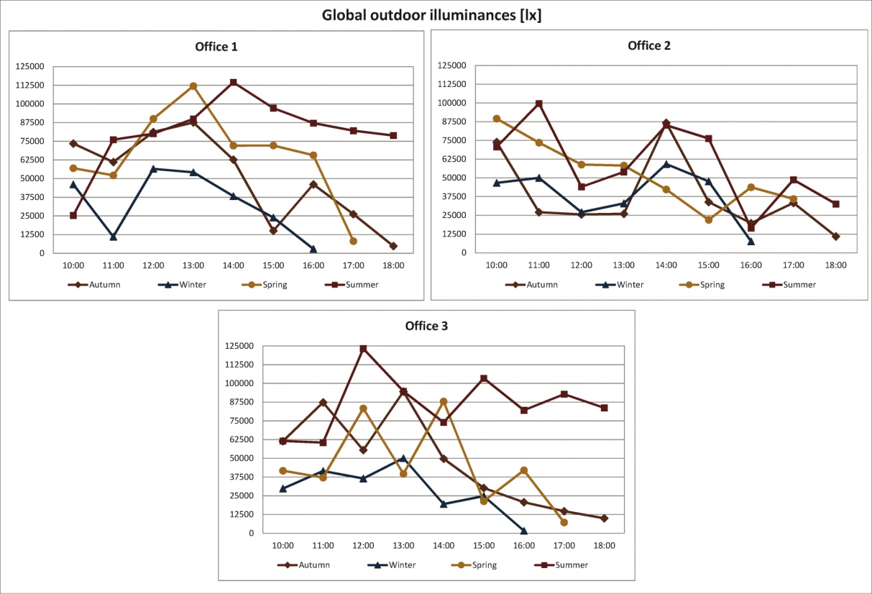
Figure 31. Global outdoor illuminances for intermediate sky days.

The graphs related to global outdoor illuminances reflect the extreme variability of this type of sky condition, in most cases the highest values were measured during summer.
Figure 32 shows sky CCTs for intermediate sky days in each season.

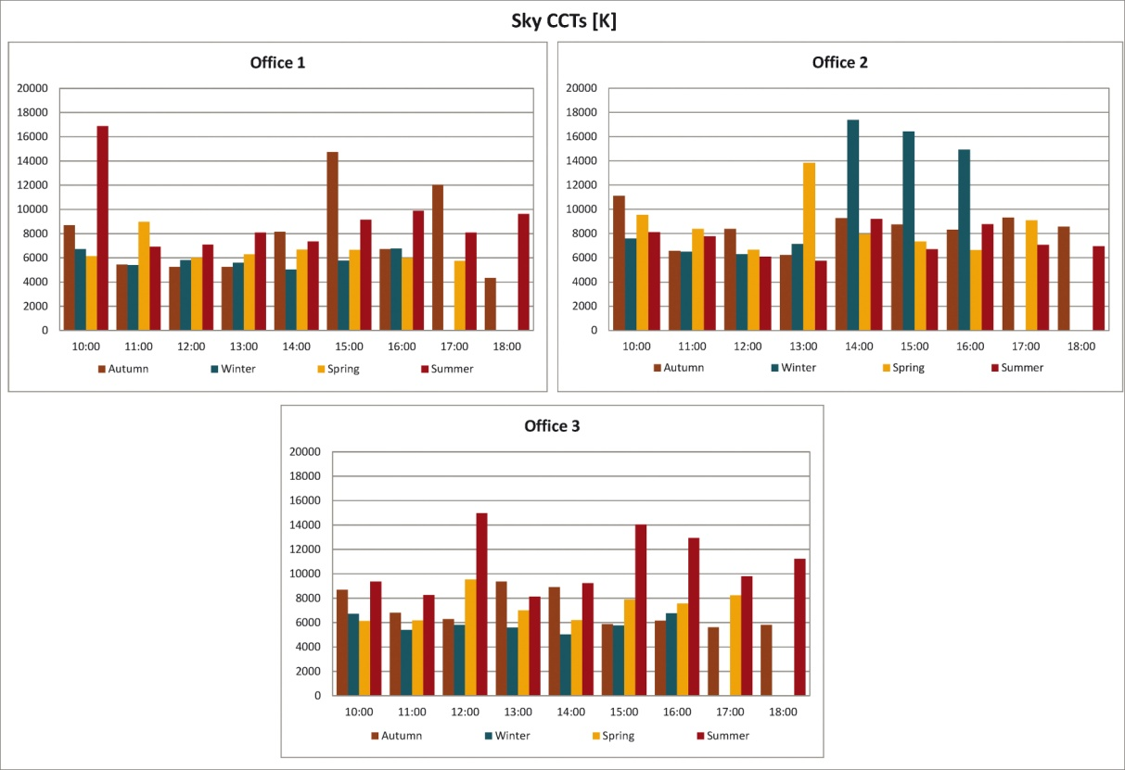
Figure 32. Sky CCTs for intermediate sky days.

Sky CCTs are also extremely variable, in more detail for Office 1 the highest values were detected during summer and autumn, for Office 3 during the latter and for Office 2 during autumn and winter.
Figure 33 shows desk illuminances for each office related to intermediate sky days in each season.

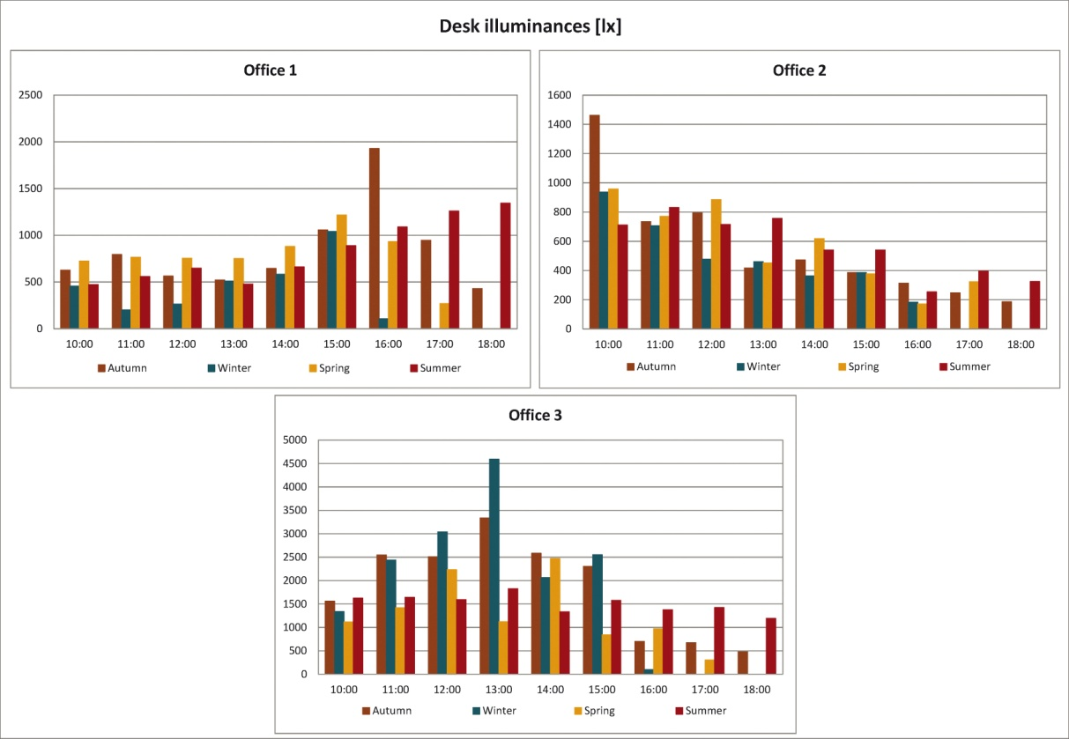
Figure 33. Desk illuminances for intermediate sky days.

With this sky condition also desk illuminances are more variable but the trends tend to reflect the offices' orientation as it was highlighted for clear sky days. Moreover for Offices 1 and 2 during autumn and also during winter for Office 3 illuminances are in some cases respectively greater than 1500 lx, 1400 lx and 3000 lx; therefore, as it was highlighted for clear sky days, discomfort is highly probable during these two seasons.
It is also important to observe that, given its Southern exposure, Office 3 is also the one with the highest values.
Average eye level CCTs are reported in Figure 34.

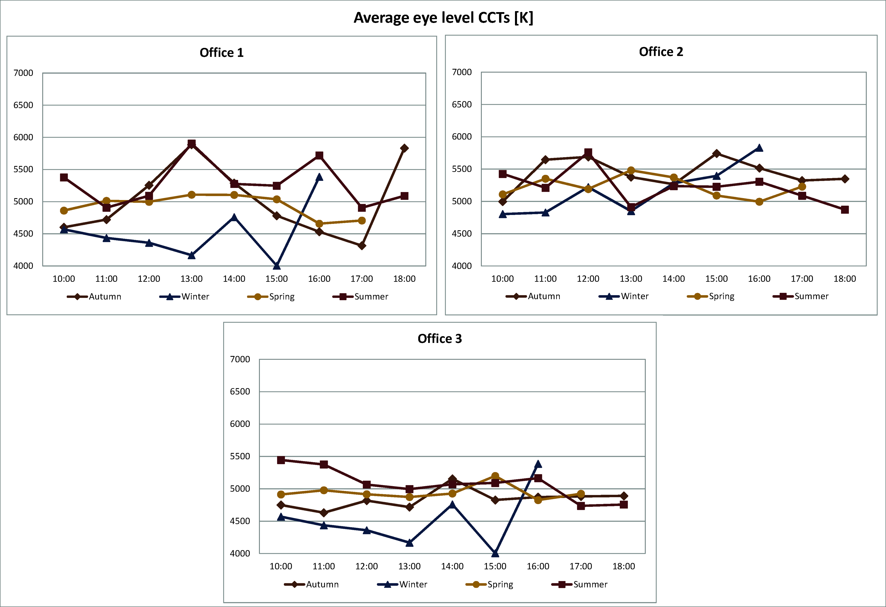
Figure 34. Average eye level CCTs for intermediate sky days.

On the contrary average eye level CCTs vary less compared to the previously analyzed sky condition, indeed they are always comprised between 4000 K and 6000 K. In more detail, Office 1's values show the greatest differences between the different seasons and their range of variation is comprised between 4000 K and 6000 K, thus it is wider than Offices 2 and 3's (4800 K - 5800 K for the former and 4000 K - 5500 K for the latter).
Another interesting finding is that during winter the highest value was always detected at 16:00, this sharp CCT increase may be caused by the incoming sunset.
The graphs in Figure 35 report average eye level illuminances for each office related to intermediate sky days in each season.

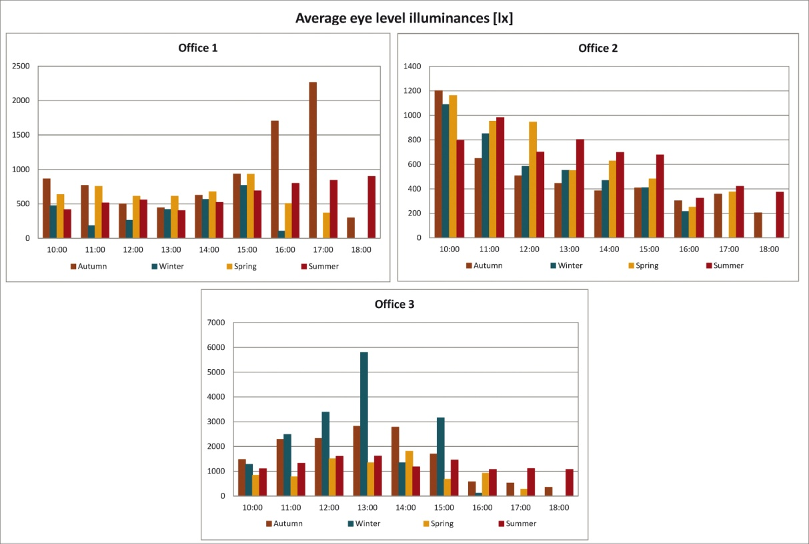
Figure 35. Average eye level illuminances for intermediate sky days.

Concerning average eye level illuminances their trends are similar to desk illuminances' ones and they also tend to reflect the offices' orientation.
Moreover, as it was observed for desk illuminances, during autumn for Offices 1 and 2 and also during winter for Office 3 illuminances reach really high values and therefore there is a high probability of discomfort and therefore a shading system is needed to reduce the amount of light that enters in the offices.
CS values were calculated for each office and season and are reported in Figure 36.

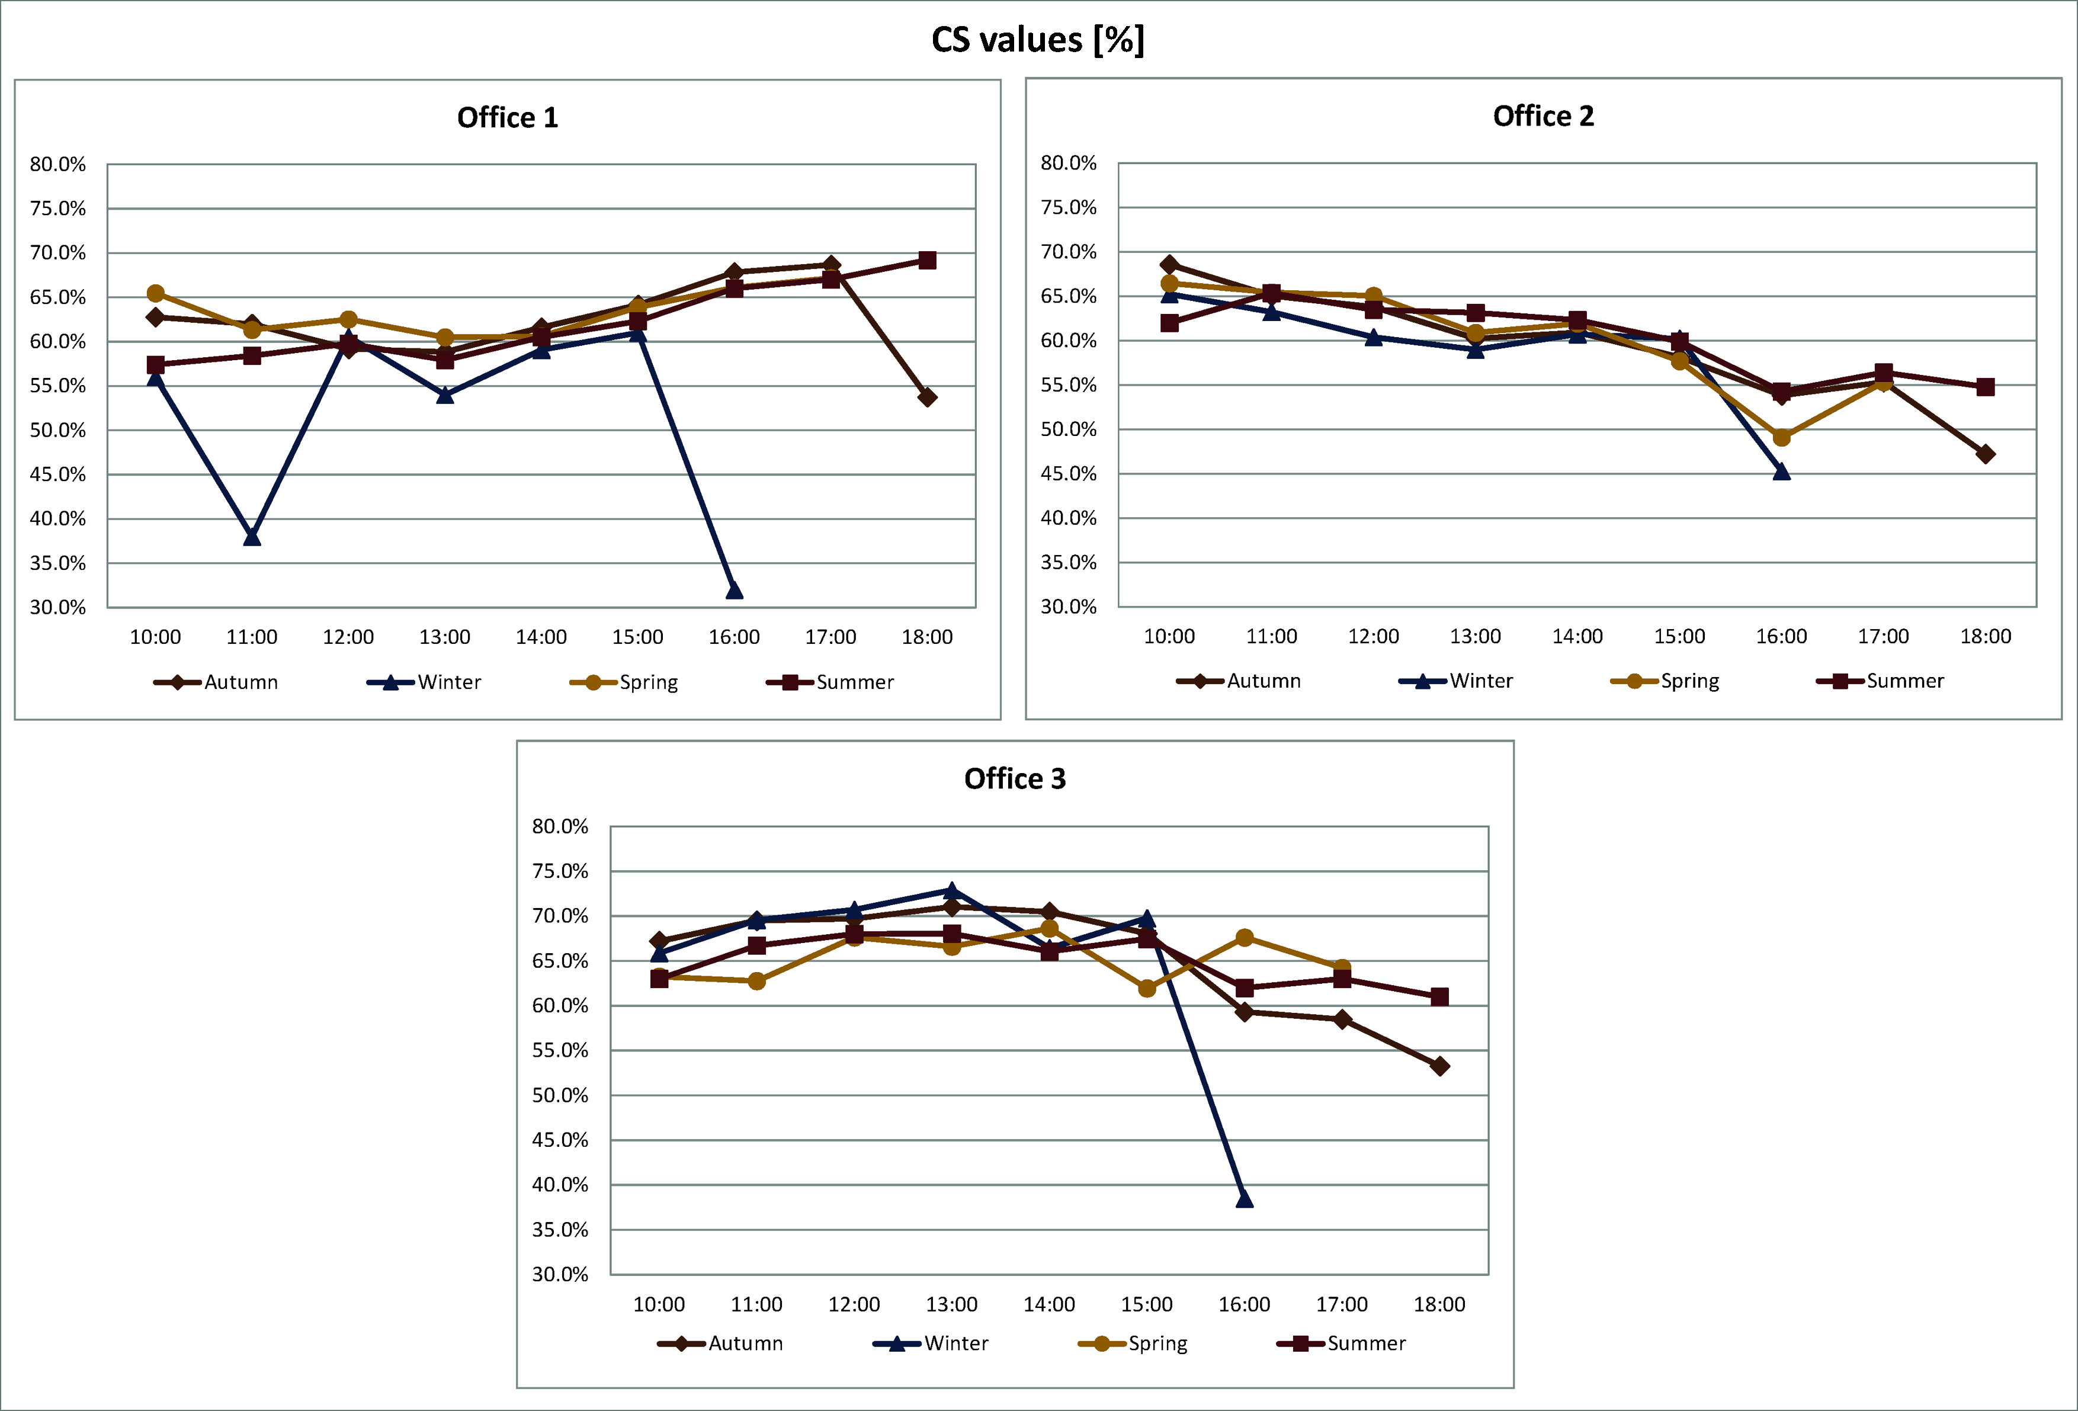
Figure 36. CS values for intermediate sky days.

CS values with this sky condition are generally high and the values related to the different seasons are also close to each other.
For Office 1 and 3 the values calculated for winter show more variation. For all offices the minimum values were calculated at 16:00 during winter and are equal to 32% for Office 1, 45% for Office 2 and 38% for Office 3.
Table 6 reports the results of the comparison between average eye level spectral irradiances and D series standard illuminants for intermediate sky days.

D series standard illuminants closest to average eye level spectral irradiances for intermediate sky days
 | Autumn |  |  | Winter |  |  | Spring |  |  | Summer
 | OF1 | OF2 | OF3 | OF1 | OF2 | OF3 | OF1 | OF2 | OF3 | OF1 | OF2 | OF3
10:00 | D55 D65 | D55 D65 | D50 D55 | - | D50 D55 | D50 D55 | - | D50 D55 | D50 D55 | D50 D65 | - | -
11:00 | D55 | D55 D65 | D50 D55 | - | D50 D55 | D50 D55 | - | D55 D65 | D50 D55 | D50 D55 | D55 D65 | D50 D55
12:00 | D50 | D55 D65 | D50 D55 | - | D50 D55 | D55 | D50 D65 | D50 D55 | D50 D55 | D50 D55 | D55 D75 | D50 D55
13:00 | D50 | D50 D55 | D50 D65 | D50 D55 | D50 D55 | D50 D55 | D50 D65 | D55 D65 | D50 D55 | D55 | D50 D55 | D50 D55
14:00 | D65 D75 | D50 D55 | D50 D55 | D50 D75 | D50 D55 | D50 D55 | D50 D65 | D55 D65 | D50 D55 | D55 | D50 D55 | D50 D55
15:00 | - | D65 D75 | D50 D55 | - | D50 D55 | D50 D55 | D50 D65 | D50 D55 | D50 D55 | D55 D65 | - | D50 D55
16:00 | D50 | D65 D75 | D50 D55 | - | D50 | D50 D55 | - | D50 D55 | - | - | D55 D65 | -
17:00 | - | - | - |  |  |  | - | D55 | - | - | - | -
18:00 | - | D50 | D50 |  |  |  |  |  |  | - | - | -
Table 6. D series standard illuminants closest to average eye level spectral irradiances for intermediate sky days.
It can be observed that, as for clear sky days, in most cases average eye level spectral irradiances' trends match at once both D50's and D55's trends (32 times) and also that frequently they are similar to only D50 (13 times) or D55 (15 times).
There are also few cases in which average eye level spectral irradiances are at once similar to D55's and D65's trends or to D50's (10 times) and D65's ones (4 times).
Moreover it is also important to highlight that in many cases no correspondence between D series illuminants and average eye level spectral irradiances was found for Office 1. At the present time it is not possible to understand the reason of such finding.

2.3.3. Data related to overcast sky days
In this subparagraph the data acquired during overcast sky days will be reported. In more detail, the graphs included in this subparagraph only show data related to autumn, winter and spring since, when measurements were carried out during summer, no overcast sky day was found.
Figure 37 shows global outdoor illuminances.

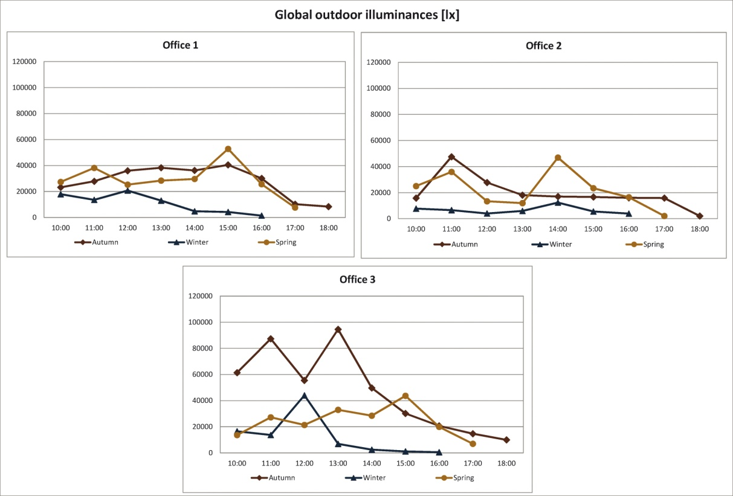
Figure 37. Global outdoor illuminances for overcast sky days.

For Office 1 and 2 global outdoor illuminances are at most equal to about 60000 lx and therefore considerably lower than those detected with the previous sky conditions. This finding could be expected with this type of sky condition, however it is interesting to highlight that for Office 3 during autumn there is less difference with global outdoor illuminances detected during clear and intermediate sky days; indeed the values measured for this office during autumn are about 100000 lx in some cases.
Moreover for all offices the lowest values were detected during winter.
Figure 38 shows sky CCTs detected with this sky condition.

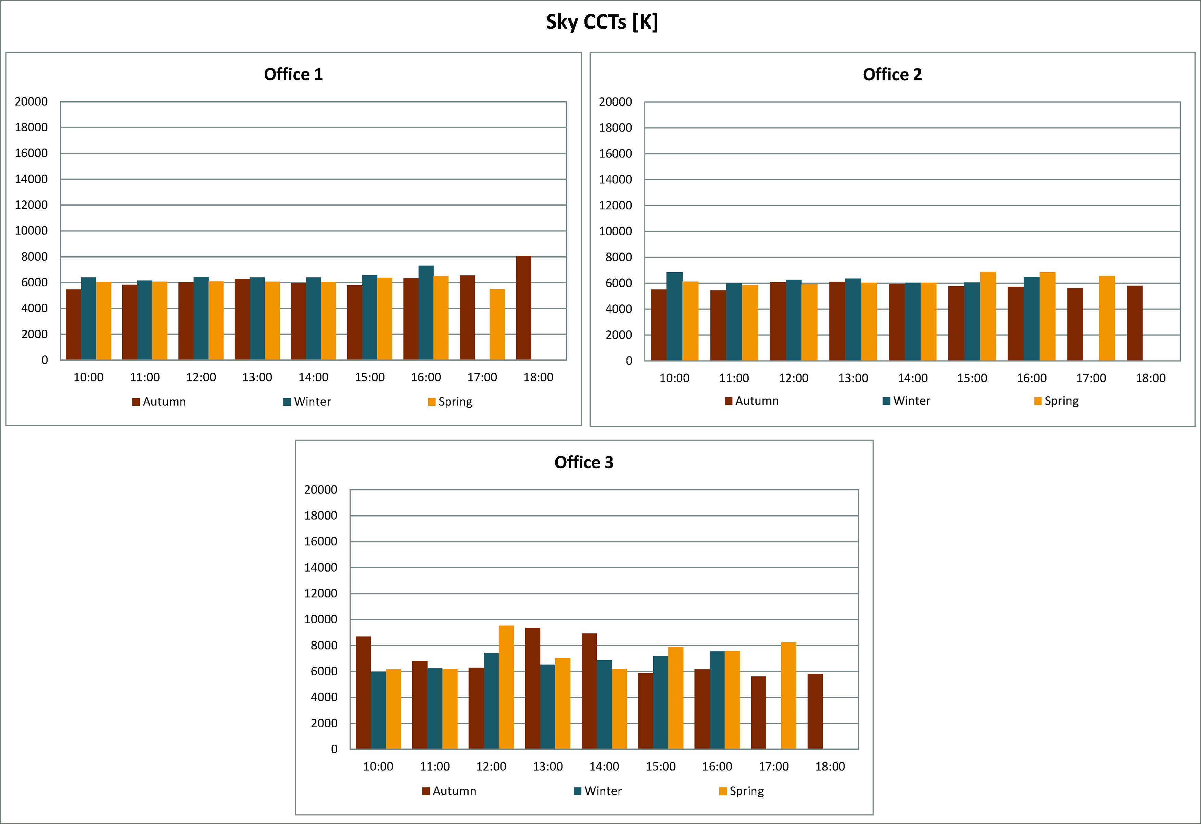
Figure 38. Sky CCTs for overcast sky days.

With this sky condition it can be observed that sky CCTs are considerably lower than those measured with the clear or intermediate skies, indeed they are always comprised between about 6000 K and 9000 K. The highest values were generally measured during winter for Office 1 and also during spring for Office 2, whereas for Office 3 they were detected during autumn and spring. Moreover for Office 3 there are many cases in which sky CCTs are above 8000 K.
The graphs related to desk illuminances are reported in Figure 39.

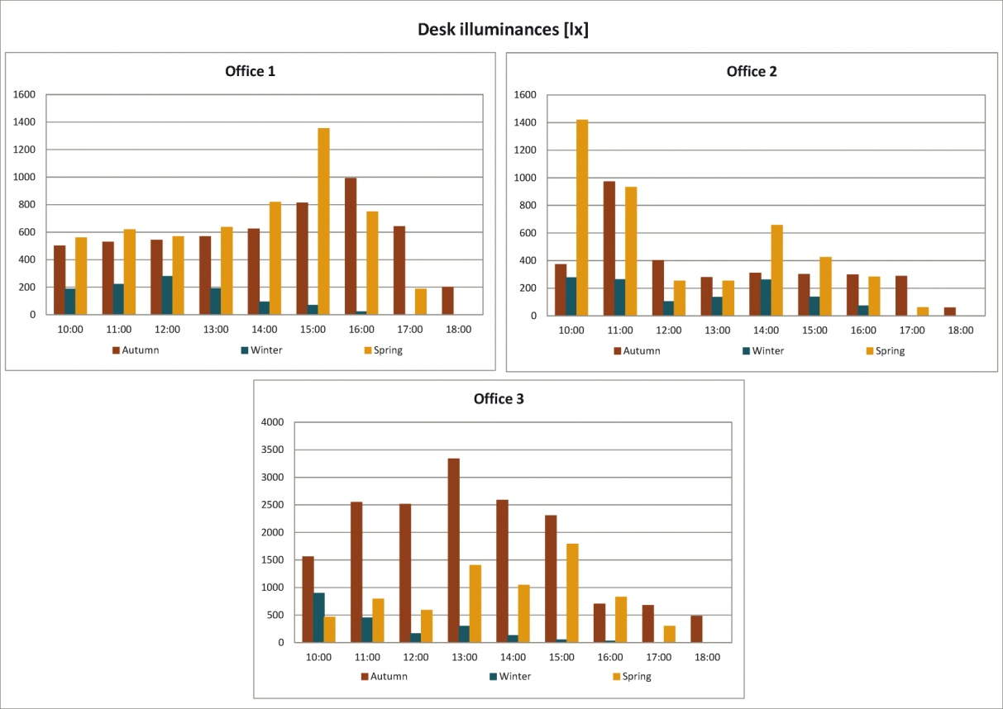
Figure 39. Desk illuminances for overcast sky days.

It can be observed that the highest desk illuminances were measured during spring and autumn for all offices, consequently winter values are always the lowest ones.
It is also important to highlight that, even with this sky condition, there are many cases in which measured desk illuminances reach really high values. Indeed for Office 1 in the afternoon during spring and autumn desk illuminances are in some cases greater than 800 lx, this also happens in the same seasons for Office 2 but in this case during the morning; for Office 3 the values are even higher since, in the same seasons, desk illuminances are greater than 1000 lx in many cases.
Therefore, even with overcast sky, there is a high probability of discomfort phenomena in these offices and thus there is probably the need to install shading devices which are not present at this time.
Figure 40 reports the average eye level CCTs measured with this sky condition during autumn, winter and spring in the offices.

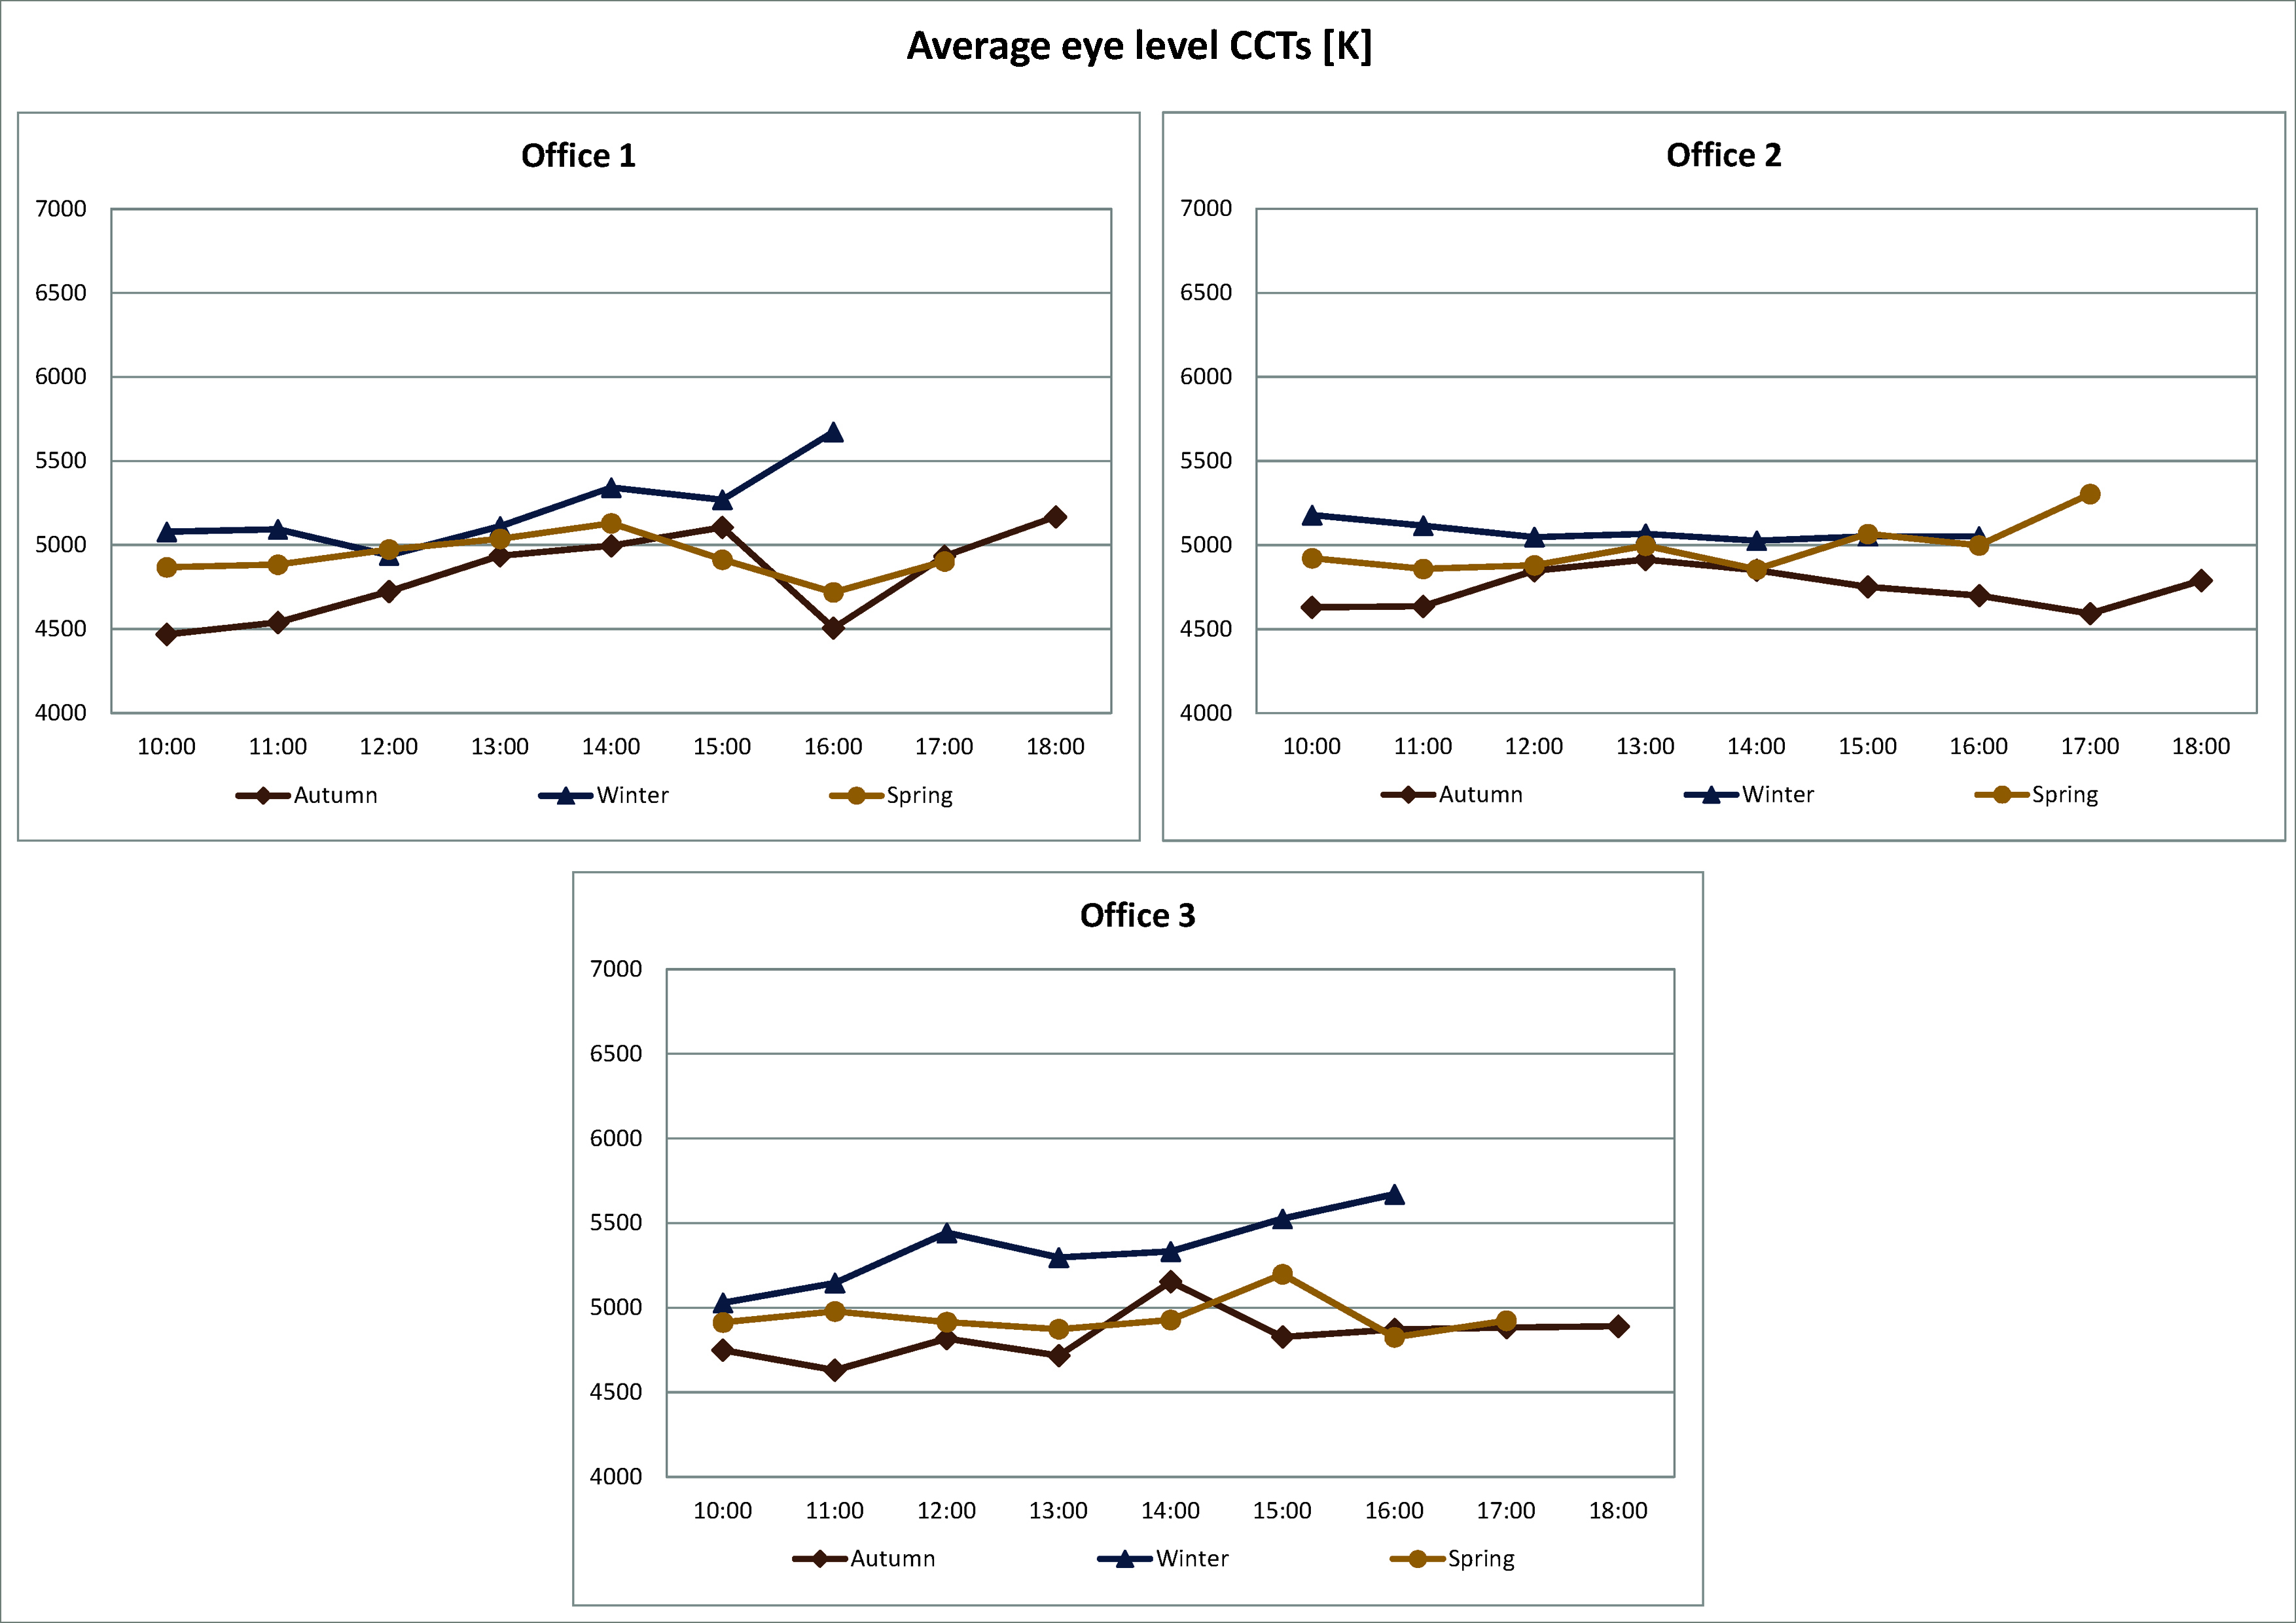
Figure 40. Average eye level CCTs for overcast sky days.

Average eye level CCTs vary in a range that is more limited compared to the clear and intermediate sky days, indeed they are comprised between 4400 K and 5700 K and so there is also less difference between them and sky CCTs.
It is also interesting to highlight that generally the highest values were measured during winter for all offices.
Average eye level illuminances detected in the offices during overcast sky days are reported in Figure 41.

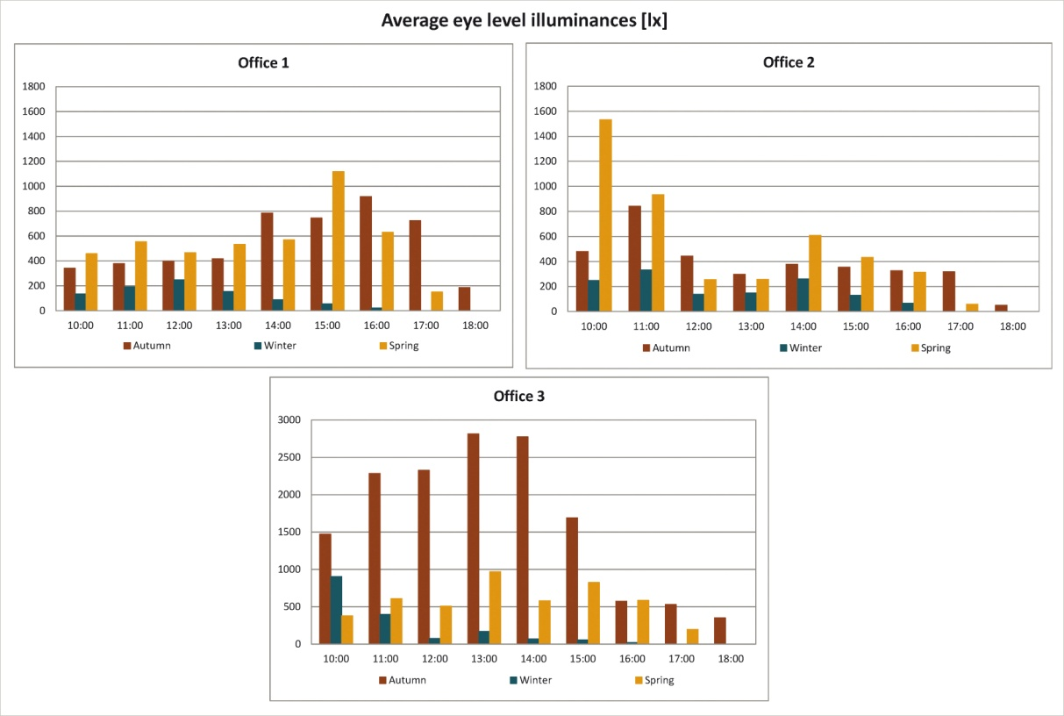
Figure 41. Average eye level illuminances for overcast sky days.

Average eye illuminances trends are similar to desk illuminances ones so the same conclusions apply.
Figure 42 shows CS values.

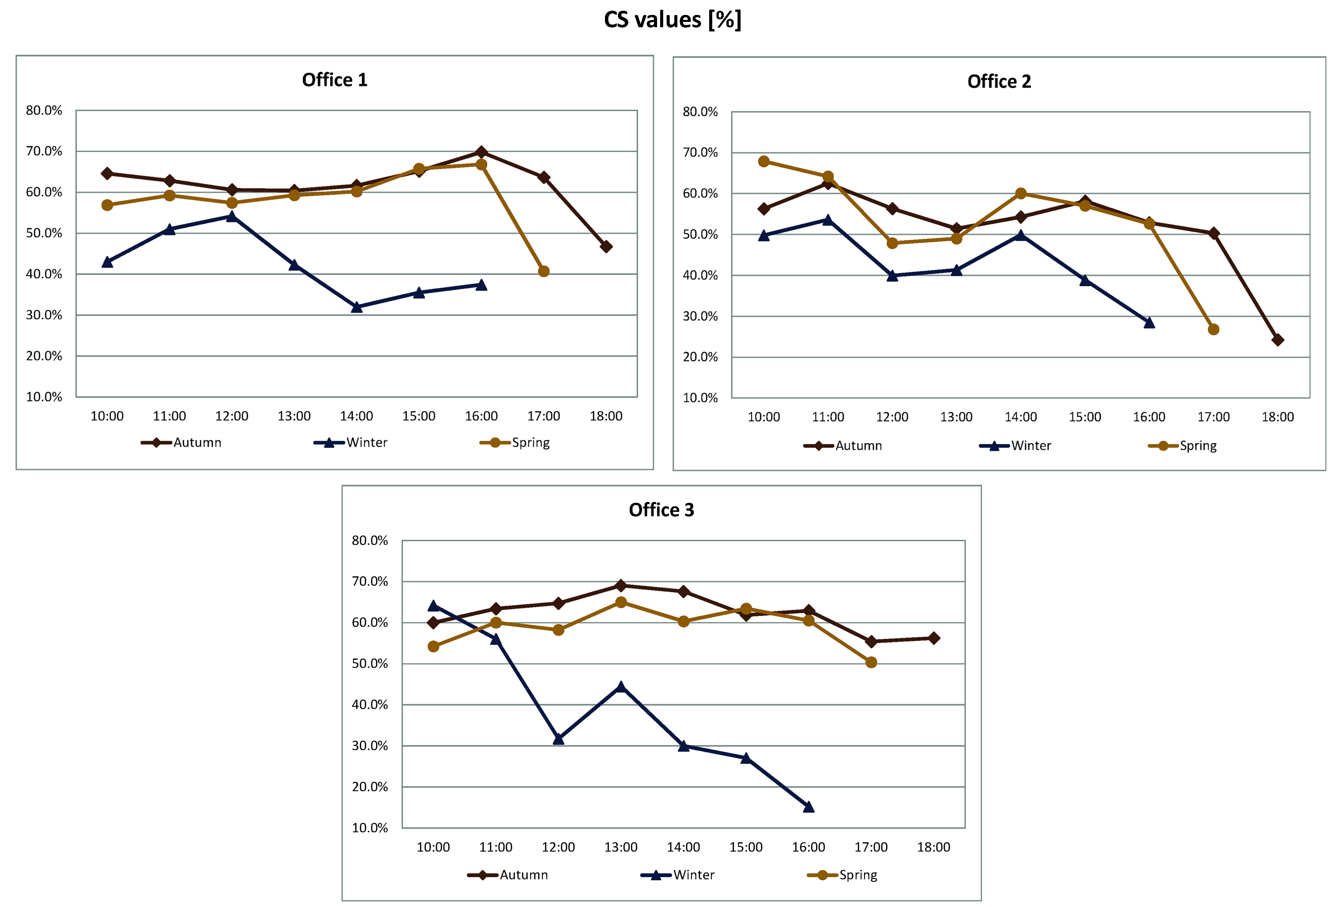
Figure 42. CS values for overcast sky days.

Concerning CS values, winter ones are always the lowest and for Office 3 they reach the absolute minimum (15%). During autumn and spring CS values are not so different from those calculated for the clear and intermediate sky days, moreover these two seasons show similar trends and values for all offices.
The comparison between D series standard illuminants and average eye level spectral irradiances produced the results reported in Table 7.
D series standard illuminants closest to average eye level spectral irradiances for overcast sky days
 | Autumn |  |  | Winter |  |  | Spring
 | OF1 | OF2 | OF3 | OF1 | OF2 | OF3 | OF1 | OF2 | OF3
10:00 | - | D50  D55 | - | - | D50  D55 | - | D50  D55 | D50  D55 | D50  D55
11:00 | - | D50  D55 | - | - | D50  D55 | - | D50  D55 | D50  D55 | D50  D55
12:00 | - | D50  D55 | - | - | D50  D55 | - | D50  D55 | D50  D55 | D50  D55
13:00 | - | D50  D55 | - | - | D50  D55 | - | D50  D55 | D50  D55 | D50  D55
14:00 | D50 | D50  D55 | D50  D55 | D50 | D50  D55 | D50  D55 | D50  D55 | D50  D55 | D50  D55
15:00 | - | - | D50  D55 | - | - | D50  D55 | D50  D55 | D50  D55 | D50  D55
16:00 | - | - | D50  D55 | - | - | D50  D55 | - | D50  D55 | D50  D55
17:00 | D50  D75 | - | D50  D65 |  |  |  | D50 | - | -
18:00 | - | - | D50  D55
Table 7. D series standard illuminants closest to average eye level spectral irradiances for overcast sky days.

It can be observed that with the overcast sky the number of cases for which no correspondence was found between standard illuminants and average eye level spectral irradiances is relevant. However, as it was already found for the previous two sky conditions in the majority of cases eye level spectral irradiances are at once similar to both D50 and D55 (37 times).

2.3.5. Electric lighting system
The three offices are equipped with the same type of fluorescent luminaires, 4 of them were installed in Office 1 whereas in Offices 2 and 3 there are two luminaires. Measurements were also performed with only the electric lighting systems switched on and therefore the SPDs of the luminaires were detected in all offices but, since the lamp type is the same and no significant difference was found, Figure 43a shows a single graph representing the luminaires' SPDs. Figure 43b reports the average eye level spectral irradiances measured in each office.
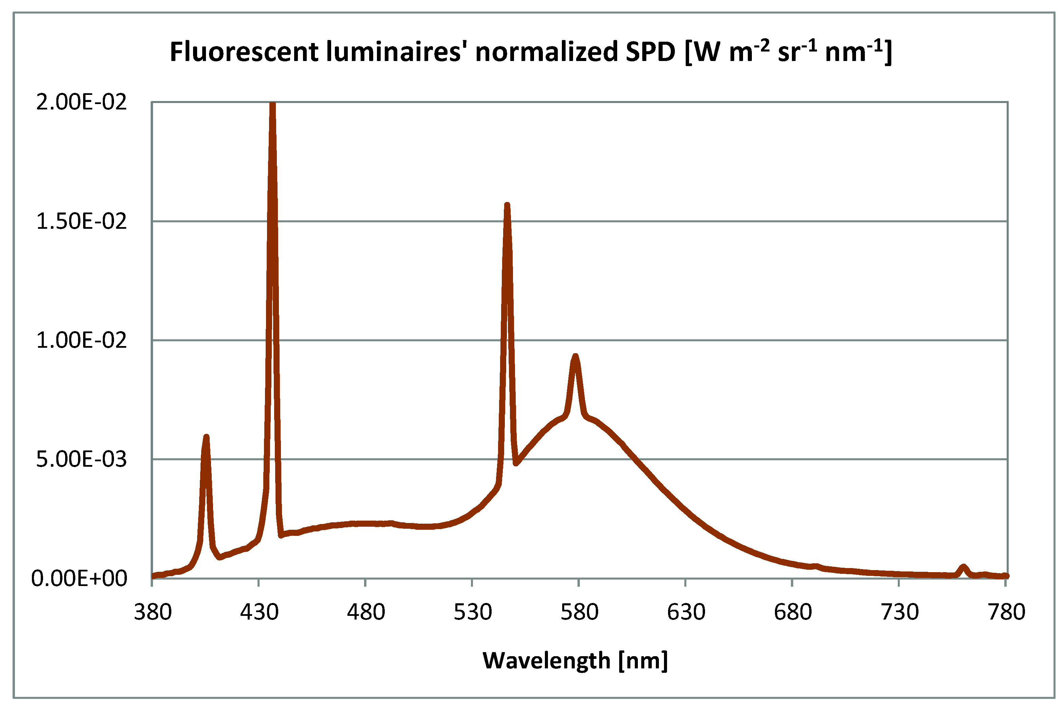
Figure 43a. Fluorescent luminaires' normalized SPDs.

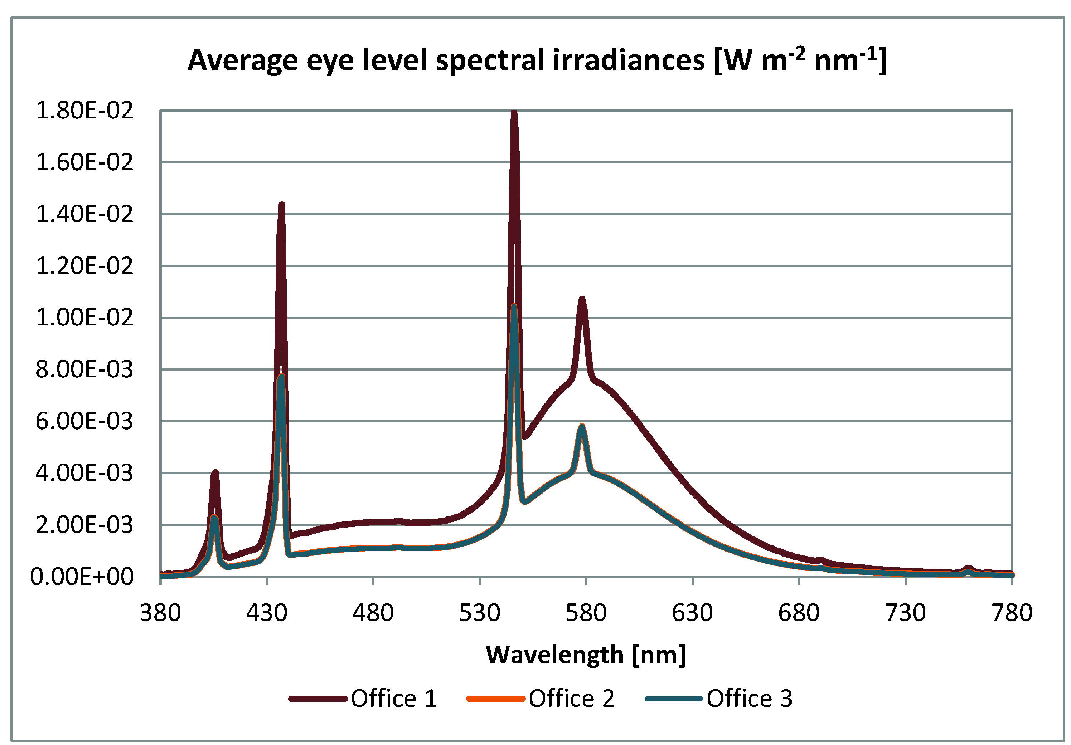
Figure 43b. Average eye level spectral irradiances.

The graphs reported in Figure 43b show that the trend of average eye level spectral irradiance related to Office 1 reaches higher values compared to Offices 2 and 3. This depends on the greater number of luminaires installed in Office 1 which also determines higher desk and average eye level illuminances as it will be later illustrated.
The luminaires' measured CCT, CRI and ∆uv values are reported in Table 8.

Measured CCT, CRI and ∆uv values related to the electric lighting system
CCT [K] | CRI | ∆uv
4209 | 59 | 0.0069
Table 8. Luminaires' measured CCT, CRI and ∆uv values.

It can be observed that the CRI of the luminaires installed in the offices is really low (59) and it does not comply with the EN 12464-1 requirements for this type of environment/activity (CRI equal or greater than 80) [2].
In each office the following data related to the fluorescent lighting systems were acquired: desk illuminances, eye level CCTs and illuminances with each tilt angle of the spectroradiometer (see Figure 8, page 9). Moreover eye level spectral irradiances were also measured with the different tilt angles and then averaged and used to calculate the corresponding CS values.
Desk illuminances, average eye level CCTs, illuminances and CS values related to the fluorescent lighting systems installed in each office are reported in Table 9.

Desk illuminances, average eye level illuminances and CCTs, CS values
 | Desk illuminances [lx] | Average eye level illuminances [lx] | Average eye level CCTs [K] | CS [%]
OF1 | 841 | 395 | 3880 | 42
OF2 | 455 | 212 | 3929 | 33
OF3 | 433 | 209 | 3891 | 30
Table 9. Luminaires' desk and average eye level illuminances, CS values and average eye level CCTs.

The data reported in Table 9 show that, given the greater number of installed luminaires, desk illuminances measured in Office 1 are about twice the values registered in Offices 2 and 3. Since the EN 12464-1 establishes that 500 lx are necessary in offices when carrying out activities such as writing, typing, reading and processing data [2], it is clear that Offices 2 and 3 do not comply with this requirement whereas Office 1's desk illuminance is considerably higher and it can be reduced to save energy.
As regards CS values, they are higher for Office 1 (42%), given the greater eye level illuminance (395 lx), compared to the other two offices (respectively 33% and 30%). Therefore they do not appear to have a great circadian impact.

2.3.4. Discussion
The measurements carried out in the three offices showed many interesting findings; indeed in autumn, during clear sky days, discomfort phenomena are highly probable for Office 1 and 3 since eye level illuminances are respectively above 2000 lx and 4000 lx, for Office 3 this also happens during winter. This problem also affects in a lesser way Office 2 for which eye level illuminances during clear sky days in summer, spring and winter are above 1000 lx at 10:00. These really high illuminance levels depend on the sun's altitude and on the offices' exposure which, in certain hours and seasons make daylight enter deeply into the offices.
It was also found, as for the University classroom, that generally there is a great difference between sky and average eye level CCTs but this does not apply to overcast sky days during which there is less difference and sky CCTs are also considerably lower than those measured during clear and intermediate sky days.
As regards CS values, they are generally high with each sky condition which means that there is usually enough daylight to help the circadian system's entrainment in these offices, however there may be not enough circadian stimulation in winter during overcast sky days (CS lower than 40%).
The results reported in the previous subparagraphs also highlighted that usually average eye level spectral irradiances match at once both D50 and D55 standard illuminants, however for the overcast sky there were many cases for which no correspondence was found. At the present time the reason of this result is not known and further measurements with this sky condition are needed.
Concerning the electric lighting systems installed in the offices, there is the need to replace them because their CRI is too low (59) and it does not comply with the EN 12464-1 requirements. Moreover desk illuminances in Offices 2 and 3 are lower than the 500 lx threshold set by the abovementioned standard whereas the illuminance value detected on the desk in Office 1 is about twice that threshold, therefore it can be reduced to save energy.
The CS values calculated for the electric lighting systems in all three offices are not very high so there is no risk of circadian disruption but they may not provide enough stimulation to help circadian entrainment during the morning if daylight is not sufficient.

3. Eye level measurements: analysis of the impact of the optical characteristics of an environment's surfaces
The previous chapter analyzed the characteristics of daylight at users' eyes in indoor environments which depend on the season, time of the day, location and dimensions of the environment and also on the optical characteristics of its surfaces. The latter is also an extremely relevant influencing factor when taking into account only electric lighting, therefore the impact of the optical characteristics of an environment's surfaces on the light reaching users' eyes was also analyzed during the PhD and the results are reported in this chapter. The research project was carried out in a test room and it included two different studies.
The first one aimed at investigating if a "neutral" environment, with grey walls, is capable of affecting the characteristics of light reaching users' eyes (paragraph 3.1); in the second study the optical characteristics of one of the walls were changed by applying colored cardboards on it (paragraph 3.2). In both cases any contribution from daylight was completely excluded by placing a panel on the only window present in the room, this panel was painted in the same color of the walls.
The second study originated from the observation that the use of colored walls, even very dark or bright ones, is increasing in the design practice and such choice may affect the perception of an environment and also people's health, given that it probably modifies the characteristics of the light at users' eye level.
The test room features both fluorescent and LED luminaires controlled by a DALI system (LUXMATE Emotion, manufactured by Zumtobel). Therefore, through a touch panel (EMOTION touch, also manufactured by Zumtobel, see Figure 44) it is possible to set different dimming levels, switch on/off single luminaires and also to change the CCT for LED ones, these settings can be saved as light scenes. The touch panel's technical data as provided by the manufacturer are reported in Table 10.

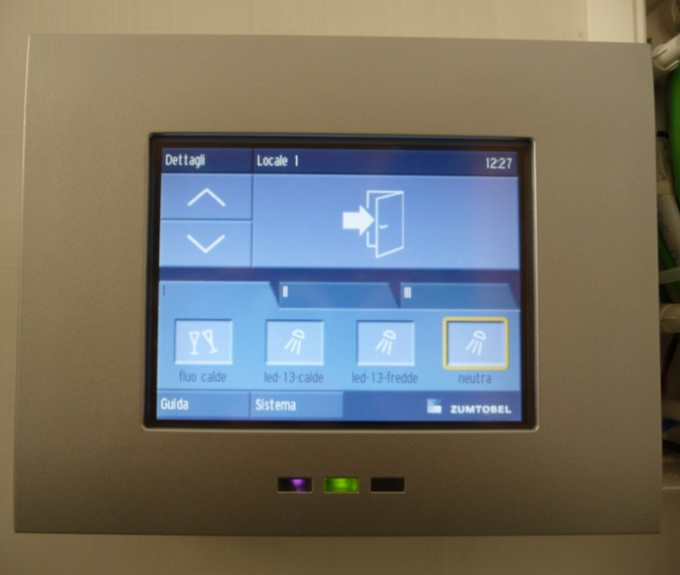
Figure 44. DALI system's touch panel.

EMOTION touch technical data
Nominal voltage | 230/240V AC, 47…64 HZ
Permitted input voltage | 85...265V AC, 47...63Hz
Power loss | <12 W
Inputs | 2 DALI lines, each for up to 64 DALI-compatible ballasts  Up to 64 EMOTION-specific ballasts and sensors per panel  2 DALI interfaces, each with a current consumption of 2mA per DALI line (1 DALI load)
Interface | USB, plug type B, 4-pin, on rear of panel for data back-up
SDMMC memory card  adapter | SD memory card for data backup
Protection type | IP20
Protection class | Class I (earthing connection)
Permitted ambient temperature | 0...+50°C
Relative humidity | 20...80% non-condensing
Table 10. Touch panel's technical data.

In the first study both LED and fluorescent light scenes were used whereas in the second one only LED light scenes were set up to perform the study. The luminaires used in both steps of the research project are also manufactured by Zumtobel, Figures 45a,b show their pictures, dimensions and photometric data whereas technical data (as provided by the manufacturer) are listed in Table 11.

Luminaires' technical data
 | LED luminaires | Fluorescent luminaires
Total Nominal luminous flux | 1824 lm | 7000 lm (all 4 lamps)
Nominal luminous efficacy | 64 lm/W | 49 lm/W
Nominal CRI | 1B | 1B
Absorbed power | 27 W | 96 W (4 x 24 W)
Table 11. Luminaires' technical data.

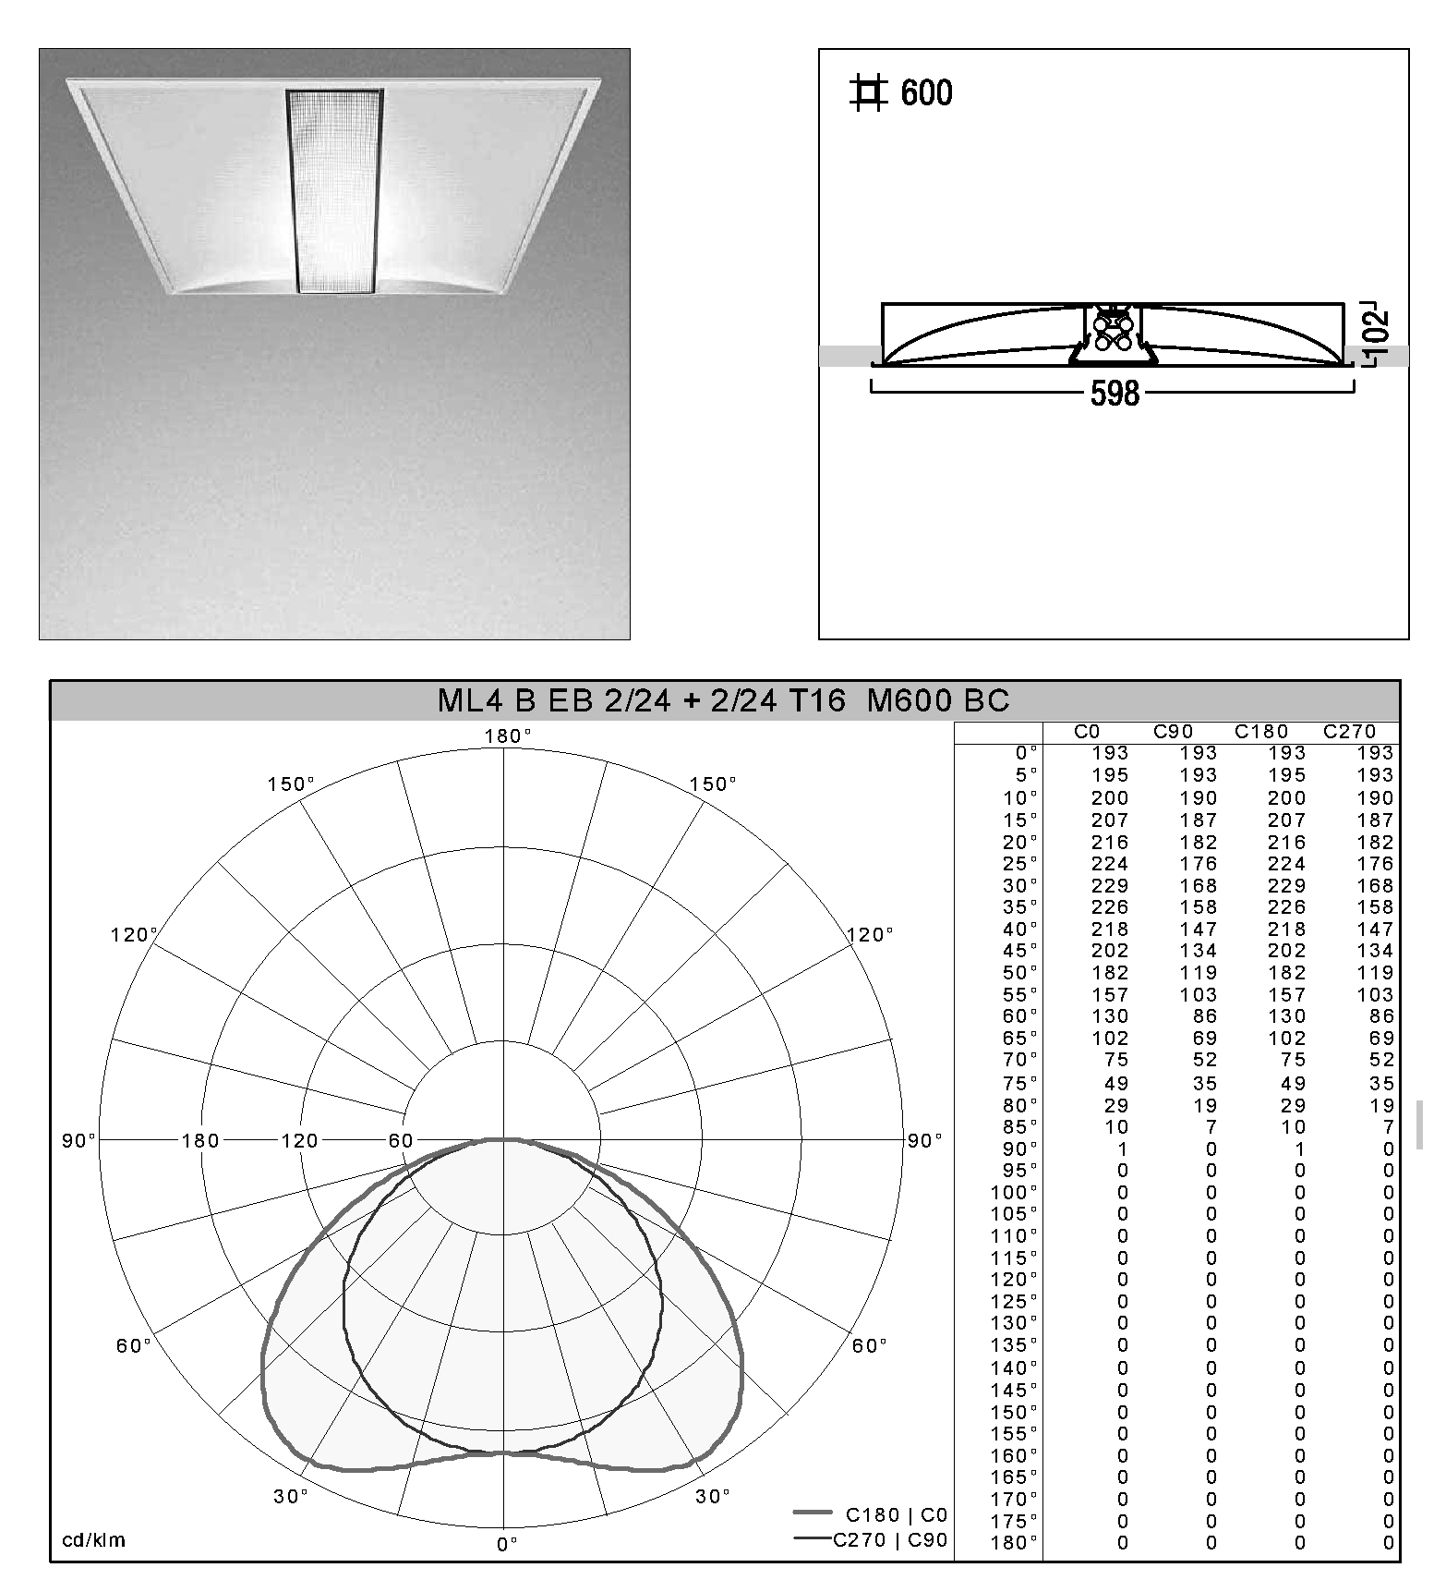
Figure 45a. Fluorescent luminaires' picture, dimensions and photometric data.

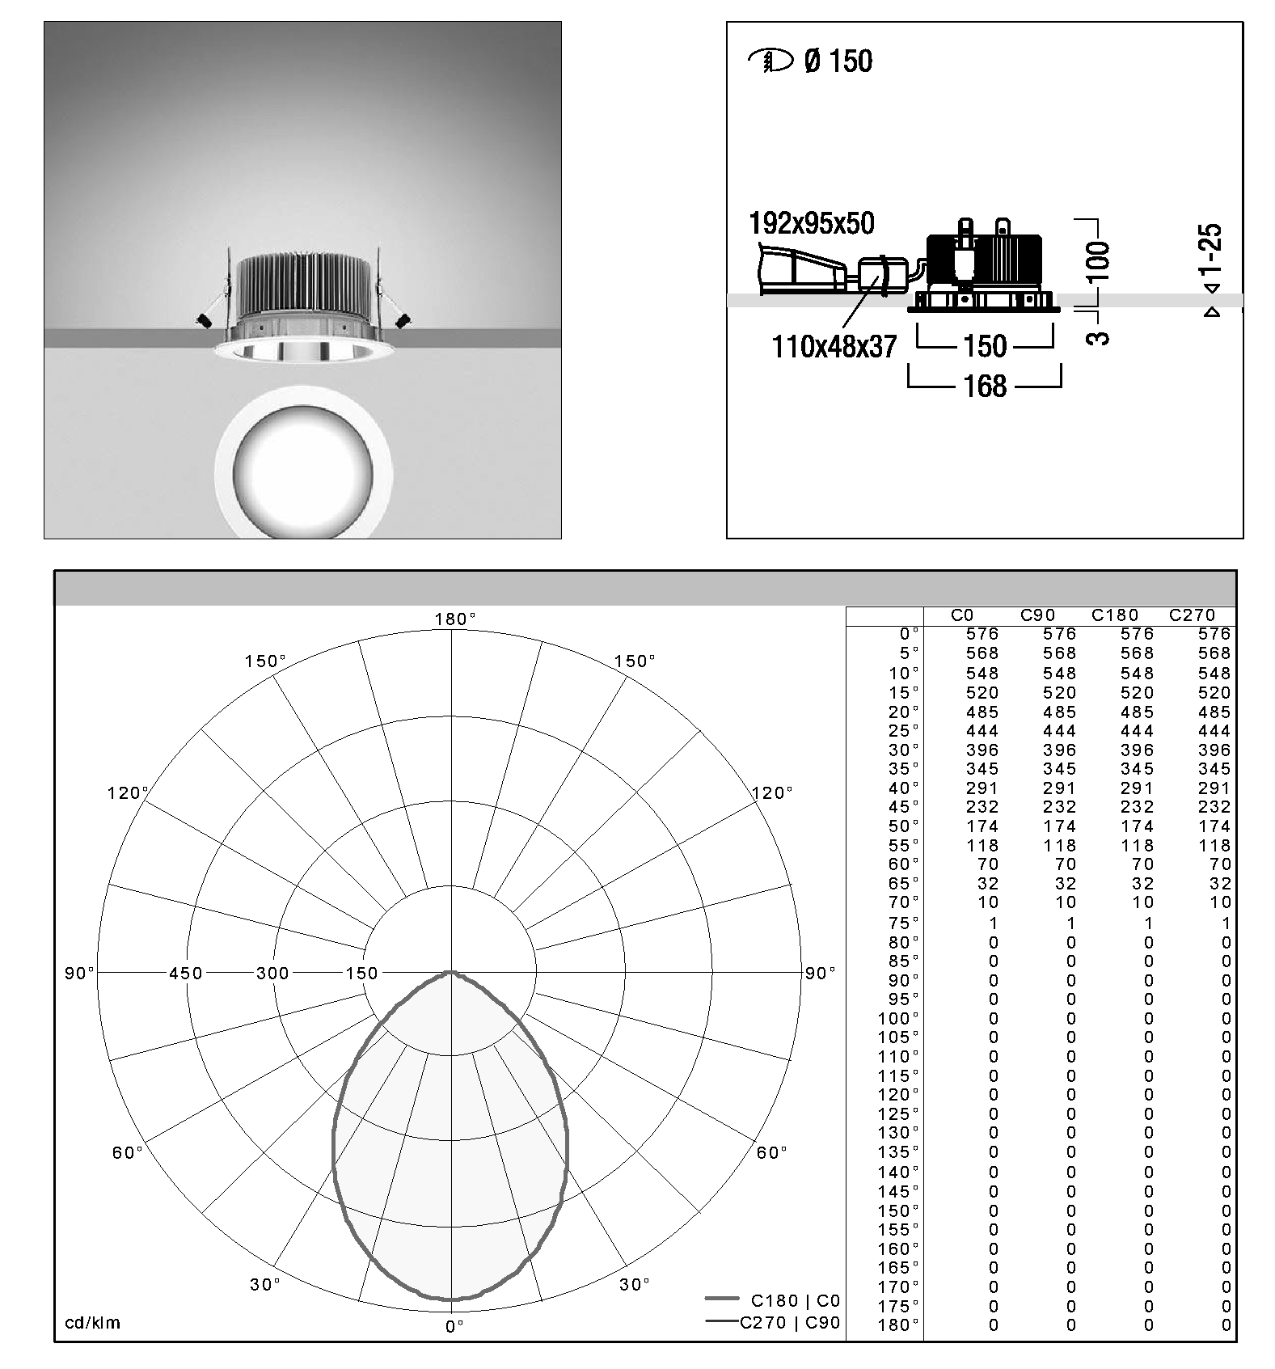
Figure 45b. LED luminaires' picture, dimensions and photometric data.

3.1. Impact of a "neutral" environment
The first step of the research project was performed using both fluorescent and LED luminaires, a total of 8 light scenes were set up (4 with fluorescent luminaires and 4 with LED ones) with about the same illuminance value on the desk (600 lx) and different CCTs (ranging from cool color tones to warm ones). Since it was not possible, given their technology, to change the fluorescent luminaires' CCT through the touch panel, the first four light scenes were set up using only this type of light sources, then the other four which use only LED luminaires were set up in order to have almost the same CCT and desk illuminances (about 600 lx) of the fluorescent light scenes. Desk illuminances and luminaires' CCT were measured using the illuminance meter and the spectroradiometer. Table 12 reports the names, nominal and measured CCTs of the light scenes, the nominal CCT represents the value reported on the fluorescent lamps or the one reported on the touch panel for LED luminaires.
Figure 46 reports the test room's photo, measured plan and section. The spectral reflectances of the test room's surfaces and furniture were already reported in Figure 24 (page 23).
Light scenes
 | Nominal CCT [K] | Measured CCT [K]
Warm Fluorescent 1 (WF1) | 2700 | 2924
Warm LED 1 (WL1) | 2900 | 2940
Warm Fluorescent 2 (WF2) | 3000 | 3070
Warm LED 2 (WL2) | 2850 | 3040
Cool Fluorescent 1 (CF1) | 6500 | 6816
Cool LED 1 (CL1) | 6100 | 6635
Cool Fluorescent 2 (CF2) | 4000 | 4222
Cool LED 2 (CL2) | 3800 | 4233
Table 12. Light scenes.

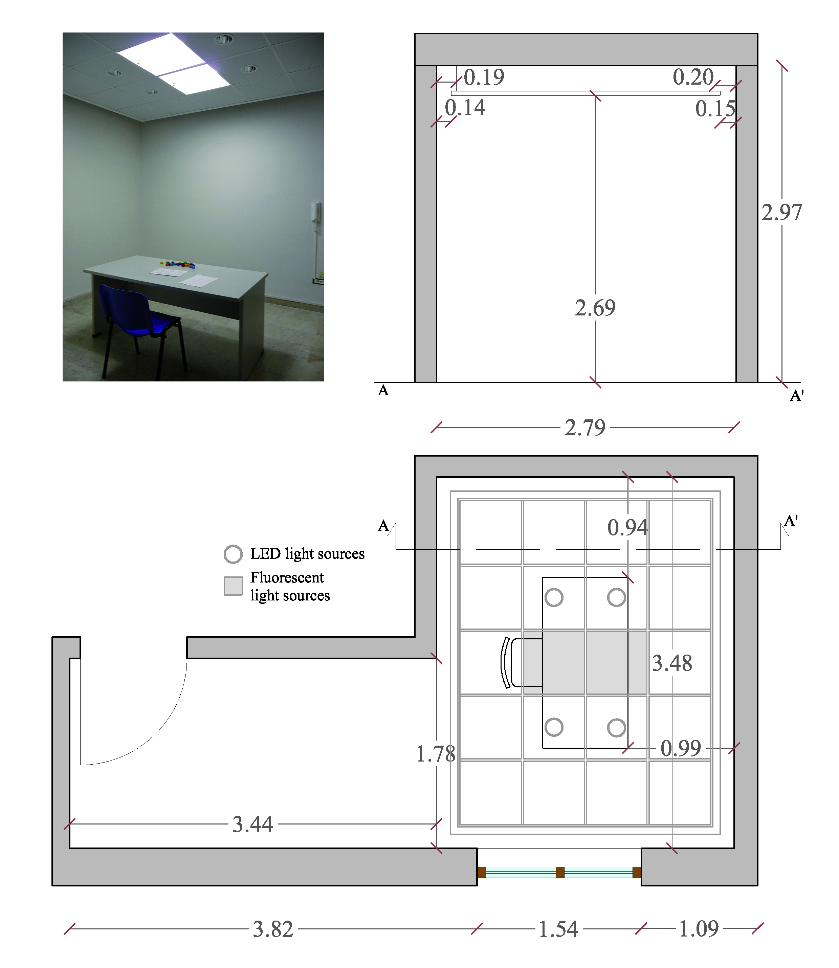
Figure 46. Test room's measured plan, section and photo.

Eye level measurements were performed as reported in chapter 2, but using only the tilt angles on the vertical plane (see Figure 8, page 9).
Table 13 lists desk and eye level illuminances (detected with each tilt angle and also average ones) for each light scene; eye level CCTs are reported in Table 14 whereas Figures 47a,b respectively show the light scenes' SPDs and average eye level spectral irradiances which, as for eye level illuminances and CCTs, were measured with the spectroradiometer; desk illuminances were detected with the illuminance meter.

Desk and eye level illuminances
Light scenes | Desk illuminances [lx] | Eye level illuminances [lx]
Light scenes | Desk illuminances [lx] | 0° | 15° | 45° | Average
WF1 | 654 | 461 | 321 | 211 | 331
WL1 | 636 | 281 | 218 | 159 | 220
WF2 | 636 | 471 | 369 | 285 | 375
WL2 | 620 | 264 | 208 | 216 | 229
CF1 | 621 | 448 | 322 | 191 | 320
CL1 | 628 | 277 | 214 | 155 | 215
CF2 | 643 | 495 | 382 | 294 | 390
CL2 | 630 | 287 | 215 | 217 | 240
Table 13. Desk and eye level illuminances.

It can be observed that desk illuminances are comprised between 620 lx and 654 lx because it was not possible to obtain exactly the same value with all the light scenes, however such differences are small and therefore undetectable for the human eye. It is also important to highlight that although the desk illuminances are similar, eye level values show more difference, indeed eye level illuminances are lower with LED light scenes; this finding depends on the different spatial distribution of the light coming from the two types of luminaires used in this study (see photometric data reported in Figures 45a,b, page 41).

Eye level CCTs [K]
Light scenes | 0° | 15° | 45° | Average
WF1 | 2822 | 2794 | 2763 | 2793
WL1 | 2712 | 2654 | 2630 | 2665
WF2 | 2915 | 2892 | 2882 | 2896
WL2 | 2673 | 2638 | 2644 | 2652
CF1 | 6158 | 6208 | 5944 | 6103
CL1 | 5610 | 5420 | 5220 | 5417
CF2 | 3962 | 3912 | 3894 | 3923
CL2 | 3523 | 3456 | 3566 | 3515
Table 14. Eye level CCTs.

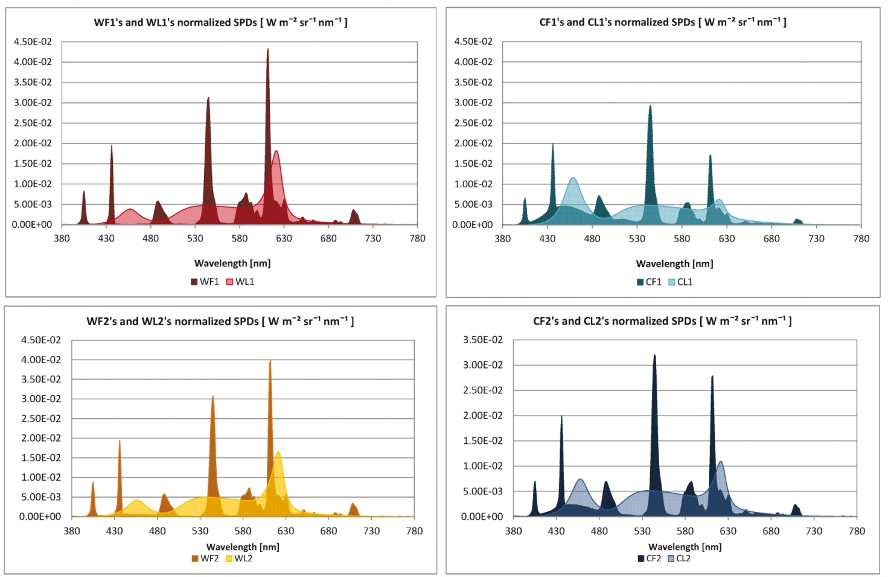Figure 47a. Light scenes' normalized SPDs.

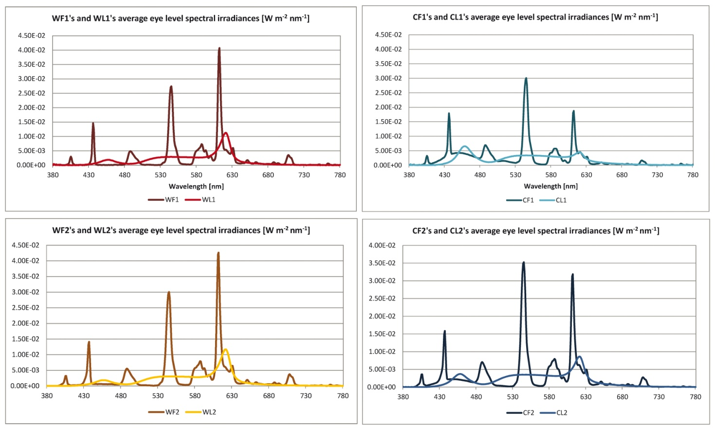
Figure 47b. Light scenes' average eye level spectral irradiances.

The analysis of the impact of the environment on the light that reaches users' eyes was performed by comparing CS values calculated using the method reported in chapter 2.1 (page 10) using as inputs average eye level spectral irradiances and spectral irradiances obtained from light scenes' SPDs. Equations 1 and 2 reported in chapter 2 (page 10) were used to transform the light scenes' SPDs into spectral irradiances. Moreover both measured eye level spectral irradiances and those obtained by transforming the SPDs were scaled in order to obtain eye level illuminances comprised between 50 lx and 1000 lx.
Figure 48 reports CS values calculated for measured eye level spectral irradiances (CS_{e}) and for SPDs derived ones (CS_{s}) and related to eye level illuminances comprised between 50 lx and 1000 lx.

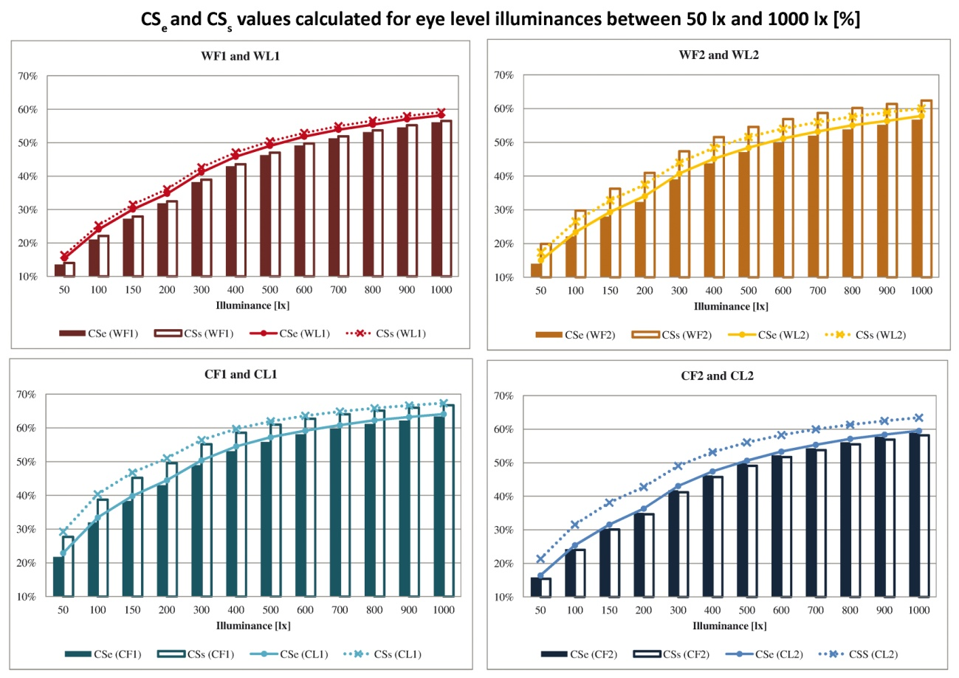
Figure 48. CS_{e} and CS_{s} values for each light scene.

Looking at the graphs reported in Figure 48 it can be observed that CS_{s} values are always greater than CS_{e} ones. In more detail, the difference between CS_{s} and CS_{e} values is not constant between the light scenes; for WF1, WL1 and CF2 it is small whereas it is relevant for CF1, CL1, CL2 and WL2 and therefore it is usually greater for cool light scenes. The reason behind this finding probably resides in the walls' spectral reflectances (Figure 24, page 23), indeed looking at them it is clear that this environment appears neutral but actually it absorbs light in the short wavelengths. Another interesting finding is that CS values increase rapidly for eye level illuminances comprised between 50 lx and 600 lx, whereas between 600 lx and 1000 lx increments are little. Therefore, to achieve a given CS value, it is not convenient to increase illuminances above 600 lx because it will not determine a significant increment but energy consumptions will instead grow. Hence, it is probably best to change the luminaires' SPD rather than increasing illuminances over the abovementioned threshold. Figure 49 further highlights this concept.

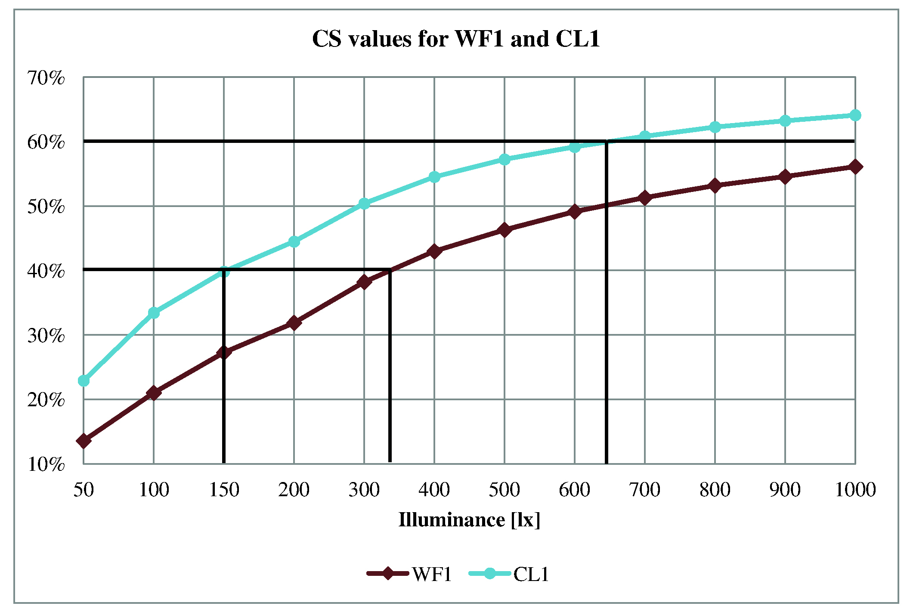
Figure 49. CS values for WF1 and CL1.

Indeed to reach a CS value equal to 40% with the WF1 light scene an eye level illuminance equal to more than 300 lx is necessary whereas with CL1 only 150 lx are required. Moreover it can be observed that with WF1 more than 1000 lx are probably required to achieve a CS value equal to 60%, whereas with CL1 about 650 lx are necessary.

3.2. Impact of colored surfaces
This second step of the research project was carried out in the same test room as the previous one. This time the optical characteristics of one of the test room's walls (the one in front of the desk) were changed by applying colored cardboards on it. Moreover, since in this study the distribution of the light in the space and thus the illuminance on the wall was an important parameter and it changes using different types of luminaires, only light scenes with the previously illustrated LED luminaires were set up. Figure 50 reports the test room measured plan with the luminaires' position, the spectral reflectances of the surfaces and furniture were already reported in Figure 24 (page 23).

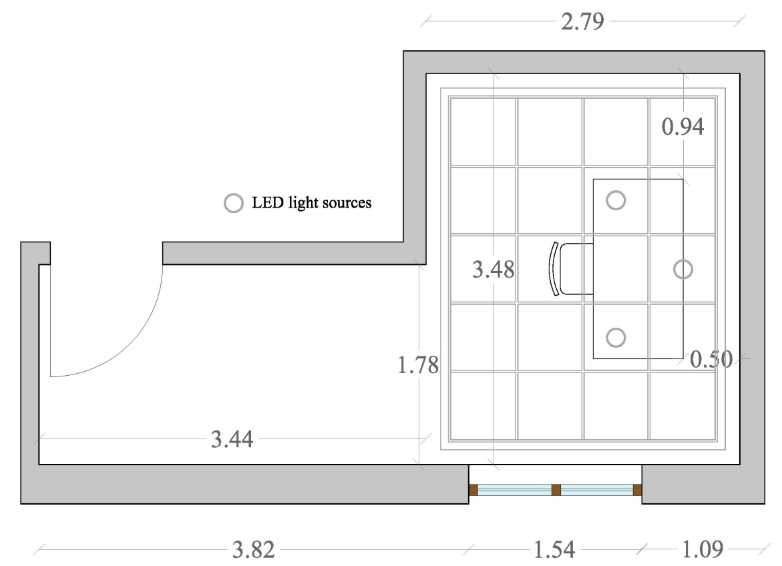
Figure 50. Test room's measured plan and luminaires' position.

The technical data of the luminaires and of the touch panel used to set the light scenes are the same reported in the introduction to this chapter (page 39; Figure 44, Table 10 and Table 11, pages 40-41; Figure 45b, page 41). The colors of the cardboards used to cover the wall in front of the desk were accurately chosen in order to be similar to the ones used in interior design. In the following graphs and tables the name "base case" is used to refer to values related to the test room without any cardboard on the wall.
Figure 51 reports the spectral reflectances of the colored cardboards measured with the spectrophotometer.

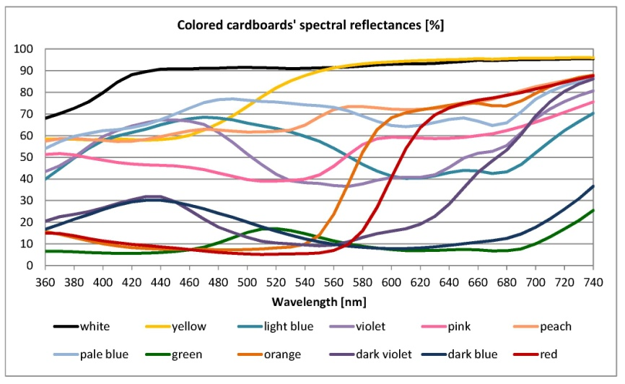
Figure 51. Colored cardboards' spectral reflectances.

Four light scenes with different CCTs (2700 K, 3000 K, 4500 K and 6500 K) were set up in order to obtain 300 lx on the desk with each one of them and using 3 LED luminaires for each light scene. Figure 52 and Table 15 respectively show the light scenes' SPDs and their CRI, CCT and ∆uv values measured with the spectroradiometer.

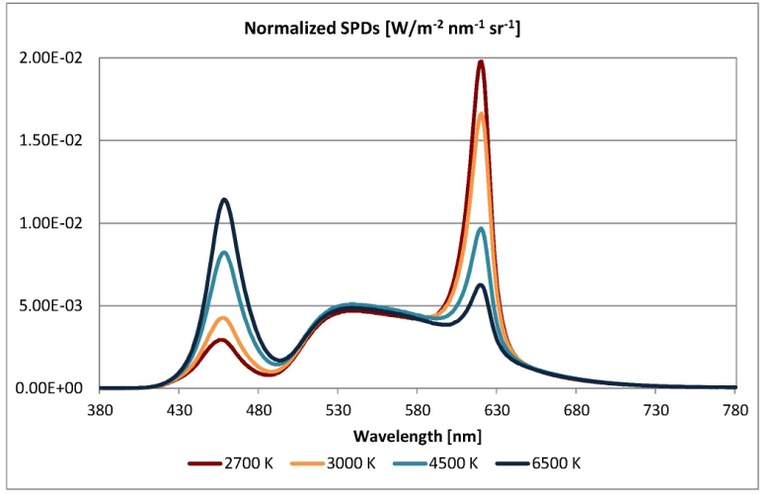
Figure 52. Light scenes' SPDs.

Light scenes' measured CRI, ∆uv and CCT values
Light scenes | CRI | ∆uv | CCT [K]
2700 K | 90 | -0.0016 | 2626
3000 K | 92 | -0.0035 | 3008
4500 K | 91 | -0.0036 | 4561
6500 K | 90 | -0.0038 | 6555
Table 15. Light scenes' measured CRI, ∆uv and CCT values.

It can be observed that CRI values are high (above 90 for all the light scenes) and ∆uv values are small and all negative, which means that the light scenes' chromatic points are all below the Planckian locus.
In this study eye level measurements were performed also using the tilt angles on the horizontal plane (see Figure 8, page 9). Average eye level spectral irradiances related to the different colored cardboards under all the light scenes are reported in Figures 53a,b,c,d. For readability reasons, there are several graphs reporting the average eye level spectral irradiances measured with the different colored cardboards on the wall.

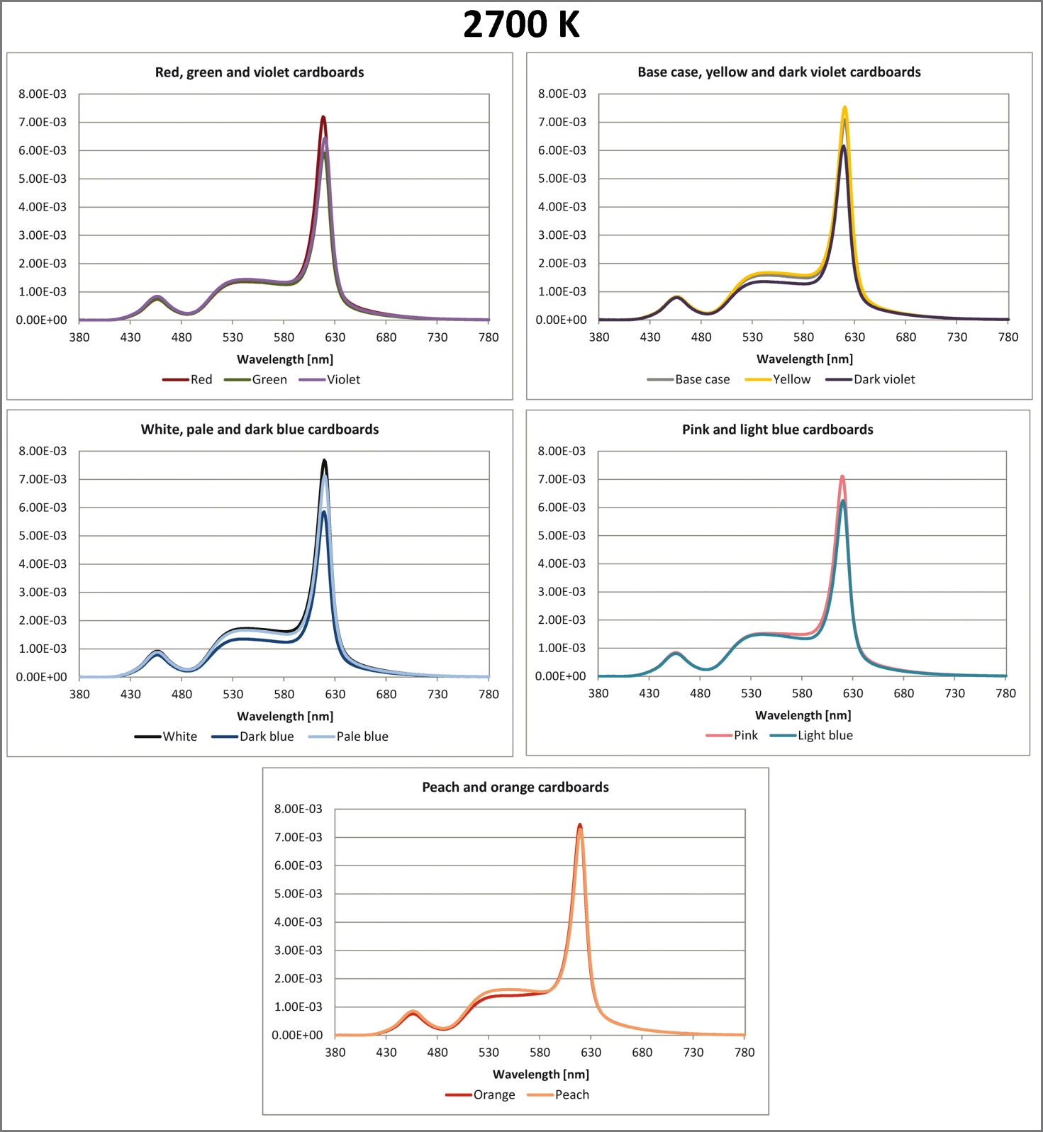
Figure 53a. Average eye level spectral irradiances for each colored cardboard under the 2700 K light scene.

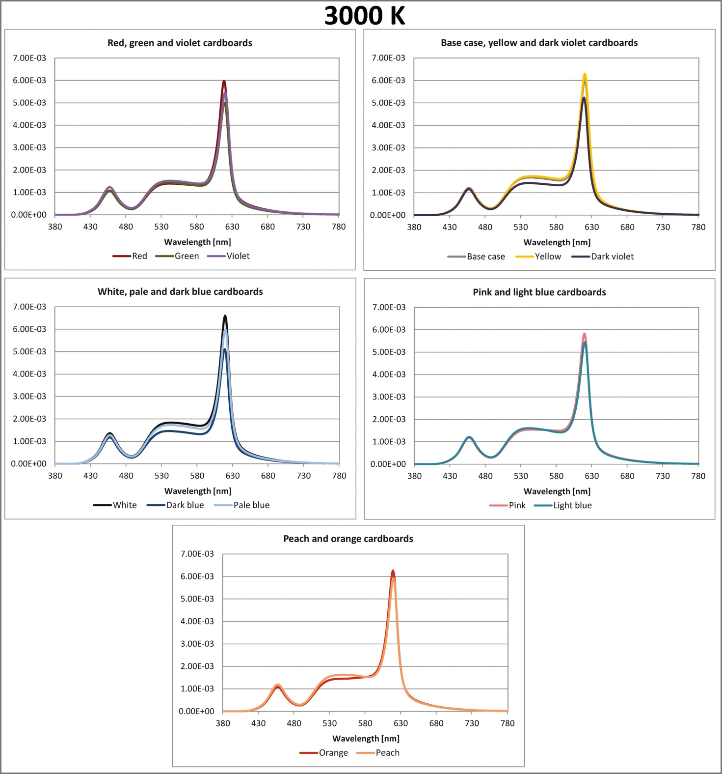
Figure 53b. Average eye level spectral irradiances for each colored cardboard under the 3000 K light scene.

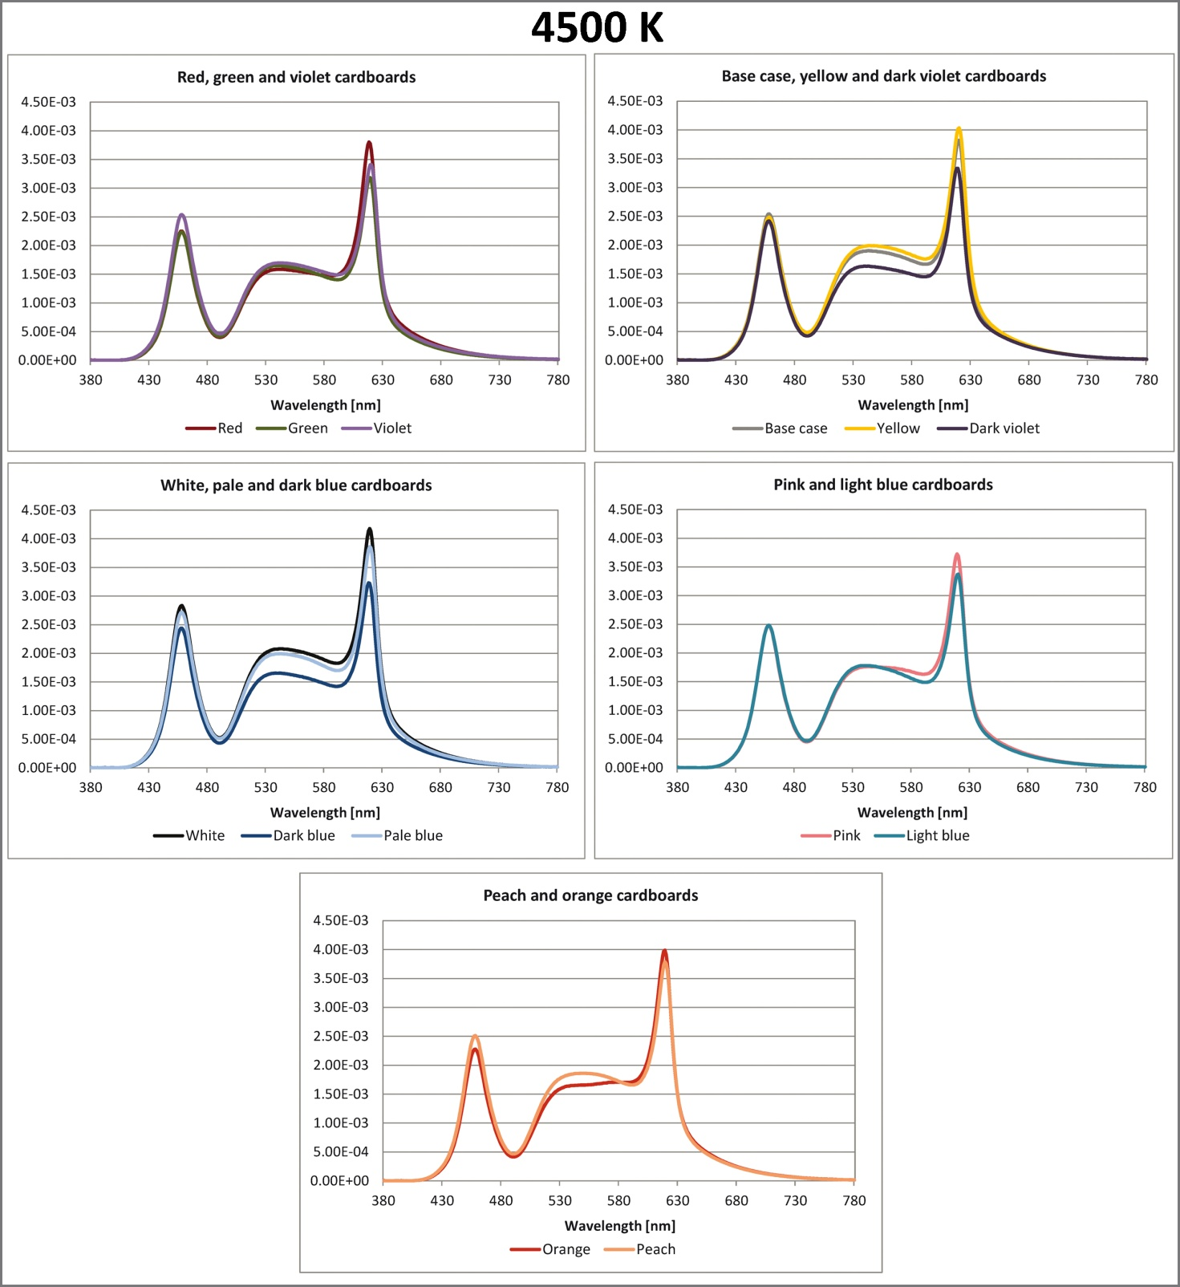
Figure 53c. Average eye level spectral irradiances for each colored cardboard under the 4500 K light scene.

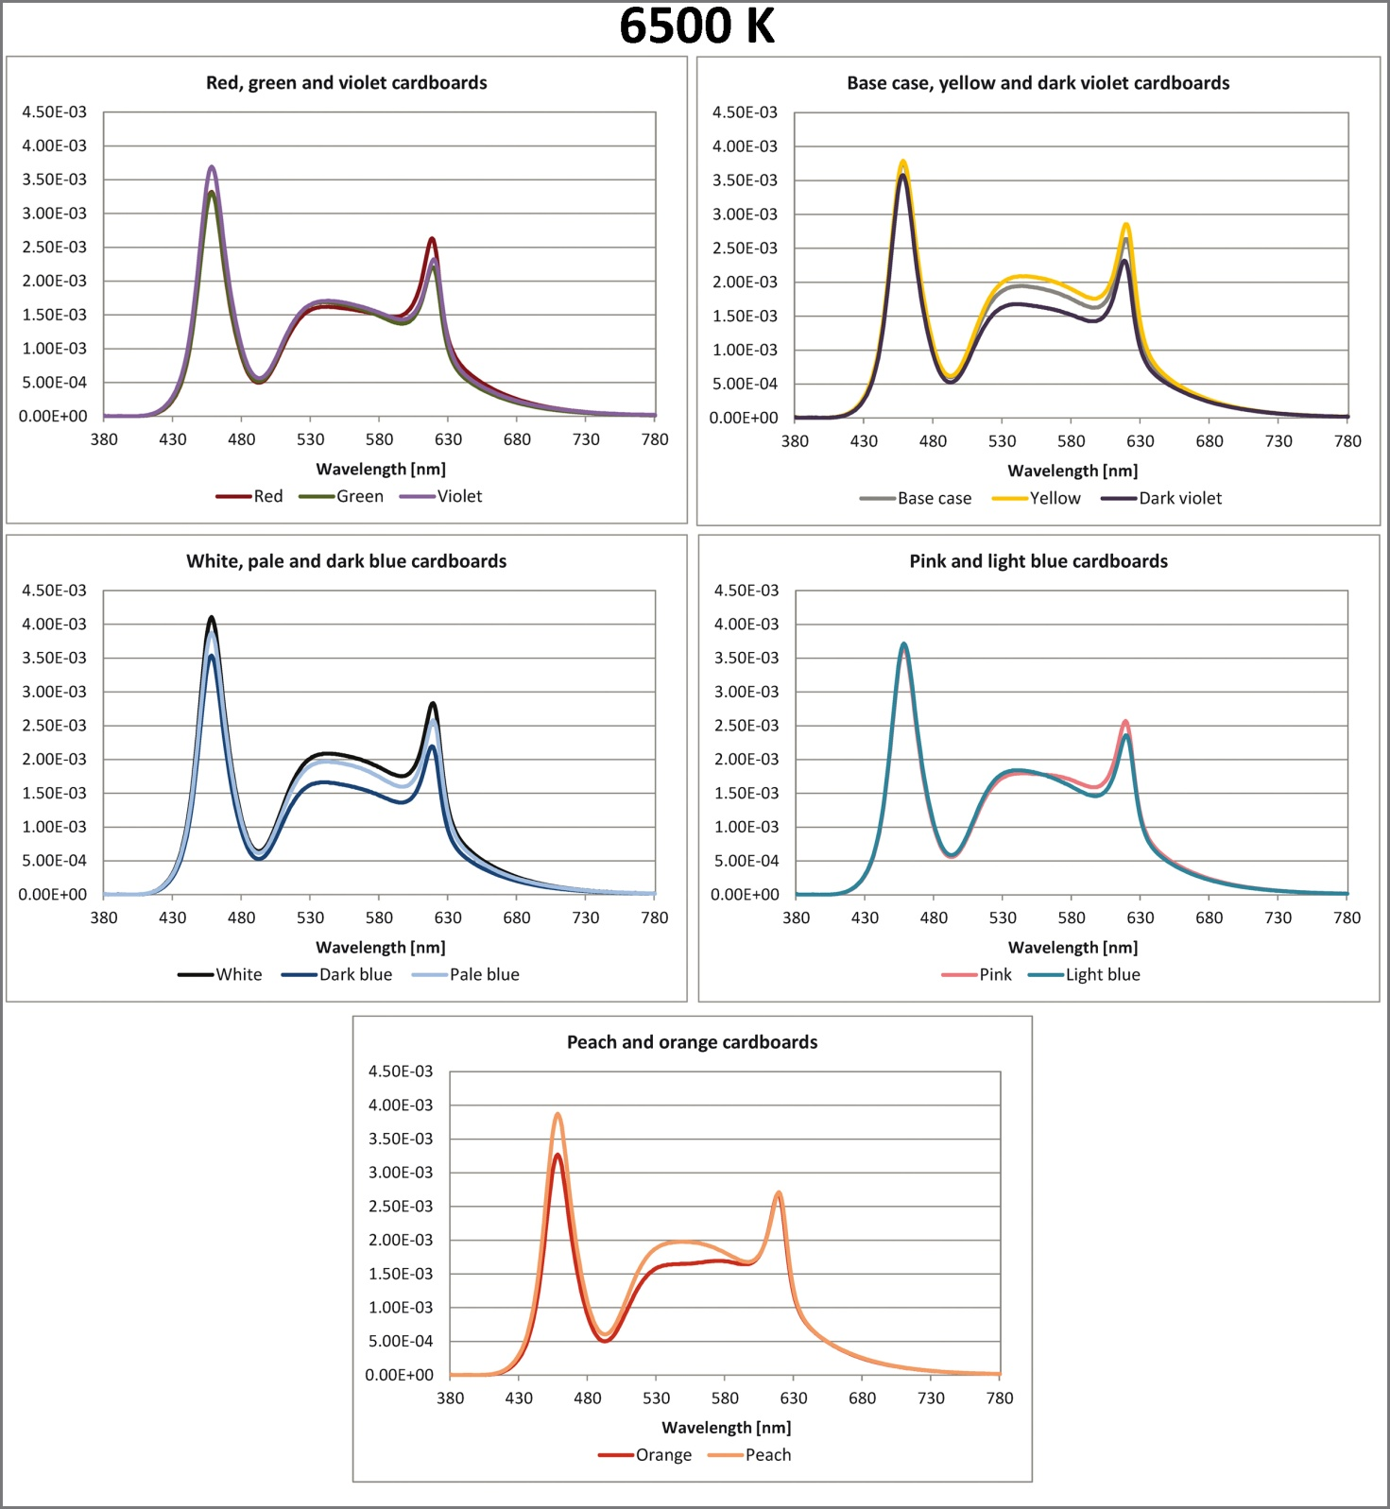
Figure 53d. Average eye level spectral irradiances for each colored cardboard under the 6500 K light scene.

The graphs reported in the previous Figures show that under the 2700 K and 3000 K light scenes the trends related to red, green and violet cardboards are almost coincident with the only exception in correspondence of the peak at about 620 nm. The curves related to the base case and to the yellow and dark violet cardboards show more differences, indeed there is more distance between them also in the medium wavelengths. The greatest difference can be observed between the white and dark blue cardboards whereas the smallest one was found between pink and light blue cardboards and between peach and orange ones. The graphs related to the 4500 K and 6500 K light scenes lead to the following conclusions: generally differences tend to increase, in more detail they are clearer in correspondence of the peaks in the short and long wavelengths but, between yellow and dark violet cardboards, white and dark blue as well as peach and orange ones they are also significant in the medium wavelengths.
It is also important to highlight that the order of magnitude of the curves related to each colored cardboard is not the same, in all cases the ones related to the white cardboard always reach the highest values and this can be explained by looking at the spectral reflectance of this cardboard reported in Figure 51, page 47. Indeed it can observed that the values of the white cardboard's reflectance are in almost the whole visible spectrum equal or greater than 90% and therefore they are higher than those related to the other colored cardboards.
To investigate if there are significant changes in the color attributes of the colored cardboards when lit by the different light scenes, the CIECAM02 color appearance model was also applied to each light scene and each colored cardboard [70]. Color appearance models were developed to describe human color vision taking into account color appearance phenomena such as chromatic adaptation, colorfulness, hue appearance, etc. The equations of the CIECAM02 model were used to calculate the values of color appearance attributes: brightness, lightness, chroma, colorfulness, hue and saturation; their definitions are reported in Table 16 [71].

Definitions of color appearance attributes
Color appearance attribute | Definition
Hue | Attribute of a visual perception according to which an area appears to be similar to one of the colors: red, yellow, green, and blue, or to a combination of adjacent pairs of these colors considered in a closed ring.
Chroma | Colourfulness of an area judged as a proportion of the brightness of a similarly illuminated area that appears white or highly transmitting.
Colorfulness | Attribute of a visual perception according to which the perceived color of an area appears to be more or less chromatic.
Lightness | Brightness of an area judged relative to the brightness of a similarly illuminated area that appears to be white or highly transmitting.
Brightness | Attribute of a visual perception according to which an area appears to emit, or reflect, more or less light.
Saturation | Colourfulness of an area judged in proportion to its brightness.
Table 16. Color appearance attributes' definitions.

To apply this model, an average surround was considered, the reference white was an A4 white paper sheet placed on the front wall and its tristimulus values were measured with each light scene and colored cardboard using the spectroradiometer. The adaptation luminance (cd/m²) was derived from the ratio of the eye level illuminance value at 0° to π. Figure 54 shows pictures of the test room with the red, dark blue and dark violet cardboards applied on the wall and lit by the different light scenes.

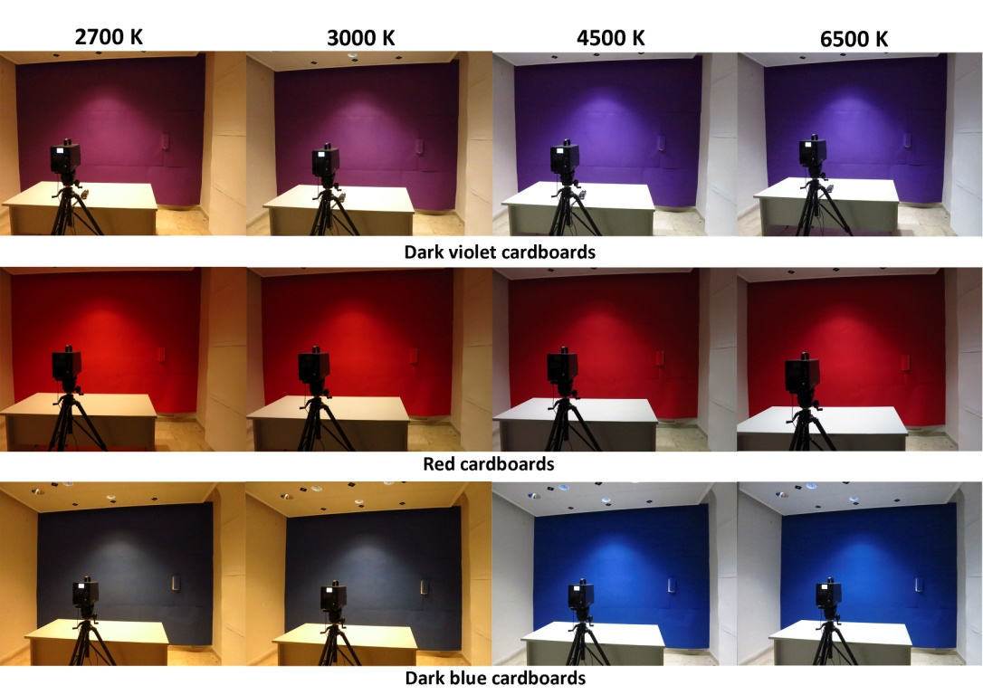
Figure 54. Pictures of the test room with the dark violet, red and dark blue cardboards lit by the different light scenes.

Desk and eye level illuminances were measured with each light scene and colored cardboard to investigate if there are significant changes. Table 17 lists desk and average eye level illuminances.

Desk and average eye level illuminances for each light scene and colored cardboard [lx]
Cardboards | 2700 K |  | 3000 K |  | 4500 K |  | 6500 K
 | Desk | Eye level | Desk | Eye level | Desk | Eye level | Desk | Eye level
Orange | 298 | 121 | 297 | 118 | 301 | 119 | 296 | 113
Green | 287 | 107 | 288 | 106 | 293 | 108 | 288 | 107
Red | 296 | 115 | 295 | 111 | 300 | 111 | 294 | 108
Dark violet | 288 | 108 | 288 | 108 | 293 | 110 | 288 | 108
Dark blue | 286 | 105 | 286 | 108 | 291 | 109 | 287 | 106
Base case | 305 | 125 | 304 | 125 | 309 | 127 | 304 | 124
Yellow | 304 | 132 | 303 | 129 | 308 | 133 | 303 | 134
Light-blue | 294 | 114 | 295 | 117 | 299 | 116 | 295 | 116
Pink | 297 | 124 | 297 | 118 | 302 | 121 | 294 | 118
Violet | 290 | 114 | 291 | 114 | 296 | 114 | 292 | 110
Peach | 301 | 129 | 301 | 122 | 304 | 125 | 301 | 127
Pale blue | 300 | 129 | 301 | 127 | 306 | 131 | 302 | 125
White | 308 | 136 | 308 | 137 | 313 | 139 | 308 | 134
Table 17. Desk and average eye level illuminances for each light scene and colored cardboard.

Both desk and eye level illuminances do not vary much between the different colored cardboards and when changing light scenes. The small differences that were found probably depend on the different reflectances of the cardboards as it can be observed by looking at the graphs in Figure 51.
Eye level CCTs were also detected with each light scene and colored cardboards and their values are reported in Table 18.

Average eye level CCTs for each light scene and colored cardboard [K]
Cardboards | 2700 K | 3000 K | 4500 K | 6500 K
Orange | 2313 | 2545 | 3605 | 4761
Green | 2567 | 2914 | 4198 | 5616
Red | 2324 | 2590 | 3721 | 5012
Dark violet | 2497 | 2839 | 4143 | 5662
Dark blue | 2574 | 2931 | 4287 | 5864
Base case | 2482 | 2816 | 4053 | 5432
Yellow | 2453 | 2772 | 3936 | 5197
Light-blue | 2585 | 2942 | 4286 | 5825
Pink | 2438 | 2759 | 3974 | 5342
Violet | 2507 | 2858 | 4212 | 5824
Peach | 2475 | 2800 | 4019 | 5390
Pale blue | 2554 | 2900 | 4195 | 5623
White | 2502 | 2839 | 4087 | 5469
Table 18. Average eye level CCTs for each light scene and colored cardboard.

The conclusions made for desk and average eye level illuminances also apply to average eye level CCTs.
CS values were calculated also in this study with each tilt angle of the spectroradiometer, and the average ones are reported in Figure 55.

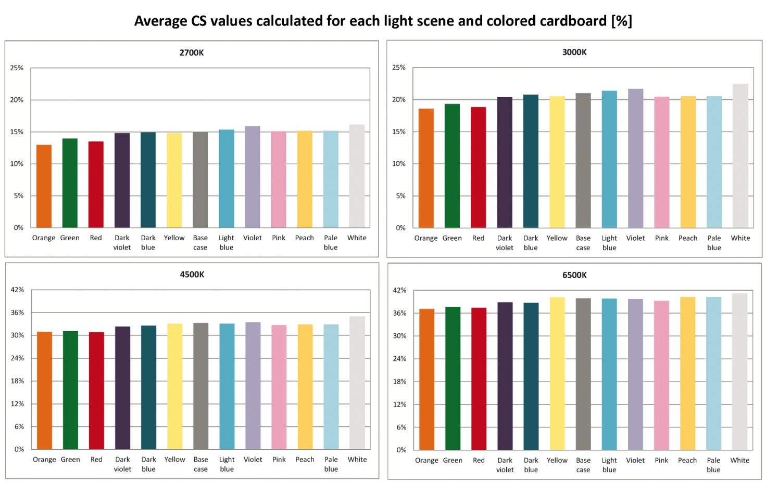
Figure 55. Average CS values for each light scene and colored cardboard.

The graphs reported in Figure 55 show that also for CS values there is no big difference among the different cardboards when lit by the same light scene. On the other hand, the difference becomes significant when changing the light scene's CCT and consequently the SPD; indeed for the 2700 K light scene CS values are all around 15% whereas for the 6500 K one they are all a little above 36%.
As it was previously done in the first step of the research project, eye level spectral irradiances measured with the different light scenes and colored cardboards were scaled to correspond to different eye level illuminances (between 50 lx and 1000 lx), then the corresponding CS values were also calculated. The greatest difference was found between orange and violet cardboards and therefore, for readability reasons, only the results related to these two are reported in Figure 56.

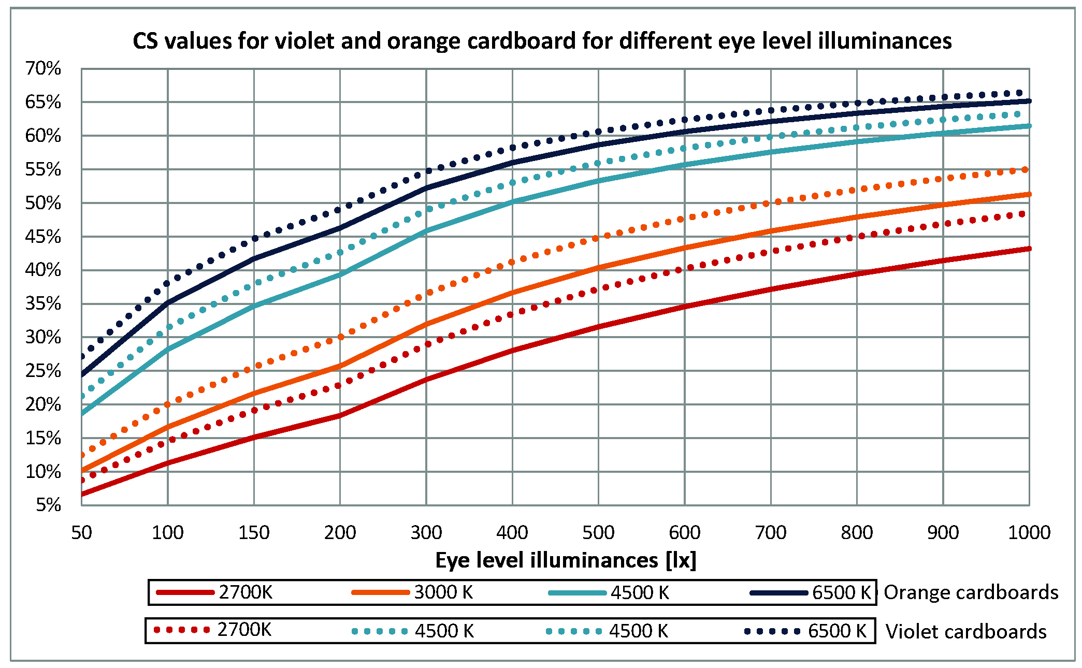
Figure 56. CS values related to orange and violet cardboards for each light scene and for different eye level illuminances.

Figure 56 shows that, to reach for example a CS value equal to 40% with the 2700 K light scene, 800 lx at the eyes level are required with orange cardboards whereas violet ones require 600 lx. Therefore the difference between these two wall's colors is significant but what affects most the evaluation of the circadian impact is the light scene's SPD; indeed to reach the same 40% CS value with the 6500 K light scene, 110 lx are needed with violet cardboards and 140 lx with orange ones.
Moreover it is interesting to notice that increasing the light scene's CCT determines a decrease of the difference between the CS values calculated for the two cardboards' colors, thus this confirms that the light sources' SPDs are more important, from a circadian impact point of view, than the walls' colors.
However this does not mean that the choice of walls' colors is unimportant, since it may affect an environment's perception. In more detail, the combination of a given wall color with a light scene may result in an unpleasant environment. The application of the CIECAM02 model gives indications about this, indeed significant shifts in the values of the color appearance attributes may correspond to an also significant difference in the perception of the environment when using a certain wall color and changing the light scene.
The values of hue and chroma calculated for each light scene and colored cardboard using the CIECAM02's equations are reported in Figure 57, moreover color differences were calculated for each colored cardboard and are reported in Table 19, the 2700 K light scene was selected as reference and the following equations were used to perform the calculation.

$∆L=L_{2700K}- L_{x}$ (Eq.6)
$∆H=H_{2700K}- H_{x}$ (Eq.7)
$∆C=C_{2700K}- C_{x}$ (Eq.8)

where x = 3000 K, 4500 K and 6500 K; L, H and C respectively represent lightness, hue and chroma.

$∆E_{ab}=\sqrt{{∆H}^{2}+ {∆C}^{2}}$ (Eq.9)

$∆{E_{ab}}^{*}=\sqrt{{∆H}^{2}+ {∆C}^{2}+ {∆L}^{2}}$ (Eq.10)

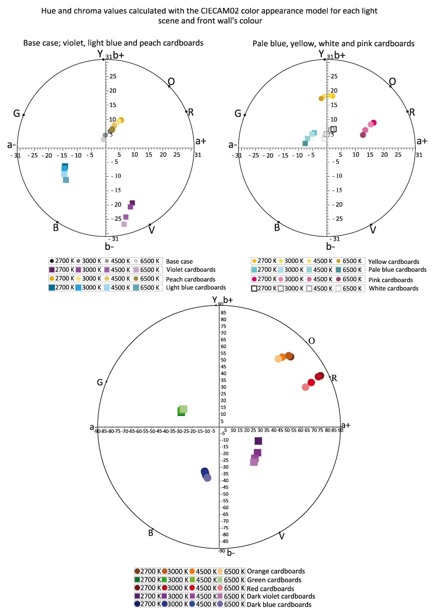
Figure 57. CIECAM02's hue and chroma values for each light scene and colored cardboard.
Chromatic differences
Cardboards |  | ∆E*_{ab} | ∆E_{ab} | ∆C | ∆H | ∆L
Orange | 2700 K - 3000 K | 1.79 | 1.27 | 0.42 | -1.20 | 1.26
Orange | 2700 K - 4500 K | 6.99 | 5.59 | 4.44 | -3.40 | 4.20
Orange | 2700 K - 6500 K | 10.40 | 8.70 | 7.45 | -4.50 | 5.69
Green | 2700 K - 3000 K | 1.85 | 1.82 | -0.28 | 1.80 | -0.31
Green | 2700 K - 4500 K | 4.94 | 4.80 | 0.15 | 4.80 | -1.17
Green | 2700 K - 6500 K | 6.02 | 5.84 | 0.71 | 5.80 | -1.45
Red | 2700 K - 3000 K | 2.59 | 1.71 | 1.71 | 0.00 | 1.95
Red | 2700 K - 4500 K | 10.49 | 8.41 | 8.34 | 1.10 | 6.27
Red | 2700 K - 6500 K | 16.52 | 13.81 | 13.65 | 2.10 | 9.07
Dark violet | 2700 K - 3000 K | 2.95 | 2.92 | -0.37 | 2.90 | 0.36
Dark violet | 2700 K - 4500 K | 10.45 | 10.39 | -1.34 | 10.30 | 1.12
Dark violet | 2700 K - 6500 K | 14.78 | 14.67 | -2.79 | 14.40 | 1.82
Dark blue | 2700 K - 3000 K | 1.39 | 1.38 | -0.84 | -1.10 | -0.11
Dark blue | 2700 K - 4500 K | 3.85 | 3.81 | -2.58 | -2.80 | -0.56
Dark blue | 2700 K - 6500 K | 6.32 | 6.30 | -3.96 | -4.90 | -0.50
Base case | 2700 K - 3000 K | 5.45 | 5.45 | 0.76 | -5.4 | 0.05
Base case | 2700 K - 4500 K | 22.35 | 22.35 | 2.55 | -22.2 | 0.08
Base case | 2700 K - 6500 K | 36.34 | 36.34 | 4.17 | -36.10 | 0.09
Yellow | 2700 K - 3000 K | 3.11 | 3.10 | -0.14 | -3.10 | -0.25
Yellow | 2700 K - 4500 K | 9.51 | 9.50 | 0.26 | -9.50 | -0.40
Yellow | 2700 K - 6500 K | 12.75 | 12.74 | 1.02 | -12.70 | -0.45
Light-blue | 2700 K - 3000 K | 2.48 | 2.47 | -0.58 | -2.40 | -0.18
Light-blue | 2700 K - 4500 K | 8.34 | 8.28 | -1.70 | -8.10 | -0.99
Light-blue | 2700 K - 6500 K | 14.98 | 14.92 | -2.54 | -14.70 | -1.36
Pink | 2700 K - 3000 K | 1.32 | 1.31 | 1.29 | 0.20 | 0.16
Pink | 2700 K - 4500 K | 5.42 | 5.37 | 4.16 | 3.40 | 0.71
Pink | 2700 K - 6500 K | 10.41 | 10.34 | 5.74 | 8.60 | 1.17
Violet | 2700 K - 3000 K | 3.33 | 3.32 | -1.20 | 3.10 | -0.12
Violet | 2700 K - 4500 K | 10.54 | 10.54 | -4.34 | 9.60 | 0.31
Violet | 2700 K - 6500 K | 14.16 | 14.14 | -6.98 | 12.30 | 0.72
Peach | 2700 K - 3000 K | 2.62 | 2.62 | 0.79 | -2.50 | -0.06
Peach | 2700 K - 4500 K | 8.44 | 8.44 | 2.98 | -7.90 | -0.09
Peach | 2700 K - 6500 K | 10.48 | 10.48 | 4.64 | -9.40 | -0.04
Pale blue | 2700 K - 3000 K | 7.42 | 7.40 | -0.23 | -7.40 | -0.44
Pale blue | 2700 K - 4500 K | 24.43 | 24.41 | -0.68 | -24.40 | -0.92
Pale blue | 2700 K - 6500 K | 38.73 | 38.71 | -0.91 | -38.70 | -1.23
White | 2700 K - 3000 K | 5.05 | 5.05 | 0.72 | -5.00 | -0.04
White | 2700 K - 4500 K | 20.55 | 20.55 | 2.50 | -20.40 | -0.12
White | 2700 K - 6500 K | 32.25 | 32.24 | 3.96 | -32.00 | -0.29
Table 19. Analysis of chromatic differences.

The results reported in Figure 57 and Table 19 show that, for some cardboards, there are significant variations in color attributes when changing the light scene. Indeed it can be observed that the greatest variations (∆E*_{ab} values) were calculated between the 2700 K and the 6500 K light scenes for pale blue and white cardboards and for the base case (respectively equal to 38.73, 32.25 and 36.34). In more detail, looking at ∆H values for the abovementioned cases it can be observed that they are also high whereas ∆C and ∆L values are not significant.
Generally there is little lightness variation (∆L) when changing the light scene except for orange and red cardboards (respectively equal to 5.69 and 9.07), they are also the only ones for which there is also a significant variation in chroma values (∆C) which are equal to 7.45 for the former and 13.65 for the latter. Therefore combining some of the colored cardboards with the light scenes used in this study may determine significant difference in the way the environment is perceived and, to investigate this important aspect, tests on subjects are required.
Given the number of colored cardboards and light scenes carrying out the tests would have required too much time and it would not have been possible to complete them during the PhD course. However, considering the importance of this topic, two smaller studies were nevertheless performed. The first one investigated the perception of colored objects under different light scenes and compared the results of tests on subjects with those obtained from the application of the CIECAM02 color appearance model [48]. The second study focused on the analysis of people's perception of an artwork when changing the light scene's and background's characteristics [49]. Both studies were performed in the same test room and their results will be reported in the following subparagraph.

3.2.1. Impact of colored surfaces: studies on people's perception
In the first study, the test room's walls were left in their original color (for surfaces' and furniture's spectral reflectances see Figure 24 page 23), the desk was covered with a white cardboard and colored objects (LEGO® cubes) were placed on the desk. Figure 58 show the LEGO® cubes spectral reflectances measured with the spectrophotometer.

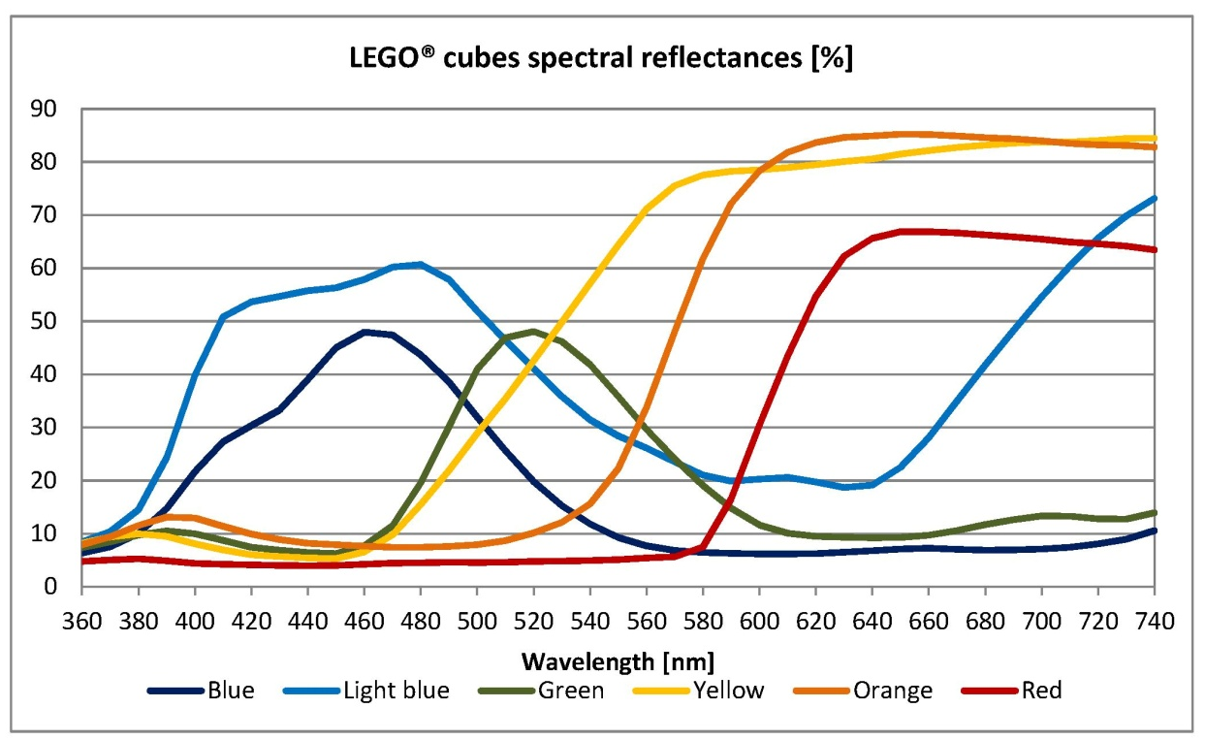
Figure 58. LEGO® cubes spectral reflectances.

Three light scenes with LED light sources and different CCTs (2700 K, 4500 K and 6500 K) were set up using the aforementioned touch panel (for the luminaires' and touch panel's characteristics see chapter 3 pages 39-41). The light scenes' measured CCTs, desk illuminances and CRI values are reported in Table 20 whereas Figures 59a,b show the light scenes' normalized SPDs and the test room lit by the different scenes.

Light scenes' measured CCTs, CRI and desk illuminances
Light scenes | CCTs [K] | CRI | Desk illuminances [lx]
2700 K | 3013 | 93 | 463
4500 K | 4623 | 90 | 478
6500 K | 6751 | 88 | 481
Table 20. Light scenes' measured CCTs, CRI and desk illuminances.

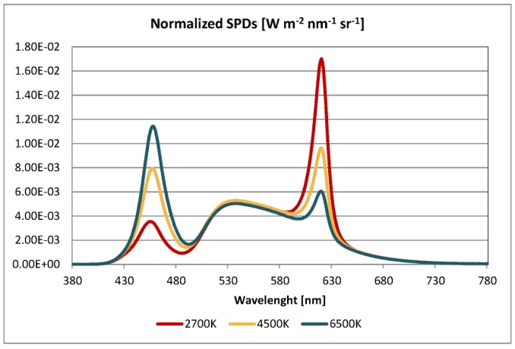
Figure 59a. Light scenes' normalized SPDs.

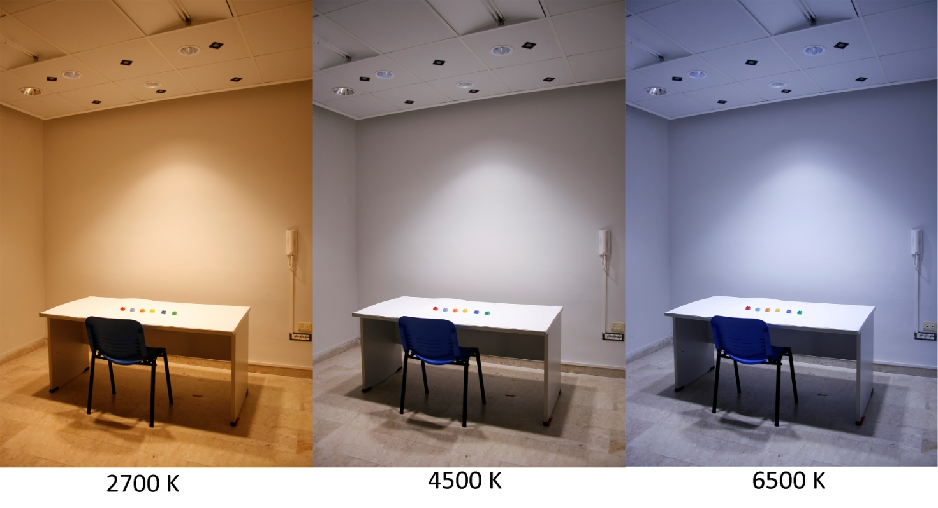
Figure 59b. Test room lit by the different light scenes.

For the application of the CIECAM02 color appearance model an average background was selected, the adapting luminance (cd/m²) was calculated by dividing for π eye level illuminance values measured for each light scene by placing the spectroradiometer at the same height of the head of a person seated at the desk. The tristimulus values of the LEGO® cubes and of the reference white were measured with the spectroradiometer under each light scene.
Ten subjects (7 females and 3 males, mean age 27 years) performed a test for the evaluation of the LEGO® cubes' color attributes, to ensure that they all possessed a normal color vision, they had to pass the Ishihara Color Blindness Test. To be selected for the study subjects also had to attend a tutorial phase in which they learned about color perception and attributes, in order to familiarize with the concepts of hue and colorfulness, blackness and whiteness. Subjects had to fill a copy of the questionnaire reported in Figure 60 for each light scene and each LEGO® cube, they repeated the test four times with each light scene and LEGO® cube during different days. The light scenes' sequence was randomized and subjects ignored which light scene was switched on when they were performing the test; moreover they had to evaluate one cube at a time.

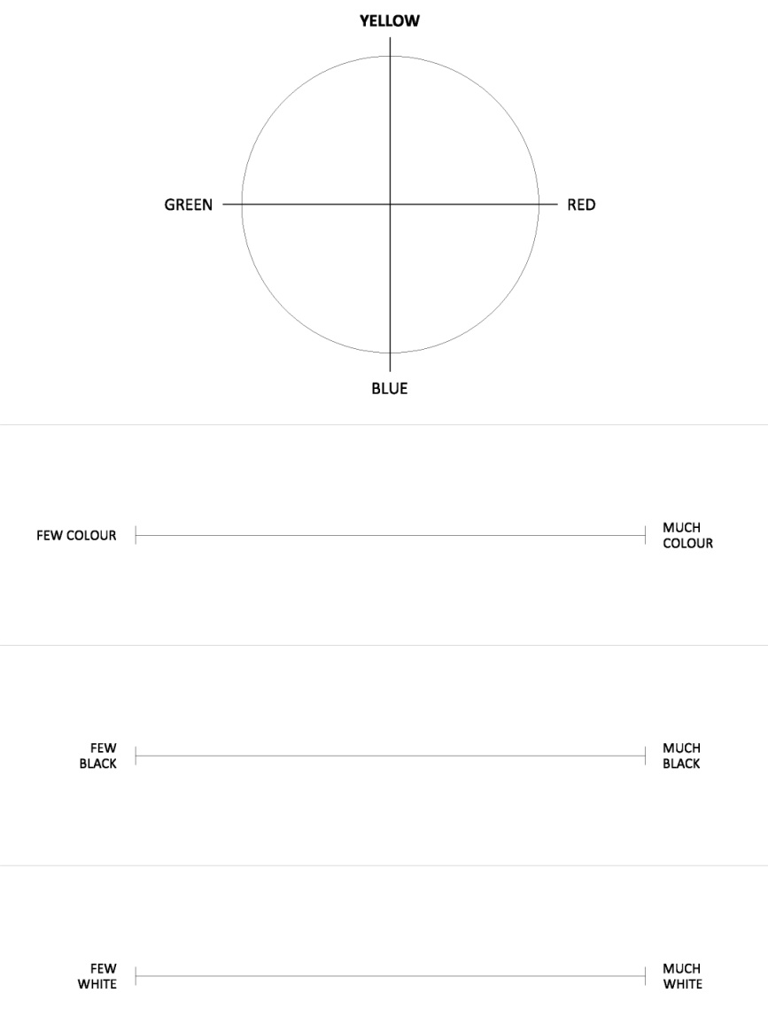
Figure 60. Test sample.

The first question concerned hue evaluation, subjects had to mark a point on the circle which they judged as representative of the object's hue. The other three questions were about color, black and white content: subjects had to mark a point on the line which they judged as representative of how much color/black or white they saw in the object under a given light scene. The question about color content was considered as representative of the evaluation of chroma. To obtain the numerical values corresponding to subjects' evaluations, graduated transparent sheets were developed and superimposed to the sheets with the subjects' answers. Table 21 show hue values derived from the tests (perceived) and those calculated using the CIECAM02 model.

Perceived and CIECAM02 hue values
LEGO® cubes |  | 2700 K | 4500 K | 6500 K
Orange | CIECAM02 | 32.3 | 37 | 39.82
Orange | Perceived | 43.9 | 45.7 | 45.2
Green | CIECAM02 | 174.26 | 165.3 | 160.71
Green | Perceived | 163.5 | 165.5 | 171.1
Red | CIECAM02 | 5.51 | 5.91 | 5.64
Red | Perceived | 10.6 | 2.25 | 1.5
Yellow | CIECAM02 | 82.44 | 88.55 | 91.38
Yellow | Perceived | 80.6 | 84 | 91.8
Light-blue | CIECAM02 | 244.37 | 249 | 251.68
Light-blue | Perceived | 267.5 | 261.6 | 261.9
Blue | CIECAM02 | 256 | 259.04 | 260.54
Blue | Perceived | 272 | 273.6 | 275
Table 21. Hue values derived from the test and from the CIECAM02 model.

The correlation coefficients R² between perceived and CIECAM02's hue values were also calculated for each light scene and are equal to 0.9901 (2700 K), 0.9971 (4500 K) and 0.9991 (6500 K). Therefore R² values are always greater than 0.99 and thus correlation is good. It is also important to point out that with the 4500 K and 6500 K light scenes red, yellow and green LEGO® cubes' hue values tend to respectively shift toward red, yellow and green unique hues.
Table 22 shows the comparison between chroma values obtained from the test and those calculated using the CIECAM02 model.

Perceived and CIECAM02 chroma values
LEGO® cubes |  | 2700 K | 4500 K | 6500 K
Orange | CIECAM02 | 81.98 | 78.61 | 76.20
Orange | Perceived | 77.80 | 75.20 | 75.90
Green | CIECAM02 | 73.08 | 72.71 | 72.20
Green | Perceived | 75.00 | 84.90 | 76.10
Red | CIECAM02 | 93.73 | 85.57 | 80.96
Red | Perceived | 85.50 | 84.90 | 86.10
Yellow | CIECAM02 | 68.72 | 76.10 | 78.57
Yellow | Perceived | 76.00 | 73.60 | 76.40
Light-blue | CIECAM02 | 38.84 | 41.29 | 41.24
Light-blue | Perceived | 50.78 | 48.33 | 47.00
Blue | CIECAM02 | 60.20 | 62.93 | 64.53
Blue | Perceived | 85.90 | 83.40 | 82.70
Table 22. Chroma values derived from the test and from the CIECAM02 model.

The values of the correlation coefficient R² were calculated also in this case for each light scene and are equal to 0.5883 (2700 K), 0.6412 (4500 K) and 0.7698 (6500 K). Therefore there is not a good correlation in this case but it can be observed that the correlation improves when increasing the light scene's CCT.
Moreover it is interesting to highlight that the greatest difference between perceived chroma values and those calculated using the CIECAM02 model was found for the blue cube, in more detail perceived values are considerably higher than CIECAM02's ones.
Table 23 reports the perceived quantities of black and white.

Perceived quantities of black and white
LEGO® cubes |  | 2700 K | 4500 K | 6500 K
Orange | Black | 1.95 | 2.53 | 1.95
Orange | White | 4.31 | 4.38 | 3.96
Green | Black | 3.41 | 2.33 | 3.41
Green | White | 3.43 | 3.66 | 3.59
Red | Black | 3.57 | 4.25 | 3.57
Red | White | 2.50 | 1.86 | 1.62
Yellow | Black | 1.53 | 1.83 | 1.53
Yellow | White | 4.81 | 4.38 | 4.15
Light-blue | Black | 2.53 | 2.50 | 2.53
Light-blue | White | 5.49 | 5.10 | 5.01
Blue | Black | 5.66 | 5.35 | 5.66
Blue | White | 1.71 | 2.00 | 1.83
Table 23. Perceived quantities of black and white.

The values reported in Table 23 show that there is no great variation in the perceived black and white quantities when changing the light scenes.
The second study investigated how people perceive an artwork when changing the light scenes' and background's characteristics by performing a test on 21 subjects. A museum setting was reproduced in the test room using a reproduction of the Henri Matisse's painting "Dame en blue" (Figure 61) and by setting, using LED wallwashers, four light scenes with two different CCTs (3000 K and 4000 K) and illuminance levels on the painting's surface (50 lx and 300 lx).


Figure 61. Henri Matisse's "Dame en blue".

The light scenes were set up using the touch panel whose technical data are reported in chapter 3, pages 39-40. Each light scene used two LED wallwashers manufactured by Zumtobel, a photo of the luminaires, their photometric data and dimensions (as provided by the manufacturer) are reported in Figure 62 while Table 24 lists their technical data.

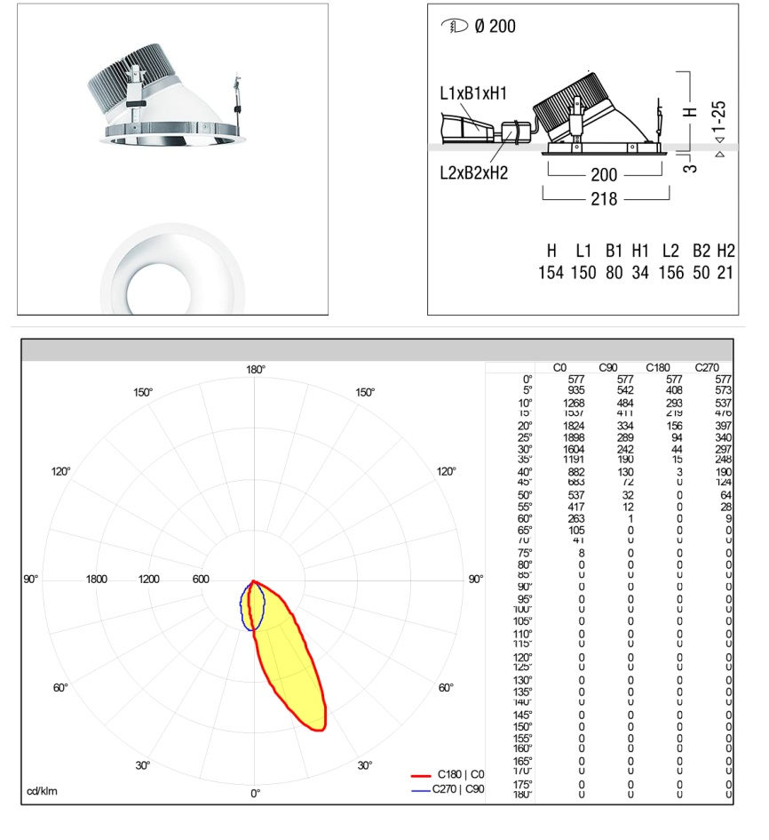
Figure 62. Luminaires' photo, dimensions and photometric data.

Wallwashers' technical data
Total Nominal luminous flux | 1068 lm
Nominal luminous efficacy | 46 lm/W
Nominal CRI | 90
Absorbed power | 23 W
Table 24. Technical data of each wallwasher.

The light scenes' characteristics are reported in Figure 63 along with their measured SPDs.

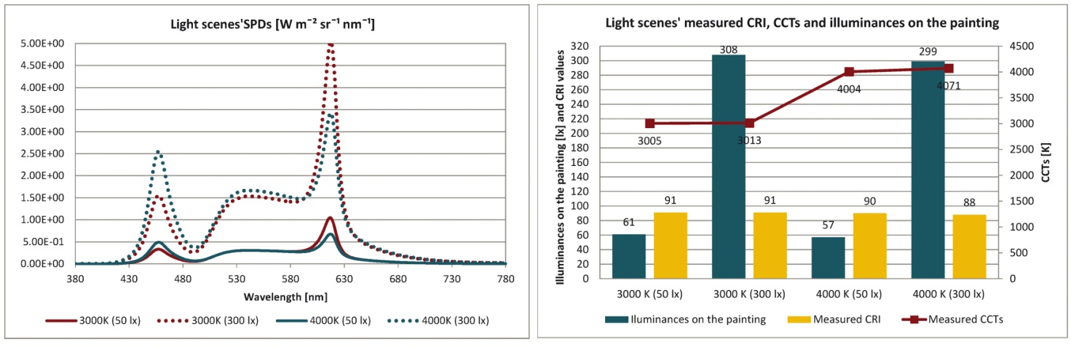
Figure 63. Light scenes' measured SPDs, CCTs, CRI values and illuminances on the painting.

Moreover three different backgrounds were chosen (white, red and blue cardboards) since these are the colors most frequently used in museums, their spectral reflectances are reported in Figure 64a together with the painting's ones. The spectral reflectances of the test room were already illustrated in Figure 24, page 23.

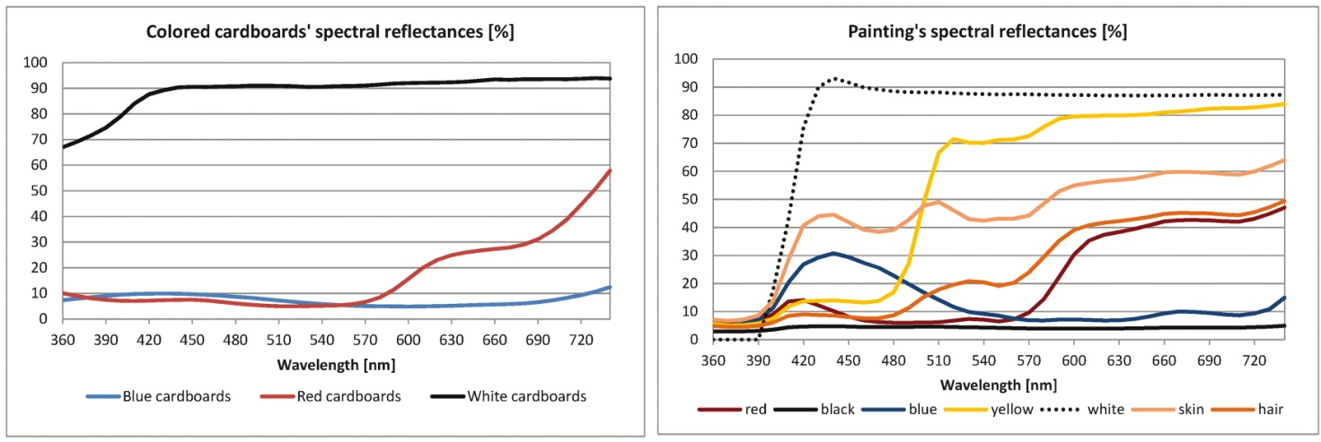
Figure 64a. Spectral reflectances of the colored cardboards and of the painting.

The coordinates to place the painting's colors in the color wheel were also measured using the spectrophotometer and they are reported in Figure 64b.
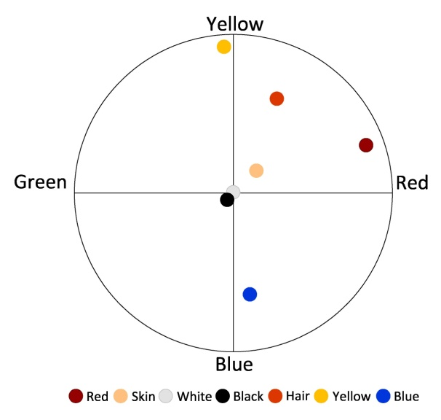
Figure 64b. Color wheel.

21 subjects performed the test (5 males, 16 females, mean age 25 years), each one of them had to pass the Ishihara Color Blindness Test to be selected for the experiment.
When taking the test, subjects were placed at a distance from the painting equal to 135 cm, in order for the visual angle to be equal to 28°. The painting's reproduction (66 cm x 53 cm) was hang at an height that determind an uniform illuminance pattern on its surface and also allowed subjects to see it without inclining their heads up or down. Figures 65a,b show the experimental setting.

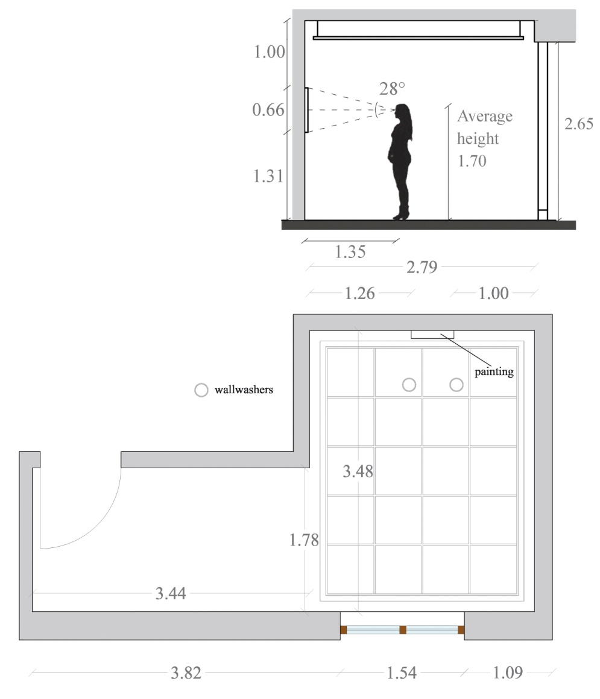
Figure 65a. Experimental setting.

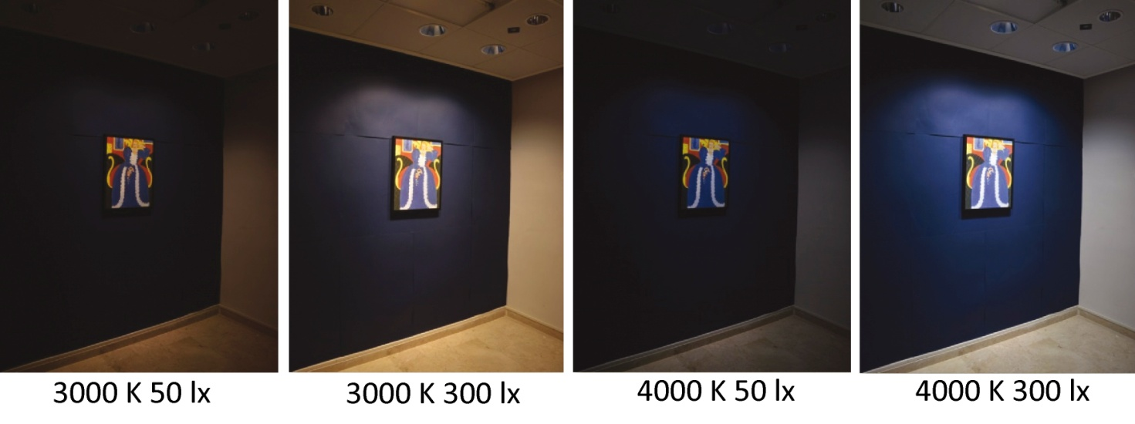
Figure 65b. Photos of the experimental setting.

The test consisted in a questionnaire on visual comfort, on the perception of the painting and of the setting. For each question the evaluation scale went from -3 (negative evaluation) to + 3 (positive evaluation), 0 represented a neutral answer. The questions' order was changed each time the subjects took the test; indeed each one of them repeated the test two times, during different days, for each light scene and background. To guarantee subjects' adaptation the questions were read by an external reader, moreover they ignored which light scene was switched on while they were performing the test.
When changing the light scene, subjects were left in the dark for 15 seconds and before starting to answer the questions a minute was left to allow their visual system's adaptation.
Before taking the test, subjects also filled the Self Assessment Manikin Test which allows to monitor mood (Figure 66).

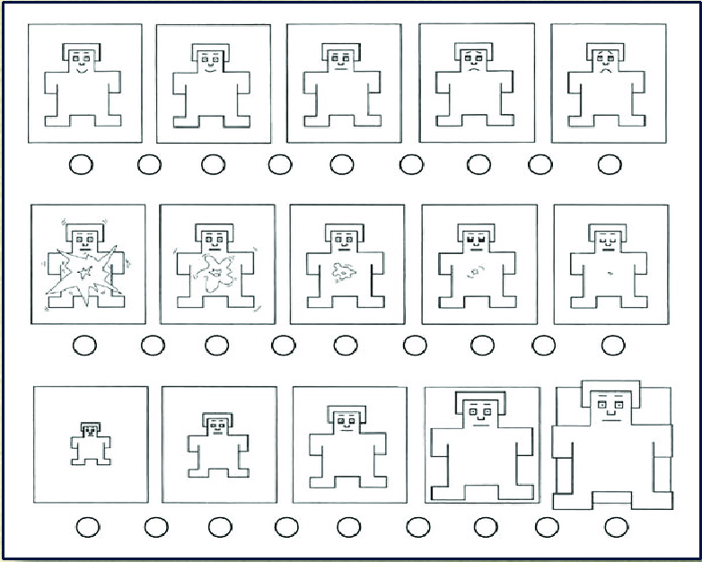
Figure 66. Self Assessment Manikin Test.

This test is based on the visualization of a series of figures which are used to measure three dimensions of emotions: the first series (top) allows to assess pleasure - displeasure, the second one (middle) the degree of arousal and the third one (bottom) is used to assess dominance - submissiveness.
The questionnaire included seven questions, the first two were about the colors of the painting and are reported in Figure 67a.

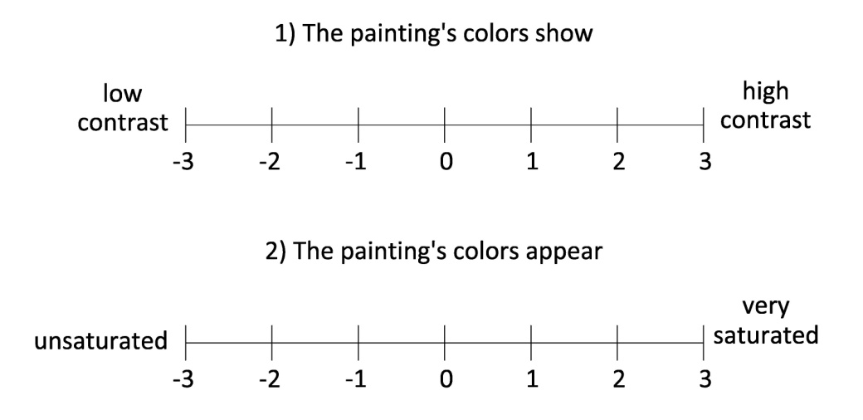
Figure 67a. Questions 1 and 2.

The following two questions were about the painting and are reported in Figure 67b.

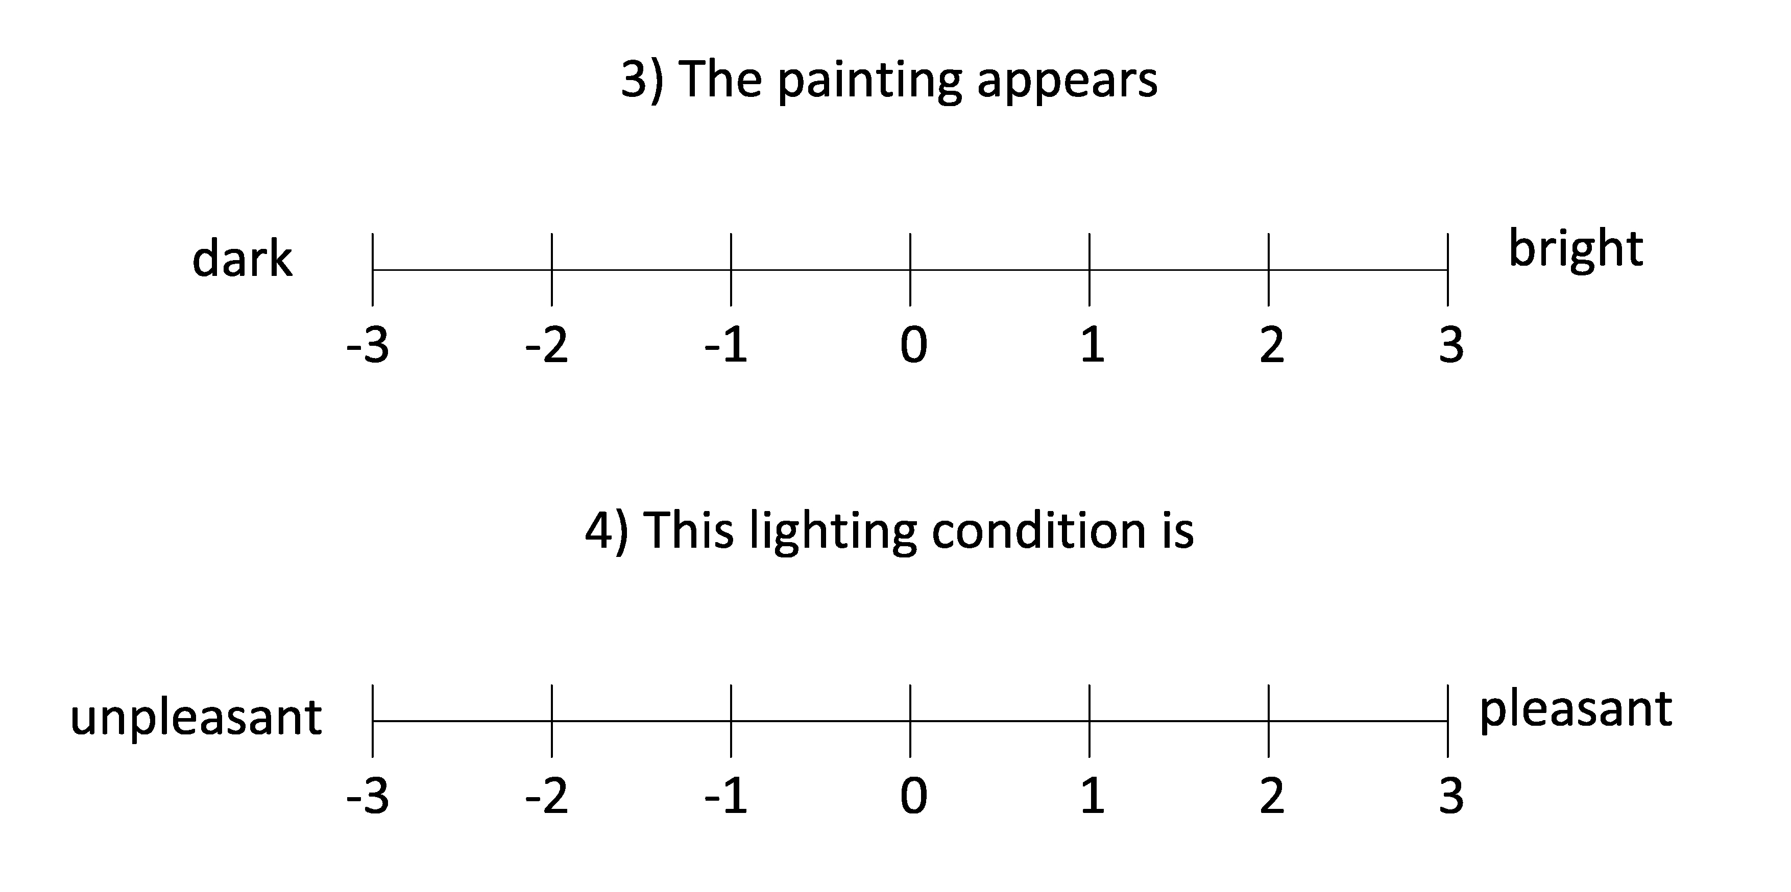
Figure 67b. Questions 3 and 4.

The last three questions were about the exhibition set-up and are illustrated in Figure 67c.

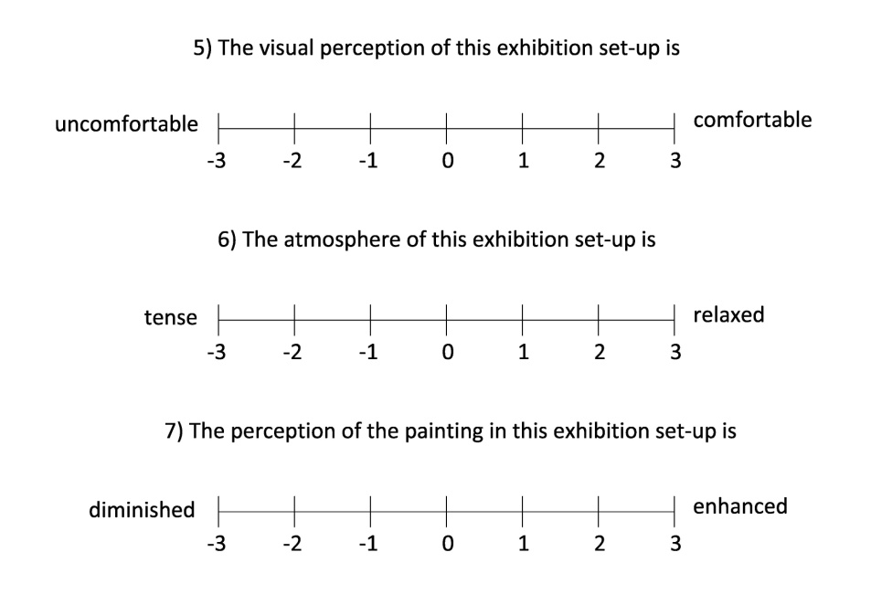
Figure 67c. Questions 5, 6 and 7.

The answers given by the subjects to each question were averaged and analyzed to investigate if the perception of a two-dimensional artwork is affected by the background's color, the light scene's CCT and by the illuminance level on the artwork's surface. Figure 68a reports the average values of the answers given by the subjects to questions 1 and 2 for each light scene and colored background.

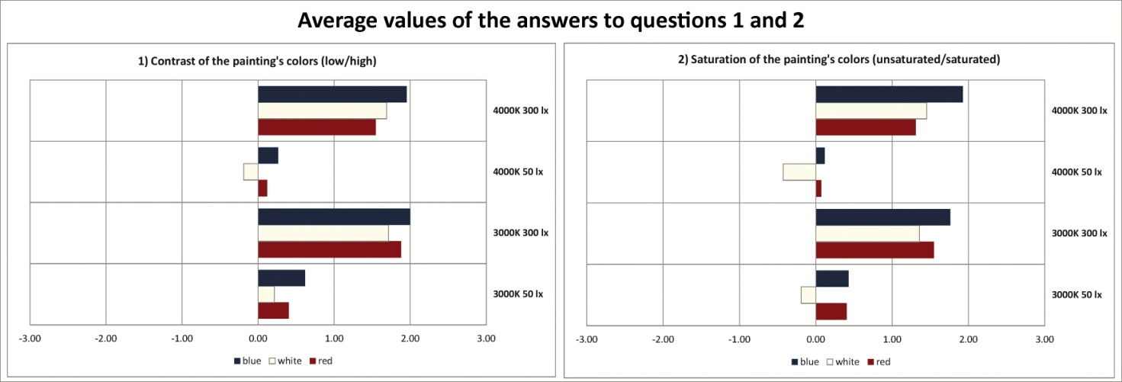
Figure 68a. Average values of the answers to questions 1 and 2.

The data reported in Figure 68a show that for question 1 the average values of the answers given by subjects are all positive except for the white background with the 4000 K - 50 lx light scene (- 0.19). The highest value was found for the blue background with the 3000 K - 300 lx light scene (2.00); generally higher average values correspond to higher illuminances on the painting's surface.
As regards question 2, it can be observed that also in this case the values are all positive except for the white background with both the 4000 K and 3000 K light scene with an illuminance value equal to 50 lx on the painting's surface (respectively - 0.19 and - 0.43).
The highest values were again found for the blue background with the 4000 K - 300 lx light scene, moreover also in this case increasing the illuminance level on the painting's surface leads to better evaluations by subjects. It is also interesting to highlight that, for all backgrounds, the lowest values were found with the 4000 K - 50 lx light scene.
Another interesting finding is that for both questions the white background is usually the one that received the lowest scores.
The average values of the answers to questions 3 and 4 are reported in Figure 68b.

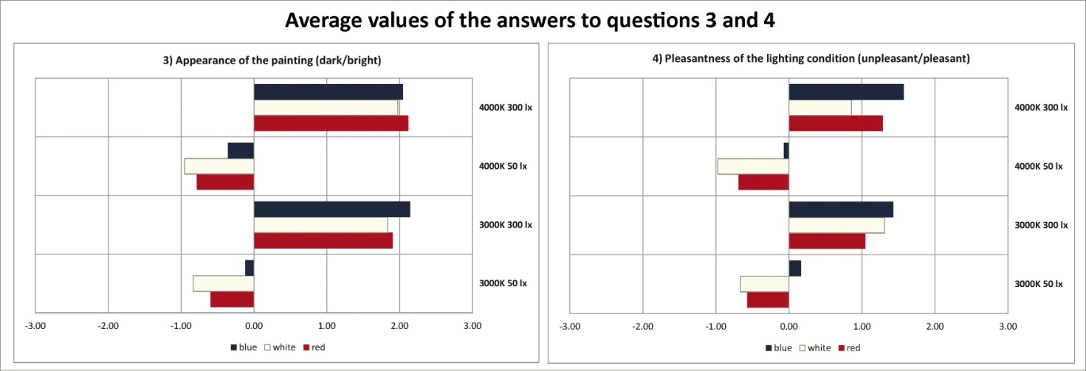
Figure 68b. Average values of the answers to questions 3 and 4.

The graphs reported in Figure 68b show an interesting result for question 3: it can be observed that with the 3000 K and 4000 K light scenes with an illuminance level on the painting equal to 50 lx the average values of the answers are negative for all backgrounds. The highest value was again found for the blue background with the 3000 K - 300 lx light scene (2.14), however with the 4000 K light scene with the same illuminance level the red background received a similar evaluation (2.12). Therefore, as it could be expected, the illuminance level is the most relevant parameter for the perception of the level of brightness/darkness.
Concerning question 4, it can be observed that also in this case with the 4000 K - 50 lx the average values of the answers related to each background are all negative and the same happens with the 3000 K - 50 lx light scene, with the only exception of the blue background. The highest value is again the one related to the blue background with the 4000 K - 300 lx light scene (1.57) but, with the 3000 K - 300 lx light scene, the same background received a similar evaluation (1.43).
In conclusion, for both questions, the white background is again the one that was poorly evaluated. Moreover, as it was already observed for questions 1 and 2, the illuminance value is a strongly influencing parameter since higher average values of the answers correspond to the light scenes with 300 lx on the painting's surface, regardless of the background's color and light scene's CCT.
Figure 68c reports the average values of the answers given by subjects to questions 5, 6 and 7.

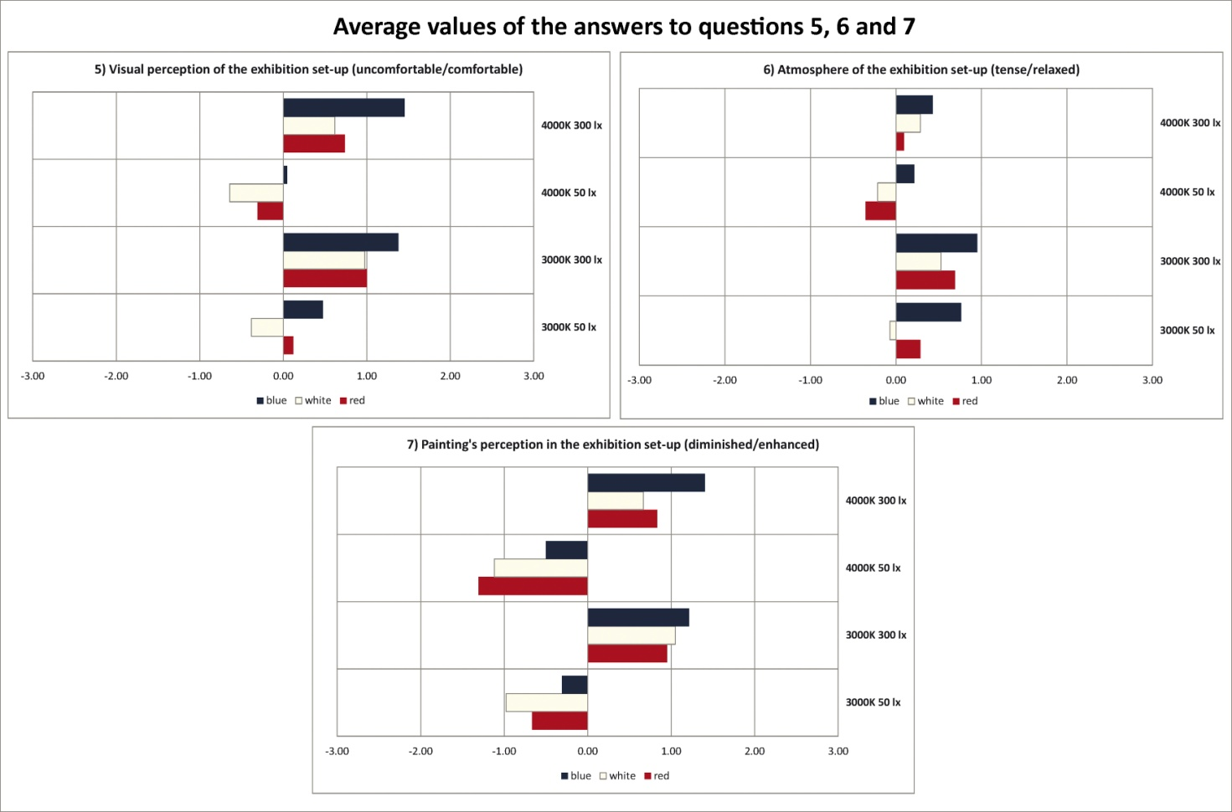
Figure 68c. Average values of the answers to questions 5, 6 and 7.

As regards the average values of the answers to question 5, it can be observed that with the 4000 K - 50 lx light scene the white and red backgrounds received a negative evaluation, the former was also poorly evaluated with the 3000 K light scene with the same illuminance level. The best evaluation was given to the blue cardboard with the 4000 K - 300 lx light scene (1.45) but the same background received a similar evaluation with the 3000 K - 300 lx light scene (1.38).
Looking at the graph related to question 6 the same conclusions made for the previous question for the 3000 K and 4000 K light scenes at 50 lx apply. The highest value was again found for the blue background with the 3000 K - 300 lx light scene (0.95) but the value related to the same background with the 3000 K - 50 lx is similar (0.76). Therefore, as regards the perception of the exhibition set-up's atmosphere, the illuminance level is a relevant parameter but the background's color is also significant.
It is also important to highlight that the range of variation of the answers given to question 6 is small compared to the other questions.
Concerning question 7, it can be noted that all backgrounds received a negative evaluation with both light scenes at 50 lx. Therefore, regardless of the background's color, the painting is perceived as diminished with that illuminance level. Moreover the blue background is again the one that was better evaluated, in more detail the average values of the answers given for it with the 4000 K and 3000 K light scenes at 300 lx are the highest and respectively equal to 1.40 and 1.21.
Table 25 reports the standard deviations for each background and light scene.

Standard deviations for each background and light scene
Background |  | Q1 | Q2 | Q3 | Q4 | Q5 | Q6 | Q7
Red | 3000 K -50 lx | 1.55 | 1.53 | 1.29 | 1.67 | 1.50 | 1.57 | 1.69
Red | 3000 K -300 lx | 0.99 | 1.09 | 1.23 | 1.43 | 1.41 | 1.52 | 1.41
Red | 4000 K -50 lx | 1.58 | 1.63 | 1.41 | 1.58 | 1.46 | 1.19 | 1.41
Red | 4000 K -300 lx | 1.09 | 1.20 | 0.92 | 1.37 | 1.43 | 1.36 | 1.64
White | 3000 K -50 lx | 1.42 | 1.73 | 1.40 | 1.75 | 1.62 | 1.49 | 1.57
White | 3000 K -300 lx | 1.07 | 1.19 | 1.12 | 1.39 | 1.14 | 1.29 | 1.31
White | 4000 K -50 lx | 1.45 | 1.64 | 1.43 | 1.46 | 1.51 | 1.42 | 1.58
White | 4000 K -300 lx | 0,92 | 1.31 | 1,22 | 1.59 | 1.45 | 1.35 | 1.63
Blue | 3000 K -50 lx | 1.38 | 1.53 | 1.37 | 1.58 | 1.49 | 1.36 | 1.51
Blue | 3000 K -300 lx | 1,08 | 1.01 | 0.78 | 1.43 | 1.34 | 1.45 | 1.14
Blue | 4000 K -50 lx | 1.62 | 1.53 | 1.62 | 1.66 | 1.65 | 1.46 | 1.78
Blue | 4000 K -300 lx | 0.96 | 1.02 | 1.01 | 1.27 | 1.31 | 1.40 | 1.43
Table 25. Standard deviations for each background and light scene.

In most cases standard deviations are high which means that there is high variability in the answers provided by subjects.
In conclusion the best set-up is the one that features the blue background with the 4000 K light scene at 300 lx.
Figure 69 summarizes the results obtained from the test by showing which parameters (illuminance level, background's color and light scene's CCT) influence the aspects of the painting's perception that were analyzed in the test (contrast, saturation, brightness, pleasantness, comfort, atmosphere and enhancement). The thickness of the lines that link the parameters to the aspects of the painting's perception indicates the strength of the relationship, i.e. a thicker lines mean a stronger relationship.

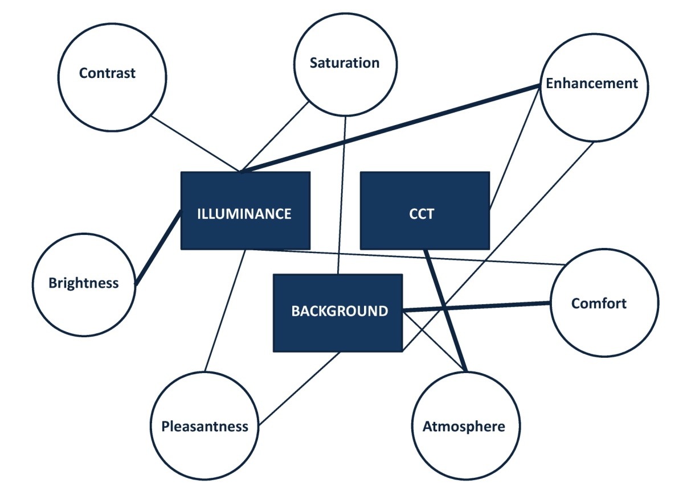
Figure 69. Parameters affecting the painting's perception.

It can be observed that there is a strong link between illuminance and enhancement, indeed the painting is perceived as more enhanced when increasing the illuminance level. The illuminance level has also a strong influence on brightness which is not surprising, moreover this parameter affects contrast, pleasantness, saturation and comfort.
As regards the background, it has a strong relationship with comfort's perception and it is also related to pleasantness, atmosphere and enhancement.
CCT is the least influencing parameter since it only has a strong relationship with atmosphere and it is also slightly related to enhancement.

3.3. Discussion
The data reported in this chapter illustrated that even a "neutral" environment modifies the spectral characteristics of the light reaching users' eyes in indoor environments. However such differences do not determine significant changes in terms of circadian impact and the same conclusions apply even in presence of colored walls in the environment.
The studies reported in this chapter also highlighted that what determines a significant change in the calculated values of CS is the light source's SPD and the eye level illuminance value. Moreover it was also observed that increasing the eye level illuminance above 600 lx determines a really small increase in CS values but it certainly determines a significant growth of energy consumptions.
Therefore, as it was illustrated in Figure 49, to reach a given value of CS it is better to change the light source's SPD rather than increasing eye level illuminances above 600 lx.
The application of the CIECAM02 model to the colored cardboards allowed to point out that, although the optical characteristics of an environment's surfaces do not significantly affect the circadian impact of a light source, there are significant changes in some color attributes of the colored cardboards when changing the light scene. Therefore the combination of a given wall color with a specific SPD may be perceived as unpleasant by users, thus determining an uncomfortable environment.
Given its relevance, this topic was further investigated by performing two studies. The test carried out in the first one allowed to collect the hue and chroma values assigned by subjects to LEGO® cubes lit by different light scenes. The comparison of such values with those calculated with the CIECAM02 model highlighted that there is a good correlation between the hue perceived by users and the one calculated with the CIECAM02 model. The correlation is instead not so good between the two sets of chroma values but it tends to get better when increasing the light scene's SPD.
Therefore this probably means that the shifts in hue values that resulted from the application of the CIECAM02 model in the experiment with the colored cardboards on the front wall in the test room will be probably also perceived by users, thus affecting the environment's perception.
The results of the second study were also interesting, indeed it was found that parameters such as illuminance level, CCT of the light scene and background's color influence the perception of a painting. The relationships between these parameters and the different aspects of a painting's perception were illustrated in detail in Figure 69.
In conclusion, the optical characteristics of an environment's surfaces do not seem to have a great impact on the evaluation of circadian impact but they affect the perception of an environment. Therefore the choice of the colors of an environment's surfaces is not merely esthetical but it has to be carefully made according to the light source's SPD in order to create a pleasant and comfortable environment.

4. Energy saving - Prediction of daylight availability
Allowing an adequate entrance of daylight in indoor environments is important not only to reduce the operating hours of electric lighting systems, determining consequent energy savings, but as it was stated in the introduction it is also important to improve users' wellbeing and health by helping the circadian system's entrainment.
Therefore the evaluation of daylight availability during the design phase is really important for both energy saving and users' health purposes. Designers generally use computer simulations to predict the amount of daylight that enters in a given environment.
The data reported in chapter 2 illustrated that, for both the University classroom and the offices, in many cases average eye level spectral irradiances' trends match D series standard illuminants' ones. If this finding will be confirmed by future researches, daylight simulations will be even more important in the lighting design practice because they could be used to calculate eye level illuminances corresponding to a given design option and then D series illuminants can be scaled to match such value and used as input in a circadian phototransduction model.
However, as it was already stated in the introduction, there are still problems related to the performance of dynamic daylight simulations. These problems are essentially related to the availability of different weather data files and software to perform such simulations and there are few studies that investigated the impact of using different weather files and software on daylight simulations' results [72,73,74].
Therefore this topic was also analyzed during the PhD by performing three studies. In the first one (subparagraph 4.3.1) the impact of using four weather data files (IWEC, Meteonorm, TRY and Satel-Light) on daylight simulations' results carried out for a North-oriented office located in five European locations (Copenhagen, London, Nancy, Milan and Rome) was analyzed.
The second one (subparagraph 4.3.2) was developed basing on the finding of the first study, this time the results of daylight simulations performed for the same office located in two European locations (Copenhagen and Rome), exposed according to the four main orientations (North, East, West and South) and using three different weather data files (IWEC, Meteonorm and Satel-Light) were analyzed.
The last study (paragraph 4.4) compared the results of dynamic daylight simulations carried out for the same office located in four European cities (Copenhagen, Nancy, Milan and Rome) and exposed toward North, East, West and South, using Daysim and 3ds Max Design®.
Table 26 reports climatic data related to the cities for which the abovementioned studies were performed.

Climatic data related to each city used in the research project
Climatic data | Copenhagen | London | Milan | Nancy | Rome
Coordinates | 55°41'00''N 12°35'00''E | 51°30'26''N 0°07'39''E | 45°27'51''N 9°11'25''E | 48°41'00''N  6°12'00''E | 41°53'35''N 12°28'58''E
Climatic zone according to Koppen climate classification | Warm summer continental or hemiboreal climate (Dfb) | Maritime temperate climate or oceanic climate (Cfb) | Humid subtropical climate (Cfa) | Maritime temperate climate or oceanic climate (Cfb) | Dry-summer subtropical - mediterranean climate (Csa)
Elevation above the sea [m] | 46.5 | 24.0 | 304.8 | 212.0 | 20.0
Average high temperature during summer [°C] | 20.0 | 22.6 | 27.6 | 23.3 | 30.4
Average high temperature during winter [°C] | 2.5 | 8.3 | 6.1 | 4.7 | 13.3
Average low temperature during summer [°C] | 12.3 | 13.1 | 16.3 | 12.0 | 16.2
Average low temperature during winter [°C] | -1.6 | 2.4 | -0,9 | -1.7 | 2.6
Yearly precipitation [mm] | 613.0 | 601.7 | 943.2 | 775.1 | 798.5
Yearly average rainy days  (≥ 1mm) | 113.0 | 109.6 | 85.5 | 124.3 | 77.7
Yearly mean sunshine hours | 1539.0 | 1632.6 | 1915.1 | 1664.9 | 2472.8
Table 26. Climatic data related to each city used in the research project.

The sources of the data reported in Table 26 are the following:
- Danmarks Meteorologiske Institut for Copenhagen [75];
- Met Office for London [76];
- Servizio Meteorologico Aeronautica Militare for Milan and Rome [77];
- Meteo France for Nancy [78].
The following paragraph will explain in detail what are weather data files and how they are developed and it will also include a focus on daylight simulations' software.

4.2. Focus on weather data files and software
Weather data files are used to characterize the climate of a given location. There are several types of weather data files available, for example there are the International Weather for Energy Calculation (IWEC), the Meteonorm, the Test Reference Year (TRY), the Typical Meteorological Year (TMY) and the Design Reference Year (DRY) weather data. Usually they all contain 8760 hourly data, the difference between them lies in the statistical method used to derive such data from historical sets of annual measurements, at least 20 years, and in the data included.
Each weather data file is built using a different method to select the data, for example the American TRY is developed by excluding the data related to years with extremely high or low temperatures, such process is repeated until only one year remains [72]. Frequently weather data files are developed to be used in energy simulations and therefore the parameters used to select/exclude data from historical sets are usually temperature and global irradiance.
Therefore it is easy to understand that they may not be very representative of the characteristics of a given location in terms of light. There was an attempt to develop a weather data file for lighting simulations during the 80's, when the Commission Internationale de l'Eclairage (CIE) started the International Daylight Measurement Programme (IDMP) [79] to set up a program of daylight measurement stations around the world. Unfortunately the project was not completed and at the present date there is no weather data file specifically developed for daylight simulations and the standard weather data files are used to perform them.
In the studies that will be illustrated in this chapter IWEC, Meteonorm, TRY and Satel-Light weather data were used and it is important to highlight the difference between Satel-Light data and those included in the weather data files. Satel-Light data are referred to a real year, i.e. they are data measured during a specific year whereas weather data files represent typical years, since their data are derived from at least 20 years of annual weather measurements and therefore they do not correspond to the data detected during a given year. It was decided to include Satel-Light data in the studies to investigate the correspondence between the data included in a typical year and those related to a real one.
In more detail, IWEC weather files are available for 227 locations around the world and they were developed by the American Society for Heating, Refrigerating and Air-conditioning Engineers (ASHRAE) [80]. They can be downloaded free of charge from the U.S. Department of Energy, Energy Efficiency & Renewable Energy (DOE) website [81]. The data included in this type of weather file are: dry bulb temperature, irradiance, wind speed, illuminance, relative humidity and sky cover.
IWEC weather files are built selecting the most representative months from an historical sets of weather data collected between 1982 and 1999 using a statistical method, then these months are combined to develop a yearlong weather file. Irradiance data are not measured but they are calculated basing on earth-sun geometry and other weather elements such as cloud amount; this method determines uncertainties in the values of global horizontal irradiance which, for the locations used in the studies illustrated in this chapter, are comprised between 35% and 50% [81].
The development of European Test Reference Years (TRY) was funded by the Commission of the European Communities and guided by the Solar R&D Programme. These files are available for 29 locations in Europe and are provided by different meteorological authorities. The data included in TRY files are: wind speed, dry bulb temperature, relative humidity, global and diffuse horizontal irradiance, sunshine duration and direct normal irradiance. The statistic method used to build the European TRY is called "Belgian", in this method two variables are selected (for example horizontal global irradiance and dry bulb temperature) and, for each one of them and for each month of the years included in the historical set, the values of the mean, of the variance and of the serial correlation derived from the daily values are calculated. These variables are then analyzed and using a statistical process only the month that results as the most representative of the observation period is selected [82].
Concerning global irradiance values, generally they are measured ones except for Dublin and Italian meteorological stations for which global irradiances are derived from daily global radiation [83]. The standard deviations between the daily sums of global irradiance included in the TRY files and those related to a period 15 years long range between 114 and 606 [82].
As regards Meteonorm weather data, they can be bought on the company website [84] and are developed using data provided by 8325 meteorological stations located around the world. The data included in this type of weather file are: humidity, global irradiance, precipitation, ambient air temperature, wind speed, wind direction, days with precipitation, sunshine duration. Temperature, humidity, wind speed and precipitation data are derived from two periods of measurements 1961-1990 and 2000-2009 whereas irradiance data from the periods 1981-1990 and 1991-2010. To build the file, hourly values of the abovementioned parameters are derived from the historical sets using a stochastic model.
In more detail, as regards global irradiance, at first daily mean values are obtained from monthly mean ones using a stochastic process, then daily mean hourly data are derived from daily mean ones using a calculation method that determines an average daily profile and then simulates the hourly variations [85].
The uncertainties related to global irradiance data included in Meteonorm file are comprised between 2% and 10% [86].
Concerning Satel-Light data, it has already been said that a Satel-Light file is not a typical year but a real one. The European Union funded the development of this database from 1996 to 1998 with the aim of creating a European solar radiation database, accessible through a website, that included data measured by Meteosat satellites every 30 minutes.
At the present date it is possible to download the half hourly values of global, diffuse and direct horizontal irradiance; cloud index; global, diffuse and direct horizontal illuminances for a given location and related to a year comprised between 1996 and 2000. These data are provided as a text file and therefore, to use them in simulation software it is necessary to convert them into another format. Moreover since weather data files usually contain hourly data, the ones related to the half-hour were neglected and only the hourly data were included in the Satel-Light file used to carry out simulations. In the Satel-Light database global irradiance is calculated from the earth albedo which is derived from the pixel values of Meteosat satellites, then all the other parameters are derived from global irradiance. This method determines mean bias deviations (MBD) comprised between -1% and 3% and root mean square deviations (RMSD) between 30% and 40% in the values of global horizontal irradiance.
At the present date the Satel-Light database only includes years between 1996 and 2000, therefore it is not possible to develop a typical year from this set of data. To select one of the years available in the database to be used in the research project, global horizontal irradiances referred to each year for each city were compared to analyze if there are significant differences between the years included in the Satel-Light database (Figure 70).

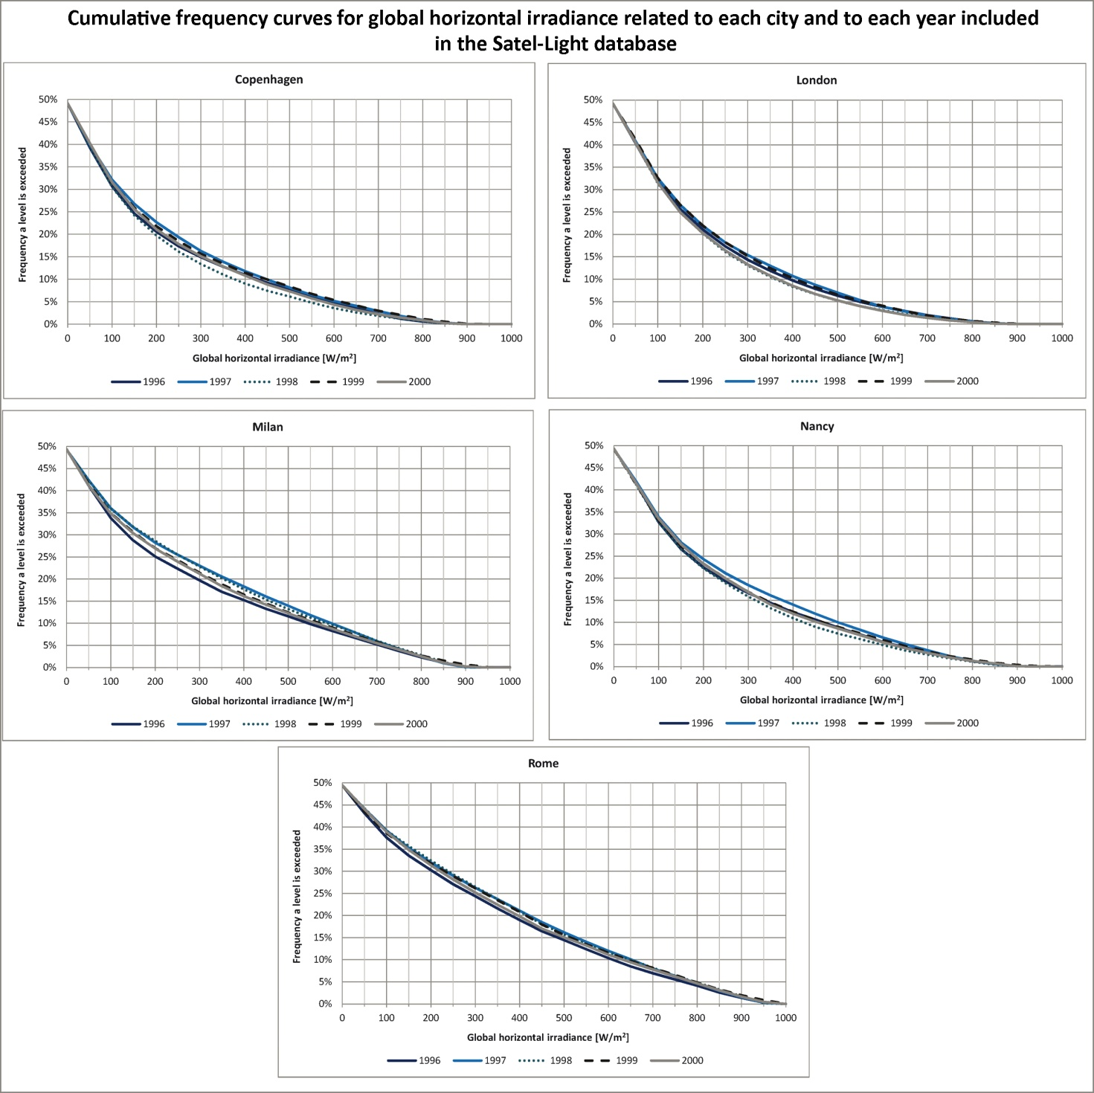
Figure 70. Cumulative frequency curves for global horizontal irradiance referred to each city and each year included in the Satel-Light database.

It can be observed that differences are almost undetectable, in more detail they are comprised between 0% and 3% for Copenhagen and Nancy, between 0% and 2% for London and Rome and between 0% and 4% for Milan. Therefore the research project was carried out using the year 1998 for each city since it is not a leap year.
Figures 71a,b,c show, for each city, the cumulative frequency curves related to global horizontal, direct normal and diffuse horizontal irradiances related to the different weather data files. This comparison was carried out in order to highlight the possible differences/similarities in the data contained in the different weather data files, which can help in performing a deeper analysis of the results obtained from the simulations.

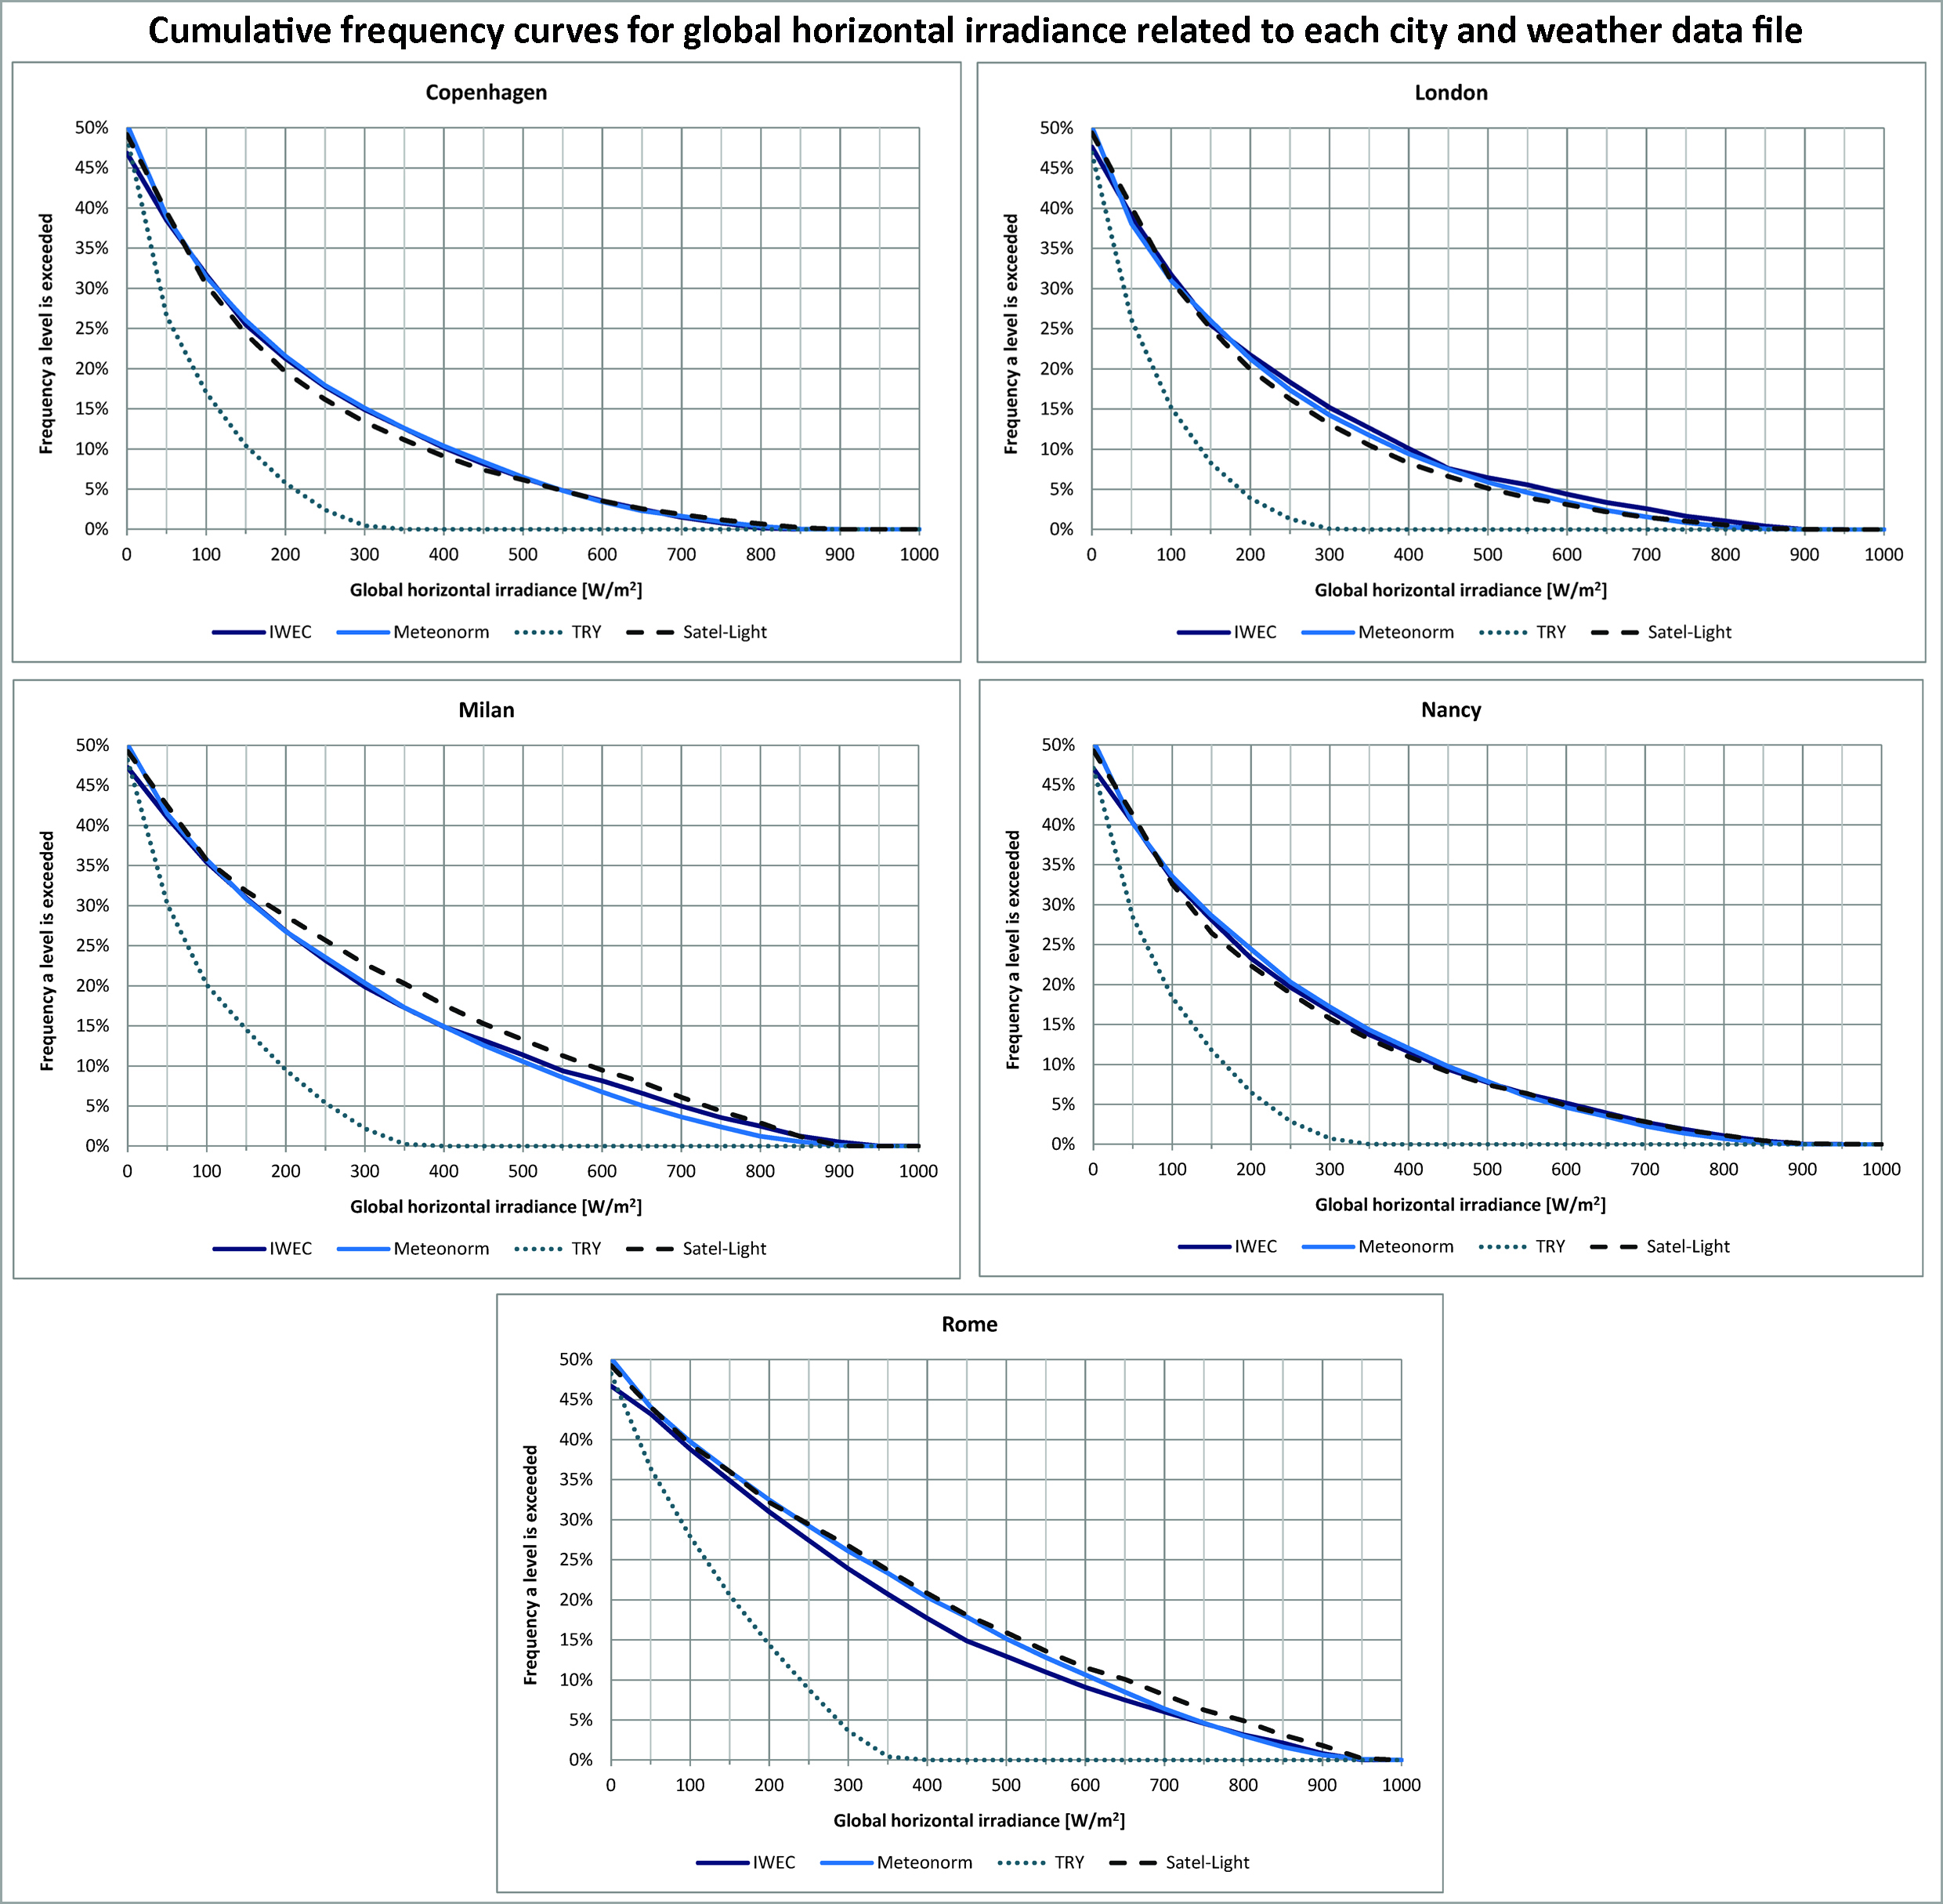
Figure 71a. Cumulative frequency curves for global horizontal irradiance referred to each city and each weather data file.

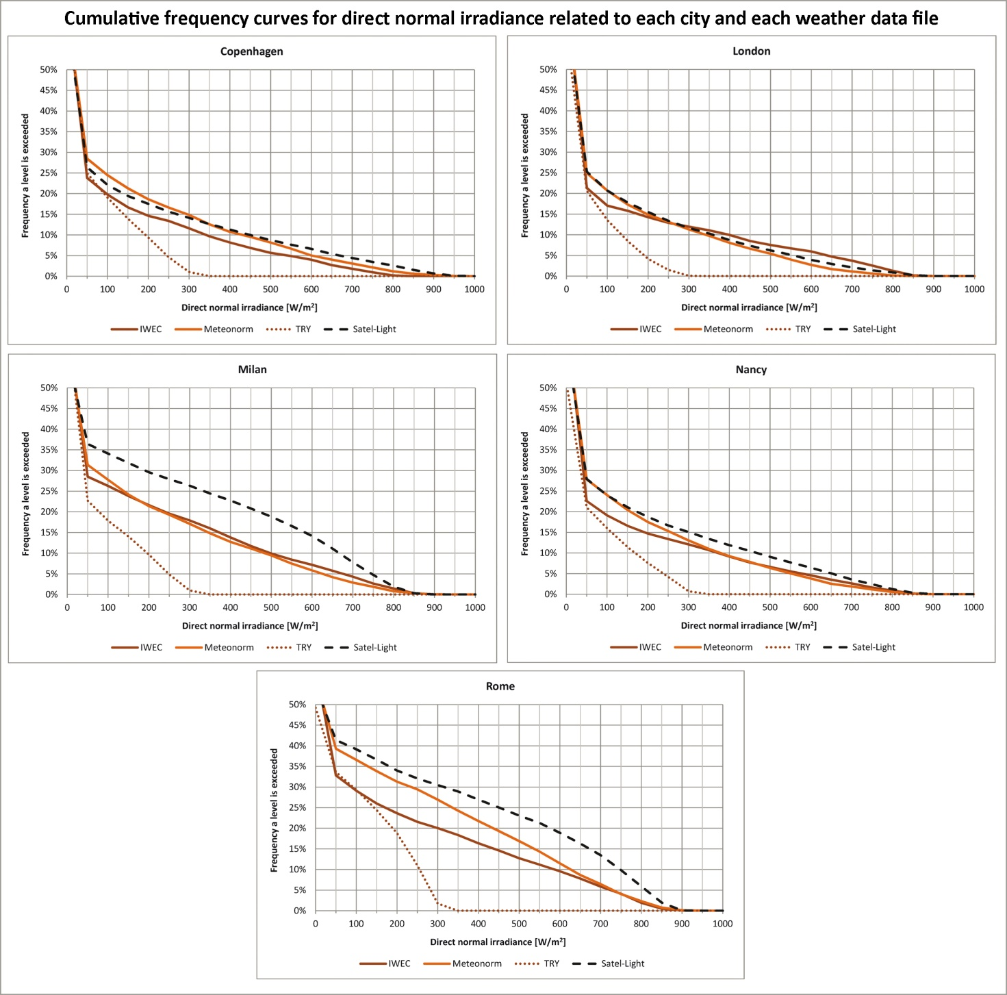
Figure 71b. Cumulative frequency curves for direct normal irradiance referred to each city and each weather data file.

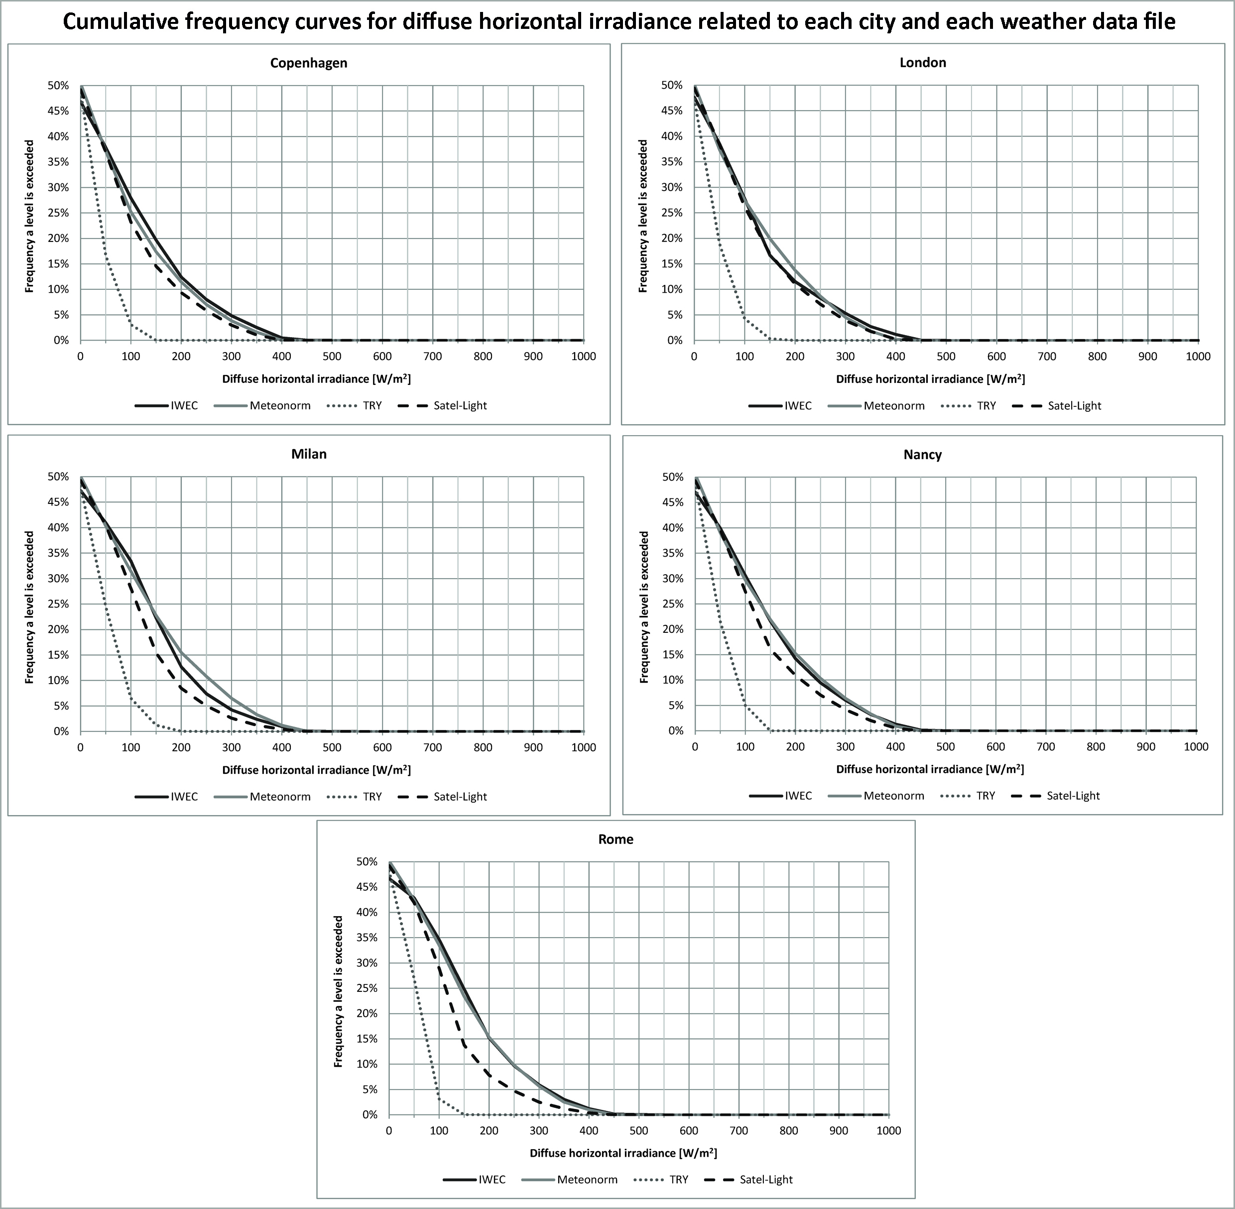
Figure 71c. Cumulative frequency curves for diffuse horizontal irradiance referred to each city and each weather data file.

The graphs reported in Figure 71a,b,c highlighted that in all cases irradiances values related to the TRY weather file are considerably lower than those contained in the other files. IWEC's and Meteonorm's trends for global horizontal and diffuse horizontal irradiances are almost coincident for all cities except Rome for the former; Satel-Light's trends are also close to IWEC's and Meteonorm's ones.
As regards direct normal irradiance, the trends related to the different weather data files show more differences. In more detail, Meteonorm's and IWEC's trends are still similar and the greatest differences can be observed for Milan and Rome.
Table 27 reports the minimum and maximum differences for global horizontal, direct normal and diffuse horizontal irradiances related to each weather data file and each city.

Minimum and maximum differences for global horizontal, direct normal and diffuse horizontal irradiances related to each weather data file and each city [%]
City | Global horizontal irradiance | Direct normal irradiance | Diffuse horizontal irradiance
Copenhagen | 0 - 16 | 0 - 14 | 0 - 25
London | 0 - 18 | 0 - 12 | 0 - 24
Milan | 0 - 21 | 0 - 25 | 0 - 27
Nancy | 0 - 18 | 0 - 14 | 0 - 26
Rome | 0 - 23 | 0 - 29 | 0 - 31
Table 27. Minimum and maximum differences for global horizontal, direct normal and diffuse horizontal irradiances related to each weather data file and each city.

It can be observed that the greatest differences were always found for Milan and Rome, whereas Copenhagen and London show the lowest differences.
As regards the software used to perform dynamic daylight simulations, many of them use Radiance [87] as simulation engine and Daysim is one of them and it is also the most widespread and studied one [55,88,89,90,91]. Daysim uses Radiance algorithms to calculate indoor illuminance/luminance profiles in an environment, the inputs are a weather data file of the location and a 3d model of the simulated environment. It also includes a stochastic user behavior model that is used to calculate the values of daylight performance indicators as DA, annual light exposure and UDI. Such user behavior model is also applied to calculate the lighting energy use related to different lighting and shading control options [92].
The data related to direct and diffuse irradiances included in the weather file, are converted by Daysim into direct and diffuse illuminances using the Perez luminous efficacy model [93]. Then, basing on the calculated direct and diffuse illuminances, the software calculates the sky luminous distribution using the Perez all weather sky model [94].
3ds Max Design® also allows to perform both static and dynamic daylight simulations, but it is not based on Radiance and it includes a lighting simulation module that uses a technology called Exposure®. This technology also features the Perez sky model and uses the mental ray® raytracer to calculate global illumination. It is important to highlight that the output of simulations performed with 3ds Max Design® are hourly illuminances, therefore this software does not provide the values of dynamic daylight performance metrics (DA, DAcon, UDI, etc.) as an output as it happens with Daysim. The values of such indicators need to be calculated later using a post-processing tool. The Exposure® technology was validated by the National Research Council (NRC) of Canada by performing a study that compared the results obtained from daylight measurements carried out in a test room located in Canada with those obtained from simulations carried out with Daysim and 3ds Max Design® [74]. So far this is the only study that compared the two software and it showed that the results obtained from Daysim and 3ds Max Design® for sensors placed on the ceiling differ more than those obtained for work plane sensors. Moreover, during sunny days, 3ds Max Design® calculates higher illuminances compared to Daysim. Therefore the two software probably model indoor daylight spatial distribution in a different way and this difference is also influenced by external conditions.

4.3. Impact of using different weather data files on daylight simulations' results
This paragraph will show the results obtained from the two studies that were carried out on the impact of using different weather data files on dynamic daylight simulations' results. In more detail, subparagraph 4.3.1 will report the results obtained from simulations carried out for a North oriented office located in five European cities (Copenhagen, London, Milan, Nancy and Rome) using four weather data files (IWEC, Meteonorm, TRY and Satel-Light) for each location.
Subparagraph 4.3.2 will show the results obtained from simulations carried out for an office located in two European locations (Copenhagen and Rome) using three weather data files (IWEC, Meteonorm and Satel-Light) for each location and varying the office's exposure (North, East, West and South).

4.3.1. Results of dynamic daylight simulations carried out for a North oriented office located in five different European locations using four weather data files
Simulations were performed with Daysim (version 3.1e) for a simple office with a single North oriented window, in this first study it was decided to use only this orientation to exclude the contribution of direct sunlight in order to simplify the analysis. Indeed since simulations were performed for five cities and four weather data files for each one of them the amount of data generated is great and therefore it was decided to deal with the contribution of direct sunlight in the second study.
The office's measured plan and section along with the analysis grid (3 x 3 m, placed at an height of 0.75 m from the floor) are reported in Figure 72. The software calculates illuminances and the values of dynamic performance metrics for the sensors that correspond to the grid's nodes, such nodes were named S1, S2,..., S9 as it can be observed from Figure 72 and for readability reasons the results obtained from the simulations will be reported only for sensors S1, S4, S5, S8 and S9 since the other sensors showed similar results. The distance between each grid's sensor is equal to 1.5 m.
Table 28 reports the reflectances of the office's surfaces and also the parameters assigned in Daysim to represent the optical characteristics of their materials.

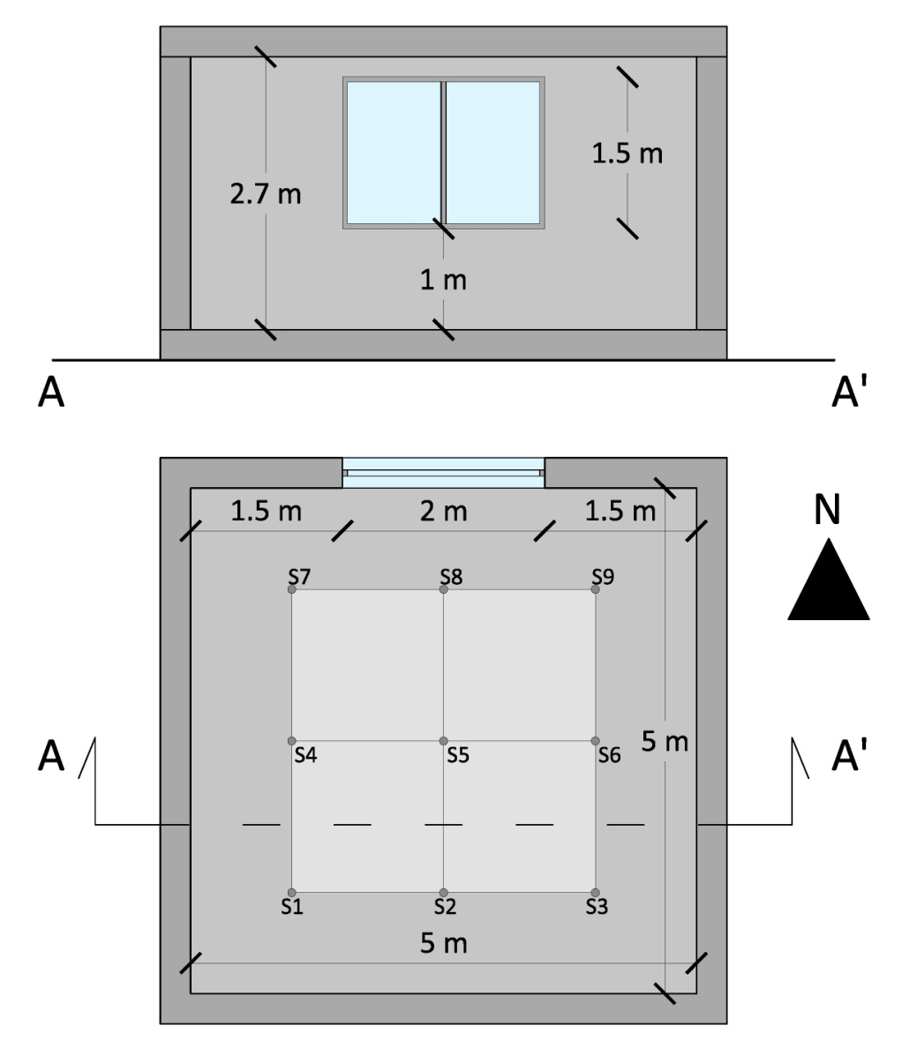
Figure 72. Measured plan and section of the simulated environment and analysis grid.

Materials' reflectances and parameters assigned in Daysim
Description | Reflectances [%] | Material's parameter assigned in Daysim
Walls | 65 | void plastic GenericWall50  0  0  5 0.65 0.65 0.65 0 0
Ceiling | 80 | void plastic GenericCeiling80  0  0  5 0.8 0.8 0.8 0 0
Floor | 30 | void plastic GenericFloor_30  0  0  5 0.3 0.3 0.3 0 0
Clear double glazing | 82 (visual transmission) | void glass GenericDoubleGlazing72  0  0  3 0.89 0.89 0.89 0 0
Ground plane | 20 | 20
Table 28. Surfaces' reflectances and parameters of their materials assigned in Daysim.

Simulations were performed considering a target illuminance equal to 300 lx on the workplane (analysis grid) according to the EN 12464-1's requirements for activities such as filing, copying, etc. [2]. Moreover the office was considered occupied from Monday to Friday between 8:00 and 16:00 without breaks and the daylight saving time starts on 1st April and ends on 31st October.
The computer used to perform the simulations had an Intel Core i7 processor (2.70 GHz), 8 GB RAM, an NVIDIA GeForce 610M (1GB) graphic card, Windows 7 64 bit as Operating System and the simulation time was about 53 minutes for each simulation.
Table 29 shows the parameters set in Daysim to perform the simulations [92].

Parameters used to perform the simulations with Daysim
Description | Assigned values
Ambient bounces | 7
Ambient divisions | 1500
Ambient super samples | 100
Ambient resolution | 300
Ambient accuracy | 0.05
Limit reflection | 6
Specular threshold | 0.1500
Specular jitter | 1.0000
Limit weight | 0.004000
Direct jitter | 0.0000
Direct sampling | 0.200
Direct relays | 2
Direct pretest density | 512
Table 29. Parameters used to perform the simulations with Daysim.

The results obtained from the simulations will be analyzed in terms of Annual Light Exposure, Monthly Light Exposure, UDI, DA and DAcon (for their definitions see Table 1 page 7).
Figure 73 reports the values of Annual Light Exposure for each city and weather data file.

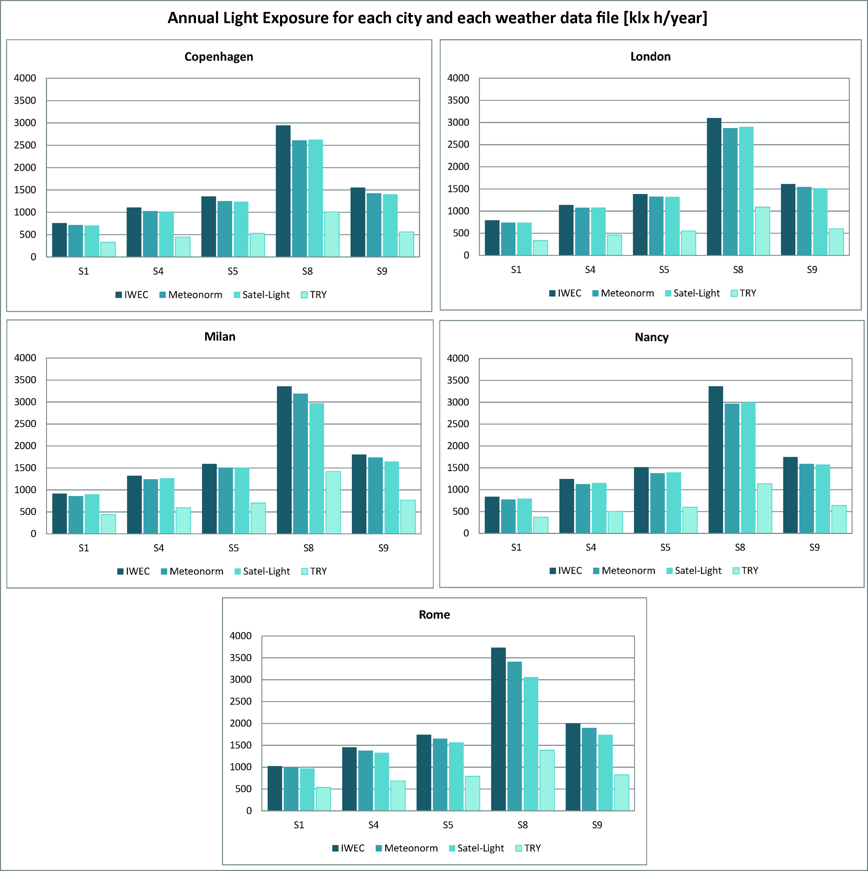
Figure 73. Annual Light Exposure for each city and weather data file.

It is interesting to observe that Annual Light Exposure values calculated for the TRY weather file are considerably lower than those related to the other weather data files for all cities. The values related to the IWEC weather data file tend to be slightly higher than those related to Meteonorm and Satel-Light. Moreover, for all cities, S8 is the sensor for which the highest values were calculated and this is not surprising since it is the sensor closest to the window.
Differences between the values of Annual Light Exposure were further analyzed: Figure 74 reports Annual Light Exposure's percentage differences between Satel-Light and the other weather data files.

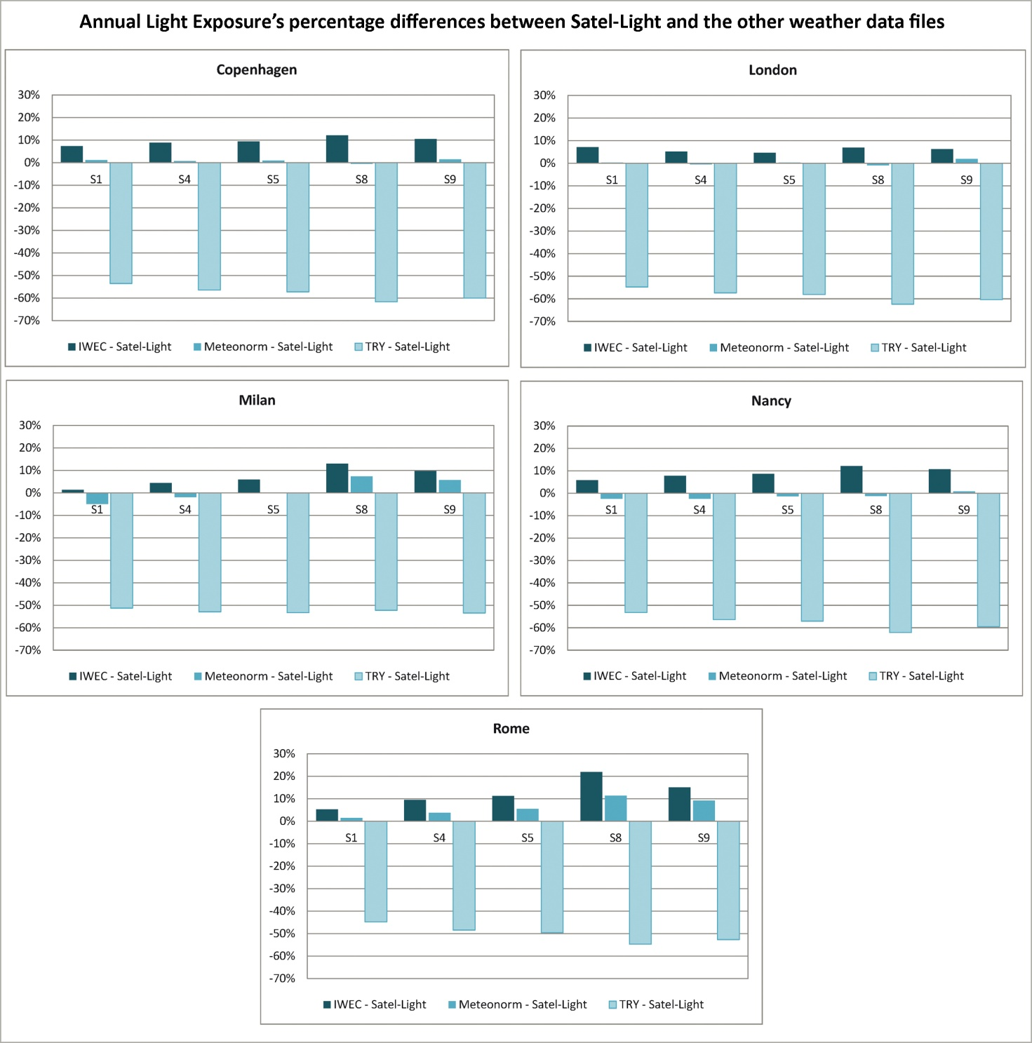
Figure 74. Annual Light Exposure percentage differences between Satel-Light and the other weather data file.

It is interesting to highlight that for Copenhagen, London and Nancy differences between Meteonorm and Satel-Light are negligible, whereas for Milan and Rome they are more relevant but still quite small.
The greatest differences, as it was previously reported, are those calculated between TRY and Satel-Light; indeed they are greater than -40% in all cases and also always negative, which means that the values calculated with the TRY weather file are lower than Satel-Light ones.
As regards percentage differences between IWEC and Satel-Light they are always positive, meaning that IWEC values are always greater than Satel-Light ones as it was previously highlighted. Moreover for all cities differences are below 10% except for the S8 sensor for which they are slightly higher, it is also important to observe that differences calculated for Rome are higher than those related to the other cities.
Monthly Light Exposure values related to each city and weather data file will be reported in Figures 75a,b,c,d,e. It is important to highlight that the graphs related to the S8 sensor will have a different order of magnitude of the y axis because Monthly Light Exposure calculated for it are considerably higher than those related to the other sensors given its proximity to the window.

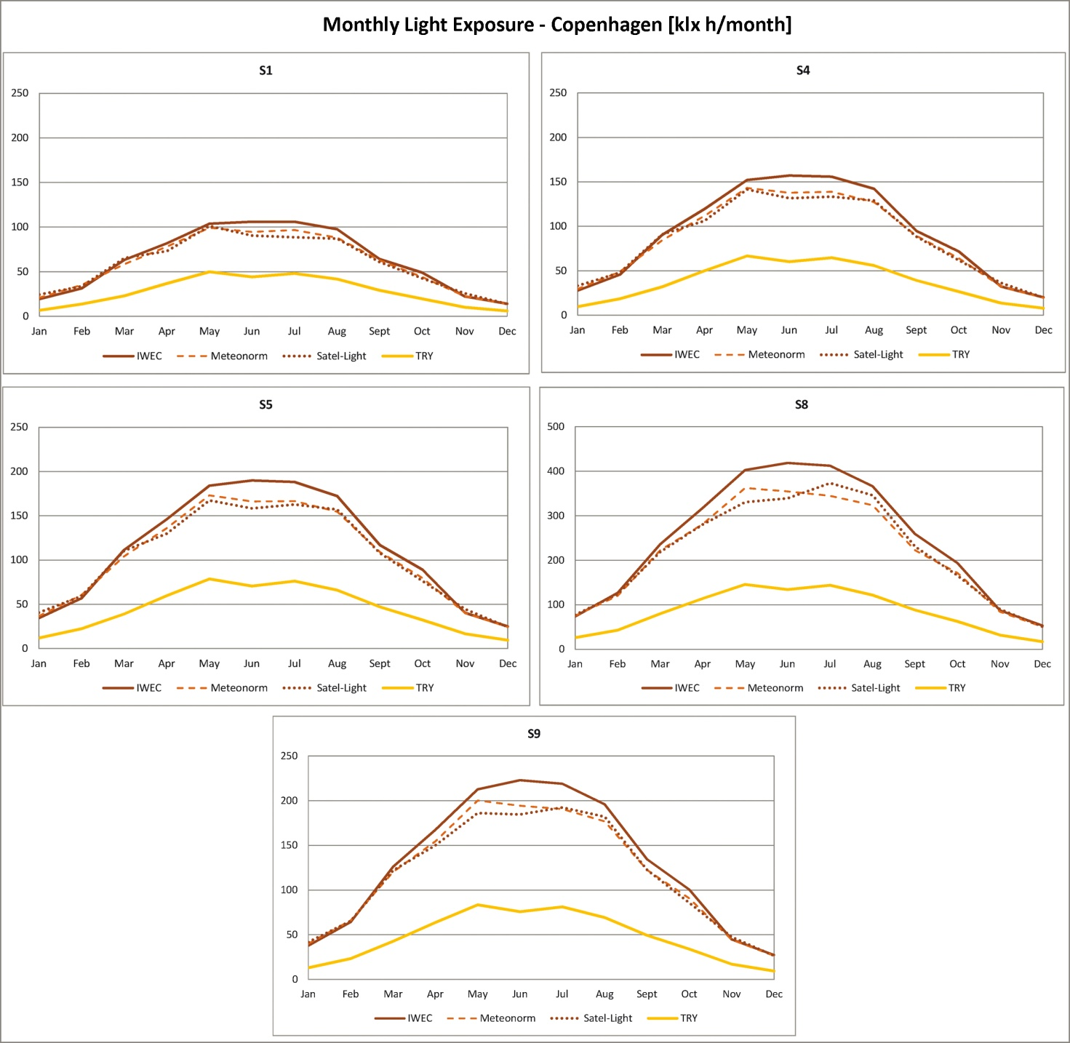
Figure 75a. Monthly Light Exposure for Copenhagen.

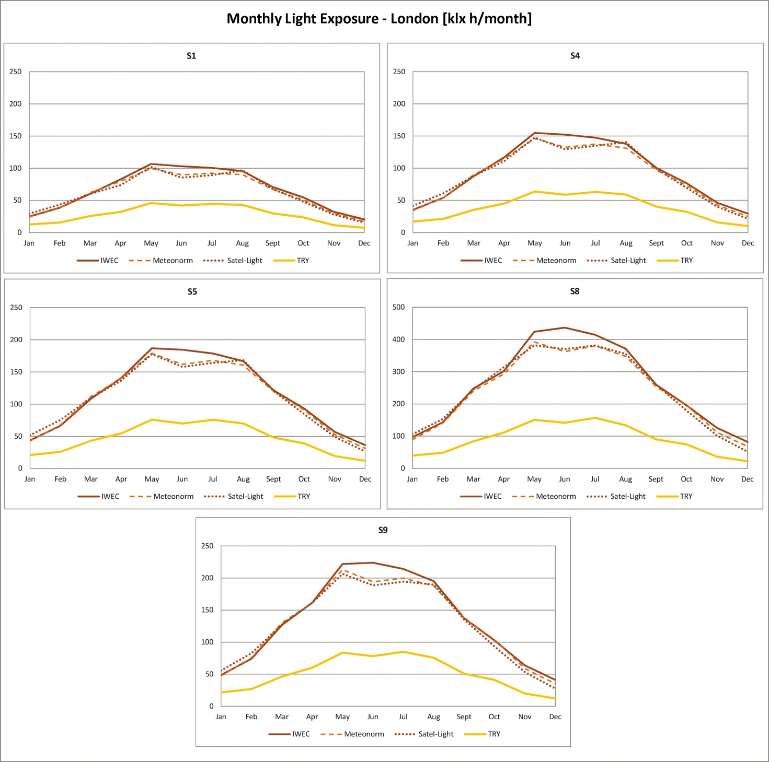
Figure 75b. Monthly Light Exposure for London.

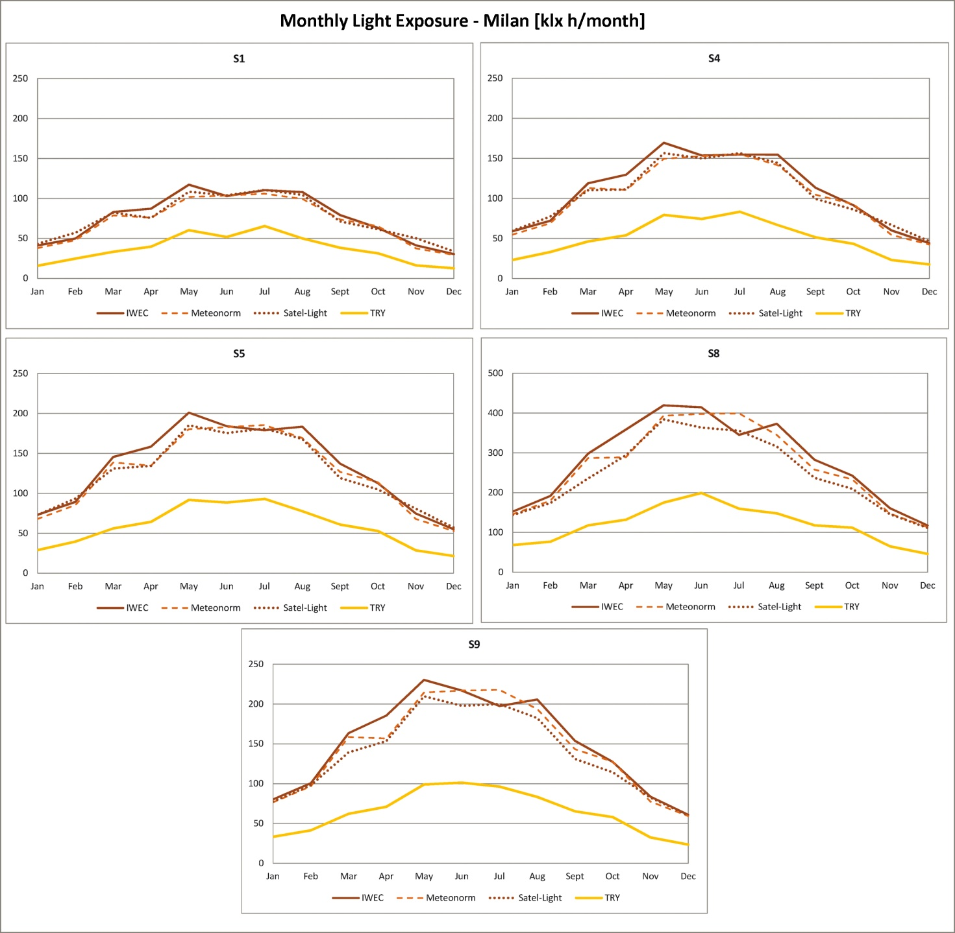
Figure 75c. Monthly Light Exposure for Milan.

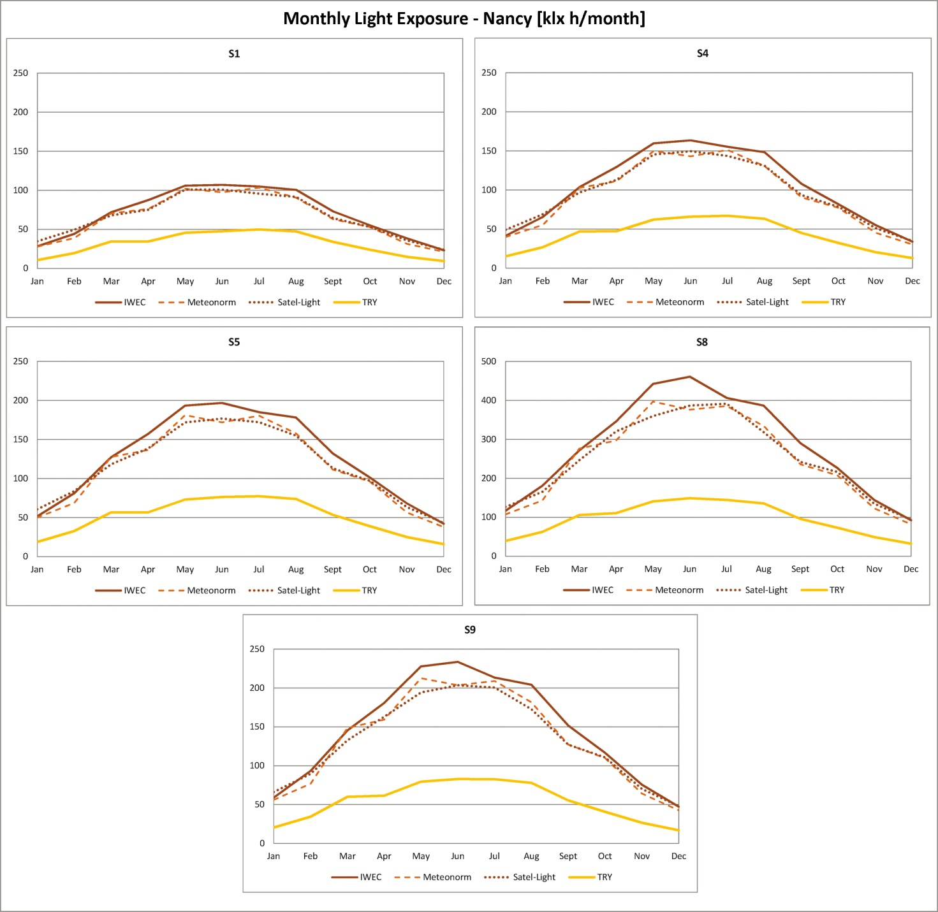
Figure 75d. Monthly Light Exposure for Nancy.

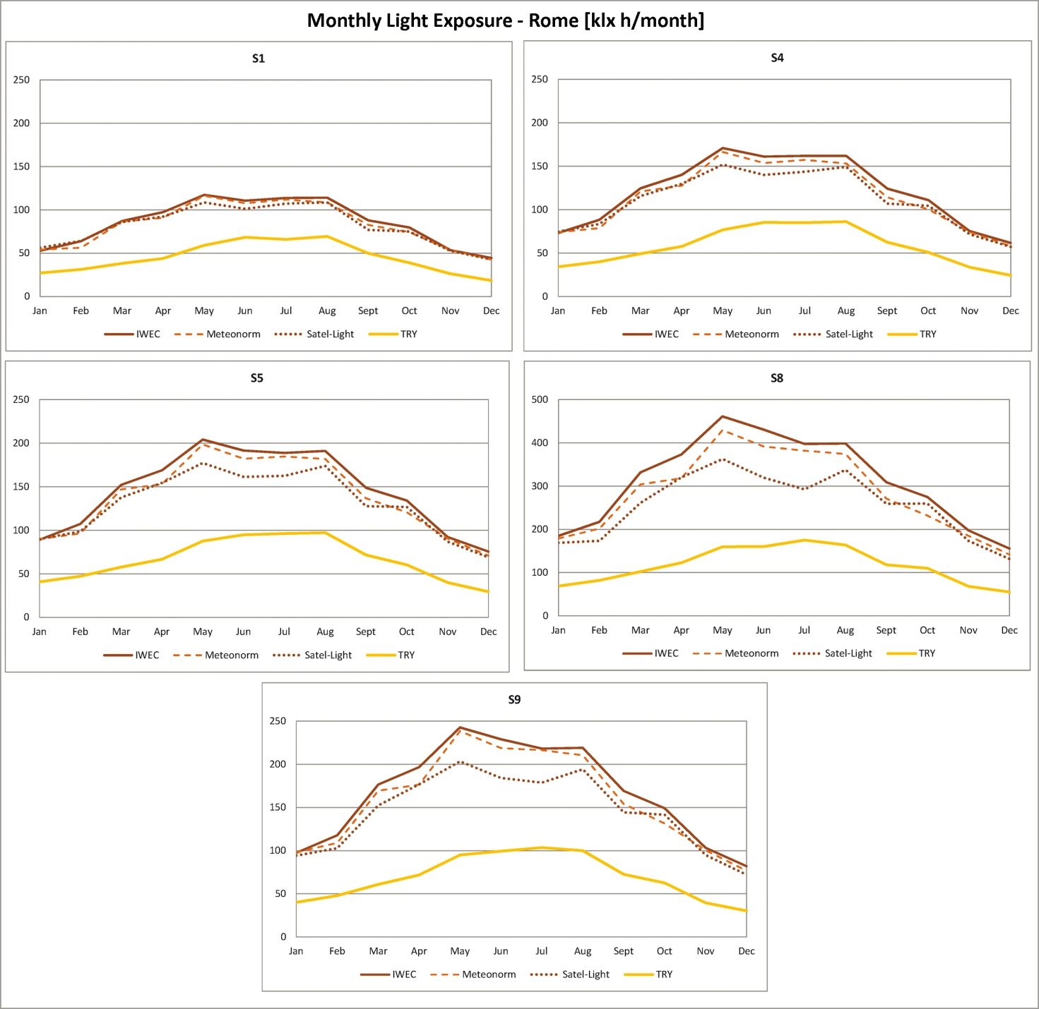
Figure 75e. Monthly Light Exposure for Rome.

From the graphs reported in Figures 75a,b,c,d,e it can be observed that also in this case the values calculated using the TRY weather data file are the lowest ones.
Another interesting finding is that Monthly Light Exposure calculated with the IWEC, Meteonorm and Satel-Light files are similar; in more detail those related to the first weather data file are always the highest whereas those related to the other two are a little lower and almost coincident except for Rome for which Meteonorm's values are more similar to IWEC ones.
It is also important to highlight that the greatest differences between Monthly Light Exposure calculated with the different weather data files were found between May and August for Copenhagen and London, between March and May for Milan and between March and October for Nancy and Rome.
Figures 76a,b show DA and DAcon values calculated for each city and each weather data file.

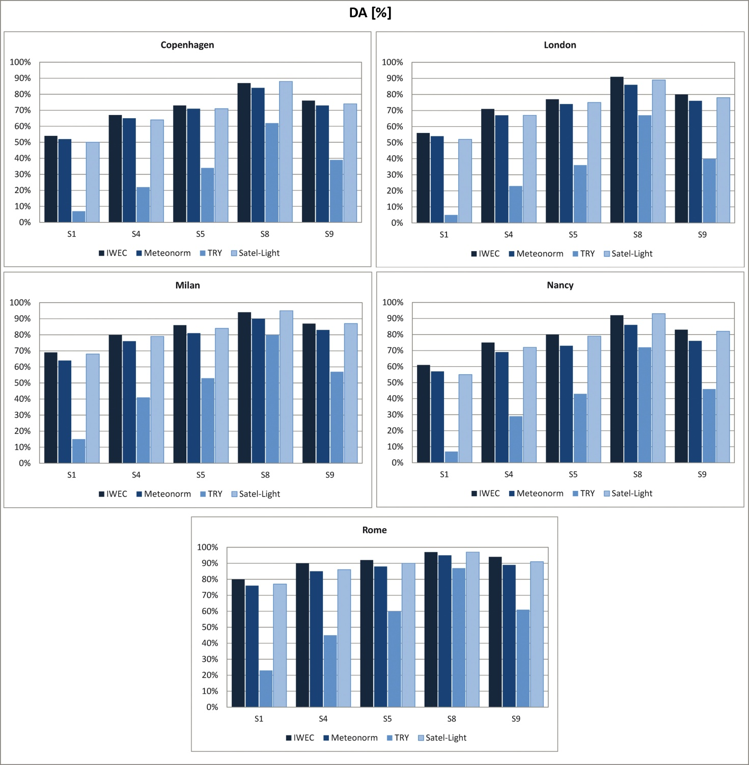
Figure 76a. DA values calculated for each city and each weather data file.

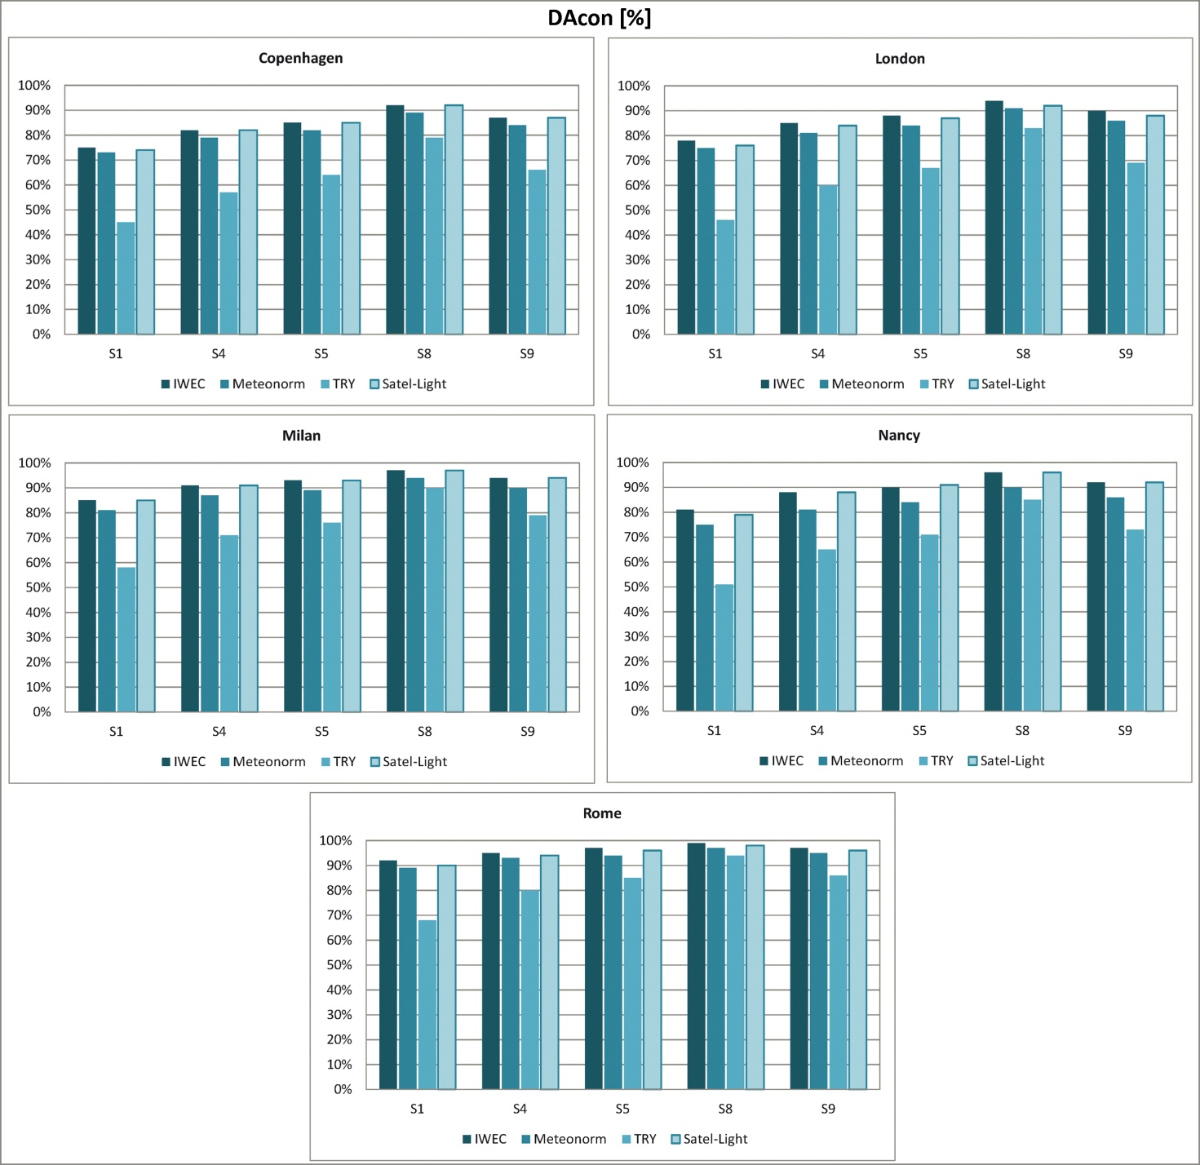
Figure 76b. DAcon values calculated for each city and each weather data file.

The graphs reported in Figures 76a,b show that both DA and DAcon values calculated using the TRY weather file are considerably lower than those obtained with the other files, the only exception is found for the S8 sensor in Rome for which differences are reduced.
DA and DAcon values calculated for IWEC, Meteonorm and Satel-Light weather files show little differences, in more detail the values related to IWEC weather file are the highest ones whereas Meteonorm and Satel-Light ones are generally a little lower.
Figure 77 reports UDI values calculated for each city and weather data file.
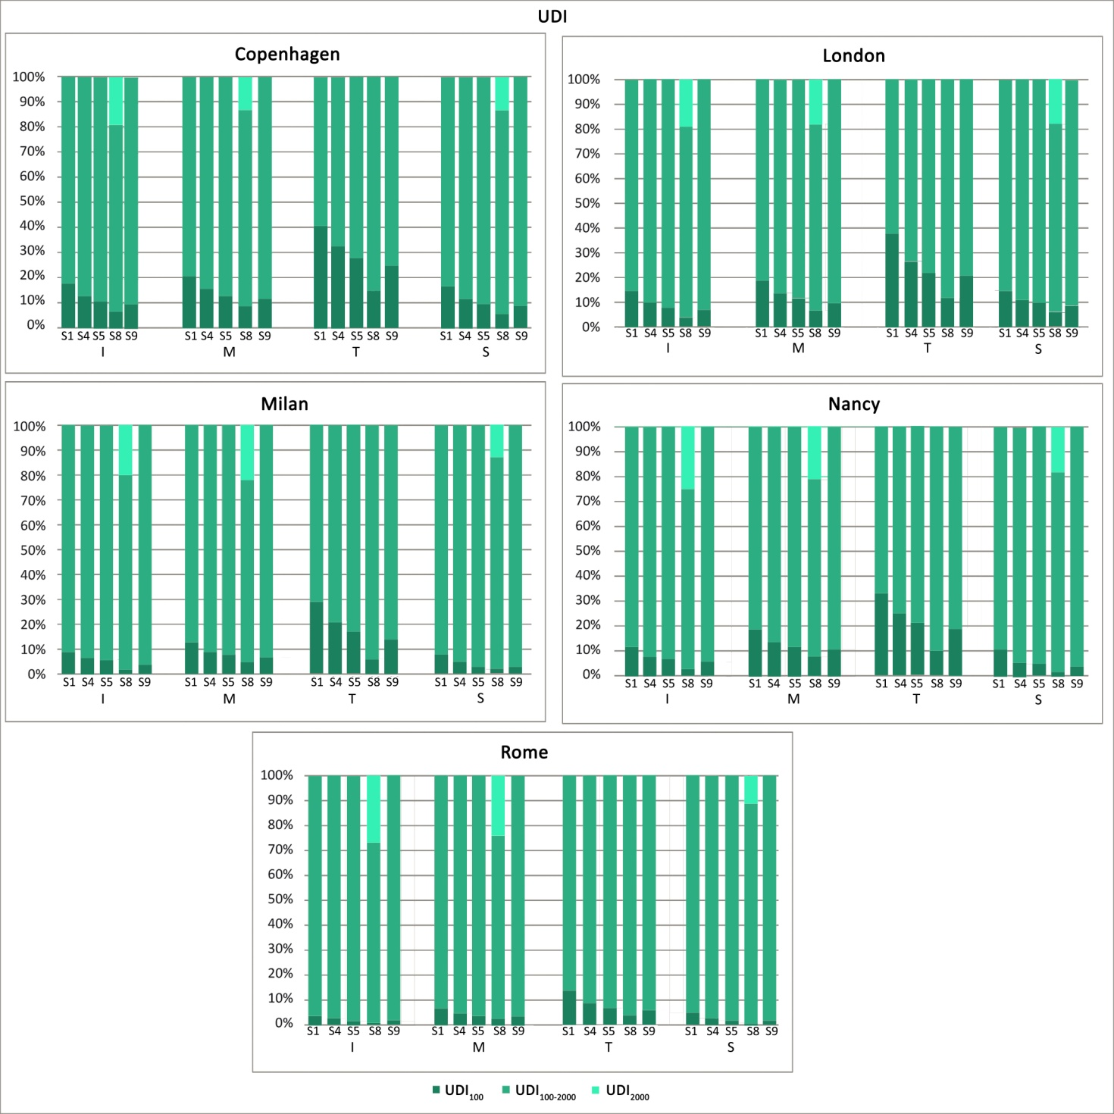
Figure 77. UDI values calculated for each city and each weather data file.

It can be observed that using the TRY weather data file the percentage of the year during which illuminances are lower than 100 lx is considerably higher compared to the other weather data files. This is a further confirmation that the use of TRY file determines results that are significantly lower than those obtained using the other files.
As regards UDI values calculated using IWEC, Meteonorm and TRY weather files they do not differ much.

4.3.2. Results of dynamic daylight simulations carried out for an office located in two European locations using three weather data files and varying its exposure
The results obtained from the first study showed that the use of the TRY weather file determines results that are significantly lower than those obtained using IWEC, Meteonorm and Satel-Light weather files; therefore it was decided to use only the last three in the second step of the research project. Moreover this time the variable of the office's exposure was taken into account and to reduce the amount of data to process, only two European locations were considered (Copenhagen and Rome).
This time simulations were performed using DIVA (3.0.0.6 version), which is a daylighting and energy modeling plug-in for Rhinoceros® based on Radiance and Daysim [95].
Figure 78 reports the office's measured plan, section and also the analysis grid (placed at an height of 0.85 m from the floor), simulations were repeated changing the office's exposure according to the four main orientations (North, East, South and West). Therefore, for readability reasons, only simulations' results related to the sensors belonging to the central, perpendicular to the window, row will be reported in this thesis. These sensors will be marked as N (near), C (central) and F (far) according to their distance from the window. A ground plane 60 m wide and 60 m long was also modeled.
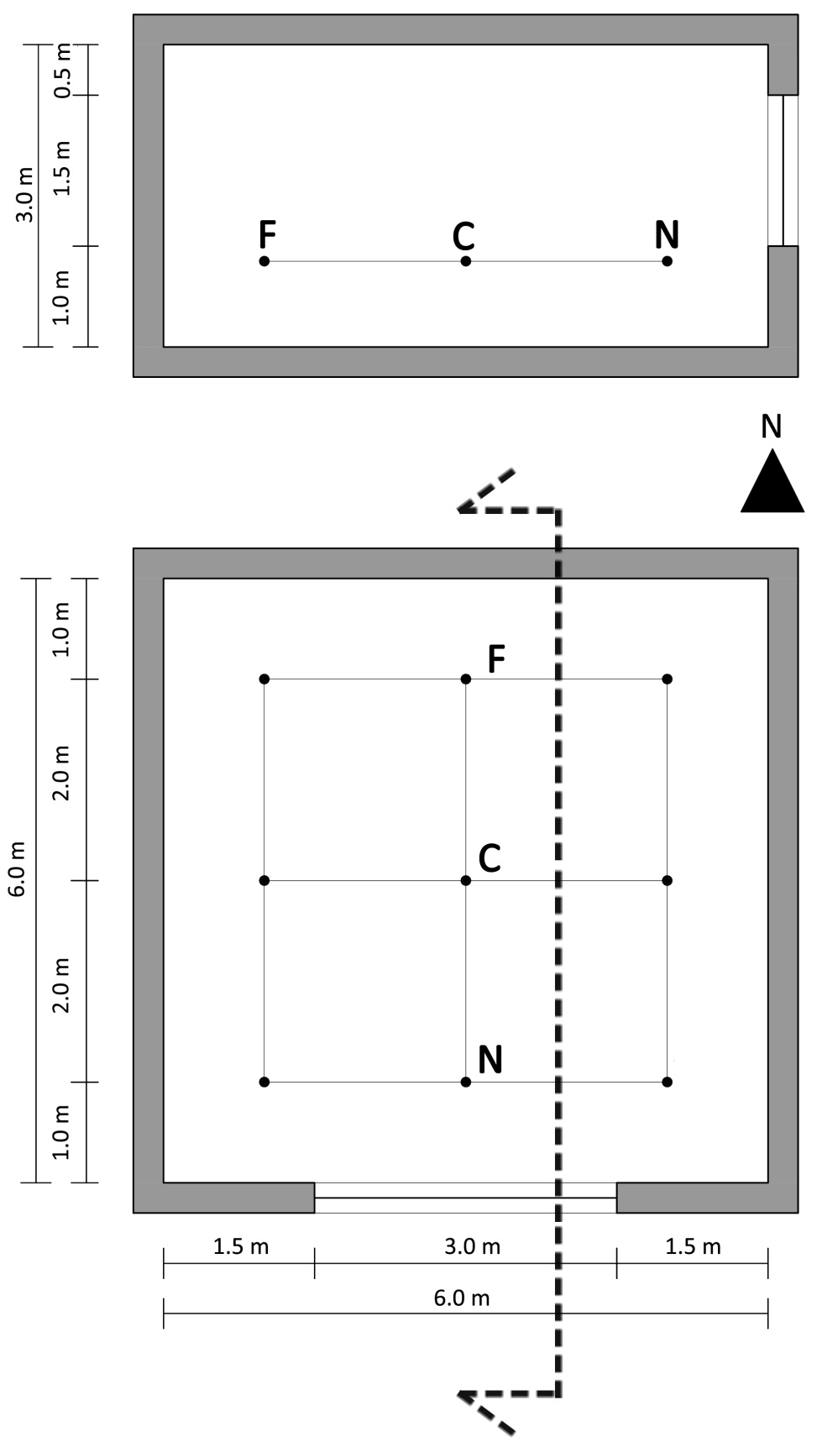
Figure 78. Office's measured plan, section and analysis grid.
Table 30 reports the reflectances of the office's surfaces and also the parameters used in DIVA to characterize them.
Materials' reflectances and parameters assigned in DIVA
Description | Reflectances [%] | Material's parameter assigned in DIVA
Internal Walls | 60 | void plastic genericwall_60  0  0  5 0.60 0.60 0.60 0 0
External Walls | 35 | void plastic outsidefacade_35  0  0  5 0.35 0.35 0.35 0 0
Ceiling | 80 | void plastic genericgeiling80  0  0  5 0.8 0.8 0.8 0 0
Floor | 30 | void plastic GenericFloor_30  0  0  5 0.3 0.3 0.3 0 0
Clear double glazing | 80 (visual transmission) | void glass glazing_doublepane_clear_80  0  0  3 0.87 0.87 0.87 0 0
Outside ground | 20 | void plastic outsideground_20  0  0  5 0.2 0.2 0.2 0 0
Table 30. Materials' reflectances and parameters assigned in DIVA.

Table 31 reports parameters set in DIVA to perform the simulations.
Parameters used to perform the simulations with DIVA
Description | Assigned values
Ambient bounces | 0 or 7
Ambient divisions | 1500
Ambient super samples | 100
Ambient resolution | 300
Ambient accuracy | 0.05
Table 31. Simulations' parameters set in DIVA.

Simulations were repeated twice for South, East and West orientations once setting ambient bounces equal to 0 and once equal to 7. This was done in order to separate the contribution of direct sunlight, indeed by performing simulations with ambient bounces set to 0 only direct sunlight is calculated. To reduce calculation times and achieve results in less time two computers were used to carry out the simulations, their characteristics and calculation times are reported in Table 32.

Characteristics and calculation times for the two computers used to carry out the simulations
 | Computer 1 | Computer 2
Processor | Intel® CORETM i7 (2.70 Ghz) | Intel® CORETM 2 Duo (2.53 Ghz)
Graphics card | NVIDIA GEFORCE® 610M (1 GB) | NVIDIA GEFORCE® GT 220m (1 GB)
RAM | 8 GB | 4 GB
OS | Windows® 7 64 bit | Windows® 7 64 bit
Calculation time | About 10 minutes | About 30 minutes
Table 32. Characteristics and calculation times for the two computers used to carry out the simulations.

Simulations were performed considering an occupancy profile that goes from Monday to Friday between 8:00 and 16:00 without breaks, daylight saving time goes from April 1st to October 31st. A target illuminance equal to 300 lx on the workplane (analysis grid) was considered according to the EN 12464-1's requirements for activities such as filing, copying, etc. [2].
The results were analyzed in terms of Annual Light Exposure, direct component of daylight and dynamic daylight performance metrics (DA, Dacon, UDI). For readability reason, in some of the following Figures and Tables, IWEC, Meteonorm and Satel-Light weather data files will be respectively noted with the letters I, M and S. Table 33 reports the values of Annual Light Exposure calculated for each city, orientation and weather data file.

Annual Light Exposure calculated for each city, orientation and weather data file [klx h/year]
 | Copenhagen
Orientation | Sensors | IWEC | Meteonorm | Satel-Light
North | N | 3852 | 3460 | 3443
North | C | 999 | 941 | 923
North | F | 535 | 512 | 502
East | N | 9565 | 8994 | 9318
East | C | 1813 | 1682 | 1738
East | F | 935 | 882 | 903
South | N | 15577 | 16530 | 15903
South | C | 3194 | 3706 | 3430
South | F | 1527 | 1694 | 1620
West | N | 8715 | 8303 | 7656
West | C | 1689 | 1505 | 1407
West | F | 811 | 776 | 734
 | Rome
Orientation | Sensors | IWEC | Meteonorm | Satel-Light
North | N | 4870 | 4492 | 4018
North | C | 1347 | 1298 | 1252
North | F | 735 | 717 | 712
East | N | 14128 | 13140 | 16256
East | C | 3134 | 2917 | 3747
East | F | 1343 | 1232 | 1440
South | N | 21376 | 23708 | 24860
South | C | 4599 | 4903 | 5398
South | F | 1643 | 1691 | 1744
West | N | 11162 | 12950 | 12392
West | C | 2141 | 2377 | 2231
West | F | 1038 | 1137 | 1098
Table 33. Annual Light Exposure calculated for each city, orientation and weather data file.
The data reported in Table 33 show that for Copenhagen the highest values were calculated using the IWEC weather file. Annual Light Exposure calculated for Rome show different trends: indeed the highest values were calculated with the Satel-Light weather file for East and South orientations, with the IWEC file for the North orientation and with Meteonorm for the West orientation.
Figure 79 reports the percentage differences between Annual Light Exposure calculated with the Satel-Light weather file and with the other weather data files.

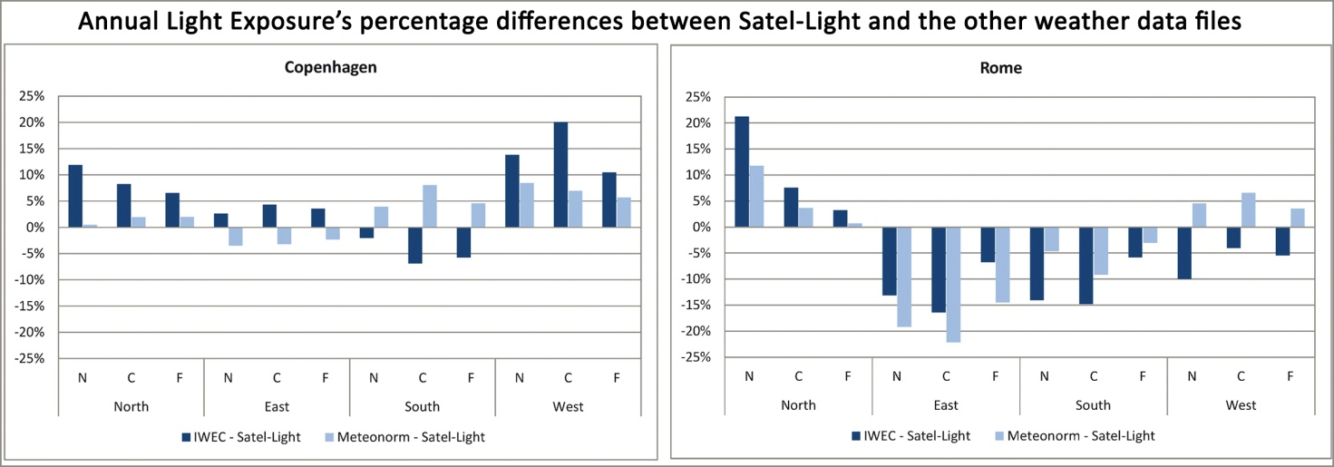
Figure 79. Annual Light Exposure percentage differences between Satel-Light and the other weather data file.

It is interesting to observe that the trends of Annual Light Exposure's percentage differences are different between the two cities. Indeed for Copenhagen the greatest differences were found between IWEC and Satel-Light weather files and they are also generally positive except for the South orientation, this means that in most cases IWEC values are greater than Satel-Light ones. Differences calculated between Meteonorm and Satel-Light weather files are generally smaller and positive, except for the East orientation.
The same conclusions do not apply to Rome, indeed for East and South orientations differences are all negative, moreover those calculated between IWEC and Satel-Light are also negative for the West orientation.
Therefore there is no general conclusion that can be inferred from the analysis of Annual Light Exposure, the reason for the differences found in the results may depend on sunlight's incidence and thus it was decided to perform an in depth analysis of the direct component of daylight. Such analysis was only performed for East, South and West orientations since for the North one the contribution of the direct component of daylight is negligible.
The annual percentage of occupied hours during which sunlight-related illuminances (E_{sun}), calculated for East, West and South orientations for both cities and with each weather data file, are comprised between 0 and 1000 lux or are greater than 1000 lx is reported in Figure 80. This 1000 lx threshold was considered since in ASE's calculation it is the limit value [58].
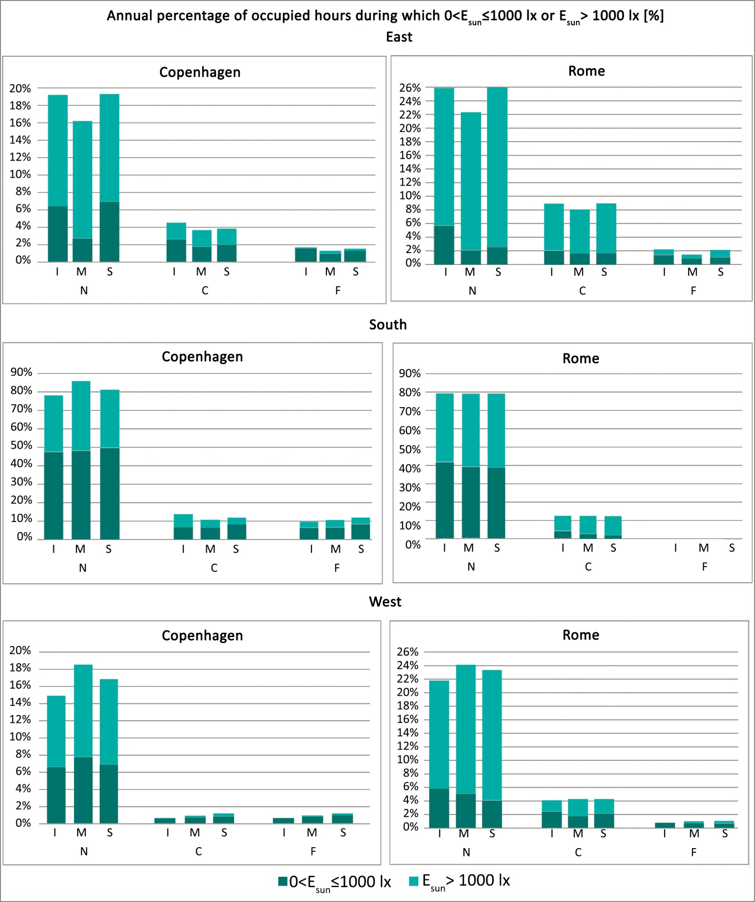
Figure 80. Annual percentage of occupied hours during which E_{sun} is comprised between 0 and 1000 lx or is greater than 1000 lx.

It is interesting to highlight that the total percentage of occupied hours during which the direct component of daylight is calculated is similar between the different weather data files, indeed differences are not greater than 5%, in more detail the highest differences can be found for the sensor near the window in each orientation.
Moreover it can be observed that the direct component of daylight was not calculated for the sensor farthest from the window in the South orientation in Rome whereas this was not found for the same sensor in the same orientation in Copenhagen. The reason behind this result is the lower sun altitude in Copenhagen which allows daylight to enter deeply into the office.
DA values calculated for each city and orientation using the different weather data files are reported in Figures 81a,b.

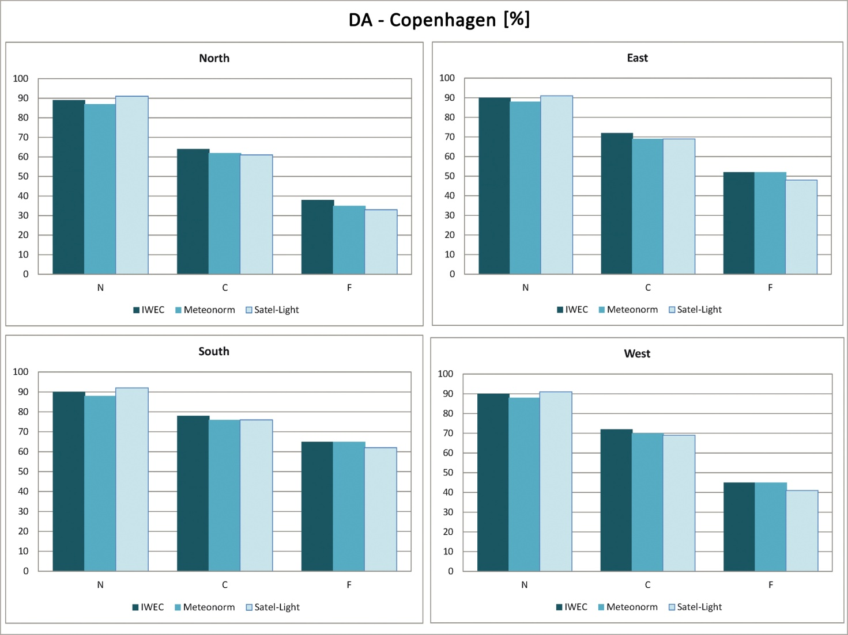
Figure 81a. DA values calculated for Copenhagen.

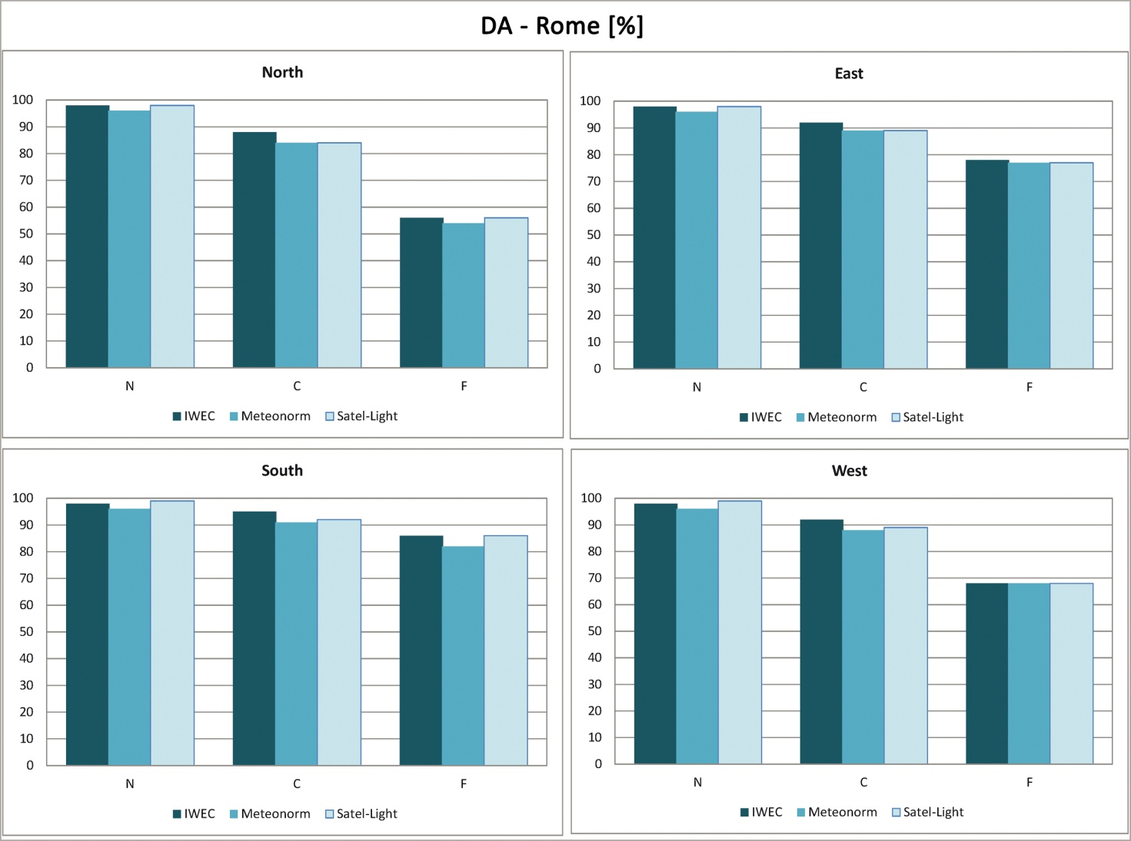
Figure 81b. DA values calculated for Rome.
Looking at the graphs reported in Figures 81a,b it can be observed that differences among DA values calculated with the different weather data files are quite small in all cases. In more detail, for both cities, the highest values for the N sensor were calculated using the Satel-Light weather file whereas for the other sensors they were calculated using the IWEC one.
Figures 82a,b report DAcon values calculated for each city and orientation using the different weather data files.

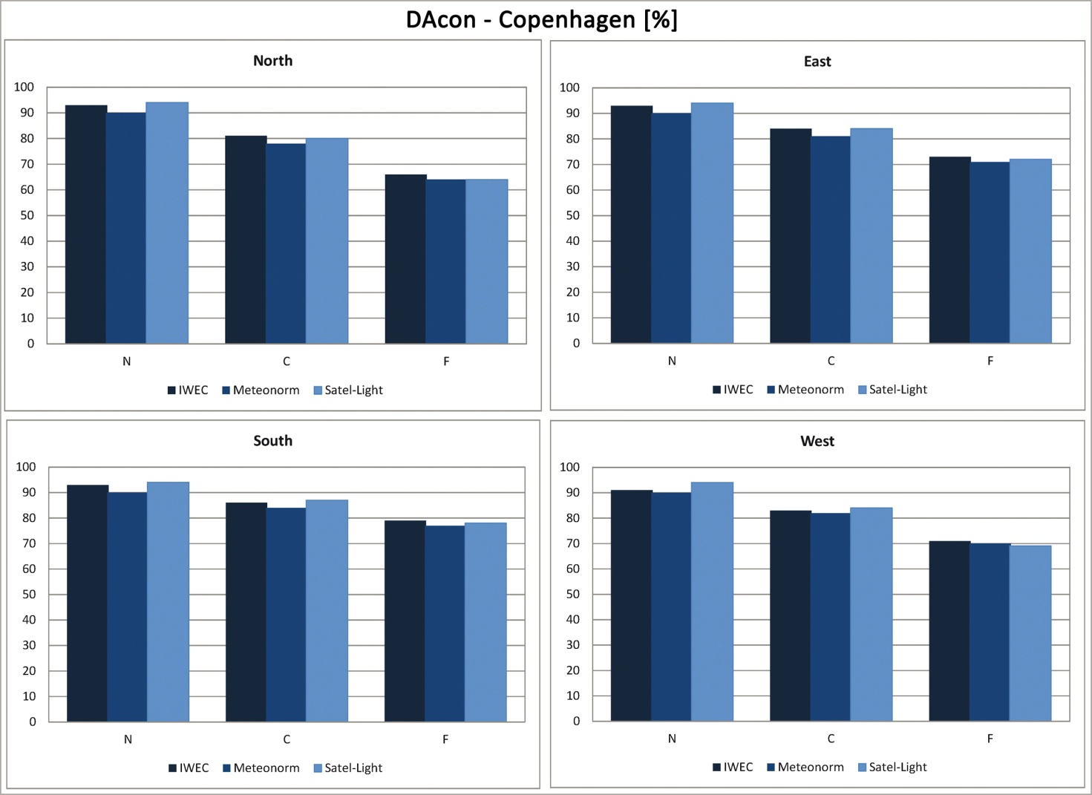
Figure 82a. DAcon values calculated for Copenhagen.

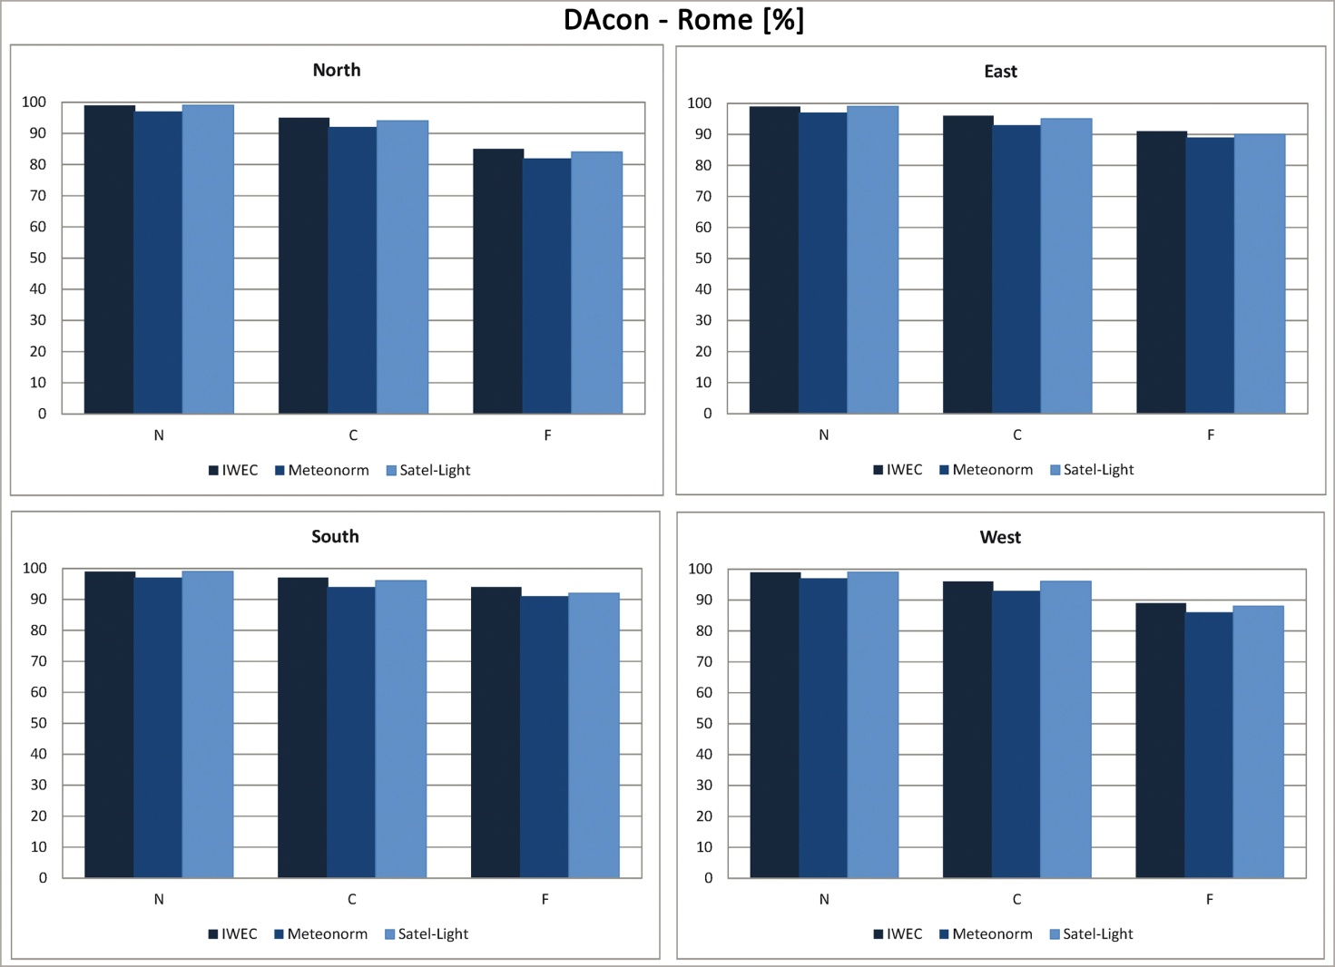
Figure 82b. DAcon values calculated for Rome.

It can be observed that also for DAcon values differences are quite small.
Figures 83a,b report UDI values calculated for each city, orientation and weather data file.

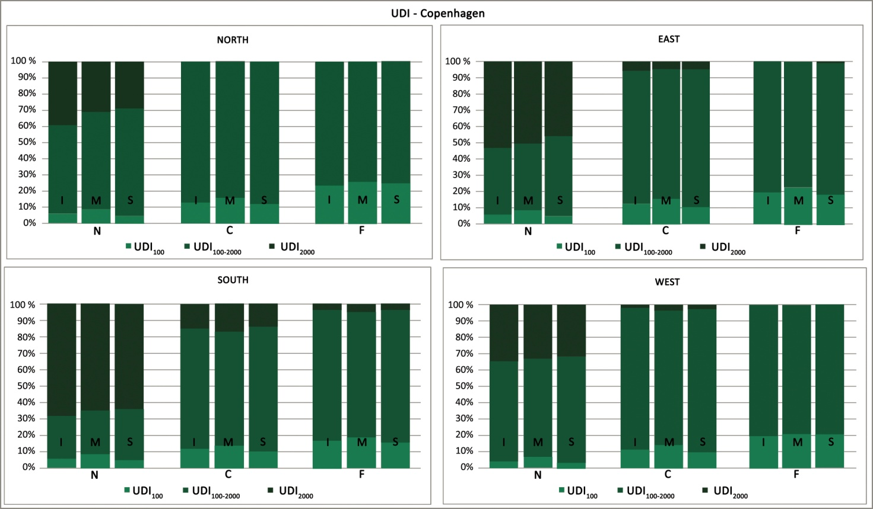
Figure 83a. UDI values calculated for Copenhagen.

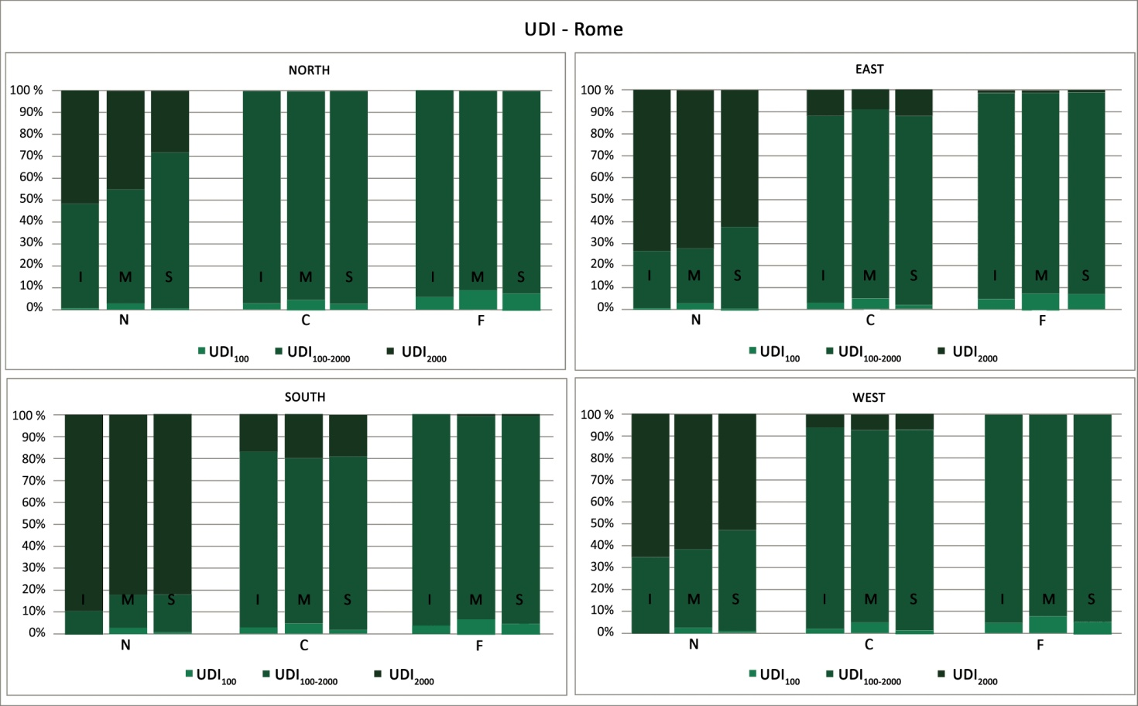
Figure 83b. UDI values calculated for Rome.

UDI₁₀₀ calculated for both cities with the Meteonorm weather data file are greater that those obtained with IWEC and Satel-Light files. Generally it can be observed that differences between UDI values calculated with the different weather files are really small, only for Rome they tend to increase for the N sensor in all orientations.

4.4. Impact of the choice of the software on daylight simulations' results
The last step of the research project involved the analysis of the impact of the use of two different software (3ds Max Design® 2013 and Daysim) on the results of dynamic daylight simulations carried out for the same office. The office's only window was oriented in turn toward North, East, South and West. The office's measured plan, section and analysis grid are reported in Figure 84, the analysis grid was placed at an height of 0.75 m from the floor and results will be reported only for the sensors belonging to the central, perpendicular to the window row. This was necessary to reduce the amount of data displayed, the sensors used to perform the analysis will be noted according to their distance from the window as near (N), central (C) and far (F).
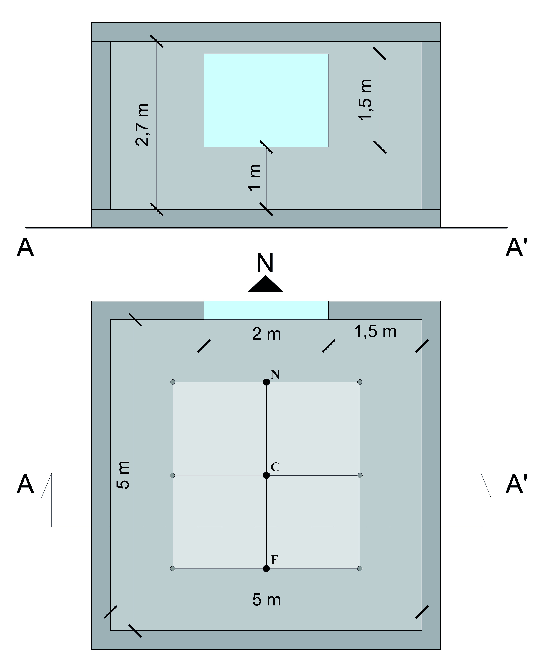
Figure 84. Office's measured plan, section and analysis grid.

A ground plane was also modeled in both Daysim and 3ds Max Design® (45 m x 45 m). Table 33 lists the values of the reflectances of the office's surfaces and the parameters assigned in Daysim and 3ds Max Design® to represent such reflectances.

Materials' reflectances and parameters assigned in Daysim and 3ds Max Design®
Description | Reflectances [%] | Material's parameter assigned in
Description | Reflectances [%] | Daysim | 3ds Max Design® (Arch & design material parameters)
Walls | 65 | void plastic GenericWall50  0  0  5 0.65 0.65 0.65 0 0 | Diffuse level: 1  Diffuse color: 0.65; 0.65; 0.65  Reflection weight: 0
Ceiling | 80 | void plastic GenericCeiling80  0  0  5 0.8 0.8 0.8 0 0 | Diffuse level: 1  Diffuse color: 0.80; 0.80; 0.80  Reflection weight: 0
Floor | 30 | void plastic GenericFloor_30  0  0  5 0.3 0.3 0.3 0 0 | Diffuse level: 1  Diffuse color: 0.30; 0.30; 0.30  Reflection weight: 0
Clear double glazing | 82 (visual transmission) | void glass GenericDoubleGlazing72  0  0  3 0.89 0.89 0.89 0 0 | Diffuse level: 0  Reflectivity: 1  Reflection color: 1.0; 1.0; 1.0  Refraction color: 0.82; 0.82; 0.82  BRDF: By IOR
Ground plane | 20 | 20 | Diffuse level: 1  Diffuse color: 0.20; 0.20; 0.20  Reflection weight: 0
Table 33. Materials' reflectances and parameters assigned in Daysim and 3ds Max Design®.

Simulations were performed for four European cities: Copenhagen, Nancy, Milan and Rome; the IWEC [80,81] weather data file related to each one of them was used in both software to represent the chosen cities' climatic conditions. The office was considered occupied from Monday to Friday between 8:00 and 16:00 without breaks and the daylight saving time was from April 1st to October 31st. A target illuminance equal to 300 lx on the workplane was assumed when performing simulations [2].
The parameters used to perform the simulations with Daysim (version 3.1e) and 3ds Max Design® 2013 are reported in Tables 34 and 35.
Parameters used to perform the simulations with Daysim
Description | Assigned values
Ambient bounces | 7
Ambient divisions | 1500
Ambient super samples | 100
Ambient resolution | 300
Ambient accuracy | 0.05
Limit reflection | 6
Specular threshold | 0.1500
Specular jitter | 1.0000
Limit weight | 0.004000
Direct jitter | 0.0000
Direct sampling | 0.200
Direct relays | 2
Direct pretest density | 512
Table 34. Parameters used to perform the simulations with Daysim.

Parameters used to perform the simulations with 3ds Max Design®
Render dialog rollout | Section | Parameter
Rendering algorithms | Scanline | Off
Rendering algorithms | Raytracing | On
Rendering algorithms | Raytracing | Max trace depth: 10
Rendering algorithms | Raytracing | Max trace reflections: 10
Rendering algorithms | Raytracing | Max trace refractions: 10
Shadows & displacement | Shadows | On
Shadows & displacement | Shadows | Mode: Simple
Final gather | Basic | On
Final gather | Basic | Multiplier: 1.0
Final gather | Basic | Initial FG point density: 4.0
Final gather | Basic | Rays per FG point: 10000
Final gather | Basic | Interpolate over num. FG points: 100
Final gather | Basic | Diffuse bounces: 7
Final gather | Basic | Weight: 1.0
Final gather | Advanced | Noise filtering: None
Final gather | Advanced | Max Depth: 10
Final gather | Advanced | Max reflections: 10
Final gather | Advanced | Max refractions: 10
Final gather | Advanced | Use falloff (limit ray distance): Off
Final gather | FG Point Interpolation | Use radius interpolation
Final gather | FG Point Interpolation | Method: Off
Caustics & global illumination | Caustics | Off
Caustics & global illumination | Global illumination | Off
Table 35. Parameters used to perform the simulations with 3ds Max Design®.

Two computers were used to perform the simulations and their characteristics and simulation times with each software are reported in Table 36.

Characteristics and calculation times for the two computers used to carry out the simulations
 | Computer 1 | Computer 2
Processor | Intel® CORETM i7 (2.70 Ghz) | Intel® CORETM 2 Duo (2.53 Ghz)
Graphics card | NVIDIA GEFORCE® 610M (1 GB) | NVIDIA GEFORCE® GT 220m (1 GB)
RAM | 8 GB | 4 GB
OS | Windows® 7 64 bit | Windows® 7 64 bit
Calculation time | About 53 min with Daysim and about 3h and 20 min with 3ds Max Design® 2013 | About 1h and half with Daysim and about 5h with 3ds Max Design® 2013
Table 36. Characteristics and calculation times for the two computers used to perform the simulations.

The results obtained from the simulations carried out with the two software will be compared in terms of illuminances and UDI values. In more detail, it was decided to use the formulation proposed by Nabil and Mardaljevic [57], thus further dividing the UDI's original three steps into four steps: illuminance (E) < 100 lx, 100 lx < E < 300 lx, 300 lx < E < 2000 lx, E > 2000 lx.
Hourly differences between global illuminances calculated by 3ds Max Design® (E_{g-3ds}) and Daysim (E_{g-Daysim}) were calculated for each city, orientation and sensor. After performing this calculation the annual frequency for which the difference between E_{g-3ds} and E_{g-Daysim} results lower, equal or greater than 0 was determined and is reported in Figure 85.

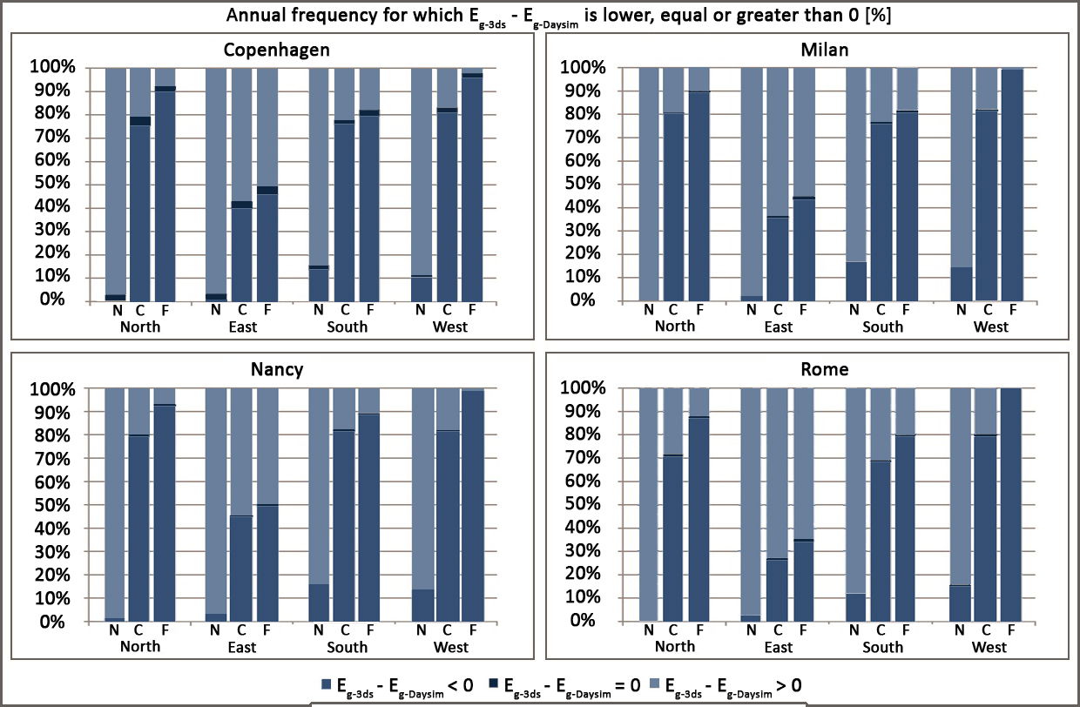
Figure 85. Annual frequency for which E_{g-3ds} - E_{g-Daysim} is lower, equal or greater than 0.

It is interesting to observe that the graphs related to the different cities are similar and the differences found in the results depend on the orientation and also on the sensor's distance from the window. Indeed the annual frequency for which E_{g-3ds} - E_{g-Daysim} is lower or greater than 0 strongly varies according to the orientation and sensor's location. Moreover Daysim and 3ds Max Design® simulate the same illuminance value only in few occasions during the year (less than 4%).
The values of Mean Bias Error (MBE) and Root Mean Square Error (RMSE) related to global illuminances were also calculated to further analyze the differences in the results obtained from the two software, the equations used to calculate them are reported below [96]:

$MBE=100 x \frac{1}{N}\sum_{i=1}^{N}{\left(\frac{{Predicted}_{i}- {Measured}_{i}}{{Measured}_{i}}\right)}$ (Eq.11)

$RMSE=100 x \sqrt{\frac{1}{N}\sum_{i=1}^{N}{{\left(\frac{{Predicted}_{i}- {Measured}_{i}}{{Measured}_{i}}\right)}^{2}}}$ (Eq.12)

N represents the number of measured data.
Usually MBE and RMSE allow to calculate the error related to simulated data with reference to measured ones. Since in this case they are used to analyze the differences among two sets of simulated data, E_{g-Daysim} are considered as measured data given that this software is also the most used and most studied one [55,88,89,90,91].
Figure 86 and 87 report MBE and RMSE values calculated for global illuminances simulated with Daysim and 3ds Max Design®.
It is important to highlight that there is no reference that sets MBEs and/or RMSEs thresholds below which the results of a simulation can be considered "reliable" [74]. Therefore, in this research project, error bands equal to plus/minus 15% for MBEs and 35% for RMSEs were assumed as it was previously done by Reinhart and Breton [74]. Such thresholds are also reported in Figures 86 and 87 (dotted lines).

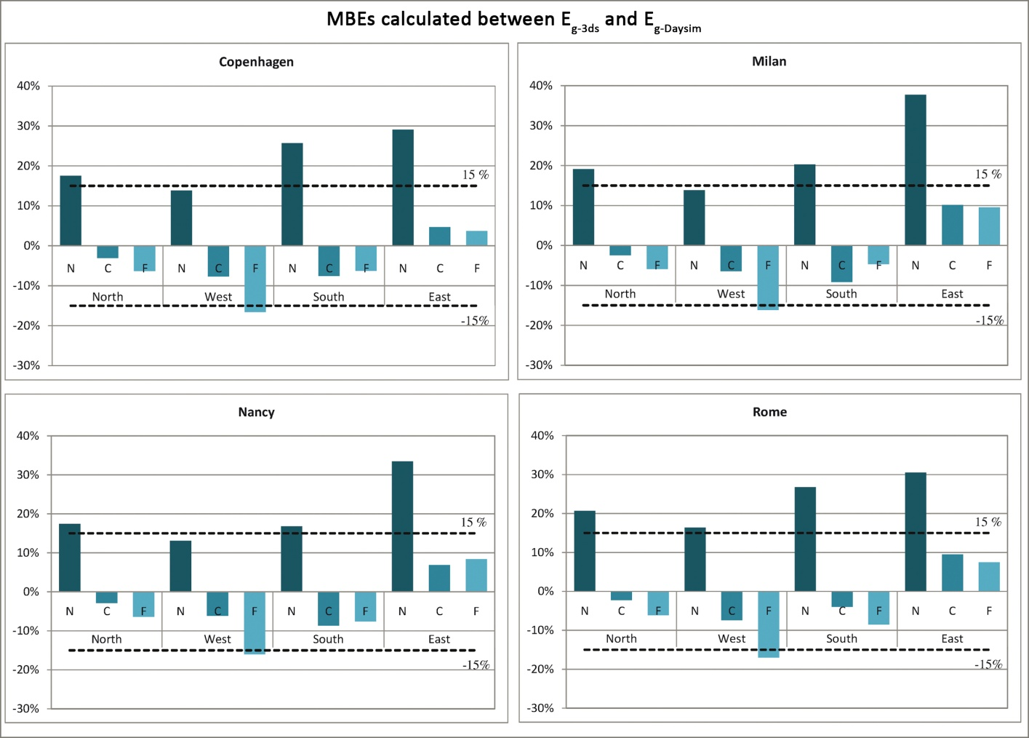
Figure 86. MBEs calculated between E_{g-3ds} - E_{g-Daysim}.

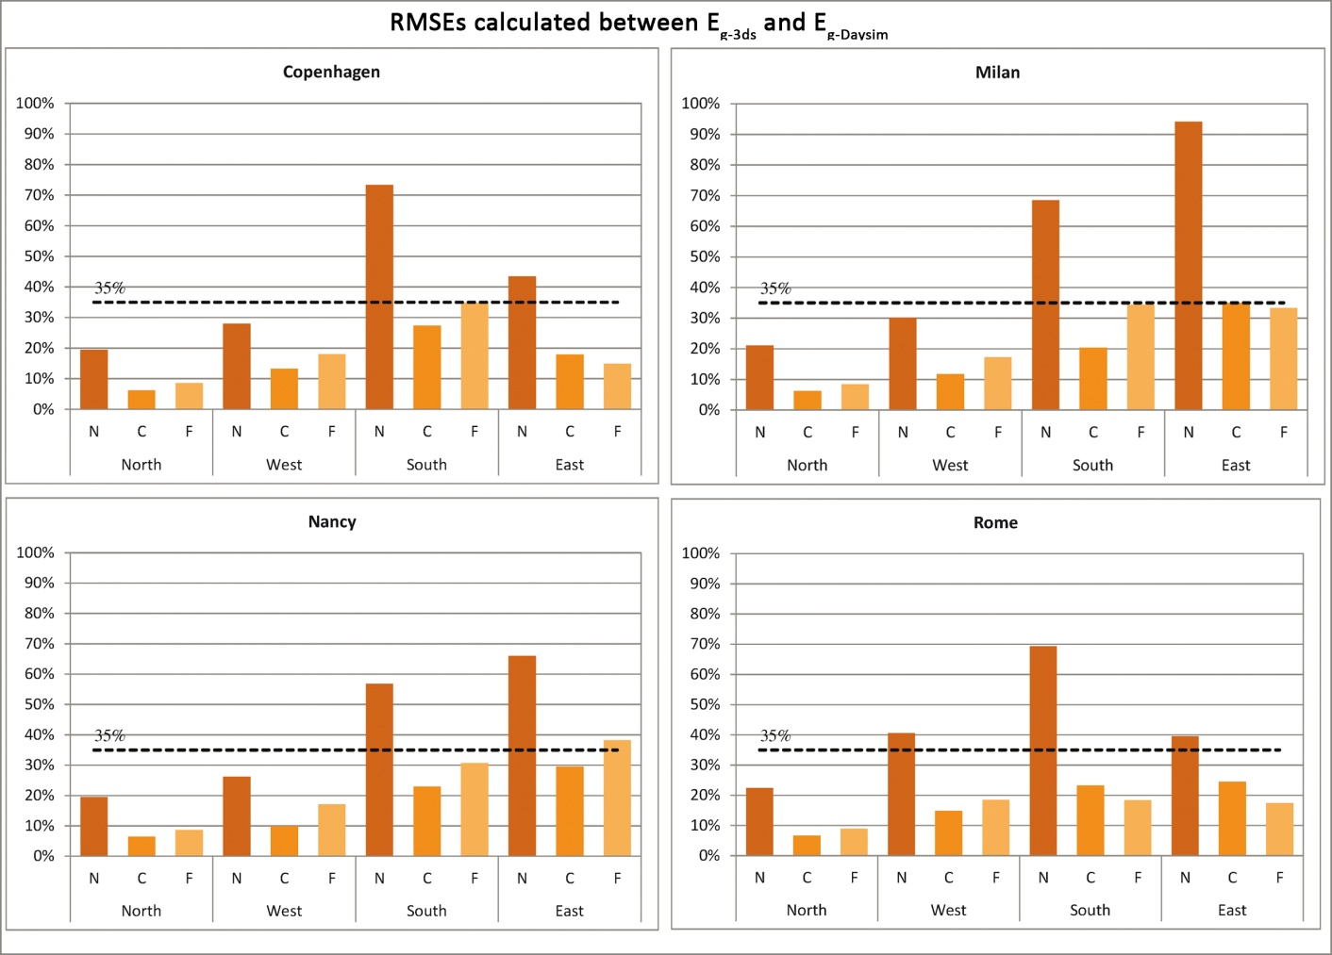
Figure 87. RMSEs calculated between E_{g-3ds} - E_{g-Daysim}.

Looking at the graphs in Figure 86 it can be observed that, for all cities, MBEs are negative for the C and F sensors in all orientations except the East one. MBE values for these two sensors are generally considerably lower than 15% and thus differences between the two software can be considered negligible, the only exception is represented by the F sensor in the West orientation in all cities for which MBEs are a little above 15%.
On the other hand MBEs are always positive for the N sensor, moreover the values are frequently above the 15% threshold thus meaning that differences between global illuminances calculated by the two software for this sensor are significant.
As regards RMSEs (Figure 87), in the majority of cases they are below the 35% threshold for all cities and orientations. The only exceptions are represented by the values calculated for the N sensor respectively in the South orientation for Copenhagen, in the South and East ones for Milan and Nancy and in the West, South and East orientations for Rome. It is really important to highlight that the RMSEs calculated for the N sensor in the abovementioned cities and orientations are really high, indeed for Milan in the East orientations RMSE is even higher than 90%.
Therefore the analysis of MBEs and RMSEs showed that the differences between the results obtained from Daysim and 3ds Max Design® strongly depend on the window's orientations and sensor's location. Moreover it was observed that differences tend to increase for the N sensor which is the one closer to the window and thus this probably means that differences also depend on the direct component of daylight. For this reason it was decided to deepen this topic by also analyzing illuminances related only to the direct component of daylight (E_{d}) calculated by the two software. Such analysis was performed for each city and orientation except the North one, since in that case the direct component of daylight is negligible.
The annual frequency for which both software or only one of them calculate the presence of the direct component of daylight is reported in Figure 88; Table 37 reports the number of occupied hours in a year during which only Daysim or 3ds Max Design® or both software calculate the presence of direct sunlight.

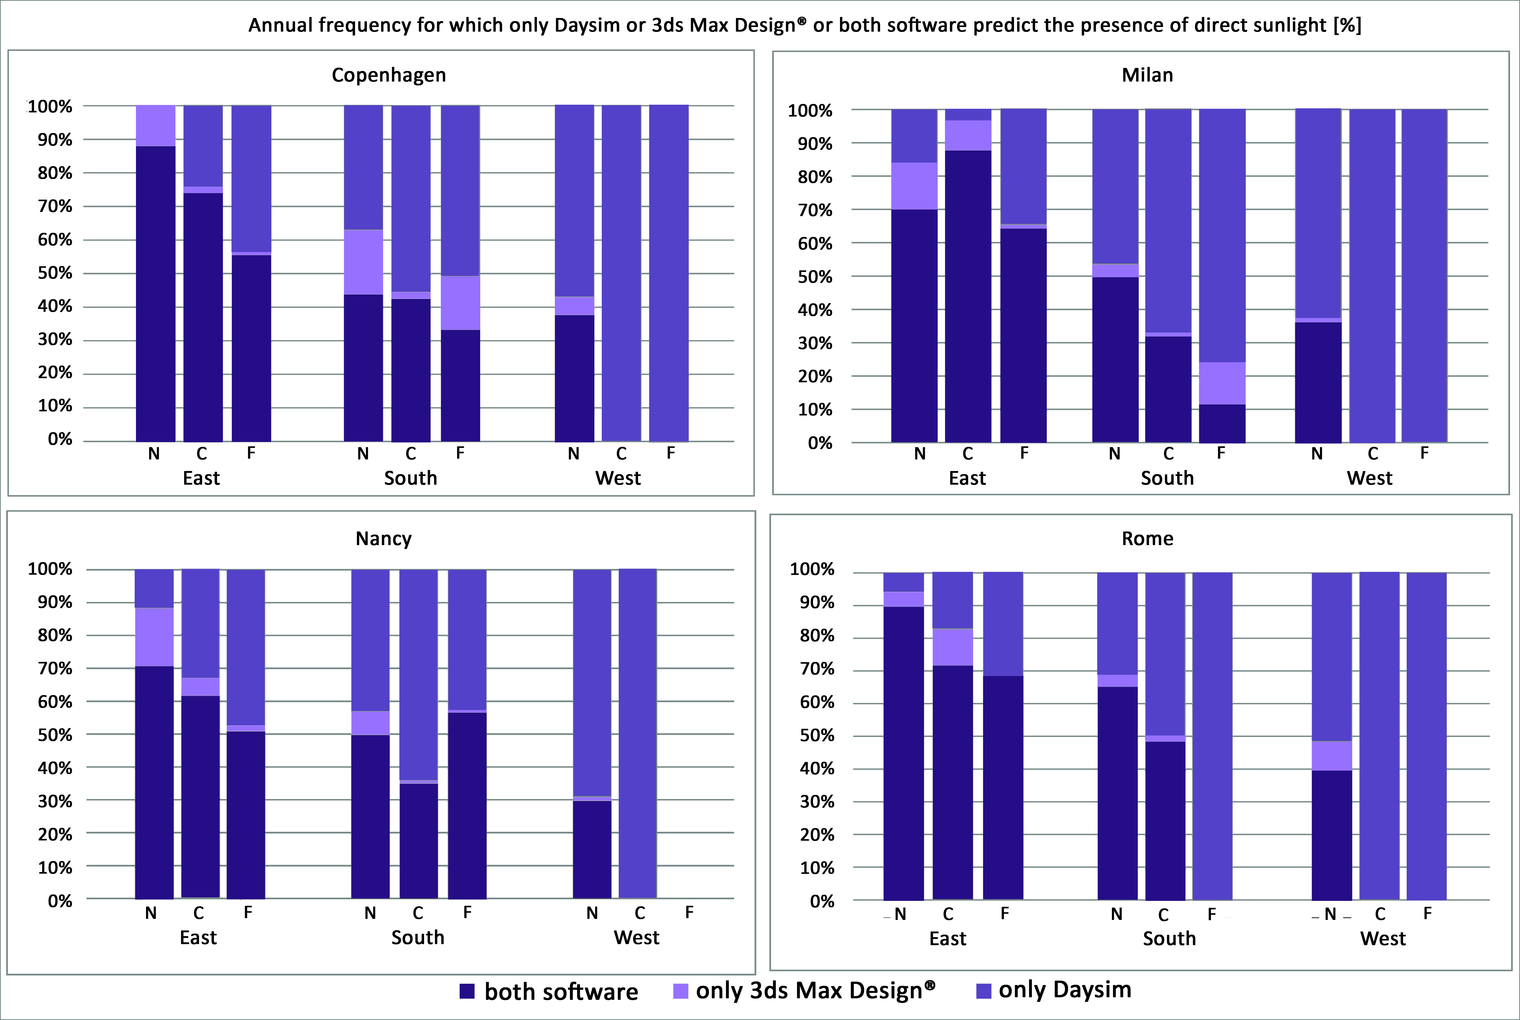
Figure 88. Annual frequency for which only Daysim or 3ds Max Design® or both software predict the presence of direct sunlight.

Number of occupied hours during which only Daysim or 3ds Max Design® or both software calculate the presence of direct sunlight
 | Copenhagen
Orientation |  | N | C | F
West | Both software | 92 | 0 | 0
West | Only 3ds Max Design® | 13 | 0 | 0
West | Only Daysim | 138 | 115 | 13
South | Both software | 388 | 210 | 65
South | Only 3ds Max Design® | 169 | 10 | 31
South | Only Daysim | 328 | 271 | 99
East | Both software | 311 | 168 | 60
East | Only 3ds Max Design® | 43 | 4 | 1
East | Only Daysim | 0 | 55 | 47
 | Milan
 |  | N | C | F
West | Both software | 107 | 0 | 0
West | Only 3ds Max Design® | 4 | 0 | 0
West | Only Daysim | 183 | 116 | 5
South | Both software | 527 | 130 | 15
South | Only 3ds Max Design® | 40 | 4 | 16
South | Only Daysim | 494 | 273 | 95
East | Both software | 343 | 200 | 113
East | Only 3ds Max Design® | 69 | 21 | 2
East | Only Daysim | 78 | 7 | 61
 | Nancy
 |  | N | C | F
West | Both software | 50 | 0 | 0
West | Only 3ds Max Design® | 2 | 0 | 0
West | Only Daysim | 116 | 6 | 0
South | Both software | 508 | 80 | 62
South | Only 3ds Max Design® | 72 | 2 | 1
South | Only Daysim | 440 | 146 | 46
East | Both software | 336 | 193 | 111
East | Only 3ds Max Design® | 83 | 17 | 4
East | Only Daysim | 54 | 104 | 102
 | Rome
 |  | N | C | F
West | Both software | 150 | 0 | 0
West | Only 3ds Max Design® | 33 | 0 | 0
West | Only Daysim | 191 | 130 | 20
South | Both software | 579 | 154 | 0
South | Only 3ds Max Design® | 32 | 6 | 0
South | Only Daysim | 276 | 155 | 154
East | Both software | 423 | 193 | 89
East | Only 3ds Max Design® | 21 | 30 | 0
East | Only Daysim | 26 | 47 | 41
Table 37. Number of occupied hours in a year during which only Daysim or 3ds Max Design® or both of them calculate direct sunlight.

The data reported in Figure 88 and Table 37 show that there are few hours in a year during which only 3ds Max Design® predicts the presence of direct sunlight whereas the opposite case happens for a considerably greater amount of time. In more detail, it can be observed that, for all cities in the West orientation, only Daysim calculates the presence of direct sunlight for the C and F sensors. Another interesting result is that for all cities in the East orientation the number of hours during which both Daysim and 3ds Max Design® predict the presence of direct sunlight increases.
MBEs and RMSEs were also calculated between E_{d} obtained from Daysim and 3ds Max Design® and they are reported in Tables 38 and 39. It is important to highlight that MBEs and RMSEs were calculated only for the occupied hours during which both software predict the presence of the direct component of daylight.

MBEs calculated between E_{d} simulated with Daysim and 3ds Max Design® [%]
 | Copenhagen
Orientation | N | C | F
West | 21.63 | 0 | 0
South | 168.55 | 639.47 | 35.72
East | 201.06 | 71.42 | 86.25
 | Milan
 | N | C | F
West | 1057.73 | 0 | 0
South | 909.51 | 7.23 | 10.11
East | 1464.04 | 186.07 | 842.92
 | Nancy
 | N | C | F
West | 124.73 | 0 | 0
South | 943.12 | 82.74 | 1324.83
East | 288.02 | 150.53 | 1747.9
 | Rome
 | N | C | F
West | 34.84 | 0 | 0
South | 1334.41 | 70.34 | 0
East | 94.84 | 96.59 | 90.28
Table 38. MBEs calculated between E_{d} simulated with Daysim and 3ds Max Design®.

RMSEs calculated between E_{d} simulated with Daysim and 3ds Max Design® [%]
 | Copenhagen
Orientation | N | C | F
West | 37.64 | 0 | 0
South | 501.68 | 3441.14 | 47.24
East | 515.24 | 150.19 | 114.50
 | Milan
 | N | C | F
West | 5348.89 | 0 | 0
South | 2922.69 | 13.22 | 25.26
East | 10114.31 | 490.29 | 2010.40
 | Nancy
 | N | C | F
West | 264.97 | 0 | 0
South | 4498.61 | 249.00 | 1960.13
East | 550.94 | 323.20 | 7069.56
 | Rome
 | N | C | F
West | 167.80 | 0 | 0
South | 6751.59 | 105.43 | 0
East | 314.42 | 281.96 | 152.59
Table 39. RMSEs calculated between E_{d} simulated with Daysim and 3ds Max Design®.

MBEs and RMSEs clearly show the great difference between E_{d} calculated by Daysim and 3ds Max Design®. It can be observed that MBEs are always positive thus meaning that, when both Daysim and 3ds Max Design® predict the presence of direct sunlight, E_{d} calculated by the latter are higher than those calculated by the former. Figure 89 further analyzes direct sunlight by reporting E_{g}, E_{d} and indirect illuminances (E_{ind}) calculated with Daysim and 3ds Max Design® for Rome on 2nd January.

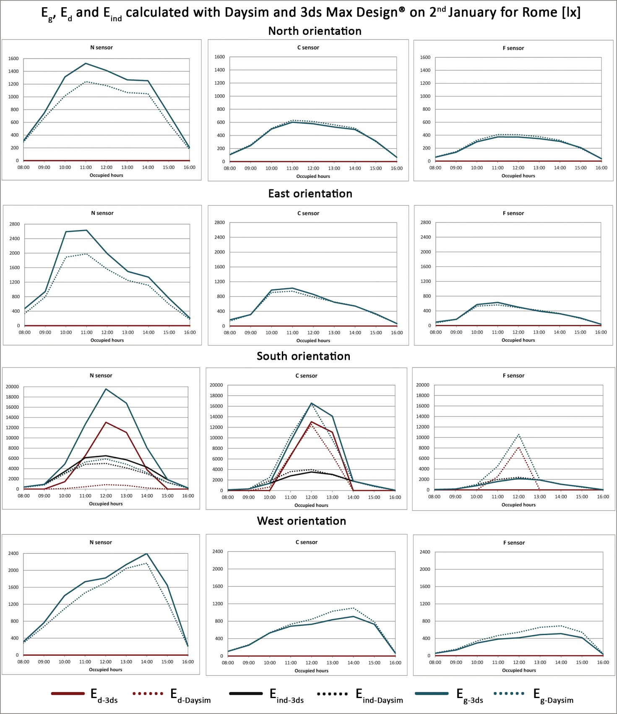
Figure 89. E_{g}, E_{d} and E_{ind} calculated with Daysim and 3ds Max Design®on 2nd January for Rome.

The graphs reported in Figure 89 show that differences in illuminances' trends depend on sensors' location and on the window's orientation. In more detail, E_{g} trends related to Daysim and 3ds Max Design are almost coincident for the C and F sensors when the window is North, East or West oriented. Moreover they are quite similar for the N sensor in the same orientations.
On the other hand, the greatest differences can be observed between E_{d-3ds} and E_{d-Daysim} related to the N sensor in the South orientation.
UDI values calculated for each city and orientation are reported in Figures 90a,b,c,d whereas Figure 91 shows differences between their values calculated with 3ds Max Design® and Daysim.

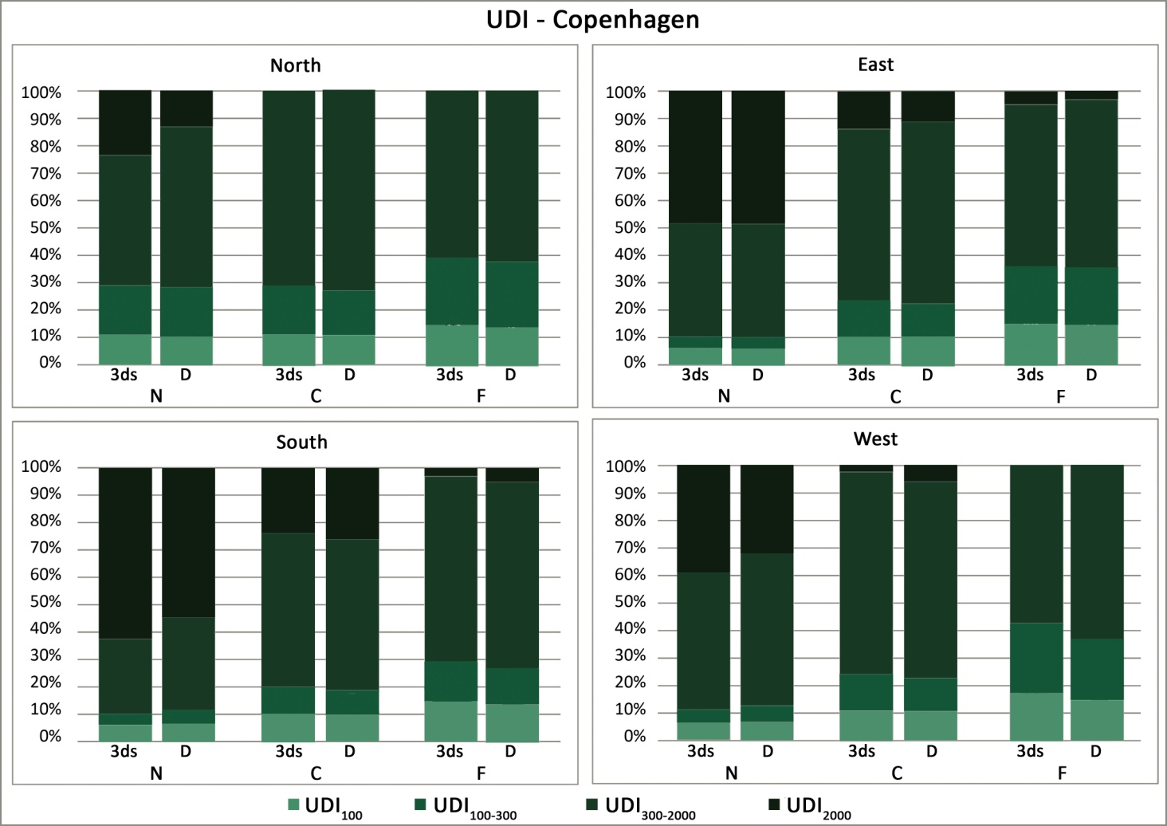
Figure 90a. UDI calculated with Daysim and 3ds Max Design® for Copenhagen.

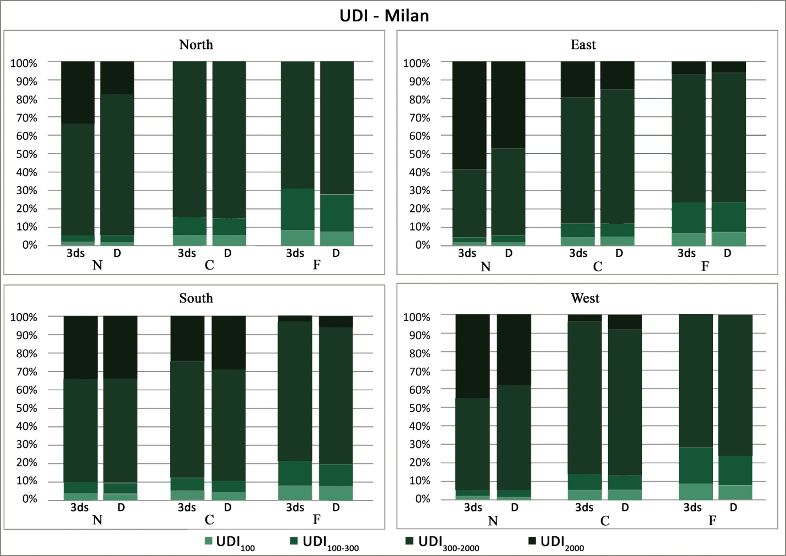
Figure 90b. UDI calculated with Daysim and 3ds Max Design® for Milan.

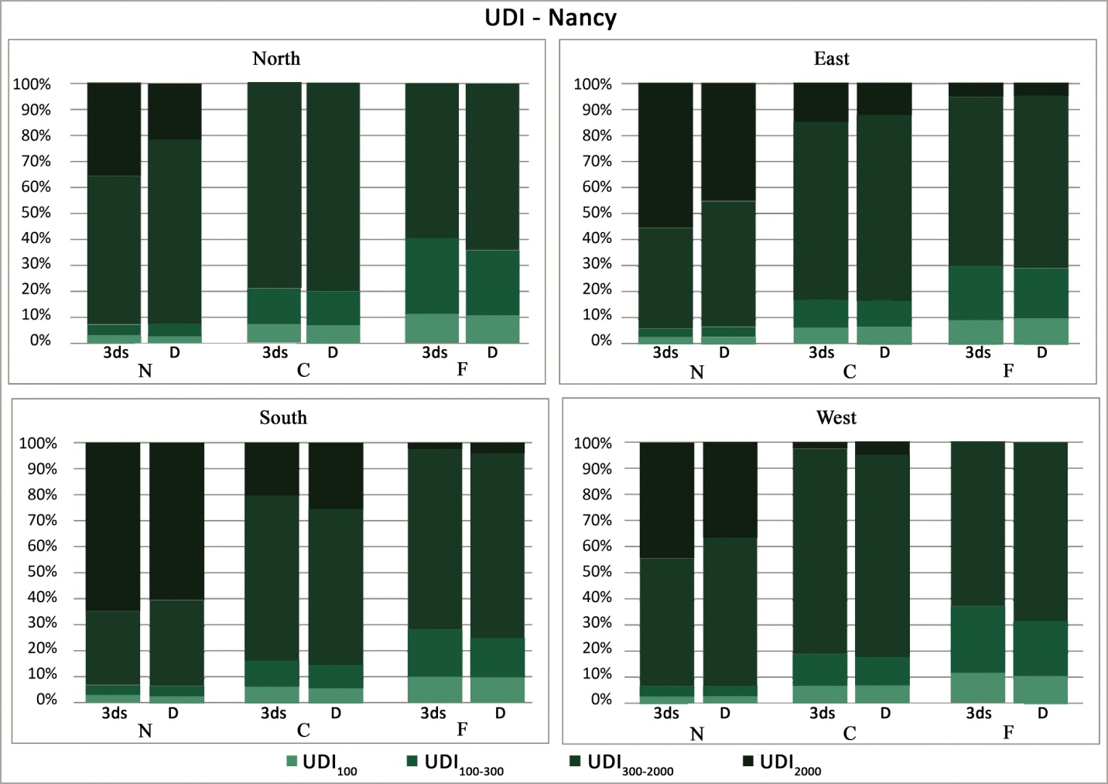
Figure 90c. UDI calculated with Daysim and 3ds Max Design® for Nancy.

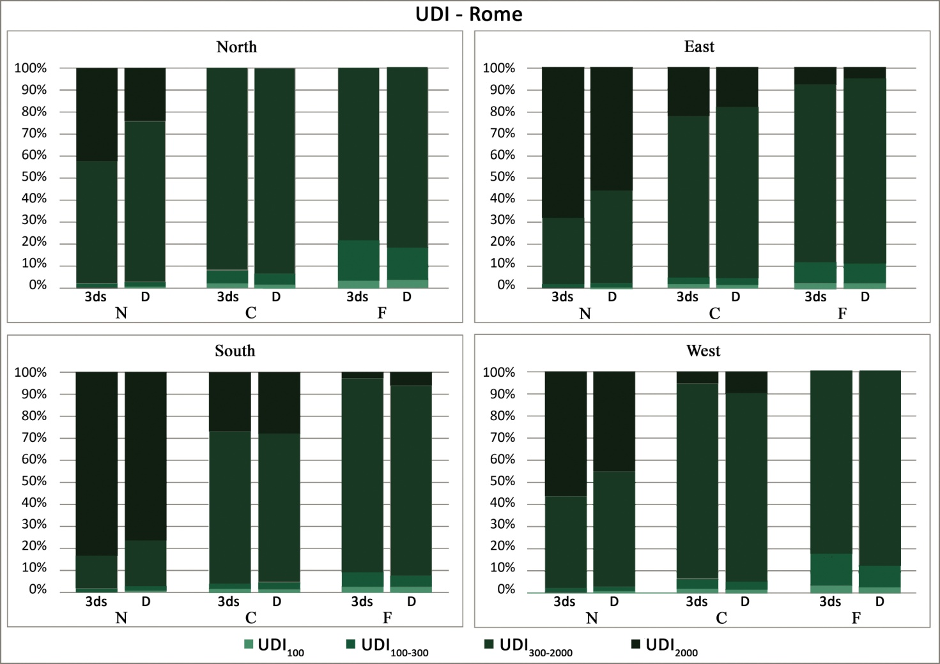
Figure 90d. UDI calculated with Daysim and 3ds Max Design® for Rome.

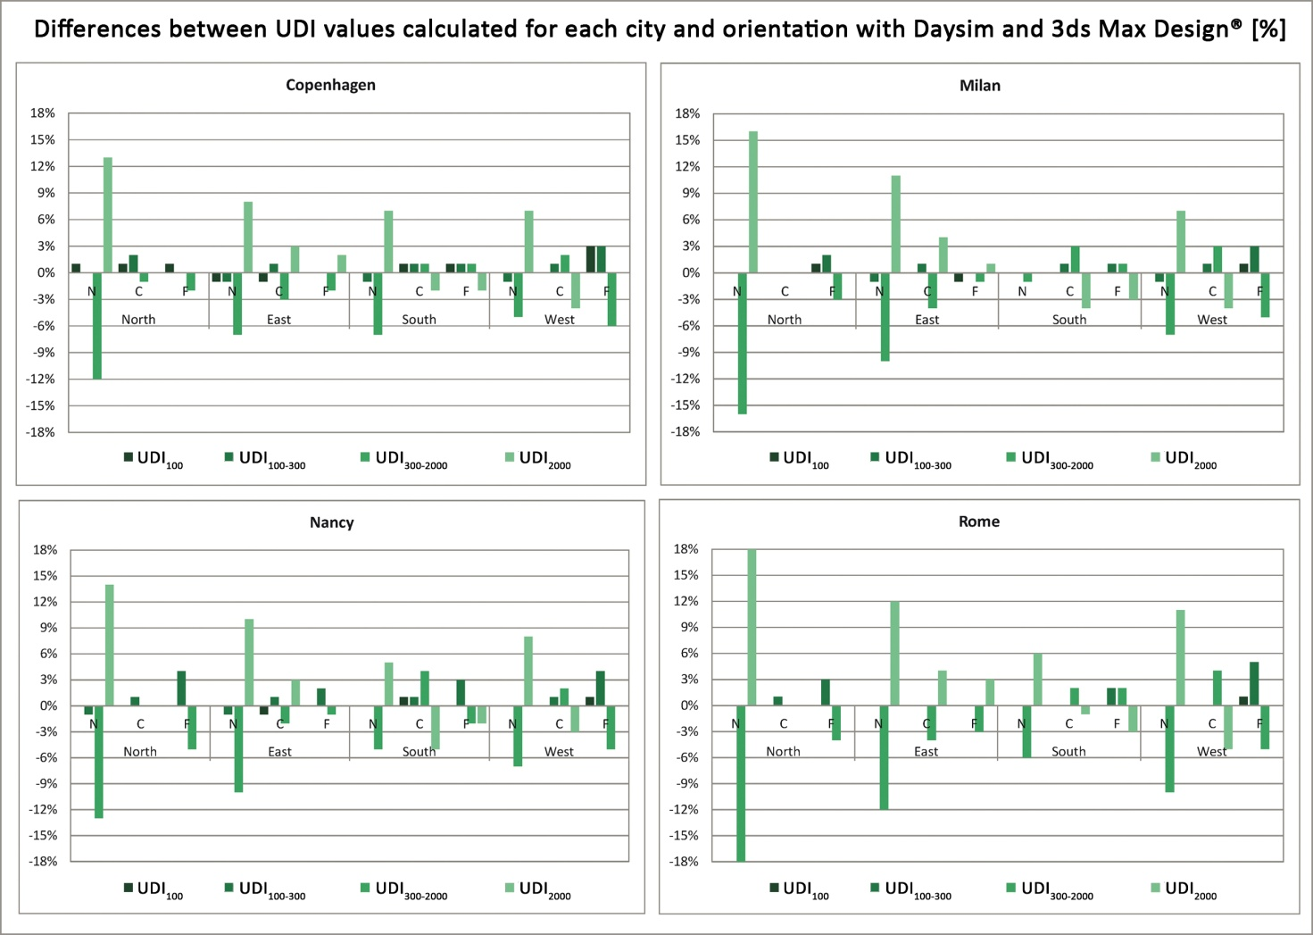
Figure 91. Differences between UDI values calculated for each city and orientation with Daysim and 3ds Max Design®.

The data reported in Figures 90a,b,c,d and 91 show that in most cases differences between UDI values calculated with Daysim and 3ds Max Design® for each city and orientation are negligible or even equal to 0%. The highest difference was found for UDI₃₀₀₋₂₀₀₀ and UDI₂₀₀₀ related to the N sensor in the North orientation in Rome (respectively -18% and 18%). High differences were also found for the same sensor, orientation and UDI ranges in the other cities and generally it can be observed that differences increase for these UDI₃₀₀₋₂₀₀₀ and UDI₂₀₀₀ in all orientations and cities. Therefore it can be inferred that the results obtained from Daysim and 3ds Max Design® tend to differ more when illuminance level are high.
The data previously reported highlighted the differences in the results obtained from the two software, such differences may have a significant impact on the calculation of lighting-related energy consumptions and thus on design choices.
To further point out this issue, basing on the daylight availability simulated by Daysim and 3ds Max Design®, the number of operating hours related to an hypothetical electric lighting system were calculated for all orientations in Rome. The hypothetical electric lighting system consists in two rows of luminaires parallel to the window as reported in Figure 92.

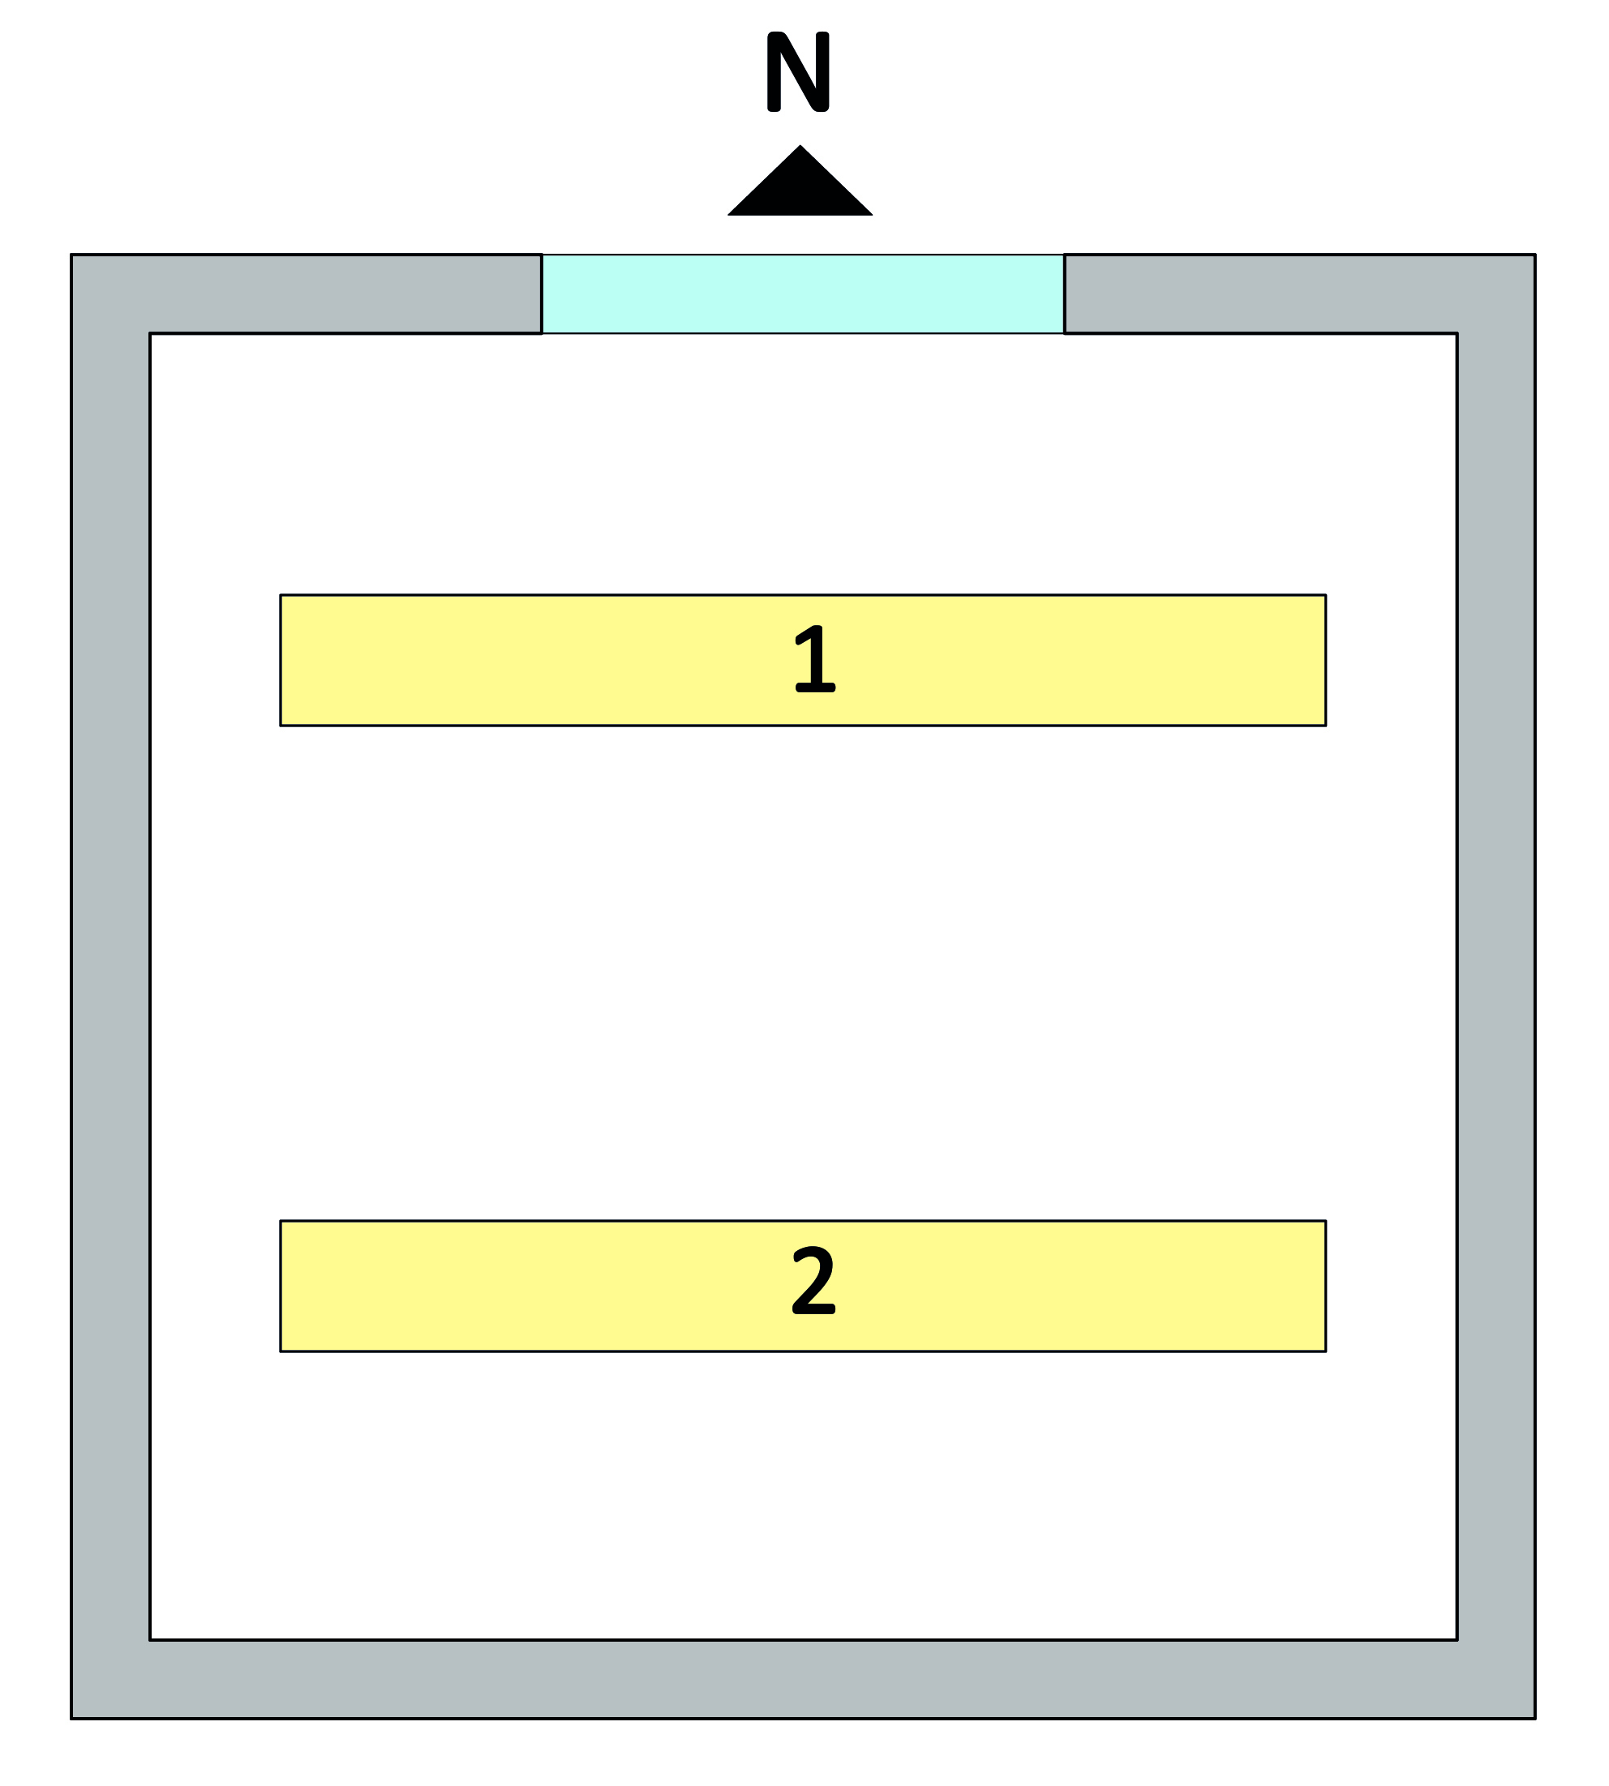
Figure 92. Hypothetical electric lighting system.

The calculation was performed by simply considering that the hypothetical lighting system will be switched on when each one of the software predicts daylight-related illuminances lower than the target illuminance (300 lx), therefore no actual electric lighting system was designed.
The results of this calculation are reported in Figure 93, they are related to two different configurations of the hypothetical lighting system: both rows of luminaires switched on or first row switched off and second one switched on.

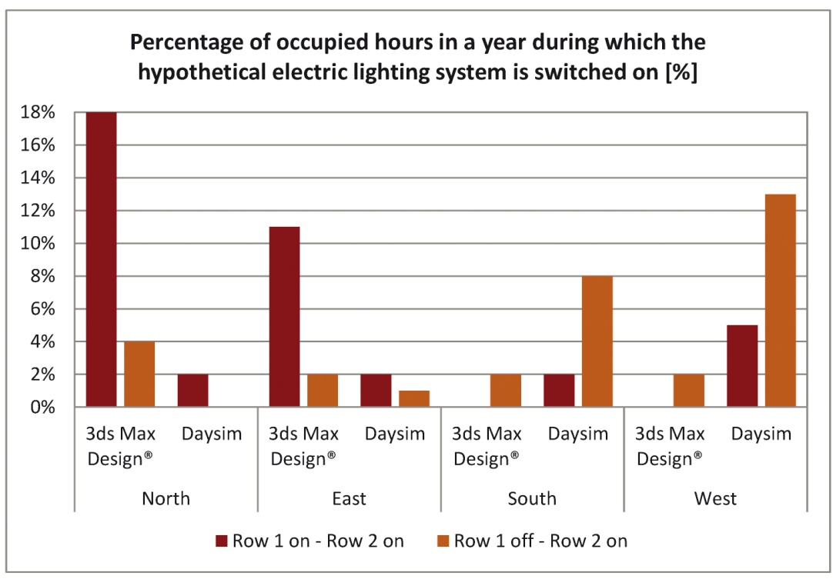
Figure 93. Percentage of occupied hours in a year during which the hypothetical electric lighting system is switched on.

It can be observed that differences are significant especially for North, East and West orientations; in more detail, with 3ds Max Design® the lighting system is switched on for a greater amount of time compared to Daysim thus meaning that the lighting-related energy consumption calculated with the former software is higher.

4.5. Discussion
The research project illustrated in this chapter demonstrated that the results of simulations carried out using TRY weather files are always considerably different than those obtained using IWEC, Meteonorm or Satel-Light weather files. In more detail, it was observed that irradiance values included in TRY files are lower than those included in IWEC, Meteonorm and Satel-Light weather files related to the same location and indeed the simulations' results obtained using TRY are lower than those obtained using the other weather files.
As regards the results obtained using IWEC, Meteonorm and Satel-Light files, they are generally similar and differences depend on the orientation, sensors' location and city, they also tend to be more significant when in presence of direct sunlight.
It is also important to highlight that in both studies on the impact of weather data files on simulations' results it was found out that differences increase when analyzing Annual or Monthly Light Exposure whereas they are smaller when comparing DA, DAcon and UDI values.
The comparison between the results of dynamic daylight simulations performed with Daysim and 3ds Max Design® also provided interesting results. Also in this case, differences depend on the orientation, sensors' location and city, in more detail it was observed that global illuminances differ more for the N sensor (the one closest to the window) for which the direct component of daylight has a greater impact. Indeed MBEs and RMSEs calculated between E_{d} related to Daysim and 3ds Max Design® are really high and the analysis of direct sunlight also showed that the amount of time during which Daysim predicts the presence of direct sunlight is greater than 3ds Max Design®'s one. Furthermore there are some sensors for which only Daysim predicts the presence of direct sunlight.
Such differences, as it was already highlighted in the previous subparagraph, are extremely relevant when designing electric lighting systems, shading devices and also when evaluating comfort (for example glare probability).
The comparison between UDI values calculated with Daysim and 3ds Max Design® also showed small differences, equal to 18% in the worst case.
In conclusion, the data obtained from this research project demonstrated that the choice of a weather file and/or software to perform dynamic daylight simulations may significantly affect the results obtained. Thus there is the need to deepen this topic by performing the same studies with other weather data files and software and also using more complex environments, in terms of geometry, characteristics of the glazing system, presence of shading devices, etc.

5. Conclusions
The introduction to this thesis illustrated the need to transition from a lighting design practice mainly based on ensuring the compliance with standards' requirements related to the performance of visual tasks and on the reduction of energy consumptions, to one that includes also the evaluation of non-visual effects of light, given their strong link with humans' health and wellbeing.
In other words, in a near future, the lighting design practice should be organized following the workflow illustrated in Figure 7 (chapter 1, page 8).

Figure 7. Lighting design workflow.

According to this workflow, the analysis of different design options is performed by carrying out both daylight and electric lighting simulations. These simulations will allow to calculate energy consumptions but they should also be performed by placing sensors not only on visual tasks but also at users' eye level in order to allow the evaluation of non-visual responses to light.
However it has been explained that there are obstacles to the applicability of this workflow that mainly lie in the still incomplete knowledge about the circadian system's working, in the need to introduce the evaluation of light's characteristics at users' eye level and also to develop a methodology to perform such evaluation, in the lack of studies that provide indications about the effects of using given weather data files and/or software on dynamic daylight simulations' outcomes.
Therefore the research project carried out during the PhD course addressed some of these obstacles in order to provide the basis to overcome them.
Indeed a methodology to perform eye level measurements was developed and used to analyze the characteristics of daylight and electric light at users' eye level (chapter 2).
The identification of a common methodology is a fundamental step in order to be able to compare results obtained from different researches and also to develop a database. This, in turn, will allow to verify if it could be possible to derive from the database standard eye level spectral irradiance distributions, in order to introduce the evaluation of non-visual responses to light in the design practice.
The proposed methodology was used to perform measurements in a University classroom and in three offices, all located in Naples, and this application allowed to improve the methodology and also provided interesting results (chapter 2, paragraphs 2.2 and 2.3).
Indeed, the data obtained highlighted the link between eye level illuminances and CS values and also showed that there is no relationship between CCTs and circadian impact. The most interesting finding is the similarity between measured eye level spectral irradiances and D50 and D55 CIE standard illuminants. This result is important because, if further researches will provide similar findings, it could be possible to use these standard illuminants to evaluate the circadian impact of given design options and therefore introduce this type of evaluation in the lighting design practice.
The application of the methodology in the University classroom also highlighted a critical point related to educational environments, which is the need to perform simultaneous measurements on several visual tasks at the same time. With standard instruments it is almost impossible to do so, therefore new techniques are required, such as the one based on the HDR imaging technique developed at the Photometry and Lighting Laboratory of the Department of Industrial Engineering of the University of Naples Federico II. This technique allows to obtain luminance maps and illuminance values on several visual tasks at the same time. Therefore a part of the PhD project also involved the study and test of this new technology, the use of which could be really helpful (chapter 2, subparagraph 2.2.4).
The characteristics of the light that reaches the eyes of people in indoor environments depend also on the optical properties of the environment's surfaces.
This influencing factor plays a more relevant role with electric light since factors such as geographical location, time of the day and period of the year cannot affect the characteristics of the light that reaches users' eyes like it happens for daylight. Therefore another significant part of the PhD course was dedicated to the investigation of the impact of the optical characteristics of an environment's surfaces on the light that reaches users' eyes (chapter 3).
A first study was carried out in an environment with "neutral" (grey) walls (paragraph 3.1) whereas in a following study one of the walls of the same environment was covered with colored cardboards (paragraph 3.2). The results obtained from the first study highlighted that even a "neutral" environment can modify the characteristics of the light that reaches users' eyes. However both studies demonstrated that the changes determined by the environment's surfaces do not produce significant variations in terms of circadian impact. Indeed it was found that the SPD of the light source and the eye level illuminance value are the parameters that significantly affect circadian impact.
Even if the optical characteristics of an environment's surfaces do not have a significant impact on the circadian system, the application of the CIECAM02 color appearance model in the second study showed that there are relevant changes in the values of color attributes related to the different colored cardboards when changing the light scenes. Such changes may translate into a perception of the environment as unpleasant when using given combinations of light sources' SPDs and walls' colors. Therefore this aspect is extremely important and should be taken into account in the design phase to avoid the determination of an unpleasant environment.
To further analyze this topic two studies were performed during the PhD course which investigated different aspects related the perception of colored objects (subparagraph 3.2.1).
The first study, about the perception of LEGO® cubes lit by different light scenes, demonstrated that there was good correlation between the hue evaluated by subjects and the one calculated with the CIECAM02 model; this was instead not verified with chroma. This result is interesting since the hue values calculated by applying the CIECAM02 model can be considered representative of hue as perceived by users. Consequently this finding may also mean that the variations in the hue values registered by applying the CIECAM02 model in the study on colored cardboards may also be perceived by users.
The second study focused on analyzing the influence of parameters such as the CCT of the light scene, the color of the background and the illuminance level on the perception of a two-dimensional artwork. According to the answers given by subjects, there is a strong relationship between the color of the background and comfort; between the illuminance level and the enhancement and the perception of brightness and also between the light scene's CCT and the atmosphere felt by users.
These results are useful not only in museum applications but they may also be taken into account when designing other types of environments.
The last part of the PhD course was dedicated to dynamic daylight simulations (chapter 4); indeed they are frequently used by designers to evaluate the daylight availability related to different design options and consequently the energy consumptions related to each one of them.
There are different software available that can perform this type of simulation and they all need a weather data file of the design location as input. There are also several weather data files available, each one of them built using a different method.
Therefore the last part of the PhD project was focused on investigating if the use of different weather data files to perform the same simulation provides different results (paragraph 4.3). Moreover the effects on simulations' results of using different software was also analyzed (paragraph 4.4).
These studies demonstrated that usually differences are greater when analyzing Annual or Monthly Light Exposure than when considering dynamic daylight metrics (DA, DAcon and UDI). It was also found that results obtained from simulations carried out using TRY files are considerably different from those obtained using IWEC, Meteonorm or Satel-Light ones which are instead similar.
The study on the impact of using different software on simulations' results showed that Daysim and 3ds Max Design® provide similar UDI values. However, when analyzing direct illuminances, the difference is instead relevant.
The differences found in these studies may significantly affect the evaluation of comfort and of the operating hours of lighting and shading systems, therefore also influencing the calculation of energy consumptions made using the data obtained from simulations.

In conclusion, this thesis provided the basis to make the current lighting design practice more human centric. Indeed lighting design should develop spaces that are designed taking into account the characteristics of the human visual and circadian systems but also the way humans perceive the world around them. In wider terms, the ultimate goal of architects, engineers and designers should be to create spaces that are comfortable, pleasant and that enhance people's health and wellbeing while keeping energy consumptions as low as possible.

6. List of Figures and Tables
Figure 1. Electricity consumptions breakdown in the EU.
Figure 2. Circadian rhythms.
Figure 3. Effects of circadian disruption on humans' health.
Figure 4. Parameters affecting the impact of a light stimulus on the circadian system.
Figure 5. Relationship between melatonin trends and light.
Figure 6. Elements to be considered in the lighting design practice.
Figure 7. Lighting design workflow.
Figure 8. Angles used to perform eye level measurements.
Figure 9. Photopigments sensitivity functions.
Figure 10. Measured plan of the classroom and pictures of the external obstructions and of its interior.
Figure 11. Spectral, SCI and SCE reflectances for the classroom's surfaces and furniture.
Figure 12. Sky SPDs and CCTs, global outdoor illuminances on 26th January 2012.
Figure 13. Horizontal plane illuminances, average eye level illuminances and CCTs, CS values on 26th January 2012.
Figure 14. Comparison between D series standard illuminants and average eye level spectral irradiances for 26th January 2012.
Figure 15. Sky SPDs and CCTs, global outdoor illuminances on 2nd February 2012.
Figure 16. Horizontal plane illuminances, average eye level illuminances and CCTs, CS values on 2nd February 2012.
Figure 17. Comparison between D series standard illuminants and average eye level spectral irradiances for 2nd February 2012.
Figure 18a. Fluorescent luminaires' SPD.
Figure 18b. Planckian locus.
Figure 19. Illuminance on a horizontal plane, average eye level CCTs and illuminances, CS values.
Figure 20. Normalized eye level spectral irradiances detected with the electric lighting system.
Figure 21. Office1's measured plan, interior and external obstructions' photos.
Figure 22. Office2's measured plan, interior and external obstructions' photos.
Figure 23. Office3's measured plan, interior and external obstructions' photos.
Figure 24. Spectral reflectances of the offices' surfaces and furniture.
Figure 25. Global outdoor illuminances on clear sky days.
Figure 26. Sky CCTs on clear sky days.
Figure 27. Desk illuminances on clear sky days.
Figure 28. Average eye level CCTs on clear sky days.
Figure 29. Average eye level illuminances on clear sky days.
Figure 30. CS values on clear sky days.
Figure 31. Global outdoor illuminances on intermediate sky days.
Figure 32. Sky CCTs on intermediate sky days.
Figure 33. Desk illuminances on intermediate sky days.
Figure 34. Average eye level CCTs on intermediate sky days.
Figure 35. Average eye level illuminances on intermediate sky days.
Figure 36. CS values on intermediate sky days.
Figure 37. Global outdoor illuminances on overcast sky days.
Figure 38. Sky CCTs on overcast sky days.
Figure 39. Desk illuminances on overcast sky days.
Figure 40. Average eye level CCTs on overcast sky days.
Figure 41. Average eye level illuminances on overcast sky days.
Figure 42. CS values on overcast sky days.
Figure 43a. Fluorescent luminaires' normalized SPDs.
Figure 43b. Average eye level spectral irradiances.
Figure 44. DALI system's touch panel.
Figure 45a. Fluorescent luminaires' picture, dimensions and photometric data.
Figure 45b. LED luminaires' picture, dimensions and photometric data.
Figure 46. Test room's measured plan, section and photo.
Figure 47a. Light scenes' normalized SPDs.
Figure 47b. Light scenes' average eye level spectral irradiances.
Figure 48. CS_{e} and CS_{s} values for each light scene.
Figure 49. CS values for WF1 and CL1.
Figure 50. Test room's measured plan and luminaires' position.
Figure 51. Colored cardboards' spectral reflectances.
Figure 52. Light scenes' SPDs.
Figure 53a. Average eye level spectral irradiances for each colored cardboard under the 2700 K light scene.
Figure 53b. Average eye level spectral irradiances for each colored cardboard under the 3000 K light scene.
Figure 53c. Average eye level spectral irradiances for each colored cardboard under the 4500 K light scene.
Figure 53d. Average eye level spectral irradiances for each colored cardboard under the 6500 K light scene.
Figure 54. Pictures of the test room with the dark violet, red and dark blue cardboards lit by the different light scenes.
Figure 55. Average CS values for each light scene and colored cardboards.
Figure 56. CS values related to orange and violet cardboards for each light scene and for different eye level illuminances.
Figure 57. CIECAM02's hue and chroma values for each light scene and colored cardboard.
Figure 58. LEGO® cubes spectral reflectances.
Figure 59a. Light scenes' normalized SPDs.
Figure 59b. Test room lit by the different light scenes.
Figure 60. Test sample.
Figure 61. Henri Matisse's "Dame en blue".
Figure 62. Luminaires' photo, dimensions and photometric data.
Figure 63. Light scenes' measured SPDs, CCTs, CRI values and illuminances on the painting.
Figure 64a. Spectral reflectances of the colored cardboards and of the painting.
Figure 64b. Color wheel.
Figure 65a. Experimental setting.
Figure 65b. Photos of the experimental setting.
Figure 66. Self Assessment Manikin Test.
Figure 67a. Questions 1 and 2.
Figure 67b. Questions 3 and 4.
Figure 67c. Questions 5, 6 and 7.
Figure 68a. Average values of the answers to questions 1 and 2.
Figure 68b. Average values of the answers to questions 3 and 4.
Figure 68c. Average values of the answers to questions 5, 6 and 7.
Figure 69. Parameters affecting the painting's perception.
Figure 70. Cumulative frequency curves for global horizontal irradiance referred to each city and each year included in the Satel-Light database.
Figure 71a. Cumulative frequency curves for global horizontal irradiance referred to each city and each weather data file.
Figure 71b. Cumulative frequency curves for direct normal irradiance referred to each city and each weather data file.
Figure 71c. Cumulative frequency curves for diffuse horizontal irradiance referred to each city and each weather data file.
Figure 72. Measured plan and section of the simulated environment and analysis grid.
Figure 73. Annual Light Exposure for each city and weather data file.
Figure 74. Annual Light Exposure percentage differences between Satel-Light and the other weather data file.
Figure 75a. Monthly Light Exposure for Copenhagen.
Figure 75b. Monthly Light Exposure for London.
Figure 75c. Monthly Light Exposure for Milan.
Figure 75d. Monthly Light Exposure for Nancy.
Figure 75e. Monthly Light Exposure for Rome.
Figure 76a. DA values calculated for each city and each weather data file.
Figure 76b. DAcon values calculated for each city and each weather data file.
Figure 77. UDI values calculated for each city and each weather data file.
Figure 78. Office's measured plan, section and analysis grid.
Figure 79. Annual Light Exposure percentage differences between Satel-Light and the other weather data file.
Figure 80. Annual percentage of occupied hours during which E_{sun} is comprised between 0 and 1000 lx or is greater than 1000 lx.
Figure 81a. DAcon values calculated for Copenhagen.
Figure 81b. DA values calculated for Rome.
Figure 82a. DAcon values calculated for Copenhagen.
Figure 82b. DAcon values calculated for Rome.
Figure 83a. UDI values calculated for Copenhagen.
Figure 83b. UDI values calculated for Rome.
Figure 84. Office's measured plan, section and analysis grid.
Figure 85. Annual frequency for which E_{g-3ds} - E_{g-Daysim} is lower, equal or greater than 0.
Figure 86. MBEs calculated between E_{g-3ds} - E_{g-Daysim}.
Figure 87. RMSEs calculated between E_{g-3ds} - E_{g-Daysim}.
Figure 88. Annual frequency for which only Daysim or 3ds Max Design® or both software predict the presence of direct sunlight.
Figure 89. E_{g}, E_{d} and E_{ind} calculated with Daysim and 3ds Max Design®on 2nd January for Rome.
Figure 90a. UDI calculated with Daysim and 3ds Max Design® for Copenhagen.
Figure 90b. UDI calculated with Daysim and 3ds Max Design® for Milan.
Figure 90c. UDI calculated with Daysim and 3ds Max Design® for Nancy.
Figure 90d. UDI calculated with Daysim and 3ds Max Design® for Rome.
Figure 91. Differences between UDI values calculated for each city and orientation with Daysim and 3ds Max Design®.
Figure 92. Hypothetical electric lighting system.
Figure 93. Percentage of occupied hours in a year during which the hypothetical electric lighting system is switched on.

Table 1. Dynamic daylight performance metrics and their definitions.
Table 2. D series standard illuminants closest to average eye level spectral irradiances for 26th January 2012 (clear sky day).
Table 3. D series standard illuminants closest to average eye level spectral irradiances for 2nd February 2012 (overcast sky day).
Table 4. Measured CCT, CRI and ∆uv values related to the fluorescent luminaires.
Table 5. D series standard illuminants closest to average eye level spectral irradiances for clear sky days.
Table 6. D series standard illuminants closest to average eye level spectral irradiances for intermediate sky days.
Table 7. D series standard illuminants closest to average eye level spectral irradiances for overcast sky days.
Table 8. Luminaires' measured CCT, CRI and ∆uv values.
Table 9. Luminaires' desk and average eye level illuminances, CS values and average eye level CCTs.
Table 10. Touch panel's technical data.
Table 11. Luminaires' technical data.
Table 12. Light scenes.
Table 13. Desk and eye level illuminances.
Table 14. Eye level CCTs.
Table 15. Light scenes' measured CRI, ∆uv and CCT value.
Table 16. Color appearance attributes' definitions.
Table 17. Desk and average eye level illuminances for each light scene and colored cardboard.
Table 18. Average eye level CCTs for each light scene and colored carboard.
Table 19. Analysis of chromatic differences.
Table 20. Light scenes' measured CCTs, CRI and desk illuminances.
Table 21. Hue values derived from the test and from the CIECAM02 model.
Table 22. Chroma values derived from the test and from the CIECAM02 model.
Table 23. Perceived quantities of black and white.
Table 24. Technical data of each wallwasher.
Table 25. Standard deviations for each background and light scene.
Table 26. Climatic data related to each city used in the research project.
Table 27. Minimum and maximum differences for global horizontal, direct normal and diffuse horizontal irradiances related to each weather data file and each city.
Table 28. Surfaces' reflectances and parameters of their materials assigned in Daysim.
Table 29. Parameters used to perform the simulations with Daysim.
Table 30. Materials' reflectances and parameters assigned in DIVA.
Table 31. Simulations' parameters set in DIVA.
Table 32. Characteristics and calculation times for the two computers used to carry out the simulations.
Table 33. Materials' reflectances and parameters assigned in Daysim and 3ds Max Design®.
Table 34. Parameters used to perform the simulations with Daysim.
Table 35. Parameters used to perform the simulations with 3ds Max Design®.
Table 36. Characteristics and calculation times for the two computers used to perform the simulations.
Table 37. Number of occupied hours in a year during which only Daysim or 3ds Max Design® or both of them calculate direct sunlight.
Table 38. MBEs calculated between E_{d} simulated with Daysim and 3ds Max Design®.
Table 39. RMSEs calculated between E_{d} simulated with Daysim and 3ds Max Design®.

7. References

[1] | Paolo Bertoldi and Bogdan Atanasiu, "Electricity Consumption and Efficiency Trends in European Union - Status Report 2009," Joint Research Center - JRC, 2009.
[2] | EN 12464-1 Light and lighting - Lighting of work places - Part I: Indoor work places, 2011.
[3] | Robert J Lucas et al., "Measuring and using light in the melanopsin age," Trends in Neurosciences, vol. 37, no. 1, pp. 1-9, 2014.
[4] | Lisa Heschong, "Daylighting and human performance," ASHRAE journal, no. 44.6, pp. 65-67, 2002.
[5] | Lennart Wetterberg, "Light and biological rhythms," Journal of internal medicine, vol. 235, no. 1, pp. 5-19, 1994.
[6] | D. C. Klein and R. Y., Reppert, S. M. Moore, Suprachiasmatic nucleus: the mind’s clock. New York: Oxford University Press, 1991.
[7] | T. Roenneberg and M Merrow, "The network of time: understanding the molecular circadian system," Current Biology, vol. 13, no. 5, pp. 198-207, 2003.
[8] | J. F. Duffy and K. P. Wright, "Entrainment of the human circadian system by light," Journal of Biological Rhythms, vol. 20, no. 4, pp. 326-338, 2005.
[9] | Jeanne F Duffy and Charles A Czeisler, "Effect of light on human circadian physiology," Sleep medicine clinics, vol. 4, no. 2, pp. 165-177, 2009.
[10] | S Gery and HP Koeffler, "Circadian rhythms and cancer," Cell Cycle, no. 9, pp. 1097 - 1103, 2010.
[11] | Igor Knez, "Effects of indoor lighting on mood and cognition," Journal of Environmental Psychology, vol. 15, no. 1, pp. 39-51, 1995.
[12] | T. A. Wehr, "Photoperiodism in humans and other primates: evidence and implications4," Journal of Biological Rhythms, vol. 16, no. 4, pp. 348-364, 2001.
[13] | I Kwon, H. K. Choe, G. H. Son, and K. Kim, "Mammalian molecular clocks," Experimental Neurobiology, vol. 20, no. 1, pp. 18-28, 2011.
[14] | Ron Chepesiuk, ""Missing the dark: health effects of light pollution"," Environmental Health Perspectives, vol. 117, no. 1, pp. A20-A27, 2009.
[15] | Roger A Ekirch, At Day's Close: Night in Times Past.: W. W. Norton & Company, 2006.
[16] | RG Stevens et al., "Meeting Report: The role of environmental lighting and circadian disruption in cancer and other diseases," Environmental Health Perspectives, no. 115 (9), pp. 1357 - 1362, 2007.
[17] | Mariana G Figueiro, "An Overview of the Effects of Light on Human Circadian Rhythms: Implications for New Light Sources and Lighting Systems Design," Journal of Light & Visual Environment, vol. 37, no. 2 & 3, pp. 15-25, 2013.
[18] | GC Brainard et al., "Sensitivity of the human circadian system to short-wavelength (420-nm) light," Biological Rhythms, no. 23, pp. 379 - 386, 2008.
[19] | Joshua J Gooley et al., "Spectral Responses of the Human Circadian System depend on the Irradiance and duration of exposure to light," Science translational Medicine, no. 2, pp. 31 - 33, 2010.
[20] | V L Revell, J Arendt, L F Fogg, and D J Skene, "Alerting effects of light are sensitive to very short wavelengths," Neuroscience letters, vol. 399, no. 1, pp. 96-100, 2006.
[21] | V L Revell, J Arendt, M Terman, and D J Skene, "Short-wavelength sensitivity of the human circadian system to phase-advancing light," Journal of biological rhythms, vol. 20, no. 3, pp. 270-272, 2005.
[22] | A U Viola, L M James, L J Schlangen, and D J Dijk, "Blue-enriched white light in the workplace improves self-reported alertness, performance and sleep quality.," Scandinavian journal of work, environment & health, pp. 297-306, 2008.
[23] | George C Brainard et al., "Action Spectrum for Melatonin Regulation in Humans : Evidence for a Novel Circadian Photoreceptor," Journal of Neuroscience, vol. 21, no. 16, pp. 6405-6412, 2001.
[24] | Kavita Thapan, Josephine Arendt, and Debra J Skene, "An action spectrum for melatonin suppression : evidence for a novel non - rod, non - cone photoreceptor system in humans," Journal of Physiology, no. 535.1, pp. 261-267, 2001.
[25] | S W Lockley, G C Brainard, and C A Czeisler, "High sensitivity of the human circadian melatonin rhythm to resetting by short wavelength light," Journal of Clinical Endocrinology Metabolism, vol. 88, no. 9, pp. 4502-4505, 2003.
[26] | Josephine Arendt and James Broadway, "Light and melatonin as zeitgebers in man," Chronobiology international , vol. 4, no. 2, pp. 273-282, 1987.
[27] | Dierich Gall and Karin Bieske, "Definition and measurement of circadian radiometric quantities," in Proceedings of the CIE Symposium'04 on Light and Health. 2004, 2004, pp. 129-132.
[28] | Christopher S Pechacek, Marilyne Andersen, and Steven W Lockley, "Preliminary method for prospective analysis of the circadian efficacy of (day) light with applications to healthcare architecture," Leukos, vol. 5, no. 1, pp. 1-26, 2008.
[29] | K Wandachowics. (2006) Calculation of the circadian illuminance distribution with radiance. [Online]. http://www.radiance-online.org/radiance-workshop5/2006_Radiance_Workshop/Presentations/Wandachowics-2_RW2006.pdf
[30] | S Gochenour and M Andersen, "Circadian effects of daylighting in a residential environment," in Proceedings of the Lux Europa 2009-11th European lighting conference, Istanbul (Turkey), 2009, pp. 1-8.
[31] | Mark S Rea, Mariana G Figueiro, John D Bullough, and Andrew Bierman, "A model of phototransduction by the human circadian system," Brain Research Review, no. 50, pp. 213-218, 2005.
[32] | Mark S Rea, Mariana G Figueiro, Andrew Bierman, and John D Bullough, "Circadian light," Journal of Circadian Rhythms, vol. 8, no. 2, 2010.
[33] | Mark S Rea, Mariana G Figueiro, Andrew Bierman, and R Hamner, "Modeling the spectral sensitivity of the human circadian system," Lighting Research and Technology, no. 0, pp. 1-12, 2011.
[34] | J al Enezi et al., "A “melanopic” spectral efficiency function predicts the sensitivity of melanopsin photoreceptors to polychromatic lights," Journal of biological rhythms, vol. 26, no. 4, pp. 314-323, 2011.
[35] | David M Berson, Felice A Dunn, and Motoharu Takao, "Phototransduction by Retinal Ganglion Cells That Set the Circadian Clock," Science, no. 295, pp. 1070–1073, 2002.
[36] | A D Güler et al., "Melanopsin cells are the principal conduits for rod–cone input to non-image-forming vision," Nature, vol. 453, no. Güler, A. D., Ecker, J. L., Lall, G. S., Haq, S., Altimus, C. M., Liao, H. W.,. & Hattar, S. (2008). Melanopsin cells are the principal conduits for rod–cone input to non-image-forming vision. Nature, 453(7191), 102-105., pp. 102-105, 2008.
[37] | Megumi Hatori et al., "Inducible Ablation of Melanopsin-Expressing Retinal Ganglion Cells Reveals Their Central Role in Non-Image Forming Visual Responses ," PLoS ONE , vol. 3, no. 6, p. e2451, 2008.
[38] | S Hattar, H W Liao, M Takao, D M Berson, and K W Yau, "Melanopsin-containing retinal ganglion cells: architecture, projections, and intrinsic photosensitivity," Science, vol. 295, no. 5557, pp. 1065-1070, 2002.
[39] | S Hattar et al., "Melanopsin and rod–cone photoreceptive systems account for all major accessory visual functions in mice," Nature, vol. 424, no. 6944, pp. 75-81, 2003.
[40] | M Andersen, J Mardaljevic, and SW Lockley, "A framework for predicting the non-visual effects of daylight - Part I: photobiology- based model," Lighting Research and Technology, vol. 44, pp. 37-53, 2012.
[41] | J Mardaljevic, M Andersen, N Roy, and J Christoffersen, "A framework for predicting the non-visual effects of daylight - Part II: The simulation model," Lighting Research and Technology, vol. 46, no. 4, pp. 388-406, 2014.
[42] | L Bellia, A Pedace, and G Barbato, "Lighting in educational environments: An example of a complete analysis of the effects of daylight and electric light on occupants," Building and Environment, vol. 68, pp. 50-65, 2013.
[43] | L Bellia, A Pedace, and G Barbato, "Daylighting offices: A first step toward an analysis of photobiological effects for design practice purposes," Building and Environment, vol. 74, pp. 54-64, 2014.
[44] | L Bellia, A Pedace, and G Barbato, "Winter and summer analysis of daylight characteristics in offices," Building and Environment, vol. 81, pp. 150-161, 2014.
[45] | Laura Bellia, Alessia Pedace, Giuseppe Barbato, and Francesca Fragliasso, "Complete evaluation of daylight characteristics in working environments," in 6th VELUX Daylight Symposium, London, 2015.
[46] | L Bellia, A Pedace, and G Barbato, "Indoor artificial lighting: Prediction of the circadian impact of different spectral power distributions," Lighting Research and Technology, vol. 46, no. 6, pp. 650-660, 2014.
[47] | Laura Bellia, Alessia Pedace, and Francesca Fragliasso, "Indoor lighting quality: Effects of different walls colours," Lighting Research & Technology, no. DOI: 10.1177/1477153515594654, 2015.
[48] | L Bellia, A Pedace, and E Stefanizzi, "Perceived and measured colour attributes under different sources," in Proceedings of the 14th International Symposium on the Science and Technology of Lighting (LS14), Como, 2014.
[49] | L Bellia, M Forgione, E Stefanizzi, Pedace A, and F Fragliasso, "Impact of backgrounds and light scenes' characteristics on paintings' perception," in 28th CIE Session CIE 216:2015, Manchester, UK; 28 June/4 July 2015, vol 1 - part 2, Manchester, 2015, pp. 933-940.
[50] | Peter Boyce, Claudia Hunter, and Owen Howlett, "The benefits of daylight through windows," Troy, New York, 2003.
[51] | PJ Waldram, A Measuring Diagram for Daylight Illumination. London: B T Batsford Ltd, 1950.
[52] | J Mardaljevic, L Heschong, and E Lee, "Daylight metrics and energy savings," Lighting Research Technology, no. 41, pp. 261–283, 2009.
[53] | Christoph Reinhart, John Mardaljevic, and Zack Rogers, "Dynamic daylight performance metrics for sustainable building design," Leukos, no. 3(1), pp. 7-31, 2006.
[54] | Zack Rogers. (2006) Daylighting Metric Development Using Daylight Autonomy Calculations In the Sensor Placement Optimization Tool. [Online]. http://www.archenergy.com/SPOT/download.html
[55] | CF Reinhart and O Walkenhorst, "Dynamic RADIANCE-based Daylight Simulations for a full-scale Test Office with outer Venetian Blinds," Energy & Buildings, no. 33(7), pp. 683-697, 2001.
[56] | Azza Nabil and John Mardaljevic, "Useful Daylight Illuminance: A New Paradigm to Access Daylight in Buildings," Lighting Research & Technology, no. 37(1), pp. 41-59, 2005.
[57] | Azza Nabil and John Mardaljevic, "Useful Daylight Illuminances: A Replacement for Daylight Factors," Energy and Buildings, no. 38(7), pp. 905-913, 2006.
[58] | IES LM-83-12 "Approved Method: IES Spatial Daylight Autonomy (sDA) and Annual Sunlight Exposure (ASE)" , 2013.
[59] | J A Jakubiec and F C Reinhart, "DIVA 2.0: Integrating daylight and thermal simulations using Rhinoceros 3D, Daysim and EnergyPlus," in 12th Conference of International Building Performance Simulation Association, Sydney, 2011.
[60] | L Bellia, A Pedace, and F Fragliasso, "The role of weather data files in Climate-based Daylight Modeling," Solar Energy , vol. 112, pp. 169-182, 2015.
[61] | L Bellia, A Pedace, and F Fragliasso, "Dynamic daylight simulations: Impact of weather file’s choice.," Solar Energy, vol. 117, pp. 224-235, 2015.
[62] | L Bellia, A Pedace, and F Fragliasso, "The impact of the software’s choice on dynamic daylight simulations’ results: A comparison between Daysim and 3ds Max Design," Solar Energy 2015, vol. 122, pp. 249-263, 2015.
[63] | CM-2600d spectrophotomer. [Online]. http://www.konicaminolta.it/fileadmin/CONTENT/Measurement_Instruments/Download/Catalogue_Download/cm2600d_e9.pdf
[64] | CS2000 spectroradiometer. [Online]. http://sensing.konicaminolta.asia/products/cs-2000-spectroradiometer/
[65] | T10 Illuminance meter. [Online]. http://sensing.konicaminolta.asia/products/t-10-t-10m-illuminance-meter/
[66] | Robert J Lucas et al. Irradiance Toolbox. [Online]. http://www.eye.ox.ac.uk/team/principal-investigators/stuart-peirson/downloadstile-14/filetile-4/@@download.
[67] | L Bellia, G Spada, and A Pedace, "Lit environments quality: A software for the analysis of luminance maps obtained with the HDR imaging technique," Energy and Buildings, vol. 67, pp. 143-152, 2013.
[68] | L Bellia, G Spada, A Pedace, and F Fragliasso, "Methods to evaluate lighting quality in educational environments," in 6th International Conference on Building Physics for a Sustainable Built Environment - IBPC, Turin, 2015.
[69] | L Bellia, G Spada, and A Pedace, "Lit environments quality: A software for the analysis of luminance maps obtained with the HDR imaging technique," Energy and Buildings, vol. 67, pp. 143-152, 2013.
[70] | 8-01 CIE TC, "A Color appearance model for color management systems," CIE Central Bureau, Vienna, Publication 159 ISBN 3-901906-29-0., 2004.
[71] | Commision Internationale de l' Eclairage - CIE. Termlist. [Online]. http://eilv.cie.co.at/
[72] | Drury B Crawley, "Which Weather Data Should You Use for Energy Simulations of Commercial Buildings?," in ASHRAE 1998 TRANSACTIONS 104.: ASHRAE, 1998, p. Part 2.
[73] | A Iversen, S Svendsen, and TR Nielsen, "The effect of different weather data sets and their resolution on climate-based daylight modelling," Lighting Research & Technology, no. 45, pp. 305–316, 2013.
[74] | Christoph Reinhart Reinhart and Pierre-Felix Breton, "Experimental Validation of Autodesk® 3ds Max® Design 2009 and Daysim 3.0," LEUKOS: The Journal of the Illuminating Engineering Society of North America, no. 6, pp. 7-35, 2009.
[75] | (2015, Nov.) Danmarks Meteorologiske Institut. [Online]. http://www.dmi.dk/vejr/arkiver/normaler-og-ekstremer/klimanormaler-dk/
[76] | (2015, Nov.) Met Office. [Online]. http://www.metoffice.gov.uk/public/weather/climate/gepsvf37b
[77] | (2015, Nov.) Servizio Meteorologico Aereonautica Militare. [Online]. http://www.meteoam.it
[78] | (2015, Nov.) Meteo France. [Online]. http://www.meteofrance.com/climat/france/nancy/54526001/normales
[79] | CIE TC 3.07. International Daylight Measurement Programme (IDMP). [Online]. http://idmp.entpe.fr/
[80] | ASHRAE, "International Weather for Energy Calculations (IWEC Weather Files) Users Manual and CD-ROM," Atlanta, 2001.
[81] | (2015, December) U.S. Department of Energy, Energy Efficiency & Renewable Energy. [Online]. http://apps1.eere.energy.gov/buildings/energyplus/weatherdata_about.cfm
[82] | H Lund and S Eirdoff, "Selection methods for production of test reference years, EUR 7306 EN Final Report, Short Version," 1981.
[83] | CEC, "Test Reference Year TRY Weather Data Sets for Computer Simulations of Solar Energy Systems and Energy Consumptions in Buildings.," Commission of the European Communities, Directorate General XII for Science, Research and Development, 1985.
[84] | Meteonorm. [Online]. http://meteonorm.com/
[85] | Meteonorm. (2014, September) Handbook Part II: Theory. [Online]. http://meteonorm.com/images/uploads/downloads/mn71_theory.pdf
[86] | J Remund and SC Müller. (2014, September) Solar radiation and uncertainty information of Metornorm 7. [Online]. http://meteonorm.com/images/uploads/downloads/PVSEC_11_mn7_p.pdf
[87] | (2015, Nov.) Radiance - A Validated Lighting Simulation Tool. [Online]. http://www.radiance-online.org/
[88] | CF Reinhart and M Andersen, "Development and validation of a Radiance model for a translucent panel," Energy and Buildings, no. 38(7) , pp. 890-904, 2006.
[89] | CF Reinhart and S Herkel, "The simulation of annual daylight illuminance distributions- A state of the art comparison of six RADIANCE based methods," Energy & Buildings, no. 32 (2) , pp. 167-187, 2000.
[90] | Christoph F Reinhart, "Lightswitch-2002: a model for manual and automated control of electric lighting and blinds," Solar Energy, no. 77, pp. 15–28, 2004.
[91] | D Bourgeois, CF Reinhart, and G Ward, "A Standard Daylight Coefficient Model for Dynamic Daylighting Simulations," Building Research & Information, no. 36(1) , pp. 68-82, 2008.
[92] | C F Reinhart, "Tutorial on the use of daysim simulations for sustainable design," Ottawa (Ont.), 2006.
[93] | R Perez, P Ineichen, R Seals, J Michalsky, and R Stewart, "Modeling daylight availability and irradiance components from direct and global irradiance," Solar Energy, vol. 44, no. 5, pp. 271 - 289, 1990.
[94] | Seals R, Michalsky J, All-Weather Model for Sky Luminance Distribution - Preliminary Perez R, "All-Weather Model for Sky Luminance Distribution - Preliminary Configuration and Validation," Solar Energy, vol. 50, no. 3, pp. 235-245 , 1993.
[95] | DIVA for Rhino. [Online]. http://diva4rhino.com/forum/topics/material
[96] | John Mardaljevic. (1999) De Montfort University. [Online]. https://www.dora.dmu.ac.uk/handle/2086/2388/browse?value=Mardaljevic%2C+John&type=author
[97] | CIE, "Ocular Lighting Effects on Human Physiology and Behaviour (CIE 158) ," 2009.
[98] | P Badia, B Myers, M Boecker, J Culpepper, and J R Harsh, "Bright light effects on body temperature, alertness, EEG and behavior," Physiology & behavior, vol. 50, no. 3, pp. 583-588, 1991.
[99] | Tiffany M Schmidt and Paulo Kofuji, "Functional and morphological differences among intrinsically photosensitive retinal ganglion cells," The Journal of neuroscience, vol. 29, no. 2, pp. 476-482, 2009.
[100] | T M Schmidt and P Kofuji, "Differential cone pathway influence on intrinsically photosensitive retinal ganglion cell subtypes," The Journal of neuroscience, vol. 30, no. 48, pp. 16262-16271, 2010.
[101] | Mariana G Figueiro, "Why field measurements of circadian light exposure are important," Lighting Research and Technology, vol. 45, no. 6, 2013.
[102] | Timo Partonen and Jouko Lönnqvist, "Bright light improves vitality and alleviates distress in healthy people," Journal of Affective disorders , vol. 57, no. 1, pp. 55-61, 2000.
[103] | Peter R Mills, Susannah C Tomkins, and Luc JM Schlangen, "The effect of high correlated colour temperature office lighting on employee wellbeing and work performance," Journal of Circadian Rhythms, vol. 5, no. 1, p. 2, 2007.
[104] | Rikard Küller and Wetterberg Lennart, "Melatonin, cortisol, EEG, ECG and subjective comfort in healthy humans: impact of two fluorescent lamp types at two light intensities," Lighting Research and Technology, vol. 25, no. 2, pp. 71-80, 1993.
[105] | J A Veitch and G R Newsham, "Preferred luminous conditions in open-plan offices: Research and practice recommendations," Lighting Research and Technology, vol. 32, no. 4, pp. 199-212, 2000.
[106] | Jennifer A Veitch and Guy R Newsham, "Lighting quality and energy-efficiency effects on task performance, mood, health, satisfaction, and comfort," Journal of the Illuminating Engineering Society, vol. 27, no. 1, pp. 107-129, 1998.
[107] | N Kwallek, K Soon, and C M Lewis, "Work week productivity, visual complexity, and individual environmental sensitivity in three offices of different color interiors," Color Research & Application, vol. 32, no. 2, pp. 130-143, 2007.
[108] | N Kwallek, "Office wall color: An assessment of spaciousness and preference," Perceptual and motor skills, vol. 83, no. 1, pp. 49-50, 1996.
[109] | N Kwallek, C M Lewis, J W D Lin-Hsiao, and H Woodson, "Effects of nine monochromatic office interior colors on clerical tasks and worker mood," Color Research and Application, vol. 21, no. 6, pp. 448-458, 1996.
[110] | K Yildirim, A Akalin-Baskaya, and M L. Hidayetoglu, "Effects of indoor color on mood and cognitive performance," Building and Environment, vol. 42, no. 9, pp. 3233-3240, 2007.
[111] | L Bellia, A Pedace, G Barbato, and F Fragliasso, "Complete evaluation of daylight characteristics in working environments," in 6th VELUX Daylight Symposium, London, 2015.

8. Nomenclature

ASHRAE | American Society of Heating, Refrigerating and Air-conditioning Engineers
ASE | Annual Sunlight Exposure [%]
C(λ) | Circadian sensitivity function
CCT | Correlated Color Temperature [K]
CIE | Commission Internationale de l'Eclairage
CL_{A} | Circadian light [weighted W m⁻²]
CS | Circadian stimulus [%]
DA | Daylight Autonomy [%]
DAcon | Continuous Daylight Autonomy [%]
DF | Daylight Factor
DOE | U.S. Department of Energy, Energy Efficiency & Renewable Energy
DRY | Design Reference Year
E | Illuminance [lx]
E_{g} | Global illuminances [lx]
E_{g-3ds} | Global illuminances simulated with 3ds Max Design® [lx]
E_{g-Daysim} | Global illuminances simulated with Daysim [lx]
E_{d} | Direct illuminances [lx]
E_{d-3ds} | Direct illuminances simulated with 3ds Max Design® [lx]
E_{d-Daysim} | Direct illuminances simulated with Daysim [lx]
E_{ind} | Indirect illuminances [lx]
E_{ind-3ds} | Indirect illuminances simulated with 3ds Max Design® [lx]
E_{ind-Daysim} | Indirect illuminances simulated with Daysim [lx]
HDR | High Dynamic Range
IDMP | International Daylight Measurement Programme
ipRGCs | Intrinsically photosensitive retinal ganglion cells
IWEC | International Weather for Energy Calculation
MBD | Mean bias deviation [%]
NIF | Non-image forming
NRC | National Research Center (Canada)
RMSD | Root mean square deviation [%]
SCE | Specular component excluded
SCI | Specular component included
sDA | Spatial Daylight Autonomy [%]
SPD | Spectral Power Distribution [W m⁻² nm⁻¹ sr⁻¹]
TMY | Typical Meteorological Year
TRY | Test Reference Year
V(λ) | Photopic luminous efficiency function
UDI | Useful Daylight Illuminances [%]

Ringraziamenti
Ringrazio la prof. Bellia per avermi guidato in questi tre anni e soprattutto per avermi offerto la possibilità di frequentare questo corso di dottorato, che non è solo un'esperienza di studio e formazione ma anche un'esperienza di vita.
Grazie anche al "gruppo degli illuminotecnici" (Gennaro, Emanuela e Francesca) e a tutti i dottorandi, professori e membri del Dipartimento di Ingegneria Industriale della Federico II.
Un ringraziamento speciale va ai "ragazzi della stanza": Marianna, Filippo, Claudio, Gerardo e Marcello, nonostante siate tutti ingegneri siete i migliori amici/colleghi che un architetto possa desiderare, vi voglio bene!
Un ringraziamento speciale va anche a Mary per essere la mia migliore amica/sorella e molto altro ancora.
Le parole non sono sufficienti a descrivere quanto sia grata alla mia famiglia, siete troppi per potervi ringraziare qui uno ad uno ma senza di voi non ce l'avrei fatta.

